User Guide
CardioMonitor WebApp
By: Petra Michael and Abdiel Ivan Rivandi

System Requirements

Hardware
  - OS: Windows 10/11 64-bit / Ubuntu 22.04+ / macOS 13+
  - Processor: Intel® Core™ i5-8250U @ 1.60GHz, quad-core or AMD Ryzen 5 2500U or better
  - GPU: Intel® UHD Graphics 620 or AMD Radeon Vega 3 or better
  - RAM: 8 GB or better
  - Storage: 4 GB available space or more

Software
  - Uses Git CLI 2.39+
  - Uses Docker Desktop 4.x or Docker Engine 24+
  - Uses GUI web browsers such as Google Chrome 120+ / Mozilla Firefox 120+ / Microsoft Edge 120+ / Safari 17+

Installation and Initialization Steps

Manually download and unzip from https://github.com/aimatochysia/cardio-monitor or clone via this command at any empty directory:
git clone https://github.com/aimatochysia/cardio-monitor.git

Make sure Docker is installed and available via CLI at the given directory and running

Build and start the webapp using the given command:
docker compose up --build

After building docker image, in your GUI web browser go to:
http://localhost:5000

Running and Using the WebApp

Initial Page
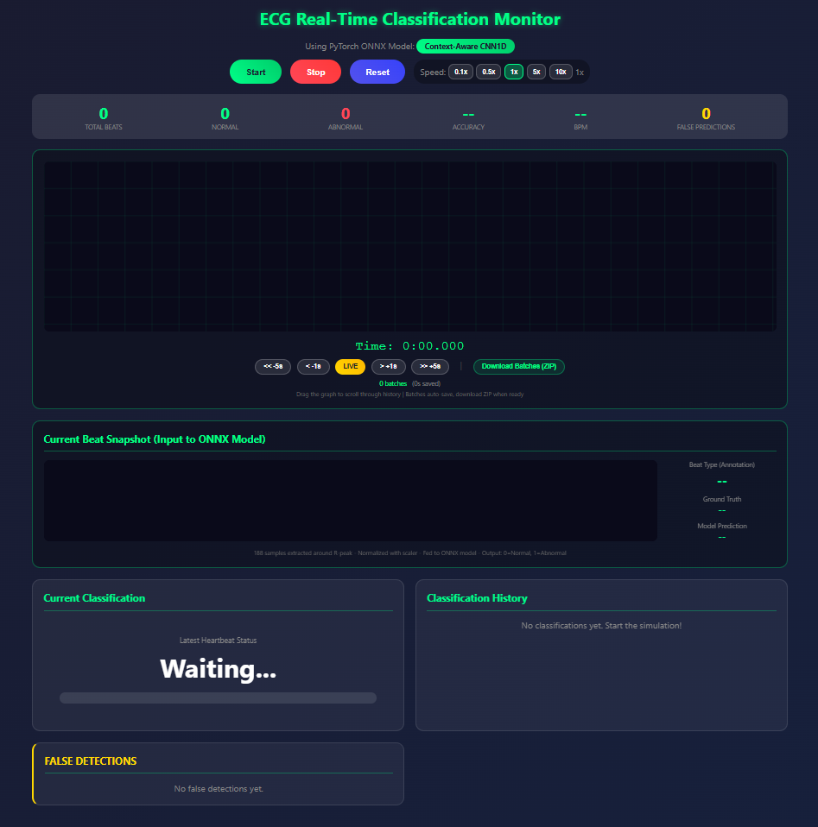
When the simulation page is first opened, the interface shows two empty graphs: the real-time input graph on top and the current beat Snapshot on bottom both of which remain un-interactable until the simulation starts. At the top, you'll find three main buttons: “Start,” “Stop,” and “Reset” to control the simulation. Once active, the “Real-Time Input Graph” becomes interactable, allowing you to scroll left or right to view historical data or return to the current time. At the bottom left, the “Current Classification” section will initially display “Waiting...” as the simulation hasn't begun, while the “Classification History” section on the bottom right remains empty until the simulation is running. Lastly, the “False Detections” section will track any incorrect classifications made by the model as the simulation progresses, remaining empty until the simulation starts.
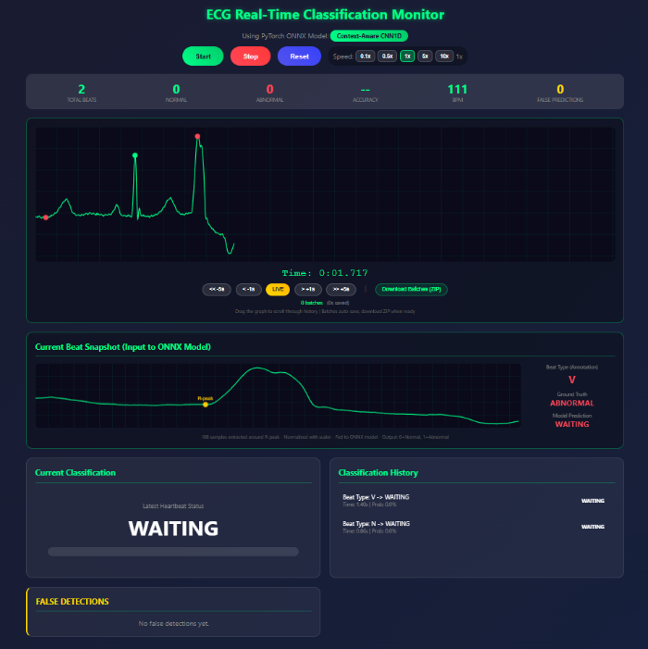
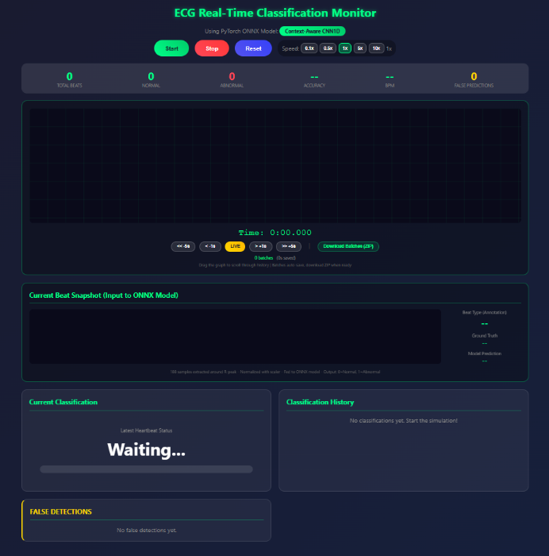
- Starting Classification
To start the simulation, simply click the “Start” button, and data will begin streaming in real-time, as shown by the graph above. The latest beat being classified will also be displayed at the bottom, initially showing the text “Waiting.” This is because the model requires 7 consecutive beats to create the context window, so until 7 beats have been processed, it will remain in a standby state. To pause or stop the simulation, click the red “Stop” button next to the “Start” button, which will halt the simulation at the most recent input. To reset the simulation, click the blue “Reset” button next to the “Stop” button.
- Viewing Classification
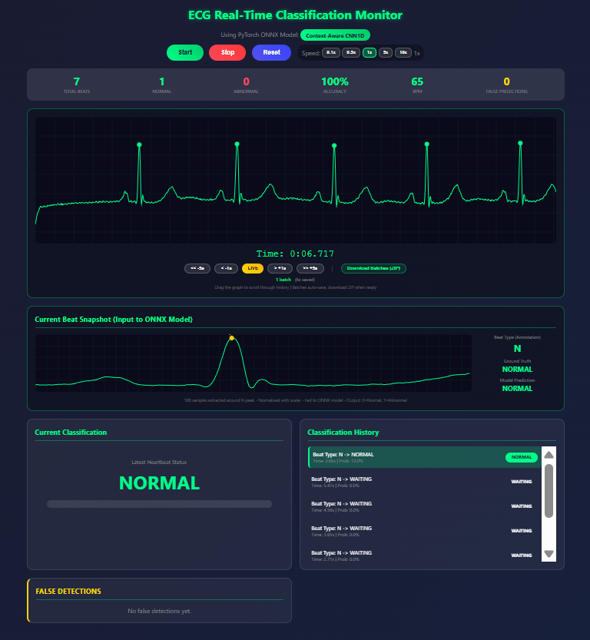
Beat classifications are delayed by 3 full beats. As shown in the red box above, the first and current successful classifications of a normal ECG beat are displayed, which are also identified as normal ECG beats. The graph below illustrates the R-peak and the full body of the ECG beat being classified. The “Classification History” section at the bottom right shows a history of all classifications, including both normal and abnormal beats, as well as any incorrect classifications.

- Speed Control and Adjustment
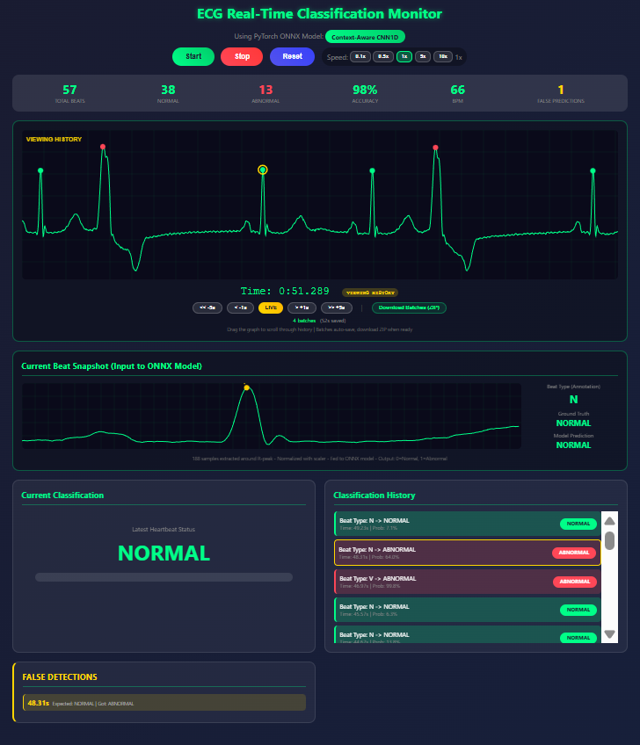
The speed of the simulation can be adjusted by clicking one of the buttons in the red-boxed area: 0.1x, 0.5x, 1x (default real-time speed), 5x, or 10x, depending on the desired speed. Keep in mind that higher speed simulations are more dependent on your CPU's capabilities. A newer and more powerful CPU can easily run the simulation at 10x speed, while older or slower CPUs may struggle, even at 5x speed.
- Incorrect Classification during Simulation

Incorrect classifications are inevitable, as shown above. Any incorrect classification will be highlighted with a yellow circle on the main graph, as indicated by the red box. It will also be marked with a yellow border in the “Classification History” section at the bottom right and in the “False Detection” section at the bottom left, both highlighted by red boxes. These markers indicate mistakes made by the model in the past.

