Bicycle meter requirements

Table of contents

1) Reference number 2

2) General requirements 2

In this document the requirements of the Bicycle meter project are stated in addition to the project reference number.

The Speedo meter along with its accessories will be noted in this document as the device except where it is stated explicitly that we note it for other thing.

# 1) Reference number

Ref.Number: BIC009907021

Reference number is constructed as follows: [Category][Speed Range][Type of display][more details for display][light enabled/backlight]=>

[Bicycle accessory = BIC][99km/hour][7 segment][ 2 = 2 lines][LED 7 segment]

# 2) General requirements

1. The Speedometer must be able to measure speeds up to 99 km/h.
2. The Speedometer resolution in speeds greater than 5 km/h must be higher than 0.2 km/h
3. The Speedometer resolution must be as accurate as possible compared to one of the high line products
4. The Speedometer shall switch to sleep mode if the current speed is zero and no HMI change is detected for at least 2 minutes.
5. The Speedometer shall wakeup from sleep mode if any change in HMI or bicycle wheel movement is detected.

# 3) User interface requirements

1. The interface is constructed of 3 buttons, 2 * 4 LED 7 segment display and 7 information LEDs clarified in fig [1] in the user interface Details chapter.
2. 1st row of the 7 segment displays the current speed.
3. 2nd row of the 7 segment shall display either covered distance, tire circumference, distance left for distance target or trip time.

**4) User interface Details**

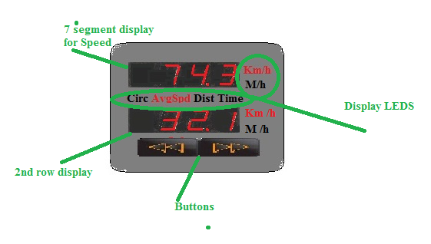Fig.1

1. To switch between measurements in Km or miles the user has to push the right button for more than 1 second(long press)
2. To switch between the data displayed in the second row the user has to push the right or the left button for less than 1 second as many times as needed (short press) until the corresponding Display LED indicate it.