RESEARCH ARTICLE

www.small-journal.com

Quantifying the Efficacy of Magnetic Nanoparticles for MRI and Hyperthermia Applications via Machine Learning Methods
Pavel Kim, Nikita Serov, Aleksandra Falchevskaya, Ilia Shabalkin, Andrei Dmitrenko, Daniil Kladko,* and Vladimir Vinogradov*

Introduction
Nanosized ferromagnets are an important class of materials whose magnetic properties such as magnetization values or co- ercivity are highly dependent on their size, shape, surface, and composition.[1] These unique properties of magnetic nanopar- ticles are pivotal for catalysis,[2] spintronics,[3,4] ecology,[5] data storage,[G] and medicine.[7–10] Medical treatments using magnetic nanoparticles have already shown promising results in clinical

P. Kim, N. Serov, A. Falchevskaya, I. Shabalkin, A. Dmitrenko, D. Kladko,
V. Vinogradov
International Institute “Solution Chemistry of Advanced Materials and Technologies”
ITMO University
St. Petersburg 191002, Russian Federation
E-mail: kladko@scamt-itmo.ru; vinogradov@scamt-itmo.ru

The ORCID identification number(s) for the author(s) of this article can be found under https://doi.org/10.1002/smll.202303522

DOI: 10.1002/smll.202303522
practice.[11] As an example, Feridex and Resovist have been approved as mag- netic resonance imagining (MRI) contrast agents for liver imagining. A number of other magnetic nanoparticles for MRI have undergone different stages of clinical trials.[12] The main reason for using mag- netic nanoparticles as MRI contrast agents is that high-resolution images of different tissues enable accurate lesion detection.[13] Moreover, magnetic nanoparticles have re- cently been used in clinical trials for hyperthermia treatment of glioblastoma, prostate, and pancreatic cancer. Under high temperature, cells undergo heat stress, so apoptosis, signal transduction, and protein expression can be controlled.[14,15] How- ever, the tedious process of synthesis of nanoparticles with satisfactory power loss for hyperthermia treatment and T1–T2 dual mode MRI contrast agents with high bio- compatibility is limiting their biomedical applications.[ 11,14,1G] Although size, shape, surface, and composition of nanoparti- cles and parameters of applied electromag- netic field can be optimized, selecting the
best combination of independent parameters is often infeasible
Magnetic nanoparticles are a prospective class of materials for use in biomedicine as agents for magnetic resonance imagining (MRI) and hyperthermia treatment. However, synthesis of nanoparticles with high efficacy is resource-intensive experimental work. In turn, the use of machine learning (ML) methods is becoming useful in materials design and serves as a great approach to designing nanomagnets for biomedicine. In this work, for the first time, an ML-based approach is developed for the prediction of main parameters of material efficacy, i.e., specific absorption rate (SAR) for hyperthermia and r₁/r₂ relaxivities in MRI, with parameters of nanoparticles as well as experimental conditions as descriptors. For that, a unique database with more than 980 magnetic nanoparticles collected from scientific articles is assembled. Using this data, several tree-based ensemble models are trained
to predict SAR, r₁ and r₂ relaxivity. After hyperparameter optimization, models reach performances of R2 = 0.86, R2 = 0.78, and R2 = 0.75, respectively.
Testing the models on samples unseen during the training shows no performance drops. Finally, DiMag, an open access resource created to guide synthesis of novel nanosized magnets for MRI and hyperthermia treatment with machine learning and boost development of new biomedical agents, is developed.
in practice due to low throughput and lack of resources.[17–19]
There are several works attempting to build phenomenolog- ical models that simplify optimization processes by establish- ing relationships between the structure and the specific prop- erties of magnetic nanoparticles.[20–22] Vuong et al. showed that r₂ relaxivity positively correlates with the diameter of spheri- cal iron oxide nanoparticles below the size limit of Motional Averaging Regime.[23] Shape of nanoparticles determines mag- netic anisotropy, while surface modification affects the behav- ior of nanoparticles inside an aqueous environment, thus influ- encing interactions with water molecules that is critical for MRI and hyperthermia treatment, as well as biocompatibility.[21,24] However, these structure–property associations refer to rather special cases, not generally applicable to other systems since they do not take into account other parameters of the system. For example, size effects on relaxivity in MRI were shown to be connected to nanoparticle composition.[1G] In this case, the- oretical models using fundamental principles of physical pro- cesses could be helpful for estimating performance of magnetic


Small 2023, 12, 2303522

2303522 (1 of 9)
© 2023 Wiley-VCH GmbH



nanoparticles, i.e., Solomon–Bloembergen–Morgan theory and quantum mechanical outer sphere theory describing MRI relax- ation processes;[ 1G,17] linear response theory, the Rayleigh, and the Stoner–Wohlfarth models that analytically determine spe- cific absorption rate (SAR) to quantify the efficacy of magnetic nanoparticles in converting electromagnetic energy into heat for hyperthermia applications.[25,2G] However, these models cannot account for all characteristics of real systems such as surface coating composition, shape, single- or multidomain of magnetic nanoparticles, magnetic dipole interactions, as well as varying ex- perimental conditions.[17,25,27,28] To do that, significant extension of theoretical models would have been necessary, which, in turn, would increase their complexity and the demand for compute.[29] Machine learning (ML) methods can overcome the aforemen- tioned limitations by leveraging large amounts of data. ML al- gorithms use training data to learn complex dependencies be- tween sample features and its properties of interest bypassing explicit mathematical formulation of their relationship. Notably, this approach can also be computationally more efficient com- pared to numerical methods in mathematical modeling.[30] ML tools have been successfully used in materials science for predict- ing properties of nanomaterials and even de novo design.[31–34] Although there is an increasing demand for magnetic nanoparti- cles with specific properties for the best performance in different applications, there are relatively few works dedicated to ML tar- geting new materials in this domain.[35] Court et al. developed magnetocaloric property prediction models using the chemical composition features for predicting Curie temperature, absolute magnetic entropy change, and relative cooling power and applied these models for inverse design of materials.[3G] Exl et al. applied an ML approach to study microstructural features of Nd2Fe14B permanent magnets with a granular structure and demonstrated importance of the position of the grain within the magnet.[37] Nel- son and Sanvito used chemical composition as the only feature for prediction of the Curie temperature of ferromagnets with an accuracy of ≈50 K.[38] Coïsson et al. leveraged data of numeri- cal simulations to predict power losses of magnetic nanoparti- cles for hyperthermia applications in good agreement with exper- imental data.[29] ML methods possess huge potential for design- ing magnetic nanoparticles for medical applications that have not
yet been fully explored.[19]
In this work, we propose an ML approach to predict the pa- rameters determining efficacy of nanoparticles in MRI (r₁ and r₂ relaxivities) or hyperthermia treatment (SAR). For this purpose, we create a unique database with physicochemical characteristics and measures of SAR and relaxivities by collecting data from the previously published articles. We perform feature engineering, train and optimize ML models to achieve tenfold cross-validation R2 = 0.8G for prediction of SAR, R2 = 0.78 and R2 = 0.75 for prediction of r₁ and r₂ relaxivities, respectively. We analyze fea- ture importances using SHAP-values and map them onto the expected dependencies (those in agreement with previously re- ported experiments) between descriptor and target variables in the data to assess interpretability of our models. Thereby, we con- firm a high degree of correspondence between the model predic- tions and the existing empirical evidence, which increases the confidence in the predictions of SAR and r₁/r₂ relaxivities. More- over, we validate the ML models on previously unseen nanopar- ticles collected independently of the initial database and show
accurate predictions of their properties, which makes a case for the use of our models in experimental practice. Finally, we present DiMag, a web service for rapid in silico screening of mag- netic nanoparticles for biomedical applications, which provides users worldwide with access to the database and the trained ML models.

Results and Discussion

Database of Magnetic Nanoparticles for Hyperthermia Treatment and MRI Diagnosis

MRI is one of the main in vivo imaging tools able to provide both anatomical and functional information. In turn, hyperther- mia is a kind of treatment frequently employed in cancer therapy. Thus, a combination of these approaches delivers hyperthermia treatment based on precise lesion diagnosis with MRI. Magnetic nanoparticles have unique properties and attract a lot of attention because of their potential use as MRI contrast agents for substi- tution of high-toxic Gd-chelates. Moreover, magnetic nanomate- rials can be used as heating agents for hyperthermia treatment as they are able to convert large amounts of energy of alternating magnetic fields into heat. Despite a lot of attention to magnetic nanoparticles for biomedical applications, however, there are cur- rently no databases of nanomagnets for MRI and hyperthermia treatment. Therefore, we set out to create such a database fol- lowing the so-called FAIR principles[39] to accelerate the develop- ment of new materials and simplify the use of artificial intelli- gence to distill new scientific knowledge from data.
For this purpose, first, we manually collected 1282 raw sam- ples from 12G unique scientific articles (Table S1, Supporting Information) with descriptions of synthesis, materials charac- terizations, and measurements of magnetic hyperthermia and MRI performances in vitro. Initial database consisted of vari- ous parameters playing a significant role in MRI and hyperther- mia applications according to the physical nature of the pro- cess. Those include chemical composition of core, shape, length, width, depth, zeta potential, hydrodynamic radius, magnetic pa- rameters of nanoparticles measured by SQUID under 300 K, pa- rameters of magnetic field during experiments, concentration of nanoparticles and efficacy of nanomagnets in hyperthermia treat- ment (SAR value) and MRI (r₁ and r₂ relaxivities) obtained via in vitro experiments. Since it is known that surface composition de- fines the properties of magnetic nanoparticles to a large extent, we used inorganic shell and organic coating compositions to de- scribe the surface of nanoparticles (Figure 1A).[17,20]
To go beyond collection of what had been readily available in the literature and enable broader downstream applications, we substantially expanded the set of characteristics of magnetic nanoparticles by feature engineering (Figure 1B). Average mag- netic moment of metals in the core was calculated using mag- netic moments of each element with help of stoichiometry to better describe composition of nanoparticles (Equation (S1), Sup- porting Information). Average spin of metal elements on the sur- face was obtained to describe interactions between the surface elements and proton spins responsible for relaxation properties of the nanoparticle (Equation (S2), Supporting Information). To describe the role of organic coating, we employed a partition coef- ficient LogP and number of H acceptors, which were calculated

Small 2023, 12, 2303522
16136829, 2023, 48, Downloaded from https://onlinelibrary.wiley.com/doi/10.1002/smll.202303522 by ITMO University, Wiley Online Library on [10/07/2025]. See the Terms and Conditions (https://onlinelibrary.wiley.com/terms-and-conditions) on Wiley Online Library for rules of use; OA articles are governed by the applicable Creative Commons License

2303522 (2 of 9)
© 2023 Wiley-VCH GmbH



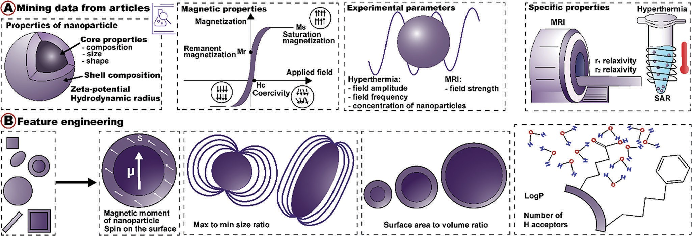
Figure 1. Database formation. A) Examples of descriptors mined from the scientific articles. B) Examples of engineered features based on core and shell composition as well as geometry of nanoparticles.

using SMILES representations of organic molecules. These pa- rameters could be informative of interactions of the surface of the nanoparticle with water molecules, and such interactions are known to have strong influence on the nanoparticle performance in MRI and magnetic hyperthermia.[40,41] Volume and surface area were calculated using the shape and size of the nanoparticle to describe morphological characteristics of nanomagnets.
All obtained and engineered features can be divided into specific groups that cover main aspects regarding behavior of nanoparticles in MRI and hyperthermia applications: 1) pa- rameters reflecting the composition of nanoparticles (e.g., av- erage magnetic moment of the metals), 2) parameters de- scribing behavior of nanoparticles in aqueous environment (e.g., average spin of metal elements at the surface, zeta po- tential, hydrodynamic radius, number of H acceptors, and LogP of organic coating molecules), 3) parameters represent- ing the structure of particles (e.g., such as area, volume, length, width, and depth), 4) SQUID-parameters (e.g., coercivity, rema- nence, and saturation magnetization reflecting magnetic prop- erties of material), and 5) experimental conditions (e.g., field strength, amplitude, and frequency, concentration of nanopar- ticles). To investigate redundancy in these groups of features, we calculated and analyzed the Pearson correlation matrix (Figure 2A). We observed, for instance, a group of geometrical features with high cross-correlations and reduced them to a sin- gle area-volume feature. On the other hand, we investigated the number of outliers and missing values to keep only the most informative features.
After minimal data cleansing, we obtained the dataset of more than 980 nanosized metals, bimetals, and metal oxides (ferrites with various compositions) materials with more than 120 core and 50 shell compositions of different kinds. Figure 2B illustrates the broad coverage of nanoparticles in the final dataset. Ferrites, being the most well studied class of magnetic nanoparticles, are also the most represented one. The majority of magnetic nano- materials have organic or inorganic shells of a wide range of com- pounds. The broad coverage of magnetic nanoparticles is espe- cially important for downstream ML applications to avoid over- fitting and improve generalization capabilities of the models.
In the following section, we use the resulting dataset to quan- tify the efficacy of magnetic nanoparticles in MRI and hyperther- mia treatment with machine learning. However, we intend to ex- pand the initial database and keep it up-to-date to allow broader use cases for fundamental research and biomedical applications.

Prediction of SAR and Relaxivity Values of Magnetic Nanoparticles

We aimed at predicting SAR and r₁/r₂ relaxivities based on the unique database of magnetic properties of nanoparticles de- scribed earlier. We started by implementing additional prepro- cessing steps to ensure high quality of the input data. Due to poor characterization of magnetic nanoparticles in the majority of scientific articles, which served as data sources for our study, it was impossible to effectively use all the collected descriptors. For example, zeta potential and hydrodynamic radius are impor- tant parameters describing the interaction between a nanoparti- cle and a media. Even so, we had to exclude them due to the large percent of missing values (>50%). Keeping those would require data imputation, which at this scale would inevitably introduce strong biases and decrease performance of ML models. As for other parameters (those having less data sparsity), we chose kNN imputation technique, because it considers the relationships be- tween the different features, it is robust to outliers, and it can handle both categorical and continuous variables.[42] In the ini-
tial dataset, we had features with high percentages of missing values, e.g., 34% for r₁ relaxation, 28% for remanent magnetiza- tion, and 21% for coercivity. To cope with that, we first removed the total of 211 samples such that each sample in the remaining dataset had no more than 15% of missing values. After that, we applied the kNN imputation algorithm to fill the gaps and obtain the complete dataset.
Further, to alleviate redundancy in data and retain only the most informative features, we transformed highly correlated ge- ometrical features into area to volume and max to min length ratios reflecting size and shape anisotropy of nanoparticles. Cor- relation analysis confirmed the absence of linear dependencies

Small 2023, 12, 2303522
16136829, 2023, 48, Downloaded from https://onlinelibrary.wiley.com/doi/10.1002/smll.202303522 by ITMO University, Wiley Online Library on [10/07/2025]. See the Terms and Conditions (https://onlinelibrary.wiley.com/terms-and-conditions) on Wiley Online Library for rules of use; OA articles are governed by the applicable Creative Commons License

2303522 (3 of 9)
© 2023 Wiley-VCH GmbH



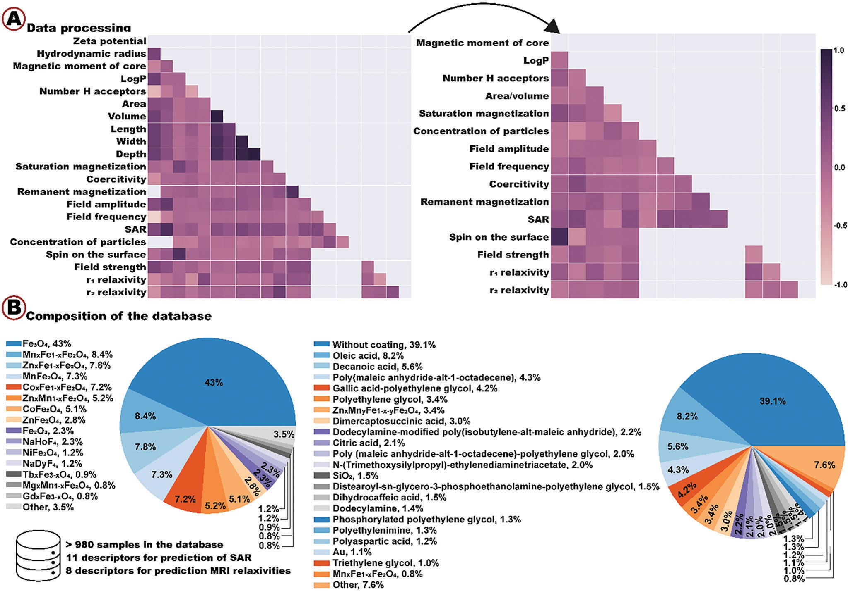
Figure 2. A) Correlation matrix for the initial and the selected parameters (empty region indicates there is no intersection between the parameters, so correlations between them cannot be calculated). B) Core and shell composition statistics for the final dataset.

for the new descriptors (Figure 2A). We also discarded nonin- formative features of low variance, i.e., coercivity and remanent magnetization values for prediction of MRI relaxivities.
Finally, we removed samples with outliers by setting empirical thresholds on feature values while analyzing their distributions. Our objective was to retain as many samples as possible while mitigating negative influence of outliers.
After the final dataset has been prepared, we divided it into three, one for each regression problem: prediction of SAR value, r₁ or r₂ relaxivity containing 4G0, 355, and 4G5 samples, respec- tively (Figures S1–S3, Supporting Information). For prediction of SAR value, 11 descriptors were used, whereas relaxivity values were predicted using 8 descriptors only (see Database collection and processing section in the Supporting Information). We nor- malized and log-scaled the data for each problem before splitting to train and test sets in the 80/20 ratio.
In this work, we opted for tree-based algorithms such as Ran- dom Forest and Gradient Boosting, as they remain state-of-the-art for midsize inhomogeneous tabular data, on par with or even out- performing modern deep learning models.[43] Ensemble of deci- sion trees is at the heart of tree-based models. While Random Forest and Extra Trees regression models are based on averaging predictions of decision trees built on a random subset of features,
LGBMRegressor and XGBRegressor algorithms build sequences of decision trees such that each next tree minimizes the error of the previous one.[44,45] To achieve the highest model performance for each regression task, hyperparameter tuning was done using the model-agnostic Optuna framework[4G] (Table S5, Supporting Information). For each regression problem, we optimized and compared performance of four models (Figure S4, Supporting Information). The best model was selected using the following metrics: mean Q2 and RMSE for tenfold cross-validation and R2 and RMSE for test samples.
One common issue for all machine learning applications is overfitting. Trained on a finite dataset, models tend to learn not only relevant dependencies among the variables but also biases. This can lead to drastic drops in model performance (i.e., in- creased errors), when evaluated on previously unseen testing ex- amples. Therefore, we carefully examined the performance of the selected models on the test sets. To our surprise, we even ob- served slight improvement in RMSE, which advocates for good generalization power of the best models (Figure 3A). For SAR prediction, RMSE of 0.28 on tenfold cross-validation dropped to 0.2G on test samples; for r₁ and r₂ relaxivities, RMSE dropped from 0.30 to 0.27 and from 0.25 to 0.22 on test samples, respec- tively.

Small 2023, 12, 2303522
16136829, 2023, 48, Downloaded from https://onlinelibrary.wiley.com/doi/10.1002/smll.202303522 by ITMO University, Wiley Online Library on [10/07/2025]. See the Terms and Conditions (https://onlinelibrary.wiley.com/terms-and-conditions) on Wiley Online Library for rules of use; OA articles are governed by the applicable Creative Commons License

2303522 (4 of 9)
© 2023 Wiley-VCH GmbH



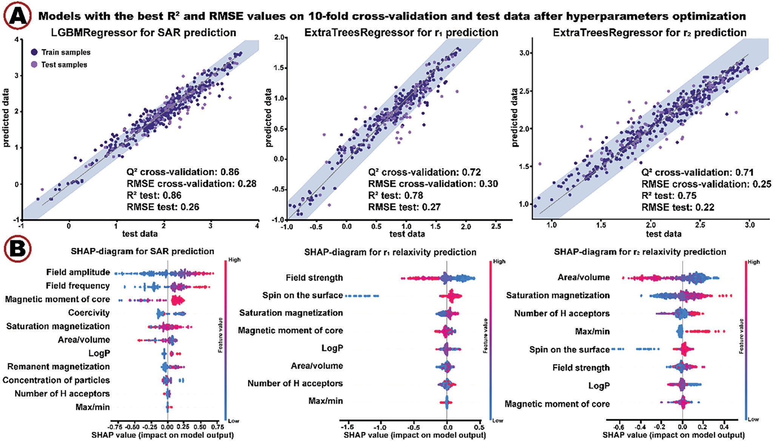
Figure 3. Machine learning methods. A) Selected models for prediction of SAR and r₁/r₂ relaxivities (shaded area corresponds to the RMSE on tenfold cross-validation). B) SHAP diagrams.

It should be noticed that after the filtering procedure we have done during data handling, we obtained increased metrics in prediction of r₁ relaxivity (R2 on test samples increased from 0.75 to 0.78) and r₂ relaxivity (Q2 on cross-validation increased from 0.G3 to 0.71), which prove the importance of the described pre- processing steps.
A longstanding concern in scientific applications of machine learning is model interpretability, i.e., the ability to understand the underlying decision making process, which is oftentimes lacking.[47] One way to approach that is to investigate feature importances to shed light on which features in the data have the strongest impact on the prediction. For this purpose, we plotted SHAP (SHapley Additive exPlanations) values for each selected ML model (Figure 3B). SHAP is a game-theoretic ap- proach to explain the output of any machine learning model by assigning each feature an importance value for a particular prediction.[48] Figure 3B demonstrates that SHAP-values high- light well-known experimental dependencies. For example, the amount of generated heat strongly depends on the amplitude and frequency of the field (Equation (SG), Supporting Informa- tion). It was previously shown that increasing field strength of MRI scanners leads to an increase in r₂ and a decrease in r₁ relaxivity values.[49] Decreasing area-to-volume ratio due to in- creasing size of nanoparticles results in larger r₂ relaxivity val- ues, which is also consistent with experimental observations.[1G] Shape anisotropy of nanoparticles, that is reflected in maximum to minimum length ratio, has a strong influence on the r₂ re- laxivity, as larger outer sphere diameter for nanoparticles with anisotropic morphology is associated with increased r2 values.[1G]
Magnetic properties of nanoparticles strongly affect their efficacy in MRI and hyperthermia applications, as heat dissipation and r₂ relaxivity are proportional to the saturation magnetization value (Equations (SG) and (S9), Supporting Information). Increasing spin of elements on the surface leads to an increase in r₁ relaxiv- ity, which is in agreement with theoretical knowledge.[1G] Thus, analysis of feature importance diagrams proves interpretability of our models and demonstrates their ability to make predic- tions in good agreement with experimental observations and theoretical knowledge.
Moreover, there are some nonobvious dependencies outlined by the SHAP diagrams. For instance, larger values of LogP are associated with increased SAR values, which can be explained by higher mobility of nanoparticles in aqueous solution. Fur- thermore, it is interesting to observe the influence of the num- ber of H acceptors of organic coating on the r₂ relaxivity value. Large number of H acceptors leads to an increasing number of water molecules near the nanoparticle (in the second sphere), and vice versa, thus strongly influencing the r₂ relaxivity, which is expected.[50] We can speculate that the intermediate number of H acceptors does not lead to a significant increase in water molecules near the nanoparticle for increasing r₂ relaxivity, how- ever, interaction with protons slows down the exchange rate of re- laxed and bulk water molecules resulting in a dramatic decrease of the r₂ relaxivity value. Consequently, the analysis of SHAP di- agrams allows to generate hypotheses about the mechanisms of efficacy of magnetic nanoparticles.
As an additional validation effort, we formed another testing set of samples (Tables SG and S7, Supporting Information) that

Small 2023, 12, 2303522
16136829, 2023, 48, Downloaded from https://onlinelibrary.wiley.com/doi/10.1002/smll.202303522 by ITMO University, Wiley Online Library on [10/07/2025]. See the Terms and Conditions (https://onlinelibrary.wiley.com/terms-and-conditions) on Wiley Online Library for rules of use; OA articles are governed by the applicable Creative Commons License

2303522 (5 of 9)
© 2023 Wiley-VCH GmbH



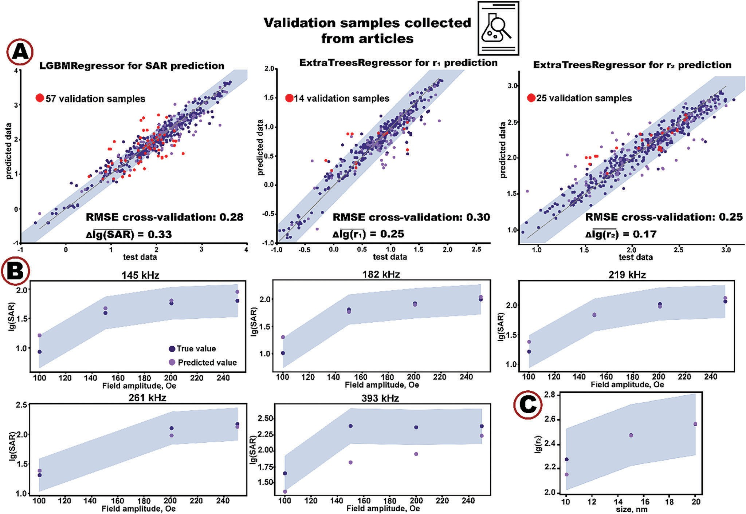
Figure 4. Validation of ML models. A) Model performance on validation samples. B) True versus predicted values of lg(SAR) over the alternating magnetic field amplitude at different frequencies. C) True versus predicted values of lg(r2) over the size of nanoparticles. Shaded area corresponds to the mean tenfold cross-validation RMSE.

have not been used for training and optimizing hyperparame- ters of the ML models. Some of them were collected from the most recent experimental works published in 2023.[51,52] In the following, we refer to these samples as validation samples for the sake of clarity and conciseness.
For prediction of relaxivity values, validation samples included nanoparticles with different morphological parameters, element compositions, and organic coatings. For prediction of SAR, validation samples with different concentrations, morphology, and composition of core and shell as well as at different exper- imental conditions were used. Therefore, the validation samples not only contained previously unseen samples but also intro- duced additional variability by allowing previously unseen com- binations of feature values. Thus, the additional testing set repre- sents a good stress-test for the models and serves as a reliability indicator.
Figure 4A compares model predictions and experimental mea- surements of log-scaled SAR, r₁ and r₂ relaxivities. Most of the validation samples appear within the blue area, which corre- sponds to the mean tenfold cross-validation RMSE. Transition- ing back from the log-scale to the real values, we computed per- cent of predictions that differed from the true values by less than 50%. For SAR, r₁ and r₂ relaxivities, the percentages were
47%, 57%, and G8%, respectively, which indicates rather high precision. Similar to interpretability analysis described earlier, we followed and validated several predictions based on the avail- able experimental data. For cubic Fe₃O₄ nanoparticles of SAR validation samples, we plotted predicted and experimental val- ues over the field amplitude at different frequencies (Figure 4B). With increasing field amplitude, predicted values remained close to the measured ones within tenfold cross-validation RMSE for the vast majority of frequencies. Deviations at 393 kHz can be explained by the fact that there are only 14% of samples in our training set measured at frequencies higher than 370 kHz (Figure S1, Supporting Information). It is known that machine learning algorithms are limited in their extrapolative power.[53–55] In practice, it means that low performance is to be expected when evaluating a model on the set of underrepresented sam- ples. Figure 4C shows predictions of r2 relaxivities for Fe3O4 nanoparticles at different sizes that almost exactly match the experimental values.
However, every machine learning model has its limitations that are important to keep in mind to avoid or minimize misuse. Despite the rather high performance of our models, they were trained on a limited dataset of nanoparticles previously charac- terized in the literature. Thus, the trained models are biased to

Small 2023, 12, 2303522
16136829, 2023, 48, Downloaded from https://onlinelibrary.wiley.com/doi/10.1002/smll.202303522 by ITMO University, Wiley Online Library on [10/07/2025]. See the Terms and Conditions (https://onlinelibrary.wiley.com/terms-and-conditions) on Wiley Online Library for rules of use; OA articles are governed by the applicable Creative Commons License

2303522 (6 of 9)
© 2023 Wiley-VCH GmbH



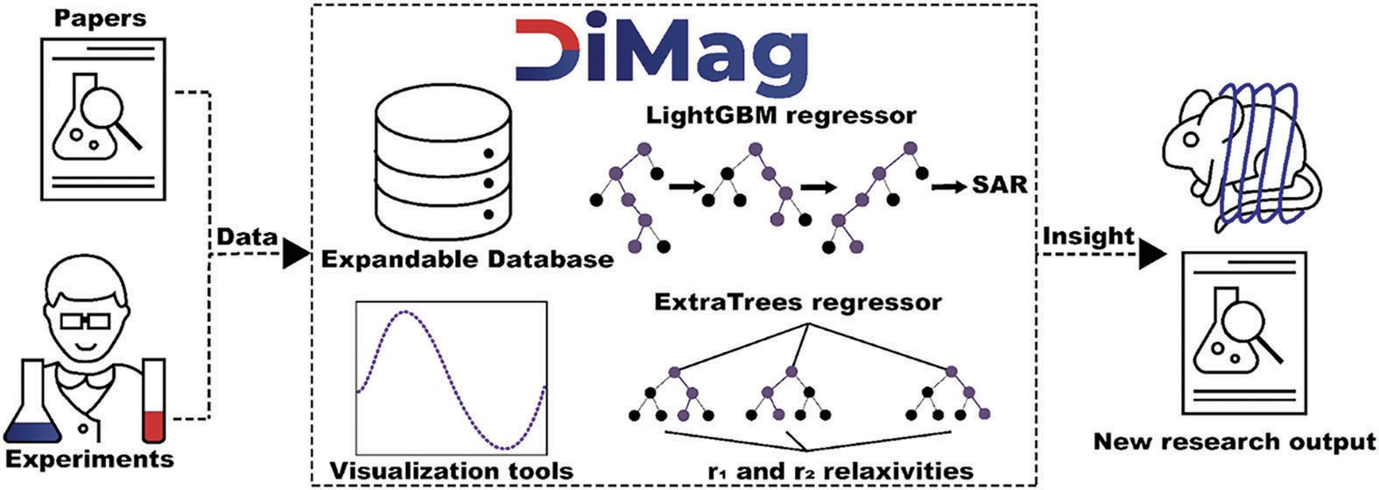
Figure 5. Functionality of developed web-recourse.

reproduce only those properties already contained in the database (Figures S1–S3, Supporting Information). With substantial ex- tension of the database to represent other types of nanomate- rials, these biases can be alleviated but never completely over- come. Therefore, prediction of properties of the new materials may be inaccurate. Moreover, descriptors used in this work do not reflect all aspects of any given system. For instance, the lack of available data for hydrodynamic radius and zeta potential pre- vented us from including this information in the training set, thus limiting the capability of the model to explain behavior of nanoparticles in the aqueous environment. Other examples in- clude blocking temperature, Neel and Brownian relaxation times, reflecting general properties of magnetized nanoparticles. Shell thickness is another important parameter of magnetic nanopar- ticles that is missing in the training set due to very few articles reporting its quantification. In practice, it means that these fea- tures cannot be used for predictions of SAR, r₁ and r₂ relaxiv- ities for new nanomaterials with our models even if this data becomes available.
Additionally, all the data used for training the models was col- lected from in vitro studies, so the models are not suited to pre- dict behavior of magnetic nanoparticles in vivo and are not gen- erally applicable in clinics. As more data from in vivo studies of magnetic nanoparticles becomes available, it will be possible to investigate the degree of correlation between the two types of ex- periments and attempt to predict the properties of magnetic NP in vivo.
It is noteworthy that performance of nanoparticles in MRI and hyperthermia is strongly dependent on their shapes. Apart from the simple shapes, there are nonstandard ones, such as Nanoflower and Dumbbell, that are impossible to describe with three length measurements. Some complex shapes can be ap- proximated as spherical or cubic, though any such simplification might lead to information loss. However, capturing the nuanced geometry of NPs requires appropriate data representations. In our view, scanning electron microscopy images could be a viable solution when processed with deep neural networks. Like any deep learning application, this approach is inherently data-greedy and simply not feasible when the number of training samples is low. Nevertheless, we strongly believe that enriched data repre- sentations obtained with deep learning will make many break- throughs in characterization and design of nanomaterials in the future.

Web Service

To facilitate user access to the trained models and the database, we developed an open access web service, called DiMag (Figure 5), available at http://dimag.acidlab.space. DiMag pro- vides the scientific community with an opportunity to 1) explore biomedical performance of existing magnetic nanoparticles for MRI and hyperthermia applications in one place, 2) quantify properties of novel nanoparticles, and 3) explore the dataset us- ing visualization of dependencies between different parameters. To allow predictions with limited data available, the platform sup- ports three modes of prediction depending on the number of de- scriptors provided by the user. We recommend using advanced mode for the most accurate prediction. Providing the service with parameters of magnetic nanoparticles, a user can expect the pre- dicted SAR or r₁/r₂ relaxivity values along with a chart of the cor- responding experimental dependency (predicted SAR over the field amplitude and frequency or predicted relaxivity over the field strength). Furthermore, the DiMag implements an interface to expand the underlying database by creating new records of mag- netic nanoparticles with links to the corresponding articles. We encourage other researchers to contribute new data to keep the database up-to-date and provide us with their feedback to further improve the usability and predictive power of DiMag.

Conclusion
We introduced an ML approach to quantify efficacy of magnetic nanoparticles by prediction parameters determining their per- formance in MRI (r₁ and r₂ relaxivities) or hyperthermia treat- ment (SAR). For this purpose, we created the unique database of magnetic nanoparticles where more than 980 nanosized metal, bimetal, and metal oxides (ferrites with various compositions) materials having more than 120 core and 50 shell composi- tions of different kinds were manually collected from 12G sci- entific articles. This data was enhanced by theoretically calcu- lated and newly engineered features related to composition (e.g., magnetic moment of the core, spin on the surface, LogP, and number of H acceptors for organic coating molecules) and struc- ture (e.g., ratio of max-to-min length and surface-to-volume ra- tio). The resulting database was used to train tree-based ensem- ble models to predict SAR, r₁ and r₂ relaxivities. Model-agnostic hyperparameter optimization yielded state-of-the-art performanc

Small 2023, 12, 2303522
16136829, 2023, 48, Downloaded from https://onlinelibrary.wiley.com/doi/10.1002/smll.202303522 by ITMO University, Wiley Online Library on [10/07/2025]. See the Terms and Conditions (https://onlinelibrary.wiley.com/terms-and-conditions) on Wiley Online Library for rules of use; OA articles are governed by the applicable Creative Commons License

2303522 (7 of 9)
© 2023 Wiley-VCH GmbH



of R2 = 0.8G, R2 = 0.78, and R2 = 0.75, respectively. Analy- sis of the best models proved high interpretability reflecting well-known experimental dependences between the predicted values and the data features. Additional validation procedure based on previously unseen samples as well as previously unseen combinations of feature values demonstrated high precision and, therefore, good generalization capability of the best models. Since the validation samples were obtained at the very late stage of the study, this validation approach is even more indicative of the model reliability than synthesis of a few selected nanoparti- cles. Nevertheless, we do consider comprehensive experimental validation in the follow-up studies. Finally, the results of this work are now publicly available through DiMag, an open access web service (http://dimag.acidlab.space) that empowers users world- wide to easily utilize our best ML models, visualize and explore our database, and contribute their own samples to foster open research of magnetic nanomaterials. We envision a significant impact of DiMag on developing and optimizing magnetic nano- materials for hyperthermia treatment and MRI by enabling rapid in silico screening as an alternative or a complement to resource- intensive laboratory work.

Supporting Information
Supporting Information is available from the Wiley Online Library or from the author.

Acknowledgements
The work was financially supported by the Russian Science Foundation no. 23-23-00334. The authors also thank Priority 2030 Federal Academic Leadership Program for infrastructure support.

Conflict of Interest
The authors declare no conflict of interest.

Author Contributions
P.K.: data collection, data processing, models development, web-resource development, and manuscript writing. N.S.: concept development and manuscript writing. A.F.: data collection. I.S.: data collection. A.D.: manuscript writing and study supervision. D.K.: concept development, data processing, and manuscript writing. V.V.: concept development, manuscript writing, and study supervision.

Data Availability Statement
The data that support the findings of this study are openly available in a GitHub repository at https://github.com/acid-design-lab/DiMag.

Keywords
hyperthermia, machine learning, magnetic nanoparticles, magnetic reso- nance imagining

Received: April 26, 2023
Revised: July 16, 2023
Published online: August 10, 2023

- Z. Ma, J. Mohapatra, K. Wei, J. P. Liu, S. Sun, Chem. Rev. 2021, 123, 3904.
- M. B. Gawande, P. S. Branco, R. S. Varma, Chem. Soc. Rev. 2013, 42, 3371.
- S. Kinge, M. Crego-Calama, D. N. Reinhoudt, ChemPhysChem 2008,
2, 20.
- K. M. Krishnan, A. B. Pakhomov, Y. Bao, P. Blomqvist, Y. Chun, M. Gonzales, K. Griffin, X. Ji, B. K. Roberts, J. Mater. Sci. 2006, 41, 793.
- X. Qu, J. Brame, Q. Li, P. J. J. Alvarez, Acc. Chem. Res. 2013, 46, 834.
- J. P. Wang, Proc. IEEE 2008, 26, 1847.
- A. H. Lu, E. L. Salabas, F. Schüth, Angew. Chem., Int. Ed. 2007, 46, 1222.
- D. Lisjak, A. Mertelj, Prog. Mater. Sci. 2018, 25, 286.
- Q. A. Pankhurst, N. K. T. Thanh, S. K. Jones, J. Dobson, J. Phys. D: Appl. Phys. 2009, 42, 224001.
- C. Bárcena, A. K. Sra, J. Gao, in Nanoscale Magnetic Materials and Applications (Eds: J. Liu, E. Fullerton, O. Gutfleisch, D. Sellmyer), Springer, Boston, MA 2009, p. 591.
- H. Huang, W. Feng, Y. Chen, J. Shi, Nano Today 2020, 35, 100972.
- Y. X. J. Wáng, J. M. Idée, Quantum Imaging Med. Surg. 2017, 7, 88.
- H. Bin Na, I. C. Song, T. Hyeon, Adv. Mater. 2009, 21, 2133.
- X. Liu, Y. Zhang, Y. Wang, W. Zhu, G. Li, X. Ma, Y. Zhang, S. Chen, S. Tiwari, K. Shi, S. Zhang, H. M. Fan, Y. X. Zhao, X. J. Liang, Theranostics 2020, 10, 3793.
- C. S. S. R. Kumar, F. Mohammad, Adv. Drug Delivery Rev. 2011, 63, 789.
- D. Ni, W. Bu, E. B. Ehlerding, W. Cai, J. Shi, Chem. Soc. Rev. 2017, 46, 7438.
- Z. Zhou, L. Yang, J. Gao, X. Chen, Adv. Mater. 2019, 31, 1804567.
- A. E. Deatsch, B. A. Evans, J. Magn. Magn. Mater. 2014, 354, 163.
- E. Y. Vedmedenko, R. K. Kawakami, D. D. Sheka, P. Gambardella, A. Kirilyuk, A. Hirohata, C. Binek, O. Chubykalo-Fesenko, S. Sanvito, B. J. Kirby, J. Grollier, K. Everschor-Sitte, T. Kampfrath, C.-Y. You, A. Berger,
J. Phys. D: Appl. Phys. 2020, 53, 453001.
- S. H. Noh, S. H. Moon, T. H. Shin, Y. Lim, J. Cheon, Nano Today 2017,
13, 61.
- L. Wu, A. Mendoza-Garcia, Q. Li, S. Sun, Chem. Rev. 2016, 116, 10473.
- Y. W. Jun, Y. M. Huh, J. S. Choi, J. H. Lee, H. T. Song, S. Kim, S. Yoon,
K. S. Kim, J. S. Shin, J. S. Suh, J. Cheon, J. Am. Chem. Soc. 2005, 127, 5732.
- Q. L. Vuong, J. F. Berret, J. Fresnais, Y. Gossuin, O. Sandre, Adv. Healthcare Mater. 2012, 1, 502.
- J. Xie, G. Liu, H. S. Eden, H. Ai, X. Chen, Acc. Chem. Res. 2011, 44, 883.
- J. Carrey, B. Mehdaoui, M. Respaud, J. Appl. Phys. 2011, 102, 083921.
- I. Raouf, S. Khalid, A. Khan, J. Lee, H. S. Kim, M. H. Kim, J. Therm. Biol. 2020, 21, 102644.
- Y. Gossuin, T. Orlando, M. Basini, D. Henrard, A. Lascialfari, C. Mattea, S. Stapf, Q. L. Vuong, Nanotechnology 2016, 27, 155706.
- B. Mehdaoui, A. Meffre, J. Carrey, S. Lachaize, L. M. Lacroix, M. Gougeon, B. Chaudret, M. Respaud, Adv. Funct. Mater. 2011, 21, 4573.
- M. Coïsson, G. Barrera, F. Celegato, P. Allia, P. Tiberto, APL Mater.
2022, 10, 081108.
- Y. Liu, T. Zhao, W. Ju, S. Shi, J. Mater. 2017, 3, 159.
- J. Cai, X. Chu, K. Xu, H. Li, J. Wei, Nanoscale Adv. 2020, 2, 3115.
- J. Razlivina, N. Serov, O. Shapovalova, V. Vinogradov, Small 2022, 18, 2105673.
- Q. Zhou, S. Lu, Y. Wu, J. Wang, J. Phys. Chem. Lett. 2020, 11, 3920.
- J. Wei, X. Chu, X. Y. Sun, K. Xu, H. X. Deng, J. Chen, Z. Wei, M. Lei,
InfoMat 2019, 1, 338.
- G. Katsikas, C. Sarafidis, J. Kioseoglou, Phys. Status Solidi B 2021, 258, 2000600.
- C. J. Court, A. Jain, J. M. Cole, Chem. Mater. 2021, 33, 7217.

Small 2023, 12, 2303522
16136829, 2023, 48, Downloaded from https://onlinelibrary.wiley.com/doi/10.1002/smll.202303522 by ITMO University, Wiley Online Library on [10/07/2025]. See the Terms and Conditions (https://onlinelibrary.wiley.com/terms-and-conditions) on Wiley Online Library for rules of use; OA articles are governed by the applicable Creative Commons License

2303522 (8 of 9)
© 2023 Wiley-VCH GmbH



www.advancedsciencenews.com www.small-journal.com

- L. Exl, J. Fischbacher, A. Kovacs, H. Oezelt, M. Gusenbauer, K. Yokota,
T. Shoji, G. Hrkac, T. Schrefl, J. Phys. Mater. 2019, 2, 014001.
- J. Nelson, S. Sanvito, Phys. Rev. Mater. 2019, 3, 104405.
- M. D. Wilkinson, M. Dumontier, I. J. Aalbersberg, G. Appleton, M. Axton, A. Baak, N. Blomberg, J.-W. Boiten, L. Bonino da Silva Santos,
P. E. Bourne, J. Bouwman, A. J. Brookes, T. Clark, M. Crosas, I. Dillo, O. Dumon, S. Edmunds, C. T. Evelo, R. Finkers, A. Gonzalez- Beltran, A. J. G. Gray, P. Groth, C. Goble, J. S. Grethe, J. Heringa,
P. A. C. ’t Hoen, R. Hooft, T. Kuhn, R. Kok, J. Kok, et al., Sci. Data
2016, 3.
- F. Ahmadpoor, A. Masood, N. Feliu, W. J. Parak, S. A. Shojaosadati,
Frontal Nanotechnol. 2021, 3, 644734.
- B. Aslibeiki, N. Eskandarzadeh, H. Jalili, A. Ghotbi Varzaneh, P. Kameli, I. Orue, V. Chernenko, A. Hajalilou, L. P. Ferreira, M. M. Cruz, Ceram. Int. 2022, 48, 27995.
- L. Grinsztajn, E. Oyallon, G. Varoquaux, arXiv, 2022.
- T. Emmanuel, T. Maupong, D. Mpoeleng, T. Semong, B. Mphago, O. Tabona, J. Big Data 2021, 8, 140.
- F. Pedregosa, G. Varoquaux, A. Gramfort, V. Michel, B. Thirion,
O. Grisel, M. Blondel, P. Prettenhofer, R. Weiss, V. Dubourg, J. Vanderplas, A. Passos, D. Cournapeau, M. Brucher, M. Perrot, É. Duchesnay, J. Mach. Learn. Res. 2011, 12, 2825.
- G. Ke, Q. Meng, T. Finley, T. Wang, W. Chen, W. Ma, Q. Ye, T. Y. Liu,
Adv. Neural Inf. Process Syst. 2017, 2017, 3147.
- T. Chen, C. Guestrin, in Proc. ACM SIGKDD Int. Conf. on Knowl- edge Discovery and Data Mining, Long Beach, CA, USA 2016,
p. 785.
- T. Akiba, S. Sano, T. Yanase, T. Ohta, M. Koyama, 2019, 2623.
- D. Minh, H. X. Wang, Y. F. Li, N. N. Tan, Artif. Intell. Rev. 2022, 55, 3503.
- S. M. Lundberg, S.-I. Lee, Adv. Neural Inf. Proc. Syst. 2017, 30.
- L. M. de Leõn-Rodríguez, A. F. Martins, M. C. Pinho, N. M. Rofsky, A.
D. Sherry, J. Magn. Reson. Imaging 2015, 42, 545.
- N. Kostevšek, Magnetochemistry 2020, 6, 11.
- H. Saeidi, M. Mozaffari, S. Ilbey, S. Dutz, D. Zahn, G. Azimi, M. Bock,
Nanomaterials 2023, 13, 331.
- P. Kushwaha, P. Chauhan, Magn. Reson. Imaging 2023, 25, 109203.
- Z. Xiong, Y. Cui, Z. Liu, Y. Zhao, M. Hu, J. Hu, Comput. Mater. Sci.
2020, 171.
- B. Kailkhura, B. Gallagher, S. Kim, A. Hiszpanski, T. Y. Han, npj Com- put. Mater. 2019, 5, 108.
- E. S. Muckley, J. E. Saal, B. Meredig, C. S. Roper, J. H. Martin, In- terpretable models for extrapolation in scientificmachine learning. arXiv:2212.10283.

Small 2023, 12, 2303522
16136829, 2023, 48, Downloaded from https://onlinelibrary.wiley.com/doi/10.1002/smll.202303522 by ITMO University, Wiley Online Library on [10/07/2025]. See the Terms and Conditions (https://onlinelibrary.wiley.com/terms-and-conditions) on Wiley Online Library for rules of use; OA articles are governed by the applicable Creative Commons License

2303522 (9 of 9)
© 2023 Wiley-VCH GmbH

