# Introduction

* DEMA is a plugin for data visualization. By generating a layout according to the network information, data analyst can use the layout to perceive the data relations.
* The source code is stored in the code folder and the DEMA plugin is stored in the plugin folder.
* You need to have the latest version of Cytoscape (3.4.0)
* Install the DEMA plugin from the Cytoscape plugin manager. If you install it manually (e.g. the version isn’t in the plugin manager yet), then it must be in the CytoscapeConfiguration\3\apps\installed

# Descriptions of files that DEMA needs

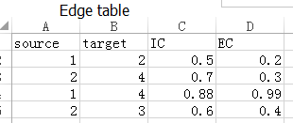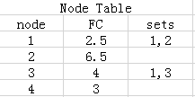

Figure 1. The files DEMA needs.

|  |  |  |  |
| --- | --- | --- | --- |
|  | **Network Centrality** | **Node/Edge Quantities** | **Shared annotation** |
| **Base Layout (L0)** | √ | × | × |
| **Parameterized Layout (L1)** | √ | √ | × |
| **Parameterized Layout with Group (L2)** | √ | √ | √ |

DEMA provides three kinds of layouts as the above table shows. Layout L0 is the most basic layout. There are two files as inputs for DEMA. One is an edge xml file (necessary) that describes a network composed of edges. The other one is node xml file (optional) that describes the properties of nodes in the network. As illustrated in Fig. 1, the information provided by the blue frame is necessary and used to compose a network. Also, according to the information from the blue frame, layout L0 is generated by DEMA. The information in the green frame is optional and used to generate layout L1. The information in the red frame is optional and used to generate layout L2.

# Instructions

1. install the .jar file library downloaded from the website

click "Apps" -> select "App Manager" -> click "Install from File..." -> choose file directory and select the .jar file -> click "open"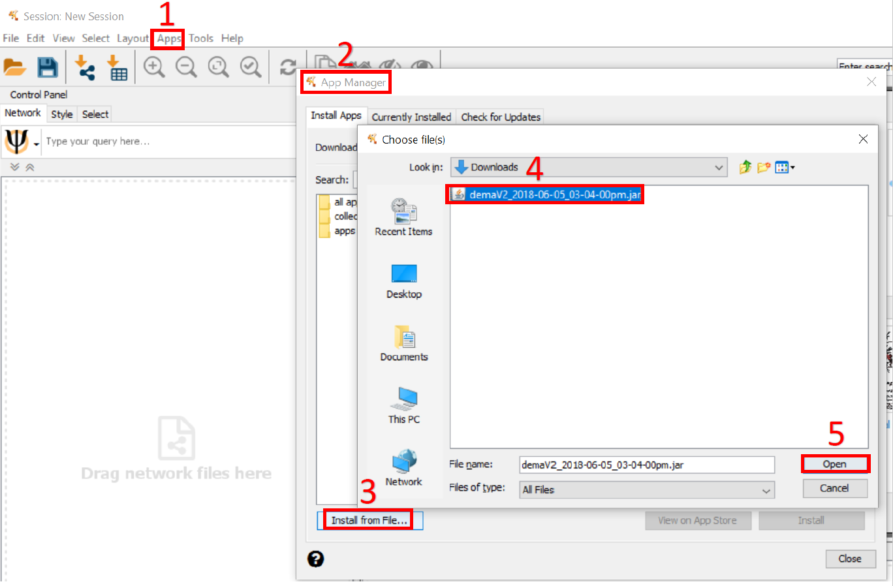

2. import the Protein-Protein Interaction file (.txt)

click "import network" button -> select file and configure the "source","target" and "IC" (import as decimal format) columns -> click "ok"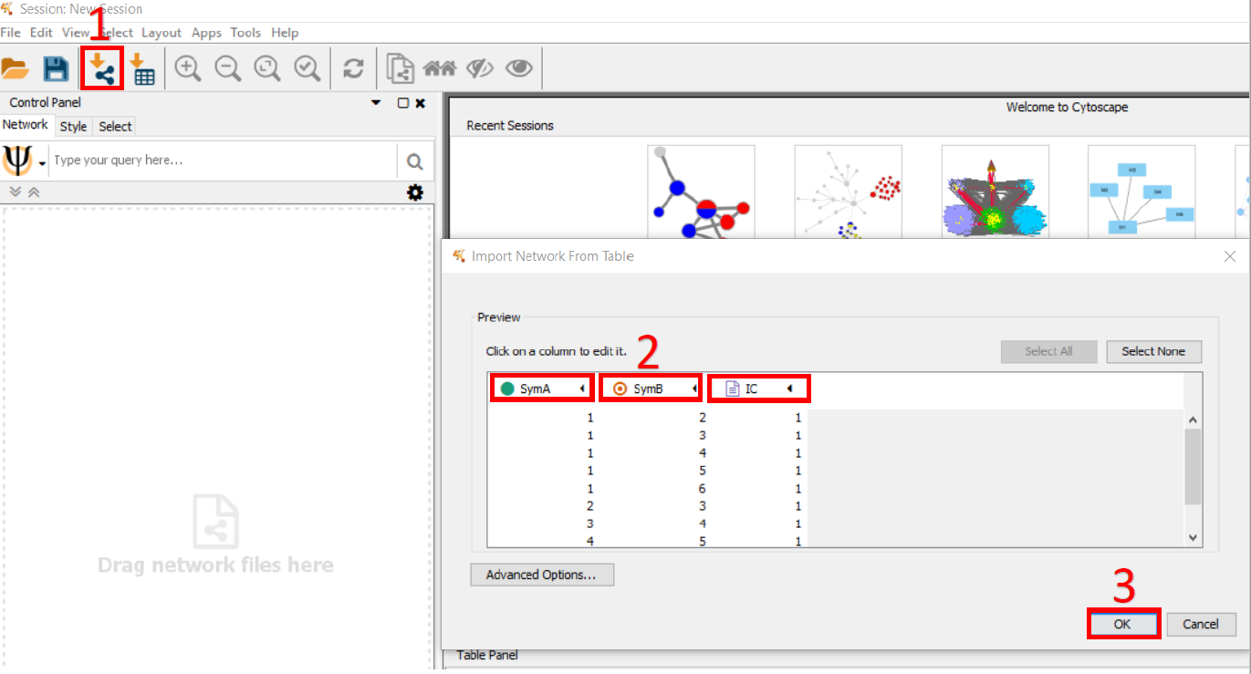

3. import the gene's attribute file (.txt)

click "import attribute" button -> select file and configure the "set" (import as string format) columns -> click "ok"

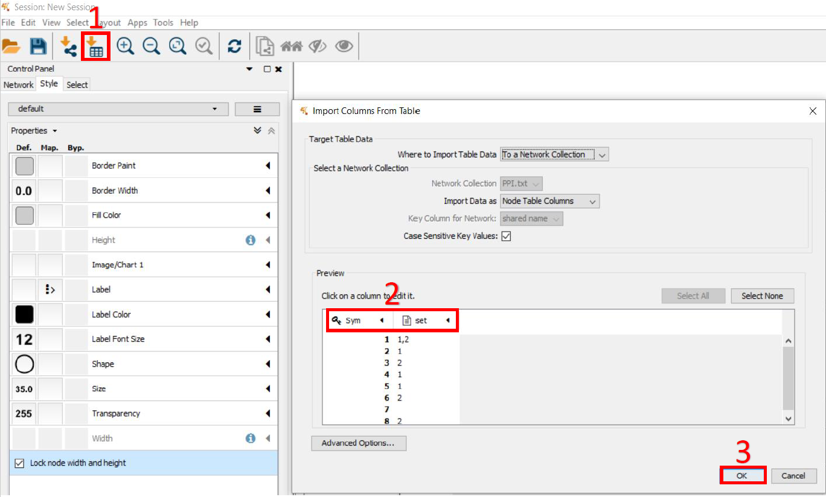

4. generate the layout

click "Layout" button -> select "DEMA" and configure the parameters -> click "ok"

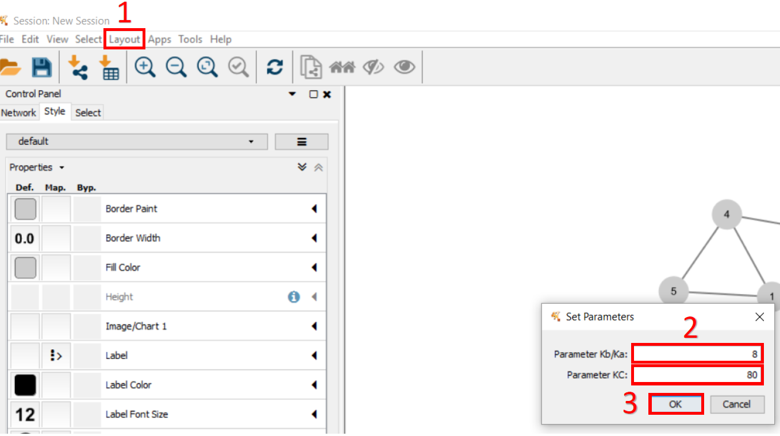

5. configure the view

adjust the properties in "style" category

