Customer Churn Analysis in European Banking Sector

Aimee Susan Joseph
Data Analyst Intern
Unified Mentor
aimeesjoseph@gmail.com

Abstract— Customer churn is a difficult challenge that most banks face, which directly impacts their profitability and long-term relationships with their clients. This study analyses customer-level data to identify patterns and key influencers of churn in one of the many European banks. Using exploratory data analysis and customer segmentation methods, this study evaluates churn behaviour across various demographic groups and regions, taking into consideration their financial profiles. This study also demonstrates the importance of data-driven decision-making, which can help in reducing churn and enhance customer loyalty in the banking and financial sector.

Keywords— customer churn, banking analytics, customer segmentation, retention, financial analytics

Introduction
Customer churn is the phenomenon where customers discontinue their relationship with a business. When it comes to the banking sector, churn can directly impact their profitability, customer lifetime value and long-term sustainability. Being able to retain customers is usually more cost-effective than acquiring new ones, which makes churn analysis an important area of focus.
This study analyses customer-level data to help identify churn patterns and provide insights that can support strategic decision-making. This analysis is contextualised for the European Central Bank ^{[1]}, focussing on their customer behaviour across different regions and demographic segments.

Problem Statement

Despite having access to rich customer-level data, banks face several challenges. These include identifying high-risk customer segments prone to churn, understanding variations in churn across geographic regions and quantifying the financial implications of churn, especially among high-value customers. These challenges limit the effectiveness of retention strategies and hinder data-driven decision-making.

Materials and Methods

Primary Objectives

The primary objectives include measuring the overall churn rate, identifying churn distributions across customer segments and comparing churn behaviour across European regions.

Secondary Objectives

The secondary objectives include analyzing customer churn among high-value customers, evaluating engagement and tenure patterns and supporting strategic planning and targeted marketing initiatives.

Data Description

The dataset contains customer-level information from the European Central Bank, including demographic, financial and behavioural attributes. Key features include Geography (France, Germany, Spain), Age, Gender, Credit Score, Balance, Tenure, Number of Products, Active Member Status (engagement indicator) and Estimated Salary. The target variables was Exited, where 1 signified that the customer churned while 0 signified the customer did not churn. The dataset provides a comprehensive view of customer profiles, enabling detailed segmentation and analysis.

Data Preparation

To ensure meaningful analysis, several preprocessing steps were done, which included removing non-analytical fields such as customer names and validating binary variables such as Active Member Status and Exited. Conversion of categorical variables was done for grouping and better visualisation. Derived features created include age groups (<30, 30-45, 46-60, 60+), tenure groups (new, mid-term, long-term), balance segments (zero, low, high) and high-value customer indicator (based on balance levels).

Exploratory Data Analysis

Overall Churn Rate

The dataset consists of 10,000 customers, out of which 2,037 customers have churned, which results in an overall churn rate of 20.37%. This implies that at least 1 in every 5 customers leaves this bank, which highlights a significant retention challenge.

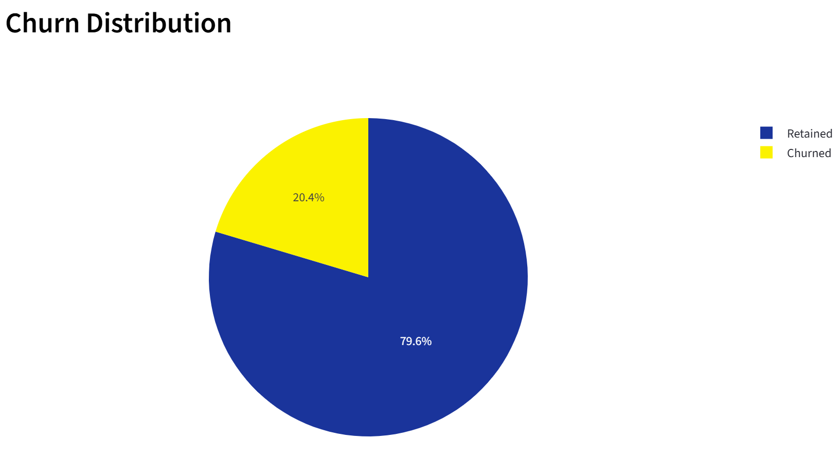

Fig. 1. Overall Churn

Geographic Analysis

Churn rates vary significantly across regions, where Germany has the highest churn with a rate of 32%, followed by Spain with 17% and France with 16%. Germany’s churn rate is nearly double that of France and Spain, which shows a strong regional imbalance. This shows a possible struggle with lower customer satisfaction, higher competition or ineffective regional strategies in Germany.

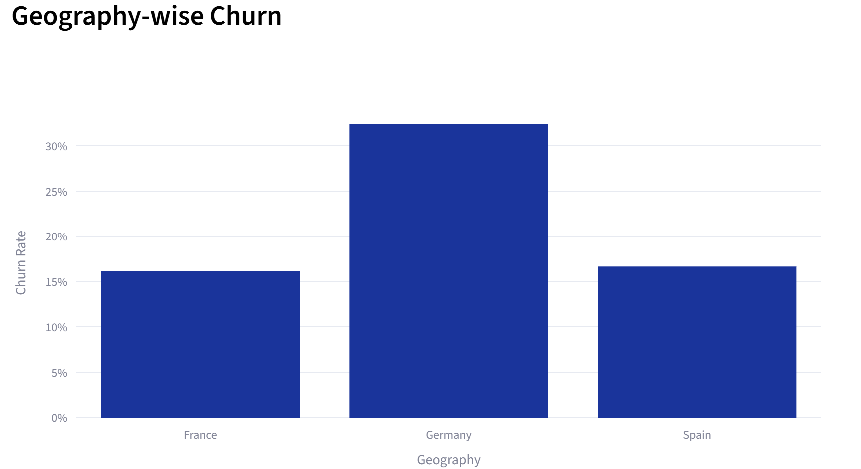

Fig. 2. Geography-wise Churn

Behavioural Analysis

Customers with 4 products have the highest churn with a rate of 100%, followed by those with 3 products with a rate of 83%. Customers with 1 product have a churn rate of 28% while customers with 2 products have the lowest churn rate of 8%. Churn rates for customers with 3 or 4 products may indicate dissatisfaction or over-complexity in service usage.

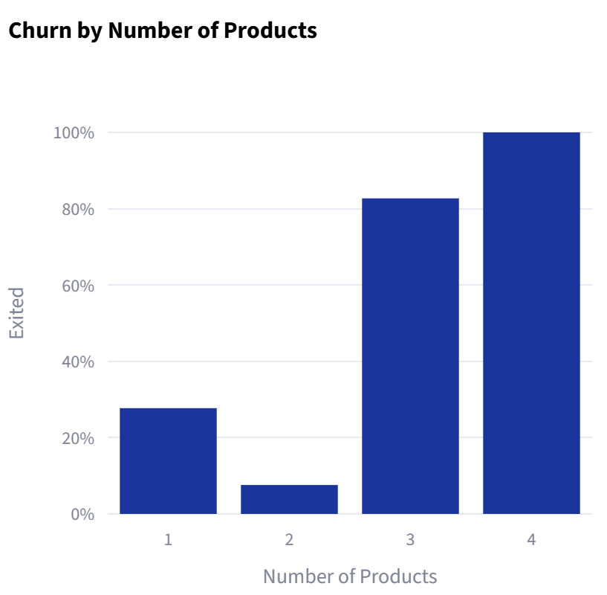

Fig. 3. Products vs Churn

Activity Status vs Churn

Inactive customers churn at nearly twice the rate (27%) of active customers (14%), making engagement one of the strongest predictors of retention.
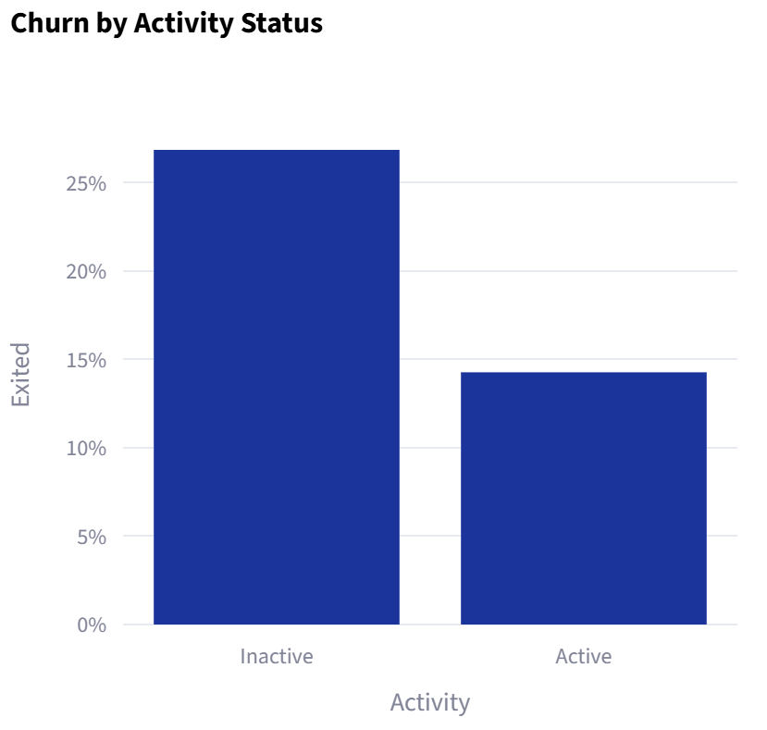

Fig. 4. Activity-wise Churn

Age Group Analysis

Middle-aged customers (46-60) show a significantly higher churn rate of 51%, which could signify a probable change in financial needs, retirement planning or dissatisfaction of services. Younger customers (<30) appear to be more stable and retained, with a churn rate of 8%.

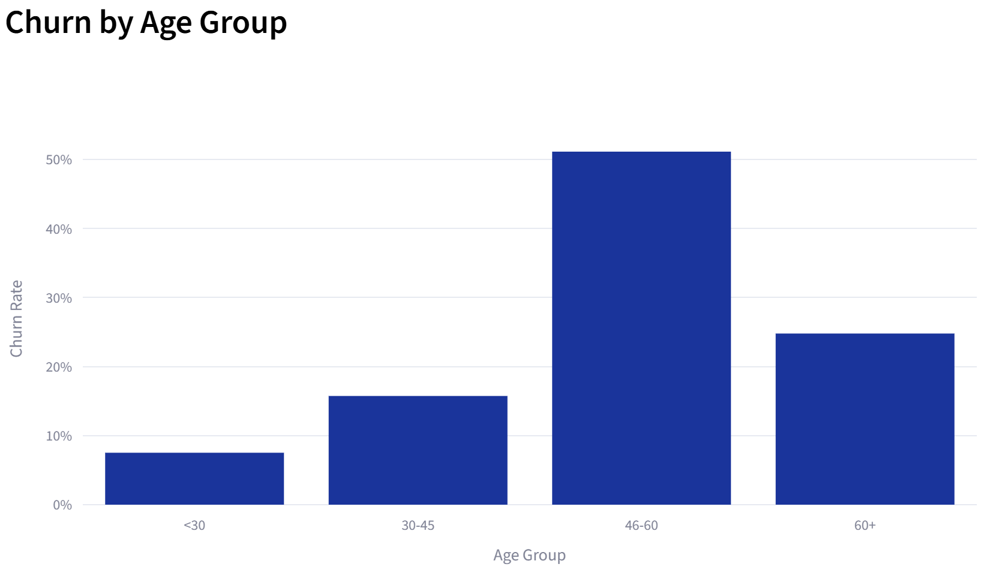

Fig. 5. Activity-wise Churn

Tenure Analysis

Churn is slightly higher among the newer customers (21%), suggesting that onboarding and experience play a role. However, churn remains relatively consistent across tenure groups indicating that other factors also influence retention.

Financial Analysis

Customers with higher bank balances show increased churn (25%), which implies that financial value does not guarantee loyalty. Customers with low and zero balances have churn rates of 21% and 14% respectively.

High-value Customer Analysis

High-value customers churn at a significantly higher rate of 25%, which is concerning as this segment of customers contributes heavily to bank revenue. This implies a critical financial risk area.

Key Ingishts

The overall churn rate of 20.37% indicates a substantial customer retention issue. Germany is the highest-risk region, which a churn rate of 32%. Customer engagement plays a vital role, where inactive users contribute to nearly double the churn rate of active users. Customers with 2 products remain the most stable, while extreme product usage correlates with higher churn. The age group 46-60 is highly vulnerable, with a churn rate of over 50%. High-balance and high-value customers are at a greater risk of churn, impacting bank revenue.

Business Recommendations

Since inactive customers show a churn rate of 27% vs 14% for active users, the bank should implement re-engagement campaigns, focus on using personalized notifications and offers and improve their digital interaction channels.
With a churn rate of 32%, Germany requires region-specific retention strategies, customer feedback analysis and competitive benchmarking.
Customers having 2 products have the lowest churn (8%). The bank should encourage cross-selling to reach this optimal level and also investigate why customers with 3 or 4 products churn excessively.
High-value customers churn at 25%, which proves to be financially risky. The bank should introduce premium loyalty programs, provide dedicated relationship managers and offer personalized financial solutions.
The 46-60 age group shows 51% churn, implying that the bank needs to customize financial planning services, creating requirement-focussed products and target engagement strategies.
Since new customers show a slightly higher churn rate, the bank should enhance the onboarding process, provide early-stage incentives and build a strong initial engagement.

Conclusion

This study showcases the major patterns in customer churn behaviour within this bank. With an overall churn rate of 20.37%, the analysis identified key risk factors, which includes geography, customer engagement, product usage and financial segmentation. High churn among inactive users, German customers, middle-aged customers and high-value clients signifies both operational and financial challenges. The findings focus on the importance of targeted retention strategies and data-driven decision-making.

By implementing the recommended actions, the bank is expected to reduce their churn, enhance their customer satisfaction and improve long-term profitability.

References

- European Central Bank. Retrieved from: https://www.ecb.europa.eu/home/html/index.en.html

