This document outlines the details of the implementation of a new website called RevolvingRoutes.com – a website for people that like cycling. The report includes details of current and past designs and technology used.

**Background**

I have an interest in cycling and have been really excited by some of the new websites and web applications that have been created over recent years – especially the ones which allow users to track their routes and engage with other users through these applications.

I have been living in London for three years now and find that sometimes I would like to go for a walk or cycle but struggle to find an interesting route as I have no prior knowledge of certain areas. I also prefer routes which a circular – that is to say that they are not A to B routes they have the same start and end points however they mostly do not return on themselves.

The plan is to develop and implement the route planner in a phased way and the purpose of tis project is to create a website for people that like cycling and to attract developer that would be interested in working with me on this project to develop the circular route planner.

**Short Description (140 characters):**

A website for people that like cycling.

**Elevator Pitch (140 words):**

RevolvingRoutes.com is a website for people that like cycling. The website will provide people with an opportunity to add/view events, discuss topics in a forum, add/view local cycle groups and read or write for the blog site. It is mainly aimed at people based in the UK and Ireland however may attract an audience from further afield.

**Twitter Pitch**

A website for people that like cycling

**Manifesto:**

To be the go to place for people in the UK and Ireland that are interested in cycling, attending cycling related events,

**Responsive Design**

In recent years the growth of mobile devices and tablets etc which can access the internet has grown exponentially. And although in previous years web designers could usually comfortably estimate the size of the screen which people will be using to access their website– that is no longer the case.

Revolving routes has been built using a responsive design principles and the website will adapt at certain breakpoints so that it can be viewed an any screensize and on any device.

The design has been made responsive by using percentage widths and media queries. Media queries have good support across browsers as shown in the diagram

**Responsive Text and Images**

For text that is responsive the site will use ems as the units for defining text size (and margins, padding etc) and the technique outlined in [Richard Rutter’s](http://clagnut.com/blog/348/) article which sets the body font-size to 62.5% which changes the body text size to 10px which makes the mathematics a bit easier when applying ems to elements. There are difficulties with using ems as the size it inherits is relative to it’s parent so dealing with nested elements can be a bit tricky.

CS3 has introduced a new unit called rem would be a better option there is not sufficient browser support at this stage. [Johnathon Snook](http://snook.ca/archives/html_and_css/font-size-with-rem) has written another good article on font-sizing.

The em unit is relative to the font-size of the parent, which causes the compounding issue. The rem unit is relative to the root—or the html—element. That means that we can define a single font size on the html element and define all rem units to be a percentage of that.

Image widths and objects (for video embedding) will be set to max-width: 100% so instead of the images/videos rendering at their native width/height so it won’t over flow its container. There is generally good support for max-width now at 94.3% according to canisuse.com.

**Mobile Access, Touchscreen Interfaces & Progressive Enhancement**

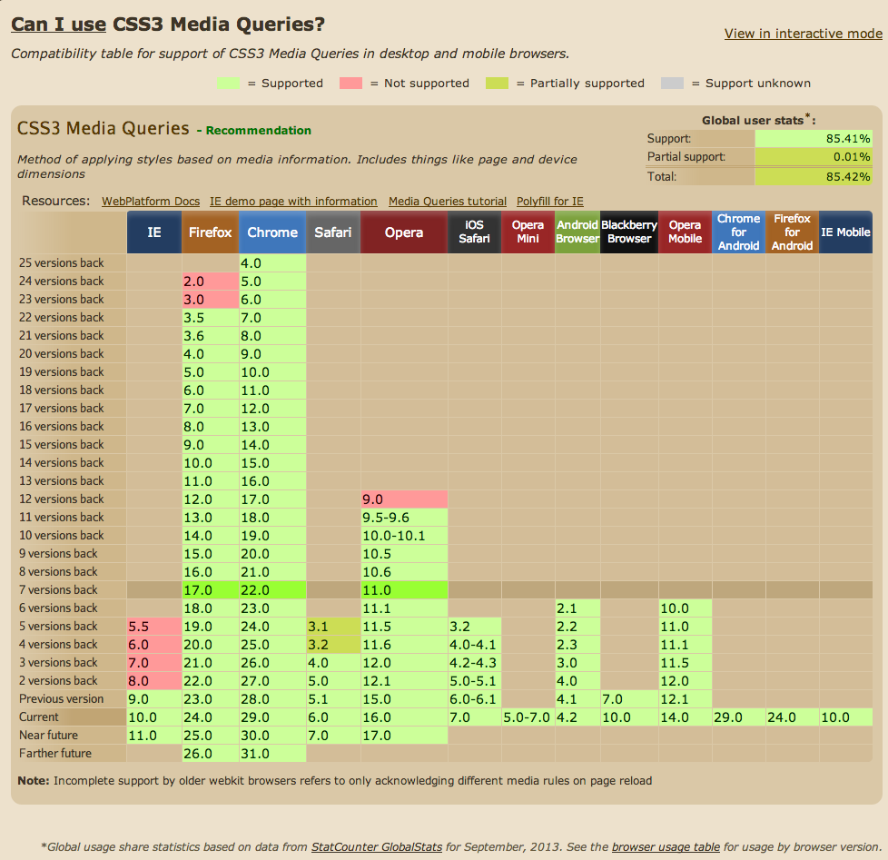

Figure

**Mobile Access, Touchscreen Interfaces & Progressive Enhancement**

**Competitor Analysis**

**Content Management**

Originally I chose to use Drupal as the content management system that would power the website. My reasons for choosing Drupal as the content management system were twofold. Firstly I had done some previous installations of Drupal and found it difficult to understand so I decided that using it for this project would be a good opportunity for me to learn it. I also believed that it was a good content management system to be familiar with as a lot of companies hire Drupal developers/designers.

According to [Buildwith](http://trends.builtwith.com/cms) of the top 10,000 websites 14.27% are built with Drupal CMS while 40.97% use Wordpress.

Wordpress

Seriously quick to install. The installation relly did take less than 5 minutes. Add plugins is quick and easy. Doe to time restraints and the fact that the design I used on the Drupal Installation didn’t really reflect what I wanted to achieve I decided to purchase the WP theme called Salient. Salient is a responsive theme that looks great.

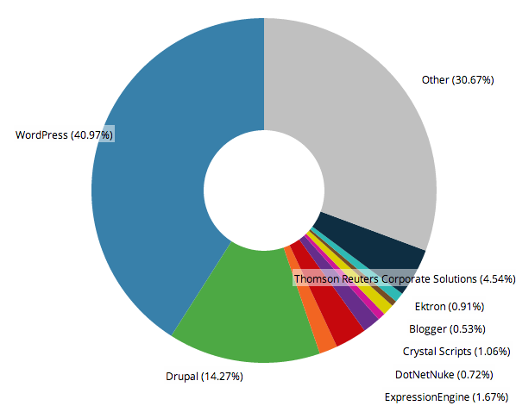

Drupal is used on a massive amount of websites worldwide. If used correctly it can offer the administrator a great amount of flexibility to create custom pages/views. It’s Open Source so it’s free to download and there is quite a bit of documentation on it.

I used the current version of Drupal which is Drupal 7 for the installation. I found Drupal to be very counter-intuitive and it needs a lot of modules added to the core in order for it to work reasonably well.

**Vimeo for video hosting**

Vimeo was selected for the video hosting as the files were quite large to upload and in this instance I was happy enough not to worry about file formats such as making sure there’s a .m4v and .ogv

**Action plan for the website analysis**

There are various tools available for site analysis to measure how users enter/find (search engine optimisation) and interact (user experience) with the website amongst other metrics. It is important to measure these metrics and to analyse the results so that a websites strategy can be optimised to target what users want and are looking for. Outlined below are the steps and technologies that will be taken following the launch of the www.RevolvingRoutes.com website to analyse the user behavior and to develop the Search Engine Optimisation (SEO) strategy for the website.

The key tools I will discuss in this report are:

* Google Analytics
* Google Webmaster Tools
* Google Adwords
* Facebook Insights
* AWStats

**Google Analytics**

Google Analytics is a free tool made available by Google for website owners and webmasters which will be used to analyse the website traffic and visitor behavior plus various other aspects of visitor behavior and conversion rates which are outlined later on. In order for the repots to be available on this tool the webmaster needs to sign up for an analytics account and will get a unique ID for the website. They will also get a unique snippet of code, which is in the form of a small piece of JavaScript, which will be inserted in to each page that is available to the users when they are visiting a website. This code will be added to RevolvingRoutes.com using the Google Analytics plugin for Drupal. Users will not see this code and this will allow admin users to login to a web portal and access the various repots available. Reports can be emailed and exported.

There are many reports in this tool which are useful for analysis but the key ones for Revolving Routes are likely to be:

**Audience Overview Report**

The Audience Overview report which is a report that displays the number of visits over a specified period of time. This can be useful for identifying number of visitors, new v returning, peak days/weeks/months for visitors. Regarding peak days/months: as Revolving Routes is primarily targeted to people that will be engaging in outdoor activities it would be expected that the winter months would have less visitor activity with a peak in activity during the spring and summer months. A strategy based peak visitor behavior could be devised to attract more visitors to the website during the colder months perhaps in the form of product reviews or a blog.

**Traffic Sources**

The traffic sources report is another important report when it comes to website analysis. The Traffic Sources Overview report gives a good view of how visitors find the website and a summary of the main keywords used. There is one major issue with the Google Keyword reporting and that is there will likely be a high number of results which are listed as ‘not provided’. This is a feature which Google set a couple of years ago and means that when a user is logged into their Google account and searching using Google their search is conducted of SSL and means that it cannot be tracked by Google so this can make it tricky to know the ROI of organic keyword searches. KissMetrics advise a couple of [work arounds](http://blog.kissmetrics.com/unlock-keyword-not-provided/) for this however another workaround is to use another analytics tool called AwStats which will be explained later.

**Demographics – Technology Report**

Importantly for a website which focuses on maps the Demographics Technology report will show what devices users are using to access the website. A later phase for Revolving Routes should include a mobile application of the website which will be specifically designed for use on mobile so the first phase, although it will be responsive, will not be the optimum user experience for visitors accessing on their mobile. Having access to this report can help to shape the mobile launch phase for the website.

**Visitors Flow and Behavior Flow**

These reports will demonstrate user behavior upon reaching the website. This can be used to measure where users are entering and what pages they visit following entry to the website. The visitors flow will also demonstrate the visitor flow by location showing which countries are interested in which pages. On the visitor flow report the webmaster can highlight the visitor flow by territory to see if some regions are more interested in certain content or aspects of the website.

**Site Speed**

This report gives an overview of site speed and load time which is very important for a good user experience. Drilling down into this tool Google will also give suggestions on how to improve site speed and what might be causing your pages to load slowly in desktop and mobile along with a Page Speed Score. Obviously using this information means that the website webmaster can improve page load times.

**Custom Reports**  
Custom reports can be put together to suit the website analysis needs. There are many filters and options for this but it is likely that the standard reports are sufficient for the needs of Revolving Routes.

**Google Webmaster Tools**

Google Webmaster Tools are another set of free tools from Google that provide data and analytics to help improve site performance in Google searches. Google Webmaster Tools integrate well with Google Analytics so that the data becomes available in Search Engine Optimisation (SEO) reports. The tools help to identify landing pages on the site that have good clickthrough rates (CTR) but might not have good average positions in search results. These could be pages that need developing.

The information from the Webmaster Tools can be used to decide which elements of the website should be focused on for particular keywords and can be used to develop and identify pages in the site that have a good click through rate (CTR) but poor position in the search results. This might mean that visitors are interested in these pages but have trouble finding them and, conversely, pages which have good keyword positioning but poor click through rates may need some attention and improved content strategy.

To enable webmaster tools a file needs to be placed on the server where the website is stored so Google knows that it is an authorised account. A short description of some of the tools is below:

**Search Appearance**

This will show how well the pages are doing in search results.

**Data Highlighter**  
The Revolving Routes website will provide details of local cycling groups and events. The Data Highlighter tool provides an easy user interface so that the webmaster can highlight page patterns so that Google knows how to provide the relevant information in search results.

**HTML Improvements**

This will alert the webmaster to any issues with content on pages that the spiders find when crawling pages i.e. problematic title tags, meta descriptions etc.

**Sitemaps**

A sitemap should be submitted to Google to ensure that Google knows all the pages on your website.

**Adwords**

Yet another free tool provided by Google is the Google Adwords tool. Not only can this be used to track paid advert campaigns but it is also has an extremely useful keyword planner tool. This tool enables the webmaster to plan a keyword strategy and to gauge the popularity and competition for certain keywords.

**Keyword Planner**

This allows the webmaster to set certain parameters and see what the competition is like for these search terms. This is not only useful for websites embarking on paid advertising campaigns but also for those that just want to see the lay of the market. There are campaign bid simulators and thee tools are quite advanced and covering each step in the software is outside the scope of this report.

**Campaigns**

If Revolving Routes was going to embark on a AdWords campaign this would be the place where budgets and campaings can be managed. The webmaster can use these tools to target specific locations and drill down to various other demographics.

**Facebook**

Facebook Insights can be used to measure a Facebook pages performance to find demographic data about he Facebook page audience.

**AWStats**AWStats is a web server analytics tool which was designed for use by network administrators to measure traffic to a server. It is by no ways as nice to use as Google Ananytics but it does offer a work around for accessing the keywords which Google provide as ‘not provided’. As this tool sits on the server it doesn’t require a snipped of code to be added to each page. It can be used as a back up in case there is a problem with the analytics.

**SEO**

**Robots.txt**

Robots.txt is a text file that is placed on the server usually at the root level. This file will tell search engines which pages to index on a website. As Revolving Routes will be using Drupal CMS the robots.txt file should advise the spiders not to index the admin pages or anything else which should not show up in search engine results.

**Keyword Targeting**

An initial keyword analysis report using the Keyword Planner tool from Google returns the following results in the table below. This information can form the initial SEO strategy which will be reviewed following the launch of the website. I have sorted this table by average month searches and it is interesting to note that the competition is quite low for nearly all of the search terms.

|  |  |  |  |  |
| --- | --- | --- | --- | --- |
| **Keyword** | **Avg. monthly searches** | **Searches: Sep 2012** | **Competition** | **Avg CPC** |
| bike trails | 4400 | 4400 | 0.28 | 0.45 |
| mountain bike trails | 3600 | 2900 | 0.29 | 0.44 |
| bike route | 2400 | 2400 | 0.15 | 0.63 |
| bike paths | 1000 | 1000 | 0.22 | 0.64 |
| walks in cheshire | 720 | 480 | 0.28 | 0.47 |
| bicycle routes | 590 | 590 | 0.4 | 0.7 |
| cycling maps | 590 | 720 | 0.34 | 0.34 |
| walks in yorkshire | 590 | 480 | 0.31 | 0.79 |
| bike routes nyc | 590 | 590 | 0.12 | 0.58 |
| walking planner | 480 | 480 | 0.23 | 0.81 |
| local walks | 390 | 260 | 0.59 | 0.17 |
| bike route map | 260 | 260 | 0.21 | 0.35 |
| walking uk | 210 | 210 | 0.49 | 0.49 |
| biking routes | 210 | 210 | 0.36 | 0.8 |
| bike routes san diego | 210 | 260 | 0.28 | 0.28 |
| uk walks | 170 | 140 | 0.35 | 0.2 |
| cycling supplies | 140 | 140 | 0.59 | 0.46 |
| road bike routes | 140 | 140 | 0.45 | 0.66 |
| road bike trails | 110 | 110 | 0.19 | 0.57 |
| biking trail | 110 | 110 | 0.1 | 0.5 |
| walks uk | 90 | 90 | 0.4 | 0.71 |
| hiking biking | 90 | 90 | 0.04 | 0 |
| bicycle route mapping | 70 | 50 | 0.47 | 0.48 |
| free online route planner | 70 | 70 | 0.43 | 1.7 |
| bike route maps | 70 | 70 | 0.36 | 0.47 |
| walking trails uk | 70 | 70 | 0.32 | 0.29 |
| trail cycling | 70 | 50 | 0.18 | 0.47 |
| cycling trail | 70 | 70 | 0.16 | 0.41 |
| mountain biking trail | 70 | 70 | 0.13 | 0.45 |
| biking hiking | 70 | 70 | 0.07 | 0.73 |
| getting into road biking | 70 | 50 | 0.03 | 0 |
| online route planner free | 50 | 50 | 0.52 | 0.28 |
| new to road biking | 50 | 70 | 0.18 | 0 |
| biking in | 50 | 40 | 0.08 | 0 |
| hiking and biking | 50 | 40 | 0.04 | 0 |
| find walking trails | 40 | 40 | 0.37 | 0.33 |
| routes maps | 40 | 50 | 0.24 | 0.72 |

Using the table above to further analyse the keywords that would be good to target below is a pivot table based on the number of times each word shows up. This will help to further develop the keyword strategy.

|  |  |
| --- | --- |
| **Word** | **Number of time word appears in suggested keywords** |
| Bike | 10 |
| Biking | 9 |
| Route | 9 |
| Planner | 7 |
| Routes | 6 |
| Walking | 6 |
| Trails | 5 |
| Walks | 5 |
| Online | 5 |
| Free | 4 |
| Trail | 4 |
| UK | 4 |
| Hiking | 3 |
| Maps | 3 |

**User Feedback**Another way of anlysing the strategy is to ask users to directly submit feedback in the form of a web form or user testing. There are various tools available for capturing this information.

**A/B Testing**

As visitor numbers increase it may be useful to implement Optimizely on the website to conduct A/B testing. Results from A/B testing may be surprising and lead to a massive increase in revenue or sign up. For phase one this will not be necessary but this may be something that gets implemented at a later stage.

Conclusion

There are various free tools available to website administrators to track user behavior, SEO performance etc. The mains tools that will be used by Revolving Routes have been discussed above but there are many more available some paid but mostly the free tools available are fit for purpose.

Bibliography:

<http://blog.kissmetrics.com/unlock-keyword-not-provided/>

<http://blog.hubspot.com/blog/tabid/6307/bid/33164/6-SEO-Tools-to-Analyze-Your-Site-Like-Google-Does.aspx>

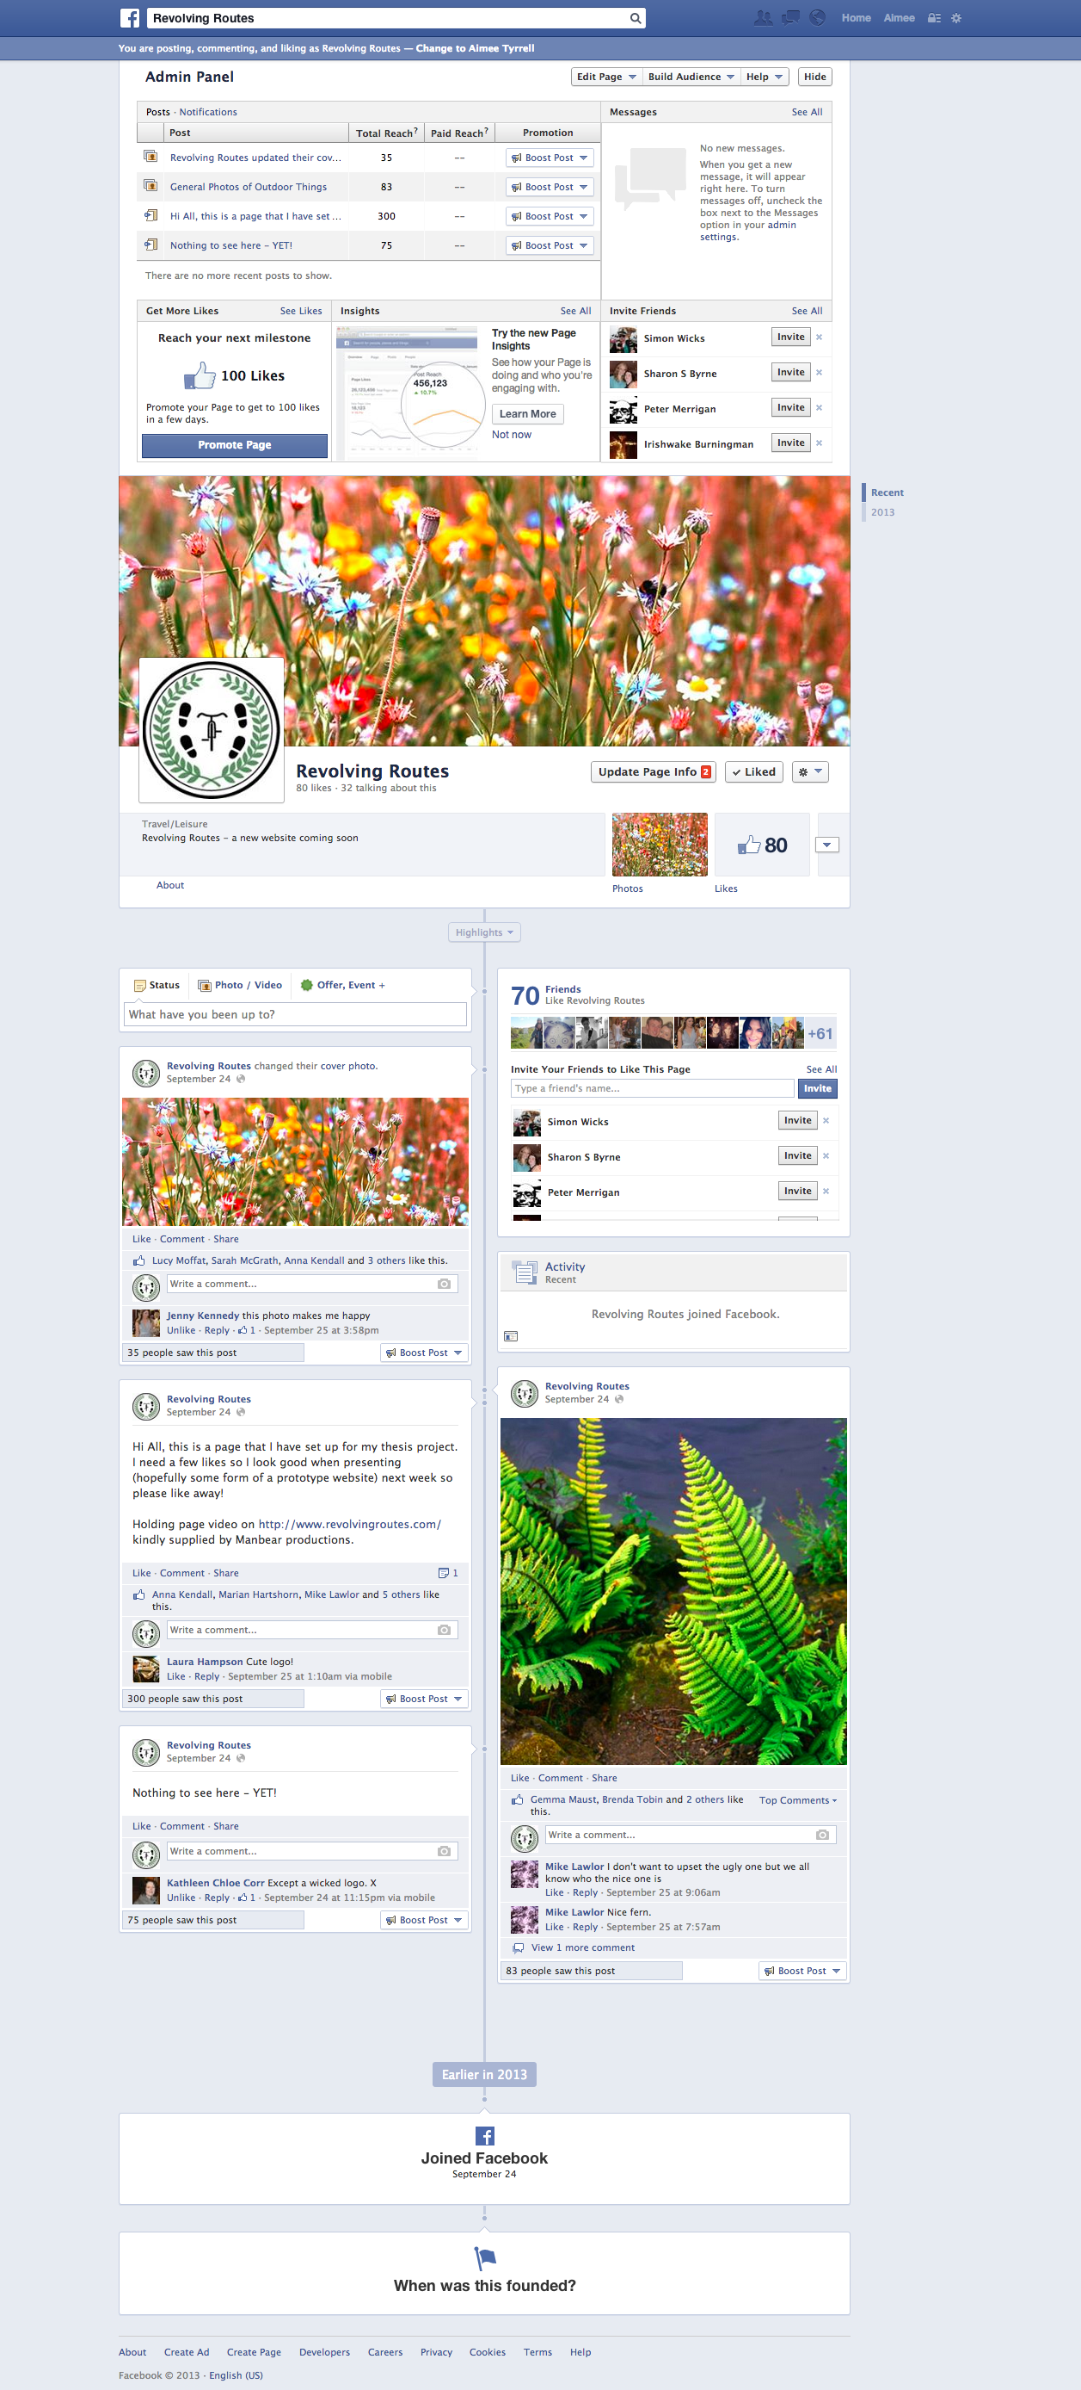

Figure

**Screenshot of Google Analytics Reporting tool**

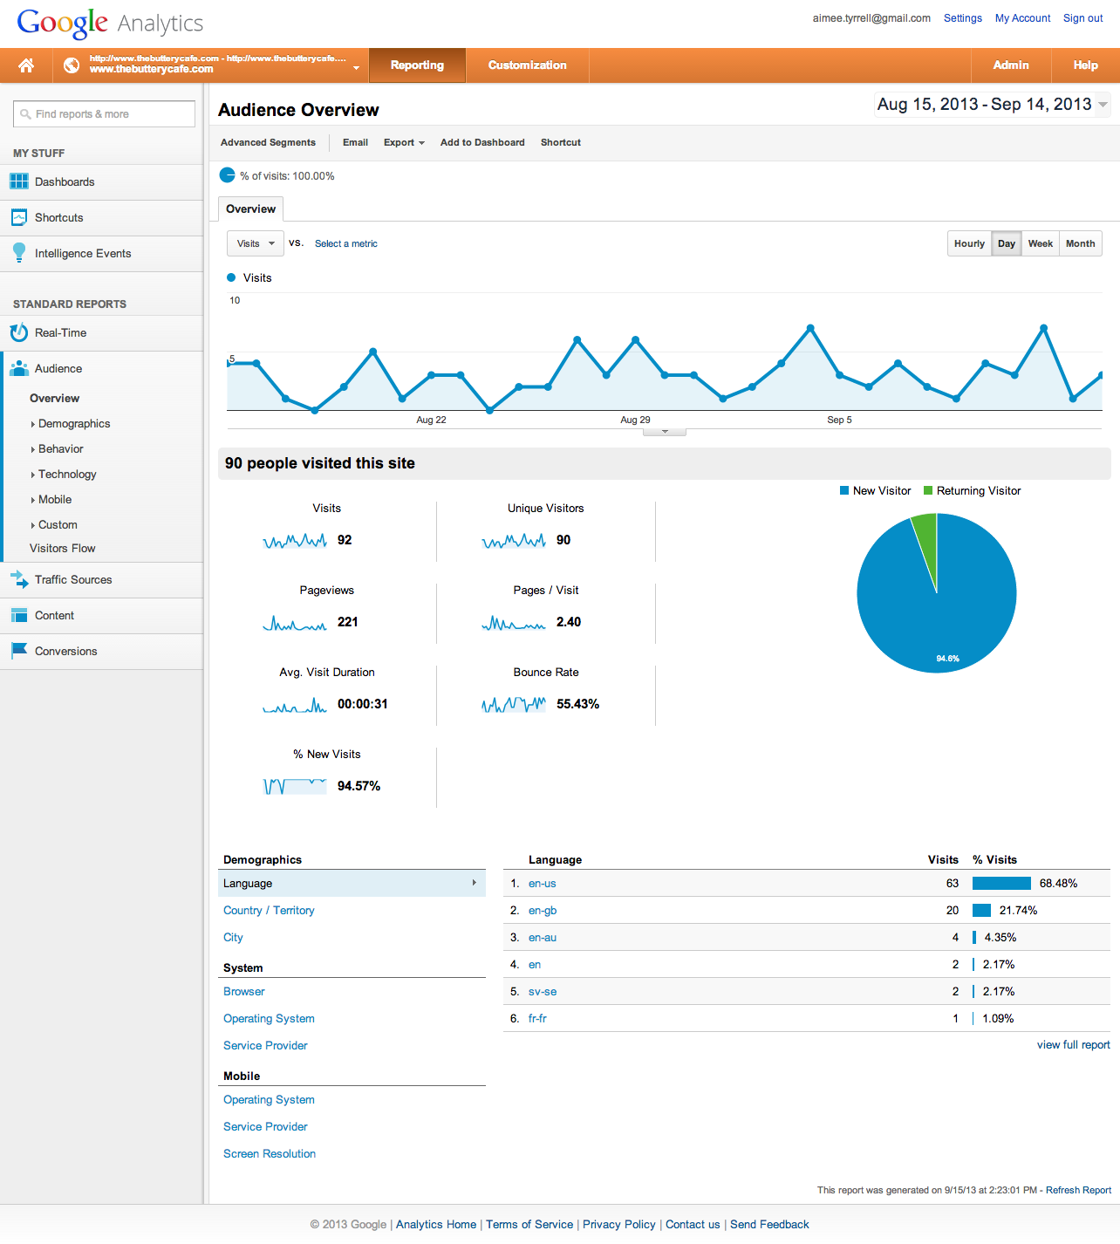

Figure

<http://alistapart.com/article/responsive-web-design>

*by*[ETHAN MARCOTTE](http://alistapart.com/author/emarcotte)May 25, 2010

<http://clagnut.com/blog/348/>

How to size text using ems, 18 May 2004

<http://snook.ca/archives/html_and_css/font-size-with-rem>

Jonathon Snook

<http://css-tricks.com/why-ems/>

Chris Coyer

<http://alistapart.com/article/howtosizetextincss>

by RICHARD RUTTER November 20, 2007

<http://elliotjaystocks.com/blog/css-transitions-media-queries/>

Elliot Jay Stocks