<http://alistapart.com/article/responsive-web-design>

*by*[ETHAN MARCOTTE](http://alistapart.com/author/emarcotte)May 25, 2010

<http://clagnut.com/blog/348/>

How to size text using ems, 18 May 2004

<http://snook.ca/archives/html_and_css/font-size-with-rem>

Jonathon Snook

<http://css-tricks.com/why-ems/>

Chris Coyer

<http://alistapart.com/article/howtosizetextincss>

by RICHARD RUTTER November 20, 2007

<http://elliotjaystocks.com/blog/css-transitions-media-queries/>

Elliot Jay Stocks

<http://www.nngroup.com/articles/banner-blindness-old-and-new-findings/>

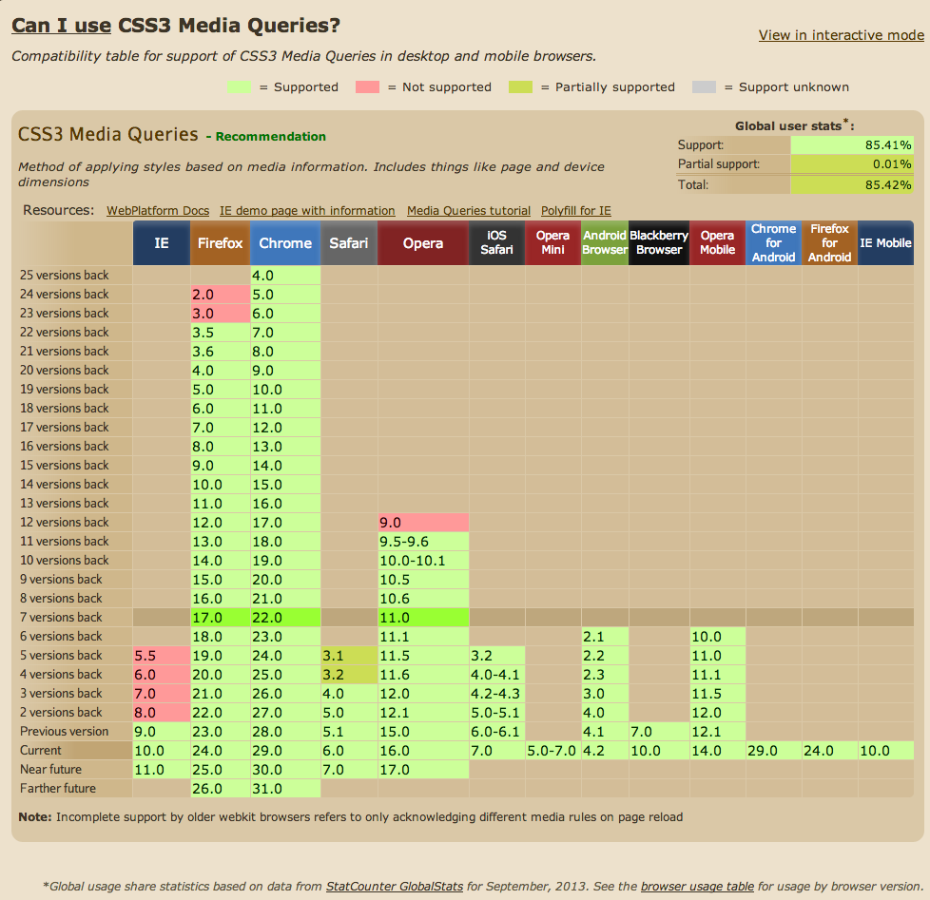

**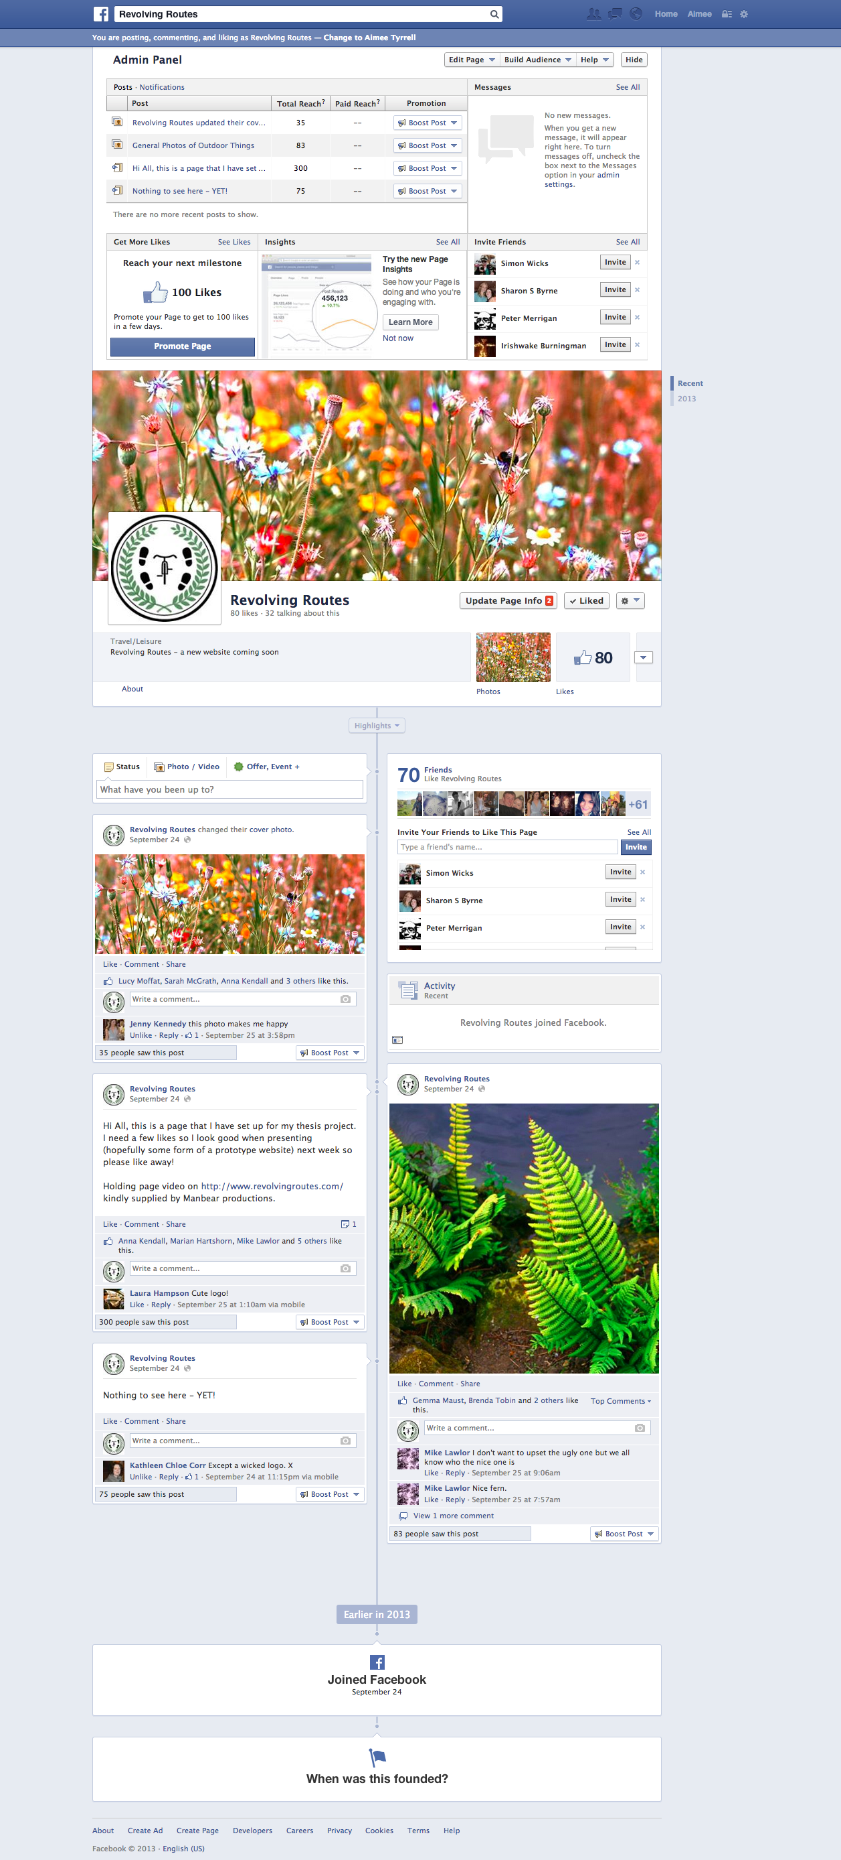**https://www.udemy.com/blog/drupal-vs-joomla-vs-wordpress/

<http://grimpeurheureux.com/best-cycle-app-strava-or-mapmyride/>

<http://www.outsideonline.com/fitness/biking/How-Strava-Is-Changing-the-Way-We-Ride.html>

Reporting & Site Analysis

<http://blog.kissmetrics.com/unlock-keyword-not-provided/>

<http://blog.hubspot.com/blog/tabid/6307/bid/33164/6-SEO-Tools-to-Analyze-Your-Site-Like-Google-Does.aspx>

Drupal Modules Installed and tested.

|  |  |  |  |  |
| --- | --- | --- | --- | --- |
| NAME | LINK | DOWNLOADED/INSTALLED | MY NOTES | DESCRIPTION |
| achievements | [https://drupal.org/project/auto\_nodetitle](http://www.google.com/url?q=https://drupal.org/project/auto_nodetitle&usd=2&usg=ALhdy28ymiDN0U8LSCOgCGDUyX_OTSbrcg" \t "_blank) | dl |  | Gamification of the website. Needs to be set up |
| acl | [https://drupal.org/project/auto\_nodetitle](http://www.google.com/url?q=https://drupal.org/project/auto_nodetitle&usd=2&usg=ALhdy28ymiDN0U8LSCOgCGDUyX_OTSbrcg" \t "_blank) |  |  | Needed to work with something else |
| activity | [https://drupal.org/project/auto\_nodetitle](http://www.google.com/url?q=https://drupal.org/project/auto_nodetitle&usd=2&usg=ALhdy28ymiDN0U8LSCOgCGDUyX_OTSbrcg" \t "_blank) | dl |  | User activity |
| addanother | [https://drupal.org/project/auto\_nodetitle](http://www.google.com/url?q=https://drupal.org/project/auto_nodetitle&usd=2&usg=ALhdy28ymiDN0U8LSCOgCGDUyX_OTSbrcg" \t "_blank) | dl |  | Save and add another. |
| addthis | [https://drupal.org/project/auto\_nodetitle](http://www.google.com/url?q=https://drupal.org/project/auto_nodetitle&usd=2&usg=ALhdy28ymiDN0U8LSCOgCGDUyX_OTSbrcg" \t "_blank) | Not yes |  | Release not ready for D7. Also would prefer to find a better way of doing this. |
| adsense | [https://drupal.org/project/auto\_nodetitle](http://www.google.com/url?q=https://drupal.org/project/auto_nodetitle&usd=2&usg=ALhdy28ymiDN0U8LSCOgCGDUyX_OTSbrcg" \t "_blank) | N |  | No Adsence |
| advanced\_forum | [https://drupal.org/project/auto\_nodetitle](http://www.google.com/url?q=https://drupal.org/project/auto_nodetitle&usd=2&usg=ALhdy28ymiDN0U8LSCOgCGDUyX_OTSbrcg" \t "_blank) |  |  | NO forum |
| auto\_nodetitle | [https://drupal.org/project/auto\_nodetitle](http://www.google.com/url?q=https://drupal.org/project/auto_nodetitle&usd=2&usg=ALhdy28ymiDN0U8LSCOgCGDUyX_OTSbrcg" \t "_blank) | Y |  | auto\_nodetitle" is a small and efficient module that allows hiding of the content title field in the form. To prevent empty content title fields one can configure it to generate the title by a given pattern. |
| better\_exposed\_filters | [https://drupal.org/project/better\_exposed\_filters](http://www.google.com/url?q=https://drupal.org/project/better_exposed_filters&usd=2&usg=ALhdy28gcGzgciJyN_gtbBtdS6LIVGlQcw" \t "_blank) | Y |  | The Better Exposed Filters module replaces the Views' default single- or multi-select boxes with radio buttons or checkboxes, respectively. Description fields and Select All/None links can be added to exposed filters to make for a better user experience. |
| better\_formats |  |  |  |  |
| block\_class | [https://drupal.org/project/block\_class](http://www.google.com/url?q=https://drupal.org/project/block_class&usd=2&usg=ALhdy2-af4_aQsZmNEIosm3wtZwyX_n8tA" \t "_blank) | y |  | added the pho code to the header. Hopefully correclty |
| boost | [https://drupal.org/project/boost](http://www.google.com/url?q=https://drupal.org/project/boost&usd=2&usg=ALhdy2_kL45ABo76WC_Li2qYis7VcrAjrQ" \t "_blank) | n |  | Boost provides static page caching for Drupal enabling a very significant performance and scalability boost for sites that receive mostly anonymous traffic. For shared hosting this is your best option in terms of improving performance. On dedicated servers, you may want to consider Varnish instead. |
| calendar | [https://drupal.org/project/calendar](http://www.google.com/url?q=https://drupal.org/project/calendar&usd=2&usg=ALhdy29KCYzEvLpgUaXPjGFBfJ7deHXrGw" \t "_blank) |  |  |  |
| calendar\_ical | [https://drupal.org/project/calendar\_ical](http://www.google.com/url?q=https://drupal.org/project/calendar_ical&usd=2&usg=ALhdy28U4Dy1extHANBgvit45Tv0C4j9Fw" \t "_blank) |  |  |  |
| colorbox | [https://drupal.org/project/colorbox](http://www.google.com/url?q=https://drupal.org/project/colorbox&usd=2&usg=ALhdy2_N4IZZ01Q2DdmTRbaB9pPlSdO0eg" \t "_blank) | Y |  |  |
| computed\_field | [https://drupal.org/project/computed\_field](http://www.google.com/url?q=https://drupal.org/project/computed_field&usd=2&usg=ALhdy28jS0ZsTaUzvRslyE8AsYOalPLCWA" \t "_blank) | y |  | This module is intended to be used by PHP developers to insert & execute PHP code on a Drupal website. |
| ctools | [https://drupal.org/project/ctools](http://www.google.com/url?q=https://drupal.org/project/ctools&usd=2&usg=ALhdy29W8bBeYur7whu_AHz9qheNJDrd-w" \t "_blank) | y |  |  |
| custom\_breadcrumbs | [https://drupal.org/project/custom\_breadcrumbs](http://www.google.com/url?q=https://drupal.org/project/custom_breadcrumbs&usd=2&usg=ALhdy2-68mBiHzqG0W58WnluDoY6uDqnbQ" \t "_blank) | Y |  |  |
| date | [https://drupal.org/project/date](http://www.google.com/url?q=https://drupal.org/project/date&usd=2&usg=ALhdy2-Qjr8gmmPwc3kKGGWiTOxsywhP0Q" \t "_blank) | N |  |  |
| diff | [https://drupal.org/project/diff](http://www.google.com/url?q=https://drupal.org/project/diff&usd=2&usg=ALhdy2_ykkxY5PfVQuEiXVwWzoX1lkMYsQ" \t "_blank) | y | Just want to see how it works | shows the differences between versoins |
| entitycache | [https://drupal.org/project/entitycache](http://www.google.com/url?q=https://drupal.org/project/entitycache&usd=2&usg=ALhdy2_FgdXNPf8GQoE7GIhDRKU9xFNUPw" \t "_blank) |  |  |  |
| exif | [https://drupal.org/project/exif](http://www.google.com/url?q=https://drupal.org/project/exif&usd=2&usg=ALhdy29WY9gNtSxIXYeLxcCwjgpZEm5uug" \t "_blank) |  |  |  |
| fast\_404 | [https://drupal.org/project/fast\_404](http://www.google.com/url?q=https://drupal.org/project/fast_404&usd=2&usg=ALhdy2-VAC4NVeB9PX-qIa1FwT-r8UKb_Q" \t "_blank) |  |  | Didn't bother with this. Maybe look at it later |
| feeds | [https://drupal.org/project/feeds](http://www.google.com/url?q=https://drupal.org/project/feeds&usd=2&usg=ALhdy29Uw6hxaoMwsSYYeBZt6McG3k5seg" \t "_blank) |  |  | Installed but not sure I totally get it. mport or aggregate data as nodes, users, taxonomy terms or simple database records. |
| filefield\_paths | [https://drupal.org/project/filefield\_paths](http://www.google.com/url?q=https://drupal.org/project/filefield_paths&usd=2&usg=ALhdy287JoZhaLnnW-aTcFHu7PSqRr13wg" \t "_blank) |  |  | Didn't look at this |
| fivestar | [https://drupal.org/project/fivestar](http://www.google.com/url?q=https://drupal.org/project/fivestar&usd=2&usg=ALhdy2_Eas3v-8qbaPPWlfDvMzMRiQD_hw" \t "_blank) | y |  | The Fivestar voting module adds a clean, attractive voting widget to nodes |
| flag | [https://drupal.org/project/flag](http://www.google.com/url?q=https://drupal.org/project/flag&usd=2&usg=ALhdy2_kkccRMeklADF4wwiVbvPyBZDeKw" \t "_blank) | y |  | Flag is a flexible flagging system that is completely customizable by the administrator. |
| gmap | [https://drupal.org/project/gmap](http://www.google.com/url?q=https://drupal.org/project/gmap&usd=2&usg=ALhdy2-BeOVLzNmf_11yobn_9hfoq0ncKw" \t "_blank) |  |  |  |
| googleanalytics | [https://drupal.org/project/googleanalytics](http://www.google.com/url?q=https://drupal.org/project/googleanalytics&usd=2&usg=ALhdy2-oRZ-pKiUsdEdgK91S_XiAWfDwZA" \t "_blank) | y |  |  |
| hierarchical\_select | [https://drupal.org/project/hierarchical\_select](http://www.google.com/url?q=https://drupal.org/project/hierarchical_select&usd=2&usg=ALhdy2_m5pEEzXtMP0iFghQFxOgkc5KQIg" \t "_blank) |  |  |  |
| inactive\_user | [https://drupal.org/project/inactive\_user](http://www.google.com/url?q=https://drupal.org/project/inactive_user&usd=2&usg=ALhdy28L-nveOYeeTRypYn0VQHDrtrGBAA" \t "_blank) | n |  | The inactive\_user module provides Drupal administrators with a way to automatically manage inactive user accounts. This module has two goals: to help keep users coming back to your site by reminding them when they've been away for a configurable period of time, and to cleanup unused accounts. |
| insert | [https://drupal.org/project/insert](http://www.google.com/url?q=https://drupal.org/project/insert&usd=2&usg=ALhdy2_zBtBf5dTwvSJM3cLBKrjpa7c2UA" \t "_blank) | y |  | Insert is a utility that makes inserting images and links to files into text areas or WYSIWYGs much easier. It adds a simple JavaScript-based button to FileField and ImageField widgets. When used with ImageField and ImageCache, images may be inserted into text areas with a specific ImageCache preset. |
| location | [https://drupal.org/project/location](http://www.google.com/url?q=https://drupal.org/project/location&usd=2&usg=ALhdy284vS_8ZDzGQKvCJXAHkevkm1ynpQ" \t "_blank) | n |  | going to use a geosomething instead |
| mailchimp | [https://drupal.org/project/mailchimp](http://www.google.com/url?q=https://drupal.org/project/mailchimp&usd=2&usg=ALhdy28-BNEHUpOwdh1NoGh1kWrFQB-Qlw" \t "_blank) | y |  |  |
| memcache | [https://drupal.org/project/memcache](http://www.google.com/url?q=https://drupal.org/project/memcache&usd=2&usg=ALhdy29OOO2gfg1Ukmfzf4AXnEbqxI15hg" \t "_blank) | n |  | Don't know what it is |
| metatag | [https://drupal.org/project/metatag](http://www.google.com/url?q=https://drupal.org/project/metatag&usd=2&usg=ALhdy2_r-WpOoTLjFfdiZyuIUqHJHBaZPQ" \t "_blank) | y |  | The Metatag module allows you to automatically provide structured metadata, aka "meta tags", about your website. |
| mollom | [https://drupal.org/project/mollom](http://www.google.com/url?q=https://drupal.org/project/mollom&usd=2&usg=ALhdy29nrSCRHg_LJKHYAE529prn4iqPgg" \t "_blank) | y |  | Mollom is an "intelligent" content moderation web service. By monitoring content activity on all sites in the Mollom network, Mollom is in a unique position to determine if a post is potentially spam; not only based on the posted content, but also on the past activity and reputation of the poster. In short, Mollom handles incoming posts intelligently, in much the same way a human moderator decides what posts are acceptable. |
| nodereference\_count | [https://drupal.org/project/nodereference\_count](http://www.google.com/url?q=https://drupal.org/project/nodereference_count&usd=2&usg=ALhdy2_Sewh1lHT25rpecKV8-YcAw_NRew" \t "_blank) | n | Didn't understand what it does | This is a CCK (Drupal 6) / Field API (Drupal 7) field type that will count the number of nodereferences to a particular node. The count is updated both when the node that is being counted is saved, as well as when a node that is referencing the node being counted is saved, updated or deleted. It will count references from individual nodereference fields as well as aggregate counts from multiple nodereference fields to the same node. |
| nodereference\_url | [https://drupal.org/project/nodereference\_url](http://www.google.com/url?q=https://drupal.org/project/nodereference_url&usd=2&usg=ALhdy29U5aihQdA6cpnmgawoPbEc0l9sMg" \t "_blank) | n | Didn't understand what it does and the demo doesn't work | The Node Reference URL Widget module adds a new widget to the Node Reference field type. It auto-populates a node reference field with a value from the URL, and does not allow this value to be changed once set. It can automatically provide a link on the referencing node types, that will contain the proper URL to prepopulate the field. |
| node\_reference | [https://drupal.org/project/node\_reference](http://www.google.com/url?q=https://drupal.org/project/node_reference&usd=2&usg=ALhdy2-10smQ_V32WJOiD7siD-3-qtBEsA" \t "_blank) | n | Page not found |  |
| opengraph\_meta | [https://drupal.org/project/opengraph\_meta](http://www.google.com/url?q=https://drupal.org/project/opengraph_meta&usd=2&usg=ALhdy2_rDe_SpSq1CYuDOTy549gONGh_4g" \t "_blank) |  | Didn't understand | This module makes it easy to add Open Graph meta tags (http://opengraphprotocol.org/) to a node to enable it to be come a "rich" social object. For instance, Facebook uses this information to work out how to preview shared content in a user's Facebook profil |
| openx | [https://drupal.org/project/openx](http://www.google.com/url?q=https://drupal.org/project/openx&usd=2&usg=ALhdy2_2mQ_W9SAA21LDP0nBp7Xi8_GNKA" \t "_blank) | n | don't want adds at the moment | Show ads from a OpenX (formerly OpenAds) server. OpenX is a open source online program that will allow you to catalog and display advertisers, just like Google, Yahoo or Microsoft. This module allows you to show some ads in your site. |
| page\_title | [https://drupal.org/project/page\_title](http://www.google.com/url?q=https://drupal.org/project/page_title&usd=2&usg=ALhdy2-P2vKxrBNHaFiYZmd5Ww6nXtE99A" \t "_blank) | y |  | This module gives you granular control over the page title. Download & Extend There are now a few modules which help you use Page Title to get the best out of your SEO.  Content Optimizer - provides you with an inline keyword analysis of your content. SEO Friend - Generate reports of content SEO across the site (eg, which pages are missing Page Titles or Meta Tags) |
| parser\_ical | [https://drupal.org/project/parser\_ical](http://www.google.com/url?q=https://drupal.org/project/parser_ical&usd=2&usg=ALhdy29GJMD7yhUvhxJDaZAeV1GMo0JgFQ" \t "_blank) | n | not at the moment |  |
| pathauto | [https://drupal.org/project/pathauto](http://www.google.com/url?q=https://drupal.org/project/pathauto&usd=2&usg=ALhdy28I1rPNFA6a1Lq1xRa4z9gwsSO-GQ" \t "_blank) | y |  | he Pathauto module automatically generates URL/path aliases for various kinds of content (nodes, taxonomy terms, users) without requiring the user to manually specify the path alias. |
| performance\_hacks | [https://drupal.org/project/performance\_hacks](http://www.google.com/url?q=https://drupal.org/project/performance_hacks&usd=2&usg=ALhdy291BpqQDzulBwRBuHC62x6JriYF2Q" \t "_blank) | n |  | note that these hacks may disable functionality that certain features rely on, use with care if at all. |
| prepopulate | [https://drupal.org/project/prepopulate](http://www.google.com/url?q=https://drupal.org/project/prepopulate&usd=2&usg=ALhdy2-N6wrpEeAUfu8zhPupM5hJ6p_1og" \t "_blank) | n | Looks good but not sure if i understand | The Prepopulate module allows fields in most forms to be pre-populated from the $\_REQUEST variable. |
| privatemsg | [https://drupal.org/project/privatemsg](http://www.google.com/url?q=https://drupal.org/project/privatemsg&usd=2&usg=ALhdy29zSyvrAmKNDx2ht7e2HUSvcPh9nQ" \t "_blank) | n | not bothered at the moment |  |
| rest\_server | [https://drupal.org/project/rest\_server](http://www.google.com/url?q=https://drupal.org/project/rest_server&usd=2&usg=ALhdy2-SABMjpr8_unYu-4xuxcmSoAOa3A" \t "_blank) | n | didn't understand |  |
| revisioning | [https://drupal.org/project/revisioning](http://www.google.com/url?q=https://drupal.org/project/revisioning&usd=2&usg=ALhdy2_Fl1Gmson4XANa82Vhjaf0PKppJg" \t "_blank) | n | don't think it's necessary | For authored content and revisions. |
| rpx | [https://drupal.org/project/rpx](http://www.google.com/url?q=https://drupal.org/project/rpx&usd=2&usg=ALhdy28qsk6FthcolEfsJjSm3S7tg9AE-g" \t "_blank) | n | I hate this feature | Using Janrain Engage, Drupal sites can authenticate new and existing users with popular social networks, map user profile data from these websites to Drupal fields, and share Drupal content with a user's friends on their social networks. |
| rules | [https://drupal.org/project/rules](http://www.google.com/url?q=https://drupal.org/project/rules&usd=2&usg=ALhdy28r5muFW59veRv7pM1IEvcO2xYc-g" \t "_blank) | n | don't think it's necessary | The Rules module allows site administrators to define conditionally executed actions based on occurring events (known as reactive or ECA rules). It's a replacement with more features for the trigger module in core and the successor of the Drupal 5 workflow-ng module. |
| services | [https://drupal.org/project/services](http://www.google.com/url?q=https://drupal.org/project/services&usd=2&usg=ALhdy28230qqhNhej-VLs-clOx04JHa8Og" \t "_blank) | n | didn't want to watch the one hour overview | A standardized solution of integrating external applications with Drupal. Service callbacks may be used with multiple interfaces like REST, XMLRPC, JSON, JSON-RPC, SOAP, AMF, etc. This allows a Drupal site to provide web services via multiple interfaces while using the same callback code. |
| services\_oauth | [https://drupal.org/project/services\_oauth](http://www.google.com/url?q=https://drupal.org/project/services_oauth&usd=2&usg=ALhdy28COESKfuQ5eWrsFw7AGbmPylLSmw" \t "_blank) | n | something to do with services auth has been addded the module above | - |
| signup | [https://drupal.org/project/signup](http://www.google.com/url?q=https://drupal.org/project/signup&usd=2&usg=ALhdy28W_tGBaMw1bG87ARLPZPlBk-jyIQ" \t "_blank) | n | add if there's an event calendar or something | Signup allows users to sign up (or register, as in register for a class) for nodes of any type. Includes options for sending a notification email to a selected email address upon a new user signup (good for notifying event coordinators, etc.) and a confirmation email to users who sign up. |
| subscriptions | [https://drupal.org/project/subscriptions](http://www.google.com/url?q=https://drupal.org/project/subscriptions&usd=2&usg=ALhdy2-UsM9bEI2jTdp5S40ijqc5pGKLfA" \t "_blank) |  |  |  |
| taxonomy\_breadcrumb | [https://drupal.org/project/taxonomy\_breadcrumb](http://www.google.com/url?q=https://drupal.org/project/taxonomy_breadcrumb&usd=2&usg=ALhdy29qTdrtrqCBkDjs7N0sLBODoav96w" \t "_blank) |  |  |  |
| taxonomy\_menu | [https://drupal.org/project/taxonomy\_menu](http://www.google.com/url?q=https://drupal.org/project/taxonomy_menu&usd=2&usg=ALhdy28xqRkWZT6SXG-ZdDI6ej8RqBL3wA" \t "_blank) |  |  |  |
| tipsy | [https://drupal.org/project/tipsy](http://www.google.com/url?q=https://drupal.org/project/tipsy&usd=2&usg=ALhdy2_iiya2C41R5_2hLUTzFXF_UlP8yw" \t "_blank) |  |  | Tipsy is a jQuery plugin for creating a Facebook-like tooltips effect to textareas, textfield, anchors or any other HTML element you specify. |
| token | [https://drupal.org/project/token](http://www.google.com/url?q=https://drupal.org/project/token&usd=2&usg=ALhdy2_8YwJxesaEwt80c890KKegJITmwA" \t "_blank) | y |  | Tokens are small bits of text that can be placed into larger documents via simple placeholders, like %site-name or [user]. The Token module provides a central API for modules to use these tokens, and expose their own token values. |
| token\_tweaks | [https://drupal.org/project/token\_tweaks](http://www.google.com/url?q=https://drupal.org/project/token_tweaks&usd=2&usg=ALhdy2_Wh8wHEUt9QoEIWrDEFNwl-20IKQ" \t "_blank) |  |  | Modify the default depth limit for the token tree UI. |
| uniqueness | [https://drupal.org/project/uniqueness](http://www.google.com/url?q=https://drupal.org/project/uniqueness&usd=2&usg=ALhdy2_fWrKq6g00pJar1vm8mpO2955Ijw" \t "_blank) | y | could be usfel to highlight similar clubs? need to test |  |
| userpoints | [https://drupal.org/project/userpoints](http://www.google.com/url?q=https://drupal.org/project/userpoints&usd=2&usg=ALhdy28cv67guUiDgTUzx7mjHwzwlcn2ow" \t "_blank) | Y |  | This module provides an API for users to gain or lose points for performing certain actions on your site.  In conjunction with other modules, such as the Userpoints Nodes and Comments users can accumulate points for actions such as posting nodes, commenting or moderation duties. |
| userpoints\_rules | [https://drupal.org/project/userpoints\_rules](http://www.google.com/url?q=https://drupal.org/project/userpoints_rules&usd=2&usg=ALhdy2-xjGMRG_fitWjCymN_nMhyIjquuQ" \t "_blank) |  |  |  |
| user\_dashboard | [https://drupal.org/project/user\_dashboard](http://www.google.com/url?q=https://drupal.org/project/user_dashboard&usd=2&usg=ALhdy2__dUw1i9EnA3teNwX1smAd4bkKMg" \t "_blank) | Y |  | The User Dashboard module forks Drupal 7's awesome Dashboard module to provide an individual dashboard for each user on the site.  Users can access their dashboards at the /user/dashboard (or /user/[uid]/dashboard) page, and take advantage of the same drag & drop functionality as in the original Dashboard module.  Administrators can configure which blocks can be used on the user dashboard via the settings form at /admin/dashboard/user\_dashboard/settings. |
| user\_reference | [https://drupal.org/project/user\_reference](http://www.google.com/url?q=https://drupal.org/project/user_reference&usd=2&usg=ALhdy29ixYMrR_HAXWDrTIZfIGMdAzZfLw" \t "_blank) | n | Page not found |  |
| video\_embed\_field | [https://drupal.org/project/video\_embed\_field](http://www.google.com/url?q=https://drupal.org/project/video_embed_field&usd=2&usg=ALhdy2-rLN1B0zdi1zUqkceyiiSoSsHh6w" \t "_blank) | n | don't need to allow users to embed vimeo or youtube at this time |  |
| views | [https://drupal.org/project/views](http://www.google.com/url?q=https://drupal.org/project/views&usd=2&usg=ALhdy296tuLSUjZGpObpaO26_XiyiDCTDg" \t "_blank) | eh yeah |  |  |
| views\_slideshow | [https://drupal.org/project/views\_slideshow](http://www.google.com/url?q=https://drupal.org/project/views_slideshow&usd=2&usg=ALhdy2_VkbBY7XvJSVWj5DNl64UquYk6Tg" \t "_blank) | y | y | Views Slideshow can be used to create a slideshow of any content (not just images) that can appear in a View. Powered by jQuery, it is heavily customizable: you may choose slideshow settings for each View you create. |
| views\_slideshow\_cycle | [https://drupal.org/project/views\_slideshow\_cycle](http://www.google.com/url?q=https://drupal.org/project/views_slideshow_cycle&usd=2&usg=ALhdy299MerNP7uN14HouD_iUA6KIsChVw" \t "_blank) | n | page not found |  |
| views\_tooltip | [https://drupal.org/project/views\_tooltip](http://www.google.com/url?q=https://drupal.org/project/views_tooltip&usd=2&usg=ALhdy28DFfcbAzs5hbj_vYsXEs1To9ErbA" \t "_blank) | y |  | Provides a global Views field with a setting called "Tooltip text", used to generate tooltips through TIpsy. |
| votingapi | [https://drupal.org/project/votingapi](http://www.google.com/url?q=https://drupal.org/project/votingapi&usd=2&usg=ALhdy29E7GRV_d6n65fUy4srb6EWm-eQ0g" \t "_blank) | y |  | VotingAPI helps developers who want to use a standardized API and schema for storing, retrieving, and tabulating votes for Drupal content.  Among other things, it supports:  Rating of any content (comments, nodes, users, fish, whatever) Multi-criteria voting (rate a game based on video, audio, and replayability) Automatic tabulation of results (with support for different voting styles, like 'percentage' and '+1/-1') |
| votingpoints | [https://drupal.org/project/votingpoints](http://www.google.com/url?q=https://drupal.org/project/votingpoints&usd=2&usg=ALhdy288KILxbIgiXU_hH7fDrA-POLmbXQ" \t "_blank) |  | pnf |  |
| voting\_rules | [https://drupal.org/project/voting\_rules](http://www.google.com/url?q=https://drupal.org/project/voting_rules&usd=2&usg=ALhdy2_8x-2MN3LtfYY5Hu2Uut2C_FuyMA" \t "_blank) | y |  | Administrators can configure actions to occur when a user submits a vote, when a user deletes a vote, and when the results of a vote are calculated. Currently, Voting Rules supports votes on nodes, users, and comments. |
| weather\_google | [https://drupal.org/project/weather\_google](http://www.google.com/url?q=https://drupal.org/project/weather_google&usd=2&usg=ALhdy2_-UCdTl0Q68TFVKJ5_JpvDj0amfA" \t "_blank) |  | pnf | Would a weather app be a good app t install? |
| xcal\_format | [https://drupal.org/project/xcal\_format](http://www.google.com/url?q=https://drupal.org/project/xcal_format&usd=2&usg=ALhdy2_xPWcLyvsQ_WGFrF_CcU9qH32NGw" \t "_blank) |  | pnf |  |
| xmlrpc\_server | [https://drupal.org/project/xmlrpc\_server](http://www.google.com/url?q=https://drupal.org/project/xmlrpc_server&usd=2&usg=ALhdy2-fQsCTRG2Lg1mAYI_YdkUEtI-LYQ" \t "_blank) |  | pnf |  |
| xmlsitemap | [https://drupal.org/project/xmlsitemap](http://www.google.com/url?q=https://drupal.org/project/xmlsitemap&usd=2&usg=ALhdy2_HmRbnOHvNXJKN1A3NHZoeC-_sQw" \t "_blank) |  | Maybe need to add a site footer | The XML sitemap module creates a sitemap that conforms to the sitemaps.org specification. This helps search engines to more intelligently crawl a website and keep their results up to date. The sitemap created by the module can be automatically submitted to Ask, Google, Bing (formerly Windows Live Search), and Yahoo! search engines. The module also comes with several submodules that can add sitemap links for content, menu items, taxonomy terms, and user profiles. |
| settings\_reset\_button | [https://drupal.org/project/settings\_reset\_button](http://www.google.com/url?q=https://drupal.org/project/settings_reset_button&usd=2&usg=ALhdy29Yid0X23lCxq25Alg1Hf3TGO_OOw" \t "_blank) | y | I broke stuff so need to see if this will reset stuff |  |
| drupal\_reset‎ | [https://drupal.org/project/drupal\_reset‎](http://www.google.com/url?q=https://drupal.org/project/drupal_reset%E2%80%8E&usd=2&usg=ALhdy29G-koOSRqk1WQwU3Pt-syGHLOj3w" \t "_blank) |  | I broke stuff so need to see if this will reset stuff |  |
| Job\_scheduler | [https://drupal.org/project/Job\_scheduler](http://www.google.com/url?q=https://drupal.org/project/Job_scheduler&usd=2&usg=ALhdy292juLS6fRyIcK8fqpmZo3RKK1upQ" \t "_blank) | y |  |  |
|  | [https://drupal.org/project/ds](http://www.google.com/url?q=https://drupal.org/project/ds&usd=2&usg=ALhdy2_1ldYDZzVskV03qvmtg4h9VwHMRg" \t "_blank) |  |  | Display Suite allows you to take full control over how your content is displayed using a drag and drop interface. Arrange your nodes, views, comments, user data etc. the way you want without having to work your way through dozens of template files. A predefined list of layouts (D7 only) is available for even more drag and drop fun! |
|  | [https://drupal.org/project/](http://www.google.com/url?q=https://drupal.org/project/&usd=2&usg=ALhdy28SGJAYrvzxRVOx8J1ESEsbcDxdzg" \t "_blank) |  |  | Workbench provides overall improvements for managing content that Drupal does not provide out of the box. Workbench gives us three important solutions:  a unified and simplified user interface for users who ONLY have to work with content. This decreases training and support time. the ability to control who has access to edit any content based on an organization's structure not the web site structure a customizable editorial workflow that integrates with the access control feature described above or works independently on its own |
|  | [https://drupal.org/project/workbench](http://www.google.com/url?q=https://drupal.org/project/workbench&usd=2&usg=ALhdy2_OYgxu4IiW1MR3fEH_j3J0d0pWsA" \t "_blank) | y |  |  |
|  | [https://drupal.org/project/webform](http://www.google.com/url?q=https://drupal.org/project/webform&usd=2&usg=ALhdy29rBRudvy8VAKTndWaJ9VDPkZML9Q" \t "_blank) | y |  | Webform is the module for making surveys in Drupal. After a submission, users may be sent an e-mail "receipt" as well as sending a notification to administrators. Results can be exported into Excel or other spreadsheet applications. Webform also provides some basic statistical review and has and extensive API for expanding its features. |
|  | [https://drupal.org/project/menu\_block](http://www.google.com/url?q=https://drupal.org/project/menu_block&usd=2&usg=ALhdy28u3vT5wfVfsJn6Q_shv6wkQ7fw9A" \t "_blank) | y |  | So… have you ever used the Main and Secondary menu links feature on your theme and wondered “how the hell do I display any menu items deeper than that?” |
|  | [https://drupal.org/project/](http://www.google.com/url?q=https://drupal.org/project/&usd=2&usg=ALhdy28SGJAYrvzxRVOx8J1ESEsbcDxdzg" \t "_blank) | y |  | IMCE is an image/file uploader and browser that supports personal directories and quota. |
| link | [https://drupal.org/project/link](http://www.google.com/url?q=https://drupal.org/project/link&usd=2&usg=ALhdy2_54dmj0Jw25NxujaipxFCYBRX2nA" \t "_blank) |  |  |  |
| email | [https://drupal.org/project/email](http://www.google.com/url?q=https://drupal.org/project/email&usd=2&usg=ALhdy2-arzNsEhbdoEzisusKtDWVlIP51Q" \t "_blank) |  |  | [https://drupal.org/project/email](http://www.google.com/url?q=https://drupal.org/project/email&usd=2&usg=ALhdy2-arzNsEhbdoEzisusKtDWVlIP51Q" \t "_blank) |
| [https://drupal.org/project/menu\_attributes](http://www.google.com/url?q=https://drupal.org/project/menu_attributes&usd=2&usg=ALhdy2_5_GuFztpwXo6ym31bAe_EjQavoQ" \t "_blank) | [https://drupal.org/project/https://drupal.org/project/menu\_attributes](http://www.google.com/url?q=https://drupal.org/project/https://drupal.org/project/menu_attributes&usd=2&usg=ALhdy29TjNnWMD0J69AVpSWg47GUwUtGKw" \t "_blank) |  |  | To add styles to the menu |
|  | [https://drupal.org/project/facebookshare](http://www.google.com/url?q=https://drupal.org/project/facebookshare&usd=2&usg=ALhdy28bjFjd0V05-V2OxIrX6Hl1eeNSoA" \t "_blank) | y |  | don't like the other share buttons |
|  | [https://drupal.org/project/](http://www.google.com/url?q=https://drupal.org/project/&usd=2&usg=ALhdy28SGJAYrvzxRVOx8J1ESEsbcDxdzg" \t "_blank) |  |  |  |

