-- ***********************

-- Name: Eun kyung (Aimee) Lee

-- ID: 056342132

-- Date: 12-11-2020

-- Purpose: Final Exam- Output

-- ***********************

**Part A**

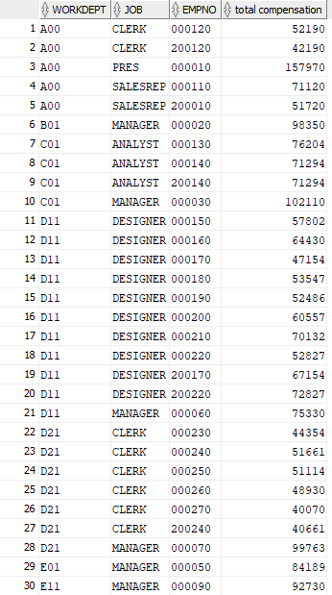

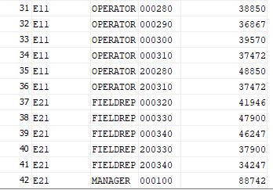



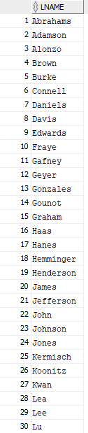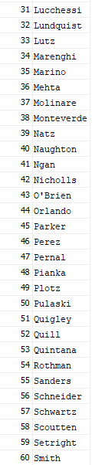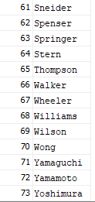



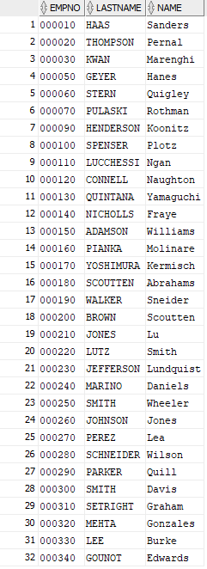



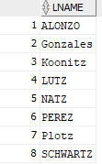







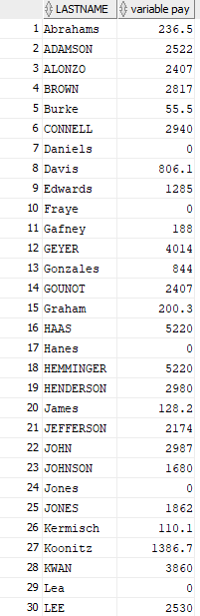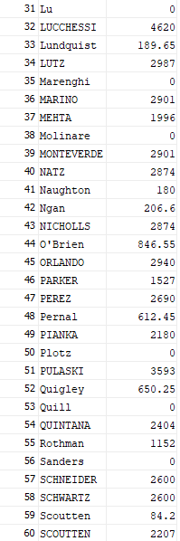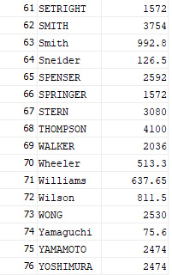



**Rating 1 (employee number: 000010)**

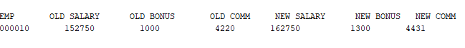

**Rating 2 (employee number: 000010)**



**Rating 3 (employee number: 000010)**



**Invalid Employee Number (null employee number)**

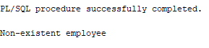

**Invalid Rating**

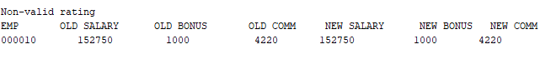



**H**



**C**



**U**



**M**

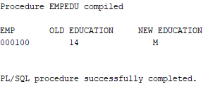

**P**

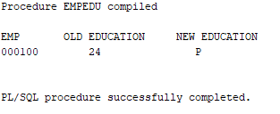

**Incorrect Education Level**

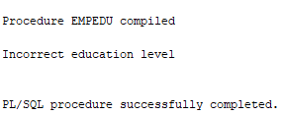

**Non-existent employee number**

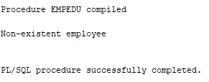

1. No output

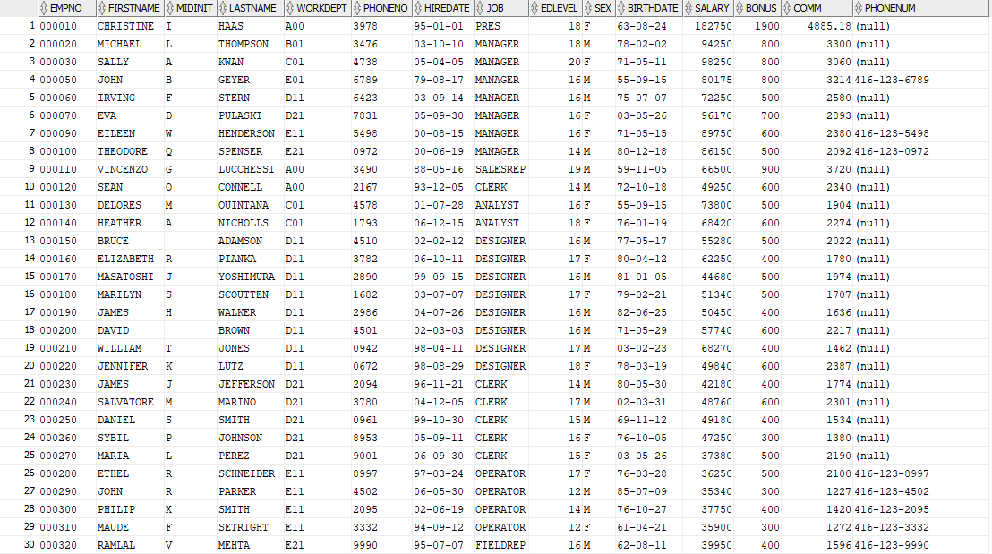

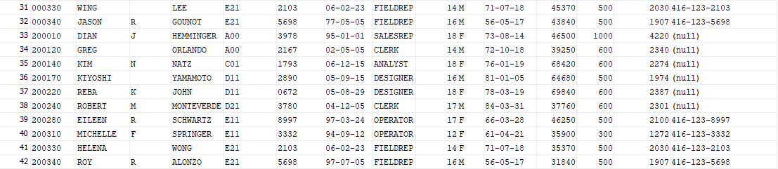

**Part B**



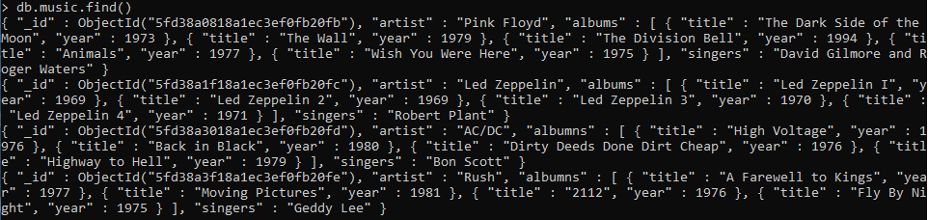



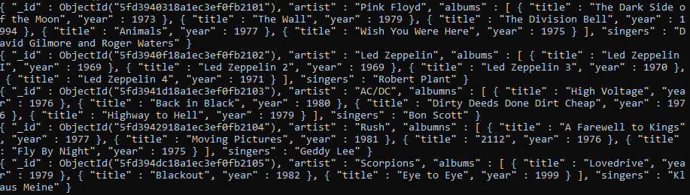



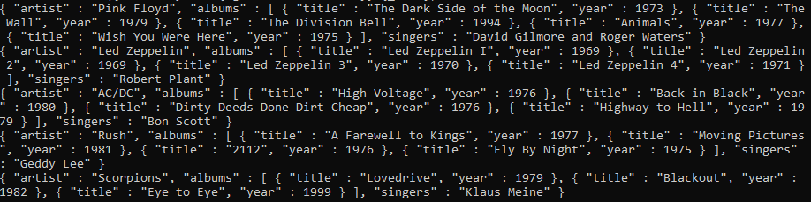



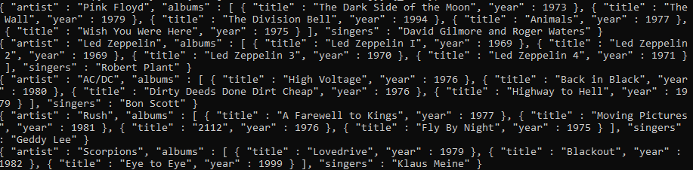



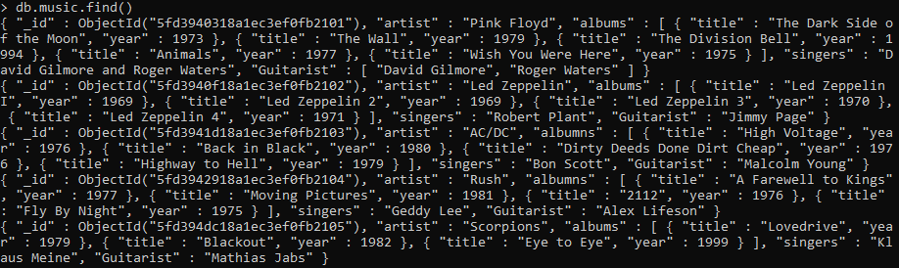





Before Increment:



After Increment:





Removed Scorpions: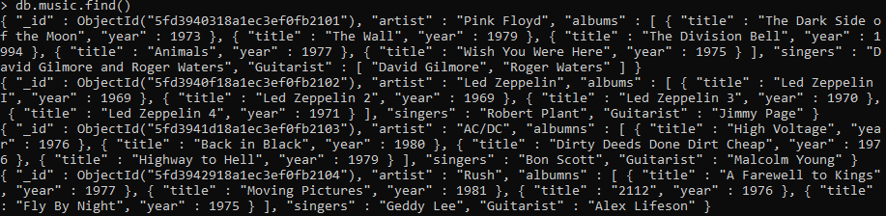

Removed “The Wall” from Pink Floyd:

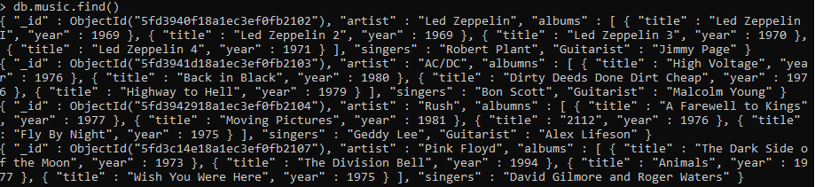

Removed all albums with the year in the 1970’s:

