Grazioso Salvare Rescue Animal Dashboard
CS 340 Project Two — README
Aimee Bevolo
Project Overview
This project is a dashboard that helps Grazioso Salvare look through animal shelter records and find dogs that may be a good fit for different types of rescue training. Users can filter the animals by rescue type, view the results in a table, see a pie chart of the breeds, and use the map to view an animal's location.
Required Functionality
· Show the full animal dataset in the initial dashboard state.
· Filter records for Water Rescue, Mountain or Wilderness Rescue, and Disaster or Individual Tracking.
· Reset to the unfiltered dataset.
· Update the table and both charts when a filter is changed.
· Display the Grazioso Salvare logo and my name on the dashboard.

Project Development
I started by connecting my CRUD module to MongoDB and getting the animal records to display in the dashboard. Then I added the filters so users could search for dogs based on the type of rescue training. After that, I worked on the pie chart and map so the information would be easier to view. I tested the filters and made adjustments when parts of the dashboard weren't working as expected.

Tools and Rationale
MongoDB stores the animal records in a way that makes them easy to work with in Python. I used PyMongo to connect to the database through my CRUD module and retrieve the information I needed. This also made it easier to search for animals based on their breed, sex, and age.
Dash and JupyterDash provide the web application layout and callback mechanism. Dash components supply the radio-button filter, data table, and Plotly chart; callbacks rerun database queries and update the displayed widgets. dash-leaflet displays animal latitude/longitude locations on an interactive map, while pandas organizes MongoDB documents into tabular data.
Project Files
· ProjectTwoDashboard.ipynb — dashboard layout, rescue filter queries, and callbacks.
· CRUD_Python_Module.py — AnimalShelter class with create, read, update, and delete methods.
· Grazioso Salvare Logo.png — dashboard logo asset.
Reproduction Instructions
1. Install or open the course Codio environment used, with Python, Jupyter, and MongoDB available.
2. Import the Austin Animal Center Outcomes dataset into the aac database and animals collection.
3. Confirm the aacuser MongoDB account has the required read permissions and that the connection settings in CRUD_Python_Module.py match the environment.
4. Place ProjectTwoDashboard.ipynb and CRUD_Python_Module.py in the same working directory.
5. Open ProjectTwoDashboard.ipynb, update the password variable to the correct aacuser password, and run the notebook cells from top to bottom.
6. Select each rescue category and confirm the table, pie chart, and map respond. Select Reset to restore all records.
7. Capture screenshots of the initial dashboard and all four filter states, including the logo and creator identifier, and insert them into the proof section below.
Testing and Deployment Evidence
I ran my dashboard in the course environment and took screenshots to show how it worked. I included each filter option, so it's easy to see how the results change. The screenshots below are where I show the dashboard running with each selection.
Initial unfiltered dashboard
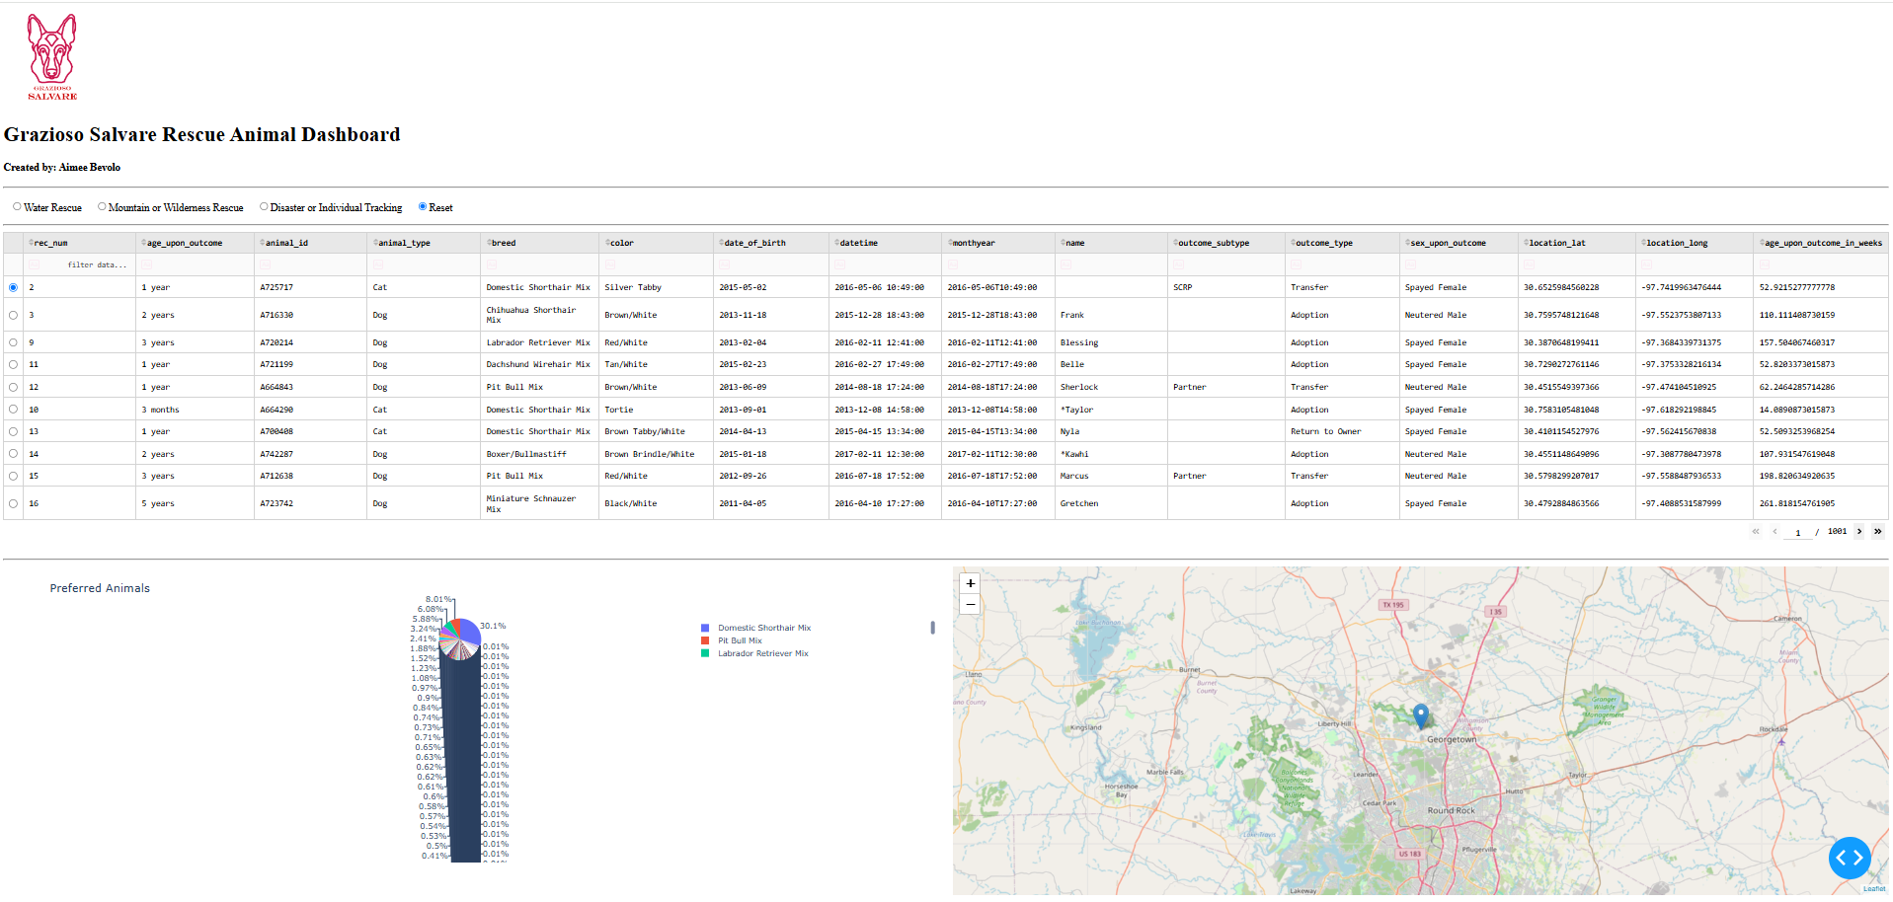
Water Rescue filter
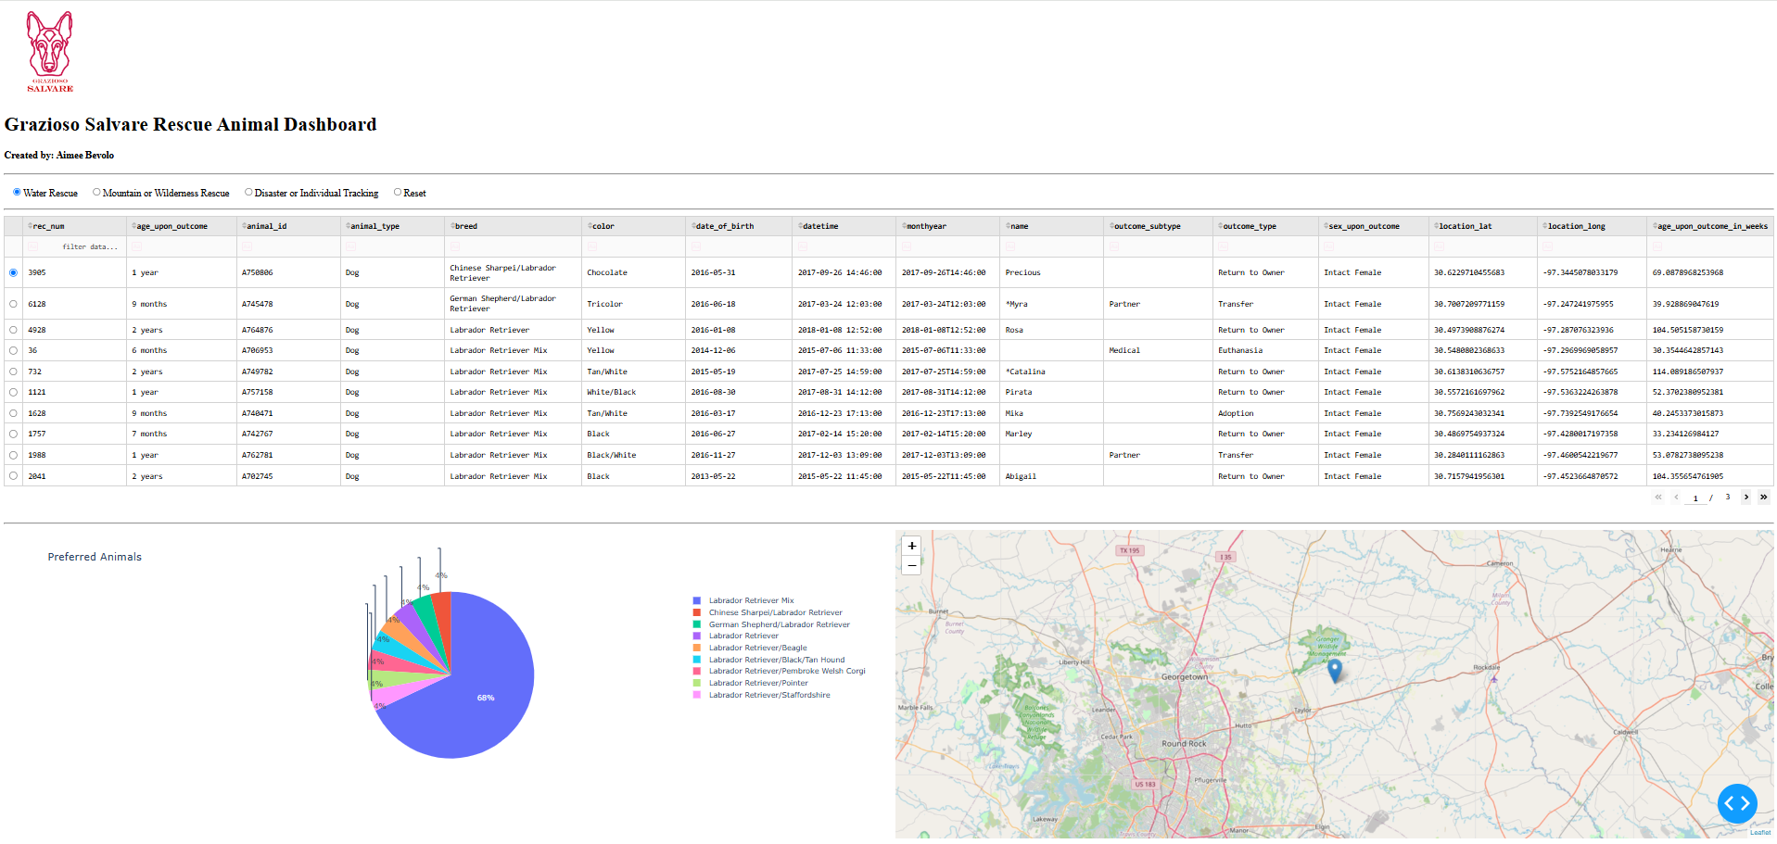
Mountain or Wilderness Rescue filter
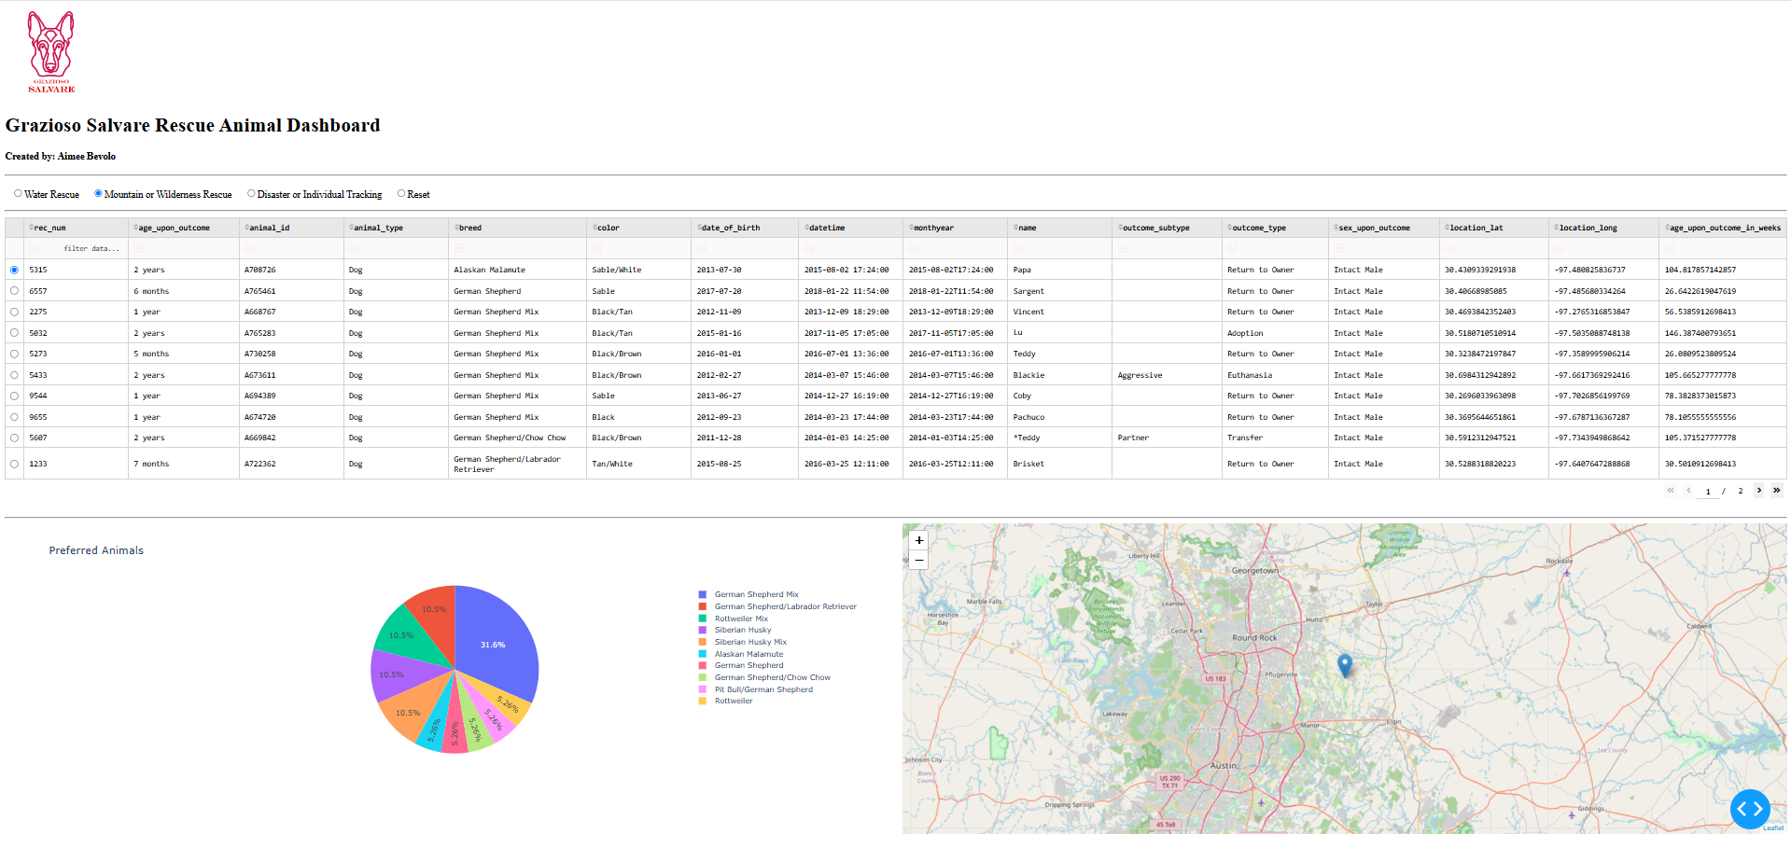
Disaster or Individual Tracking filter
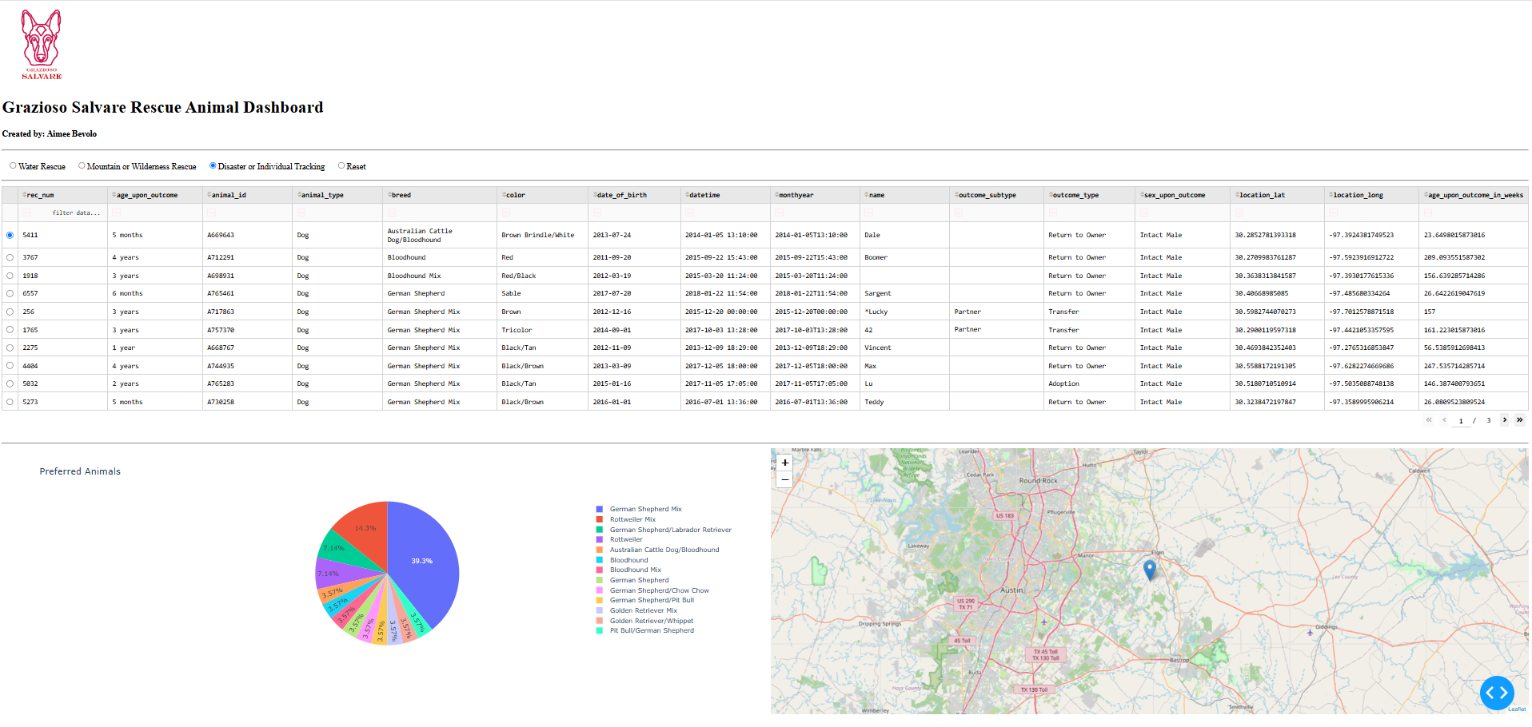
Reset
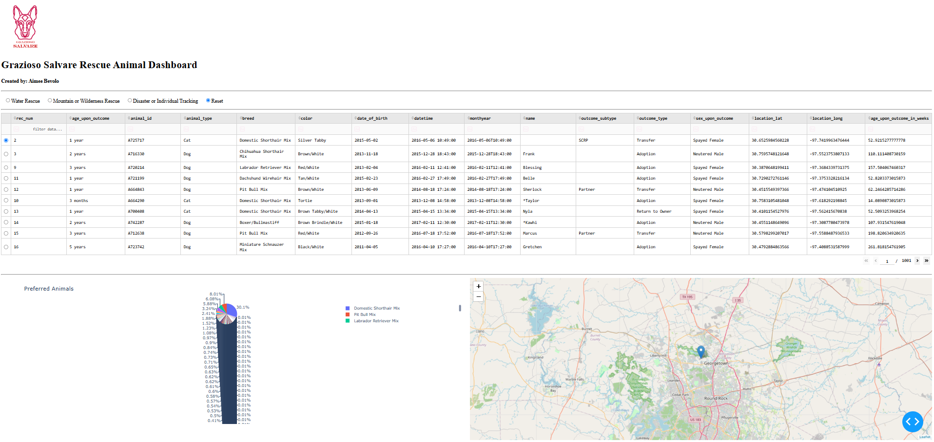
Challenges and Solutions
One thing I had trouble with was getting the animal information to show up correctly in the dashboard. I found that the _id field from MongoDB was causing problems with the data table, so I removed it. I also had to work on the filters because some dogs have mixed-breed names, which made it harder to find the right matches. Using regular expressions helped me get better results when searching for the breeds needed for each rescue type. I also made changes to the map so it could handle missing location information without causing problems.
Before I submitted my project, I went through a few checks. I tested the dashboard to make sure everything was working the way it should. I made sure MongoDB was connecting correctly and clicked through each filter to check that the table and charts changed like they were supposed to. I also took screenshots of the dashboard with each filter selected so I could show the results.
Resources
· https://dash.plotly.com/
· https://pymongo.readthedocs.io/
· https://plotly.com/python/plotly-express/
· https://www.dash-leaflet.com/
· https://www.mongodb.com/docs/

