Giant anteater revisions (adult)

2024-01-25

# Load packages  
library(ctmm)  
library(dplyr)  
library(tidyverse)  
library(glmmTMB)  
library(lme4)

The pre-print analyses contained 23 range-resident giant anteaters. Within the 23 individuals contained 12 males (8 adults, 4 subadults) and 11 females (all adults). This script is based on adult giant anteaters only. Subadults have been removed.

#import data, cleaned giant anteater GPS tracking data, containing no outliers  
COLLAR_DATA <- read.csv("data/Anteaters_NoOutliers.csv")  
  
#correct mismatch ID entries  
COLLAR_DATA$ID[COLLAR_DATA$ID == "Larry 267"] <- "Larry"  
  
COLLAR_DAT <- data.frame(timestamp = COLLAR_DATA$timestamp,  
 ID = COLLAR_DATA$ID,  
 GPS.Latitude = COLLAR_DATA$GPS.Latitude,  
 GPS.Longitude = COLLAR_DATA$GPS.Longitude,  
 GPS.Horizontal.Dilution = COLLAR_DATA$GPS.Horizontal.Dilution,  
 OUT = COLLAR_DATA$OUT,  
 Road = COLLAR_DATA$Road)  
  
#subset to the 20 adult range-resident individuals  
anteater_data <- COLLAR_DAT[which(COLLAR_DAT$ID   
 %in% c("Alexander", "Annie", "Beto", "Bumpus", "Cate",   
 "Christoffer","Elaine", "Hannah","Jackson", "Jane",   
 "Larry", "Luigi", "Makao", "Margaret", "Maria",   
 "Puji", "Rodolfo", "Sheron", "Thomas")),]

anteater_data <- readRDS("data/anteater_data_adults.rds")

#import supplementary data containing biological information  
DATA_META <- read.csv("data/Anteater_Results_Final.csv")  
  
#subset biological data from supplementary data  
bio_data <- DATA_META[which(DATA_META$ID   
 %in% c("Alexander", "Annie", "Beto", "Bumpus", "Cate",   
 "Christoffer","Elaine", "Hannah","Jackson", "Jane",   
 "Larry", "Luigi", "Makao", "Margaret", "Maria",   
 "Puji", "Rodolfo", "Sheron", "Thomas")),c(1:5)]  
  
#add site location   
bio_data$Site[bio_data$Road == "MS-040"] <- 1  
bio_data$Site[bio_data$Road == "BR_267"] <- 2  
  
#add bio data  
anteater_data <- merge(anteater_data, bio_data, all = TRUE)  
  
#convert dataset to a telemetry object  
DATA_TELEMETRY <- as.telemetry(anteater_data)

#import movement models  
load("data/anteater_fit.rda")  
  
#subset to adults only  
FIT <- FIT[-c(3,12,14,20)]  
  
#import home-range estimates  
load("data/anteater_AKDE.rda")  
  
#subset to adults only  
AKDE <- AKDE[-c(3,12,14,20)]

## Home-range results

#Mean HR size...  
meta(AKDE)

## ΔAICc  
## inverse-Gaussian 0.000  
## Dirac-δ 1671.981

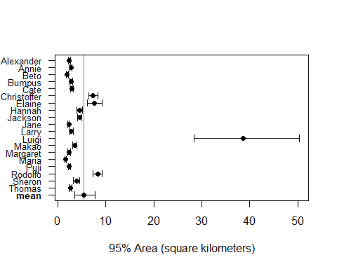

## low est high  
## mean (km²) 3.5554087 5.3982357 7.852936  
## CoV² (RVAR) 0.2798331 0.7412662 1.423521  
## CoV (RSTD) 0.5394160 0.8779329 1.216623

#Compare between sex...  
AKDE_male <- AKDE[c("Alexander", "Beto","Christoffer","Jackson", "Larry",   
 "Luigi", "Rodolfo", "Thomas")]  
AKDE_female <- AKDE[c("Annie", "Bumpus", "Cate", "Elaine", "Hannah",  
 "Jane","Makao", "Margaret", "Maria", "Puji",  
 "Sheron")]  
  
#calculate mean home range sizes for male  
meta(AKDE_male)

## ΔAICc  
## inverse-Gaussian 0.000  
## Dirac-δ 1018.877

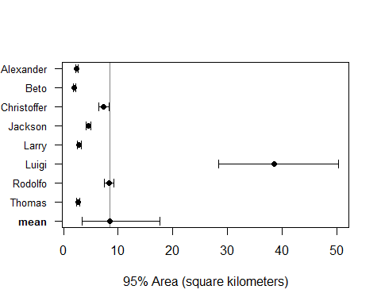

## low est high  
## mean (km²) 3.4269511 8.473694 17.647143  
## CoV² (RVAR) 0.2042960 1.471644 3.963360  
## CoV (RSTD) 0.4770962 1.280494 2.101396

#calculate mean home range sizes for female  
meta(AKDE_female)

## ΔAICc  
## inverse-Gaussian 0.0000  
## Dirac-δ 288.9002

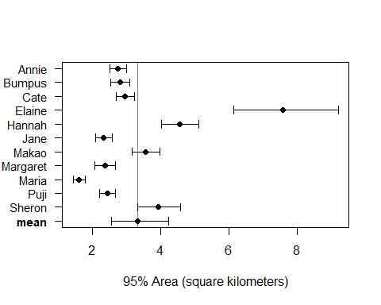

## low est high  
## mean (km²) 2.56403337 3.3229336 4.2340253  
## CoV² (RVAR) 0.05286222 0.1735890 0.3647910  
## CoV (RSTD) 0.23610030 0.4278435 0.6202202

#female/male ratio of mean home-range areas  
AKDE_sex_compare <- list(male = AKDE_male,  
 female = AKDE_female)  
meta(AKDE_sex_compare, col = c("#004488", "#A50026"), sort = TRUE)

## * Sub-population male

## ΔAICc  
## inverse-Gaussian 0.000  
## Dirac-δ 1018.877

## * Sub-population female

## ΔAICc  
## inverse-Gaussian 0.0000  
## Dirac-δ 288.9002

## * Joint population

## ΔAICc  
## inverse-Gaussian 0.000  
## Dirac-δ 1671.981

## * Joint population versus sub-populations (best models)

## ΔAICc  
## Sub-population 0.000000  
## Joint population 3.607806

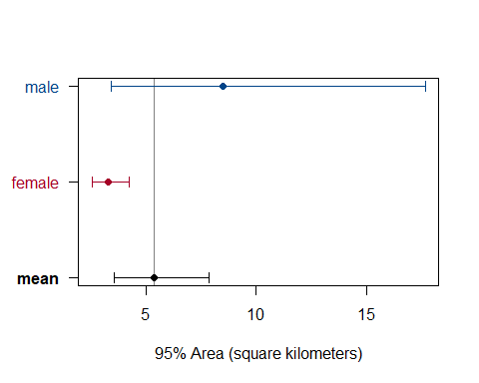

## , , low  
##   
## /male /female  
## male/ 1.0000000 0.8082377  
## female/ 0.1107186 1.0000000  
##   
## , , est  
##   
## /male /female  
## male/ 1.0000000 2.507956  
## female/ 0.3169989 1.000000  
##   
## , , high  
##   
## /male /female  
## male/ 1.0000000 5.262085  
## female/ 0.8380671 1.000000

## Estimating home-range overlap

#subset home range overlap based on site location  
AKDE_1 <- AKDE[c("Alexander", "Bumpus", "Cate", "Christoffer",  
 "Elaine", "Jackson", "Makao",  
 "Puji", "Rodolfo")]  
  
AKDE_2 <- AKDE[c("Annie", "Beto", "Hannah", "Jane", "Larry",  
 "Luigi", "Margaret", "Maria", "Sheron",  
 "Thomas")]  
  
#calculate 95% AKDE home range overlap for a pairwise comparison for each site  
overlap1 <- overlap(AKDE_1, level = 0.95)  
overlap2 <- overlap(AKDE_2, level = 0.95)  
  
overlap_data <- readRDS("data/home_range/overlap_data_adults.rds")

# Home-range overlap results

#Is sex a factor?...  
  
#rescale the values  
min_val <- min(overlap_data$overlap_est)  
max_val <- max(overlap_data$overlap_est)  
squeeze_min <- 0.001  
squeeze_max <- 0.999  
overlap_data$overlap_est_squeezed <- ((overlap_data$overlap_est - min_val) / (max_val - min_val)) * (squeeze_max - squeeze_min) + squeeze_min  
  
#compare model with and without sex as a variable  
HRO_test <- glmmTMB(overlap_est_squeezed ~ sex_comparison + (1|site),   
 family = beta_family(link = "logit"), data = overlap_data)  
HRO_test2 <- glmmTMB(overlap_est_squeezed ~ 1 + (1|site),   
 family = beta_family(link = "logit"), data = overlap_data)  
HRO_test_results <- anova(HRO_test, HRO_test2)  
HRO_test_results

## Data: overlap_data  
## Models:  
## HRO_test2: overlap_est_squeezed ~ 1 + (1 | site), zi=~0, disp=~1  
## HRO_test: overlap_est_squeezed ~ sex_comparison + (1 | site), zi=~0, disp=~1  
## Df AIC BIC logLik deviance Chisq Chi Df Pr(>Chisq)  
## HRO_test2 3 -267.69 -260.51 136.84 -273.69   
## HRO_test 5 -264.82 -252.85 137.41 -274.82 1.1323 2 0.5677

#calculate sex impact via likelihood ratio test  
HRO_test_pvalue <- round(HRO_test_results$`Pr(>Chisq)`[2], 2)  
HRO_test_pvalue

## [1] 0.57

#Home range overlap results based on sex comparisons (i.e.. male-male, female-female, and female-male).  
  
#number of home range overlap in each sex comparison category  
table(overlap_data$sex_comparison)

##   
## female-female female-male male-male   
## 25 44 12

#calculate mean home range overlap and the range based on sex comparisons  
round(mean(overlap_data$overlap_est[overlap_data$sex_comparison == "male-male"]), 2)

## [1] 0.14

round(min(overlap_data$overlap_est[overlap_data$sex_comparison == "male-male"]), 2)

## [1] 0

round(max(overlap_data$overlap_est[overlap_data$sex_comparison == "male-male"]), 2)

## [1] 0.69

round(mean(overlap_data$overlap_est[overlap_data$sex_comparison == "female-female"]), 2)

## [1] 0.14

round(min(overlap_data$overlap_est[overlap_data$sex_comparison == "female-female"]), 2)

## [1] 0

round(max(overlap_data$overlap_est[overlap_data$sex_comparison == "female-female"]), 2)

## [1] 0.87

round(mean(overlap_data$overlap_est[overlap_data$sex_comparison == "female-male"]), 2)

## [1] 0.19

round(min(overlap_data$overlap_est[overlap_data$sex_comparison == "female-male"]), 2)

## [1] 0

round(max(overlap_data$overlap_est[overlap_data$sex_comparison == "female-male"]), 2)

## [1] 0.96

# Estimating proximity ratio

#import proximity data  
proximity_data <- readRDS("data/proximity/proximity_df.rds")  
proximity_data <- as.data.frame(proximity_data)  
  
#remove subadults from proximity data  
proximity_data <- proximity_data[!(proximity_data$anteater_A %in% "Anthony" | proximity_data$anteater_B %in% "Anthony"),]  
proximity_data <- proximity_data[!(proximity_data$anteater_A %in% "Kyle" | proximity_data$anteater_B %in% "Kyle"),]  
proximity_data <- proximity_data[!(proximity_data$anteater_A %in% "Little_Rick" | proximity_data$anteater_B %in% "Little_Rick"),]  
proximity_data <- proximity_data[!(proximity_data$anteater_A %in% "Reid" | proximity_data$anteater_B %in% "Reid"),]  
  
#combine overlap and proximity data  
overlap_data <- merge(overlap_data, proximity_data, all = TRUE)

# Proximity ratio results

#test for significance in sex, compare model with and without sex as a variable  
proximity_test <- glmer(proximity_est ~ sex_comparison + (1|site),   
 family = Gamma(link = "log"), data = overlap_data)

## boundary (singular) fit: see help('isSingular')

proximity_test2 <- glmer(proximity_est ~ 1 + (1|site),   
 family = Gamma(link = "log"), data = overlap_data)

## boundary (singular) fit: see help('isSingular')

proximity_test_results <- anova(proximity_test, proximity_test2)  
  
#calculate sex impact on proximity ratio via likelihood ratio test  
proximity_test_pvalue <- round(proximity_test_results$`Pr(>Chisq)`[2], 2)  
proximity_test_pvalue

## [1] 0.12

#compare model with and without overlap as a variable  
prox_overlap_test <- glmer(proximity_est ~ overlap_est + (1|site),   
 family = Gamma(link = "log"), data = overlap_data)

## boundary (singular) fit: see help('isSingular')

prox_overlap_test2 <- glmer(proximity_est ~ 1 + (1|site),   
 family = Gamma(link = "log"), data = overlap_data)

## boundary (singular) fit: see help('isSingular')

prox_overlap_test_results <- anova(prox_overlap_test, prox_overlap_test2)  
  
#calculate home-range overlap impact via likelihood ratio test  
prox_overlap_test_pvalue <- round(prox_overlap_test_results$`Pr(>Chisq)`[2], 2)  
prox_overlap_test_pvalue

## [1] 0.02

# Estimating encounters

# Encounter results

#calculate the number of encounters based on threshold of 15m  
sum(overlap_data$encounter_count)

## [1] 1209

sum(overlap_data$encounter_count[overlap_data$sex_comparison == "male-male"])

## [1] 16

sum(overlap_data$encounter_count[overlap_data$sex_comparison == "female-female"])

## [1] 145

sum(overlap_data$encounter_count[overlap_data$sex_comparison == "female-male"])

## [1] 1048

#effect of sex and overlap on encounter rates and does not include 0 encounter counts  
encounter_test <- glmer(encounter_count ~ overlap_est + sex_comparison + (1|site),   
 family = poisson(link = "log"),   
 data = overlap_data, subset = encounter_count > 0)  
encounter_test2 <- glmer(encounter_count ~ 1 + (1|site),   
 family = poisson(link = "log"),   
 data = overlap_data, subset = encounter_count > 0)  
encounter_test_results <- anova(encounter_test, encounter_test2)  
encounter_test_results

## Data: overlap_data  
## Subset: encounter_count > 0  
## Models:  
## encounter_test2: encounter_count ~ 1 + (1 | site)  
## encounter_test: encounter_count ~ overlap_est + sex_comparison + (1 | site)  
## npar AIC BIC logLik deviance Chisq Df Pr(>Chisq)   
## encounter_test2 2 2134.8 2137.3 -1065.38 2130.8   
## encounter_test 5 1429.3 1435.6 -709.66 1419.3 711.44 3 < 2.2e-16 ***  
## ---  
## Signif. codes: 0 '***' 0.001 '**' 0.01 '*' 0.05 '.' 0.1 ' ' 1

#calculate sex impact on encounters via likelihood ratio test  
encounter_test_pvalue <- round(encounter_test_results$`Pr(>Chisq)`[2], 2)  
encounter_test_pvalue

## [1] 0

#amount of home range overlap and the number of observed encounters  
summary(encounter_test)

## Generalized linear mixed model fit by maximum likelihood (Laplace  
## Approximation) [glmerMod]  
## Family: poisson ( log )  
## Formula: encounter_count ~ overlap_est + sex_comparison + (1 | site)  
## Data: overlap_data  
## Subset: encounter_count > 0  
##   
## AIC BIC logLik deviance df.resid   
## 1429.3 1435.6 -709.7 1419.3 21   
##   
## Scaled residuals:   
## Min 1Q Median 3Q Max   
## -6.3616 -5.2131 -2.4377 -0.5606 28.1608   
##   
## Random effects:  
## Groups Name Variance Std.Dev.  
## site (Intercept) 0.005524 0.07433   
## Number of obs: 26, groups: site, 2  
##   
## Fixed effects:  
## Estimate Std. Error z value Pr(>|z|)   
## (Intercept) 1.94374 0.13669 14.220 < 2e-16 ***  
## overlap_est 1.95462 0.12774 15.302 < 2e-16 ***  
## sex_comparisonfemale-male 1.24952 0.09199 13.583 < 2e-16 ***  
## sex_comparisonmale-male -1.19742 0.26718 -4.482 7.41e-06 ***  
## ---  
## Signif. codes: 0 '***' 0.001 '**' 0.01 '*' 0.05 '.' 0.1 ' ' 1  
##   
## Correlation of Fixed Effects:  
## (Intr) ovrlp_ sx_cmprsnf-  
## overlap_est -0.690   
## sx_cmprsnf- -0.722 0.236   
## sx_cmprsnm- -0.305 0.164 0.324

# Deviated pairs

#import identified deviated pairs (7 pairs)  
proximity_identified_pairs_df <- readRDS("data/proximity/proximity_identified_adult_pairs_df.rds")  
  
#number of pairs with a deviated proximity ratio based on sex comparison  
table(proximity_identified_pairs_df$sex_comparison)

##   
## female-female female-male   
## 3 4

#test for significance in sex, compare model with and without sex as a variable  
proximity_test_pairs <- glmer(proximity_est ~ sex_comparison + (1|site),   
 family = Gamma(link = "log"),   
 data = proximity_identified_pairs_df)  
proximity_test2_pairs <- glmer(proximity_est ~ 1 + (1|site),   
 family = Gamma(link = "log"),   
 data = proximity_identified_pairs_df)

## boundary (singular) fit: see help('isSingular')

proximity_test_results_pairs <- anova(proximity_test_pairs, proximity_test2_pairs)  
proximity_test_results_pairs

## Data: proximity_identified_pairs_df  
## Models:  
## proximity_test2_pairs: proximity_est ~ 1 + (1 | site)  
## proximity_test_pairs: proximity_est ~ sex_comparison + (1 | site)  
## npar AIC BIC logLik deviance Chisq Df Pr(>Chisq)  
## proximity_test2_pairs 3 11.042 10.88 -2.5211 5.0423   
## proximity_test_pairs 4 10.746 10.53 -1.3730 2.7460 2.2963 1 0.1297

#calculate sex impact via likelihood ratio test  
proximity_test_pvalue_pairs <- round(proximity_test_results_pairs$`Pr(>Chisq)`[2], 2)  
proximity_test_pvalue_pairs

## [1] 0.13

#test for significance in home range overlap, compare model with and without overlap as a variable  
prox_overlap_test_pairs <- glmer(proximity_est ~ overlap_est + (1|site),   
 family = Gamma(link = "log"),   
 data = proximity_identified_pairs_df)

## boundary (singular) fit: see help('isSingular')

prox_overlap_test2_pairs <- glmer(proximity_est ~ 1 + (1|site),   
 family = Gamma(link = "log"),   
 data = proximity_identified_pairs_df)

## boundary (singular) fit: see help('isSingular')

prox_overlap_test_results_pairs <- anova(prox_overlap_test_pairs, prox_overlap_test2_pairs)  
prox_overlap_test_results_pairs

## Data: proximity_identified_pairs_df  
## Models:  
## prox_overlap_test2_pairs: proximity_est ~ 1 + (1 | site)  
## prox_overlap_test_pairs: proximity_est ~ overlap_est + (1 | site)  
## npar AIC BIC logLik deviance Chisq Df  
## prox_overlap_test2_pairs 3 11.042 10.880 -2.5211 5.0423   
## prox_overlap_test_pairs 4 11.492 11.275 -1.7458 3.4916 1.5506 1  
## Pr(>Chisq)  
## prox_overlap_test2_pairs   
## prox_overlap_test_pairs 0.213

#calculate home-range overlap impact via likelihood ratio test  
prox_overlap_test_pvalue_pairs <- round(prox_overlap_test_results_pairs$`Pr(>Chisq)`[2], 2)  
prox_overlap_test_pvalue_pairs

## [1] 0.21