# BACKGROUND

British Columbia’s protected areas are experiencing an abrupt, climate-induced increase in wildfire activity in recent years.

Fire danger is increasing for mountainous regions1 and wildfire activity is occurring at higher elevations2

Understanding the immediate responses of wildlife to wildfires is critically important for ensuring individuals can survive wildfire events.

However, major knowledge gaps remain:

* Limited research on wildlife behavioural responses during a wildfire3
* Direct effects of fires on wildlife are largely unknown3

Mountain goats occur in areas at risk of megafires and vulnerable to effects of climate-driven habitat change.

Given these knowledge gaps and challenges, we set out to gain insight on:

**How do mountain goats respond in real time to the progression of wildfire?**

**Do changing properties of the fire affect mountain goat responses?**

# METHODS

**Cathedral Provincial Park**

* Part of the unceded and ancestral territory of the Syilx Okanagan Nation, including the traditional lands of the Lower Similkameen Indian Band
* Located in the southern interior of BC on the US-Canada border North-east region of the Cascade Mountain Range
* Size: 33,512 hectares

**Crater Creek wildfire** (K52125)

* Active fire period: Jul 22 to Oct 26, 2023
* Burning duration: 96 days
* Burned size: 46,504 hectares

**Mountain goats**

* 6 mountain goats
* GPS tracked continuously during the Crater Creek wildfire
* 6 years of GPS collar data (2019-2024)

**Figure 1. Map of mountain goat location in and around Cathedral Provincial Park, British Columbia.** GPS locations for 6 mountain goats from July 22 to October 26, 2023, and the Crater Creek wildfire boundaries. The inconsistent dashed line marks the Canada-USA international border.

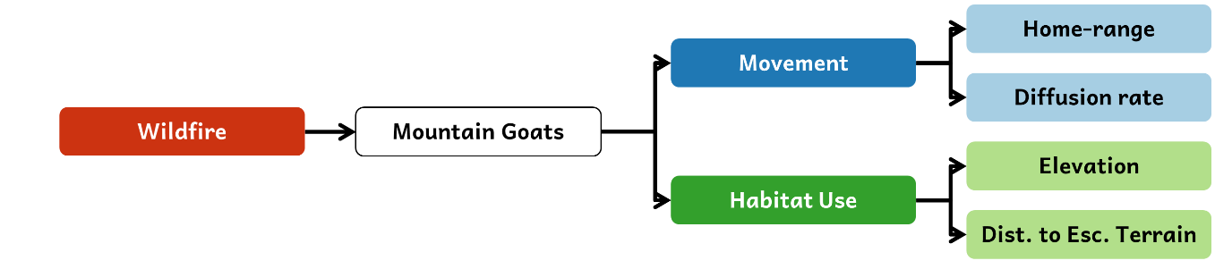

**Figure 2. Project schematics of the workflow examining the response of mountain goats to wildfire.** Movement (blue) was evaluated by home-range size and diffusion rate. Habitat-use (green) was investigated based on elevation and distance to escape terrain.

**Figure 3. Mountain goat habitat-use from 2019 to 2024 in Cathedral Provincial Park, British Columbia.** Results of a window analysis estimating individuals’ mean elevation (m) across all 6 years (2019-2024). The red line indicates the year of the Crater Creek wildfire, and the grey lines are all the other years. The black dashed line represents the Crater Creek wildfire period.

# RESULTS

## COARSE SCALE RESPONSE

**Mountain goats exhibited comparable home-range sizes across all 6 years but had increased diffusion rates during the fire.**

**Figure 4. Mountain goat home-range and movement during the 2023 Crater Creek wildfire compared to non-fire years in Cathedral Provincial Park, British Columbia.** Home-range sizes and diffusion rates during wildfire period (July 22 to October 26) across all years (2019-2024). Red indicates the fire year, and the points depict the underlying individual data.

**Mountain goats exhibited similar resource selection for elevation and distance to escape terrain across all 6 years.**

**Figure 5. Mountain goat resource selection during the 2023 Crater Creek wildfire in Cathedral Provincial Park, British Columbia, compared to non-fire years.** Points show resource selection function (RSF) parameter coefficient (β) estimate with 95% confidence intervals. Values above 0 indicates selection for and values below 0 suggest avoidance for the habitat p. The fire year is indicated in red and other years of the same period in grey.

## FINE SCALE RESPONSE

**Mountain goats selected for higher elevation when the fire was close.**

**Figure 6. Mountain goat habitat selection during the 2023 Crater Creek wildfire in Cathedral Provincial Park, British Columbia based on step selection function (SSFs).** Panel A) Estimated effects exp(f(β)) of the habitat parameters influencing location selection relative to other available options with population-level estimate (black lines, 95% confidence intervals in grey), and individual responses (blue lines). Panel B) Combined estimated effect of habitat parameters on the likelihood of selecting a location relative to other options available based on the mountain goats’ distance to the fire. Estimated values above 0 (blue) indicates the mountain goats selected for, values below 0 (red) suggest avoidance, and 0 (white) denotes neutrality for the habitat parameter.

# Take home message

* Mountain goat home-range sizes were not affected by the fire, but their movement rates increased (coarse-scale findings).
* Mountain goats occupied higher elevations when fire was nearby (fine-scale results).
* Wildfire may be an ecological trap in mountainous areas for mountain goats.

**There could be serious implications for mountain goats in the future because of fires moving upslope and occurring at higher elevations.**

# Next steps

* Enhance fire data resolution using fire models to reconstruct the Crater Creek wildfire progression in greater detail.
* Determine the tipping point(s) for when mountain goats alter their behaviour in response to wildfire.

# References

1. Alizadeh MR et al. Elevation-dependent intensification of fire danger in the western United States. Nature Communications. 2023;14(1):1773. https://doi.org/10.1038/s41467-023-37311-4

2. Alizadeh MR et al. Warming enabled upslope advance in western US forest fires. Proceedings of the National Academy of Sciences. 2021;118(22):e2009717118. https://doi.org/10.1073/pnas.2009717118

3. Jolly CJ et al. Animal mortality during fire. Global Change Biology. 2022;28(6):2053–2065. https://doi.org/10.1111/gcb.16044