**Cyclistic Case Study:** **Analysing customer behaviours to recommend marketing strategies for converting casual members into annual members**

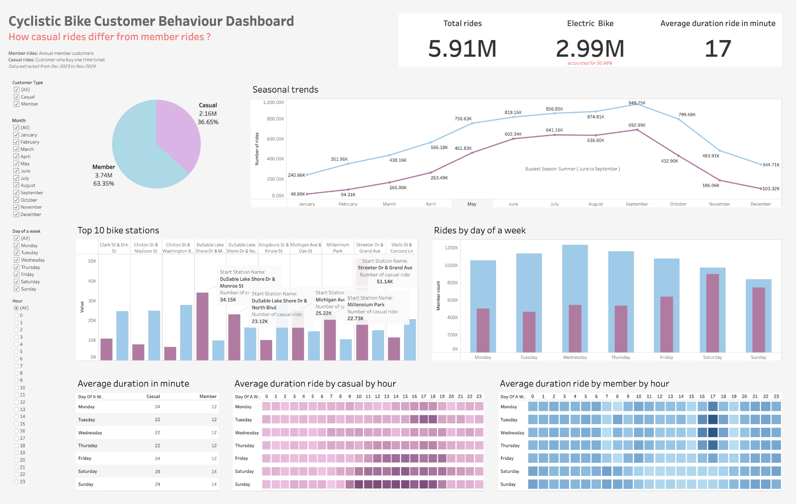

**Code Link:**

* **Data Collection_Python:** [**Github**](https://github.com/aimeele97/cyclistic_customer_behaviour_analysis/blob/main/Combine_Datasets.ipynb)
* **Data Cleaning_SQL:** [**GIthub**](https://github.com/aimeele97/cyclistic_customer_behaviour_analysis/blob/main/Data_Process.sql)
* **Data Analysis_SQL:** [**Github**](https://github.com/aimeele97/cyclistic_customer_behaviour_analysis/blob/main/Data_Analysis.sql)
* **Tableau Visualization:** [**Tableau Public**](https://public.tableau.com/app/profile/aimee.le9707/viz/CyclisticDashboard_17343165311580/Dashboard1)

**Table of Contents**

1. Introduction 3

1.1. Summary 3

1.2. About the company 3

1.3. Business questions 3

1.4. Data Source 4

2. Data Analysis Process 4

2.1. Data collection (Python) 4

2.2. Data cleaning and manipulation (SQL) 4

2.2.1. Detect and remove duplicates 4

2.2.2. Remove data errors 5

2.2.3. Cleaned data 5

2.3. Data analysis (SQL) 6

2.4. Data visualization 9

2.5. Key insights and recommendations 10

2.5.1. Key Insights 10

2.5.2. Recommendation for marketing strategies to convert casual members into annual members 10

3. Conclusion 12

# 

# Introduction

## Summary

This project aims to analyze Cyclistic’s one-year bike ride data from Chicago to identify key differences between casual riders and annual members. The Director of Marketing believes converting casual riders into annual members is critical for the company’s long-term success and revenue growth. By uncovering these usage patterns, the insights will drive a focused marketing strategy to increase annual memberships.

Read more about case study: [Link](https://github.com/aimeele97/cyclistic_customer_behaviour_analysis/blob/main/Case%20Study%202_%20How-can-a-wellness-technology-company-play-it-smart.pdf)

**Analysis Steps:**

* **Data Preparation**:

Download the monthly rides data from December 2023 to November 2024, merge the files into a single DataFrame using a Python script, export it as a CSV, and import the data into a SQL database for analysis.

* **Data Cleaning**:

Explore the data to identify and address potential issues such as duplicates, invalid transactions, and data inconsistencies. Use SQL Data Manipulation Language (DML) to clean and transform the dataset.

* **Data Analysis**:

Query the cleaned dataset to answer key business questions to uncover trends and patterns that differentiate casual riders from annual members.

* **Data Visualization**:

Export the cleaned dataset from the SQL database and upload it to Tableau. Create visualizations that highlight three key insights from the analysis.

* **Deliverables**:

A comprehensive report documenting the analysis process, highlighting key insights, and providing actionable, data-driven recommendations for presentation to key business stakeholders.

## About the company

Overview case study In 2016, Cyclistic launched a successful bike-share offering. Since then, the program has grown to a set of 5,824 bicycles that are geotracked and locked into a network of 692 stations across Chicago. The bikes can be unlocked from one station and returned to any other station in the system anytime. Cyclistic’s marketing strategy relied on building general awareness and appealing to broad consumer segments.

Cyclistic pricing plans including: single-ride passes, full-day passes, and annual memberships. Customers who purchase single-ride or full-day passes are referred to as casual riders. Customers who purchase annual memberships are Cyclistic members.

## Business questions

Three questions will guide the future marketing program:

* How do annual members and casual riders use Cyclistic bikes differently?
* Why would casual riders buy Cyclistic annual memberships?
* How can Cyclistic use digital media to influence casual riders to become members?

## Data Source

The analysis using the Cyclistic historical rides data from December 2023 to November 2024, the dataset contains columns such as ride id, rides started datetime, ended datetime, start and end ride location, longitude and latitude.

Dataset source: [Link](https://divvy-tripdata.s3.amazonaws.com/index.html)

# Data Analysis Process

## Data collection (Python)

Using Pandas and the OS libraries in Python, I accessed the files folder and merged all the datasets into a DataFrame. Below is the Python code used for this task.

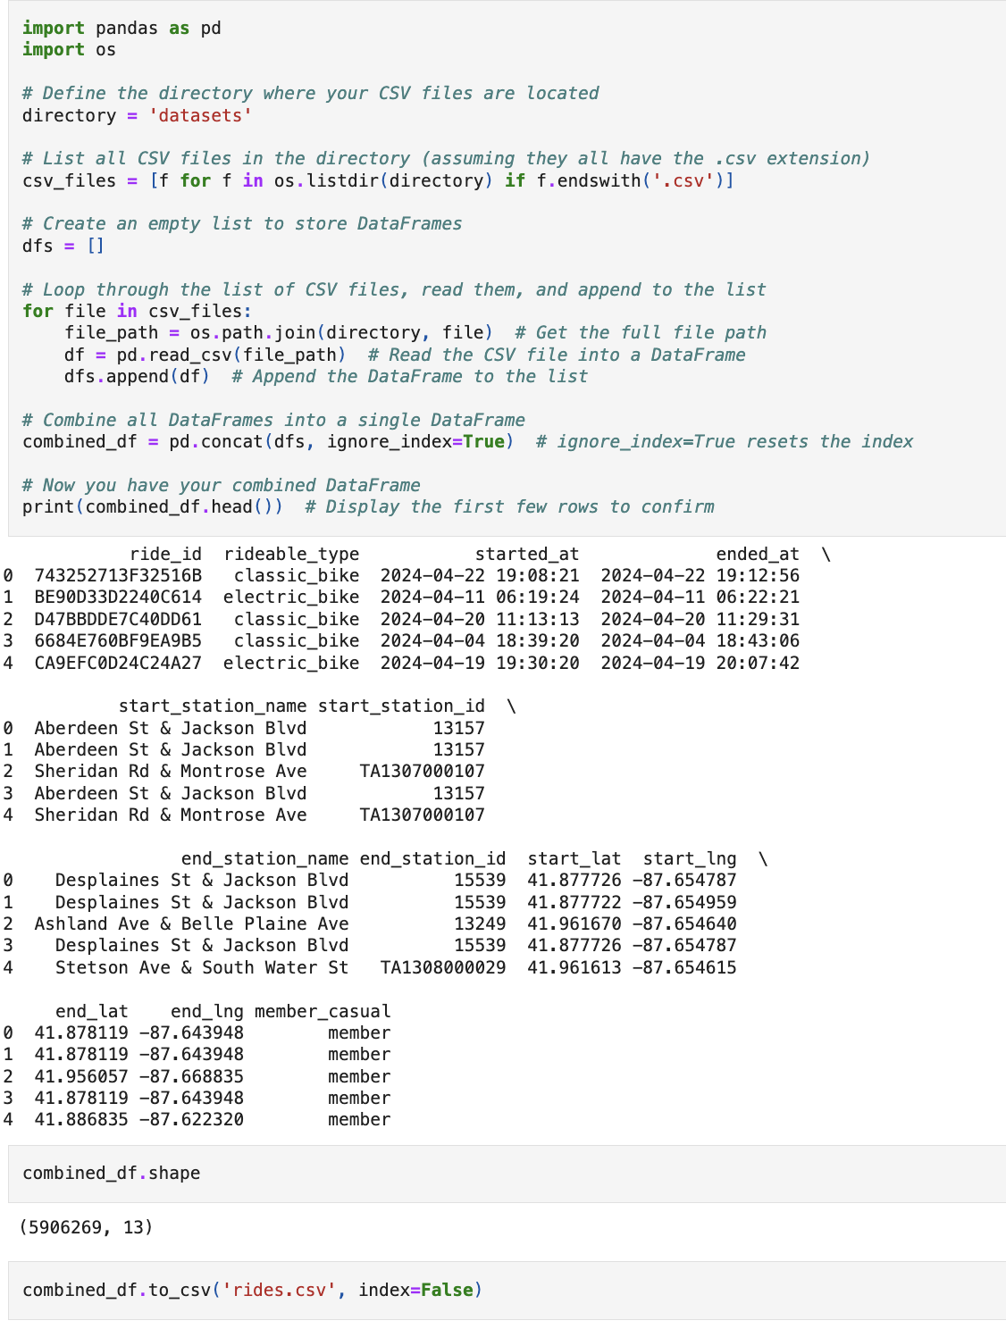

## Data cleaning and manipulation (SQL)

### 2.2.1. Detect and remove duplicates

After reviewing the data, I identified that duplicates were likely caused by a system error. The differences between duplicate rows were found in the started_at and ended_at timestamps, specifically in the milliseconds portion, which suggests the issue might be related to how the timestamps were recorded or processed.

**Process**: Removed the milliseconds from the datetime fields to match duplicate rows, then updated the table with distinct rows.

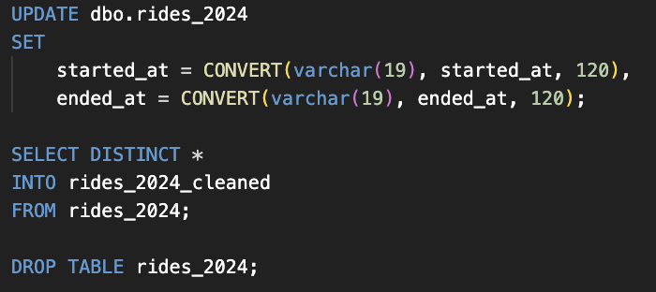

### 2.2.2. Remove data errors

There were instances where the ride start time was later than the end time, which is incorrect. I removed all rows where the start time was greater than or equal to the end time.

**SQL code:**

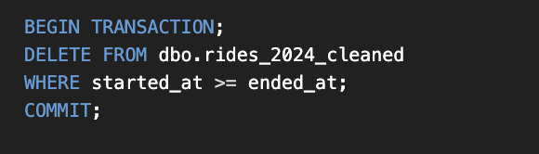

### 2.2.3. Cleaned data

* **Original dataset**: 5,906,269 rows
* **Dataset after cleaning**: 5,905,278 rows (991 rows were deleted)

Note: There were some null values in the start and end locations; however, these rows still contained valid latitude and longitude data. Since this does not affect my analysis, I decided to not delete these rows.

Display the top 10 rows after cleaning:

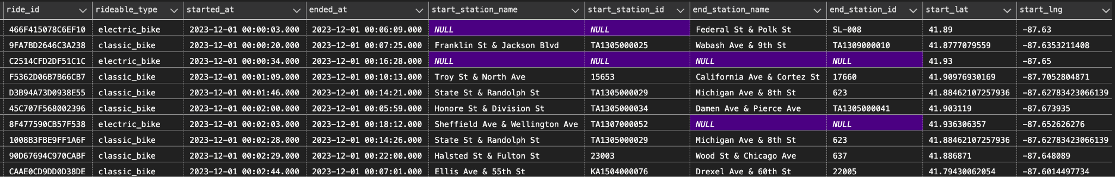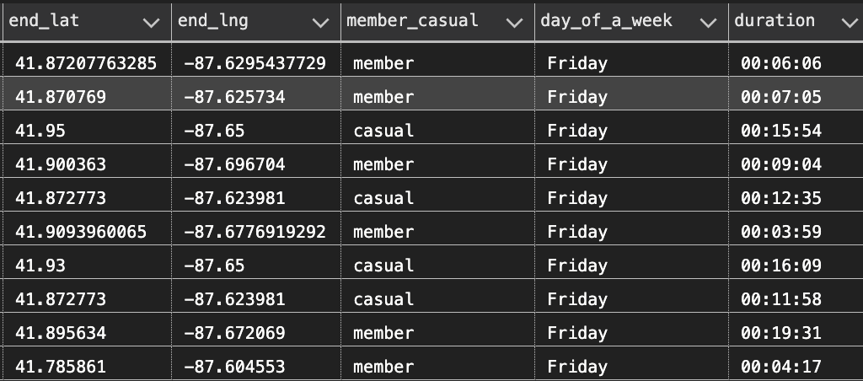

## Data analysis (SQL)

The total number of rides from December 2023 to November 2024 is 5,9M, with casual riders accounting for approximately 37% of all rides.

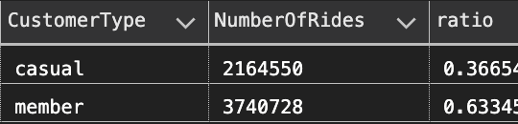

* The number of rides was slow during the winter (December to March) and gradually increased, reaching its peak during the summer season (June to September).

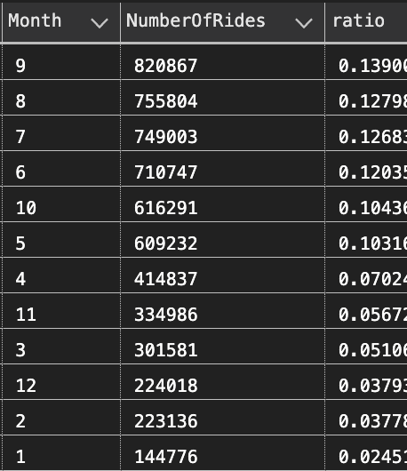

* While member rides were highest in the middle of the week and slowest on the weekends, casual rides peaked on the weekends.This suggests that member rides are most likely used for work purposes and casual rides are more commonly used for leisure.

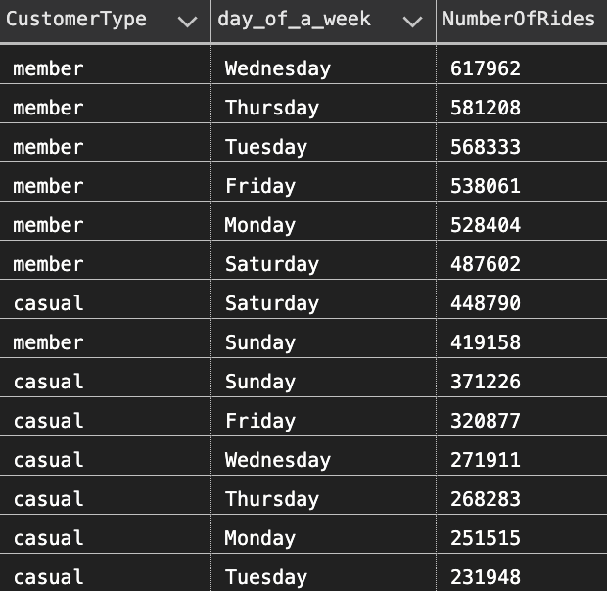

* On average, casual riders ride longer than those who are the members, 25 minutes compared to 13 minutes.

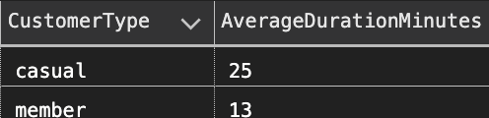

* The average duration held constant during the week

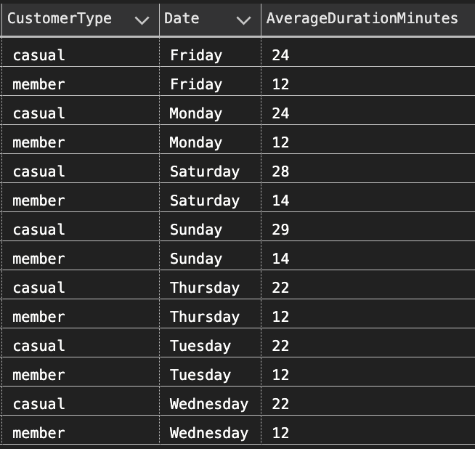

* Both casual and member riders tend to use the service more frequently during the **late afternoon to evening hours**, with the highest activity observed between **4:00 PM and 7:00 PM** (16:00-18:00). The activity significantly drops during the **early morning and late night hours**, particularly between **12:00 AM to 6:00 AM**, where ride counts are very low.

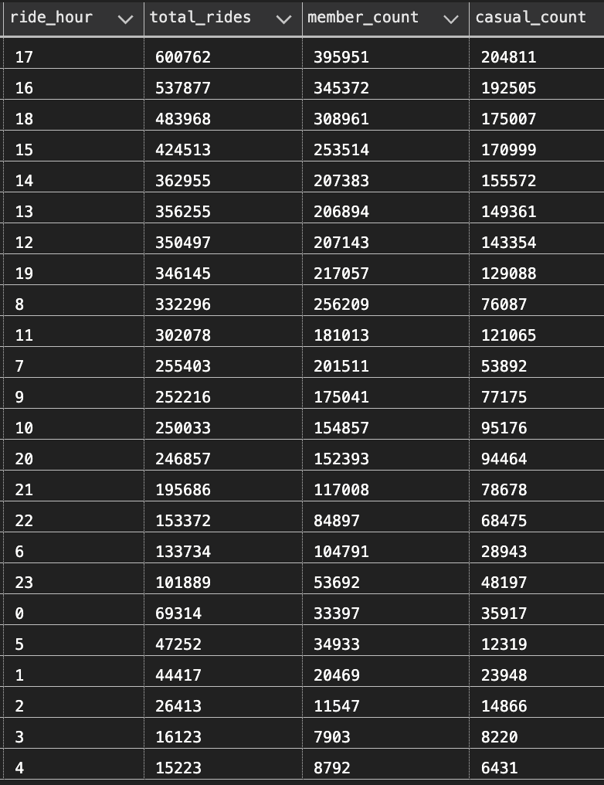

* About 9% of casual riders return the bikes to the same location where the ride started, while only 3% of member riders return the same.

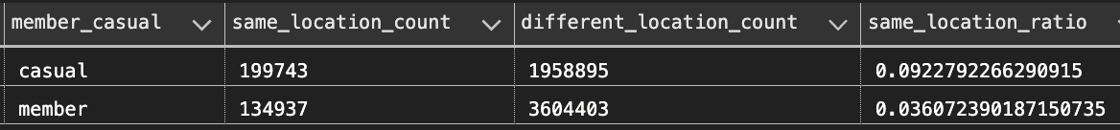

* Electric bikes are the most popular choice for both casual and member riders, followed by classic bikes, with electric scooters being the least popular. However, electric scooters are more popular among casual riders than member riders.

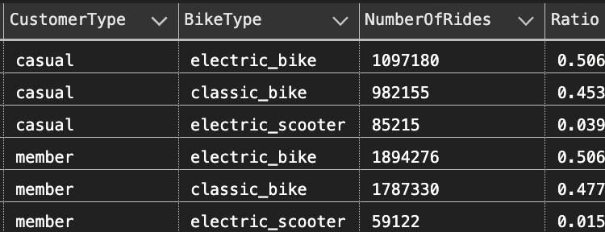

* The locations which are near **41.892278, -87.612043** **(Streeter Dr & Grand Ave)** and **41.880958, -87.616743** **(DuSable Lake Shore Dr & Monroe St)**, have a larger proportion of casual riders, while other areas like **41.90096039, -87.62377664** **(Michigan Ave & Oak St)** exhibit strong member engagement, suggesting opportunities to target casual riders for membership conversion in these areas.

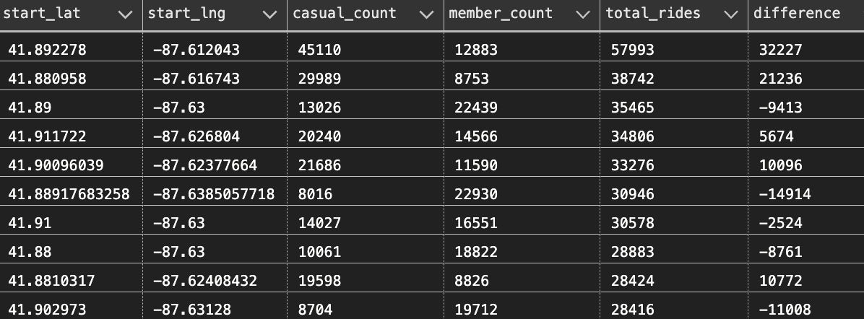

—> Based on the analysis, a noticeable difference in customer behavior between the two types of riders is observed in terms of ride location, day of the week, and average ride duration. The results also suggest that casual riders tend to use the service for leisure, while member riders tend to use it more for regular commuting or work-related purposes.

## Data visualization

This dashboard visualizes key differences in customer behavior between casual riders and annual members based on ride location, day of the week, and average ride duration. The analysis reveals that **c**asual riders primarily use the service for leisure, with higher activity on weekends and longer ride durations, while member riders tend to ride more frequently during weekdays, likely for commuting purposes. The insights also highlight the locations where casual riders dominate and where there may be opportunities to target them for membership conversion.

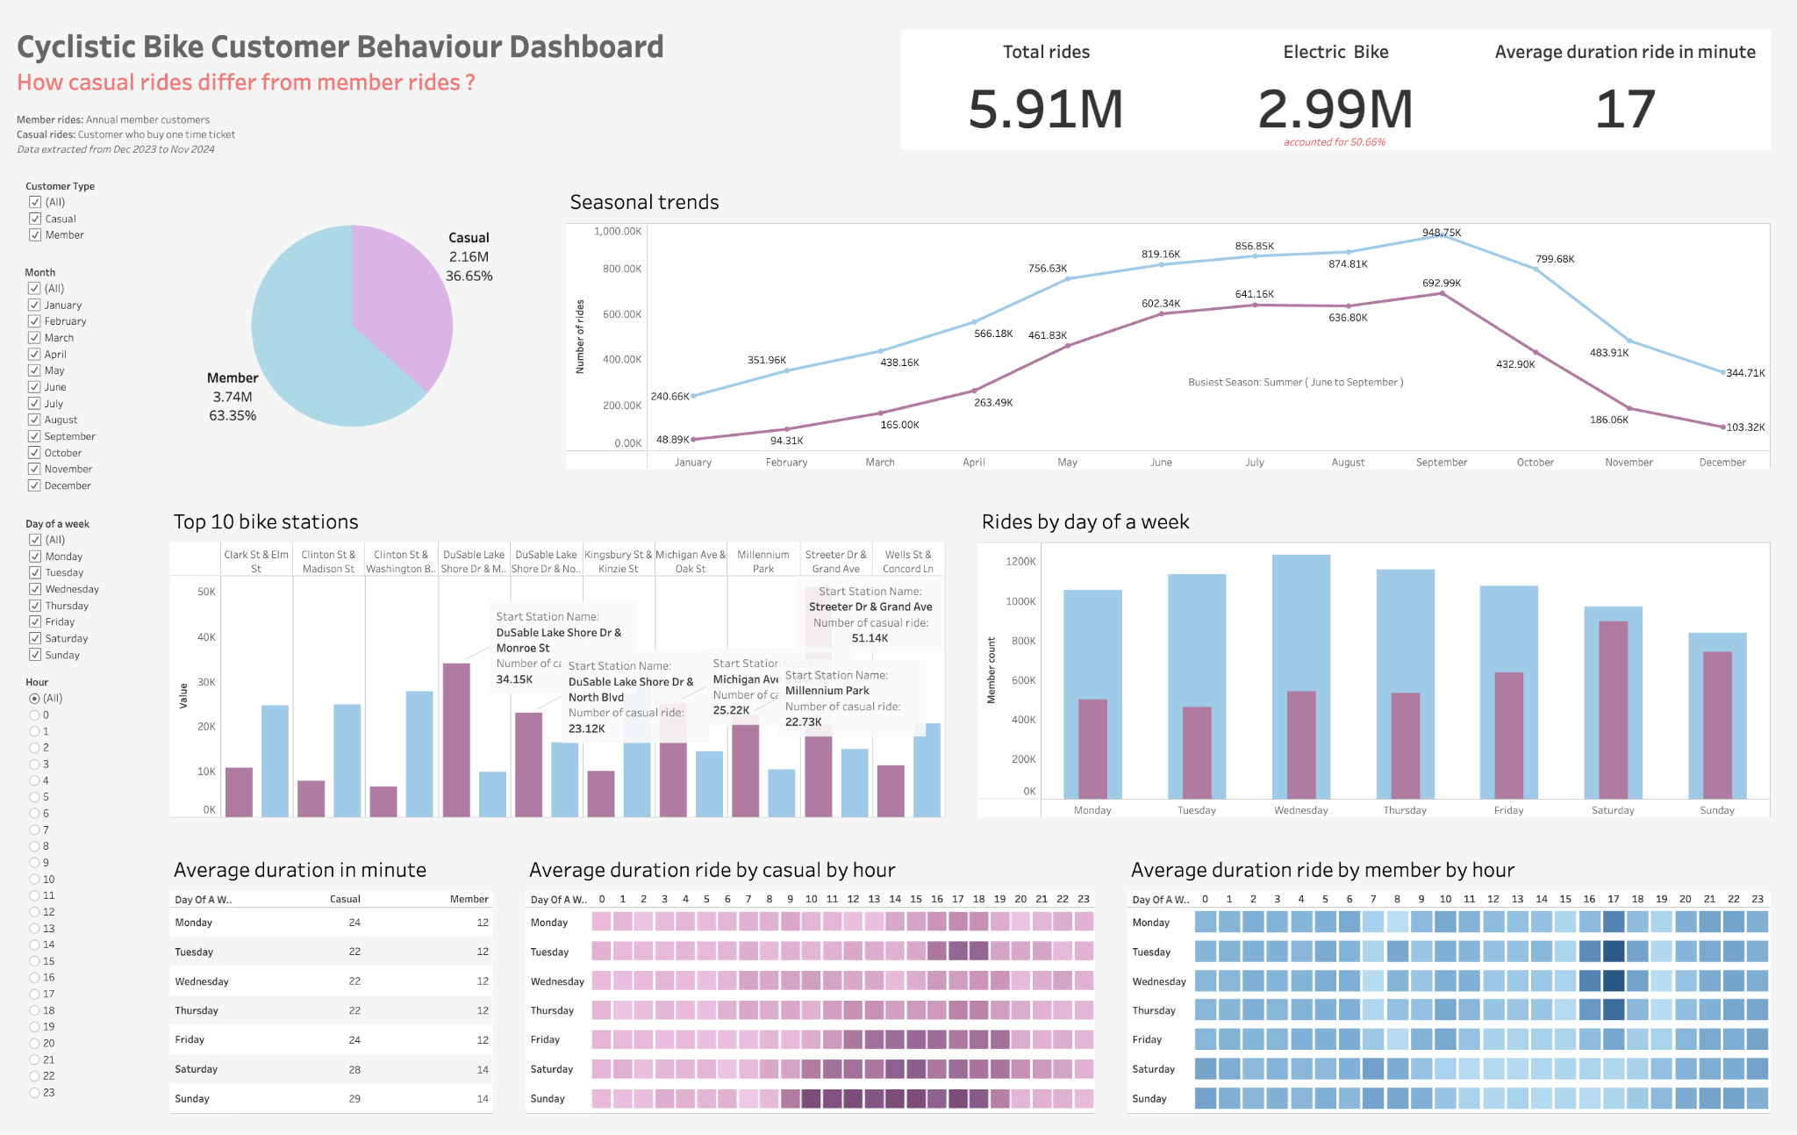

## Key insights and recommendations

### **2.5.1. Key Insights**

**Seasonal Demand (Summer Peak: June to September)**:

* Summer is the peak season for bike rides, so marketing efforts should be concentrated during this period to maximize conversions.
* Casual riders use bikes mainly for leisure on weekends, implying they enjoy the experience but may not be fully committed to long-term memberships.

**Top Locations Dominated by Casual Riders**:

* While casual riders dominate 50% of the top 10 ride service locations, they contribute only 36.65% of the total usage, suggesting there's potential to engage these users more effectively and increase their conversion rate.

**Longer Ride Duration for Casual Riders**:

* Casual riders tend to ride for twice as long as members, which shows that while they are engaging with the service, they may lack the perceived value or convenience of committing to an annual membership.

**Preference for Electric Bikes**:

* Both casual and member riders prefer electric bikes, which suggests that emphasizing electric bikes in marketing materials may appeal to both customer segments.

### **2.5.2. Recommendation for marketing strategies to convert casual members into annual members**

**Introduce Exclusive Benefits for Annual Members:**

* Discounts for Long-Term Riders: Offer a limited-time discount (e.g., 10-20%) for casual riders who convert to annual membership during the summer months. Highlight the value proposition of an annual membership compared to the cost of renting bikes casually for long durations.
* Free Trial Days: Offer casual riders a free day of unlimited rides on electric bikes if they sign up for an annual membership. This gives them a chance to experience the benefits and convenience of an annual membership.
* Member-Only Access: Introduce perks such as priority access to bikes, especially electric bikes, at the top ride locations. This will be attractive during the peak season when demand is high.

**Leverage Data to Target Specific Locations and Segments:**

* Localized Marketing: Since casual riders dominate top ride locations, run location-based advertisements or promotions targeting these areas. You can use geofencing or location-based campaigns to send personalized offers to casual riders who are at the top locations during peak times.
* Peak-Time Incentives: Offer discounts or special benefits for casual riders who ride during off-peak times (e.g., weekdays or non-peak hours). This can help convert casual riders who are primarily weekend users into more regular members.

**Emphasize the Electric Bike Experience:**

* Since both casual and member riders prefer electric bikes, highlight the benefits of electric bikes in your marketing campaigns. Emphasize that annual members have unlimited access to electric bikes, positioning it as a superior and more convenient option.
* Create targeted content (videos, social media posts, etc.) that showcase the experience of using electric bikes for longer rides, especially in scenic routes, to appeal to casual riders who enjoy longer ride durations.

**Create a Loyalty Program to Reward Regular Use:**

* Develop a loyalty program that rewards casual riders for frequent use. For example, after a certain number of rides or hours, offer them a discount on an annual membership or free credits. This can encourage casual riders to sign up for the annual membership as they start to see tangible benefits from regular use.
* Introduce membership milestones where casual riders earn rewards or discounts for consistently choosing your service over time. For example, after 5 or 10 casual rides, a rider can earn a discounted rate on membership.

**Seasonal Membership Offers:**

* Since the business ride season peaks during the summer months, consider launching seasonal membership packages with benefits tailored to casual riders who may only need bikes during specific periods.

For example:

Summer Membership: Offer a special summer-only membership at a discounted price, which could convert casual riders into annual members for the peak season.

Flexible Membership: Create flexible membership options (e.g., 3-month summer memberships) to bridge the gap between casual use and full-year membership.

**Enhanced Communication & Engagement:**

* Email Marketing & Alerts: Send targeted emails or push notifications to casual riders, especially those who frequent popular locations, highlighting the benefits of converting to an annual membership. Include testimonials or data-driven insights showing that annual members save money and ride more often.
* Social Proof & Testimonials: Use customer testimonials or success stories from current members who switched from casual to annual membership. This can help build trust and show the value of long-term membership.

**Simplify the Conversion Process:**

* Make the conversion from casual to annual membership easy and seamless. For example, provide a one-click sign-up option or offer in-app promotions that are visible when casual riders check their ride history or payment options.
* Offer a money-back guarantee or trial period where casual riders can try the annual membership risk-free for a short period, allowing them to experience the benefits without full commitment initially.

# Conclusion

The key to converting casual riders into annual members lies in emphasizing the **value** of membership, leveraging **personalized promotions**, and **creating a seamless transition** from occasional to regular use. By offering exclusive benefits for electric bike access, localized offers, and creating flexible membership options, Cyclistic can make annual membership more appealing to casual riders. Additionally, using data to understand customer preferences and tailoring your marketing to those insights will help increase the likelihood of conversion.