Aimee Simons

SMNAIM002

CSC2001F Assignment 4

**Testing the program with different values**

The Binary Search Tree was initialised with 18 Users. This provided a good basis for adding and deleting from the Tree.

Testing for Action 1: (Find the profile description for a given account)

Test for when username exists:

Input

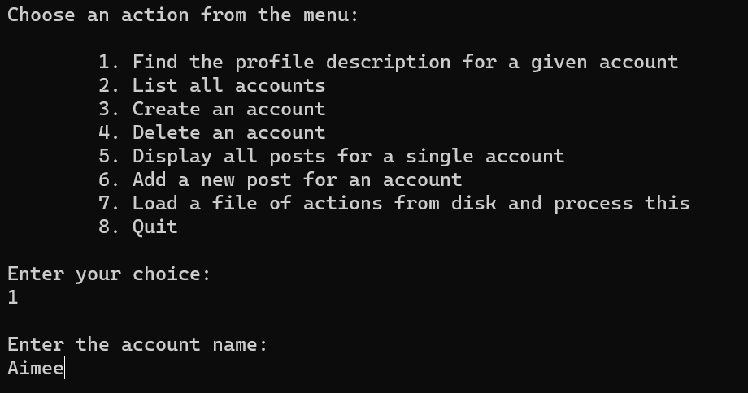

Output

Test for when username does not exist:

Input

Output

Testing for Action 3: (Create an account)

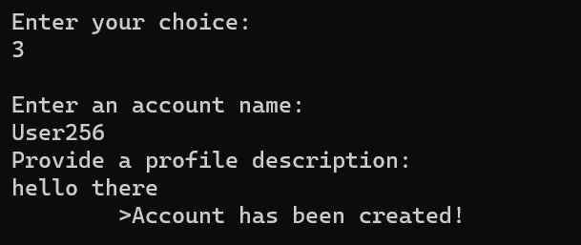

Listing accounts to confirm account has been created:

Testing for Action 4: (Delete an account)

Input when a username that exists has been provided.

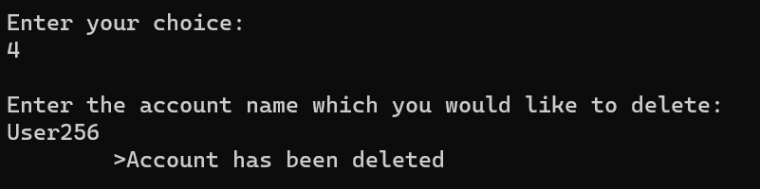

Listing the accounts:

Input when a username that exists has been provided.

