Q1 Github [1]

<https://github.com/aimeesimons/EEE3088F-Group-14.git>

Q2 Power Subsystem Failure Management [2]

* Various failure management processes can be implemented that could cater for various failure instances. In the event of component failure, the datasheets of the different components must be carefully read to ensure that the components operate at rated electrical characteristics. The component packages are chosen to be sizes readily available elsewhere, such as the UCT white lab, in the event that components need to be replaced.
* If trace damage occurs, the various test points can be connected with means of an external soldered wire, thus forming an alternate route for current flow. The test points themselves can be used to check for continuity in the traces, and identify exact traces with damage.
* Where possible, components were selected to be basic parts, which the supplier is more likely to have ready access to. In the cases where extended parts need to be used, the different parts available can be sorted by stock available, thus mitigating the chances component shortage. In the event that component shortage still occurs, most components can be chosen to be common package sizes, so that they can be sourced and soldered on locally.
* Designs will be simulated beforehand, to lower chances of error. Test points will be added for debugging purposes and 0Ω resistors will be used to break connection and bypass the different components if required.

Q3 Sensing Subsystem Failure Management [2]

* Components could become damaged due to various circumstances, whether it be current overload or damage in transit. With regards to damage due to current overload, zero-ohm resistors can be placed within the circuit and used as fuses to prevent damages that could be caused to these components. Components damaged in transit could be remedied by removing that damaged component and soldering on an alternative component. If it is the worst-case scenario and most of the components fail, a breadboard can be used to show the functionality of the HAT, in the meantime, before making adjustments to the circuit schematic and/or ordering a new PCB.
* In terms of trace damage; this could be damage to the point of causing an open circuit; short wires could be soldered to connect components previously disconnected by damaged traces. Test points will be located at several points in the circuit to test continuity, which should indicate whether there has been any trace damage.
* In terms of availability of parts, on the JLCPCB website, The TTP223 chip seems to be out of stock and/or discontinued. A similar chip which works in the same way and is available was found as an alternative. In terms of specialised components, such as the use of a variable capacitor, which has very limited stock, this will prove to be trickier. An alternative would have to be to purchase a normal capacitor.
* There could also be errors in the design that went undetected and was only discovered upon manufacture. If the error has to do with the connections, traces could be purposefully damaged or open circuits can be made in order to physically make the correct connections using wires. As mentioned above, ordering a normal capacitor instead of a variable capacitor could prove to have some consequences. Ordering a specific capacitor would require calculations before purchase, in order to adjust the sensitivity of the touch sensor. This could, however, result in either a very sensitive touch sensor (too sensitive - meaning you can just hover your finger over the touch-pad and it will be detected) or not sensitive enough (meaning it will be very difficult for the chip to detect any touch at all). This capacitor connection should therefore not be too close to other components, as it would have to be easily removable and replaceable.

Q4 Microcontroller interfacing Failure Management [2]

To manage failures in our circuit design we can take.

(i) Component failure/destruction:

We will use high-quality but affordable components from a reputable manufacturer.

(ii) Trace damage:

Make sure the traces are not too thin and can handle the expected current.

Add protective components like TVS diodes to prevent damage to the traces.

Place vias to allow for the routing of the trace on the other side of the board.

(iii) Component shortage:

Choose components that are readily available.

Select alternative components with similar specifications that have huge stock and use them in the design.

Work with the PCB assembly house to find replacement components if the original component is no longer in stock.

(iv) Errors in circuit design:

Use simulation software to verify the circuit design before manufacturing.

Add test points for each circuit block to allow for easy debugging and testing.

Use a modular design approach to reduce the impact of design errors on the entire circuit.

By incorporating these measures, you can manage failures in your circuit design, ensuring a reliable and functional PCB.

Q5 Power Subsystem Schematic [2]

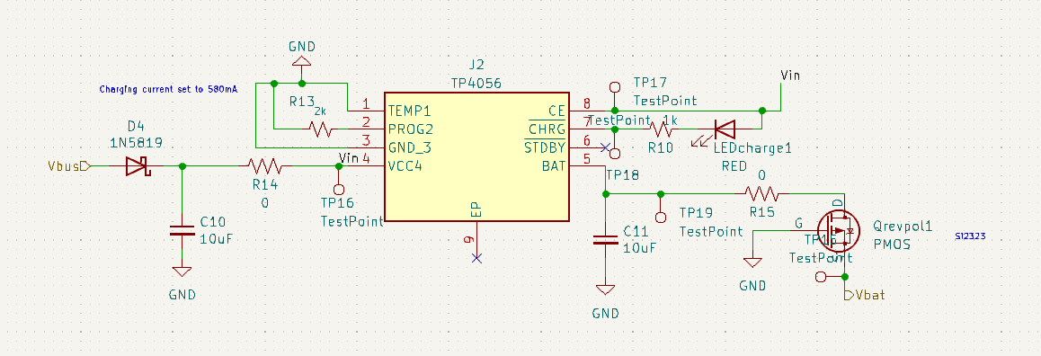

Charging Module

Regulating Module

Q6 Sensing Subsystem Schematics [2]

Analogue Sensor

Digital Sensor

Q7 Microcontroller Interfacing Schematic [2]

Microcontroller module

Q8 Updated ERCs [2]

* All hierarchal labels should be connected and should be connected properly.
* All net labels should be identical, example T_Sensor and T-sensor will cause confusion.
* All pins that are to be unconnected should have an indicator that they are unused.
* All components should be named uniquely, with no duplicates.
* Check that current is limited for important chips/components.

Q9 DRCs [2]

Q10 Updated BOM [5]

<https://github.com/aimeesimons/EEE3088F-Group-14/blob/main/FullSchematic/FullSchematic/FullSchematic_Spreadsheet.xlsx>

Q11 PCB [15]