**NetworkCrossStackCloudformation**

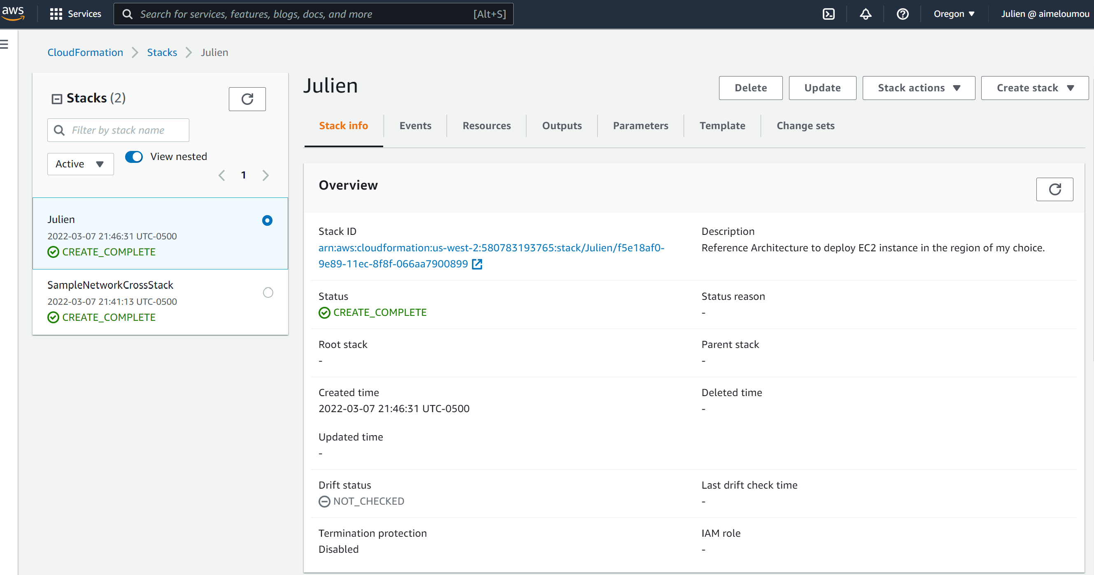

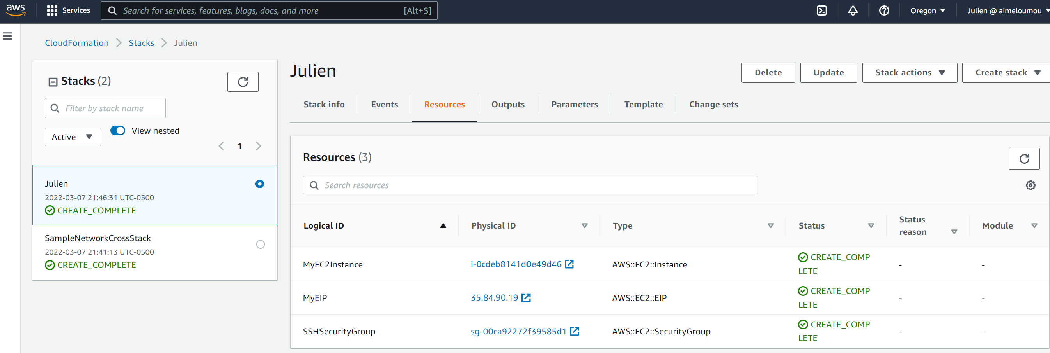

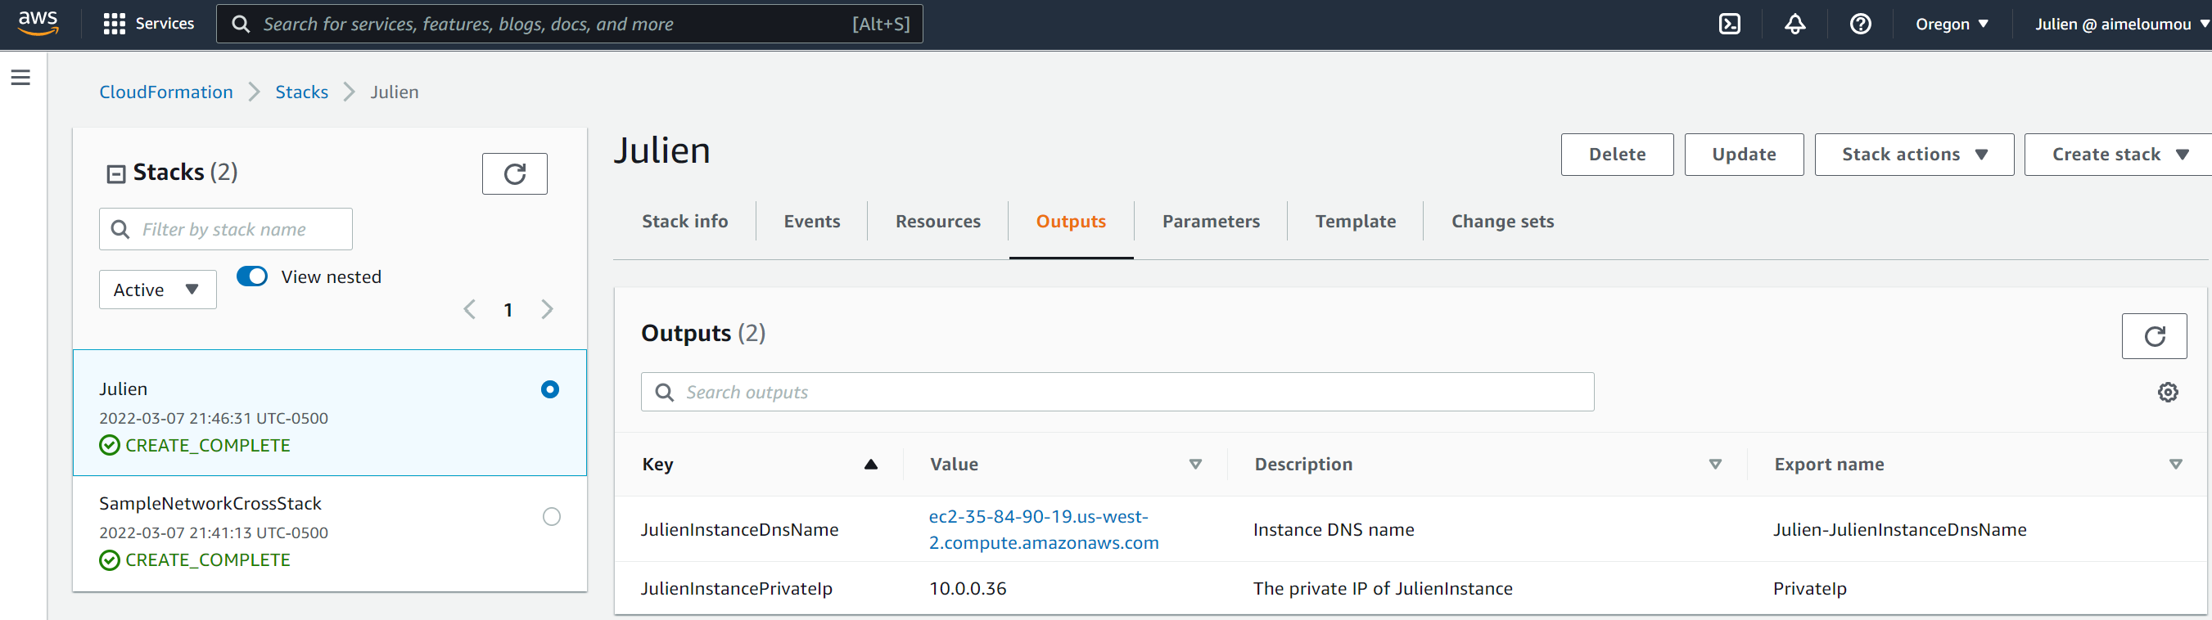

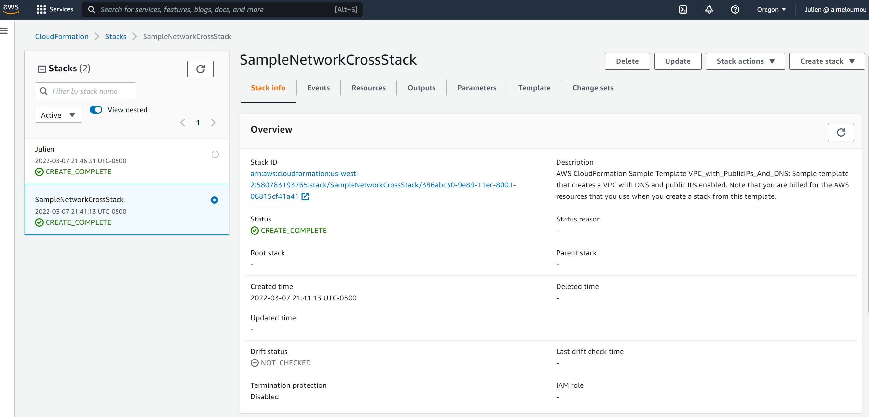

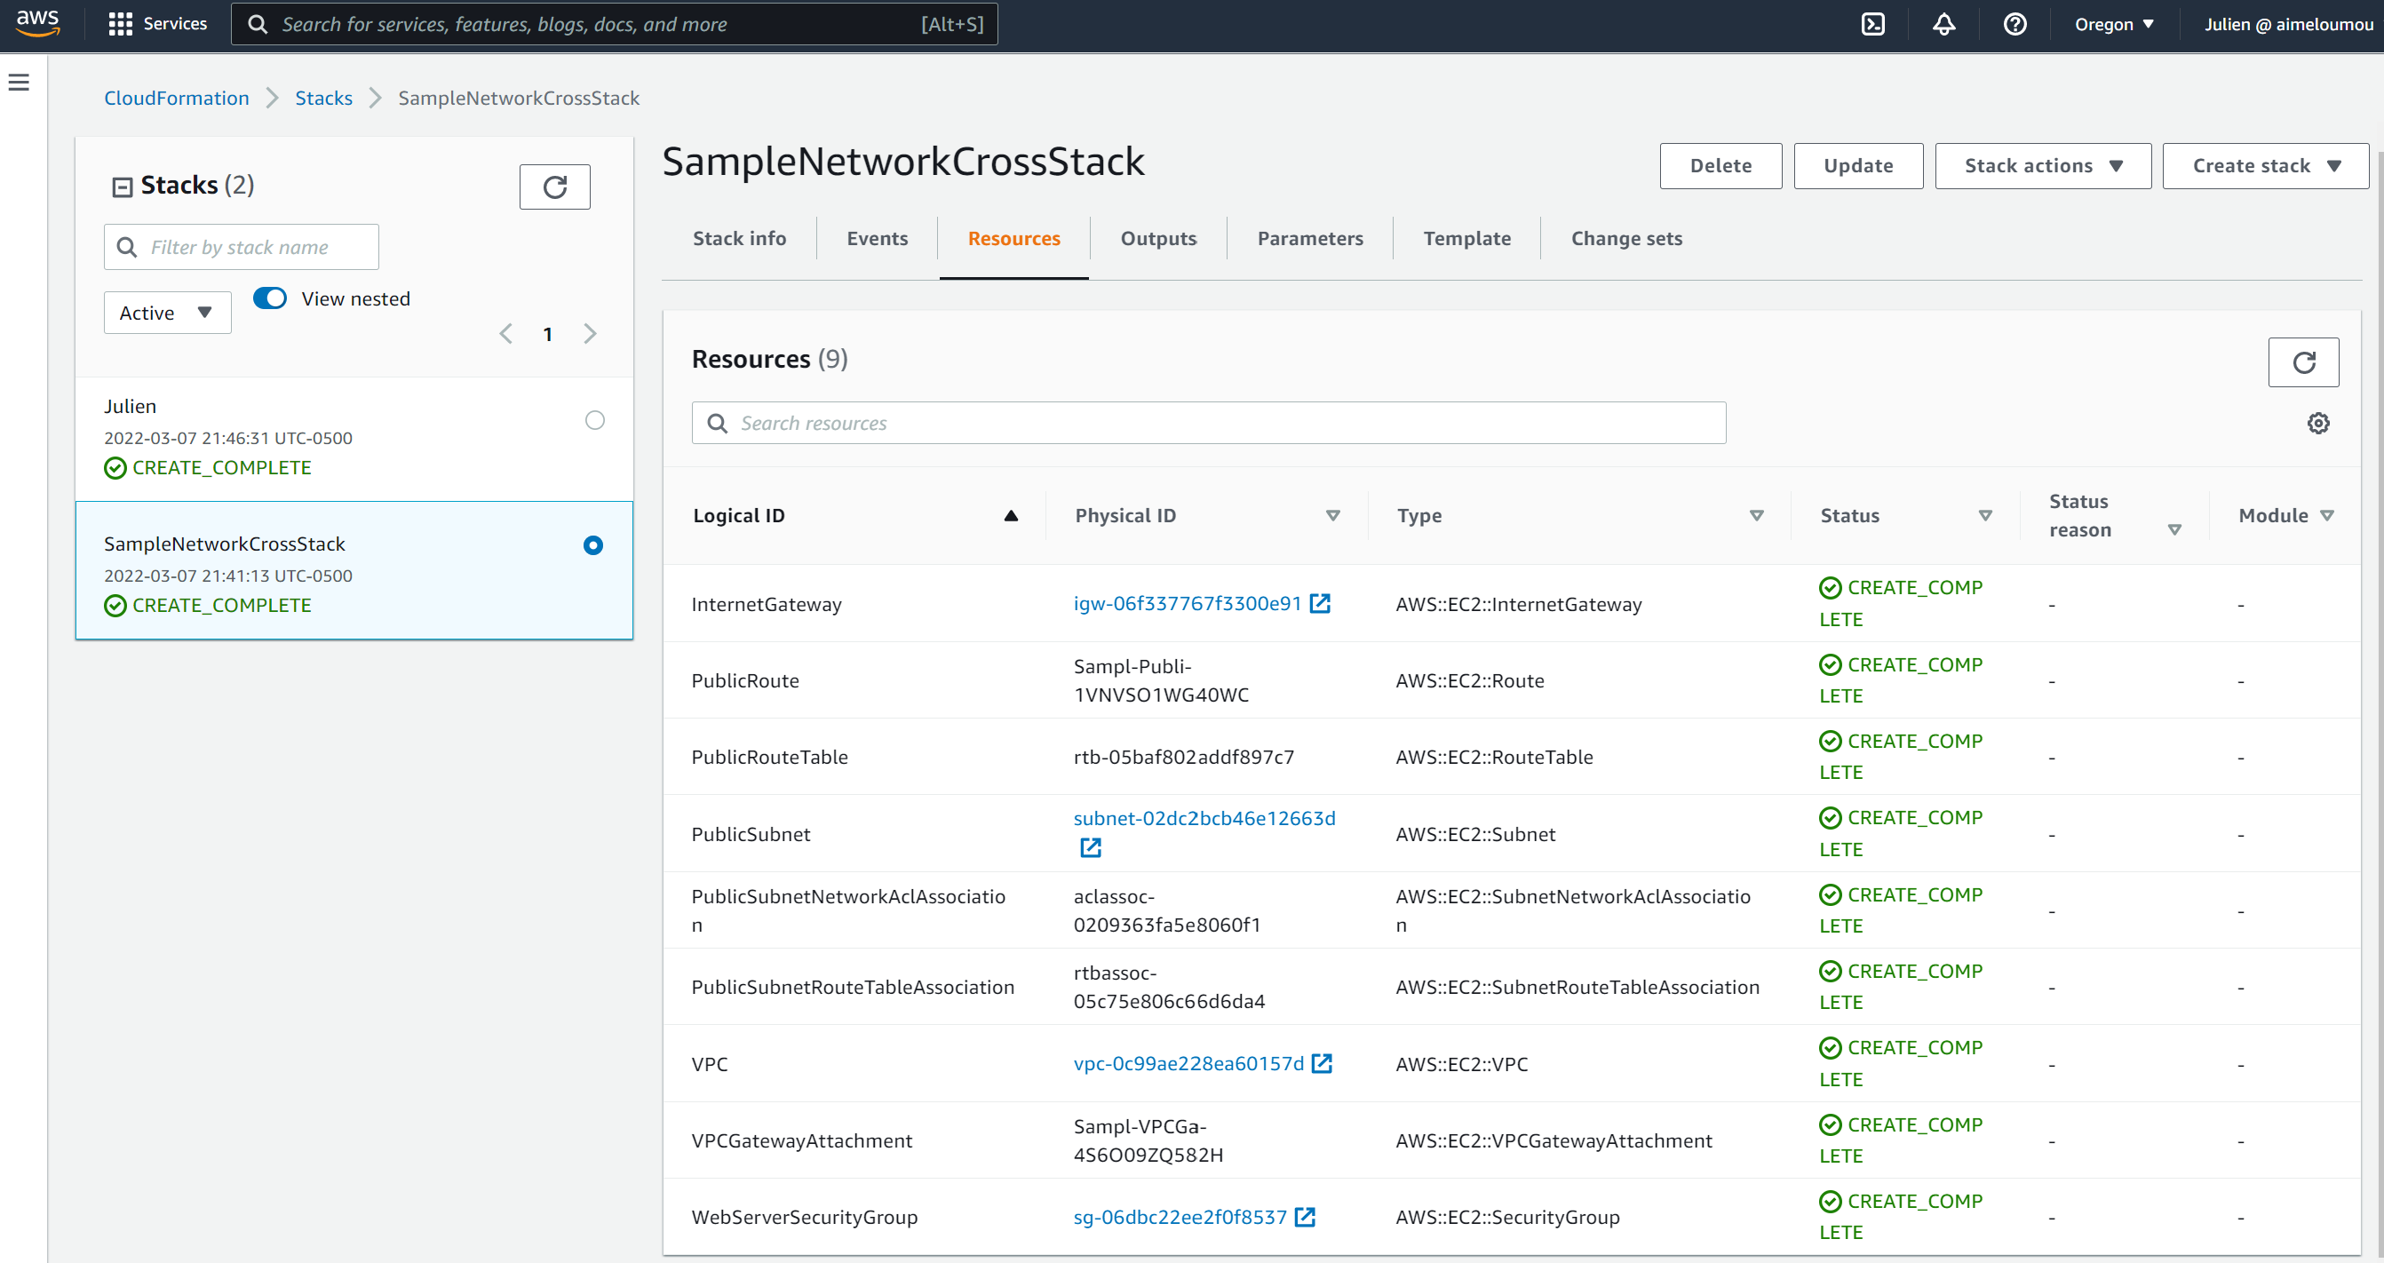

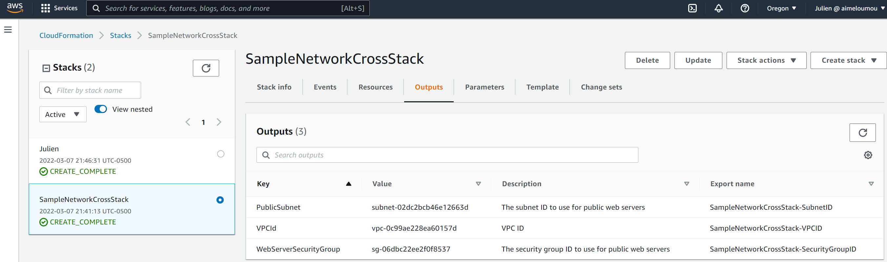

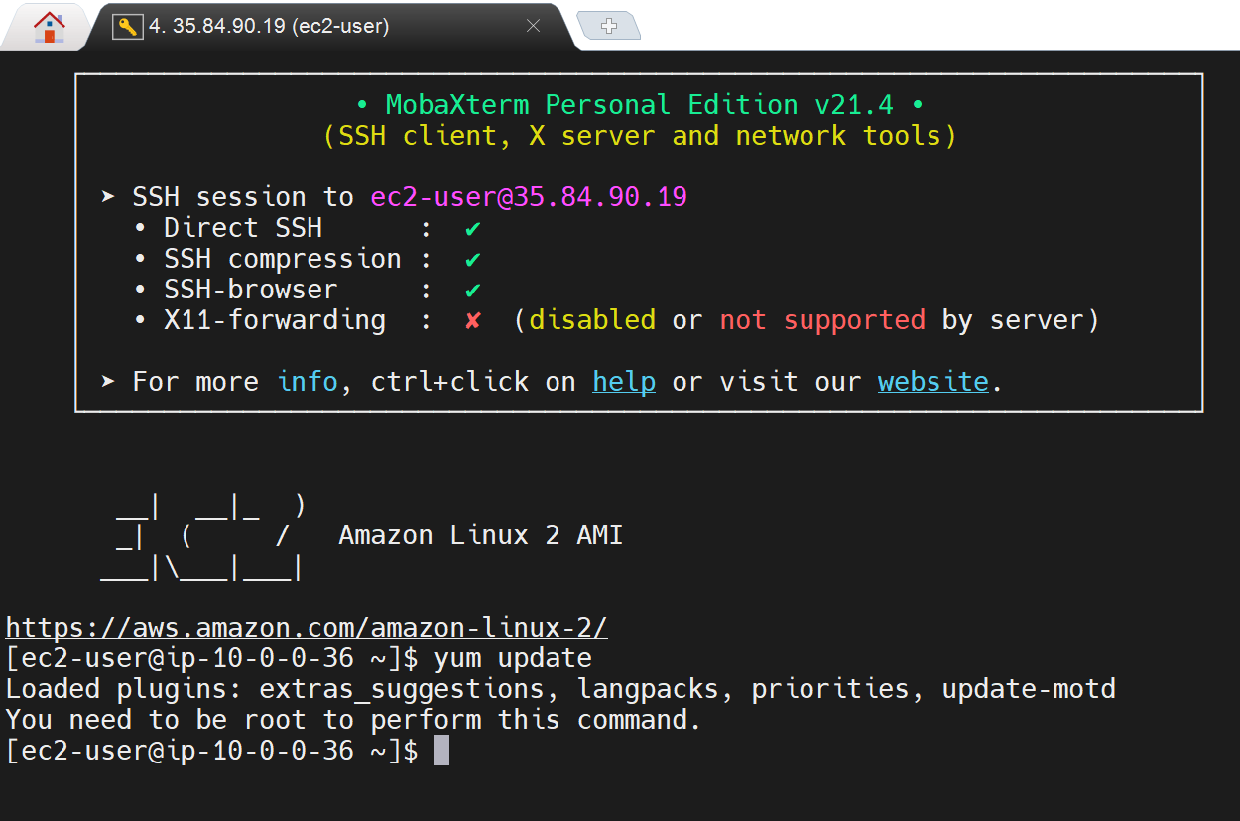

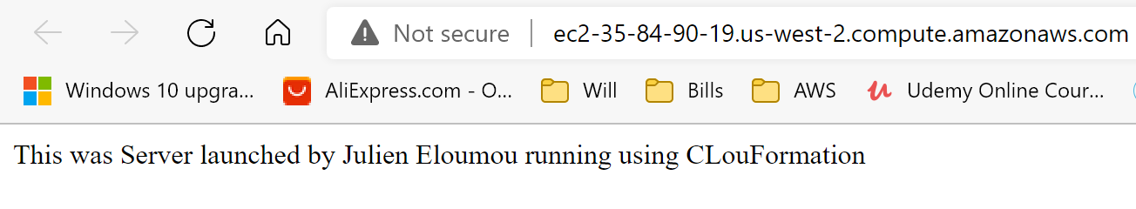

**\*\*\* FINAL CLOUDFORMATION HOMEWORK \*\*\***

Please go to this GITHUB link and retrieve the homework base template <https://github.com/sidiclaudio/cloudformation-network-template> and follow all the instructions.

SUBMISSION:  
Submit the homework on your personal Github account and share the link with us.  
Please create a repository called **cloudformation-cross-stack-reference**where you will upload your final template including the template provided in the github above

**Step1** - Deploy a sample network configuration stack with the network template provided. For stackname use: SampleNetworkCrossStack

**Step2** – Deploy a new stack that will setup a Linux EC2 instance (Web server) and reference the sample network stack previously created. Deploy template in us-west-2 region.

* Reference all available variables from SampleNetworkCrossStack.
* Create a Mapping function to dynamically choosing regions.
* Allocate an Elastic IP address using resources.
* Create parameters for requesting user inputs as much as possible.
* Output the values of the private IPv4 address and DNS name of the EC2 instance.
* Log in into the ec2 server afterward and provide screenshots.
* Install and configure apache on the EC2 using User data to display your name a webpage.