National University of Computer & Emerging Sciences
Karachi Campus

Department of CS



Final Year Project Proposal - Research
Session Fall 2026

“X-Retina: An Explainable Deep Learning Framework for Diabetic Retinopathy Grading and Lesion Localization”

15th September 2026

Group Members:

Aiman Nadeem Khan (23K-0876)
Amna Rais (23K-0824)
Maheen Sodha (23K-0822)

Project Registration
Project ID (for office use)
Type of project |  |  | [ ] Traditional [ ] Industrial [ ] Continuing
Nature of project |  |  | [ ] Development [ ] Research & Development [ ] Research
Sustainable Development Goals(SDGs) |  |  | [ ] Good Health and Well-Being [ ] Quality Education  [ ] Industry, Innovation, and Infrastructure [ ] Gender Equality  [ ] Decent Work and Economic Growth [ ] Climate Action
Area of specialization |  |  | [ ] Artificial Intelligence (AI) [ ] Data Science and Analytics  [ ] Internet of Things (IoT) [ ] Blockchain  [ ] Mobile App Development [ ] Web Development [ ] Cybersecurity  [ ] Game Development [ ] Natural Language Processing (NLP)  [ ] Other(Computer Vision)
Project Group Members
Sr.# | Reg. # | Student Name |  | CGPA | Email ID | Phone # | Signature
(i) | 23K-0876 | Aiman Nadeem khan |  | 3.14 | k230876@nu.edu.pk | 0335-2718252
(ii) | 23K-0824 | Amna Rais |  | 2.83 | k230824@nu.edu.pk | 0332-1276862
(iii) | 23k-0822 | Maheen Sodha |  | 2.92 | k230822@nu.edu.pk | 0323-8996745
Declaration: FYP group members have cleared all prerequisite courses For FYP-I as per their degree requirements.

1. Project Abstract
Diabetic Retinopathy (DR) is one of the main causes of preventable blindness, thus detecting it in the early stage is critical for sight conservation. Even though deep learning based methods are reported to achieve promising results in diabetic retinopathy diagnosis, applying such methods in a medical practice is still challenging as medical professionals need to be able to understand and validate an AI result. Most of the prior works focus on the visual inspection of the heatmaps with limited analysis on agreement between predicted results and actual lesions present in the retinal fundus photographs. Moreover, there is a common class imbalance problem for DR severity stages, which is particularly challenging for the underrepresented classes. Lastly, many articles report only one score representing the overall performance, thus, obscuring the differences between classes. To address these gaps, this project introduces the X-Retina model that combines EfficientNet-B4 and Transformer architecture with SE and CBAM attention modules. Focal Loss and SMOTE upsampling will be investigated for handling the class imbalance, and Grad-CAM, Grad-CAM++, Score-CAM and Saliency methods will be applied for the model explanation and interpretation. The explanations will be validated with respect to the expert annotations using Dice scores and be analyzed for each DR stage. This project aims to evaluate the classification performance and the quality of model explanations for different DR stages.

2. Introduction
Diabetic Retinopathy is a complication of long term diabetes in which high blood sugar gradually damages the small blood vessels of the retina, eventually leading to blindness. What makes it particularly dangerous is that it develops silently, with no pain and no noticeable symptoms in its early stages, so by the time a patient notices blurred vision, meaningful and sometimes irreversible damage has already occurred. Early detection is therefore the single most effective way to prevent vision loss from this disease, since up to 95% of DR related blindness can be avoided if the condition is caught at Stage 1 or Stage 2 and treated with a simple, low cost laser procedure. This problem is especially serious in Pakistan, where a 2026 meta-analysis of over 45,000 diabetic patients found that DR prevalence nearly doubled over two decades, rising from 21.3% to 39.6%, at the same time as the number of ophthalmologists available relative to the diabetic population remains far too low [1]. Deep learning has already shown that it can perform the technical side of this problem well, with Gulshan et al. [2]demonstrating expert level DR detection accuracy as early as 2016. However, accuracy on its own has not been enough to bring these systems into actual clinical use. When a similar model was deployed as part of Thailand's national screening programme, Ruamviboonsuk et al. [3]found that although the system matched the performance of retina specialists, clinicians hesitated to rely on results they could not personally verify, and a comparable pattern was observed locally as well, where a real time deployment at the Sindh Institute of Ophthalmology and Visual Sciences achieved strong accuracy without giving clinicians any way to interpret individual predictions [4].This research is situated at the critical intersection of medical image analysis and explainable artificial intelligence (XAI) for diabetic retinopathy grading, a domain where a model's clinical adoption is governed as much by its interpretability and human trust as by its raw diagnostic accuracy for doctors to actually use it .

3. Problem Statement
Deep learning models for DR grading have already reached strong classification accuracy on public datasets, so the core problem this project addresses is not whether automated DR detection works, since it clearly does, but whether the explanations these models generate for their predictions can actually be trusted, and whether that trust holds up consistently across different stages of the disease and on data the model has never seen before. The review of existing literature reveals few gaps that remain unresolved.
- Most studies that use explainable AI methods such as Grad-CAM only show heatmap images for visual inspection. They never check whether the highlighted regions actually match expert marked lesions. Osman's review [5]found that 78.8% of 52 studies skip this check entirely.

- Some studies that do validate their heatmaps quantitatively like Mahipal and Kumar [6], report only a single overall score per model. This results in not knowing whether explanation quality stays consistent across all five DR stages.

- Studies that address DR's class imbalance problem such as Ahmed [7]and Atitallah et al. [8], only measure their improvement using classification recall. No checks were made whether fixing the imbalance also improves the quality of the model's explanations for underrepresented sections.

- Studies about how well a model generalizes to new data such as Patni and Yagnik [9], only test whether classification accuracy transfers to a new dataset. They do not test whether the model's explanations remain meaningful on data it was not trained or validated on.

4. Related Work
Automated DR detection has a fairly established research history at this point. Gulshan et al. [2]were among the first to show that a deep convolutional network could detect referable DR with expert level accuracy. This was later tested in real clinical settings, where Ruamviboonsuk et al. [3]deployed a similar system across Thailand's national screening programme and found that diagnostic accuracy matched retina specialists. A similar real time deployment at the Sindh Institute of Ophthalmology and Visual. Sciences in Pakistan achieved strong accuracy as well, but again offered no way for clinicians to interpret individual predictions [4]. Van Craenendonck et al. [10]moved past simple visual inspection of heatmaps and introduced a quantitative way to compare different heatmapping methods against IDRiD's lesion annotations. The findings were that VGG16 combined with Grad-CAM produced the strongest agreement out of all the methods they tested. Osman's systematic review of 52 studies [5]confirms that this kind of rigorous, quantitative validation is still the exception in this field rather than the norm.
More recent work has focused on individual pieces of this overall problem. Burkul and Waghere [11]benchmarked EfficientNet variants B0 through B5 for DR detection and found that B4 gave the strongest test accuracy. They built a dashboard showing Grad-CAM heatmaps alongside predictions. Their evaluation used only a single short training run with no class imbalance handling and no comparison of their heatmaps against expert marked lesions. Patni and Yagnik [9] used a Vision Transformer architecture instead of a CNN and reported very high accuracy on both APTOS and EyePACS. but they did not check whether this claim held up against expert lesion annotations. Yi et al. [12]used a similar approach by adding an attention feature to an EfficientNet model to help it tell apart similar looking lesions. They argued that attention features really help the model extract details, but they only tested its accuracy and completely ignored the model's explanation ability.
Class imbalance is one of the most consistently reported problems in this literature because the number of images available for the mild and moderate DR stages is far lower than for the healthy and proliferative stages.Most models tend to perform poorly on whichever class is underrepresented in training. Ahmed [7]addressed this directly using large scale synthetic oversampling across EfficientNet and ResNet variants and reported a solid improvement in five class accuracy. No explainability evaluation was included. Atitallah et al. [8] tested different features separately, including fine tuning, SMOTE, and Focal Loss. They found that combining SMOTE and Focal Loss gave the best results. This combination significantly improved the model's ability to catch Proliferative DR, which is usually one of the hardest stages to detect. However, no XAI components were included so it remains unknown whether correcting the imbalance in training data also improves the quality of the resulting explanations .
- Comparison of studies
Study | Technique Used | Reported Improvement | Explainability Evaluated
Ahmed [7] | Synthetic oversampling | Improved five class accuracy on APTOS 2019 | No
Atitallah et al. [8] | SMOTE + Focal Loss (ablation) | QWK improved from 0.841 (baseline) to 0.919 (combined); Proliferative DR recall up 13 points | No
Burkul and Waghere [11] | None applied | N/A | Grad-CAM shown, not validated
Our research (X-Retina) | Focal Loss and SMOTE (compared) | To be measured on both recall and stage wise explanation quality | Yes, per stage

5. Project Rationale
This study is motivated by the need for efficient and interpretable automated Diabetic Retinopathy (DR) grading. While prior work demonstrates promising classification results, previous studies evaluate the quality of explanations mostly qualitatively or use only one aggregated metric. Additionally, the literature lacks comparison and analysis of explanation quality for different stages of DR, class-imbalanced analysis, and objective evaluation across different datasets. X-Retina addresses these limitations by developing a hybrid EfficientNet-B4–Transformer architecture with SE and CBAM modules, will investigate and compare established class-imbalance techniques (Focal Loss and SMOTE), and performing a thorough quantitative analysis of different XAI methods with expert annotations for each DR stage.

5.1. Aims and Objectives
- Build EfficientNet-B4–Transformer hybrid five-stage diabetic retinopathy (DR) grading model with SE and CBAM, and evaluate the classification accuracy against the chosen classification baseline EfficientNet-B4 model [11].
- Compare different class imbalance handling approaches (Focal Loss and SMOTE) in terms of the quality of obtained classification and explanation.
- Implement Grad-CAM, Grad-CAM ++, Score-CAM, and Saliency Maps interpretation techniques, evaluate the quality of obtained explanations in terms of Dice-score agreement with the expert IDRiD [13]lesion masks across different stages of DR.
- Assess the classification accuracy and explanation quality on unseen test data, and perform ablation studies to evaluate the contribution of the Transformer component, as well as the SE and CBAM modules.

5.2. Scope of the Project
The X-Retina project relies mainly on four public datasets which are as follows: APTOS 2019 [14], EyePACS [15], IDRiD [13], and Messidor-2 [16]. APTOS 2019 and EyePACS serve for training, IDRiD for quantitative XAI evaluation versus expert lesion annotations, and Messidor-2 for cross-dataset generalization testing.
Fyp-I:
- Review of literature, validation of the research gap, and acquisition of the dataset with preprocessing.
- Application of CLAHE preprocessing as well as approaches to address class-imbalance, notably Focal Loss and SMOTE.
- Initial building and baseline training of the proposed EfficientNet-B4–Transformer model with the application of SE and CBAM modules.
Fyp-II:
- Refinement of the model and completion of the ablation study.
- Application of the four XAI methods and quantitative assessment thereof using stage-wise Dice scores relative to IDRiD lesion annotations.
- Comparison to the selected baseline [11] studies as well as cross-dataset testing on the Messidor-2 [16]benchmark.
- Development of FastAPI + React.js dashboard to visualize predictions, XAI heatmaps, and stage-wise reliability scores.
Functional cost: Public datasets: APTOS 2019, EyePACS, IDRiD, Messidor-2. Wherever possible, the project will rely on pretrained open source models and free tier GPUs on Google Colab and Kaggle. No hardware, clinical licensing, or paid dataset access will be used. Colab Pro is a low-cost alternative if free tier computation proves to be inadequate.
The project will not involve collecting new patient data, deploying or implementing anything in a clinical environment, or seeking regulatory approvals. The final product will be a research prototype, not a CE/ FDA-certified medical device.

6. Proposed Methodology and Architecture
The project uses systematic deep learning, which involves the integration of the development of its architecture and quantitative assessment of its explainability rather than only classification accuracy. The pipeline consists of 9 stages, namely, Data Collection, Data Preprocessing, Feature Extraction, Model Development, Training, Validation, Testing, Evaluation, and Interpretation. The same nine-stage pipeline remains unchanged, with each stage briefly described below and depicted in figure 1.

6.1. Data Collection
The project uses and relies upon four publicly available datasets, which all serve different purposes:
- APTOS 2019 [14] and EyePACS [15] is utilized to train the model
- IDRiD [13]is employed to provide expert lesion annotations to validate XAI.
- Messidor-2 [16]is an external test set to evaluate the model’s cross dataset generalization.

6.2. Data Preprocessing
The pictures are resized and cleaned. The CLAHE algorithm is used to improve the image quality, similarly to the baseline study [11]. The imbalanced distribution of images (some of which contain too few images of a particular stage of the disease) gets addressed by using Focal Loss and SMOTE, which are proved effective in other studies [7], [8].

6.3. Feature Extraction
The hybrid backbone employs two separate strategies to extract features from the input data: first, an EfficientNet-B4 convolutional network is used to acquire local and fine-grained lesion features (e.g., microaneurysms, small hemorrhages, exudates), while a Transformer module with self-attention, as proposed by Patni and Yagnik [9], learns long-range spatial relations within the retina that are beyond the reach of convolutions. Finally, two attention mechanisms refine these features by recalibrating the importance of each channel according to the information learned by the model: the Squeeze-and-Excitation (SE) blocks and the Convolutional Block Attention Module (CBAM), which focus on the most diagnostic regions of the image, thus transforming the single-mechanism approach of Yi et al. [12]into a combined channel and spatial attention framework.

6.4. Model Development
The model predicts a probability distribution over five DR severity classes, namely, No DR, Mild, Moderate, Severe, and Proliferative. We use EfficientNet-B4 as a convolutional backbone, as it was found to perform best by Burkul and Waghere [11]on the EfficientNet-B0 to B5 variants. This modular design lets components be disabled systematically for ablation studies.

6.5. Training
The model is trained on APTOS 2019 and EyePACS under standard protocols, comparing Focal Loss with SMOTE configurations separately. It also applies learning-rate scheduling, early stopping, and validation-based checkpoint selection for stable training and fair comparison with the baselines [7], [8], [11]

6.6. Validation
Hyperparameter tuning and model selection during training rely on a held-out validation split from the training data. This ensures that the final test and generalization results (Section 6.7-6.8) are free from any form of biases caused from model-selection decisions

6.7. Testing (Ablation Study)
An ablation study examines the contribution of each component of the proposed architecture, namely, the Transformer module, SE attention, and CBAM attention, as well as each of the proposed methods for addressing the class imbalance problem (Focal Loss and SMOTE). In this study, the algorithms under investigation have some components removed, which allows for determining which of the removed components contributed to the improvement in performance found in the experiments of Section 3.1. This way, the ablation study directly addresses the architectural gap discussed in Section 3.1, testing whether the hybrid design truly benefits from the combination of the Transformer encoder and the attention mechanisms.

6.8. Evaluation
The classification performance is measured in terms of Accuracy and Quadratic Weighted Kappa (QWK) and compared with the baseline and related works [7], [8] , [11] , [12]. The explainability is evaluated using Grad-CAM, Grad-CAM++, Score-CAM, and Saliency Maps. The heatmaps are generated for the retinal fundus images. The quality of explanation is measured using Dice-coefficient overlap with respect to IDRiD [13]expert annotated lesions. Unlike [6], we report Dice-coefficient overlap for all levels of DR severity instead of a pooled metric.

6.9. Interpretation
The results are analyzed to determine how much the hybrid CNN-Transformer-attention architecture improves classification accuracy, the quality of explanation, or both, compared to the pure-CNN and pure-Transformer baselines, evaluate the differences in explanation reliability across DR stages, analyze the impact of addressing class imbalance (Focal Loss or SMOTE), and investigate the model's performance on the unseen Messidor-2 dataset [16].
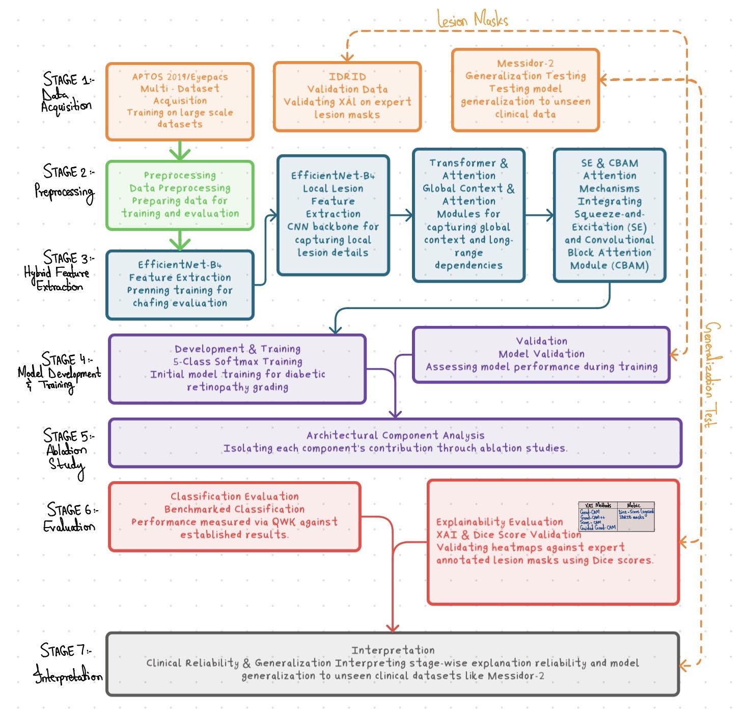
Figure. 1. Pipeline Flow.

7.Individual Tasks
Table 1 below shows that our FYP equally divides the work among three people, showing balanced individual effort across the one-year project.

- Individual Task Distribution Across the Project Team
Team Member | Activity | Tentative Date
Aiman Nadeem | Finishing the literature review and determining the research gap | Week 1-2  (21Sep-4Oct 2026)
Aiman Nadeem | Use of class-imbalance methods (Focal Loss and SMOTE) | Week 2-7  (28Sep-8Nov 2026)
 | Designing the hybrid CNN-transformer architecture (EfficientNet-B4 + Transformer) | Week 7-13  (2Nov-20Dec 2026)
 | Incorporation of SE and CBAM attention modules | Week 13-18  (14Dec-24Jan 2027)
 | Conduct an ablation study of each component | Week 18-25  (18Jan-14Mar 2027)
 | Writing the methodology section of the FYP-II report | Week 25-35  (8Mar-23May 2027)
Amna Rais | Downloading the datasets (APTOS and EyePACS) and performing their preprocessing | Week 1-3  (21Sep-11Oct 2026)
Amna Rais | Applying the CLAHE-based preprocessing pipeline | Week 3-5  (5Oct-25Oct 2026)
Amna Rais | Training the baseline model and validating it | Week 5-18  (19Oct-24Jan 2027)
Amna Rais | Preparing IDRiD expert masks for the XAI validation step | Week 18-22  (18Jan-21Feb 2027)
Amna Rais | Assessing the performance of each XAI method | Week 22-30  (15Feb-18Apr 2027)
Amna Rais | FYP-I and FYP-II report consolidation & IEEE reference formatting | Week 30-36  (12Apr-30May 2027)
Maheen Sodha | Establishing the comparison benchmark for the baseline model [11] | Week 1-15  (21Sep-3Jan 2027)
Maheen Sodha | Implementing XAI methods (Grad-CAM, Score-CAM, etc.) | Week 15-22  (28Dec-21Feb 2027)
Maheen Sodha | Comparing the baseline model and performing generalization validation on Messidor-2 [16] | Week 22-32  (15Feb-2May 2027)
Maheen Sodha | Designing a dashboard using FastAPI and React | Week 32-35  (26Apr-23May 2027)
Maheen Sodha | Finalizing the documentation and performing tests | Week 35-36  (17May-30May 2027)

Gantt Chart
Figure 2 illustrates the complete one-year timeline of the Final Year Project (FYP), showing the planned activities and their duration across each month and week

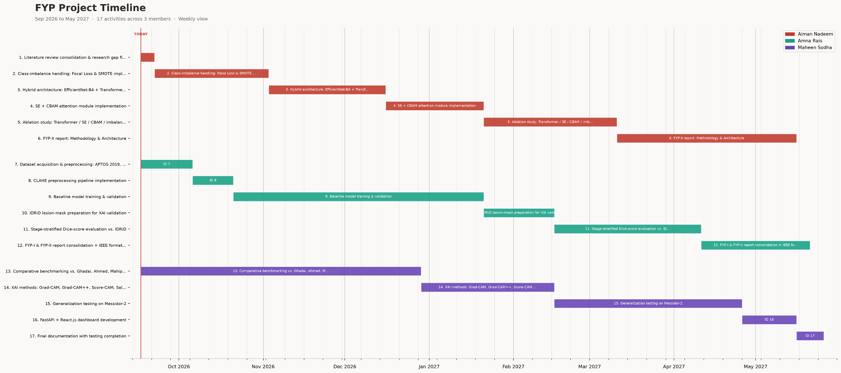 Figure. 2. Gantt Chart.

8.Conclusion
This project proposes X-Retina, a hybrid framework that combines EfficientNet-B4 and Transformers to classify and explain the five stages of Diabetic Retinopathy. To address the issue of class imbalance among DR stages, the project will utilize the SE and CBAM attention modules, Focal Loss, and SMOTE. To identify areas on the retina that influence the model's predictions, this project will employ various XAI methods such as Grad-CAM, Grad-CAM++, Score-CAM, and Saliency Maps. By using the expert lesion annotations from IDRiD and Dice scores, the explanations from the aforementioned XAI methods will be evaluated at every stage to determine what level of DR the model is predicting. APTOS 2019 and EyePACS will be used to train the model while Messidor-2 will be for external validation. An ablation study will also be conducted to evaluate the impact of the aforementioned architectural modifications and class-balancing techniques on the model's performance. The project will provide insights into how model performance is related to the faithfulness of the explanations, in particular, when predicting the early stages of DR. Furthermore, this project proposes the development of a dashboard using FastAPI and React to present model predictions and XAI heatmaps through a user-friendly interface. Overall, the project aims to provide a systematic approach in evaluating the faithfulness of explanations generated by AI models that are used to predict the various stages of diabetic retinopathy.

References

[1] | A. S. A. O. A. A. A. S. B. A. K. I. K. M. Ahmad F, “The prevalence of diabetic retinopathy in type-2 diabetes in Pakistan: a systematic review and meta-analysis,” Frontiers in Clinical Diabetes and Healthcare, vol. 7, p. 1758759, 2026.
[2] | V. Gulshan, “Development and Validation of a Deep Learning Algorithm for Detection of Diabetic Retinopathy in Retinal Fundus Photographs,” JAMA, vol. 316, no. 22, p. 2402–2410, 2016.
[3] | P. Ruamviboonsuk, “Real-time diabetic retinopathy screening by deep learning in a multisite national screening programme: a prospective interventional cohort study,” The Lancet Digital Health, vol. 4, no. 4, p. e235–e244, 2022.
[4] | A. Bajwa, “A Prospective Study on Diabetic Retinopathy Detection Based on Modified Convolutional Neural Network Using Fundus Images at Sindh Institute of Ophthalmology & Visual Sciences,” Diagnostics, vol. 13, no. 3, p. 393, 2023.
[5] | A. A. F. Osman, “Explainable AI for Diabetic Retinopathy Detection: A Systematic Review of Machine Learning Approaches,” Vascular and Endovascular Review, vol. 8, no. 10s, p. 165–178, 2025.
[6] | A. Mahipal, “Integrating explainable AI for diabetic retinopathy screening: A comparative and clinically grounded study,” Informatics in Medicine Unlocked, vol. 63, p. 101753, 2026.
[7] | F. Ahmed, “Addressing High Class Imbalance in Multi-Class Diabetic Retinopathy Severity Grading with Augmentation and Transfer Learning,” arXiv, Ithaca, New York, USA, 2025.
[8] | N. Atitallah, “CLIP-DR: Efficient Multi-Grade Diabetic Retinopathy Classification Using SMOTE and Focal Loss with Fine-Tuned Vision Transformers,” in 2026, 2026 International Conference on Artificial Intelligence Systems and Emerging Technologies (ICAISET).
[9] | K. Patni, “Cross-Dataset Unified Vision Transformer Model for Diabetic Retinopathy Detection,” Journal of Computational and Biomedical Informatics, vol. 10, no. 1, 2025.
[10] | T. V. Craenendonck, “Systematic Comparison of Heatmapping Techniques in Deep Learning in the Context of Diabetic Retinopathy Lesion Detection,” Translational Vision Science & Technology, vol. 9, no. 2, p. 64, 2020.
[11] | R. Burkul, “Transfer Learning for Early Diabetic Retinopathy Detection Using EfficientNet with Explainable AI,” in 2026 International Conference on Emerging Trends and Innovations in ICT (ICEI), Pune, India, 2026.
[12] | S.-L. Yi, “Diabetic Retinopathy Diagnosis Based on RA-EfficientNet,” Applied Sciences, vol. 11, no. 22, p. 11035, 2021.
[13] | P. Porwal, “IDRiD: Diabetic Retinopathy – Segmentation and Grading Challenge,” Medical Image Analysis, vol. 59, p. 101561, 2020.
[14] | Asia Pacific Tele-Ophthalmology Society (APTOS), “APTOS 2019 Blindness Detection,” Kaggle, 2019. [Online]. Available: https://www.kaggle.com/datasets/mariaherrerot/aptos2019. [Accessed 15 September 2026].
[15] | B. Graham, “Kaggle diabetic retinopathy detection competition report,” EyePACS/Kaggle, 2015. [Online]. Available: https://www.kaggle.com/datasets/dreamer07/eyepacs. [Accessed 15 September 2026].
[16] | M. Herrero, “Messidor-2,” Kaggle, 2014. [Online]. Available: https://www.kaggle.com/datasets/mariaherrerot/messidor2preprocess. [Accessed 15 September 2026].

