22i0922
Aimen Ahmad

Assignment 3
MLOps AI Agent · Section A

What I built
An AI agent that answers plain-English questions about one ML project. It never guesses: it calls tools on four real systems and answers from what they return. It can also do two actions, but only after I type yes.
System | What it does here
DVC | Keeps versions of the dataset
MLflow | Records every training run and model
Airflow | Runs the training pipeline
Kubernetes | Serves the prediction API

The model is a breast-cancer classifier. The LLM is openai/gpt-oss-120b on Groq.
Code: github.com/aimennnnn/assignment-03-mlops-agent
The agent answering the main question, with the tools it used.
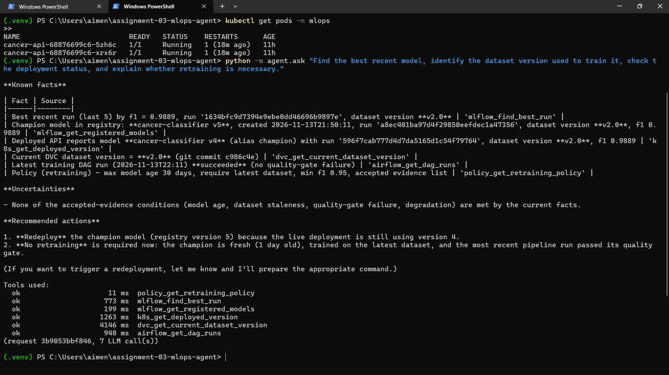

How it works
The LLM chooses what to look at. Plain code decides what is allowed.
- I ask a question in plain English.
- The LLM picks the tools it needs, out of 25.
- Code checks every tool call first: valid inputs, allowed action, time limit.
- The results go back to the LLM, which writes the answer.
- Code adds what the LLM is not trusted to add: which tools failed, and anything still waiting for my yes.

The LLM picks the tools and writes the answer. | Plain code decides whether a tool is allowed to run.

Where things run
System | Runs in
DVC | The project folder
MLflow | My laptop, port 5000
Airflow | One Docker container, port 8080
Kubernetes | Docker Desktop, namespace mlops

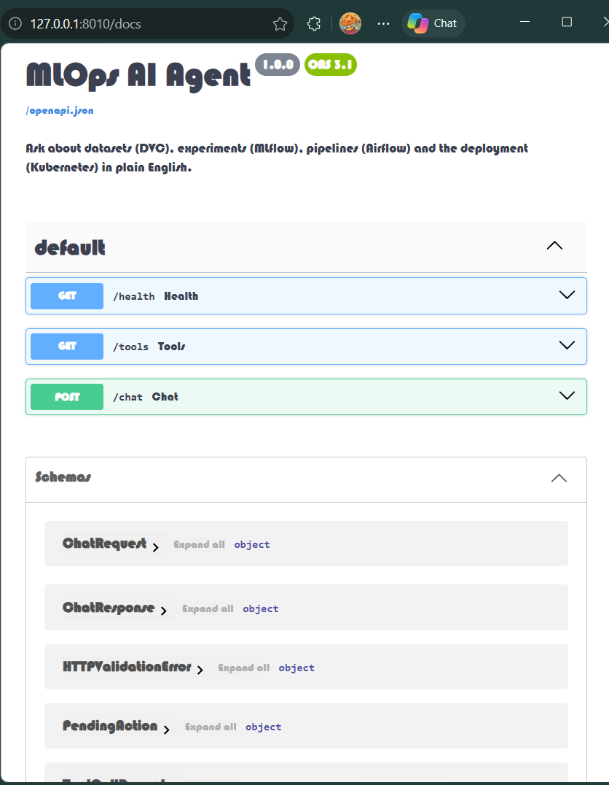 | NOTE  The agent runs from the terminal or through its own API. The picture is the API's docs page. It has three endpoints: one for health, one that lists the tools, and one for chat.

The main question: is retraining needed?
No retraining is needed. But the deployment should be updated, because Kubernetes is one version behind the champion.
The question was: find the best recent model, the dataset it was trained on, the deployment status, and say if retraining is needed. The agent called 6 tools across all four systems.
What it checked | What it found
Best model | F1 0.9889, trained on dataset v2.0
Latest pipeline run | Passed
Champion in the registry | Version 5
Running on Kubernetes | Version 4

Asked earlier, right after a run failed the quality gate, the agent said retrain. Same question, different evidence, different answer.
22i0922
Aimen Ahmad

Evidence

How the four connect
Every training run is tagged with its dataset version, and the running app reports its model version. The same ids show up in every system, and that is how the agent connects them.

DVC: dataset versions
There are two versions of the dataset. Checking out a tag brings back exactly that file, and its hash proves it.
 | v1.0 | v2.0 (current)
Rows | 400 | 569
Git commit | 64e5e07 | c986c4e
File hash starts with | 94bc26a8 | 24d9881f

A version that does not exist is refused, not guessed: asking for v9.9 returns an error.

MLflow: training runs
The best model is logistic regression on v2.0 with F1 0.9889. It is version 5 in the registry and holds the champion alias.
There are 10 runs in 2 experiments. The first five were made by hand:
Model | Settings | Dataset | F1
Random forest | 10 trees | v1.0 | 0.9369
Logistic regression | C 0.01 | v1.0 | 0.9661
Random forest | 10 trees | v2.0 | 0.9457
Random forest | 200 trees | v2.0 | 0.9670
Logistic regression | C 1.0 | v2.0 | 0.9889

The best-run tool also warns when runs used different dataset versions, so the top score is not trusted blindly.
MLflow: the training runs.
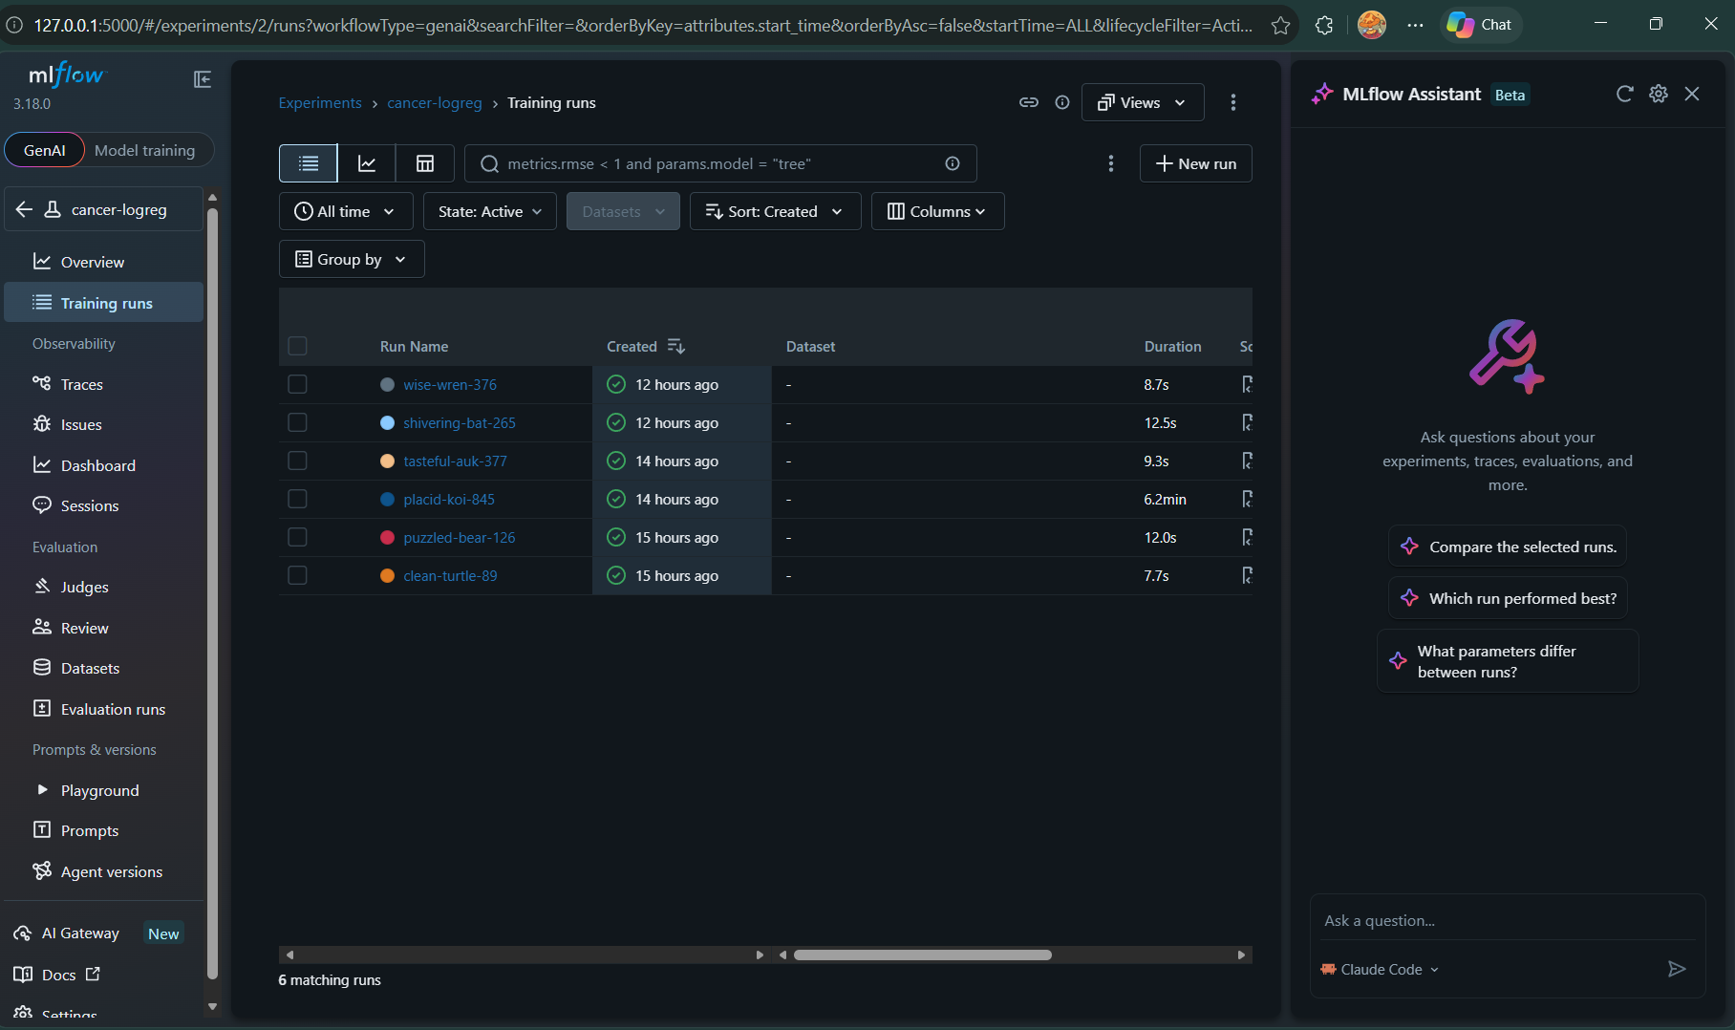

Airflow: the training pipeline
One DAG runs 5 tasks in a row: validate, preprocess, train, evaluate, quality gate. If one fails, the rest do not run.
A failed task is retried twice, 20 s apart. Validation and the quality gate are never retried, because bad data or a weak model does not fix itself.
Run (13 Nov, UTC) | Result | Time | Failed at
22:11:36 | Passed | 30.1 s
22:11:05 | Failed | 10.9 s | Validation
21:49:23 | Passed | 48.2 s
19:56:30 | Failed | 31.2 s | Quality gate (weak model)

Airflow: the DAG runs and task results.
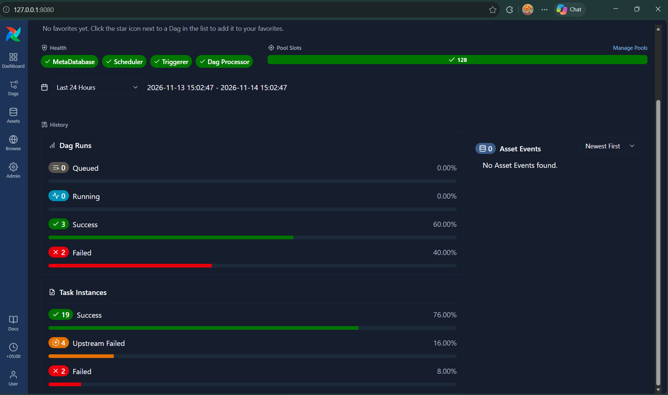

Kubernetes: the prediction API
Both pods are ready, and the app reports that it serves model version 4, trained on dataset v2.0.
Requirement | How it is met
At least 2 replicas | 2 replicas, 2 of 2 ready
ClusterIP Service | Port 80 goes to the app's port 8000
Health checks | Readiness on /ready, liveness on /health
CPU and memory | Asks for 100m and 256Mi, capped at 500m and 512Mi
ConfigMap | Holds the app version, model path and log level

Kubernetes: the deployment is available 2 of 2 and both pods are running.
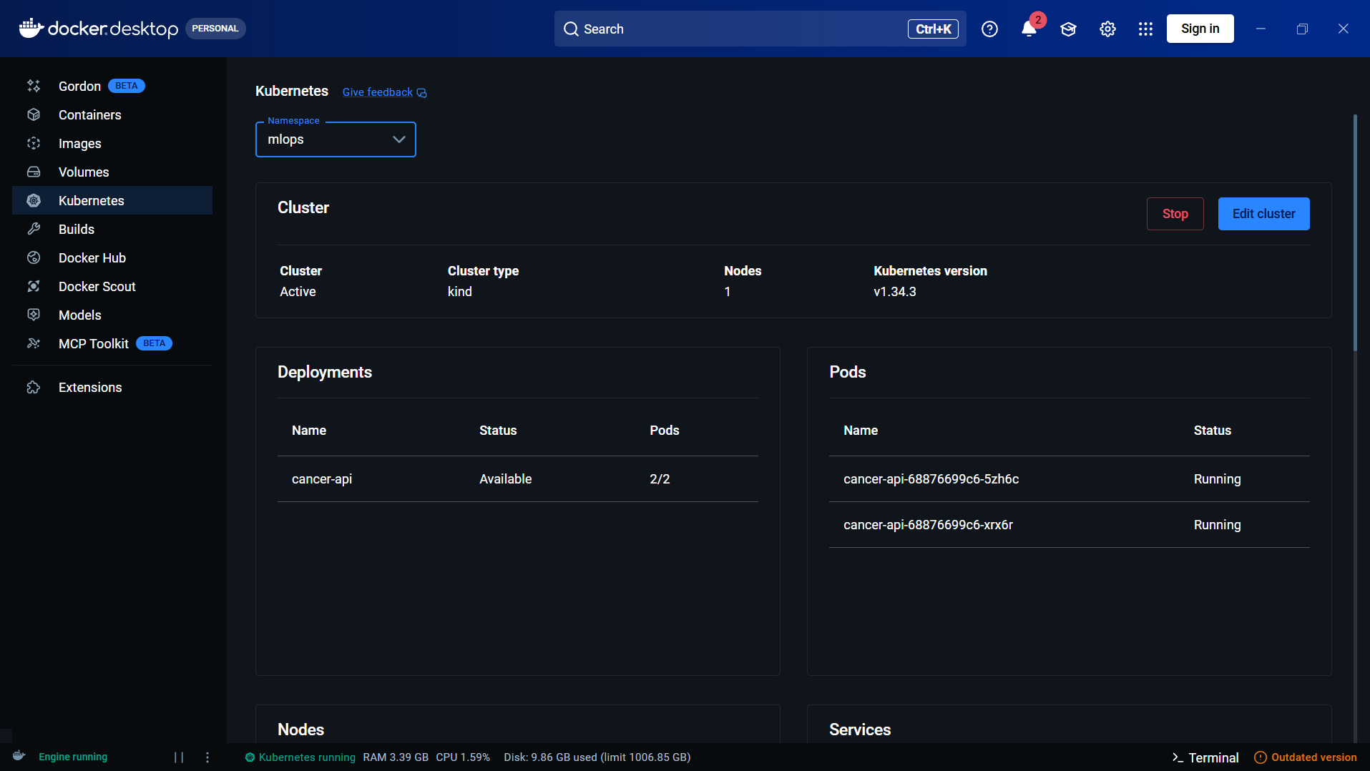
Kubernetes: the ClusterIP Service and the ConfigMap.
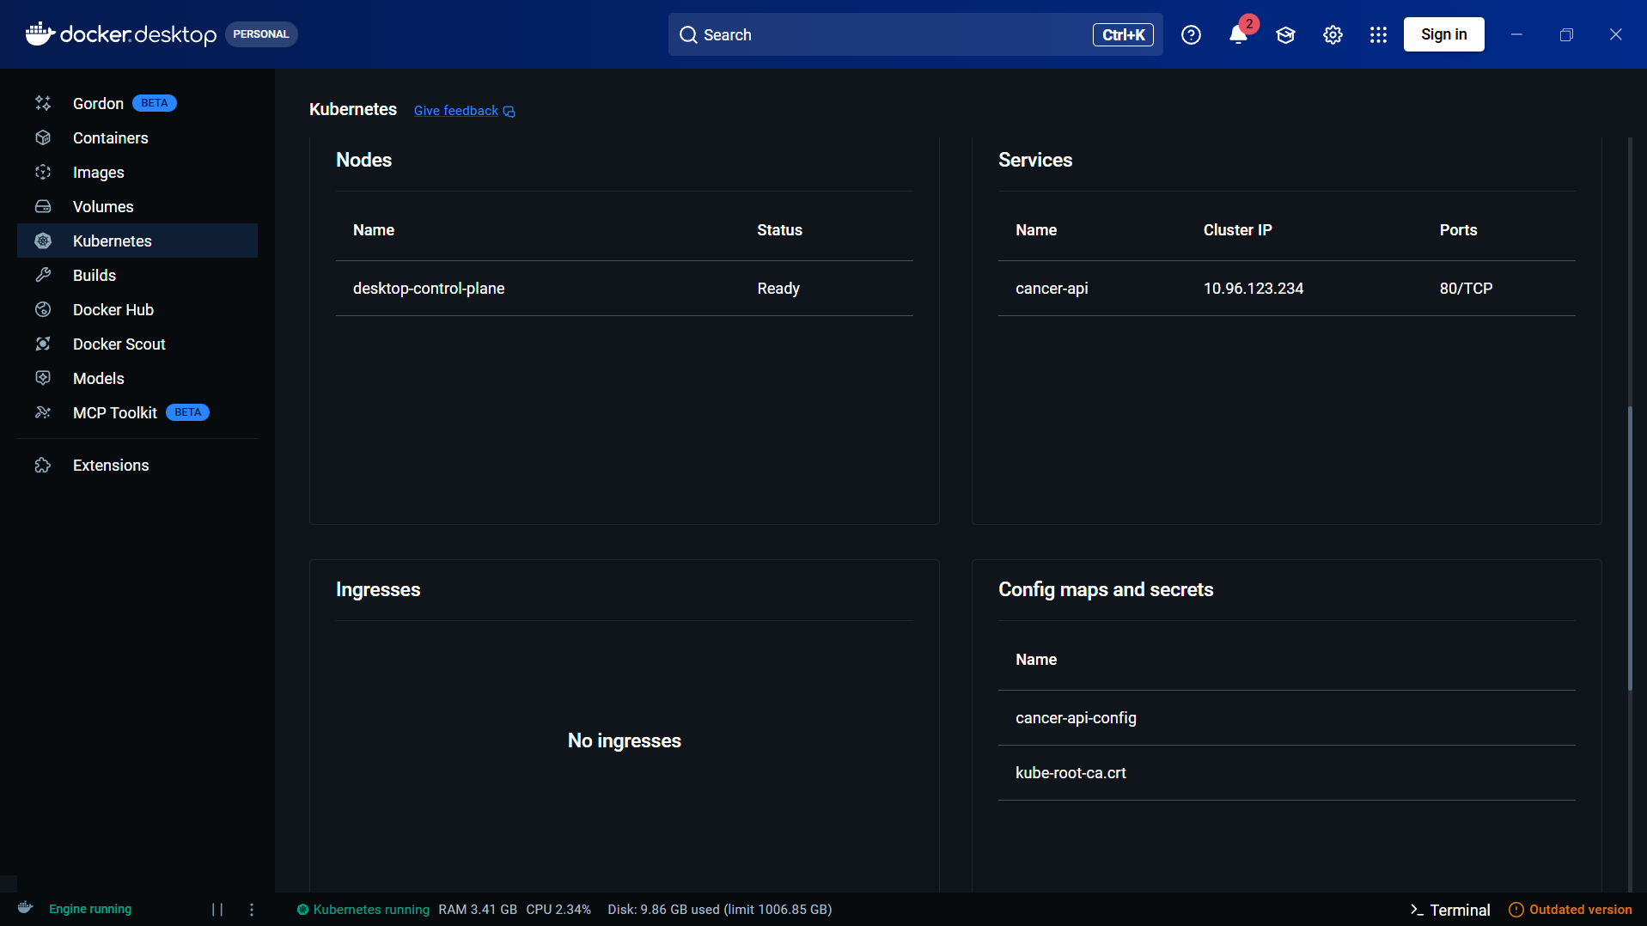
22i0922
Aimen Ahmad

Agent conversations

How to read this part
Each conversation shows my question, the tools the agent chose, and what it answered. The times come from the agent's own log.

1. Is retraining needed? (all four systems)
Find the best recent model, identify the dataset version used to train it, check the deployment status, and explain whether retraining is necessary.
Tool | Result | Time
policy_get_retraining_policy | ok | 4 ms
mlflow_find_best_run | ok | 933 ms
mlflow_get_registered_models | ok | 150 ms
dvc_get_current_dataset_version | ok | 2543 ms
k8s_get_deployed_version | ok | 999 ms
airflow_get_dag_runs | ok | 1076 ms

Answer. Best model has F1 0.9889 on dataset v2.0. The champion is version 5, but Kubernetes serves version 4. The latest pipeline run passed. So: no retraining, but redeploy.
The agent's full answer, with the tools it used.
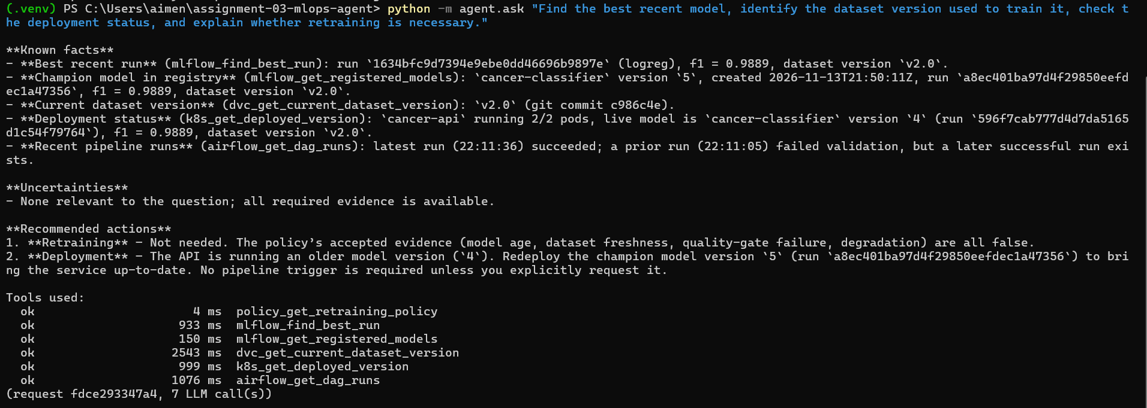

2. Start the training pipeline (needs my yes)
Trigger the model training pipeline and report whether execution succeeded.
The agent did not start anything at first. It showed what it wanted to do and waited. After I typed yes:
Tool | Result | Time
airflow_trigger_training_dag | ok | 793 ms
airflow_get_dag_run_status | ok | 53,633 ms (waited for the run)

Answer. The run finished with state success in about 53 s. All five tasks passed.
The agent waiting for my yes, then running the pipeline.
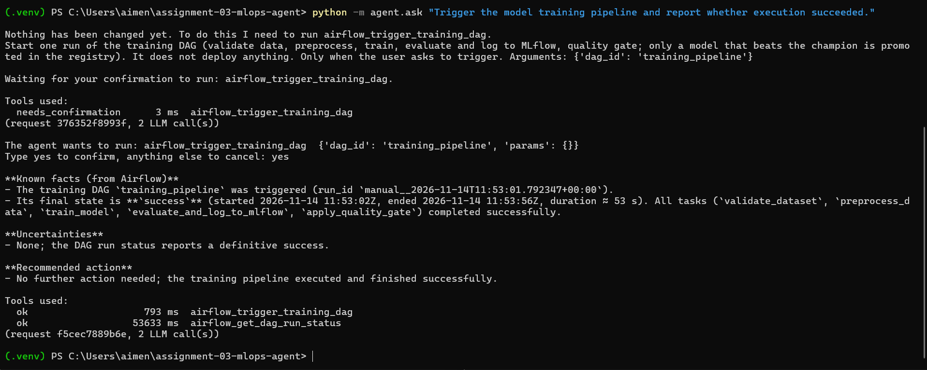

3. Why did the pipeline fail?
The latest training pipeline run failed. Find out which task failed and why, and tell me how to fix it.
Tool | Result | Time
airflow_get_dag_runs | ok | 115 ms
airflow_get_failed_tasks | ok | 47 ms
airflow_get_task_diagnostics | ok | 181 ms

Answer. The failed task is validate_dataset. Its log says data/cancer.csv was changed without dvc add: the file's hash 99e2a9a3… is not the DVC version 24d9881f…

4. Why is my API down?
Why is my prediction API unavailable?
Tool | Result | Time
k8s_list_workloads | ok | 1199 ms
k8s_get_pod_logs | ok | 46 ms
k8s_get_deployed_version | ok | 12 ms

Answer. 0 of 2 pods are ready and both are in CrashLoopBackOff. The pod log says the model file /app/model/missing-model.joblib does not exist. The ConfigMap's MODEL_PATH points to that file.

5. A system is unreachable
What is the best model by F1 score?
Asked while MLflow could not be reached.
Tool | Result | Time
mlflow_find_best_run | error | 2057 ms
mlflow_list_runs | error | 2028 ms
mlflow_get_registered_models | error | 2082 ms

Answer. The agent said it could not identify the best model. The reply ended with an "Unavailable evidence" note listing the three failed tools. It did not invent a number.
22i0922
Aimen Ahmad

Failures and testing

Failures I caused on purpose
I broke three things on purpose. Each time the agent found the real cause from the evidence.

Data changed without DVC
I added a line to cancer.csv without running dvc add. The pipeline stopped at its first task, validate_dataset, after 10.9 s, because the file's hash no longer matched DVC.
Nothing bad happened: validation is the first task, so the four tasks after it never started. Nothing was trained or promoted. The agent found the failed task and read its log.
Fix: dvc checkout --force. The next run passed in 30.1 s.

Wrong setting on Kubernetes
I pointed MODEL_PATH in the ConfigMap at a file that does not exist. Both pods went into CrashLoopBackOff and the API went down.
The agent read the pod log, saw the missing file and traced it to the ConfigMap. So it was a settings mistake, not a code or image problem.
Fix: apply the correct ConfigMap, then the agent restarted the deployment after I said yes.

MLflow unreachable
The agent said it could not answer and listed the tools that failed. It did not invent a number.
NOTE
Both failed pipeline runs are in Airflow's history: the changed dataset, and a weak model that the quality gate refused to promote. In both cases the bad result stopped there.

Airflow: the two failed runs of the training pipeline.
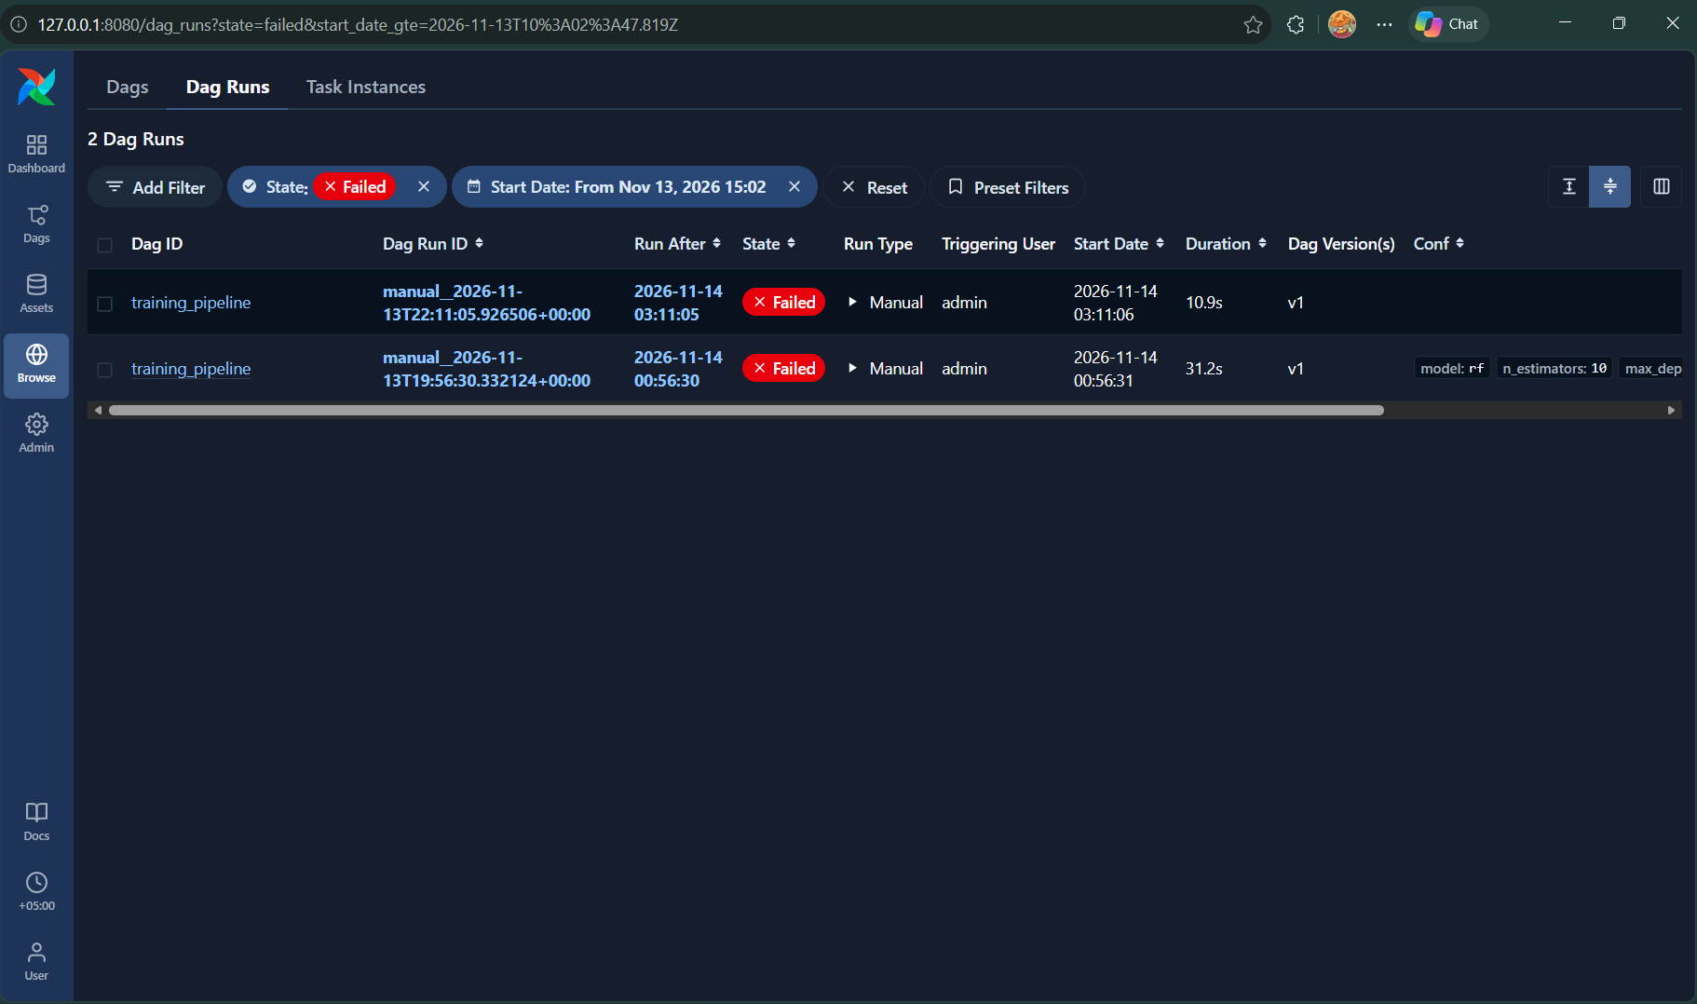

Safety and testing
Safety is in code, not in the prompt, and 52 automated tests check it.

Safety rules
- Only approved commands, one approved DAG and one namespace (mlops) can be touched.
- The 2 tools that change something wait for my yes, and one yes allows one change.
- Bad inputs are refused before a tool runs.
- A failed tool is always listed in the answer.
- Logs hide secrets.

The 25 tools
System | Tools | Can change something
DVC | 5 | No
MLflow | 6 | No
Airflow | 6 | 1: start the training pipeline
Kubernetes | 7 | 1: restart the deployment
Policy | 1 | No

Example: asked to start the pipeline, the agent stopped and waited. After I typed yes, it started the run, waited about 53 s and reported success with all five tasks done.

Testing and CI
All 52 tests pass on my laptop and on GitHub. They use fakes, so they need no real cluster, server or API key. CI runs ruff and pytest on every pull request and every push to main.
GitHub Actions: lint and tests passing on a pull request.
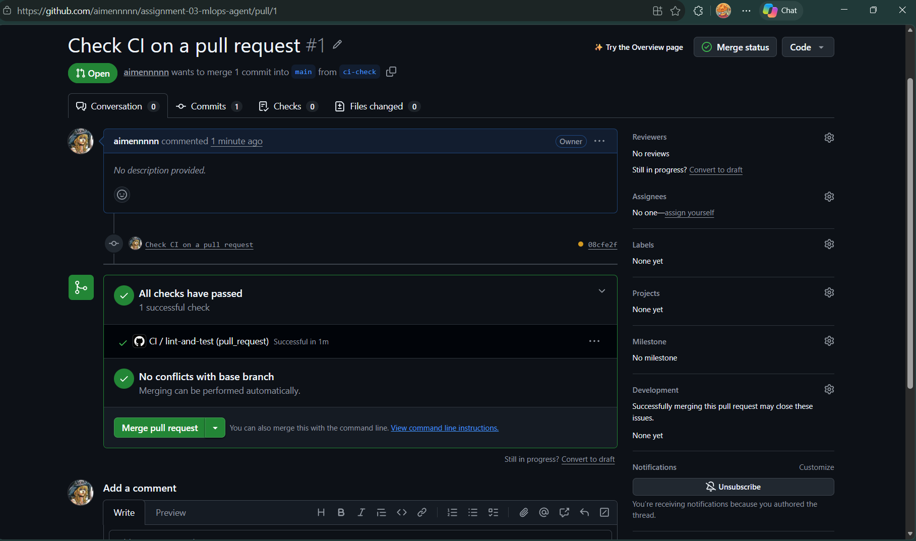
What the tests prove:
- The agent runs the tools the LLM picks.
- A slow tool times out cleanly.
- Bad requests are rejected.
- A service that is down returns an error, not data.
- The agent does not invent results.
- A Kubernetes change outside mlops is refused.
- Secrets never reach the logs.
- The quality gate blocks a weak model.

Fixed after real testing
Problem I saw | Fix
The agent judged retraining without checking Airflow | Code rejects an answer that skipped a system
Every run replaced the champion | A model is promoted only if it is better
It mixed up the deployed version with the champion | The registry tool names the champion clearly
A restart reported 0 ready pods, because it answered too early | The restart tool waits for the rollout
A pipeline step took 6 minutes, because calls to MLflow hung | MLflow runs with one worker and a 20 s timeout

What I would improve
The biggest gap is that deploying a new champion is still manual. That is why Kubernetes serves version 4 while the champion is version 5.
Limit today | What I would do
Deploying a new champion is manual | Add a confirmed "deploy champion" tool
The DVC remote is a folder in the repo | Move it to cloud storage
MLflow uses SQLite and one worker | Move it to PostgreSQL
Airflow keeps its history inside the container | Give it its own database
The agent's API has no login | Add API keys in front of it
The agent forgets between questions | Add short memory per session
The LLM calls one tool at a time, so six tools take about a minute | Use an LLM that can call several tools at once
The agent only checks when asked | Add scheduled health checks that raise alerts
The quality gate checks one score on one split | Add cross-validation and a fixed test set

