
"Mind Over Media: A Statistical Study of Social Media's Effect on Focus"


GROUP MEMBERS:
Izaan omair 23k-5530
ruhan khalid 23k-5512
aimen binte 23k-5502
omama ahmed 23k-5546

subject: data analysis for business II
teachers: sir mushtaq and sir anwar mughees
Abstract
This report investigates the impact of social media usage on mental health, specifically focusing on whether individuals feel distracted after using social media. A logistic regression model was employed to analyse the relationship between the dependent variable—distraction—and three independent variables: hours spent on social media, addiction level, and age. The study hypothesizes that increased usage time and higher addiction levels are associated with greater odds of experiencing distraction. Age is included as a control variable to capture behavioural differences across demographics. Data was collected through a survey, and results were analysed to identify statistically significant predictors of distraction. The findings contribute to a better understanding of how digital behaviour patterns may affect cognitive focus and psychological well-being.
Supporting Literature
- Mark et al. by Gloria Mark and her co-authors (2018) found that excessive screen time is associated with fragmented attention and cognitive overload.
- Andreassen et al. by Cecilie Schou Andreassen and her colleagues (2016) demonstrated that higher levels of social media addiction are linked to compulsive usage and reduced focus.
- Rideout et al. Victoria Rideout and colleagues (2010) emphasized that younger age groups exhibit more pronounced digital engagement patterns, making them more susceptible to distraction.

Introduction
Social media has become an integral part of modern communication, especially among younger populations. However, concerns have grown over its effects on cognitive and emotional well-being. This study investigates whether social media usage—measured in terms of time spent, addiction level, and user age—can predict the likelihood of distraction. Prior studies (e.g., Mark et al., 2018; Andreassen et al., 2016; Rideout et al., 2010) suggest that prolonged usage and addictive behaviors are key contributors to attention fragmentation and cognitive overload.
Methodology
The dependent variable is binary: whether the respondent reports feeling distracted after using social media. Logistic regression was chosen due to the categorical nature of the outcome.
Independent Variables:
- Hours Spent: Measured in average daily hours on social media.
- Addiction Level: Self-assessed on a scale from 1 to 5.
- Age: Recorded in years.
Data was collected from 50 individuals via structured survey.

Dependant Variable:
Do you feel distracted after using Social Media?
- Why choose this variable?
- A binary outcome is required for logistic regression.
- "Distraction" is a tangible measure of social media’s negative impact, aligning with common research on digital well-being.

Independent Variables:
- Hours Spent:
- Behavioural Impact: Prior studies show that excessive screen time correlates with attention fragmentation (e.g., Mark et al., 2018).
- Hypothesis: "More hours spent → Higher odds of distraction."

- Addiction Level:
- Why Include It? Psychological Mechanism: Addiction scales predict compulsive use, which exacerbates distraction (e.g., Andreassen et al., 2016).
- Hypothesis: "Higher addiction scores → Higher distraction odds."
3. Age:
- Why Replace platform with age?
- Theoretical Strength: Age influences digital behaviour; younger users are more prone to distraction (Rideout et al., 2010).
- Platform variable lacks diversity (only Instagram/WhatsApp), limiting insights.
- Hypothesis: "Younger age → Higher distraction odds."
Label list:
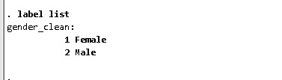

Commands
- This command creates a new variable called gender_clean where each unique category in the original gender variable (e.g., "Male", "Female", "Other") is assigned a unique numeric code.

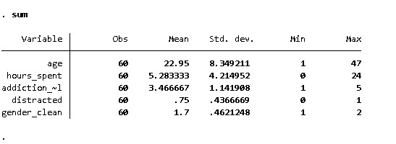

1. Sample Size
Each variable has 60 observations, which means the data is complete for all the variables shown (no missing values).

2. Age
- Mean = 22.95 years, suggesting a predominantly young sample.
- Range = 1 to 47, with SD = 8.35, indicating a moderately spread-out age distribution.

3. Hours Spent (Likely on Social Media or Device Use)
- Mean = 5.28 hours per day, indicating moderate usage.
- Range = 0 to 24 hours, showing some extreme cases (someone reported spending a full day).
- SD = 4.21, suggesting high variation in time spent.

4. Addiction Level
- Mean = 3.47 on a scale of 1 to 5, with a standard deviation = 1.14.
- This indicates that, on average, participants reported moderate to high levels of addiction, and responses vary moderately.

5. Binary Variables
- Distracted:
  - Mean = 0.75 → implies 75% of participants are distracted (value 1).
- Gender_clean:
  - Mean = 1.7 with Min = 1 and Max = 2 → likely coded as 1 = Male, 2 = Female.
  - A mean of 1.7 suggests the majority are female (closer to 2).
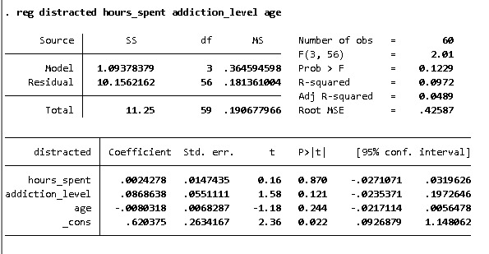

1. Overall Model Fit
- R-squared = 0.0972, so only 9.72% of the variation in distracted is explained by the model — quite low.
- F(3, 56) = 2.01 with P = 0.1229: The model is not statistically significant, meaning the predictors jointly do not explain a significant portion of the outcome.

2. Significance of Individual Predictors
- None of the predictors (hours_spent, addiction_level, age) are statistically significant (P > 0.05).
  - hours_spent: P = 0.870
  - addiction_level: P = 0.121
  - age: P = 0.244

3. Interpretation of Coefficients
- hours_spent (0.0024): Very small and non-significant — more time spent doesn't meaningfully affect distraction level.
- addiction_level (0.0869): Positive association — higher addiction may relate to greater distraction, but not strongly.
- age (-0.0210): Slight negative relationship — older age could be linked with less distraction, but it’s not reliable statistically.
4. Intercept
- The constant (_cons) is 0.6204, significant at P = 0.022. This represents the expected distraction score when all predictors are zero (though not very meaningful in isolation).
5. Conclusion
- The linear regression model is weak and statistically insignificant overall, and no individual variable significantly predicts distraction in this setup.
- You may need to conwsider a larger sample size, different predictors, or a better-fitting model (e.g., logistic regression with improved variable coding).

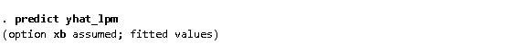To obtain predicted probabilities of distraction, the command. predict yhat_lpm was implemented after the linear probability model estimation. The generated variable, yhat_lpm, provides an estimate of the likelihood of distraction for each observation, derived from their specific values of hours spent, addiction level, and age, according to the model's parameters.
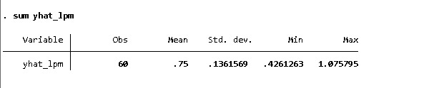
- 60 observations: Decent sample size for analysis.
- Mean 0.75: Average predicted probability is high.
- Std. dev. 0.136: Moderate spread in predictions.
- Min 0.426: Lowest predicted probability is still notable.
- Max 1.076: Predicted probability above 1, a limitation of the model.

The command creates yhat_logit, a new variable with predicted probabilities (0 to 1) of text trust for each individual, based on age, education, and author_choice.

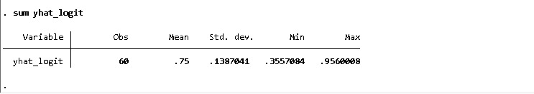
The model predicts a generally high propensity for trust within the sample, with the average estimated probability hovering around 75%. However, the distribution of these probabilities exhibits a range, indicating a subset of individuals with considerably lower predicted trust levels alongside those with very high predicted trust.

LOGISTIC REGRESSION:
For binary outcomes, logistic regression is the statistically rigorous and widely adopted method. It directly models the probability of the event of interest within the logical 0-1 range using a non-linear (sigmoid) function, accommodating the typical relationship between predictors and binary responses. Furthermore, it provides interpretable odds ratios, quantifying the change in the odds of the outcome associated with unit changes in the predictors. This makes it a powerful tool for both understanding the drivers of binary events and for classification tasks.
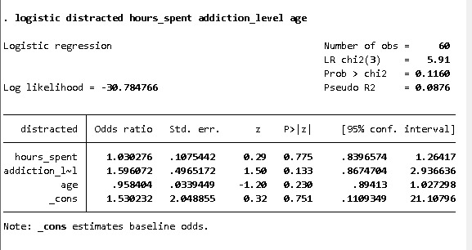

- Overall Model: The Likelihood Ratio chi-squared test (LR chi2(3) = 5.91, Prob > chi2 = 0.1160) suggests that the model as a whole is not statistically significant in predicting the odds of being distracted compared to a model with no predictors.
- Individual Predictors (Odds Ratios):
- hours_spent: The odds ratio is 1.030. This means that for every one-unit increase in hours spent, the odds of being distracted increase by approximately 3.0% (calculated as (1.030 - 1) * 100%). However, the p-value (0.775) is high, and the 95% confidence interval (0.840 to 1.264) includes 1, indicating that this effect is not statistically significant.
- addiction_level: The odds ratio is 1.596. For every one-unit increase in addiction level, the odds of being distracted increase by approximately 59.6%. Again, the p-value (0.133) is above the conventional significance level, and the 95% confidence interval (0.867 to 2.937) includes 1, suggesting that this effect is not statistically significant in this model.
- age: The odds ratio is 0.958. For every one-year increase in age, the odds of being distracted decrease by approximately 4.2% (calculated as (0.958 - 1) * 100%). The p-value (0.230) is not statistically significant, and the 95% confidence interval (0.894 to 1.027) includes 1, indicating that the effect of age on the odds of being distracted is not statistically significant in this model.
- Constant (_cons): The odds ratio for the constant is 1.530. This represents the baseline odds of being distracted when hours spent, addiction level, and age are all zero. However, interpreting the constant directly can be less meaningful in many logistic regression models.
Discussion
Although prior research points to a strong theoretical link between social media use and cognitive distraction, this model failed to find statistically significant results. This may be due to:
- Limited sample size (n=60)
- Self-reported and possibly biased measures
- Narrow demographic range (mean age ~23)
The outcome indicates that other psychological or situational factors (e.g., academic stress, digital multitasking context) may better predict mental distraction.
Conclusion
This analysis attempted to assess the impact of social media behavior on self-reported distraction using logistic regression. Despite a theoretically sound model, results were statistically insignificant, highlighting the complexity of digital mental health. Future studies should explore more nuanced variables and a larger, more diverse sample.

References
• Mark, G., Iqbal, S. T., & Czerwinski, M. (2018). Neurotics can't focus: An in-situ study of online multitasking. CHI.
• Andreassen, C. S., Pallesen, S., & Griffiths, M. D. (2016). Addictive use of social media, narcissism, and self-esteem. Addictive Behaviors, 64, 287–293.
• Rideout, V., Foehr, U., & Roberts, D. (2010). Generation M2: Media in the Lives of 8–18 Year-Olds. Kaiser Family Foundation.

