IMAGES

Each tagged image is a stack of 41 PNG files representing different Z-planes ranging from -20 um to 20 um. Each PNG image is 1000x1000 pixels.

For example, the image below was constructed from 41 PNG files with the file structure: 42.2007-2007-15-35.379.*.50000.39000.png

* “42” refers to a randomized slide number index and is not included in the metadata (described later). This can be ignored.
* “2007-2007-15-35” refers to the sampling year and pollen trap coordinate
* “379” represents the random image number (ranging from 1-1000)
* “*” represents the Z-plane (-20 to 20 um) currently being viewed
* “50000.39000” represents the x,y coordinates of the upper left corner of the current image stack within the larger, original scanned NGR file

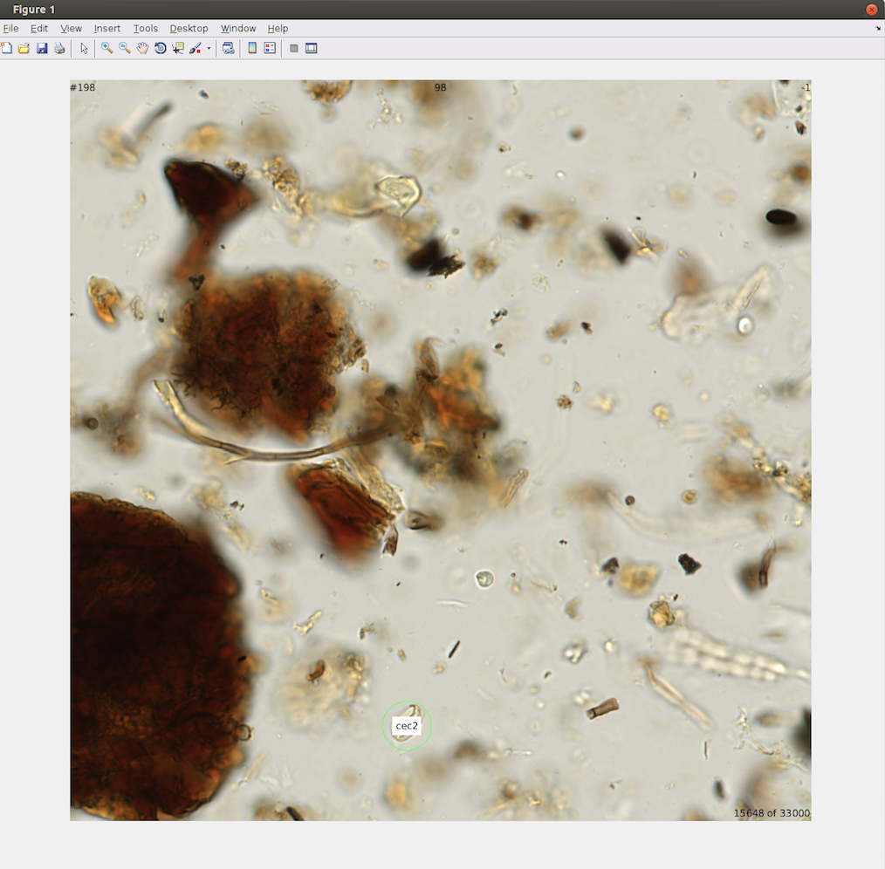

METADATA

Identified grains have been circled/tagged and given a 3-letter identification code and a confidence rating ranging from 0-9, with 9 being the most confident. The image above contains one annotated pollen grain (cec2).

The metadata annotation for this grain follows the format

|  |  |  |  |  |  |  |  |  |  |  |
| --- | --- | --- | --- | --- | --- | --- | --- | --- | --- | --- |
| 15648 | 198 | 50000 | 39000 | 1 | 455 | 872 | -1 | 3.30E+01 | 2 | cec |

where the columns from left to right are defined as:

1. The random image window number (this can be ignored)
2. The slide number (“198”) corresponds to the pollen sample. A list of all 199 pollen samples counted can be found in a separate file (SlideNumbersAndNames.txt). In this instance, 198 (viewable in the upper left corner of the image) corresponds to the pollen sample “2007-2007-15-35”
3. The (absolute) x coordinate of image within the original scanned image
4. The (absolute) y coordinate of image within the original scanned image
5. Annotated pollen number within the tagged PNG. The numbers range from 1 to the total number of grains counted within a single image stack.
6. The (relative) x coordinate of the tagged pollen grain within the PNG stack
7. The (relative) y coordinate of the tagged pollen grain within the PNG stack
8. The z-plane where the pollen grain was identified (In this case -1; viewable in the upper right corner of the image). When gains span multiple depths, the center plane is tagged.
9. The radius of the circled pollen grain
10. The confidence level of the taxon identification (0-9)
11. The 3-letter identification code