Lecture 5 Logistic, Poisson and Negative Binomial Regressions

Ahmed Nadeem

2024-10-09

We’re going to simulate some predictor variables for each logistic regression, poisson regression and negative bionomial regression, and then analyze each.

## Logistic Regression

* We’re going to have one response variable and two predictor variables (one which is yes or no, the other which is continuous).

### QUESTION: What are you imagining your response variable to be? What are your two predictor variables?

* I am imagining a forced choice task (the most common psychophysics experiment methodology), where someone is trying to discern if the first stimuli or second stimuli is faster

N=50  
predictor_cont<-rnorm(N,0,0.2)   
predictor_binary<-rbinom(N,1,0.5)  
  
y<-1.44*predictor_cont+2.5*predictor_binary+rnorm(N, 0, 0.01) ### Remember that to make this do-able in a linear framework, like this, we're assuming this is on a log scale!  
exp(1.44)

## [1] 4.220696

### We're now going to draw a probability distribution from y, assuming that y is on a logit scale  
y_prob<-plogis(y)  
y_prob

## [1] 0.4297075 0.9280403 0.4879707 0.9395580 0.9366252 0.3732710 0.9383962  
## [8] 0.3362835 0.8909783 0.4429920 0.8949733 0.9400513 0.9339490 0.3683425  
## [15] 0.5694267 0.9270567 0.9301856 0.9300962 0.4893657 0.4459459 0.5395909  
## [22] 0.5221986 0.3950844 0.9240946 0.9175359 0.9059089 0.9041947 0.4639260  
## [29] 0.4332127 0.9215526 0.9285852 0.4812979 0.9389923 0.6097789 0.9396123  
## [36] 0.9248008 0.9460888 0.3515584 0.6348080 0.5995490 0.4904547 0.4950127  
## [43] 0.4218379 0.4662894 0.9425567 0.4976073 0.4108515 0.4503441 0.4820954  
## [50] 0.4871322

### we can now draw from the probability distribution (so that all of our responses are 0,1)  
  
y_dummy = rbinom(n = N, size = 1, prob = y_prob)  
  
  
data<-cbind.data.frame(1:N, y_prob, y, predictor_cont, predictor_binary)  
  
log_reg_model<-glm(y_dummy~predictor_binary+predictor_cont, data=data, family='binomial')  
  
### if you have loaded and installed lmerTest, it will give you p-values in your summary, if not, it won't  
summary(log_reg_model)

##   
## Call:  
## glm(formula = y_dummy ~ predictor_binary + predictor_cont, family = "binomial",   
## data = data)  
##   
## Coefficients:  
## Estimate Std. Error z value Pr(>|z|)  
## (Intercept) 0.1098 0.4120 0.267 0.790  
## predictor_binary 19.4177 2281.7231 0.009 0.993  
## predictor_cont 1.3304 1.8682 0.712 0.476  
##   
## (Dispersion parameter for binomial family taken to be 1)  
##   
## Null deviance: 59.295 on 49 degrees of freedom  
## Residual deviance: 38.296 on 47 degrees of freedom  
## AIC: 44.296  
##   
## Number of Fisher Scoring iterations: 18

### From here, you need to back transform to get the estimates on the y scale, instead of the log(y) scale  
  
exp(coef(log_reg_model)) ### these are on the 'regular' scale, not the log scale

## (Intercept) predictor_binary predictor_cont   
## 1.116103e+00 2.710272e+08 3.782536e+00

exp(confint(log_reg_model))

## Waiting for profiling to be done...

## Warning: glm.fit: fitted probabilities numerically 0 or 1 occurred## Warning: glm.fit: fitted probabilities numerically 0 or 1 occurred

## 2.5 % 97.5 %  
## (Intercept) 4.987303e-01 2.585791  
## predictor_binary 7.525318e-60 NA  
## predictor_cont 1.026819e-01 196.800595

pR2(log_reg_model) ### r2CU (Nagelkerke R2 is the most comparable to our typical R2)

## fitting null model for pseudo-r2

## llh llhNull G2 McFadden r2ML r2CU   
## -19.1478947 -29.6476659 20.9995423 0.3541517 0.3429472 0.4937824

###Question, tell me about the distribution of y_prob?! - It would be a distribution between 0-1 and mostly focus on 1, because my predictor_cont has a low SD

### Question: What did you expect the effect sizes of the predictors to be, based on what you simulated (hint, you will need to transform from line 25)?

* The effect sizes would be 1.44 and 2.5, but they wont be those exact values as a tiny bit of noise was added

### Question: The coefficient for predictor_cont is 1.44 This means that the expected log OR for a one-unit increase in predictor_cont is 1.44. This means that the OR (biological scale) for a one unit increase in predictor_cont is 4.220696. The R2 for this model is 0.2516362. This means that 25.1% of the variance can be explained by the model.

Let’s simulate some Poisson data!

## Poisson Regression

This is mostly borrowed from [Simulate Simulate Simulate 3!](https://aosmith.rbind.io/2018/07/18/simulate-poisson-edition/)

### Question: What is your imagined response variable here? What is your imagined predictor?

* Count of correct responses in the stimuli presented to a participant ### Question: What happens if you add more than one predictor (i.e. x2)?
* Then I am modelling 2 different effects on one outcome, as opposed to one

x1 = rnorm(1000,1,0.2) ### here there is one predictor, this a good place to imagine some biology  
  
### Question,   
  
lambda = exp(0.5 + 2.5*x1) ### this is where I change the effect sizes for each predictor  
exp(2.5)

## [1] 12.18249

###remember that this means that log(lambda) is a linear model!!  
### here I'm simulating three betas against my three predictor variables to make my lambda  
### The step above simulates the mean of each value of the response variable. lambda values are continuous, not discrete counts.  
## λ is the unobserved true mean of the Poisson distribution for the t-th observation  
  
head(lambda)

## [1] 33.61513 30.51258 30.88292 13.24118 18.61517 14.56936

y = rpois(1000, lambda = lambda) ### error is added in this step, remembering that the mean and the variance are the same!  
### remember that y is count data!  
head(y)

## [1] 41 35 39 14 17 13

plot(x1, log(y)) ### note the residuals - are they normally distributed? Is that okay?

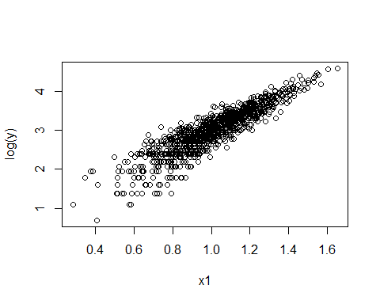

plot(x1,y)

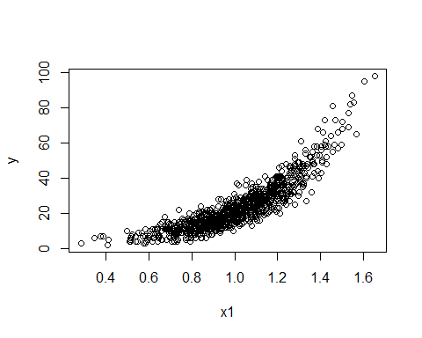

data_poisson<-cbind.data.frame(y, x1)  
  
poisson_model<-glm(y ~ x1, family="poisson", data=data_poisson)  
summary(poisson_model)

##   
## Call:  
## glm(formula = y ~ x1, family = "poisson", data = data_poisson)  
##   
## Coefficients:  
## Estimate Std. Error z value Pr(>|z|)   
## (Intercept) 0.55256 0.03582 15.43 <2e-16 ***  
## x1 2.45012 0.03176 77.13 <2e-16 ***  
## ---  
## Signif. codes: 0 '***' 0.001 '**' 0.01 '*' 0.05 '.' 0.1 ' ' 1  
##   
## (Dispersion parameter for poisson family taken to be 1)  
##   
## Null deviance: 6979.7 on 999 degrees of freedom  
## Residual deviance: 1005.2 on 998 degrees of freedom  
## AIC: 5836.7  
##   
## Number of Fisher Scoring iterations: 4

###back transform the coefficients   
  
exp(coef(poisson_model)) ### these are on the 'regular' scale, not the log scale

## (Intercept) x1   
## 1.73770 11.58969

exp(confint(poisson_model))

## Waiting for profiling to be done...

## 2.5 % 97.5 %  
## (Intercept) 1.619762 1.863905  
## x1 10.890202 12.334215

pR2(poisson_model) ### r2CU (Nagelkerke R2 is the most comparable to our typical R2)

## fitting null model for pseudo-r2

## llh llhNull G2 McFadden r2ML   
## -2916.3667909 -5903.6236704 5974.5137590 0.5060039 0.9974573   
## r2CU   
## 0.9974647

### Question: The coefficient for x1 is 2.5 (FILL ME IN!) This means that the expected log count for a one-unit increase in x1 is 2.5. This means that the count difference (biological scale) for a one unit increase in x1 is 12.18249. The R2 for this model is 0.9956404. This means that the model explains 99.56% of the variation.

library(MASS)  
  
neg_binom_predictor <- rnorm(1000, mean = 0, sd = 1) ### what is your imagined predictor?  
# - my imagined predictor would be arm length   
  
# Log link function: log(mu) = beta0 + beta1 * X  
mu <- exp(5+1.5 * neg_binom_predictor) ### notice that this is ALSO on a log scale  
### mu is the expected mean for each observation  
exp(1.5)

## [1] 4.481689

# Dispersion parameter for the negative binomial distribution  
theta <- 2 ### this makes the difference between negative binomial and poisson. A very large theta would lead the negative binomial to approximate a poisson  
##Play around with theta and see what happens!  
  
  
y_neg_binom <- rnegbin(1000, mu = mu, theta = theta)  
  
# Create a data frame to store the simulated data  
data_negbiom <- cbind.data.frame(y_neg_binom, neg_binom_predictor)  
  
plot(neg_binom_predictor, log(y_neg_binom))

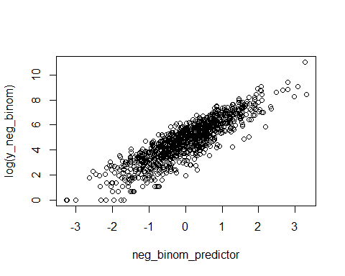

plot(neg_binom_predictor, y_neg_binom)

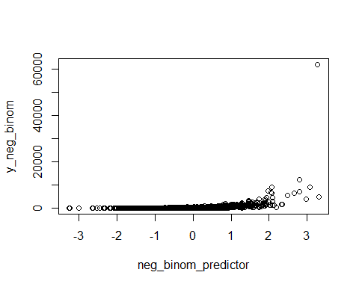

negative_binomial_model<-glm.nb(y_neg_binom ~ neg_binom_predictor, data=data_negbiom)  
summary(negative_binomial_model)

##   
## Call:  
## glm.nb(formula = y_neg_binom ~ neg_binom_predictor, data = data_negbiom,   
## init.theta = 2.062995895, link = log)  
##   
## Coefficients:  
## Estimate Std. Error z value Pr(>|z|)   
## (Intercept) 4.99848 0.02241 223.0 <2e-16 ***  
## neg_binom_predictor 1.48062 0.02369 62.5 <2e-16 ***  
## ---  
## Signif. codes: 0 '***' 0.001 '**' 0.01 '*' 0.05 '.' 0.1 ' ' 1  
##   
## (Dispersion parameter for Negative Binomial(2.063) family taken to be 1)  
##   
## Null deviance: 5556.1 on 999 degrees of freedom  
## Residual deviance: 1082.6 on 998 degrees of freedom  
## AIC: 11794  
##   
## Number of Fisher Scoring iterations: 1  
##   
##   
## Theta: 2.0630   
## Std. Err.: 0.0902   
##   
## 2 x log-likelihood: -11787.5310

exp(coef(negative_binomial_model)) ### these are on the 'regular' scale, not the log scale

## (Intercept) neg_binom_predictor   
## 148.188170 4.395671

exp(confint(negative_binomial_model))

## Waiting for profiling to be done...

## 2.5 % 97.5 %  
## (Intercept) 141.860664 154.890923  
## neg_binom_predictor 4.196119 4.605886

pR2(negative_binomial_model)

## fitting null model for pseudo-r2

## llh llhNull G2 McFadden r2ML   
## -5893.7652823 -6833.8022956 1880.0740265 0.1375570 0.8474212   
## r2CU   
## 0.8474222

### r2CU (Nagelkerke R2 is the most comparable to our typical R2)

### Question: The coefficient for neg_binom_predictor is 1.5 (FILL ME IN!) This means that the expected log count for a one-unit increase in neg_binom_predictor is 1.5. This means that the count difference (biological scale) for a one unit increase in neg_binom_predictor is 4.481689. The R2 for this model is 0.8342348 This means that 83.42% of the model explains the variance seen in the data.