Bi-directional LSTM.

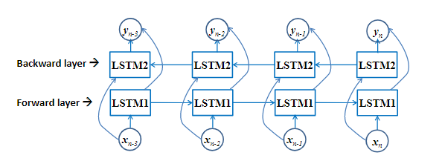

When a problem requires a reverse flow of information then it’s better to use this model.

Example : POS tagging (Part of speech) .

Example:

model = Sequential()  
model.add(Bidirectional(LSTM(10, return_sequences=True), input_shape=(5, 10)))  
model.add(Bidirectional(LSTM(10)))  
model.add(Dense(5))  
model.add(Activation('softmax'))  
model.compile(loss='categorical_crossentropy', optimizer='rmsprop')  
  
 # With custom backward layer  
 model = Sequential()  
 forward_layer = LSTM(10, return_sequences=True)  
 backward_layer = LSTM(10, activation='relu', return_sequences=True,  
                       go_backwards=True)  
 model.add(Bidirectional(forward_layer, backward_layer=backward_layer,  
                         input_shape=(5, 10)))  
 model.add(Dense(5))  
 model.add(Activation('softmax'))  
 model.compile(loss='categorical_crossentropy', optimizer='rmsprop')

Example 2:

from keras.models import Sequential

from keras.layers import Activation, LSTM, Merge, TimeDistributedDense

from keras.optimizers import SGD

def fork (model, n=2):

forks = []

for i in range(n):

f = Sequential()

f.add (model)

forks.append(f)

return forks

# First bidirectional LSTM layer

forward = Sequential()

forward.add(LSTM(output_dim=512, input_shape=(50, 43), return_sequences=True))

backward = Sequential()

backward.add(LSTM(output_dim=512, input_shape=(50, 43), return_sequences=True, go_backwards=True))

model = Sequential()

model.add(Merge([forward, backward], mode='concat'))

# Second bidirectionl LSTM layer

forward_2, backward_2 = fork(model)

forward_2.add(LSTM(output_dim=512, input_shape=(50, 512), return_sequences=True))

backward_2.add(LSTM(output_dim=512, input_shape=(50, 512), return_sequences=True, go_backwards=True))

model = Sequential()

model.add(Merge([forward_2, backward_2], mode='concat'))

# Softmax decision layer

model.add(TimeDistributedDense(output_dim=5))

model.add(Activation('softmax'))

# Optimizer function

sgd = SGD(lr=0.1, decay=1e-5, momentum=0.9, nesterov=True)

model.compile(loss='categorical_crossentropy', optimizer=sgd)

print("Train...")

model.fit([X_train, X_train], Y_train, batch_size=1, nb_epoch=nb_epoches, validation_data=([X_test, X_test], Y_test), verbose=1, show_accuracy=True)

Reference Link:

1: <https://www.tensorflow.org/api_docs/python/tf/keras/layers/Bidirectional>

2: <https://github.com/keras-team/keras/issues/1629>