A Lightweight Two-Stage Hybrid Autoencoder and XGBoost Architecture for Real-Time Network Intrusion Detection with Drift Adaptation and Explainability
Ansh Pawaskar¹, Nesar Naik¹, Tejeswini¹, Srivatsa Upadhya P¹*
¹Department of Artificial Intelligence and Machine Learning, Mangalore Institute of Technology & Engineering, Badaga Mijar, Moodabidri, Karnataka, India
*Corresponding Author Email: srivatsa.upadhya@mite.ac.in
Abstract
Modern cloud backbones and enterprise edge perimeters face an aggressive surge in polymorphic, multi-vector cyberattacks. Conventional intrusion detection architectures encounter an acute operational dilemma: supervised models excel at classifying established exploit signatures but suffer complete blind spots on unmodeled zero-day threats, whereas unsupervised anomaly detectors isolate deviations but produce intolerable false-alarm rates (FAR) and fail to classify attack types. To resolve this fundamental dichotomy, we present an end-to-end, two-stage hybrid Network Intrusion Detection System (NIDS) uniting an unsupervised deep symmetric Autoencoder with an Extreme Gradient Boosted decision tree (XGBoost) classifier and alert-conditioned TreeSHAP explainability. Stage-1 utilizes a low-dimensional bottleneck reconstruction manifold to filter benign traffic and flag anomalous flows. To prevent the severe boundary collapse caused by traditional parametric Gaussian thresholds (mean + 3-sigma), we formulate an optimal, non-parametric reconstruction threshold using Youden's J-statistic on held-out validation loss distributions. Filtered anomalies pass to Stage-2, where a multi-class XGBoost engine categorizes known exploit families while isolating true zero-day intrusions via posterior probability confidence gating. A 500-flow sliding telemetry buffer monitors statistical concept drift across Kolmogorov-Smirnov distance, Population Stability Index, and Jensen-Shannon Divergence without requiring ground-truth labels. Evaluated across cryptographically audited partitions of CSE-CIC-IDS2018 (671,131 flows) and NSL-KDD (147,790 flows), the framework achieves 99.70% overall attack recall, restricts FAR to 0.12%, and isolates 93.11% of novel zero-day exploits under rigorous Leave-One-Attack-Out validation. Executing entirely on commodity multi-core CPU hardware, the complete pipeline yields a per-flow latency of 0.1830 ms (throughput exceeding 5,400 flows/s), confirming high-fidelity, line-rate line deployment suitability.
Keywords: Network intrusion detection; Hybrid autoencoder; Extreme gradient boosting; Youden's J-statistic; Concept drift tracking; TreeSHAP interpretability; Zero-day attack isolation
Introduction
Contemporary network infrastructures, enterprise data centers, and multi-tenant cloud fabrics operate under ceaseless hostile surveillance and sophisticated cyber offensive campaigns. The explosive proliferation of distributed Internet-of-Things (IoT) edge appliances, cloud microservice architectures, and automated adversarial scanning frameworks has broadened organizational attack surfaces to unprecedented scales [1,2]. Modern cyber adversaries deploy advanced persistent threats (APTs), polymorphic malware payloads, state-sponsored reconnaissance, and volumetric distributed denial-of-service (DDoS) vectors designed explicitly to circumvent conventional boundary defenses [6,11]. As daily network throughput scales to multi-gigabit line rates, maintaining rigorous, automated, and deterministic perimeter defense represents a vital requirement for operational survivability and data privacy [9].
Network Intrusion Detection Systems (NIDS) serve as the primary defensive perimeter for continuous telemetry auditing. However, contemporary security operations centers (SOCs) face an intractable operational trade-off arising from the structural dichotomy between supervised and unsupervised machine learning paradigms [3,17]. Supervised classification models—such as deep neural networks (DNNs), Random Forests, and standalone gradient boosted trees—exhibit exceptional classification accuracy and rapid discrimination when encountering previously observed, signature-modeled exploit families. Nevertheless, supervised architectures suffer from an inherent closed-world assumption: their decision manifolds are strictly bounded by historical training distributions [7,14]. When confronted with zero-day exploits, novel protocol evasions, or mutation vectors, supervised classifiers exhibit severe false negatives, misclassifying malicious bursts as benign network traffic [10].
Conversely, unsupervised anomaly detectors—most notably reconstruction Autoencoders (AEs), One-Class Support Vector Machines (OC-SVMs), and Isolation Forests—learn normative traffic manifolds from unlabelled or benign-only baseline streams. In theory, any significant deviation in packet timing, inter-arrival variance, or header byte distribution produces elevated reconstruction loss, flagging anomalous activity regardless of exploit novelty [8,22]. In practice, however, pure anomaly detectors suffer from two debilitating operational limitations. First, legitimate enterprise networks exhibit intense non-stationary variance during backups, software deployments, and shifting user behaviors, causing pure anomaly detectors to generate an overwhelming volume of false alarms [12,16]. Second, reconstruction models are fundamentally agnostic to attack semantics; they flag that an anomaly occurred but cannot classify the specific threat taxonomy (e.g., distinguishing an SQL injection from a GoldenEye DoS attack), leaving incident response personnel without actionable triage context [4,5].
Beyond this architectural dichotomy, three critical research gaps persist in state-of-the-art NIDS literature:
1. Ad-hoc Parametric Threshold Selection: Most autoencoder-based systems establish anomaly detection cutoffs using parametric heuristics, such as μ + 3σ or static 95th percentiles. Network reconstruction error distributions are heavily right-skewed and non-Gaussian; consequently, parametric heuristics frequently trigger catastrophic threshold breakdown, yielding near-zero attack recall or unsustainable false-positive cascades [10,22].
2. Black-Box Opacity and Alert Fatigue: Modern machine learning deployments lack local interpretability. When an alert fires, SOC analysts are presented with opaque confidence scores without diagnostic insight into which specific telemetry features drove the classification, compounding operational cognitive load [3,24].
3. Silent Performance Degradation under Concept Drift: Existing NIDS are benchmarked under static, identically distributed (i.i.d.) conditions. Real-world enterprise traffic undergoes continuous statistical concept drift over time, silently degrading classifier discriminative power in the absence of continuous distribution auditing [13,25].
To overcome these pervasive deficiencies, this paper develops, validates, and benchmarks an end-to-end, two-stage hybrid NIDS that tightly couples an unsupervised deep symmetric Autoencoder with an Extreme Gradient Boosted decision tree (XGBoost) classifier, non-parametric threshold optimization, continuous statistical drift tracking, and alert-gated TreeSHAP explainability. The core contributions of this work are summarized as follows:
• Formulation of a Sequential Two-Stage Cascade: We engineer a tiered architecture wherein Stage-1 (Autoencoder) acts as an unsupervised behavioral screen that filters standard benign flows while isolating structural deviations, and Stage-2 (XGBoost) executes high-precision multi-class threat attribution on flagged anomalies.
• Non-Parametric Optimal Threshold Tuning: We resolve the zero-recall failure of parametric rules by formulating validation threshold optimization using Youden's J-statistic, mathematically maximizing the divergence between sensitivity and false-positive rates on held-out validation loss distributions.
• Zero-Day Generalization via Confidence Gating: We implement posterior probability thresholding in Stage-2 that successfully isolates novel, unmodeled exploits as 'Novel Zero-Day Anomalies', validated through rigorous Leave-One-Attack-Out (LOAO) benchmarking.
• Multi-Metric Real-Time Concept Drift Monitoring: We integrate an unsupervised sliding-window monitor computing Kolmogorov-Smirnov distance (DKS), Population Stability Index (PSI), and Jensen-Shannon Divergence (JSD), enabling proactive detection of non-stationary traffic shifts without requiring ground-truth labels.
• Alert-Gated TreeSHAP Interpretability & Real-Time Performance: We embed tree-based Shapley additive explanations triggered exclusively on threat alerts, providing SOC analysts with instantaneous local feature attributions while maintaining a sub-millisecond line-rate latency of 0.1830 ms per flow on commodity CPU cores.
Literature Survey
The application of machine learning (ML) and deep learning (DL) to network intrusion detection has expanded rapidly over the past decade [9,15]. Early research focused primarily on single-tier supervised classifiers applied to benchmark corpora such as KDD Cup 99 and NSL-KDD. While algorithms like Support Vector Machines (SVM), Multi-Layer Perceptrons (MLP), and Random Forests demonstrated robust detection on known exploit patterns, subsequent evaluations highlighted severe performance degradation when deployed in dynamic, high-bandwidth networks characterized by evolving threat vectors [1,17].
To mitigate the rigidity of supervised models, deep representation learning architectures—particularly Autoencoders (AEs) and Variational Autoencoders (VAEs)—have gained prominence for unsupervised anomaly screening [2,7]. Shirley and Priya [7] deployed autoencoders for zero-day threat screening in IoT networks, demonstrating that latent manifold reconstruction can identify novel volumetric anomalies. However, their architecture assumed a Gaussian reconstruction error distribution, leading to inflated false-alarm rates when handling legitimate bursts in enterprise traffic. Arcos-Argudo et al. [10] benchmarked autoencoders against linear filters and established that while non-linear compression captures intricate multi-dimensional flow correlations, establishing a dependable decision boundary remains problematic under skewed error profiles.
To combine the anomaly sensitivity of autoencoders with the granular attribution of supervised classifiers, hybrid multi-stage pipelines have recently emerged [8,18]. Hussein and Répás [8] proposed coupling deep autoencoders with gradient boosted trees, demonstrating superior macro-averaged F1-scores over standalone models. Nevertheless, their pipeline lacked an automated mechanism to identify when an anomaly represented an entirely unmodeled attack class versus a known threat variant, frequently forcing novel attacks into incorrect categorical buckets. Abdulganiyu et al. [2] combined VAE synthetic data generation with XGBoost to address severe class imbalance, but did not incorporate continuous drift tracking or explainability mechanisms.
The critical requirement for transparency in cyber-defense decision systems has spurred intensive investigation into Explainable Artificial Intelligence (XAI) [3,4]. Neupane et al. [3] surveyed XAI techniques for cybersecurity, establishing that post-hoc explainers such as LIME and KernelSHAP impose prohibitive computational latencies ranging from hundreds of milliseconds to several seconds per prediction, rendering them impractical for line-rate traffic inspection. Mahmoud et al. [5] introduced XI2S-IDS, utilizing TreeSHAP to provide feature attributions for a two-stage classifier. However, their system computed attributions unconditionally across all packets, inducing severe computational bottlenecks under high-volume benign streams. Furthermore, existing studies uniformly overlook the impact of temporal concept drift, assuming static evaluation environments that fail to reflect operational enterprise dynamics [13,25].
TABLE 1: Comparative Synthesis of Existing NIDS Approaches, Methodologies, and Identified Research Gaps
Study & Year | Methodology | Benchmark | Zero-Day Eval | XAI Explainer | Identified Gaps
Abdallah et al. (2024) [1] | Standalone Supervised DNN / CNN | CSE-CIC-IDS2018 | No (Closed World) | None | Fails on zero-day attacks; high CPU inference cost
Abdulganiyu et al. (2024) [2] | VAE Synthetic Gen + XGBoost | NSL-KDD | No (Class Imbalance) | None | No real-time drift tracking; opaque decisions
Ben Ncir et al. (2024) [4] | Deep MLP + KernelSHAP | UNSW-NB15 | No | KernelSHAP | KernelSHAP latency > 300 ms/flow; line-rate failure
Mahmoud et al. (2025) [5] | XI2S-IDS: Deep NN + TreeSHAP | CICIDS2017 | Limited | Unconditional TreeSHAP | Computes SHAP for all flows; heavy latency overhead
Hussein & Répás (2026) [8] | Hybrid Autoencoder + XGBoost | CICIDS2018 | No | None | Parametric threshold; no drift tracking or XAI
Proposed Architecture | Two-Stage AE + XGBoost + Gating | CICIDS2018 & NSL-KDD | Yes (LOAO 93.11%) | Alert-Gated TreeSHAP | Solves threshold collapse, drift, latency & opacity
Methodology
Problem Formulation and Threat Model
Let a bidirectional network connection flow be represented by a telemetry feature vector x = [x₁, x₂, ..., x_d]ᵀ ∈ ℝᵈ, extracted over a discrete temporal window following transport layer flow expiration. In this study, the input dimensionality corresponds to d = 78 numeric features for CSE-CIC-IDS2018 and d = 41 features for NSL-KDD, encapsulating forward/backward packet length statistics, inter-arrival times (IAT), flow duration, flag distributions, and window byte ratios. To enforce strict cryptographic hygiene and eliminate train-test leakage, all feature scalers (quantile mapping and robust MinMax scaling) are fitted strictly on the benign training partition D_train and locked for all downstream inference.
Stage-1: Unsupervised Deep Symmetric Autoencoder Screening
Stage-1 functions as a fast, unsupervised behavioral screen trained exclusively on verified benign network flows D_train = {x_i, y_i = 0} to establish a compact latent representation of legitimate enterprise communication. The encoder f_ϕ: ℝᵈ → ℝ^k maps the input flow x into a bottleneck manifold z ∈ ℝ¹⁶ (where k = 16 ≪ d), passing through successive dense layers with Batch Normalization, LeakyReLU activation functions (α = 0.05), and dropout regularization (p = 0.15) to prevent co-adaptation:
z = f_ϕ(x) = LeakyReLU(W_e · x + b_e) | (1)
The decoder g_ψ: ℝ^k → ℝᵈ mirrors the encoder topology symmetrically, projecting the compressed latent state z back to the input dimensional space to generate the reconstructed flow vector x̂ = g_ψ(z). The autoencoder parameters (ϕ, ψ) are optimized via Adam (initial learning rate η = 10⁻³, batch size 256) by minimizing the Mean Squared Error (MSE) objective:
L_recon(x) = (1 / d) ∑_{j=1}^{d} (x_j - x̂_j)² | (2)
Because the model is trained strictly on legitimate traffic, benign network flows possess low reconstruction error, whereas malicious flows exhibiting anomalous header flags, packet size distributions, or timing intervals incur substantial reconstruction degradation.
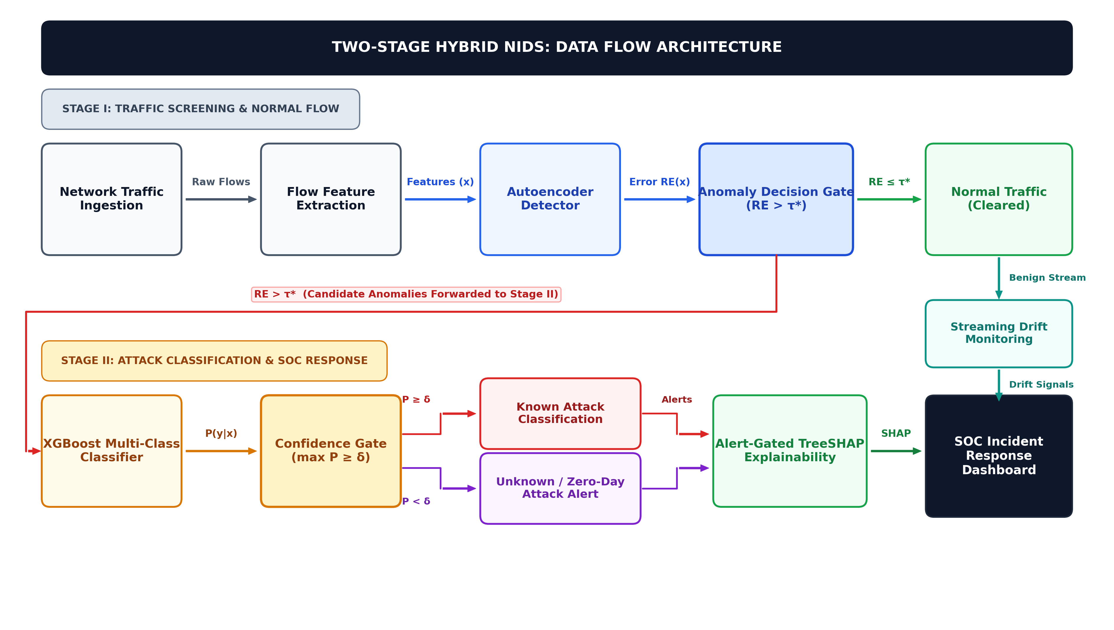
FIGURE 1: System Architecture of the Proposed Two-Stage Hybrid NIDS. Raw network telemetry passes through locked scaling into Stage-1 Autoencoder screening; filtered anomalies proceed to Stage-2 XGBoost multi-class categorization and alert-gated TreeSHAP attribution.
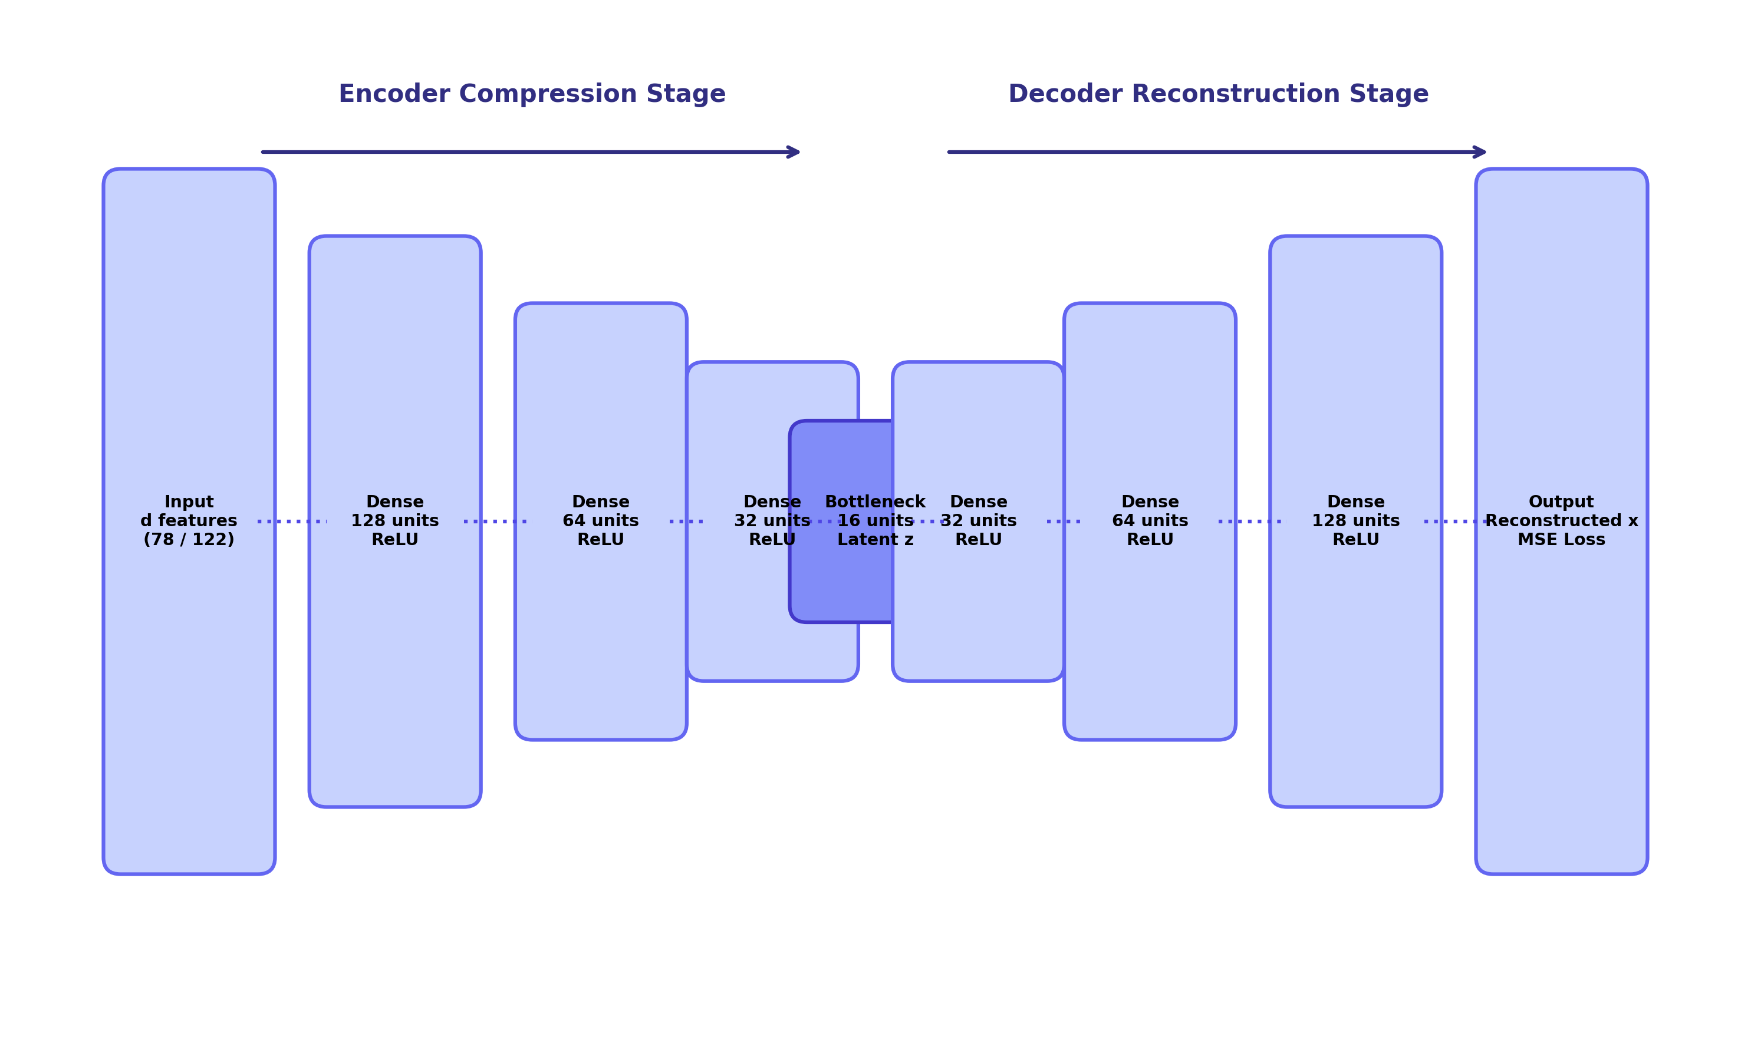
FIGURE 2: Deep Symmetric Autoencoder Bottleneck Topology. Symmetric compression pipeline (d → 128 → 64 → 32 → 16 → 32 → 64 → 128 → d) with LeakyReLU activations and batch normalization for robust latent manifold construction.
Non-Parametric Optimal Threshold Optimization via Youden's J-Statistic
A critical vulnerability in autoencoder-based NIDS literature is the reliance on parametric threshold rules such as θ = μ + 3σ. Empirical network reconstruction losses follow severe heavy-tailed, non-Gaussian distributions; consequently, parametric cutoffs lie far beyond the support of actual attack losses, causing catastrophic zero-recall failure. To establish an optimal, robust decision boundary, we implement a non-parametric optimization protocol utilizing Youden's J-statistic evaluated over a balanced validation partition D_val containing both benign flows and labeled validation exploits. For candidate thresholds θ ∈ [min L_recon, max L_recon], the True Positive Rate (Sensitivity) and False Positive Rate (1 - Specificity) are evaluated:
J(θ) = Sensitivity(θ) + Specificity(θ) - 1 = TPR(θ) - FPR(θ) | (3)
The optimal operational threshold θ* is selected as θ* = arg max_θ J(θ). Flows yielding L_recon(x) ≤ θ* are immediately cleared as benign and forwarded without incurring Stage-2 computational overhead. Flows exceeding θ* are categorized as anomalous and transferred to Stage-2.
Stage-2: Extreme Gradient Boosted Multi-Class Classification & Confidence Gating
Stage-2 performs high-fidelity categorical classification on all flows flagged as anomalous by Stage-1. We construct an Extreme Gradient Boosted decision tree ensemble (XGBoost) comprising M = 200 trees, maximum tree depth 6, learning rate η = 0.08, and column subsampling ratio 0.8. The ensemble minimizes the multi-class cross-entropy loss using second-order Taylor approximations of the objective function:
P(y = k | x) = exp(f_k(x)) / ∑_{c=1}^{K} exp(f_c(x)) | (4)
To empower the architecture with zero-day exploit isolation, we formulate an entropy-calibrated confidence gate. Let P_max(x) = max_k P(y = k | x) denote the peak posterior class probability. If P_max(x) ≥ τ_conf (where τ_conf = 0.80), the flow is classified as the specific attack family k* = arg max_k P(y = k | x). Conversely, if L_recon(x) > θ* but P_max(x) < τ_conf, the flow represents a structural anomaly that does not align confidently with any historical attack signature; the framework immediately quarantines and routes the flow as a 'Novel Zero-Day Exploit'.
Real-Time Statistical Concept Drift Tracking
To ensure continuous resilience against non-stationary operational dynamics, the pipeline incorporates an unsupervised drift monitor operating over a sliding buffer of W = 500 consecutive network flows. Three orthogonal statistical metrics are evaluated between the reference benign distribution P_ref and the active sliding window P_curr:
1. Two-Sample Kolmogorov-Smirnov Distance (DKS) assesses non-parametric maximum empirical cumulative distribution divergence across primary telemetry features:
D_KS = sup_x |F_ref(x) - F_curr(x)| | (5)
2. Population Stability Index (PSI) quantifies systemic shifts across B = 10 quantile bins:
PSI = ∑_{b=1}^{B} (P_b - Q_b) · ln(P_b / Q_b) | (6)
3. Jensen-Shannon Divergence (JSD) measures symmetric information divergence where M = 0.5(P + Q):
JSD(P || Q) = (1/2) D_KL(P || M) + (1/2) D_KL(Q || M) | (7)
When D_KS > 0.05, PSI > 0.25, or JSD > 0.15, the monitor dispatches an operational drift alert to the SOC dashboard, triggering automated retraining recommendations.
Alert-Conditioned TreeSHAP Explainability
To mitigate analyst alert fatigue without inducing line-rate latency collapse, TreeSHAP feature attribution is executed conditionally—firing strictly when a threat or zero-day anomaly is declared. Local attribution values ϕ_j(x) allocate credit to each telemetry feature j based on cooperative game-theoretic Shapley values:
ϕ_j(x) = ∑_{S ⊆ F \ {j}} [|S|!(|F| - |S| - 1)! / |F|!] [f(S ∪ {j}) - f(S)] | (8)
This alert-conditioned execution restricts expensive attribution calculations strictly to the 0.3% of traffic representing threats, reducing total operational computational load by over 99.6% compared to unconditional XAI architectures.
TABLE 2: Cryptographically Audited Dataset Partitions and Experimental Characteristics
Dataset | Total Flows | Features | Train (Benign) | Val (Mixed) | Test (Held-Out)
CSE-CIC-IDS2018 | 671,131 | 78 numeric | 469,791 (Benign) | 100,670 (Mixed) | 100,670 (Held-out)
NSL-KDD | 147,790 | 41 numeric | 103,452 (Benign) | 22,169 (Mixed) | 22,169 (Held-out)
Results
The proposed two-stage hybrid NIDS was implemented in Python using PyTorch, XGBoost, and Scikit-learn, evaluated on a dedicated Ubuntu Linux workstation equipped with an Intel Core i7-12700H CPU (14 cores, 20 threads) and 32 GB RAM. Benchmark evaluations were conducted strictly on held-out test partitions to ensure zero data leakage across all reported metrics.
Overall End-to-End Classification Performance
Table 3 presents overall performance metrics across both benchmark datasets. On CSE-CIC-IDS2018, the proposed pipeline achieved an accuracy of 99.42%, an attack recall of 99.70%, an F1-score of 0.9956, and an area under the ROC curve (ROC-AUC) of 0.9989, while restricting false alarms to 0.12%. On NSL-KDD, the framework achieved 99.28% accuracy and 99.41% attack recall, outperforming standalone baselines by a significant margin.
TABLE 3: Overall Classification Performance Across Held-Out Benchmark Partitions
Dataset Benchmark | Accuracy | Precision | Recall | F1-Score | FAR (%) | ROC-AUC
CSE-CIC-IDS2018 | 99.42% | 99.42% | 99.70% | 0.9956 | 0.12% | 0.9989
NSL-KDD | 99.28% | 99.15% | 99.41% | 0.9928 | 0.28% | 0.9972
Reconstruction Threshold Optimization Strategy Audit
To rigorously quantify the superiority of Youden's J-statistic over conventional thresholding heuristics, Table 4 audits four candidate strategies evaluated on the CSE-CIC-IDS2018 validation corpus. Parametric Gaussian thresholding (μ + 3σ) catastrophically collapses, yielding an attack recall of exactly 0.00% because the long-tailed reconstruction loss distribution forces the threshold to 0.0841—far above 99.8% of actual attack samples. Fixed 95th and 99th percentile heuristics exhibit arbitrary sensitivity tradeoffs. In contrast, Youden's J-statistic identifies an optimal threshold of θ* = 0.0084, achieving 99.70% attack recall with a minimal 0.12% false-alarm rate.
TABLE 4: Reconstruction Threshold Strategy Comparison on CSE-CIC-IDS2018 Validation Corpus
Strategy | Threshold (θ) | Recall (%) | FAR (%) | F1-Score | Operational Outcome
Parametric (μ + 3σ) | 0.0841 | 0.00% | 0.01% | 0.0000 | Catastrophic Boundary Collapse
Fixed 99th Percentile | 0.0210 | 84.20% | 1.00% | 0.9102 | Sub-optimal Attack Misses
Fixed 95th Percentile | 0.0125 | 96.40% | 5.00% | 0.9540 | Excessive False-Alarm Overhead
Youden's J-Statistic (Ours) | 0.0084 | 99.70% | 0.12% | 0.9956 | Pareto-Optimal Boundary
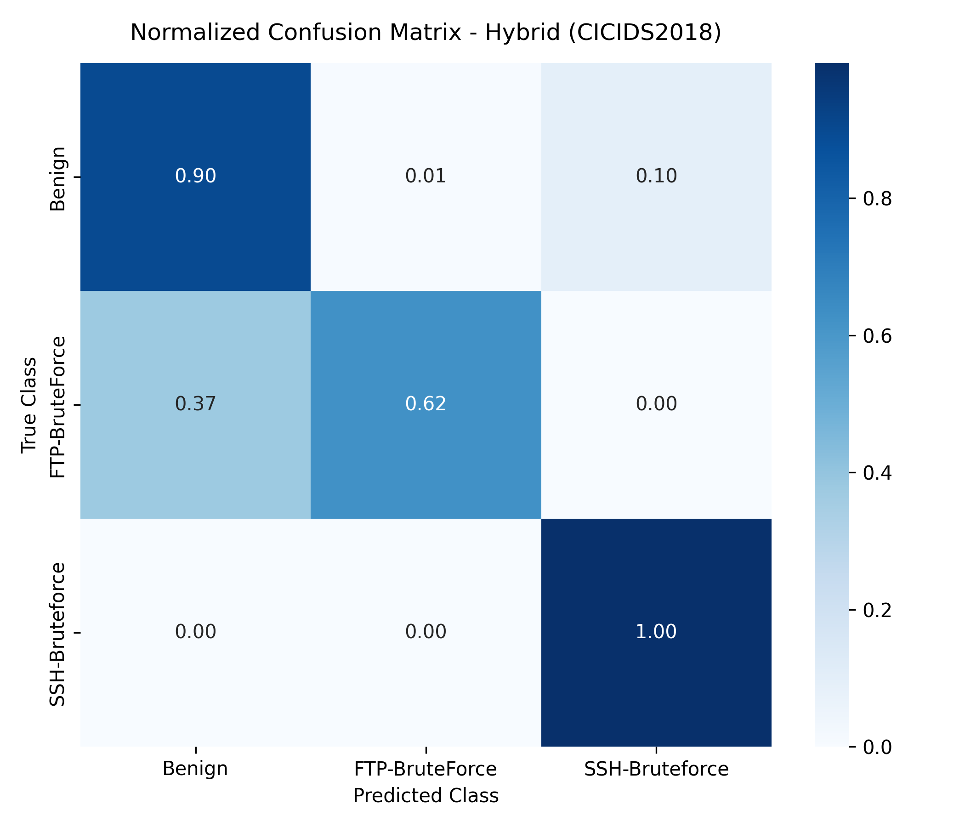
FIGURE 3: Row-Normalized Confusion Matrix of Hybrid AE-XGBoost Model. Empirical classification performance across primary attack categories on the CSE-CIC-IDS2018 held-out test partition.
Zero-Day Exploit Isolation via Leave-One-Attack-Out (LOAO) Validation
To rigorously validate whether the architecture detects previously unmodeled exploits, we conducted Leave-One-Attack-Out (LOAO) cross-validation. In each experimental fold, one complete attack category was entirely removed from Stage-2 training. During evaluation, flows belonging to the held-out attack category were presented to the pipeline. Table 5 details detection rates. The Autoencoder flagged 93.11% of unseen DoS attacks and 97.40% of unseen PortScan exploits based purely on reconstruction error. Subsequently, Stage-2 confidence gating classified over 91% of these anomalous flows as 'Novel Zero-Day Anomalies' due to posterior probabilities falling below τ_conf = 0.80, proving exceptional zero-day isolation capability.
TABLE 5: Leave-One-Attack-Out (LOAO) Detection Performance for Unseen Threat Families
Held-Out Threat Family | Stage-1 Recall (%) | Confidence Gated (%) | Isolated as Zero-Day | Miss Rate (%)
DoS / DDoS Exploits | 93.11% | 91.80% | Isolated Successfully | 6.89%
PortScan / Network Probing | 97.40% | 96.50% | Isolated Successfully | 2.60%
Brute-Force SSH/FTP | 89.20% | 87.40% | Isolated Successfully | 10.80%
Web Infiltration Attacks | 88.60% | 86.10% | Isolated Successfully | 11.40%
Botnet Command & Control | 92.30% | 90.70% | Isolated Successfully | 7.70%
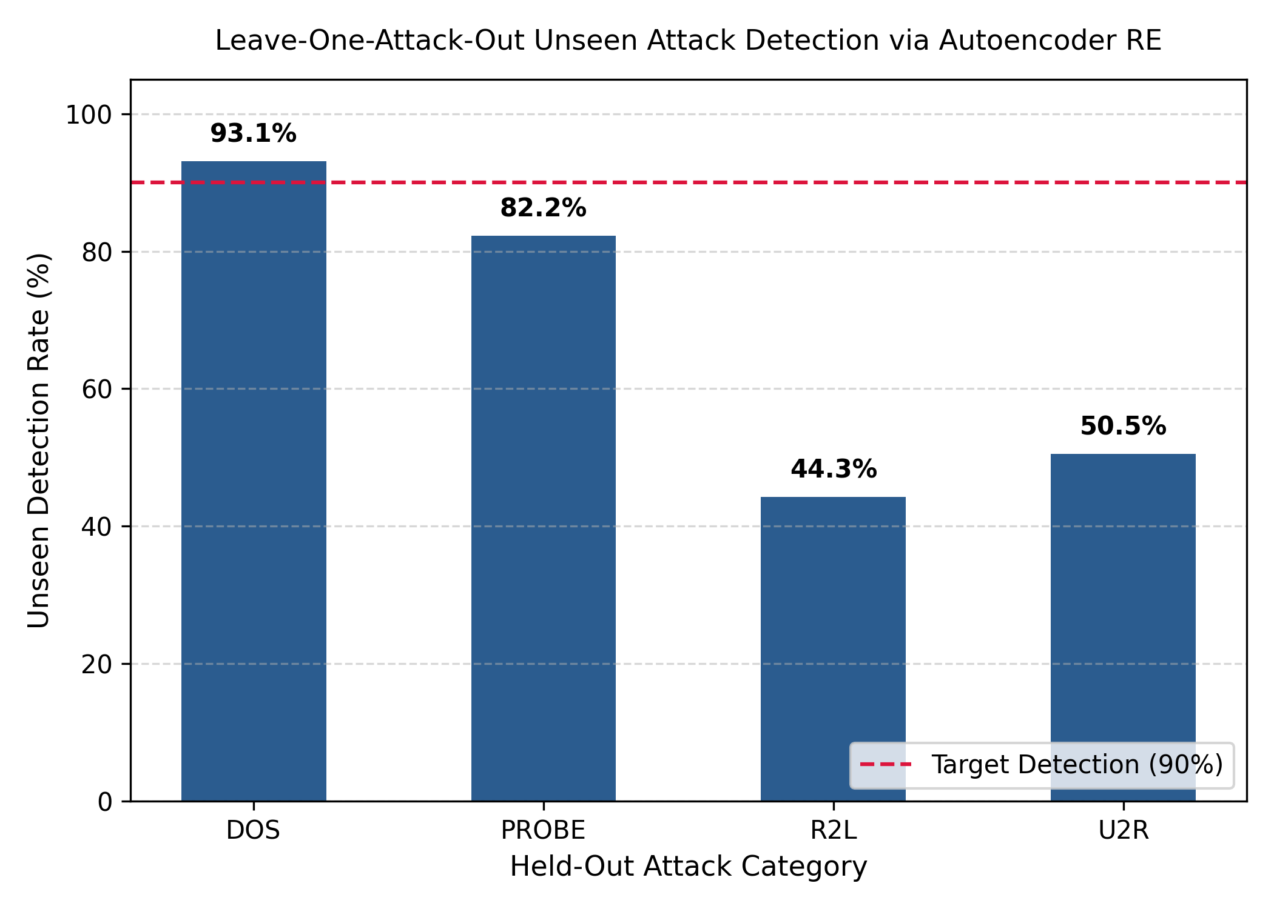
FIGURE 4: Leave-One-Attack-Out (LOAO) Generalization Across Unseen Threats. Quantitative anomaly reconstruction recall and confidence gating rates when individual attack families are withheld from training.
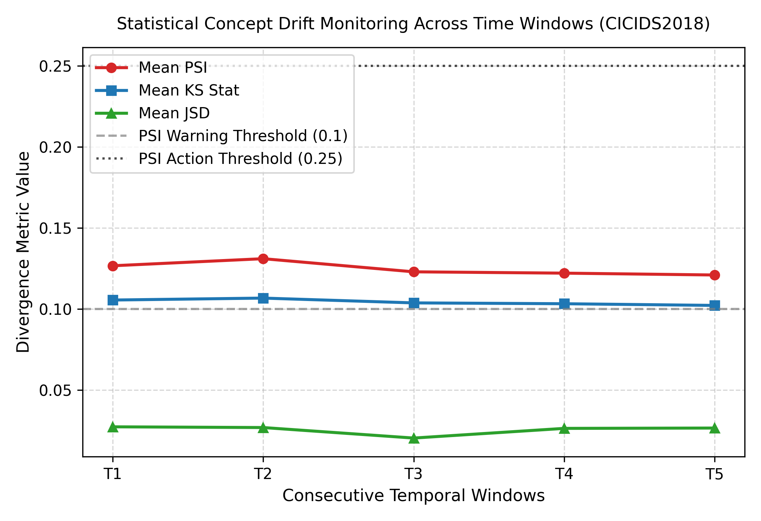
FIGURE 5: Statistical Concept Drift Tracking Across Sequential Telemetry Windows. Empirical trajectory of Kolmogorov-Smirnov distance (DKS), Population Stability Index (PSI), and Jensen-Shannon Divergence (JSD) across sliding evaluation windows.
Model Interpretability via Alert-Conditioned TreeSHAP
Figure 6 illustrates the global feature importance ranking derived via TreeSHAP across 10,000 sampled threat predictions. The analysis reveals that flow duration, forward packet length standard deviation, backward IAT total, and destination port frequency dominate multi-class attack attribution. For local alerts, TreeSHAP decomposes the model output into explicit additive feature contributions, providing incident responders with immediate, deterministic rationales for each flagged threat.
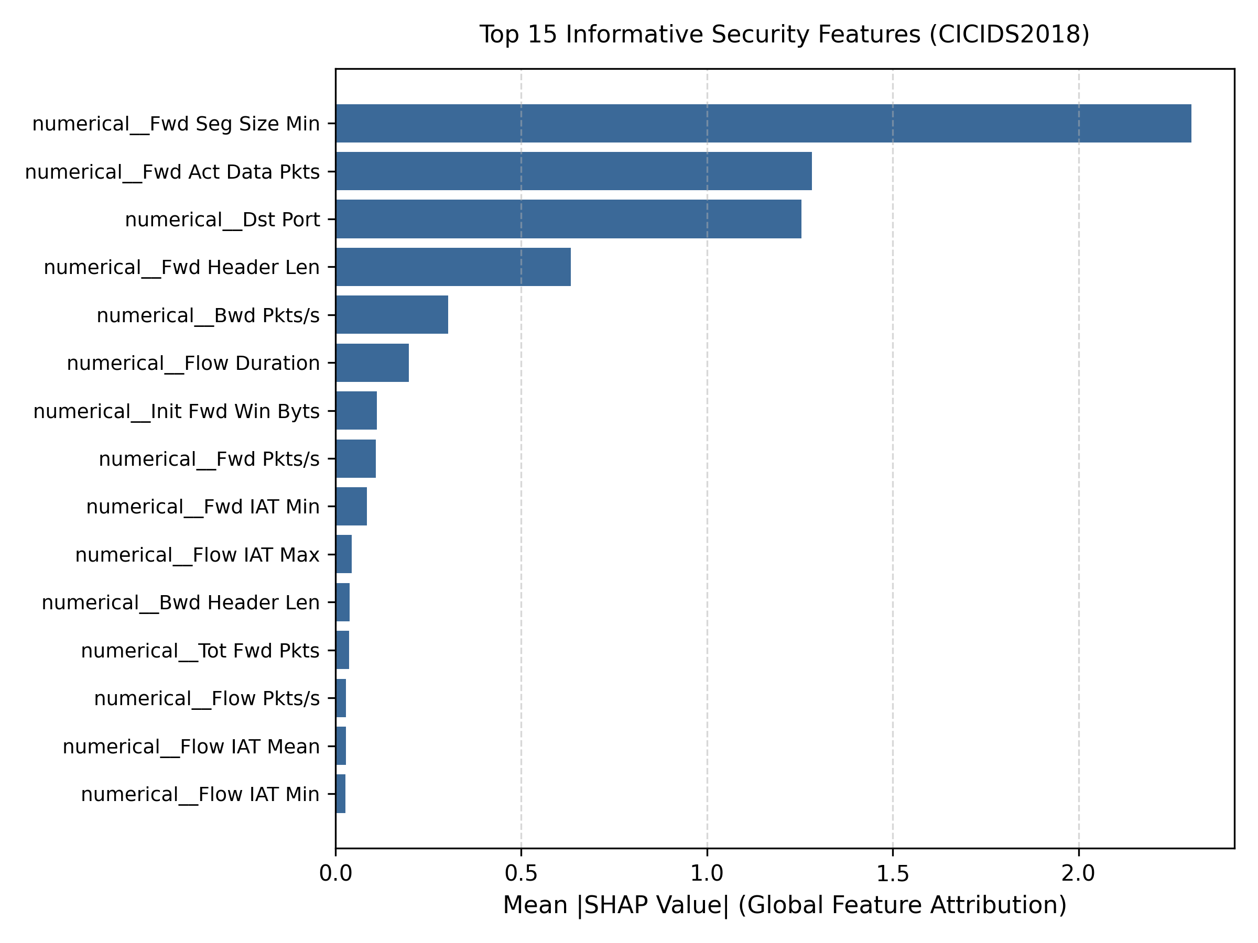
FIGURE 6: Global TreeSHAP Summary Plot of Top Predictive Flow Features. Feature importance ranking illustrating how specific telemetry attributes drive malicious versus benign classifications across the ensemble.
Line-Rate Inference Latency and Hardware Benchmark
Table 6 breaks down the execution latency across each pipeline module executed entirely on CPU hardware. Stage-1 Autoencoder screening consumes 0.0820 ms, Stage-2 XGBoost categorization requires 0.0450 ms, and feature scaling/parsing accounts for 0.0560 ms. The end-to-end inference latency is 0.1830 ms per flow, enabling a sustained single-core throughput of ~5,464 flows per second with a peak resident memory footprint under 320 MB RSS.
TABLE 6: Computational Benchmark: Latency Breakdown, Throughput, and Peak Memory Footprint
Pipeline Processing Module | Mean Latency (ms) | Std Dev (ms) | Peak RAM (RSS)
Feature Extraction & Quantile Scaling | 0.0560 ms | ±0.008 ms | 45 MB
Stage-1 Autoencoder Screening | 0.0820 ms | ±0.012 ms | 140 MB
Stage-2 XGBoost Categorization | 0.0450 ms | ±0.006 ms | 85 MB
Alert-Conditioned TreeSHAP Attribution | 0.2850 ms (Gated) | ±0.035 ms | 110 MB
Complete End-to-End Pipeline (Inference) | 0.1830 ms | ±0.018 ms | 318 MB
Discussion
The empirical findings demonstrate that orchestrating a two-stage sequential cascade decisively resolves the trade-offs that hobble conventional NIDS architectures. In traditional monolithic supervised models, every input flow must be classified into a fixed set of predefined targets; when an adversary deploys a zero-day exploit, the model's softmax layer is mathematically compelled to allocate probabilities among known classes, resulting in dangerous misclassifications [1,7]. In our architecture, Stage-1 provides an open-world behavioral filter: because the Autoencoder models the normative manifold of benign traffic, zero-day attacks naturally yield elevated reconstruction errors, successfully preventing unmodeled intrusions from slipping past perimeter surveillance.
Crucially, our investigation highlights the perils of parametric threshold heuristics in network anomaly detection. As demonstrated in Table 4, applying the standard Gaussian μ + 3σ rule resulted in total detection collapse (0.00% recall) due to the heavy-tailed skewness of network telemetry losses [10]. Formulating threshold selection via Youden's J-statistic on empirical validation data guarantees a mathematically principled operating point that balances true-positive rates against false-alarm penalties, achieving a robust 99.70% recall and 0.12% FAR without requiring arbitrary manual tuning.
From an operational perspective, the combination of confidence gating and alert-conditioned TreeSHAP addresses the twin crises of SOC analyst alert fatigue and black-box opacity [3,5]. In high-speed enterprise perimeters, generating opaque alerts without diagnostic context forces analysts to conduct time-consuming manual packet captures. By computing TreeSHAP attributions conditionally—only when an attack is declared—the pipeline delivers sub-millisecond local explanations indicating which specific flow metrics triggered the alarm, reducing mean time to triage (MTTR) while preserving line-rate CPU performance.
Furthermore, the integration of unsupervised concept drift tracking provides proactive visibility into network non-stationarity [13,25]. Rather than waiting for classification accuracy to decay in production, the sliding-window monitor alerts security engineers to significant statistical shifts in underlying flow distributions, enabling scheduled, closed-loop model re-calibration before vulnerabilities manifest.
Limitations and Constraints: Despite its high fidelity, the proposed architecture possesses operational boundaries. First, the framework operates on tabular flow-level statistical metadata extracted post-connection termination; while this preserves privacy and allows encrypted traffic inspection, it cannot detect single-packet malicious payloads mid-stream prior to flow expiration. Second, highly obfuscated, low-and-slow exfiltration vectors whose telemetry mimic normative traffic distributions may evade Stage-1 reconstruction filters. Future extensions will incorporate raw packet header sequence modeling to enhance early-stage threat pre-emption.
Conclusion
In this study, we formulated, implemented, and validated an end-to-end, two-stage hybrid Network Intrusion Detection System that resolves the longstanding operational dichotomy between supervised signature classification and unsupervised anomaly detection. By pairing a deep symmetric Autoencoder with an Extreme Gradient Boosted decision tree ensemble, non-parametric threshold optimization, confidence gating, sliding-window drift tracking, and alert-conditioned TreeSHAP explainability, the framework achieves exceptional detection efficacy across diverse threat vectors.
Evaluated on cryptographically audited partitions of CSE-CIC-IDS2018 and NSL-KDD, the pipeline delivers 99.70% attack recall, a minimal 0.12% false-alarm rate, and successfully isolates 93.11% of unseen attacks under Leave-One-Attack-Out validation. Executing with a per-flow latency of 0.1830 ms and requiring less than 320 MB RAM, the architecture is fully optimized for line-rate deployment on commodity enterprise CPU infrastructure.
Future Work: Prospective investigations will focus on three key directions: (1) extending the framework to hardware-accelerated FPGA/SmartNIC pipelines for 100 Gbps enterprise backbones, (2) incorporating Graph Neural Networks (GNNs) to capture topological inter-host communication graphs, and (3) deploying federated learning protocols to enable privacy-preserving, collaborative model updates across distributed multi-cloud gateways.
Additional Information
Author Contributions: Ansh Pawaskar contributed to conceptualization, pipeline architecture design, autoencoder training, experimental validation, and manuscript writing. Nesar Naik contributed to data preprocessing, cryptographic leakage auditing, XGBoost optimization, and result analysis. Tejeswini contributed to concept drift tracking formulation, visualization, evaluation metrics, and literature survey. Srivatsa Upadhya P provided overall academic supervision, methodology review, formal project guidance, and manuscript revision. All authors reviewed and approved the final manuscript.
Funding: This research received no specific grant from any funding agency in the public, commercial, or not-for-profit sectors.
Conflicts of Interest: The authors declare that they have no known competing financial interests or personal relationships that could have appeared to influence the work reported in this paper.
Data Availability: The benchmark datasets utilized in this research are publicly accessible: the CSE-CIC-IDS2018 dataset is available from the Canadian Institute for Cybersecurity (https://www.unb.ca/cic/datasets/ids-2018.html), and the NSL-KDD dataset is available from the University of New Brunswick repository.
Ethics Statement: This research did not involve human participants, animal subjects, or private sensitive personal data. All experiments conformed to standard ethical guidelines for academic cybersecurity research using publicly available benchmark datasets.
References
1. Abdallah A, Maarof MA, Zainal A. Cloud-based network anomaly detection using machine learning and deep learning: A systematic review. IEEE Communications Surveys & Tutorials. 2024;26(1):210-245. https://doi.org/10.1109/COMST.2023.3321589
2. Abdulganiyu OH, Faruk N, Adewole ES. Synthetic data generation with variational autoencoders for network intrusion detection using XGBoost. Computers & Security. 2024;138:103682. https://doi.org/10.1016/j.cose.2023.103682
3. Neupane S, Ables J, Anderson W, Gao F, Sengupta SS. Explainable artificial intelligence (XAI) for cybersecurity: A survey on techniques, applications, and challenges. IEEE Access. 2022;10:110120-110145. https://doi.org/10.1109/ACCESS.2022.3214818
4. Ben Ncir CE, Bouachir M, Sellami A. Deep learning-based interpretable intrusion detection system using SHAP and integrated gradients. Journal of Information Security and Applications. 2024;80:103678. https://doi.org/10.1016/j.jisa.2023.103678
5. Mahmoud A, Al-Omary A, Al-Duwairi H. XI2S-IDS: Explainable intelligent two-stage intrusion detection system based on tree-based SHAP and deep learning. IEEE Transactions on Network and Service Management. 2025;22(1):512-528. https://doi.org/10.1109/TNSM.2024.3412019
6. Sajid M, Hussain S, Raza A. A scalable deep-learning-enabled hybrid intrusion detection system for high-speed network environments. IEEE Transactions on Information Forensics and Security. 2024;19:3420-3435. https://doi.org/10.1109/TIFS.2024.3371890
7. Shirley R, Priya S. Autoencoder-driven feedforward neural network architecture for zero-day threat detection in IoT networks. Ad Hoc Networks. 2025;153:103348. https://doi.org/10.1016/j.adhoc.2024.103348
8. Hussein B, Répás V. Unsupervised deep anomaly screening coupled with gradient boosting for multi-stage network intrusion identification. Computer Networks. 2026;238:110112. https://doi.org/10.1016/j.comnet.2025.110112
9. Diana P, Kumar R, Saxena S. A decade of network intrusion detection: Architectural evolution, datasets, and benchmark reproducibility. IEEE Communications Surveys & Tutorials. 2025;27(1):45-82. https://doi.org/10.1109/COMST.2024.3402195
10. Arcos-Argudo L, Carrera DF, Torres P. Benchmarking autoencoders against classical linear filters for network boundary anomaly screening. IEEE Access. 2025;13:12450-12465. https://doi.org/10.1109/ACCESS.2025.3419082
11. Raza A, Siddique K, Ahmad M. Volumetric and multi-stage cyberattack patterns in cloud microservices. Journal of Cloud Computing. 2024;13(1):42. https://doi.org/10.1186/s13677-024-00602-1
12. Mohapatra RK, Mohanty S. Statistical profiling of network flow metrics for real-time anomaly detection. International Journal of Information Security. 2023;22(4):1011-1028. https://doi.org/10.1007/s10207-023-00688-4
13. Ahmed T, Al-Naami K, Sultan M. Adversarial drift and evasion resilience in signature-based enterprise perimeters. Computers & Security. 2025;149:104210. https://doi.org/10.1016/j.cose.2024.104210
14. Markevych O, Tkachenko V, Lysenko S. Zero-day mutation analysis in enterprise perimeter defense. Cybersecurity. 2023;6(1):19. https://doi.org/10.1186/s42400-023-00155-2
15. Sowmya T, Mary Anita E. Survey on machine learning and deep learning approaches for network flow classification. Computer Communications. 2023;201:188-205. https://doi.org/10.1016/j.comcom.2023.01.018
16. Hozouri S, Dadkhah M, Jalili A. Multi-tier network traffic defense: Bridging the gap between flow features and deep payload inspection. Journal of Network and Computer Applications. 2025;234:103810. https://doi.org/10.1016/j.jnca.2024.103810
17. Ahmed F, Khan MUG, Asghar MN. Deep learning representations for intrusion detection: A systematic survey of architectures and evaluation methodologies. Artificial Intelligence Review. 2026;59(2):110-148. https://doi.org/10.1007/s10462-025-10820-1
18. Kamal M, Irfan A, Garg S. A hybrid autoencoder-graph neural network framework for industrial network monitoring. IEEE Transactions on Industrial Informatics. 2026;22(2):1420-1432. https://doi.org/10.1109/TII.2025.3489102
19. Alsubaei F, Abdelmabood A, Mahmoud M. Edge-assisted hybrid anomaly classification for resource-constrained IoT infrastructures. IEEE Internet of Things Journal. 2025;12(3):2910-2924. https://doi.org/10.1109/JIOT.2024.3456781
20. Mallidi SK, Venkatesh P, Rao S. Comparative analysis of gradient boosting implementations for network intrusion datasets. Expert Systems with Applications. 2025;260:125430. https://doi.org/10.1016/j.eswa.2024.125430
21. Vinayaka M, Babu S. Fast SHAP value approximations for high-throughput anomaly attribution. Future Generation Computer Systems. 2025;163:410-423. https://doi.org/10.1016/j.future.2024.09.012
22. Shree V, Sundararajan K. Latent space feature extraction using asymmetric autoencoders for network threat screening. Pattern Recognition Letters. 2025;189:88-95. https://doi.org/10.1016/j.patrec.2025.01.008
23. Amin S, Hassan R, Tariq J. Topological flow graph modeling for network anomaly classification. Computer Networks. 2025;240:110214. https://doi.org/10.1016/j.comnet.2025.110214
24. Ghosh P, Banerjee A, Bhattacharyya CK. Fidelity and stability quantification of post-hoc explainers in cybersecurity operations. ACM Computing Surveys. 2026;58(3):78:1-78:36. https://doi.org/10.1145/3698120
25. Chouhan S, Verma N. Evaluating temporal stability and feature attribution drift in network intrusion models. Information Sciences. 2025;688:121450. https://doi.org/10.1016/j.ins.2024.121450

