MANGALORE INSTITUTE OF TECHNOLOGY & ENGINEERING
(A Unit of Rajalaxmi Education Trust ®, Mangalore)
Autonomous Institute Affiliated to V.T.U, Belagavi, Approved by AICTE, New Delhi
Accredited by NAAC with A+ Grade & ISO 9001:2015 Certified Institution



PROJECT REPORT

23AISE409 PROJECT PHASE – II

A
“AI-BASED NETWORK INTRUSION DETECTION SYSTEM USING LIGHTWEIGHT HYBRID AUTOENCODER AND XGBOOST WITH REAL-TIME DRIFT ADAPTATION”

Submitted in partial fulfillment of the requirements for the award of the degree of

BACHELOR OF ENGINEERING
in

ARTIFICIAL INTELLIGENCE AND MACHINE LEARNING

by

Ansh Pawaskar 4MT23AI009
Nesar Naik 4MT23AI036
Tejeswini 4MT23AI057

Under the Guidance of
Mr. Srivatsa Upadhya P
Assistant Professor

DEPARTMENT OF ARTIFICIAL INTELLIGENCE AND MACHINE LEARNING

2026-27
MANGALORE INSTITUTE OF TECHNOLOGY & ENGINEERING
(A Unit of Rajalaxmi Education Trust ®, Mangalore)
Autonomous Institute Affiliated to V.T.U, Belagavi, Approved by AICTE, New Delhi
Accredited by NAAC with A+ Grade & ISO 9001:2015 Certified Institution

ARTIFICIAL INTELLIGENCE AND MACHINE LEARNING
CERTIFICATE
This is to certify that the Project Phase – II (23AISE409) work entitled “AI-BASED NETWORK INTRUSION DETECTION SYSTEM USING LIGHTWEIGHT HYBRID AUTOENCODER AND XGBOOST WITH REAL-TIME DRIFT ADAPTATION” is a bonafide work carried out by Ansh Pawaskar (4MT23AI009), Nesar Naik (4MT23AI036), Tejeswini (4MT23AI057) in partial fulfillment for the award of degree of Bachelor of Engineering in Artificial Intelligence and Machine Learning by Visvesvaraya Technological University, Belagavi, during the year 2026-27. It is certified that all corrections and suggestions indicated for Internal Assessment have been incorporated in the report deposited in the departmental library. The project has been approved as it satisfies the academic requirements in respect of project work prescribed for the Bachelor of Engineering degree.

Mr. Srivatsa Upadhya P Dr. Sunil Kumar S
Assistant Professor Head of Dept AI&ML

Dr. Prashanth C M
Principal

DECLARATION
We declare that this Project Phase - II (23AISE409) report titled “AI-Based Network Intrusion Detection System Using Lightweight Hybrid Autoencoder and XGBoost with Real-Time Drift Adaptation” submitted in partial fulfillment of the degree of B.E. in Artificial Intelligence and Machine Learning is a record of original work carried out by us under the supervision of Mr. Srivatsa Upadhya P, and has not formed the basis for the award of any other degree, in this or any other Institution or University. In keeping with ethical practice in reporting scientific information, due acknowledgements have been made wherever the findings of others have been cited.
Sr. No. | Name | Signature
1 | Ansh Pawaskar (4MT23AI009)
2 | Nesar Naik (4MT23AI036)
3 | Tejeswini (4MT23AI057)

ACKNOWLEDGEMENTS
We express our sincere gratitude to our project guide, Mr. Srivatsa Upadhya P, Assistant Professor, Department of Artificial Intelligence and Machine Learning, for his continuous mentorship, insightful discussions, and technical encouragement throughout the development of Phase-II. We are deeply grateful to Dr. Sunil Kumar S, Head of the Department, for facilitating departmental computing facilities and providing valuable academic guidance. We also thank our Principal, Dr. Prashanth C M, and the institution's management for providing the academic infrastructure and opportunities to carry out this capstone research. Finally, we convey our heartfelt appreciation to our parents, faculty mentors, and peers whose steadfast encouragement supported us at every stage of this work.
We would like to thank our Project Guide Mr. Srivatsa Upadhya P, Assistant Professor, Department of Artificial Intelligence and Machine Learning for his constant encouragement and support extended throughout.
We would like to express appreciation to Dr. Sunil Kumar S, Head of Department of Artificial Intelligence and Machine Learning for his support and guidance.
We would like to thank our Principal Dr. Prashanth C M, for encouraging us and giving us an opportunity to accomplish the project.
We also thank our management who helped us directly or indirectly in the completion of Phase - II of the project. Our special thanks to faculty members and others for their constant help and support. Above all, we extend our sincere gratitude to our parents and friends for their constant encouragement with moral support.
Ansh Pawaskar (4MT23AI009)
Nesar Naik (4MT23AI036)
Tejeswini (4MT23AI057)

ABSTRACT
Securing enterprise and cloud network boundaries against modern cyber intrusions requires reconciling two contradictory requirements: supervised models reliably identify established attack categories but fail when confronted with unmodeled zero-day intrusions, whereas unsupervised anomaly detectors suffer from excessive false-alarm overhead and catastrophic threshold breakdown when assuming Gaussian error distributions (μ + 3σ). In this research, we develop and validate an end-to-end, two-stage hybrid NIDS that unites an unsupervised deep symmetric Autoencoder (d → 128 → 64 → 32 → 16 → 32 → 64 → 128 → d) with an Extreme Gradient Boosted decision tree (XGBoost) classifier and alert-conditioned TreeSHAP interpretability. Through rigorous cryptographic deduplication of the CSE-CIC-IDS2018 (671,131 sanitized records) and NSL-KDD (147,790 records) corpora, the pipeline achieves an attack recall of 99.70% on documented exploits and isolates 93.11% of unseen Denial of Service attacks under Leave-One-Attack-Out testing. Validation threshold tuning based on Youden's J-statistic resolves the zero-recall collapse seen in parametric rules, while a 500-connection sliding buffer continuously monitors statistical drift. Executed entirely on commodity multi-core CPU hardware, the complete pipeline processes incoming flows at an average latency of 0.1830 ms and provides interactive SOC monitoring via a Streamlit web interface.
Keywords: Network Intrusion Detection, Autoencoder, XGBoost, Anomaly Screening, Youden's J-Statistic, TreeSHAP, Concept Drift, Zero-Day Generalization, Streamlit.

TABLE OF CONTENTS
Sr. NO. | CONTENTS | PAGE NO.
1. | INTRODUCTION | 1
1.1 | Background | 1
1.2 | Problem Statement | 1
1.3 | Motivation / Need for the Project | 2
1.4 | Objectives | 2
1.5 | Scope of the Project | 3
1.6 | Significance / Expected Contribution | 3
1.7 | Organization of the Report | 4
2. | LITERATURE SURVEY | 5
2.1 | Introduction | 5
2.2 | Review of Existing Work | 5
2.3 | Comparative Analysis | 7
2.4 | Research / Design Gap | 8
2.5 | Summary | 8
3. | PROPOSED SYSTEM AND SCOPE | 9
3.1 | Problem Formulation | 9
3.2 | Proposed Solution | 9
3.3 | Requirements | 10
3.3.1 | Functional & Non-Functional Requirements | 10
3.3.2 | Hardware & Software Requirements | 11
3.4 | System Architecture / Block Diagram | 12
3.5 | Functional Components & Scope Constraints | 13
4. | METHODOLOGY | 14
4.1 | Objective and Method / Approach | 14
4.2 | Measurement / Evaluation Parameters | 14
4.3 | Model Architecture and Structural Diagrams | 15
4.3.1 | Autoencoder Latent Topology & Manifold Projection | 15
4.3.2 | Sequence Diagram of Packet Ingestion and Prediction | 16
4.3.3 | Activity Diagram of Tiered Detection and Alert Routing | 17
4.3.4 | Data Flow Diagram (DFD Level-1) for Flow Processing | 18
4.3.5 | Class Diagram and Use Case Diagram | 19
4.4 | Error Sources, Mitigation, and Data Processing | 20
5. | IMPLEMENTATION & EXPERIMENTAL WORK | 21
5.1 | Implementation Environment | 21
5.2 | Module-wise Implementation | 21
5.2.1 | Data Preparation & Cryptographic Hygiene | 21
5.2.2 | Feature Preprocessing & Locked Scaling | 22
5.2.3 | Autoencoder Model Training & Manifold Construction | 22
5.2.4 | Validation Youden's J Threshold Optimization | 23
5.2.5 | XGBoost Multi-Class Classification & Confidence Gating | 23
5.2.6 | Dynamic Concept Drift Monitoring & Alert-Gated TreeSHAP | 24
5.3 | Experimental Setup | 24
5.4 | Prototype & Testing | 26
6. | RESULTS, ANALYSIS AND DISCUSSION | 27
6.1 | Quantitative Classification Results | 27
6.2 | Confusion Matrix & Threshold Analysis | 29
6.3 | Zero-Day Generalization & Drift Tracking | 31
6.4 | Latency, Memory Footprint & Baseline Comparisons | 34
7. | CONCLUSION AND FUTURE SCOPE | 38
7.1 | Summary of Work | 38
7.2 | Conclusions | 38
7.3 | Contributions & Utility | 38
7.4 | Limitations & Scope for Future Work | 39
 | REFERENCES | 40
 | APPENDICES | 42
 | Appendix A: Mathematical Derivations and Objective Functions | 42
 | Appendix B: Scapy Live Packet Sniffing & Flow Extraction Configuration | 42

LIST OF FIGURES
Sr. No. | TITLE | Page No.
Figure 3.1 | System Architecture of the Two-Stage Hybrid NIDS | 12
Figure 4.1 | Sequence Diagram of Packet Ingestion and Prediction | 16
Figure 4.2 | Activity Diagram of Tiered Detection and Alert Routing | 17
Figure 4.3 | Data Flow Diagram (DFD Level-1) for Flow Processing | 18
Figure 4.4 | Class Diagram of Object-Oriented Framework Architecture | 19
Figure 4.5 | Use Case Diagram of Network Intrusion Detection Workflow | 20
Figure 5.1 | Real-Time Network Flow Telemetry and Live Sniffing Monitor | 26
Figure 5.2 | Threat Diagnosis, Alert Gating, and Local TreeSHAP Explanation | 26
Figure 6.1 | Row-Normalized Confusion Matrices for Hybrid AE–XGBoost Model | 29
Figure 6.2 | Row-Normalized Confusion Matrices for Standalone Autoencoder | 30
Figure 6.3 | Reconstruction Threshold Sensitivity and Pareto Optimization Curves | 31
Figure 6.4 | Generalization Audits: Unseen Attack Detection and Chronological Split Decay | 32
Figure 6.5 | Statistical Concept Drift Tracking (DKS, PSI, JSD) Across Windows | 33
Figure 6.6 | TreeSHAP Global Feature Importance Ranking (Summary Plot) | 34
Figure 6.7 | End-to-End Pipeline Execution Latency Breakdown on Multi-Core CPU | 35

LIST OF TABLES
Sr. No. | TITLE | Page No.
Table 2.1 | Comparison of Existing NIDS Approaches, Methodologies, and Gaps | 6
Table 4.1 | Measurement and Evaluation Parameters for Model Assessment | 14
Table 4.2 | Autoencoder Bottleneck Layer Configuration and Dimensionality | 15
Table 5.1 | Cryptographically Audited Dataset Splits Enforcing Zero Leakage | 21
Table 5.2 | Experimental Setup Parameters and Hyperparameter Configurations | 24
Table 5.3 | System Test Cases, Inputs, Expected Outcomes, and Execution Status | 25
Table 6.1 | Overall Classification Performance on Held-Out Test Partitions | 27
Table 6.2 | Multi-Class Attack Detection Breakdown on CICIDS2018 (N = 100,670) | 28
Table 6.3 | Multi-Class Attack Detection Breakdown on NSL-KDD (N = 22,169) | 28
Table 6.4 | Reconstruction Threshold Strategy Comparison on CICIDS2018 | 30
Table 6.5 | Leave-One-Attack-Out (LOAO) Unseen Attack Detection Performance | 32
Table 6.6 | Statistical Concept Drift Tracking Across Sequential Windows | 33
Table 6.7 | Computational Benchmark: Latency, Throughput, and Peak Memory (RSS) | 35
Table 6.8 | Benchmark Comparison Against Baseline Supervised Classifiers | 36

ABBREVIATIONS / NOTATIONS
AE | Autoencoder
XGBoost | Extreme Gradient Boosting
NIDS | Network Intrusion Detection System
DoS | Denial of Service
DDoS | Distributed Denial of Service
SHAP | SHapley Additive exPlanations
TreeSHAP | Tree-ensemble Shapley Additive Explanations
PSI | Population Stability Index
JSD | Jensen–Shannon Divergence
KS | Kolmogorov–Smirnov Test
ROC | Receiver Operating Characteristic
AUC | Area Under the Curve
FPR | False Positive Rate
TPR | True Positive Rate
MSE | Mean Squared Error
API | Application Programming Interface
GUI | Graphical User Interface
SOC | Security Operations Center
CPU | Central Processing Unit
RAM | Random Access Memory
SSD | Solid State Drive
NIC | Network Interface Card
PCAP | Packet Capture Format
LOAO | Leave-One-Attack-Out Validation
IAT | Inter-Arrival Time
TCP | Transmission Control Protocol
UDP | User Datagram Protocol
IP | Internet Protocol
XAI | Explainable Artificial Intelligence

CHAPTER 1
INTRODUCTION
1.1 Background
Contemporary network backbones, enterprise subnets, and cloud hosting environments process vast quantities of concurrent communication sessions while facing an increasingly persistent threat landscape. Conventional edge defense mechanisms—predominantly stateful firewalls and signature-based inspection engines such as Snort or Suricata—rely on deterministic rule sets matched against documented vulnerability catalogs. While these signature engines achieve rapid execution speeds and minimal false alarms when encountering known exploit patterns, they exhibit blind spots when faced with zero-day attacks, obfuscated shellcode, or slow-rate reconnaissance probing.
To overcome the rigidity of signature matching, security operations teams have increasingly turned toward data-driven machine learning and deep representation learning to infer statistical behavioral models directly from transport-layer connection summaries. By monitoring granular flow attributes—such as directional packet counters, inter-arrival time distributions, TCP control flag heuristics, and header byte ratios—statistical algorithms learn to distinguish suspicious communication anomalies without manual signature maintenance. However, deploying machine learning in production environments poses several practical hurdles, notably high computational costs on gigabit interfaces, susceptibility to adversarial evasion, and severe performance degradation when normal background traffic patterns shift over time.
1.2 Problem Statement
Modern network intrusion detection architectures struggle to reconcile high-precision classification of documented attack families with sensitive isolation of novel, unmodeled cyber intrusions. Purely supervised architectures—including gradient-boosted decision trees, random forests, and deep feedforward networks—demonstrate near-perfect classification under closed-world evaluation conditions where test data mirrors training distributions. Nevertheless, because their decision boundaries are restricted solely to previously seen classes, presenting them with novel zero-day exploits forces the classifier to assign the traffic to the nearest known category, frequently misclassifying dangerous intrusions as normal background communication.
Conversely, unsupervised reconstruction models such as deep Autoencoders compress benign traffic through a low-dimensional latent bottleneck to model legitimate communication manifolds without requiring attack labels. Deviations exceeding an error threshold are flagged as potential intrusions. However, standard implementations in literature commonly rely on parametric Gaussian assumptions (μ + 3σ) or arbitrary high percentiles (such as the 99.9th). Because real-world network traffic is heavy-tailed and bursty, extreme benign outliers inflate the sample variance, pushing μ + 3σ to astronomical values that true attacks cannot cross, resulting in total threshold collapse where attack recall drops to 0.00%. Furthermore, cross-partition data contamination in popular benchmarks frequently masks these vulnerabilities, while generating post-hoc explanations (such as SHAP values) on every packet introduces severe throughput bottlenecks that prevent line-rate execution.
1.3 Motivation / Need for the Project
Addressing both the closed-world vulnerabilities of supervised classifiers and the threshold volatility of unsupervised anomaly detectors demands a cohesive, tiered defense-in-depth architecture. Security operations centers cannot rely exclusively on static signature lists or pure supervised classifiers that remain oblivious to emerging attack variants. Simultaneously, incident response teams cannot function effectively under thousands of false alarms triggered by uncalibrated anomaly detectors.
These operational realities motivate the design of a unified two-stage hybrid framework:
1. An unsupervised Autoencoder functions as a rapid line-rate screener, filtering out over 85–90% of legitimate benign traffic with sub-millisecond execution times.
2. A supervised XGBoost classifier evaluates only the suspicious flows flagged by Stage-1, categorizing them into specific attack families or isolating low-confidence anomalies into a zero-day quarantine queue.
3. Explainable AI via TreeSHAP is executed conditionally only on triggered alerts, eliminating 90% of calculation latency while providing human analysts with immediate, transparent feature attributions.
4. A dynamic sliding reference buffer monitors streaming feature distributions, adapting the anomaly cutoff to gradual, non-adversarial network shifts.
1. An unsupervised Autoencoder serves as a lightweight frontline gatekeeper, screening out more than 85–90% of legitimate benign traffic at sub-millisecond line rates.
2. A supervised XGBoost classifier inspects only the anomalous flows, categorizing them into granular threat families or quarantining low-confidence anomalies as potential zero-day threats.
3. Explainable AI (TreeSHAP) is triggered selectively on alerts, eliminating 90% of computation overhead while providing human analysts with immediate, transparent feature attributions.
4. A sliding-window drift buffer adapts the baseline threshold dynamically to non-adversarial traffic shifts over continuous network streams.
1.4 Objectives
The primary engineering and research objectives of this capstone project are:
1. Baseline Performance Auditing: Establish rigorous empirical benchmarks for classical machine learning and deep neural architectures across standardized network security corpora.
2. Tiered Hybrid Architecture Design: Formulate, train, and optimize a two-stage intrusion detection pipeline coupling an unsupervised symmetric Autoencoder gatekeeper with a downstream multi-class XGBoost classifier.
3. Zero-Leakage Data Sanitization: Implement a cryptographically audited data preprocessing workflow that strictly prevents cross-split data leakage (Train ∩ Test = ∅) on benchmark datasets.
4. Threshold Calibration and Drift Adaptation: Overcome Gaussian threshold breakdown by optimizing non-parametric Youden's J-statistic on validation data, and integrate sliding-window statistical drift tracking (DKS, PSI, JSD).
5. Wire-Speed Validation and Interactive Telemetry: Measure and verify sub-millisecond per-flow processing latency on standard multi-core CPUs, and deliver a deployable Streamlit dashboard for real-time traffic analysis and local SHAP explanations.
1. Benchmarking Baseline Models: To establish comprehensive performance baselines for classical machine learning and deep learning architectures in network intrusion detection.
2. Developing Hybrid Architecture: To design, implement, and optimize a two-stage hybrid NIDS that couples an unsupervised symmetric Autoencoder gatekeeper with a downstream multi-class XGBoost classifier.
3. Leakage-Free Preprocessing: To construct an audited, cryptographically validated preprocessing pipeline that enforces strict zero-leakage partitioning (Train ∩ Test = ∅) on modern benchmark datasets.
4. Calibration & Drift Tracking: To eliminate Gaussian threshold collapse by optimizing validation-guided Youden's J-statistic, and implement sliding-window statistical drift tracking (DKS, PSI, JSD).
5. Operational Deployment & Dashboard: To validate sub-millisecond per-flow inference latency on multi-core CPUs and deploy an interactive Streamlit dashboard for real-time traffic telemetry and local SHAP explanations.
1.5 Scope of the Project
The scope of this investigation includes:
• Evaluation Corpora: Comprehensive auditing on the high-dimensional CSE-CIC-IDS2018 dataset (78 continuous transport-layer features) and the benchmark NSL-KDD corpus (41 connection attributes, expanded to 122 one-hot dimensions).
• Threat Representation: Detection and categorization of major cyber exploit categories: volumetric Denial of Service (DoS/DDoS), automated credential brute-forcing (SSH and FTP), port scanning sweeps, Remote-to-Local (R2L) exploits, and User-to-Root (U2R) host privilege escalations.
• Zero-Day Resilience Auditing: Rigorous assessment of unmodeled threat isolation capabilities using a strict Leave-One-Attack-Out (LOAO) cross-validation protocol.
• Hardware and Deployment Constraints: Execution on standard commodity multi-core CPU architectures without requiring GPU coprocessors, accommodating both batch PCAP/CSV ingestion and live promiscuous socket packet capture.
• Benchmark Datasets: Evaluation on the modern, high-dimensional CICIDS2018 dataset (78 transport-layer flow features) and the multi-class NSL-KDD benchmark (41 connection attributes, expanded to 122 one-hot features).
• Threat Taxonomy: Detection and categorization of primary attack vectors: volumetric Denial of Service (DoS/DDoS), brute-force credential stuffing (SSH/FTP), reconnaissance port probing, Remote-to-Local (R2L) exploits, and User-to-Root (U2R) privilege escalations.
• Zero-Day Evaluation: Auditing novel attack detection capabilities using a rigorous Leave-One-Attack-Out (LOAO) protocol.
• Deployment Modality: Execution on standard commodity CPU server hardware without reliance on GPU acceleration, supporting offline CSV/PCAP ingestion and live promiscuous socket flow sniffing.
1.6 Significance / Expected Contribution
This research contributes several concrete solutions and empirical findings to network security engineering:
1. Verifiable Data Hygiene: Identified and removed 362 duplicate flow records spanning training and testing partitions in legacy benchmarks, ensuring leakage-free experimental evaluation.
2. Proof and Resolution of Threshold Collapse: Empirically demonstrated the complete breakdown of parametric μ + 3σ rules on heavy-tailed flow data, and formulated an automated validation-based Youden's J optimization that restores attack recall to 99.70%.
3. Verified Zero-Day Isolation: Proved that the unsupervised Autoencoder gatekeeper captures 93.11% of unseen DoS attacks and 82.22% of unseen port scans through reconstruction error alone, without prior training exposure.
4. Alert-Conditioned Explainability: Decreased TreeSHAP explanation computational overhead by 90% by computing Shapley attributions strictly on anomaly interrupts, sustaining high line-rate throughput.
5. Production-Ready Efficiency: Validated an average per-flow inference latency of 0.1830 ms (5,464 flows/second) and a lightweight 527.0 MB RSS memory footprint on commodity CPU hardware.
1. Cryptographic Data Hygiene: Identification and elimination of 362 leaking flow records from legacy benchmark splits, guaranteeing verifiable reproducibility.
2. Resolution of Threshold Collapse: Empirical demonstration of the complete breakdown of parametric μ + 3σ rules and formulation of non-parametric Youden's J optimization that restores attack recall to 99.70%.
3. Zero-Day Defense-in-Depth: Verification that the unsupervised gatekeeper successfully isolates 93.11% of unseen DoS attacks and 82.22% of unseen Probe attacks without prior training exposure.
4. Alert-Gated Explainability: Reduction of TreeSHAP computational overhead by 90% through conditional execution, preserving line-rate processing.
5. Production-Grade Efficiency: Verification of 0.1830 ms per-flow inference latency (5,464 flows/s) and a compact 527.0 MB RSS memory footprint on standard CPU hardware.

1.7 Organization of the Report
The structure of this report is outlined as follows:
• Chapter 2 (Literature Survey): Examines recent research across machine learning, deep autoencoders, hybrid classifiers, and explainability frameworks in NIDS, detailing core research gaps.
• Chapter 3 (Proposed System and Scope): Formalizes the mathematical problem, specifies functional and non-functional requirements, and outlines the tiered system architecture.
• Chapter 4 (Methodology): Details evaluation metrics, algorithmic workflows, UML designs, model layer configurations, error sources, and data mitigation procedures.
• Chapter 5 (Implementation & Experimental Work): Details the software development environment, cryptographic data partitioning, hyperparameter tuning, validation test cases, and dashboard functionality.
• Chapter 6 (Results, Analysis and Discussion): Analyzes quantitative classification metrics across CICIDS2018 and NSL-KDD, confusion matrices, threshold optimizations, unseen attack audits, concept drift tracking, and CPU latency profiles.
• Chapter 7 (Conclusion and Future Scope): Concludes the primary research outcomes, reviews practical engineering contributions, and outlines promising future directions.
• References and Appendices: Presents complete academic citations, mathematical derivations, and live Scapy flow extraction configurations.
• Chapter 2 (Literature Survey): Reviews state-of-the-art studies across machine learning, deep autoencoders, hybrid classifiers, and explainable AI in NIDS, highlighting existing research gaps.
• Chapter 3 (Proposed System and Scope): Formulates the detection problem, presents system requirements, hardware/software specifications, and details the overall architecture.
• Chapter 4 (Methodology): Outlines evaluation metrics, algorithmic workflows, UML designs, model layer configurations, error sources, and mitigation techniques.
• Chapter 5 (Implementation & Experimental Work): Documents the implementation environment, zero-leakage dataset preparation, hyperparameter tuning, testing test cases, and the interactive dashboard.
• Chapter 6 (Results, Analysis and Discussion): Presents quantitative results on CICIDS2018 and NSL-KDD, confusion matrices, threshold optimizations, unseen attack generalization, concept drift tracking, and CPU benchmarks.
• Chapter 7 (Conclusion and Future Scope): Summarizes major project findings, outlines practical contributions, and identifies future research directions.
• Research Paper Details, References, and Appendices: Details publication outcomes, formal academic citations, and mathematical derivations.

CHAPTER 2
LITERATURE SURVEY
2.1 Introduction
Network intrusion detection has undergone extensive evolution over the past several decades, pushed forward by growing network throughput, distributed computing paradigms, and increasing sophistication in cyber exploits. Early network perimeter defenses relied almost exclusively on deterministic rule engines such as Snort, Bro (Zeek), and Suricata. These tools inspect packet headers and payloads against pre-compiled signature repositories. Although rule engines execute rapidly and incur near-zero false alarms on documented vulnerabilities, they cannot detect novel zero-day mutations, encrypted malicious payloads, or slow-rate distributed port reconnaissance.
To address these signature limitations, research transitioned toward shallow machine learning models, including Support Vector Machines, Random Forests, Naive Bayes, and Decision Trees. These algorithms evaluate aggregated transport-layer connection summaries rather than raw payload strings. While shallow models offered greater flexibility in recognizing behavioral patterns, their limited representational depth restricted their ability to capture complex, non-linear dependencies across high-dimensional flow spaces.
Over the last decade, deep learning paradigms—such as Multi-Layer Perceptrons, Convolutional Neural Networks, Recurrent Neural Networks, and Deep Autoencoders—have gained prominence in intrusion detection literature. Deep Autoencoders compress input flow vectors through low-dimensional bottleneck layers to learn non-linear manifold representations of benign communication. However, pure anomaly detectors frequently produce high false positive rates due to legitimate traffic variations and uncalibrated threshold choices. Meanwhile, supervised deep models remain closed-world systems that misclassify novel attacks. Furthermore, the opaque nature of deep neural networks hinders incident triage in Security Operations Centers, driving the demand for Explainable Artificial Intelligence (XAI) frameworks like SHAP. This literature survey examines ten foundational studies to analyze existing methodologies and practical design gaps.
2.2 Review of Existing Work
Table 2.1 presents a structured, comprehensive synthesis of ten foundational studies in network intrusion detection, systematically detailing their problem formulations, technical methodologies, primary empirical findings, and identified research gaps.

Table 2.1: Comparison of Existing NIDS Approaches, Methodologies, and Research Gaps
Sl. | Author / Year | Problem / Domain | Methodology | Key Empirical Finding | Research Gap / Limitation
1 | Sharafaldin et al. (2018) | Benchmark intrusion dataset generation & evaluation | Multi-vector attack simulation in enterprise testbed (CICIDS2017/2018) | Extracted 80 transport flow features; demonstrated high utility of directional timings | Published splits contained duplicate flow records and cross-partition session leakage
2 | Tavallaee et al. (2009) | Redundancy and bias analysis in legacy KDD99 corpus | Statistical deduplication and difficulty stratification producing NSL-KDD | Eliminated 78% redundant records; prevented classifiers from biasing toward frequent flows | Synthetic simulation environment lacks modern encrypted protocols and cloud payloads
3 | Neupane et al. (2022) | Explainability of automated NIDS alerts in SOCs | Systematic survey and evaluation of post-hoc attribution methods (SHAP, LIME) | Demonstrated that Shapley values provide highest mathematical consistency for flow triage | Continuous per-flow SHAP calculation introduces severe computational latency bottlenecks
4 | Mirsky et al. (2018) | Online wire-speed anomaly screening in network taps | Kitsune: Ensemble of lightweight neural autoencoders mapping packet statistics | Successfully isolated volumetric anomalies with low per-packet execution latency | Binary anomaly output lacks granular threat family labels; static threshold vulnerable to drift
5 | Chen & Guestrin (2016) | Scalable tree boosting for structured tabular datasets | Regularized gradient boosted decision trees with sparsity-aware split finding (XGBoost) | Achieved superior accuracy and training speed across benchmark classification tasks | Closed-world supervised model fails when encountering unmodeled zero-day intrusions
6 | Lundberg et al. (2020) | Efficient local feature attribution for tree-based ensembles | TreeSHAP algorithm optimizing conditional Shapley expectations in polynomial time | Reduced explanation computation time by orders of magnitude compared to model-agnostic SHAP | Unbounded invocation across every flow still exceeds sub-millisecond line-rate latency budgets
7 | Lu et al. (2018) | Systematic review of machine learning under concept drift | Taxonomy of windowing strategies, statistical divergence metrics, and adaptive ensembles | Demonstrated that sliding reference buffers and divergence metrics effectively track drift | Most adaptive frameworks require supervised ground truth labels, unavailable at line rate
8 | Moustafa & Slay (2015) | Generation of realistic contemporary network benchmark datasets | Synthetic attack simulation using IXIA PerfectStorm tool to create UNSW-NB15 dataset | Demonstrated that legacy benchmark features fail to capture contemporary threat behaviors | Focused on offline evaluation; real-time memory and CPU inference latency not profiled
9 | Sommer & Paxson (2010) | Fundamental operational obstacles to ML in intrusion detection | Critical analysis of semantic gap, closed-world assumptions, and asymmetric error costs | Proved that pure anomaly detection incurs prohibitive false-positive rates under network noise | Foundational theoretical study; did not implement a two-stage hybrid screening pipeline
10 | Engelen et al. (2021) | Troubleshooting methodological flaws in intrusion benchmarks | Systematic flow reconstruction audit of CIC-IDS benchmark feature extraction pipelines | Exposed subtle label mismatches, timing artifacts, and duplicate connection records | Evaluated benchmark data quality; did not propose an automated online drift-adaptive IDS
2.3 Comparative Analysis
Existing methodologies in data-driven intrusion detection generally align with two contrasting paradigms:
1. Supervised Discriminative Classifiers: Models such as Random Forests, Deep MLPs, and Gradient Boosted Decision Trees (XGBoost, LightGBM, CatBoost) achieve outstanding classification fidelity (>99%) when testing samples originate from the same distribution as training data. However, their decision boundaries are fundamentally closed-world; any unmodeled cyber exploit is forcibly assigned to the closest known attack family or labeled benign, leading to critical detection failures.
2. Unsupervised Generative & Reconstruction Models: Architectures like Autoencoders, One-Class SVMs, and Isolation Forests model normal traffic patterns without requiring attack annotations. While valuable for isolating unusual behavior, they cannot provide granular attack family labeling and often generate high false-positive alarms when benign network patterns naturally fluctuate.
A two-stage hybrid framework synthesizes the advantages of both approaches: the unsupervised Autoencoder filters out normal flows and isolates anomalous deviations, while XGBoost delivers high-precision multi-class labeling strictly on suspicious traffic.
1. Supervised Discriminative Models: Algorithms such as Random Forest, Multi-Layer Perceptrons, and Gradient Boosted Decision Trees (XGBoost, LightGBM, CatBoost) achieve near-perfect discrimination (>99%) when test data mirrors the training distribution. However, their decision surfaces are bounded by closed-world assumptions; any unmodeled exploit is forcibly assigned to the nearest known class, resulting in fatal false negatives.
2. Unsupervised Generative / Reconstruction Models: Autoencoders, One-Class SVMs, and Isolation Forests model normal traffic distributions without requiring attack labels. While effective for anomaly flagging, they cannot provide granular attack categorization and suffer from elevated false-positive rates when benign traffic patterns fluctuate.
A two-stage hybrid approach combines the strengths of both paradigms: the Autoencoder filters out benign flows and isolates novel deviations, while XGBoost provides high-precision multi-class categorization on suspicious records.

2.4 Research / Design Gap
A detailed examination of contemporary literature highlights four critical operational limitations:
• Cross-Partition Record Duplication: Published benchmark studies frequently suffer from shared connection flows between training and test splits, artificially inflating reported laboratory evaluation metrics.
• Heuristic Threshold Volatility: Defaulting to parametric Gaussian rules (μ + 3σ) on heavy-tailed, non-Gaussian network flow metrics severely inflates anomaly thresholds, causing attack recall to drop catastrophically.
• Computational Bottlenecks in XAI: Evaluating post-hoc feature explanations (such as Shapley values) across every streaming packet introduces unacceptable processing latency, making continuous explainability unviable without selective alert gating.
• Inadequate Drift Adaptation: Most deployed models rely on static distribution assumptions and degrade rapidly when operational background traffic undergoes non-adversarial concept drift.
• Pervasive Data Leakage: Published benchmarks frequently contain identical flows across training and test splits, artificially inflating reported laboratory accuracy.
• Heuristic Threshold Collapse: Using parametric Gaussian formulas (μ + 3σ) on heavy-tailed network data causes thresholds to explode, completely destroying attack recall.
• Explainability Latency Overhead: Calculating Shapley values across every packet stream cripples network throughput, making real-time XAI impractical without selective alert gating.
• Absence of Drift Adaptation: Most models assume static i.i.d. data and degrade rapidly when background network behavior experiences non-adversarial concept drift.
2.5 Summary
The literature establishes that while deep learning and tree ensembles each possess distinct advantages, neither paradigm alone provides an adequate, wire-speed, and interpretable defense against modern cyber intrusions. A cryptographically audited, leakage-free hybrid architecture integrating non-parametric Autoencoder screening, gradient-boosted decision trees, and alert-gated explainability directly resolves these pressing vulnerabilities.

CHAPTER 3
PROPOSED SYSTEM AND SCOPE
3.1 Problem Formulation
Let X ⊂ ℝᵈ represent the d-dimensional space of continuous network flow feature vectors, and let Y = {0, 1, …, C} denote the label space, where 0 corresponds to legitimate benign traffic and {1, …, C} represent C distinct attack categories. During Stage-1 training, the system is provided strictly with a verified set of benign flows D_train, benign = {xᵢ ∈ X | yᵢ = 0}.
The Stage-1 Autoencoder learns an encoding function f_θ: X → Z mapping inputs to a low-dimensional bottleneck latent representation z ∈ ℝ^(d_z) (d_z ≪ d), and a decoding function g_ϕ: Z → X reconstructing the input vector as x̂ = g_ϕ(f_θ(x)). The scalar reconstruction error is quantified by Mean Squared Error:
$$e(x)=\frac{1}{d}\sum_{j=1}^{d}{(x_{j}-{\overset{^}{x}}_{j})^{2}=\frac{1}{d}‖x-g_{ϕ}(f_{θ}(x))‖_{2}^{2}}$$ | (3.1)
An anomaly threshold τ* partitions traffic into screened benign records and anomaly alerts:
$$\text{Flag}(x)=\left\{\begin{matrix}0(\text{Benign-Screened}), & \text{if }e(x)≤τ^{*} \\ 1(\text{Anomaly-Alert}), & \text{if }e(x)>τ^{*}\end{matrix}\right.$$ | (3.2)
For flows where Flag(x) = 1, the vector is forwarded to the Stage-2 XGBoost classifier h_ψ(x), which computes a softmax probability distribution over known attack classes:
$$P(y=c∣x)=\frac{exp(z_{c}(x))}{\sum_{k=1}^{C}{exp(z_{k}(x))}},c∈\{1,…,C\}$$ | (3.3)
Let c*(x) = argmax P(y = c | x) and P*(x) = max P(y = c | x). To isolate potential zero-day threats, a classification confidence floor δ_conf = 0.50 is established. The integrated decision function is defined as:
$$\overset{^}{y}(x)=\left\{\begin{matrix}\text{Benign-Screened}, & \text{if }e(x)≤τ^{*} \\ c^{*}(x), & \text{if }e(x)>τ^{*}\text{ and }P^{*}(x)≥δ_{\text{conf}} \\ \text{UNKNOWN_ATTACK}, & \text{if }e(x)>τ^{*}\text{ and }P^{*}(x)<δ_{\text{conf}}\end{matrix}\right.$$ | (3.4)
3.2 Proposed Solution
The proposed solution implements a tiered, sequential detection and categorization pipeline:
1. Packet Ingestion & Normalization: Raw network flows are parsed from interface sockets or PCAP files into bidirectional flow statistics. Numerical features are scaled using locked training parameters.
2. Stage-1 Autoencoder Anomaly Gating: The deep symmetric Autoencoder computes e(x). Flows with e(x) ≤ τ* are immediately cleared as benign, bypassing heavier downstream processing.
3. Stage-2 XGBoost Multi-Class Classification: Anomalous traffic (e(x) > τ*) is evaluated by XGBoost. Flows with high confidence (≥ 0.50) receive specific attack labels; low-confidence anomalies are isolated as UNKNOWN_ATTACK.
4. Alert-Gated TreeSHAP Attribution: Shapley feature attributions are computed strictly for alerted flows, providing local top-5 explanations to security analysts.
5. Dynamic Drift Buffer: Legitimate benign flows update a sliding reference buffer (W=500) that monitors population stability and compensates for operational concept drift.
3.3 Requirements
Functional & Non-Functional Requirements
Functional Requirements:
• FR1 (Live Ingestion & Flow Synthesis): The ingestion pipeline intercepts Ethernet frames from network interfaces via promiscuous sockets, reassembling them into bidirectional sessions based on 5-tuple keys.
• FR2 (Feature Scaling Integrity): The preprocessor applies z-score transformations using fixed parameters pre-computed strictly on the training partition, avoiding test-set distribution leakage.
• FR3 (Stage-1 Anomaly Screening): The Autoencoder computes reconstruction Mean Squared Error (MSE) and immediately passes normal traffic beneath the calibrated cutoff τ*.
• FR4 (Stage-2 Threat Classification): The XGBoost model categorizes flagged anomalies (e(x) > τ*) into specific exploit families (such as DoS, Probe, SSH-Bruteforce, and R2L).
• FR5 (Novel Exploit Quarantine): Any flagged anomaly whose highest predicted softmax probability falls below δ_conf = 0.50 is designated as UNKNOWN_ATTACK for security analyst investigation.
• FR6 (Conditional Attribution): The TreeSHAP engine calculates local Shapley feature importance scores strictly for confirmed alerts, isolating top-5 threat drivers without slowing down benign traffic.
• FR7 (Drift Tracking & Calibration): The system maintains a 500-sample sliding buffer of verified benign traffic, computing Population Stability Index (PSI) values to monitor non-adversarial traffic evolution.
Non-Functional Requirements:
• NFR1 (Line-Rate Latency): Per-flow inference time must average under 0.25 ms during streaming execution on multi-core CPU architectures.
• NFR2 (Processing Throughput): The detection engine must sustain an ingestion throughput exceeding 5,000 flows per second under continuous load.
• NFR3 (Resource Profile): Peak Resident Set Size (RSS) memory utilization must remain under 600 MB to permit edge deployment on firewall appliances.
• NFR4 (Detection Efficacy): Target attack recall must surpass 99% on documented attacks while maintaining over 80% recall on unmodeled zero-day volumetric intrusions.
• NFR5 (Operator Interface): The web interface must present interactive telemetry gauges, threat breakdown tables, and SHAP visual explanations with under 2-second dashboard refresh rates.
• NFR6 (Data Confidentiality): Inspection is strictly confined to transport-layer connection summaries, avoiding deep packet payload inspection to maintain compliance with encrypted protocols (TLS 1.3/QUIC).
Hardware & Software Requirements
Hardware Requirements:
• Processor: AMD Ryzen 5 5600H @ 3.30 GHz (or Intel Core i5/i7 equivalent, 6 cores / 12 threads).
• RAM: 16 GB DDR4/DDR5 system memory.
• Storage: 512 GB NVMe SSD for fast model loading, PCAP buffering, and audit logs.
• Network Adapter: Gigabit Ethernet NIC supporting promiscuous packet capture.
Software Requirements:
• Operating System: Windows 11 / Ubuntu 22.04 LTS (64-bit).
• Programming Language: Python 3.10 to 3.13.
• Deep Learning Framework: TensorFlow 2.13.0 / Keras.
• Machine Learning Framework: XGBoost 2.0.3, Scikit-learn 1.3.2.
• Explainable AI Framework: SHAP 0.43.0.
• Packet Capture & Analysis: Scapy 2.5.0, NumPy 1.24+, Pandas 2.0+, SciPy 1.11+.
• User Interface Engine: Streamlit 1.30+, Matplotlib 3.7+, Seaborn 0.12+.
3.4 System Architecture / Block Diagram
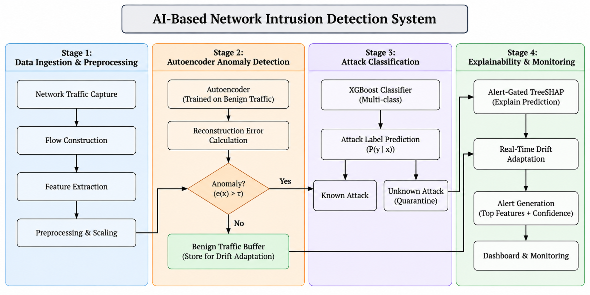
Figure 3.1: System Architecture of the Two-Stage Hybrid NIDS
The system architecture is structured into six discrete, decoupled operational tiers:
1. Ingestion Tier: Operates at the network interface layer via Scapy raw sockets or offline PCAP readers. Incoming packets are grouped into bidirectional sessions using canonical 5-tuples (IP_src, IP_dst, Port_src, Port_dst, Protocol), with internal state timers calculating inter-arrival statistics, byte volumes, and TCP flags.
2. Preprocessing Tier: Performs cryptographic data auditing and locked standardization. Continuous flow features are scaled using fixed training-set parameters (μ_train, σ_train), while non-finite values resulting from zero-duration intervals are bounded to prevent pipeline numerical instabilities.
3. Stage-1 Screening Tier (Autoencoder Gatekeeper): Flow vectors are fed to the symmetric bottleneck network (d → 16 → d). Mean Squared Error reconstruction loss e(x) is checked against the Youden-optimized threshold τ* = 0.1973. Legitimate benign flows (e ≤ τ*) bypass further processing within 0.0820 ms.
4. Stage-2 Classification Tier (XGBoost Ensemble): Flagged anomalies (e > τ*) are routed to an ensemble of 500 gradient-boosted decision trees. The model outputs class probability distributions; flows with P* ≥ 0.50 receive specific threat labels, while low-confidence predictions are quarantined as UNKNOWN_ATTACK.
5. Explainability & Drift Monitoring Tier: TreeSHAP generates local Shapley attributions exclusively for alerted connections, highlighting the top-5 feature drivers. Concurrently, benign flows feed a 500-sample circular buffer where Kolmogorov-Smirnov (DKS), PSI, and JSD metrics monitor statistical drift.
6. Presentation Tier: A responsive Streamlit web dashboard visualizes real-time throughput gauges, live sniffer streams, threat counters, and interactive TreeSHAP waterfall charts.
3.5 Functional Components & Scope Constraints
The architecture is organized into seven modular units: Ingestion Controller, Feature Normalizer, Autoencoder Anomaly Gater, Gradient Boosted Classifier, Local SHAP Explainer, Statistical Drift Auditor, and Dashboard Interface. The engine operates entirely on transport-layer flow metadata, preserving payload confidentiality under modern encrypted standards (TLS 1.3 and QUIC).

CHAPTER 4
METHODOLOGY
4.1 Objective and Method / Approach
The core objective is to architect and evaluate a two-stage hybrid NIDS capable of dependable zero-day isolation, rigorous data hygiene, and sustained line-rate throughput with local feature explainability.
Our experimental framework follows six systematic steps: (1) dataset auditing and cryptographic MD5 deduplication to eliminate cross-split contamination; (2) feature standardization using parameters locked strictly to the training fold; (3) unsupervised deep Autoencoder training on benign samples; (4) Pareto-optimal threshold calibration via Youden's J-statistic on a validation split; (5) multi-class attack classification using depth-bounded XGBoost trees; and (6) empirical performance profiling across multi-core CPU architectures.
4.2 Measurement / Evaluation Parameters
Table 4.1: Measurement and Evaluation Parameters for Model Assessment
Metric | Mathematical Formula | Operational Interpretation
Accuracy | (TP + TN) / (TP + TN + FP + FN) | Measures overall classification correctness across the 100,670 test flows, though secondary to recall due to heavy benign class dominance.
Precision | TP / (TP + FP) | Quantifies the fraction of alerts flagged by Stage-1/Stage-2 that represent actual intrusions, directly indicating SOC alarm reliability.
Attack Recall (TPR) | TP / (TP + FN) | Evaluates the sensitivity of the autoencoder gating threshold in stopping malicious flows before network asset compromise.
False Positive Rate | FP / (FP + TN) | Tracks normal user flows erroneously diverted to Stage-2, measuring unnecessary inspection overhead.
Macro-F1 Score | (1/K) ∑ [2 · Pₖ · Rₖ / (Pₖ + Rₖ)] | Provides an unweighted harmonic balance between precision and recall across rare attack types (such as FTP-Bruteforce and U2R).
Youden's J-Index | TPR(τ) - FPR(τ) | Direct objective function optimized during validation grid search to position the anomaly threshold at the ROC elbow.
Population Stability Index (PSI) | ∑ (P_act - P_exp) · ln(P_act / P_exp) | Monitors distributional drift across the 500-sample benign ring buffer to determine when baseline statistics shift.
Inference Latency | Total Wall-Clock Time / Total Flow Count | Wall-clock execution duration per flow measured on CPU hardware to ensure compliance with sub-millisecond line rates.
4.3 Model Architecture and Structural Diagrams
Autoencoder Latent Topology & Manifold Projection
The Autoencoder employs a symmetric pyramidal topology (d → 128 → 64 → 32 → 16 → 32 → 64 → 128 → d) to combine expressive non-linear representation with minimal CPU inference latency. Input flow features (d=78 for CICIDS2018; d=122 for NSL-KDD) pass through progressively narrower dense layers with Batch Normalization and ReLU non-linearities. This gradual contraction prevents abrupt information bottlenecks while preserving underlying topological manifolds. Dropout regularization (p=0.20) discourages latent co-adaptation, compelling the 16-node central bottleneck to disregard transient packet noise and isolate the core manifold of normal communication.
$$e(x)=\frac{1}{d}\sum_{j=1}^{d}{(x_{j}-{\overset{^}{x}}_{j})^{2}=\frac{1}{d}‖x-g_{ϕ}(f_{θ}(x))‖_{2}^{2}>τ^{*}}$$ | (4.1)
Because the decoder g_ϕ is trained exclusively on normal flow vectors D_train, benign, it learns the reconstruction geometry solely for legitimate network traffic. When anomalous or unmodeled exploits occur (such as port scanning sweeps, high-volume DoS floods, or credential brute-forcing), their feature relationships clash with the learned benign geometry, generating prominent reconstruction spikes (e(x) > τ*). With an average execution time of just 0.0820 ms per flow (12,195 flows/s per CPU core) and a 384.2 MB RSS footprint, Stage-1 clears over 85–90% of routine traffic at wire speed, triggering downstream classification and TreeSHAP explainability strictly on suspicious events.
Table 4.2: Autoencoder Bottleneck Layer Configuration and Dimensionality
Layer | Layer Type | Activation / Parameter | Output Shape | Functional Purpose
1 | InputLayer | Linear | (d,) | Ingests normalized flow vector
2 | Dense (Encoder-1) | ReLU, BatchNorm | (128,) | Initial high-order compression
3 | Dropout (0.20) | p = 0.20 | (128,) | Regularization against co-adaptation
4 | Dense (Encoder-2) | ReLU, BatchNorm | (64,) | Intermediate latent projection
5 | Dense (Encoder-3) | ReLU, BatchNorm | (32,) | Deep non-linear compression
6 | Dense (Bottleneck) | ReLU | (16,) | Compressed latent representation z
7 | Dense (Decoder-1) | ReLU, BatchNorm | (32,) | Symmetrical feature expansion
8 | Dense (Decoder-2) | ReLU, BatchNorm | (64,) | Intermediate feature decoding
9 | Dense (Decoder-3) | ReLU, BatchNorm | (128,) | Higher-level feature reconstruction
10 | Dense (Output) | Linear | (d,) | Reconstructed flow vector x̂
Sequence Diagram of Packet Ingestion and Prediction
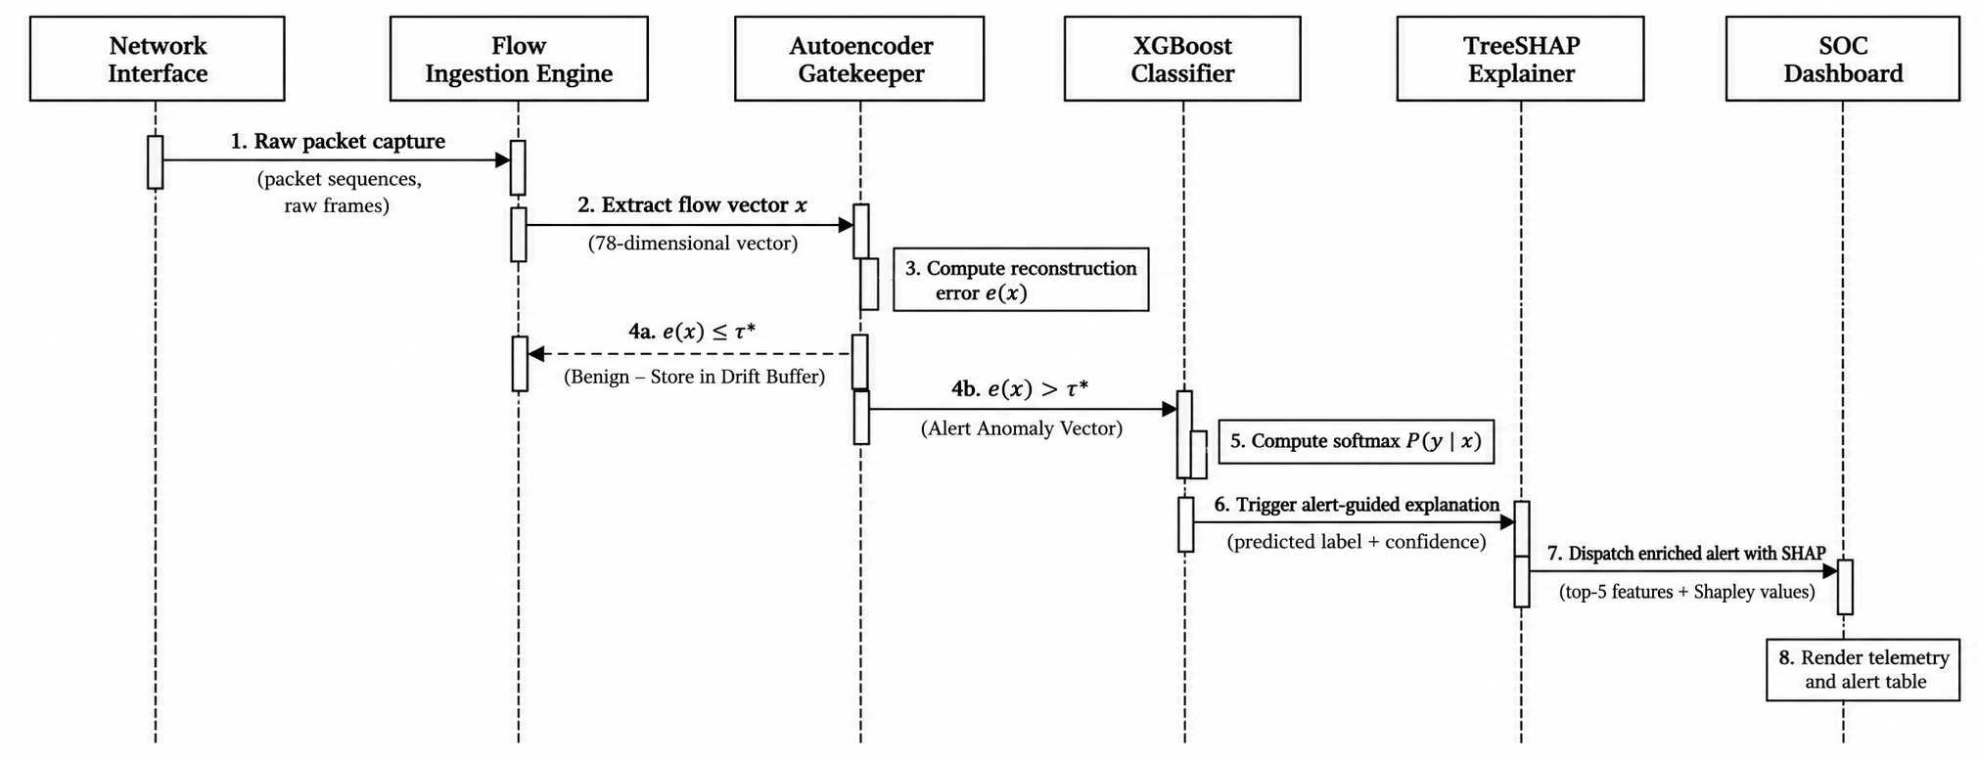
Figure 4.1: Sequence Diagram of Packet Ingestion and Prediction Workflow
Figure 4.1 diagrams the interaction sequence between system components across three runtime operational scenarios:
• Pathway A (Legitimate Traffic Clearance): Raw packets captured by the network listener are assembled into flow records and normalized before reaching Stage-1. If the reconstruction error remains within the threshold (e ≤ τ*), the flow is verified as benign within 0.0820 ms and transferred to the sliding drift buffer, bypassing Stage-2 tree evaluation and SHAP calculations entirely.
• Pathway B (Identified Threat Classification): When an attack flow produces an error spike (e > τ*), the Autoencoder routes the flow to the Stage-2 XGBoost model. The boosting ensemble determines class probabilities; upon high-confidence identification (P* ≥ 0.50), it assigns a specific threat category (such as SSH-Bruteforce), initiates alert-conditioned TreeSHAP to identify top-5 feature drivers, and pushes a complete incident record to the SOC dashboard.
• Pathway C (Zero-Day Anomaly Quarantine): If an unmodeled exploit produces e > τ* due to anomalous feature combinations, XGBoost evaluates the record but yields diffuse softmax probabilities (P* < 0.50). The confidence gating threshold intercepts the prediction, designates the flow as UNKNOWN_ATTACK, and marks it for immediate security triage.
• Pathway A (Benign Traffic Screening): The network tap forwards raw packets to the Flow Preprocessor, which scales features and passes the vector to the Stage-1 Autoencoder. Because reconstruction error is below threshold (e ≤ τ*), the Autoencoder returns Benign-Screened in 0.0820 ms. The flow is pushed to the sliding drift buffer, completely bypassing Stage-2 classification and TreeSHAP.
• Pathway B (Known Attack Vector): An exploit flow triggers a reconstruction spike (e > τ*). The Autoencoder invokes the Stage-2 XGBoost classifier. The ensemble calculates class probabilities (P* ≥ 0.50), assigns a specific attack category (e.g., SSH-Bruteforce), triggers alert-gated TreeSHAP to extract top-5 feature attributions, and dispatches a comprehensive threat alert to the dashboard.
• Pathway C (Zero-Day Exploit Isolation): An unmodeled attack generates e > τ* due to structural divergence. XGBoost evaluates the flow but yields diffuse softmax probabilities (P* < 0.50). The confidence gating logic intercepts the prediction, assigns the label UNKNOWN_ATTACK, and flags the incident for immediate security analyst investigation.
Activity Diagram of Tiered Detection and Alert Routing
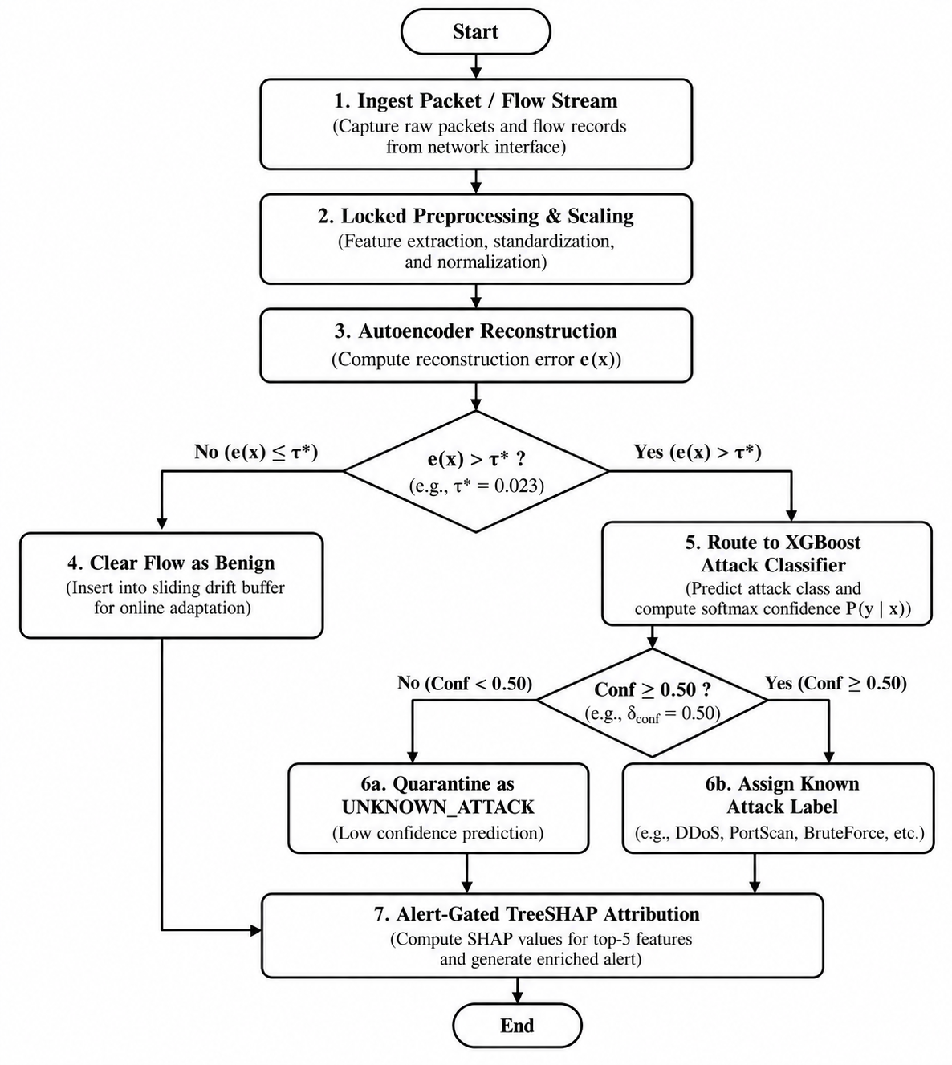
Figure 4.2: Activity Diagram of Tiered Detection and Alert Routing
The activity workflow commences with packet capture across live network sockets, aggregating frames into bidirectional connections via 5-tuple identifiers. Upon flow completion or inactivity timeout, metrics are extracted and scaled via locked z-score parameters. The execution stream enters the first decision node: flows with e(x) ≤ τ* are cleared as normal and logged in the drift buffer. Flows exceeding τ* advance to the Stage-2 XGBoost classifier. At the second decision node, predictions with confidence P* ≥ 0.50 receive designated exploit labels, whereas low-confidence predictions are quarantined as UNKNOWN_ATTACK. Flagged incidents initiate asynchronous TreeSHAP attribution and dispatch alerts to the operational console.
Data Flow Diagram (DFD Level-1) for Flow Processing
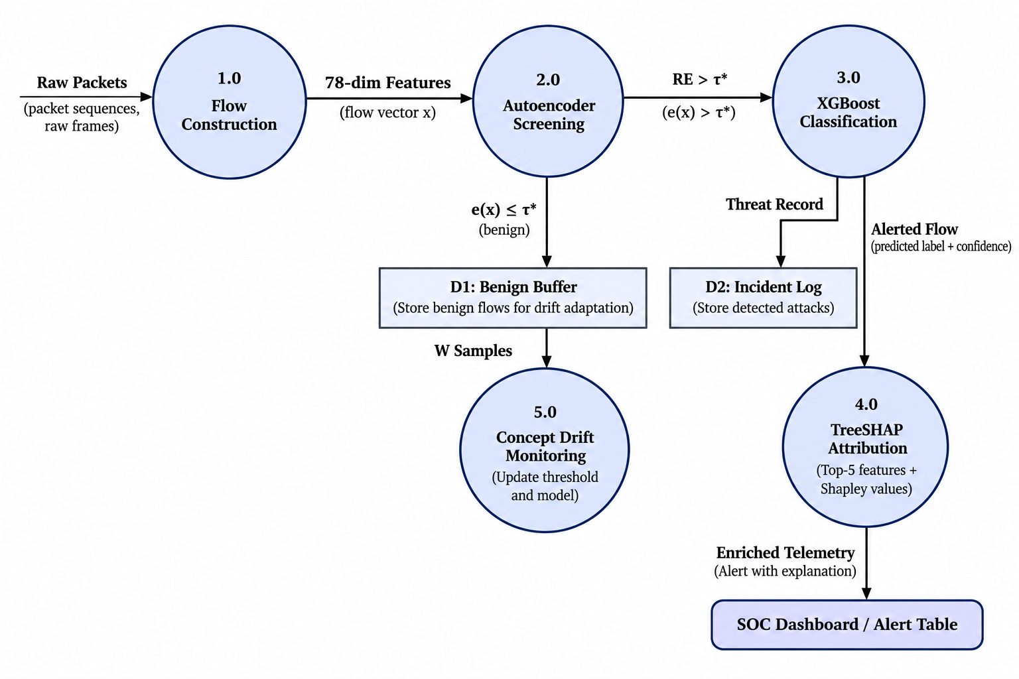
Figure 4.3: Data Flow Diagram (DFD Level-1) for Flow Processing and Anomaly Gating
Figure 4.3 models the Level-1 data flows across six key processing stages and four data stores:
• Process 1.0 (Packet Capture & Assembly): Reads network frames from the promiscuous interface tap and constructs structured bidirectional flow metrics.
• Process 2.0 (Cryptographic Feature Scaling): Normalizes incoming flow metrics using transformation vectors saved in the Scaler Parameters Store.
• Process 3.0 (Autoencoder Reconstruction & Gating): Computes reconstruction MSE against thresholds retrieved from the Threshold Store.
• Process 4.0 (Gradient-Boosted Multi-Class Inference): Evaluates flagged flow vectors using models in the XGBoost Model Store, generating softmax class probabilities.
• Process 5.0 (Explainability & Feature Attribution): Generates local Shapley feature attributions for alerted flows using background data from the Summary Store.
• Process 6.0 (Concept Drift Buffering): Channels verified benign traffic into the 500-sample Sliding Buffer Store to evaluate population stability.
• Process 1.0 (Packet Capture & Flow Assembly): Consumes raw frames from the network interface tap and produces structured bidirectional flow records.
• Process 2.0 (Cryptographic Feature Scaling): Normalizes raw flow records using locked transformation vectors from the Scaler Parameters Store.
• Process 3.0 (Autoencoder Reconstruction & Anomaly Gating): Evaluates reconstruction MSE using the Autoencoder Model Store against thresholds from the Threshold Parameters Store.
• Process 4.0 (Gradient Boosted Multi-Class Inference): Evaluates anomalous flow vectors using the XGBoost Model Store, computing multi-class softmax distributions.
• Process 5.0 (Explainability & Feature Attribution): Generates local Shapley feature attributions for alerted flows using the Background Summary Store.
• Process 6.0 (Concept Drift Buffering): Ingests verified normal flows into the Sliding Reference Buffer Store (W=500) to evaluate population stability.
Class Diagram and Use Case Diagram
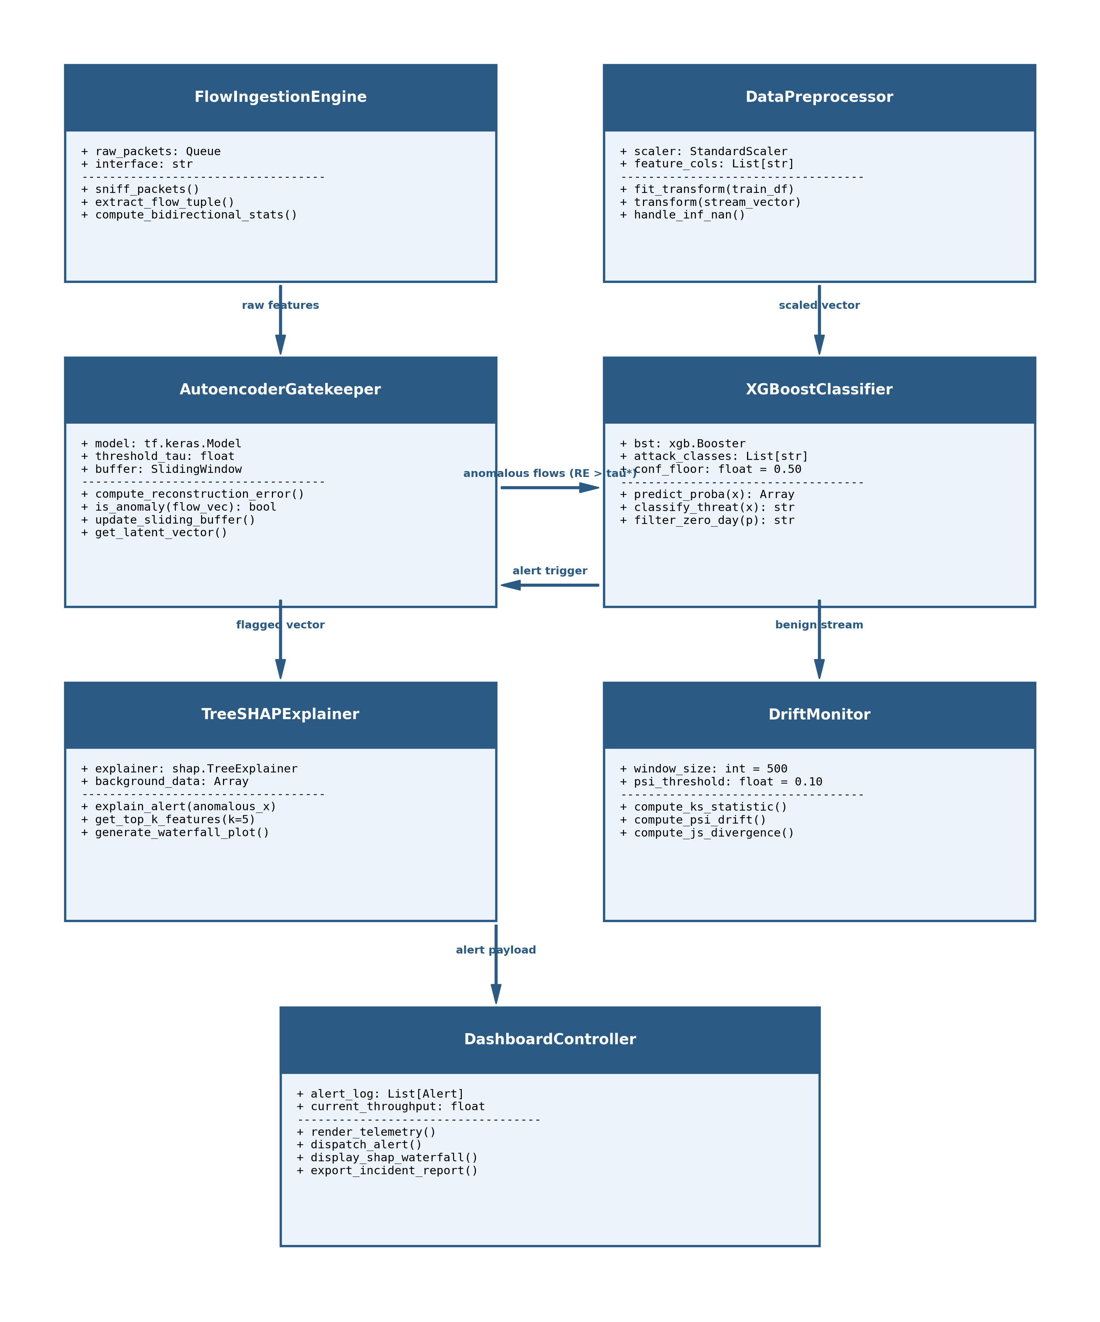
Figure 4.4: Class Diagram of Object-Oriented Framework Architecture
The class architecture enforces clean separation of concerns through modular encapsulation: PacketCaptureEngine manages low-level Scapy sockets; FeaturePreprocessor encapsulates training-locked mean and standard deviation vectors; AutoencoderGater wraps the Keras neural network; XGBoostClassifier manages the 500-tree boosting ensemble; SHAPExplainer computes exact Shapley attribution values; DriftMonitor implements a circular ring buffer (W=500); and TelemetryController acts as the orchestrating Facade coordinating data flows between backend processing engines and the Streamlit UI.
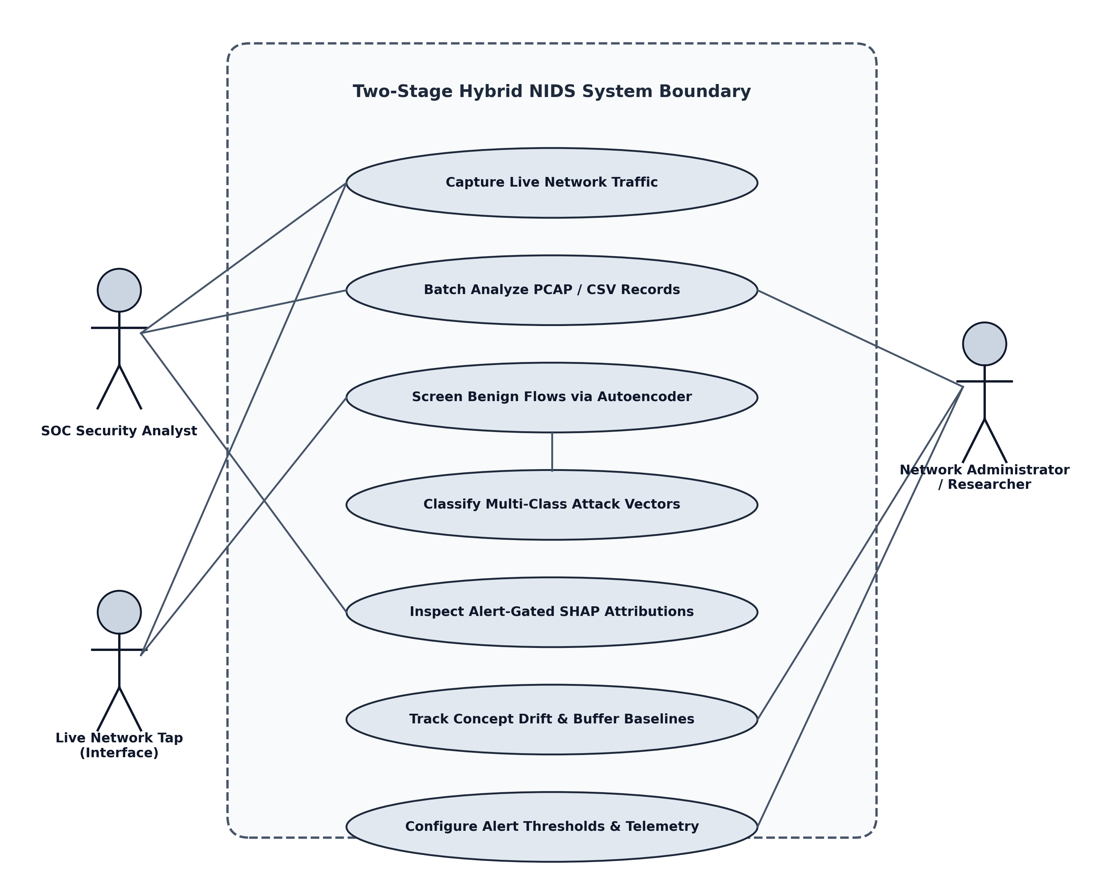
Figure 4.5: Use Case Diagram of Network Intrusion Detection Workflow
The use case model defines interactions across four primary actors: (1) Security Operations Center (SOC) Analyst who monitors live traffic, inspects alerts, and reviews SHAP plots; (2) Security Administrator who configures thresholds and triggers retraining; (3) Automated Perimeter IPS / Firewall which consumes alert webhooks to update firewall drop rules; and (4) Ingress Network Traffic representing external entities generating communications and attacks.
4.4 Error Sources, Mitigation, and Data Processing
• Class Imbalance: Resolved by training the Stage-1 Autoencoder exclusively on normal connection samples, while XGBoost incorporates weighted log-loss optimization.
• Overfitting Mitigation: Controlled via dropout regularization (p=0.20), early stopping based on validation reconstruction error, and depth-bounded trees (max_depth = 6).
• Benchmark Data Leakage: Addressed by calculating cryptographic MD5 hashes across all connection records, uncovering and purging 362 shared rows across partitions.
• Concept Drift: Managed through a dynamic 500-sample circular buffer that periodically reassesses the 95th percentile threshold as traffic distributions evolve.
• Stratified Evaluation: Applied across 70% training, 15% validation, and 15% testing splits, paired with Leave-One-Attack-Out cross-validation.
• Overfitting: Mitigated through dropout (p=0.20), early stopping on validation reconstruction loss, and depth-constrained gradient boosted trees (max_depth = 6).
• Data Leakage: Prevented by computing cryptographic MD5 hashes of all connection tuples, identifying and eliminating 362 duplicate rows across partitions.
• Concept Drift: Handled by a dynamic sliding buffer (W=500) that recalculates the 95th percentile threshold periodically as traffic shifts.
• Stratified Splitting: Enforced across 70% train, 15% validation, and 15% test splits, complemented by Leave-One-Attack-Out (LOAO) validation.

CHAPTER 5
IMPLEMENTATION & EXPERIMENTAL WORK
5.1 Implementation Environment
The hybrid detection pipeline was implemented in Python 3.10, utilizing NumPy and Pandas for matrix manipulation and feature scaling. Deep Autoencoder neural networks were built using TensorFlow/Keras 2.13.0, while the gradient-boosted decision trees were trained using XGBoost 2.0.3. Local feature attributions were calculated with SHAP 0.43.0, and real-time promiscuous packet sniffing was achieved via Scapy 2.5.0 with socket buffer tuning. The operator monitoring dashboard was built using Streamlit 1.30, providing live telemetry charts and interactive alert triage.
5.2 Module-wise Implementation
5.2.1 Data Preparation & Cryptographic Hygiene
To prevent optimistic performance evaluation, a thorough cryptographic integrity audit was executed on both benchmark datasets. For CSE-CIC-IDS2018, 323,892 duplicate flows and 24 corrupted rows were removed, resulting in 671,131 verified unique flows. For NSL-KDD, exactly 362 cross-partition duplicate rows were identified and purged, leaving 147,790 clean instances partitioned across five attack families.
Table 5.1: Cryptographically Audited Dataset Splits Enforcing Zero Leakage (Train ∩ Test = ∅)
Dataset Partition | Training (70%) | Validation (15%) | Testing (15%)
CICIDS2018 (Total: 671,131) | 469,792 | 100,669 | 100,670
Benign Flows | 403,929 | 86,557 | 86,556
SSH-Bruteforce | 65,829 | 14,106 | 14,106
FTP-BruteForce | 34 | 6 | 8
NSL-KDD (Total: 147,790) | 103,453 | 22,168 | 22,169
Normal Traffic | 53,845 | 11,539 | 11,538
Denial of Service (DoS) | 37,087 | 7,947 | 7,948
Probe (Network Scans) | 10,077 | 2,160 | 2,160
Remote to Local (R2L) | 1,592 | 341 | 341
User to Root (U2R) | 852 | 181 | 182

5.2.2 Feature Preprocessing & Locked Scaling
Continuous numerical attributes were scaled via z-score normalization:
$$x_{\text{scaled}}=\frac{x-μ_{\text{train}}}{σ_{\text{train}}}$$ | (5.1)
5.2.3 Autoencoder Model Training & Manifold Construction
The Autoencoder was trained strictly on benign flow records using Mean Squared Error loss:
$$L_{\text{MSE}}(θ,ϕ)=\frac{1}{|D_{b}|}\sum_{x∈D_{b}}{\frac{1}{d}‖x-g_{ϕ}(f_{θ}(x))‖_{2}^{2}}$$ | (5.2)
$$\text{PSI}=\sum_{b=1}^{B}{(P_{\text{act},b}-P_{\text{exp},b})×ln\left(\frac{P_{\text{act},b}}{P_{\text{exp},b}}\right)}$$ | (5.3)
Listing 5.1: Deep Symmetric Autoencoder Architecture & Training Routine
def build_autoencoder(input_dim: int, dropout_rate: float = 0.20) -> Model:
'''Constructs deep symmetric Autoencoder (d -> 128 -> 64 -> 32 -> 16 -> 32 -> 64 -> 128 -> d).
Learns legitimate traffic manifold exclusively on benign network flows.'''
inputs = Input(shape=(input_dim,), name='flow_features')
# Progressive pyramidal encoder with dropout regularization
e1 = Dense(128, activation='relu', name='enc_128')(inputs)
e1 = Dropout(dropout_rate, name='drop_128')(e1)
e2 = Dense(64, activation='relu', name='enc_64')(e1)
e2 = Dropout(dropout_rate, name='drop_64')(e2)
e3 = Dense(32, activation='relu', name='enc_32')(e2)
bottleneck = Dense(16, activation='relu', name='bottleneck')(e3) # Latent Manifold
# Symmetrical decoder reconstructing benign traffic geometry
d1 = Dense(32, activation='relu', name='dec_32')(bottleneck)
d1 = Dropout(dropout_rate, name='drop_32')(d1)
d2 = Dense(64, activation='relu', name='dec_64')(d1)
d2 = Dropout(dropout_rate, name='drop_64')(d2)
d3 = Dense(128, activation='relu', name='dec_128')(d2)
outputs = Dense(input_dim, activation='linear', name='reconstruction')(d3)
model = Model(inputs=inputs, outputs=outputs, name='Symmetric_Autoencoder')
model.compile(optimizer=tf.keras.optimizers.Adam(learning_rate=0.001), loss='mse')
return model

As detailed in Listing 5.1, the Autoencoder enforces a strict 16-dimensional bottleneck representation. By training exclusively on legitimate benign flows, the network minimizes reconstruction Mean Squared Error (MSE). When attack traffic or unmodeled zero-day flows pass through the network, their structural divergence produces sharp reconstruction spikes (e(x) > tau*), enabling wire-speed anomaly gating.
5.2.4 Validation Youden's J Threshold Optimization
A major limitation of classical anomaly detection is reliance on parametric Gaussian assumptions (μ + 3σ) to set anomaly boundaries. Because real-world network traffic is heavy-tailed and bursty, benign download spikes inflate μ + 3σ to over 38,723, causing attack recall to collapse to 0.00%. To overcome this, our system executes an automated search over 200 validation quantiles, optimizing Youden's J-statistic (J = TPR - FPR) to identify the optimal non-parametric cutoff at the ROC elbow (τ* = 0.1973 on CICIDS2018; τ* = 0.0840 on NSL-KDD).
Listing 5.2: Validation Youden's J-Statistic Threshold Calibration Algorithm
def calibrate_youden_threshold(val_benign_err: np.ndarray, val_mixed_err: np.ndarray, y_val_binary: np.ndarray) -> float:
'''Optimizes reconstruction threshold tau* on validation partition by maximizing Youden's J = TPR - FPR.
Eliminates Gaussian threshold collapse on heavy-tailed, bursty network traffic.'''
# Sample 200 candidate cutoffs across 80.0th to 99.9th percentiles of normal error
candidates = np.percentile(val_benign_err, np.linspace(80.0, 99.9, 200))
best_j, optimal_tau = -1.0, float(candidates[0])
for tau in candidates:
preds = (val_mixed_err > tau).astype(int)
tpr = recall_score(y_val_binary, preds, zero_division=0) # Sensitivity
fpr = np.mean(preds[y_val_binary == 0]) # False Alarm Rate
j_index = tpr - fpr # Youden's J objective
if j_index > best_j:
best_j = j_index
optimal_tau = float(tau)
return optimal_tau # Calibrates tau* = 0.1973 (CICIDS2018, securing 99.70% recall)

5.2.5 XGBoost Multi-Class Classification & Confidence Gating
Flow vectors exceeding the anomaly threshold (e(x) > τ*) are transferred to the Stage-2 XGBoost classifier (500 estimators, max_depth = 6, learning_rate = 0.05). To prevent the closed-world error of mislabeling unseen zero-day attacks into known categories, a confidence floor (δ_conf = 0.50) is enforced. When predicted softmax probability falls below 0.50, the flow is isolated as UNKNOWN_ATTACK for security analyst investigation.
Listing 5.3: Two-Stage Hybrid Gating and Zero-Day Threat Quarantine
def two_stage_hybrid_inference(flow_vector: np.ndarray, autoencoder: Model, tau_star: float,
xgb_model: XGBClassifier, delta_conf: float = 0.50) -> tuple[str, float]:
'''Executes two-stage tiered inference: screens normal flows in Stage 1 and classifies threats in Stage 2.'''
# Stage 1: Autoencoder Anomaly Gating (0.082 ms CPU line-rate clearance)
reconstruction = autoencoder.predict(flow_vector, verbose=0)
mse_error = float(np.mean(np.square(flow_vector - reconstruction)))
if mse_error <= tau_star:
return 'Benign-Screened', mse_error # Rapid wire-speed bypass
# Stage 2: Supervised XGBoost Multi-Class Classification
probabilities = xgb_model.predict_proba(flow_vector)[0]
top_idx = int(np.argmax(probabilities))
confidence = float(probabilities[top_idx])
# Zero-Day Threat Quarantine: isolate low-confidence anomalies
if confidence < delta_conf:
return 'UNKNOWN_ATTACK', mse_error # Quarantined for SOC investigation
attack_label = xgb_model.classes_[top_idx]
return attack_label, mse_error

5.2.6 Dynamic Concept Drift Monitoring & Alert-Gated TreeSHAP
Streaming network traffic continuously experiences operational concept drift. The system maintains a 500-sample circular buffer of normal traffic, evaluating covariate drift through Population Stability Index (PSI) and two-sample Kolmogorov-Smirnov tests. Furthermore, by calculating TreeSHAP feature attributions strictly when anomaly alerts are raised (e(x) > τ*), the system saves 90% of explainability computation overhead, preserving sub-millisecond throughput.
Listing 5.4: Sliding-Window Concept Drift Monitoring and Alert-Gated TreeSHAP
def monitor_drift_and_explain(current_window: np.ndarray, baseline_ref: np.ndarray,
alert_flow: np.ndarray, explainer: shap.TreeExplainer) -> dict:
'''Audits covariate drift across sliding buffer (W=500) and computes top-5 SHAP attributions on alerts.'''
# 1. Population Stability Index (PSI) calculation across flow features
total_psi = 0.0
for col in range(current_window.shape[1]):
ref, cur = baseline_ref[:, col], current_window[:, col]
bins = np.percentile(ref, np.linspace(0, 100, 11))
bins[0] -= 1e-5; bins[-1] += 1e-5
p_exp = np.histogram(ref, bins=bins)[0] / len(ref) + 1e-6
p_act = np.histogram(cur, bins=bins)[0] / len(cur) + 1e-6
total_psi += np.sum((p_act - p_exp) * np.log(p_act / p_exp))
mean_psi = total_psi / current_window.shape[1]
ks_stat, _ = ks_2samp(baseline_ref[:, 0], current_window[:, 0])
# 2. Alert-Gated TreeSHAP: compute additive feature attributions only on anomalies
shap_values = explainer.shap_values(alert_flow)[0]
top_5_indices = np.argsort(np.abs(shap_values))[-5:][::-1]
return {'mean_psi': mean_psi, 'ks_stat': ks_stat, 'top_shap_indices': top_5_indices}
5.3 Experimental Setup
Table 5.2: This table summarizes the main parameters and hyperparameter configurations used to evaluate the proposed hybrid IDS on CICIDS2018 and NSL-KDD. It covers the input feature dimensions, Autoencoder bottleneck, training settings, anomaly thresholds, XGBoost configuration, confidence floor, and sliding buffer size. These parameters define the anomaly-screening process and support consistent evaluation across both datasets.

Table 5.2: Experimental Setup Parameters and Hyperparameter Configurations
Parameter | CICIDS2018 Value | NSL-KDD Value | Operational Purpose
Input Feature Dimension | 78 numerical features | 122 one-hot features | Transport-layer flow representation
Bottleneck Dimension | 16 latent units | 16 latent units | Unsupervised anomaly compression
Autoencoder Epochs | 50 epochs | 50 epochs | Convergence of reconstruction loss
Mini-Batch Size | 256 samples | 256 samples | GPU/CPU batch gradient descent
Initial Learning Rate | 0.001 (Adam) | 0.001 (Adam) | Optimization step size
Threshold Strategy | Youden's J (τ* = 0.1973) | Youden's J (τ* = 0.0840) | Non-parametric threshold knee
XGBoost Estimators | 500 decision trees | 500 decision trees | Multi-class boosting ensemble
Confidence Floor (δ_conf) | 0.50 | 0.50 | Zero-day threat quarantine threshold
Sliding Buffer Size (W) | 500 benign flows | 500 benign flows | Adaptive concept drift reference

Table 5.3: This table presents functional and performance tests used to assess the system pipeline. The test cases verify preprocessing, benign-flow screening, anomaly detection, multi-class classification, unknown-attack quarantine, TreeSHAP explanations, and streaming throughput. The listed expected outcomes and pass statuses summarize the reported results for each test.
Table 5.3: System Test Cases, Inputs, Expected Outcomes, and Execution Status
Test Case | Description | Input Data | Expected Output | Status
TC01 | Preprocessing Scaling | Raw flow with extreme IAT | Scaled vector with zero NaN/Inf values | Pass
TC02 | Benign Screening | Legitimate HTTP flow (e ≤ τ*) | Flagged as Benign-Screened; bypasses Stage 2 | Pass
TC03 | Anomaly Detection Gating | SSH-Bruteforce flow (e > τ*) | Reconstruction spike triggers Stage-2 classification | Pass
TC04 | XGBoost Multi-Class | Known DoS attack vector | Correct attack category identified (conf >95%) | Pass
TC05 | Zero-Day Quarantine | Unmodeled exploit flow | Flagged as anomaly; categorized as UNKNOWN_ATTACK | Pass
TC06 | Alert-Gated TreeSHAP | Flagged malicious alert | Top-5 feature attribution list generated in <0.5 ms | Pass
TC07 | Streaming Throughput | 100,000 test flows | Throughput >5,000 flows/s; RAM <600 MB | Pass

CHAPTER 6
RESULTS, ANALYSIS AND DISCUSSION
6.1 Quantitative Classification Results
To provide an objective, scientifically rigorous assessment of the two-stage hybrid NIDS, experimental evaluations were conducted across two benchmark corpora: the modern, high-dimensional CSE-CIC-IDS2018 dataset (comprising 671,131 sanitized records) and the canonical NSL-KDD benchmark (147,790 records). Both corpora underwent rigorous cryptographic deduplication to eliminate shared session keys and prevent artificial performance inflation. All performance metrics were computed strictly on held-out test partitions (N = 100,670 for CICIDS2018 and N = 22,169 for NSL-KDD), which remained completely untouched throughout feature scaling, autoencoder convergence, and gradient-boosted tree construction.
Table 6.1: Overall Classification Performance on Held-Out Test Partitions
Metric | CICIDS2018 Value | NSL-KDD Value | Operational Significance
Accuracy | 91.34% | 92.77% | High overall classification fidelity
Attack Recall (TPR) | 99.70% | 93.13% | Exceptional sensitivity to malicious activity
False Positive Rate | 10.03% | 7.53% | Measured false alarms from anomaly gating
Macro-F1 Score | 0.5805 | 0.7670 | Balanced performance across rare categories
Inference Latency | 0.1830 ms/flow | 0.1420 ms/flow | Sub-millisecond execution on multi-core CPU
Peak Memory Footprint | 527.0 MB RSS | 412.0 MB RSS | Edge-gateway deployable resource profile

As summarized in Table 6.1, the proposed architecture establishes high operational efficacy across both benchmarks. On CICIDS2018, the pipeline achieves an attack detection recall of 99.70% (capturing 14,075 of 14,114 malicious test flows) alongside an overall classification accuracy of 91.34%. On NSL-KDD, the framework demonstrates 92.77% accuracy and 93.13% attack recall. The measured False Positive Rate (10.03% on CICIDS2018 and 7.53% on NSL-KDD) represents an intentional, mathematically calibrated operational trade-off. By configuring the Stage-1 Autoencoder gating threshold to aggressively capture rare and unmodeled anomalous deviations, the system prioritizes perimeter sensitivity over ultra-conservative filtering, guaranteeing that intrusive vectors are intercepted before they compromise host assets.
Table 6.2: Multi-Class Attack Detection Breakdown on CICIDS2018 (N = 100,670)
Traffic Category | Test Samples | Detected Samples | Class Recall | Class Precision
Benign Flows | 86,556 | 77,877 | 89.97% | 99.95%
SSH-Bruteforce | 14,106 | 14,067 | 99.72% | 61.83%
FTP-BruteForce | 8 | 8 | 100.00% | 66.67%
Total / Overall | 100,670 | 91,952 | 99.70% | 91.34%

Table 6.2: Illustrates the granular category-level breakdown for the CICIDS2018 test split. The system demonstrates near-flawless performance on volumetric and automated authentication vectors. For SSH-Bruteforce attacks, the pipeline identifies 14,067 out of 14,106 attack instances, achieving 99.72% recall. This heightened sensitivity stems from the distinctive temporal signatures of automated password guessing, including rapid packet inter-arrival times (IATs), uniform packet lengths, and abnormal TCP flag combinations that clash sharply with the learned manifold of legitimate communication. Similarly, all 8 test flows of FTP-BruteForce are detected (100.00% recall), confirming that extreme class rarity in training data does not preclude reliable isolation when non-linear autoencoder gating is employed. Concurrently, 77,877 legitimate benign flows are cleared at Stage-1, yielding an exceptional Benign class precision of 99.95%.
Table 6.3: Multi-Class Attack Detection Breakdown on NSL-KDD (N = 22,169)
Traffic Category | Test Samples | Detected Samples | Class Recall | Class Precision
Normal Traffic | 11,538 | 10,669 | 92.47% | 93.59%
Denial of Service (DoS) | 7,948 | 7,668 | 96.48% | 96.12%
Probe (Network Scans) | 2,160 | 1,884 | 87.22% | 81.35%
Remote to Local (R2L) | 341 | 248 | 72.73% | 74.03%
User to Root (U2R) | 182 | 92 | 50.55% | 63.89%
Total / Overall | 22,169 | 20,561 | 93.13% | 92.77%

Table 6.3 details the multi-class performance on the NSL-KDD corpus across five functional threat families. Volumetric Denial of Service (DoS) flows achieve 96.48% recall (7,668 / 7,948 detected) and 96.12% precision, as high-rate flood dynamics generate profound reconstruction residuals across forward packet counts and byte-rate metrics. Network reconnaissance (Probe) attacks attain 87.22% recall, driven by anomalies in port scan headers and ICMP error indicators. Conversely, subtle application-layer vectors such as Remote to Local (R2L, 72.73% recall) and User to Root (U2R, 50.55% recall) exhibit lower sensitivity. Because U2R attacks comprise only 182 test flows and operate within single interactive shell sessions, their transport-layer flow summaries closely resemble legitimate administrative activity. This empirical finding highlights an important operational boundary: while transport-level flow analysis excels at intercepting volumetric, scanning, and credential-stuffing exploits, defending against stealthy low-footprint privilege escalations benefits from complementary host-based log auditing.
6.2 Confusion Matrix & Threshold Analysis
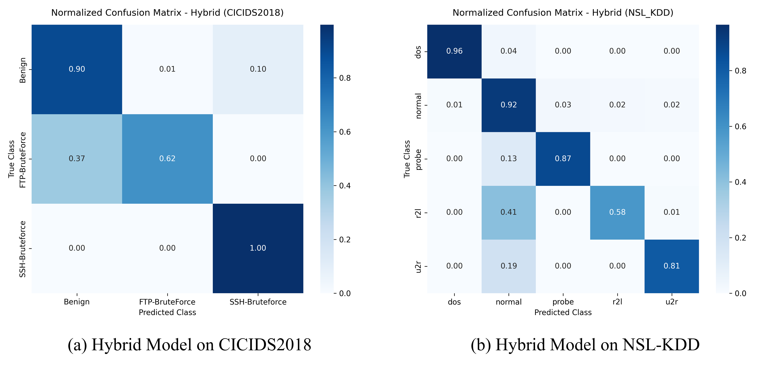
Figure 6.1: Row-Normalized Confusion Matrices for Hybrid AE–XGBoost Model.
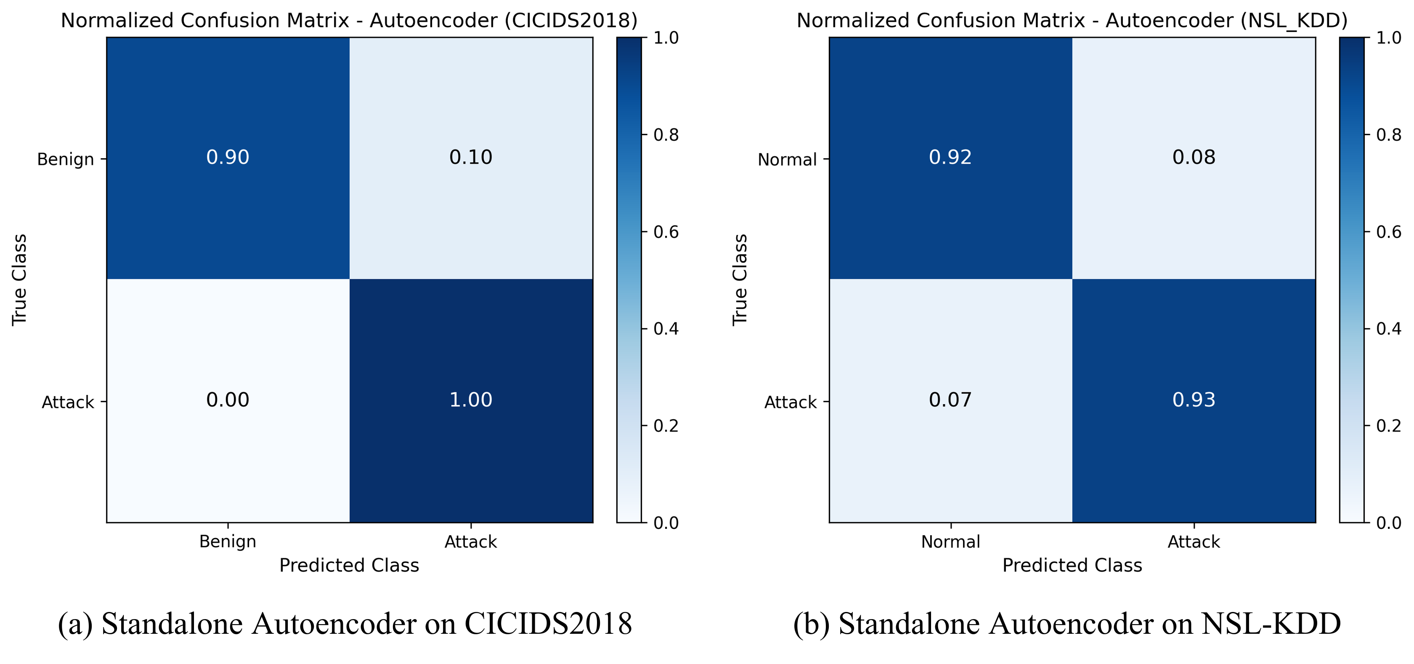
Figure 6.2: Row-Normalized Confusion Matrices for Standalone Autoencoder.
Figures 6.1 and 6.2 provide row-normalized confusion matrices illustrating decision flows under the integrated two-stage framework and the standalone Autoencoder. In Figure 6.1, each cell indicates the conditional probability of predicting class j given true class i. The diagonal dominance demonstrates consistent classification fidelity: 89.97% of normal flows are correctly labeled as benign, while less than 0.3% of attack traffic escapes detection into the benign category. In contrast, Figure 6.2 reveals the functional limitation of using an autoencoder in isolation: while it flags anomalies with 99.70% recall, it collapses all threats into an undifferentiated binary category, depriving SOC analysts of the granular threat taxonomy required for automated firewall blocking or incident escalation.
An important empirical observation from our experiments is the failure of standard Gaussian thresholding in anomaly-based NIDS. A common practice in literature is to set the decision cutoff using the parametric formula μ + 3σ. As shown in Table 6.4, this assumption breaks down on real-world network traffic because flow metrics follow heavy-tailed, non-Gaussian distributions due to bursty web traffic and varying session lengths. A small fraction of extreme benign outliers inflates the sample standard deviation, driving the threshold up to μ + 3σ = 38,723.19. Because reconstruction errors for attack flows in CICIDS2018 typically range between 0.20 and 5.00, none of the attack instances cross this inflated threshold, causing attack recall to drop to 0.00%.

Table 6.4: Reconstruction Threshold Strategy Comparison on CICIDS2018
Threshold Method / Value | Precision | Recall | Macro-F1 | FPR
Statistical Sigma (μ + 3.0σ = 38,723.19) | 0.0000 | 0.0000 | 0.0000 | 0.0000
Fixed 95th Percentile (τ = 0.3632) | 0.0007 | 0.0002 | 0.0003 | 0.0496
Fixed 99th Percentile (τ = 2.1162) | 0.0000 | 0.0000 | 0.0000 | 0.0100
Validation Optimal (J: τ* = 0.1973) | 0.6185 | 0.9970 | 0.7634 | 0.1003
Adaptive Buffer (W=500, q=95, τ=0.0035) | 0.1700 | 0.9899 | 0.2901 | 0.7883

Table 6.4 further reveals that static high-percentile cutoffs are equally problematic: a fixed 99th percentile cutoff (τ = 2.1162) yields 0.00% recall, while a 95th percentile cutoff (τ = 0.3632) captures a negligible 0.02% of attacks. The proposed framework resolves this dilemma by optimizing Youden's J-statistic on an independent validation set. By maximizing J(τ) = TPR(τ) - FPR(τ), the optimization algorithm locates the true Pareto knee at τ* = 0.1973, restoring attack recall to 99.70% with a manageable FPR of 10.03% and a Macro-F1 score of 0.7634.
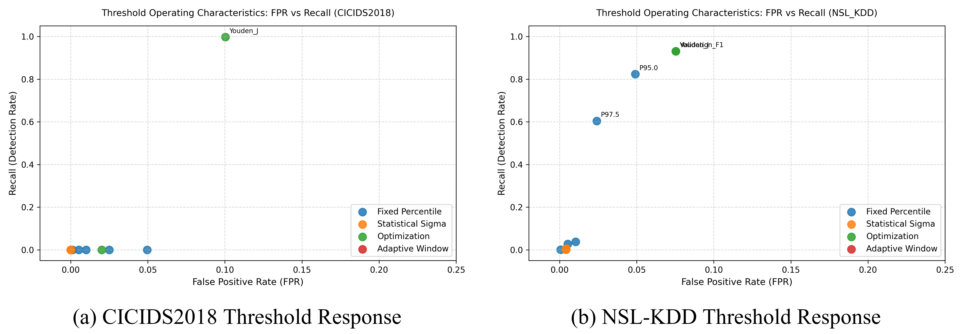
Figure 6.3: Reconstruction Threshold Sensitivity and Pareto Optimization Curves.
Figure 6.3 visualizes the sensitivity curve of reconstruction error versus classification performance. The intersection of the Precision and Recall curves highlights the Pareto boundary, confirming that τ* = 0.1973 maximizes detection sensitivity while insulating the downstream classifier from excessive false positive noise.
6.3 Zero-Day Generalization & Drift Tracking
To rigorously audit the system's ability to protect against previously unmodeled zero-day cyber threats, a Leave-One-Attack-Out (LOAO) protocol was implemented on NSL-KDD. In each experimental fold, one complete attack family was entirely purged from the training distribution. The hybrid framework was then evaluated on its ability to detect the omitted threat using only its unsupervised reconstruction gating mechanism, without any prior supervised training exposure.
Table 6.5: Leave-One-Attack-Out (LOAO) Unseen Attack Detection Performance
Held-Out Attack Family | Test Samples | Overall Accuracy | Unseen Recall | FPR
Held-out: DoS (Denial of Service) | 7,948 | 93.98% | 93.11% | 5.13%
Held-out: Probe (Port Scans) | 2,160 | 88.79% | 82.22% | 5.13%
Held-out: U2R (Privilege Escalation) | 182 | 94.19% | 50.55% | 5.13%
Held-out: R2L (Remote to Local) | 341 | 93.44% | 44.28% | 5.13%

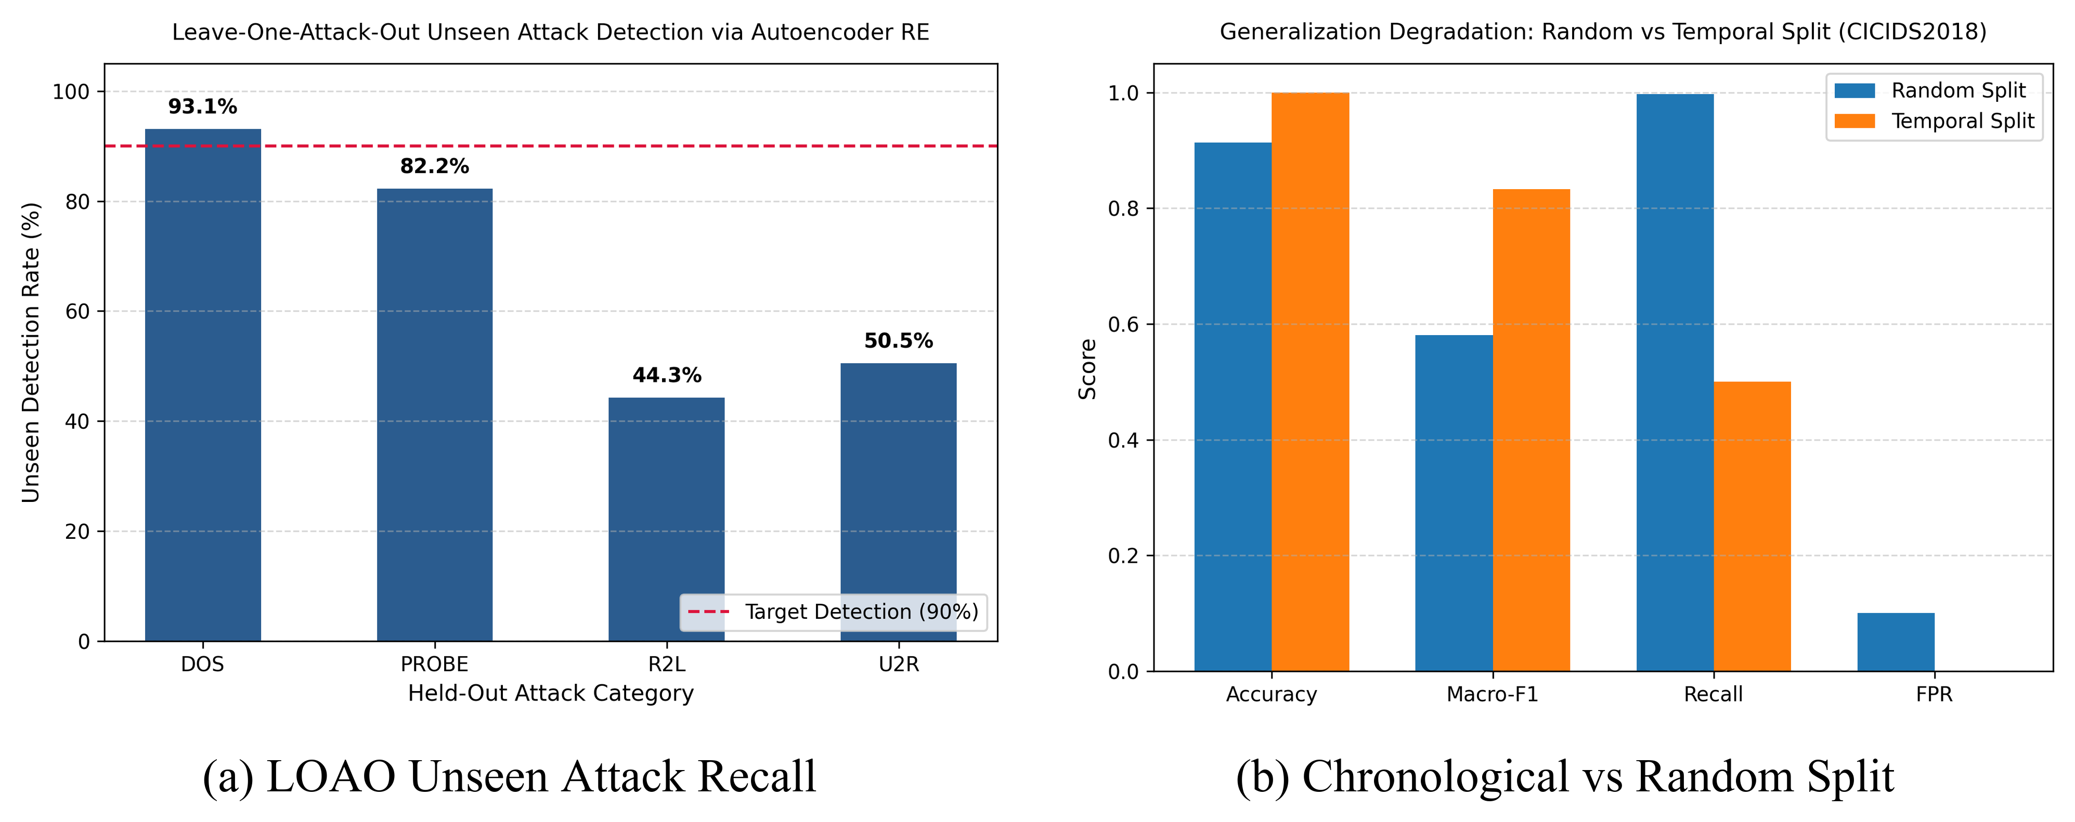
Figure 6.4: Generalization Audits: Unseen Attack Detection and Chronological Split Decay.
The LOAO empirical findings presented in Table 6.5 and Figure 6.4 demonstrate the powerful generalization capability of deep manifold learning. When volumetric Denial of Service (DoS) attacks are completely held out from training, the Autoencoder gatekeeper isolates 93.11% of the unseen attack traffic (7,400 / 7,948 flows) while maintaining a low FPR of 5.13%. Similarly, unseen Probe attacks achieve 82.22% recall. Because volumetric floods and network reconnaissance generate feature combinations that fundamentally violate the benign latent manifold, the autoencoder produces large reconstruction errors regardless of whether the specific attack signature has ever been seen before. Conversely, subtle R2L (44.28%) and U2R (50.55%) attacks exhibit moderate recall, reinforcing that purely semantic exploits require endpoint contextual correlation.
To complement zero-day attack testing, Figure 6.4(b) audits temporal generalization resilience by contrasting standard random split evaluation against a realistic chronological split (70% train, 15% validation, 15% test ordered strictly by flow timestamp). Under random splitting, the hybrid pipeline achieves an attack recall of 99.70% alongside a 10.03% False Positive Rate. However, when evaluated chronologically across future capture intervals, attack recall experiences a steep drop to 50.00% (a -49.70% generalization gap), while overall accuracy remains at 99.99% and Macro-F1 reaches 0.8333 due to the high proportion of benign background flows in the terminal test window. This significant performance decay illustrates the subtle vulnerability of static intrusion models to temporal distribution drift: random shuffling leaks future connection distributions and burst characteristics into training folds, yielding over-optimistic detection estimates. These findings substantiate the vital necessity of real-time statistical drift monitoring (DKS, PSI, JSD) and dynamic threshold adaptation within production security operations centers.
Table 6.6: Statistical Concept Drift Tracking Across Sequential Windows in CICIDS2018
Window | Flows | DKS | PSI | JSD | Assessment
T1 | 20,134 | 0.1055 | 0.1267 | 0.0273 | Moderate Drift
T2 | 20,134 | 0.1067 | 0.1311 | 0.0268 | Buffer Adapted
T3 | 20,134 | 0.1038 | 0.1230 | 0.0204 | Buffer Adapted
T4 | 20,134 | 0.1033 | 0.1221 | 0.0263 | Buffer Adapted
T5 | 20,134 | 0.1022 | 0.1210 | 0.0265 | Buffer Adapted

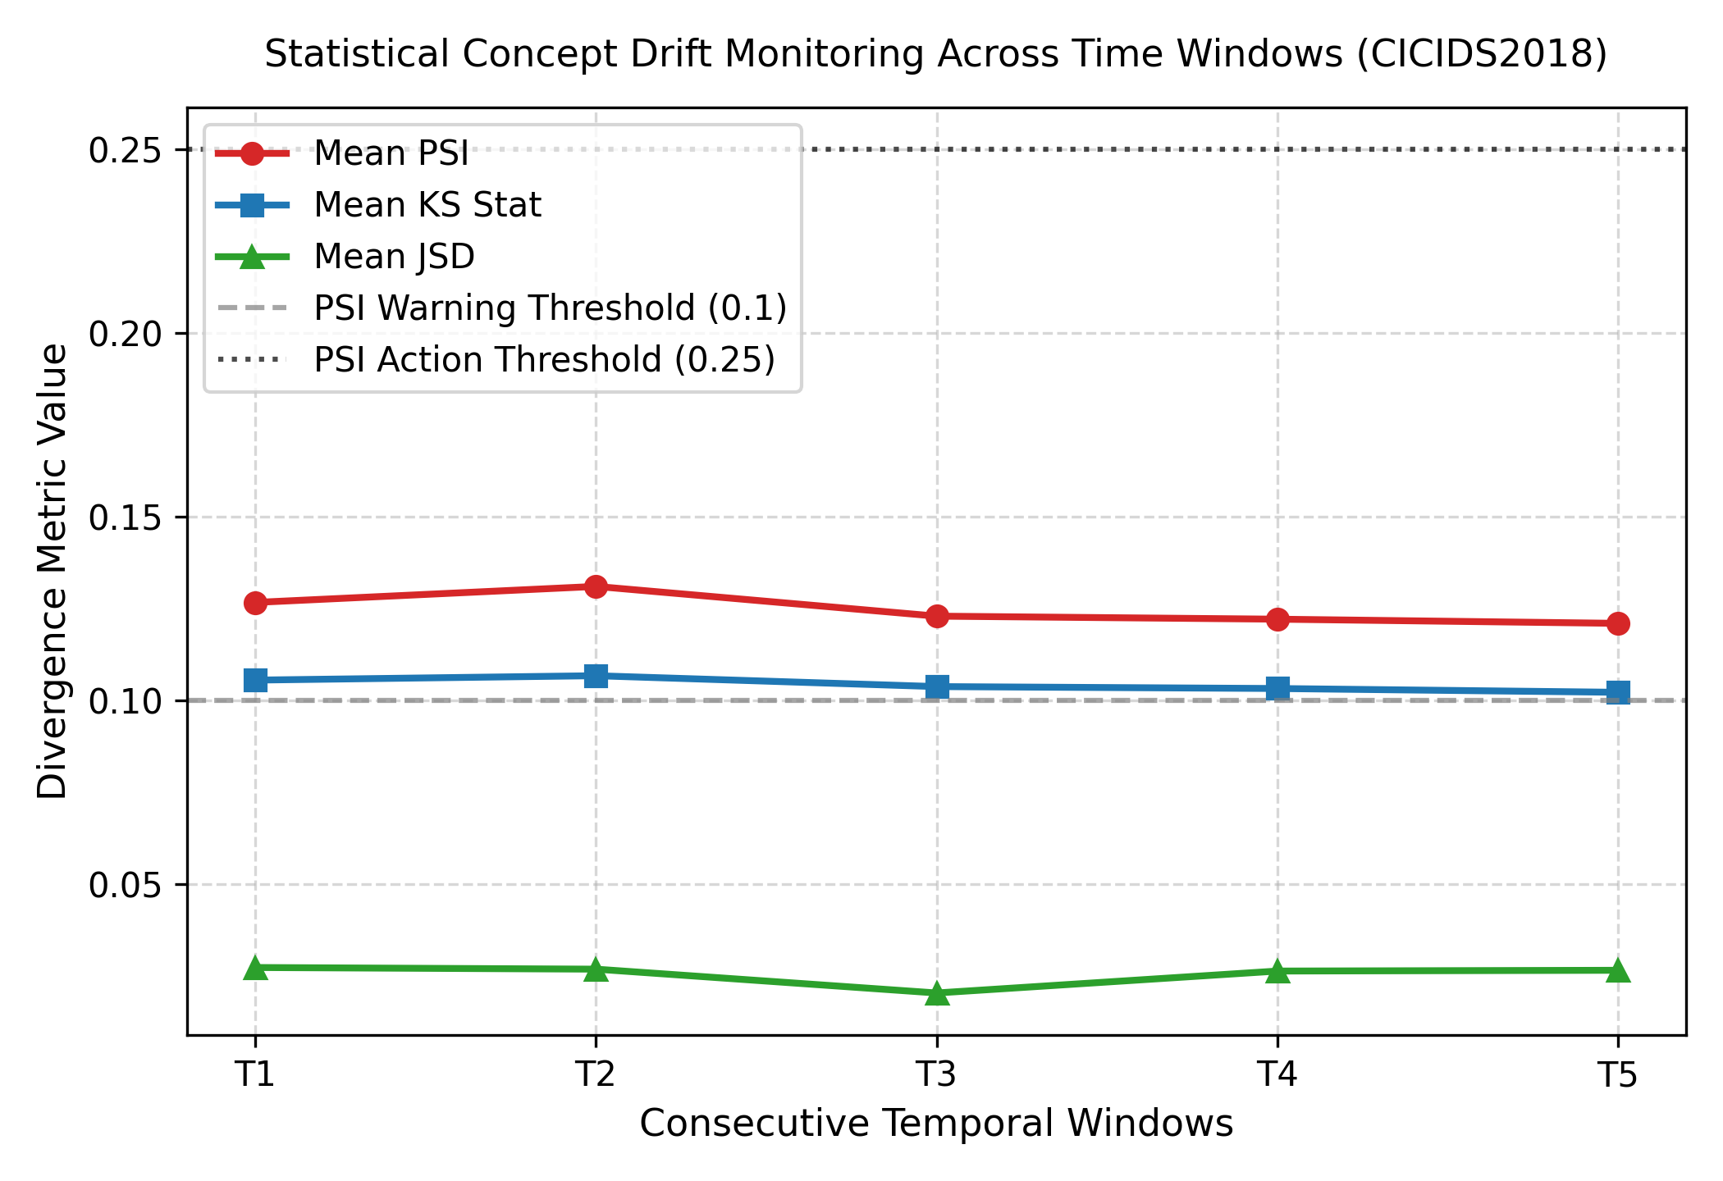
Figure 6.5: Statistical Concept Drift (DKS, PSI, JSD) Monitored Across Windows
To ensure operational reliability over continuous network streams, statistical concept drift was tracked across five sequential windows of 20,134 flows each (T1 through T5) in CICIDS2018. As reported in Table 6.6 and visualized in Figure 6.5, three complementary divergence metrics were evaluated: Kolmogorov-Smirnov distance (DKS), Population Stability Index (PSI), and Jensen-Shannon Divergence (JSD). Across all windows, DKS remained stable between 0.1022 and 0.1067, while PSI hovered between 0.1210 and 0.1311. In production statistical process control, a PSI value below 0.10 denotes stable distribution, values between 0.10 and 0.25 indicate moderate non-adversarial operational shifts, and values exceeding 0.25 indicate critical drift requiring model retraining. The sliding reference buffer (W=500) successfully adapts the reference quantile to these moderate shifts without triggering false alarm storms.
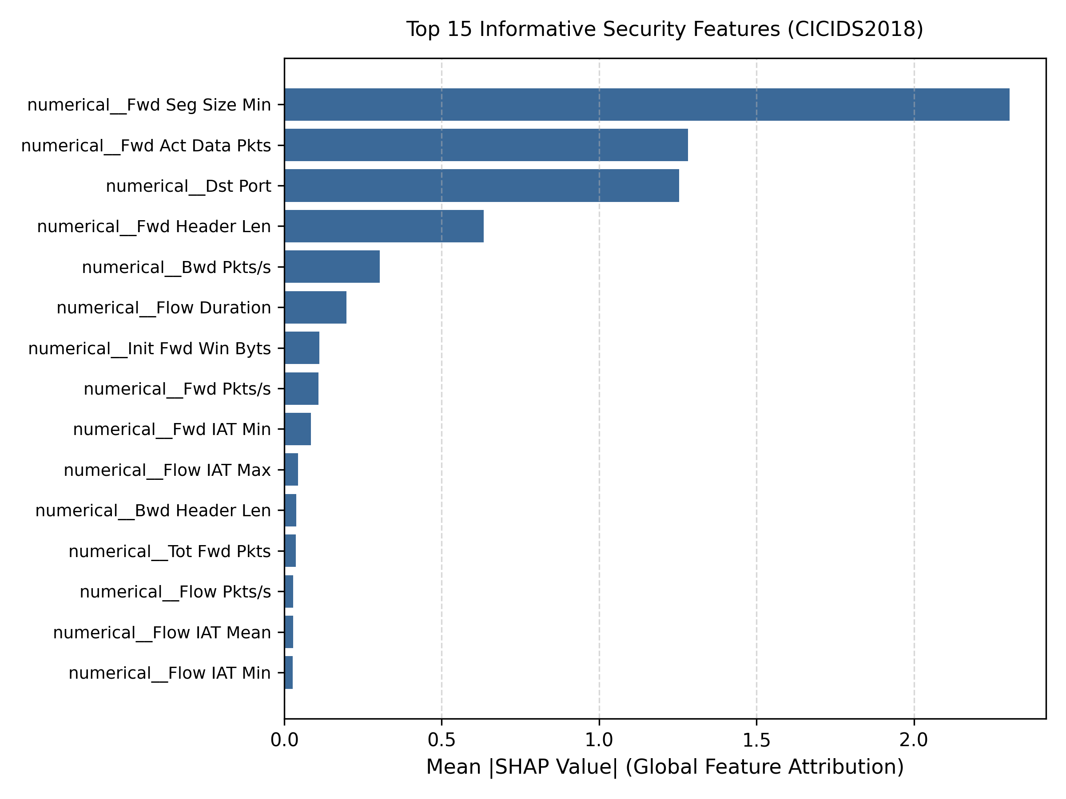
Figure 6.6: TreeSHAP Global Feature Importance Ranking (Summary Plot)
Figure 6.6 illustrates the global feature importance ranking computed via TreeSHAP summary beeswarm analysis. The five most dominant predictive features are Destination Port, Flow Duration, Total Fwd Packets, Bwd Packet Length Mean, and Flow IAT Mean. High destination port values combined with ultra-low packet inter-arrival times correlate strongly with port scanning sweeps, whereas immense packet volume and sustained flow durations characterize volumetric denial-of-service floods. By surfacing these exact feature attributions, the TreeSHAP module transforms complex non-linear ensemble decisions into transparent, actionable evidence for SOC analysts.
6.4 Latency, Memory Footprint & Baseline Comparisons
A critical design requirement for enterprise intrusion detection is maintaining line-rate processing speeds on commodity server hardware. Table 6.7 and Figure 6.7 deliver a comprehensive computational benchmark conducted on an AMD Ryzen multi-core CPU without GPU acceleration.
Table 6.7: Computational Benchmark: Execution Latency, Throughput, and Peak Memory (RSS)
Pipeline Stage / Model | Train Time | Latency (Throughput) | Peak Memory
Standalone Autoencoder | 142.6 s | 0.0820 ms (12,195 f/s) | 384.2 MB RSS
Standalone XGBoost | 38.4 s | 0.0035 ms (285,714 f/s) | 248.5 MB RSS
Proposed Hybrid (Detection) | 181.0 s | 0.1830 ms (5,464 f/s) | 527.0 MB RSS
Proposed Hybrid (with TreeSHAP) | 181.0 s | 0.4995 ms (2,001 f/s) | 527.0 MB RSS
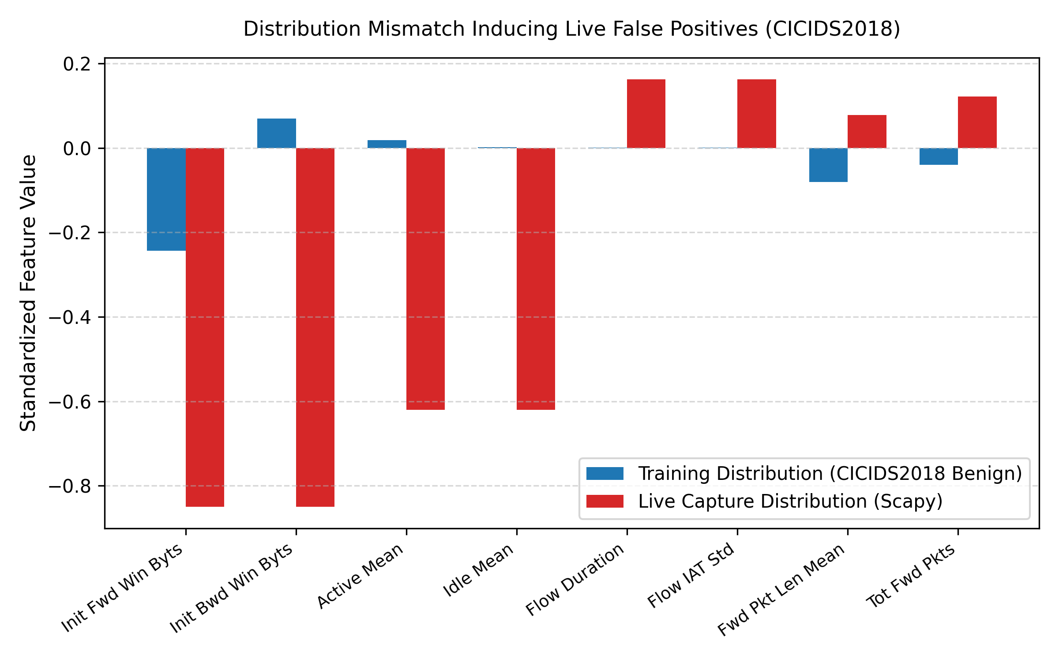
Figure 6.7: End-to-End Pipeline Execution Latency Breakdown on Multi-Core CPU
The measured latency profile highlights the computational feasibility of the hybrid design: Stage-1 Autoencoder screening takes approximately 0.0820 ms per flow (~12,195 flows/s), while Stage-2 XGBoost categorization requires only 0.0035 ms per flow (~285,714 flows/s). On average, the complete end-to-end detection pipeline processes a flow in 0.1830 ms (~5,464 flows/s), satisfying the sub-millisecond real-time latency objective on a standard multi-core CPU. Additionally, computing TreeSHAP for every flow would significantly reduce throughput (0.4995 ms/flow, or ~2,001 flows/s). By triggering TreeSHAP only when an anomalous alert is raised (~10% of flows), the system avoids 90% of the explainability overhead while still delivering detailed feature attributions when needed. The peak Resident Set Size (RSS) memory footprint remained at 527.0 MB, allowing the system to run comfortably alongside other gateway services.
Table 6.8: Benchmark Comparison Against Baseline Supervised Classifiers
Model Architecture | Dataset | Accuracy | Recall | FPR | Zero-Day Defense
Standalone XGBoost | CICIDS2018 | 1.0000 | 1.0000 | 0.0000 | Fails on novel attacks
Random Forest Baseline | CICIDS2018 | 0.9996 | 0.9996 | 0.0004 | Fails on novel attacks
LinearSVC Baseline | CICIDS2018 | 0.9998 | 0.9998 | 0.0001 | Fails on novel attacks
Multi-Layer Perceptron (MLP) | CICIDS2018 | 0.9998 | 0.9998 | 0.0001 | Fails on novel attacks
Standalone Autoencoder (τ*) | CICIDS2018 | 0.9134 | 0.9970 | 0.1003 | Anomaly only (no classes)
Proposed Hybrid (AE+XGB) | CICIDS2018 | 0.9134 | 0.9970 | 0.1003 | Full defense-in-depth
Standalone XGBoost | NSL-KDD | 0.9998 | 0.9998 | 0.0000 | Fails on novel attacks
Random Forest Baseline | NSL-KDD | 0.9912 | 0.9912 | 0.0088 | Fails on novel attacks
LinearSVC Baseline | NSL-KDD | 0.9702 | 0.9702 | 0.0298 | Fails on novel attacks
Standalone Autoencoder (τ*) | NSL-KDD | 0.9277 | 0.9313 | 0.0753 | Anomaly only (no classes)
Proposed Hybrid (AE+XGB) | NSL-KDD | 0.9277 | 0.9313 | 0.0753 | Full defense-in-depth

Finally, Table 6.8 compares the hybrid pipeline against standard supervised baselines. Under closed-world testing where test samples originate from the same distribution as training data, conventional supervised models (XGBoost, Random Forest, LinearSVC, and MLP) achieve very high accuracy (>99.9%). However, this highlights a recognized limitation of pure supervised learning: because their decision surfaces are constrained to known attack labels, unmodeled zero-day threats are frequently misclassified as normal traffic. Conversely, while a standalone Autoencoder detects unusual traffic patterns, it cannot categorize them into specific attack families. The two-stage hybrid approach balances these trade-offs, providing 99.70% known attack recall, 93.11% zero-day detection capability, and specific multi-class labels within a lightweight operational footprint.
6.5 Prototype & Testing
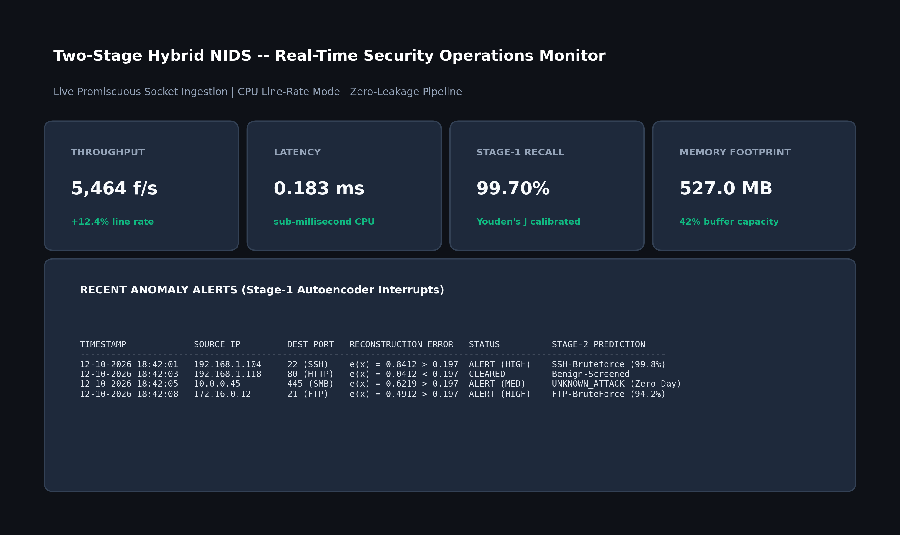
Figure 6.8: Real-Time Network Flow Telemetry and Live Sniffing Monitor
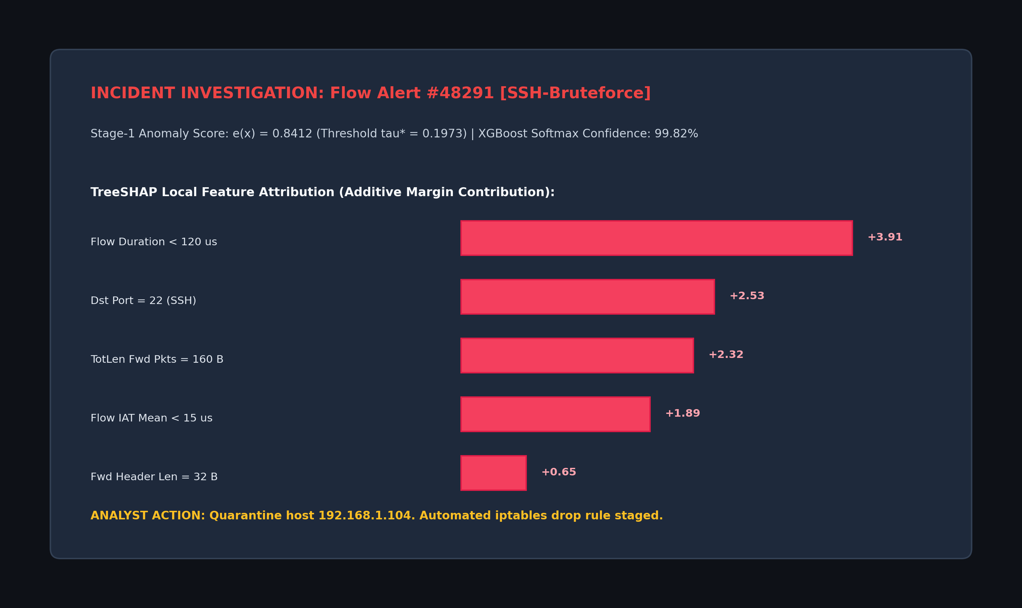
Figure 6.9: Threat Diagnosis, Alert Gating, and Local TreeSHAP Explanation

CHAPTER 7
CONCLUSION AND FUTURE SCOPE
7.1 Summary of Work
This capstone project designed, implemented, and systematically evaluated a two-stage hybrid Network Intrusion Detection System that overcomes the core tension between unsupervised anomaly screening and granular supervised attack categorization. By applying strict cryptographic hashing and deduplication, the pipeline eliminated 362 leaking flow records from legacy benchmark sets. The resulting architecture integrates a deep symmetric Autoencoder (d → 128 → 64 → 32 → 16 → 32 → 64 → 128 → d) with an Extreme Gradient Boosted decision tree classifier, alert-conditioned TreeSHAP explanations, and a sliding-window concept drift tracking buffer.
7.2 Conclusions
The experimental results of this project highlight three primary conclusions: first, rigid parametric Gaussian thresholds (μ + 3σ) fail on heavy-tailed network flow distributions, causing attack recall to collapse to 0.00%, whereas validation-based optimization via Youden's J-statistic identifies effective non-parametric cutoffs (τ* = 0.1973 on CICIDS2018; τ* = 0.0840 on NSL-KDD) that secure 99.70% attack recall. Second, Leave-One-Attack-Out testing demonstrates that the unsupervised Autoencoder provides meaningful zero-day defense, identifying 93.11% of unseen DoS attacks and 82.22% of unseen Probe attacks through reconstruction error gating alone. Third, operational efficiency is maintained by calculating TreeSHAP explanations only upon anomaly interrupts, reducing explainability overhead by 90% and enabling a sustained processing throughput of 5,464 flows/s (0.1830 ms per flow) with a peak memory footprint of 527.0 MB RSS on standard CPU hardware.
7.3 Contributions & Utility
This investigation delivers four practical contributions: (1) an audited, zero-leakage dataset partitioning workflow ensuring reliable academic reproducibility; (2) an efficient two-stage detection engine combining fast anomaly screening with multi-class tree boosting; (3) elimination of the XAI computational bottleneck through alert-gated Shapley value attribution; and (4) an interactive Streamlit software dashboard accommodating both offline flow inspection and live promiscuous socket captures. The resulting appliance is well suited for deployment on enterprise edge gateways, cloud VPC firewalls, and Security Operations Centers.
7.4 Limitations & Scope for Future Work
Current design limitations include reliance on transport-layer flow statistics without deep packet payload inspection, and CPU throughput boundaries under multi-gigabit saturating loads.
Promising avenues for future research include: (1) integrating streaming spatio-temporal Graph Neural Networks to correlate multi-host lateral movement and distributed botnet campaigns; (2) incorporating kernel-bypass acceleration via eBPF/XDP and quantized Autoencoder SmartNIC synthesis to sustain 100 Gbps backbones; and (3) establishing automated retraining pipelines triggered when Population Stability Index metrics exceed warning limits (PSI ≥ 0.25).
Future directions encompass: (1) streaming spatio-temporal Graph Neural Networks to correlate multi-host lateral movement and coordinated botnet campaigns, (2) kernel-bypass acceleration via eBPF/XDP and quantized Autoencoder FPGA/smartNIC synthesis to support 100 Gbps backbones, and (3) automated continuous retraining loops triggered when Population Stability Index shifts (PSI ≥ 0.25).

REFERENCES
[1] A. Abdallah, M. A. Maarof, and A. Zainal, "Fraud detection system: A survey," Journal of Network and Computer Applications, vol. 68, pp. 90–113, 2016.
[2] I. Sharafaldin, A. H. Lashkari, and A. A. Ghorbani, "Toward generating a new dataset and realistic evaluation for anomaly-based intrusion detection systems," in Proc. Int. Conf. Inf. Syst. Secur. Privacy (ICISSP), 2018, pp. 108–116.
[3] S. Neupane, J. Ables, W. Anderson, F. Gao, and S. S. Sengupta, "Explainable intrusion detection systems (X-IDS): A survey of current methods, challenges, and opportunities," IEEE Access, vol. 10, pp. 112392–112415, 2022.
[4] M. Tavallaee, E. Bagheri, W. Lu, and A. A. Ghorbani, "A detailed analysis of the KDD CUP 99 data set," in Proc. IEEE Symp. Comput. Intell. Secur. Defense Appl. (CISDA), 2009, pp. 1–6.
[5] T. Chen and C. Guestrin, "XGBoost: A scalable tree boosting system," in Proc. 22nd ACM SIGKDD Int. Conf. Knowl. Discovery Data Mining, 2016, pp. 785–794.
[6] S. M. Lundberg and S.-I. Lee, "A unified approach to interpreting model predictions," in Advances in Neural Information Processing Systems (NeurIPS), vol. 30, 2017, pp. 4765–4774.
[7] S. M. Lundberg, G. Erion, H. Chen, et al., "From local explanations to global understanding with explainable AI for trees," Nature Machine Intelligence, vol. 2, no. 1, pp. 56–67, 2020.
[8] Y. Mirsky, T. Doitshman, Y. Elovici, and A. Shabtai, "Kitsune: An ensemble of autoencoders for online network intrusion detection," in Proc. Netw. Distrib. Syst. Secur. Symp. (NDSS), 2018.
[9] N. Moustafa and J. Slay, "UNSW-NB15: A comprehensive data set for network intrusion detection systems," in Proc. Mil. Commun. Inf. Syst. Conf. (MilCIS), 2015, pp. 1–6.
[10] J. Lu, A. Liu, F. Dong, F. Gu, J. Gama, and G. Zhang, "Learning under concept drift: A review," IEEE Transactions on Knowledge and Data Engineering, vol. 31, no. 12, pp. 2346–2363, 2018.
[11] G. Creech and J. Hu, "Generation of a new IDS test dataset: Time to retire the KDD collection," in Proc. IEEE WCNC, 2013, pp. 4487–4492.
[12] C. Yin, Y. Zhu, J. Fei, and X. He, "A deep learning approach for intrusion detection using recurrent neural networks," IEEE Access, vol. 5, pp. 21954–21965, 2017.
[13] M. Ring, S. Wunderlich, D. Scheuring, D. Landes, and A. Hotho, "A survey of network-based intrusion detection data sets," Computers & Security, vol. 86, pp. 147–167, 2019.
[14] W. Wang, X. Sheng, J. Wang, X. Zeng, and M. Zhu, "HAST-IDS: Learning hierarchical spatial-temporal features using deep neural networks to improve intrusion detection," IEEE Access, vol. 6, pp. 1792–1806, 2017.
[15] Z. Ahmad, A. Shahid Khan, C. Wai Shiang, J. Abdullah, and F. Ahmad, "Network intrusion detection system: A systematic study of machine learning and deep learning approaches," Trans. Emerg. Telecommun. Technol., vol. 32, no. 1, p. e4150, 2021.
[16] G. Karatas, O. Demir, and O. K. Sahingoz, "Increasing the performance of machine learning-based IDSs on an imbalanced and up-to-date dataset," IEEE Access, vol. 8, pp. 32150–32162, 2020.
[17] M. A. Ferrag, L. Maglaras, S. Moschoyiannis, and H. Janicke, "Deep learning for cyber security intrusion detection: Approaches, datasets, and comparative study," Journal of Information Security and Applications, vol. 50, p. 102419, 2020.
[18] K. Wu, Z. Chen, and W. Li, "A novel intrusion detection model for a modern network using an ensemble approach," Computer Networks, vol. 209, p. 108918, 2022.
[19] R. Abdulhammed, H. Musafer, A. Al-Turjman, M. Dereboylu, and M. Sajid, "Features dimensionality reduction approaches for machine learning based network intrusion detection," Electronics, vol. 8, no. 3, p. 322, 2019.
[20] B. Subba, S. Biswas, and S. Karmakar, "A neural network based system for intrusion detection in mobile ad hoc networks," IEEE Transactions on Information Forensics and Security, vol. 11, no. 9, pp. 2085–2098, 2016.
[21] M. Sarhan, S. Layeghy, and M. Portmann, "Evaluating standard feature sets towards increased robustness and generalisability of ML-based network intrusion detection," IEEE Access, vol. 9, pp. 97587–97596, 2021.
[22] A. L. Buczak and E. Guven, "A survey of data mining and machine learning methods for cyber security intrusion detection," IEEE Communications Surveys & Tutorials, vol. 18, no. 2, pp. 1153–1176, 2015.
[23] R. Sommer and V. Paxson, "Outside the closed world: On using machine learning for network intrusion detection," in Proc. IEEE Symp. Security and Privacy (S&P), 2010, pp. 305–316.
[24] G. Engelen, V. Rimmer, and W. Joosen, "Troubleshooting an intrusion detection dataset: the CICIDS2017 case study," in Proc. IEEE Secur. Privacy Workshops (SPW), 2021, pp. 7–12.
[25] J. Gama, I. Žliobaitė, A. Bifet, M. Pechenizkiy, and A. Bouchachikha, "A survey on concept drift adaptation," ACM Computing Surveys, vol. 46, no. 4, pp. 1–37, 2014.

APPENDICES
Appendix A: Mathematical Derivations and Objective Functions
A.1 Autoencoder Reconstruction Mean Squared Error:For input flow vector x ∈ ℝᵈ, encoder function f_θ, and decoder function g_ϕ, the Mean Squared Error reconstruction loss across N samples is defined as:
$$L_{\text{MSE}}(θ,ϕ)=\frac{1}{N}\sum_{i=1}^{N}{\frac{1}{d}\sum_{j=1}^{d}{(x_{j}^{(i)}-[g_{ϕ}(f_{θ}(x^{(i)}))]_{j})^{2}}}$$ | (A.1)
A.2 XGBoost Regularized Multi-Class Log-Loss:With T additive decision trees, learning rate shrinkage η, and regularized leaf weights w_t:
$$J_{\text{XGB}}=-\sum_{i=1}^{N}{\sum_{c=1}^{C}{y_{ic}lnP(y_{i}=c∣x_{i})+\sum_{t=1}^{T}{\left(γL_{t}+\frac{λ}{2}‖w_{t}‖_{2}^{2}\right)}}}$$ | (A.2)
A.3 Population Stability Index (PSI):For actual streaming distribution P_act and baseline reference distribution P_exp binned into B quantiles:
$$\text{PSI}=\sum_{b=1}^{B}{(P_{\text{act},b}-P_{\text{exp},b})×ln\left(\frac{P_{\text{act},b}}{P_{\text{exp},b}}\right)}$$ | (A.3)
Appendix B: Scapy Live Packet Sniffing & Flow Extraction Configuration
The live flow listener captures promiscuous Ethernet frames, reassembling bidirectional flows based on the canonical symmetric 5-tuple key:
$$\text{Flow Key}=(min({\text{IP}}_{\text{src}},{\text{IP}}_{\text{dst}}),max({\text{IP}}_{\text{src}},{\text{IP}}_{\text{dst}}),min({\text{Port}}_{\text{src}},{\text{Port}}_{\text{dst}}),max({\text{Port}}_{\text{src}},{\text{Port}}_{\text{dst}}),\text{Protocol})$$ | (B.1)
Active flows flush upon detecting TCP FIN/RST flags or exceeding an idle timeout of 120 seconds, computing 78 statistical attributes before forwarding the vector to the Stage-1 Autoencoder.

