

**Department of**

**Artificial Intelligence & Machine Learning**

AML23403

# Database Management System Laboratory

**VASUGI I**

***ASSISTANT PROFESSOR***

***DEPARTMENT OF AI & ML***

# Exercise-1

**Consider the following schema for a Library Database:**

**BOOK(Book_id, Title, Publisher_Name, Pub_Year) BOOK_AUTHORS(Book_id, Author_Name) PUBLISHER(Name, Address, Phone) BOOK_COPIES(Book_id, Branch_id, No-of_Copies)**

**BOOK_LENDING(Book_id, Branch_id, Card_No, Date_Out, Due_Date)**

**LIBRARY_BRANCH(Branch_id, Branch_Name, Address)**

# Write SQL queries to

1. **Retrieve details of all books in the library – id, title, name of publisher, authors, number of copies in each branch, etc.**
2. **Get the particulars of borrowers who have borrowed more than 3 books, but from Jan 2021 to Aug 2021.**
3. **Delete a book in BOOK table. Update the contents of other tables to reflect this data manipulation operation.**
4. **Partition the BOOK table based on year of publication. Demonstrate its working with a simple query.**
5. **Create a view of all books and the number of copies that are currently available in the Library.**

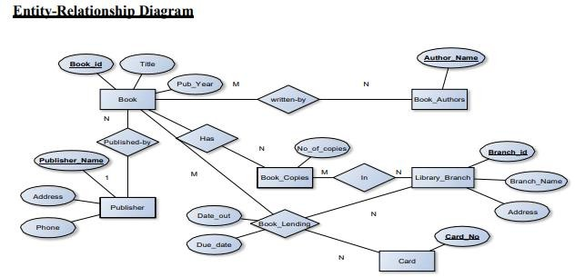

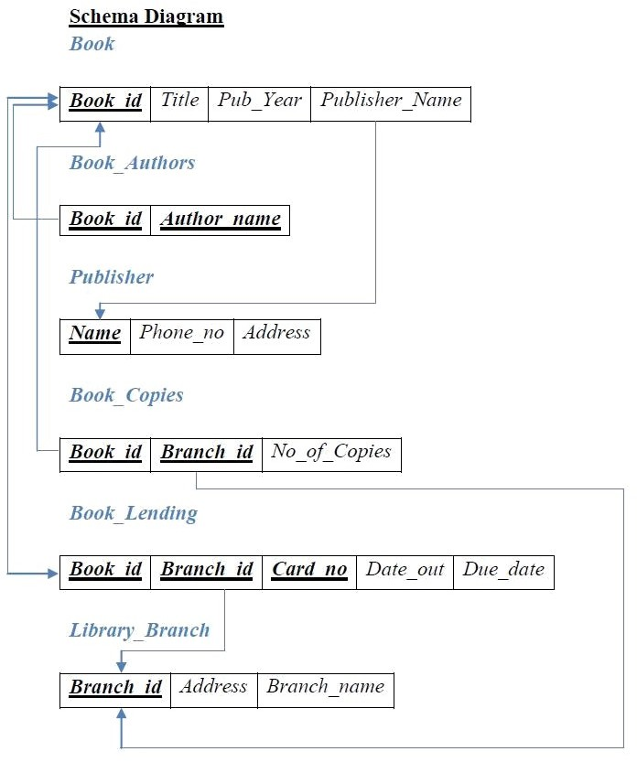

1. CREATE TABLE PUBLISHER (NAME VARCHAR (20) PRIMARY KEY, PHONE VARCHAR(15), ADDRESS VARCHAR (20));
2. CREATE TABLE BOOK (BOOK_ID INTEGER PRIMARY KEY, TITLE VARCHAR (20), PUB_YEAR VARCHAR (20), PUBLISHER_NAME VARCHAR(20), FOREIGN KEY (PUBLISHER_NAME) REFERENCES PUBLISHER(NAME) ON DELETE CASCADE);
3. CREATE TABLE BOOK_AUTHORS (AUTHOR_NAME VARCHAR (20), BOOK_ID INTEGER, FOREIGN KEY(BOOK_ID) REFERENCES BOOK (BOOK_ID) ON DELETE CASCADE,

PRIMARY KEY (BOOK_ID, AUTHOR_NAME));

1. CREATE TABLE LIBRARY_BRANCH (BRANCH_ID INTEGER PRIMARY KEY, BRANCH_NAME VARCHAR (50), ADDRESS VARCHAR (50));
2. CREATE TABLE BOOK_COPIES (NO_OF_COPIES INTEGER,

BOOK_ID INTEGER, FOREIGN KEY(BOOK_ID) REFERENCES BOOK (BOOK_ID) ON DELETE CASCADE,

BRANCH_ID INTEGER, FOREIGN KEY(BRANCH_ID) REFERENCES LIBRARY_BRANCH (BRANCH_ID) ON DELETE CASCADE,

PRIMARY KEY (BOOK_ID, BRANCH_ID));

1. CREATE TABLE CARD (CARD_NO INTEGER PRIMARY KEY);
2. CREATE TABLE BOOK_LENDING (DATE_OUT DATE, DUE_DATE DATE, BOOK_ID INTEGER, FOREIGN KEY(BOOK_ID) REFERENCES BOOK (BOOK_ID) ON DELETE CASCADE,

BRANCH_ID INTEGER, FOREIGN KEY(BRANCH_ID) REFERENCES LIBRARY_BRANCH (BRANCH_ID) ON DELETE CASCADE,

CARD_NO INTEGER, FOREIGN KEY(CARD_NO) REFERENCES CARD (CARD_NO) ON DELETE CASCADE,

PRIMARY KEY (BOOK_ID, BRANCH_ID, CARD_NO));

# Table Description

* + DESC PUBLISHER;
  + DESC BOOK;
  + DESC BOOK_AUTHORS;
  + DESC LIBRARY_BRANCH;
  + DESC BOOK_COPIES;
  + DESC CARD;
  + DESC BOOK_LENDING;

1. *INSERT INTO PUBLISHER TABLE:*
   * INSERT INTO PUBLISHER VALUES('MCGRAWHILL',9191919191,'BANGALORE');
   * INSERT INTO PUBLISHER VALUES('PEARSON',8181818181,'NEWDELHI');
   * INSERT INTO PUBLISHER VALUES('RANDOMHOUSE',7171717171,'HYDERABAD');
   * INSERT INTO PUBLISHER VALUES('LIVRE',6161616161,'CHENNAI');
   * INSERT INTO PUBLISHER VALUES('PLANETA',5151515151,'BANGALORE');
   * SELECT * FROM PUBLISHER;
2. *INSERT INTO BOOK TABLE:*
   * INSERT INTO BOOK VALUES(1,'DBMS','JAN-2017','MCGRAWHILL');
   * INSERT INTO BOOK VALUES(2,'ADBMS','JUN-2016','MCGRAWHILL');
   * INSERT INTO BOOK VALUES(3,'CN','SEP-2016','PEARSON');
   * INSERT INTO BOOK VALUES(4,'CG','SEP-2015','PLANETA');
   * INSERT INTO BOOK VALUES(5,'OS','MAY-2016','PEARSON');
   * SELECT * FROM BOOK;
3. *INSERT INTO BOOK_AUTHORS TABLE:*
   * INSERT INTO BOOK_AUTHORS VALUES ('NAVATHE', 1);
   * INSERT INTO BOOK_AUTHORS VALUES ('NAVATHE', 2);
   * INSERT INTO BOOK_AUTHORS VALUES ('TANENBAUM', 3);
   * INSERT INTO BOOK_AUTHORS VALUES ('EDWARD ANGEL', 4);
   * INSERT INTO BOOK_AUTHORS VALUES ('GALVIN', 5);
   * SELECT * FROM BOOK_AUTHORS;
4. *INSERT INTO LIBRARY_BRANCH TABLE:*
   * INSERT INTO LIBRARY_BRANCH VALUES (10, 'RR NAGAR', 'BANGALORE');
   * INSERT INTO LIBRARY_BRANCH VALUES (11, 'KENGERI', 'BANGALORE');
   * INSERT INTO LIBRARY_BRANCH VALUES (12, 'RAJAJI NAGAR', 'BANGALORE');
   * INSERT INTO LIBRARY_BRANCH VALUES (13, 'NITTE', 'MANGALORE');
   * INSERT INTO LIBRARY_BRANCH VALUES (14, 'MANIPAL', 'UDUPI');
   * SELECT *FROM LIBRARY_BRANCH;
5. *INSERT INTO BOOK_COPIES TABLE:*
   * INSERT INTO BOOK_COPIES VALUES (10, 1, 10);
   * INSERT INTO BOOK_COPIES VALUES (5, 1, 11);
   * INSERT INTO BOOK_COPIES VALUES (2, 2, 12);
   * INSERT INTO BOOK_COPIES VALUES (5, 2, 13);
   * INSERT INTO BOOK_COPIES VALUES (7, 3, 14);
   * INSERT INTO BOOK_COPIES VALUES (1, 5, 10);
   * INSERT INTO BOOK_COPIES VALUES (3, 4, 11);
   * SELECT *FROM BOOK_COPIES;
6. *INSERT INTO CARD TABLE:*
   * INSERT INTO CARD VALUES (100);
   * INSERT INTO CARD VALUES (101);
   * INSERT INTO CARD VALUES (102);
   * INSERT INTO CARD VALUES (103);
   * INSERT INTO CARD VALUES (104);
   * SELECT *FROM CARD ;
7. *INSERT INTO BOOK_LENDING TABLE*:
   * INSERT INTO BOOK_LENDING VALUES ('2021-06-01', '2021-07-01', 1, 10, 101);
   * INSERT INTO BOOK_LENDING VALUES ('2021-01-05', '2021-02-05', 3, 14, 101);
   * INSERT INTO BOOK_LENDING VALUES ('2021-07-03', '2021-08-03', 2, 13, 101);
   * INSERT INTO BOOK_LENDING VALUES ('2021-12-11', '2022-01-11', 4, 11, 101);
   * INSERT INTO BOOK_LENDING VALUES ('2021-10-01', '2021-11-01', 1, 11, 104);
   * SELECT *FROM BOOK_LENDING;

## Retrieve details of all books in the library – id, title, name of publisher, authors, number of copies in each branch, etc.

SELECT B.BOOK_ID, B.TITLE, B.PUBLISHER_NAME, A.AUTHOR_NAME, C.NO_OF_COPIES, L.BRANCH_ID

FROM BOOK B, BOOK_AUTHORS A, BOOK_COPIES C, LIBRARY_BRANCH L WHERE

B.BOOK_ID=A.BOOK_ID AND B.BOOK_ID=C.BOOK_ID AND L.BRANCH_ID=C.BRANCH_ID;

## Get the particulars of borrowers who have borrowed more than 3 books, but from Jan 2021 to Aug 2021

SELECT CARD_NO FROM BOOK_LENDING

WHERE DATE_OUT BETWEEN '2021-01-01' AND '2021-08-01' GROUP BY CARD_NO

HAVING COUNT(*)>3;

## Delete a book in BOOK table. Update the contents of other tables to reflect this data manipulation operation.

* DELETE FROM BOOK WHERE BOOK_ID=3;

*(Note: Check BOOK_COPIES and BOOK_LENDING tables to see whether the deletion of record with BOOK_ID = 3, has been reflected)*

## Partition the BOOK table based on year of publication. Demonstrate its working with a simple query

* CREATE VIEW V_PUBLICATION AS SELECT PUB_YEAR

FROM BOOK;

* SELECT * FROM V_PUBLICATION;

## Create a view of all books and its number of copies that are currently available in the Library

CREATE VIEW V_BOOKS AS

SELECT B.BOOK_ID, B.TITLE, C.NO_OF_COPIES

FROM BOOK B, BOOK_COPIES C, LIBRARY_BRANCH L

WHERE B.BOOK_ID=C.BOOK_ID AND C.BRANCH_ID=L.BRANCH_ID;