We covered measures of central tendency. Now lets talk about measures that help understand about spread or variability.

Range: difference between largest and smallest number.
Eg: what is range of 1,2,6,100

Variance:
1,2,3 spread 1-2, 3-2 we -1,+1

Std. Deviation:

Prob. Distribution:
A mathematical function that provides the probability of occurance of different possible outcomes in an experiment.

Prob. Density fun:
probability density function (PDF), or density of a continuous random variable, is a function whose value at any given sample (or point) in the sample space (the set of possible values taken by the random variable) can be interpreted as providing a relative likelihood that the value of the random variable would equal that sample .

where
U= mean
Sigma = sd
Sigma sq = variance

Binomial:
new drug is introduced to cure a disease, it either cures the disease (it’s successful) or it doesn’t cure the disease (it’s a failure). If you purchase a lottery ticket, you’re either going to win money, or you aren’t. Basically, anything you can think of that can only be a success or a failure can be represented by a binomial distribution.

Poisson:
Poisson distribution is applied in situations where there are a large number of independent trials with a very small probability of success in any trial say p. Thus very commonly encountered situations of Poisson distribution are:
- The number of aircraft/road accidents in any time interval.
- The number of arrivals in any service facility like at an ATM, bank, railway station, petrol pump,…
- The number of patients in a doctor's clinic.
- The number of beds occupied in a large hospital or hotel.
- The number of visitors to a mall, exhibition,…

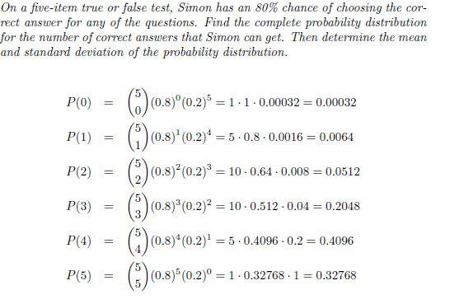

What is
P(0)+....+P(5) ? Why
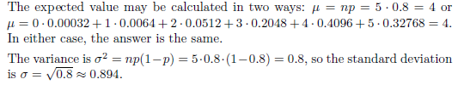

Binomial distributions are often used in quality control systems, where a small
number of samples are tested out of a shipment, and the shipment is only
accepted if the number of defects found among the sampled units falls below a
specified number. In order to analyze whether a sampling plan effectively screens
out shipments containing a great number of defects and accepts shipments with
very few defects, one must calculate the probability that a shipment will be
accepted given various defect levels.

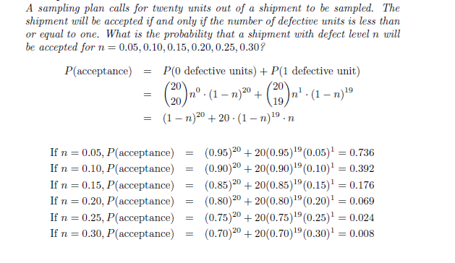

POISSON dist:
At first, the requirement that n be large, p be small, and the mean (np) be
a known, moderate number seems overly restrictive. However, there are many
cases where this occurs.
For example, a grocer might sell 5 heads of lettuce each
day. It’s impractical to say how many heads of lettuce he didn’t sell, because
we do not know how many customers visited his store or how many they could
have bought (and there is really no way to determine the latter). However, we
can assume that there were many chances for someone to buy a head of lettuce,so n is very large.
The chance of someone buying a head of lettuce at any
given moment is very small, so p is small. Finally, the mean, 5 heads of lettuce
per day, is known. Thus, the Poisson distribution could probably be used to
describe this situation.

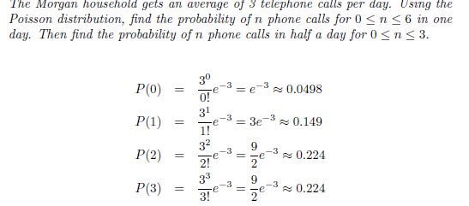

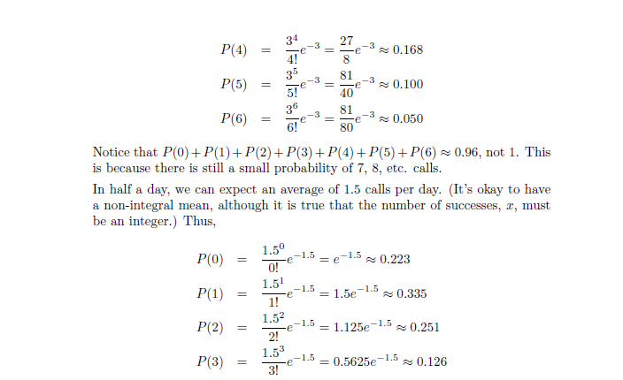

Z-score:

