Parametric Machine Learning Algorithms
A learning model that summarizes data with a set of parameters of fixed size (independent of the number of training examples) is called a parametric model. No matter how much data you throw at a parametric model, it won’t change its mind about how many parameters it needs.

—AI Modern Approach, page 737

Often the assumed functional form is a linear combination of the input variables and as such parametric machine learning algorithms are often also called “Linear ML Algorithms“.

Eg: Logistic Regression, Simple Neural Nets

Nonparametric Machine Learning Algorithms
Algorithms that do not make strong assumptions about the form of the mapping function are called nonparametric machine learning algorithms. By not making assumptions, they are free to learn any functional form from the training data.

Nonparametric methods are good when you have a lot of data and no prior knowledge, and when you don’t want to worry too much about choosing just the right features.
AI Modern Approach- page 757
Eg: KNN, SVM

Mean Absolute Error:
Mean Absolute Error (MAE): MAE measures the average magnitude of the errors in a set of predictions, without considering their direction. It’s the average over the test sample of the absolute differences between prediction and actual observation where all individual differences have equal weight.

Root mean squared error (RMSE): RMSE is a quadratic scoring rule that also measures the average magnitude of the error. It’s the square root of the average of squared differences between prediction and actual observation.

Similarities: Both MAE and RMSE express average model prediction error in units of the variable of interest. Both metrics can range from 0 to ∞ and are indifferent to the direction of errors. They are negatively-oriented scores, which means lower values are better.

Differences: Taking the square root of the average squared errors has some interesting implications for RMSE. Since the errors are squared before they are averaged, the RMSE gives a relatively high weight to large errors. This means the RMSE should be more useful when large errors are particularly undesirable.

Linear Regression:
https://www.mathsisfun.com/equation_of_line.html

Learning a linear regression model is nothing but estimating/computing the values of the coeficients used in the representation with the data that we have.

Ordinary Least Squares
When we have more than one input we can use Ordinary Least Squares to estimate the values
of the coecients. The Ordinary Least Squares procedure seeks to minimize the sum of the
squared residuals. This means that given a regression line through the data we calculate the
distance from each data point to the regression line, square it, and sum all of the squared errors
together. This is the quantity that ordinary least squares seeks to minimize.

Gradient Descent
When there are one or more inputs you can use a process of optimizing the values of the
coecients by iteratively minimizing the error of the model on your training data. This
operation is called Gradient Descent and works by starting with zero values for each coecient.
The sum of the squared errors are calculated for each pair of input and output values. A learning
rate is used as a scale factor and the coecients are updated in the direction towards minimizing
the error. The process is repeated until a minimum sum squared error is achieved or no further
improvement is possible.

Making Predictions with Linear Regression
Given the representation is a linear equation, making predictions is as simple as solving the
equation for a specic set of inputs. Let's make this concrete with an example. Imagine we
are predicting weight (y) from height (x). Our linear regression model representation for this
problem would be:

y = B0 + B1 * X1
weight = B0 + B1 * height

Where B0 is the bias coefient and B1 is the coecient for the height column. We use a
learning technique to nd a good set of coecient values. Once found, we can plug in dierent
height values to predict the weight. For example, let's use B0 = 0.1 and B1 = 0.5. Let's plug
them in and calculate the weight (in kilograms) for a person with the height of 182 centimeters.
Weight = 0.1 + 0.5 * 182
Weight = 91.1

You can see that the above equation could be plotted as a line in two-dimensions. The B0
is our starting point regardless of what height we have. We can run through a bunch of heights
from 100 to 250 centimeters and plug them to the equation and get weight values, creating our
line.

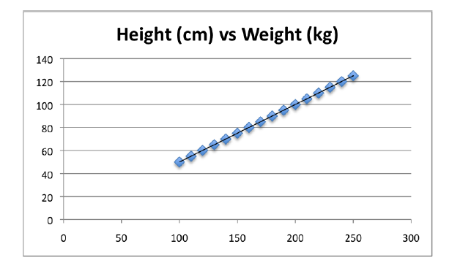
Assumptions:
Linear Assumption. Linear regression assumes that the relationship between your input
and output is linear. It does not support anything else.

Remove Noise. Linear regression assumes that your input and output variables are
not noisy. Consider using data cleaning operations that let you better expose and clarify
the signal in your data. This is most important for the output variable and you want to
remove outliers in the output variable (y) if possible.

Remove Collinearity. Linear regression will overfit your data when you have highly
correlated input variables.

Gaussian Distributions. Linear regression will make more reliable predictions if your
input and output variables have a Gaussian distribution.

Sample Dataset:

x y
1 1
2 3
4 3
3 2
5 5

The attribute x is the input variable and y is the output variable that we are trying to
predict.

Scatter Plot

With simple linear regression we want to model our data as follows:
y = B0 + B1 * x
This is a line where y is the output variable we want to predict, x is the input variable
we know and B0 and B1 are coecients that we need to estimate .
B0 is called the intercept because it determines where the line intercepts the y-axis.
In machine learning we can call this the bias, because it is added to offset all predictions that
we make. The B1 term is called the slope because it defies the slope of the line or how x
translates into a y value before we add our bias.
The goal is to find the best estimates for the coecients to minimize the errors in predicting
y from x.

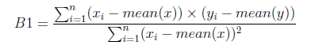

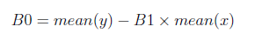

Now we need to calculate the error of each variable from the mean. Let's do this with x firrst:
x mean(x) x - mean(x)
1 3 -2
2 -1
4 1
3 0
5 2

Above calc for::: Residual of each x value from the mean.

Now let's do that for the y variable.
y mean(y) y - mean(y)
1 2.8 -1.8
3 0.2
3 0.2
2 -0.8
5 2.2
Residual of each y value from the mean.

We now have the parts for calculating the numerator. All we need to do is multiple the error

for each x with the error for each y and calculate the sum of these multiplications.

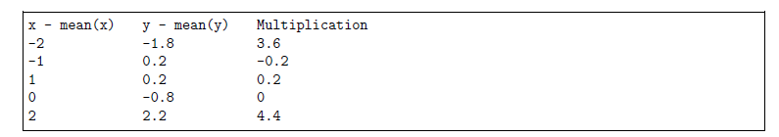
Multiplication of the x and y residuals from their means.

Summing the final column we have calculated our numerator as 8.

Now we need to calculate
the bottom part of the equation for calculating B1, or the denominator. This is calculated as
the sum of the squared dierences of each x value from the mean. We have already calculated
the dierence of each x value from the mean, all we need to do is square each value and calculate
the sum.

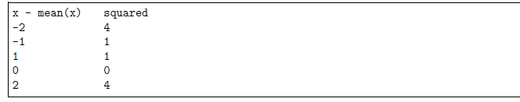
Calculating the sum of these squared values gives us a denominator of 10. Now we can calculate the value of our slope.

B1 = 8/10
B1 = 0.8

Estimating The Intercept (B0)
This is much easier as we already know the values of all of the terms involved.
B0 = mean(y) - B1 * mean(x)
B0 = 2.8 – 0.8 * 3
B0 = 0.4

LET's make some predictions:

We now have the coecients for our simple linear regression equation.
y = B0 + B1 * x
y = 0.4 + 0.8 * x

Let's try out the model by making predictions for our training data.
x Predicted Y
1 1.2
2 2
3 2.8
4 3.6
5 4.4

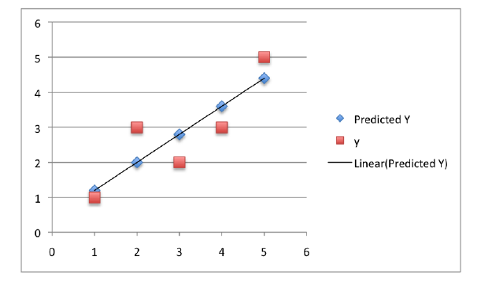

How good is our prediction?

Lets use Root Mean Squared Error – RMSE

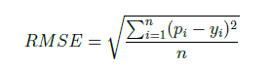

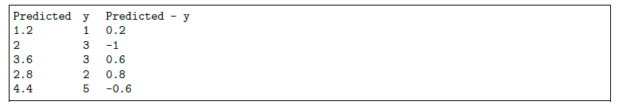
Error for Predicted Values

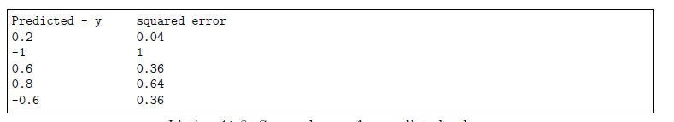
Squared Error for Predicted Values

The sum of these errors is 2.4 units, dividing by 5 and taking the square root gives us:
RMSE = 0.692820323

We can infer that each of our prediction AT AN AVERAGE is off by 0.7

What is linear and non-linear:
Need to change constan with a value

Statisticians use the correlation coefficient to measure the strength and direction of the linear relationship between two numerical variables X and Y. The correlation coefficient for a sample of data is denoted by r.

1.Find the mean of all the x-values
2. Find the standard deviation of all the x-values (call it sx) and the standard deviation of all the y-values (call it sy).
3.For each of the n pairs (x, y) in the data set, take

Add up the n results from Step 3.
4.Divide the sum by sx ∗ sy.
5.Divide the result by n – 1, where n is the number of (x, y) pairs. (It’s the same as multiplying by 1 over n – 1.)
This gives you the correlation, r.

suppose you have the data set (3, 2), (3, 3), and (6, 4). You calculate the correlation coefficient r via the following steps. (Note that for this data the x-values are 3, 3, 6, and the y-values are 2, 3, 4.)

Mean of x,y are 4,3

2. The standard deviations are sx = 1.73 and sy = 1.00

3. The n = 3 differences found in Step 2 multiplied together are: (3 – 4)(2 – 3) = (– 1)( – 1) = +1; (3 – 4)(3 – 3) = (– 1)(0) = 0; (6 – 4)(4 – 3) = (2)(1) = +2.

Adding the n = 3 Step 3 results, you get 1 + 0 + 2 = 3.

4.Dividing by sx ∗ sy gives you 3 / (1.73 ∗ 1.00) = 3 / 1.73 = 1.73. (It’s just a coincidence that the result from Step 5 is also 1.73.)

5. Now divide the Step 5 result by 3 – 1 (which is 2), and you get the correlation r = 0.87.

Y = mX+C
Eqn of st. Line

LHS Y -> Dependent variable
RHS X -> Independent variable

1. Eqn of st. Line. What these parameters mean
https://www.mathsisfun.com/equation_of_line.html

2. Linear Regression
What is Linear
What is regression

What is meant by linear:
Linear basically means a st. Line relationship between dependent and independent variables.

X Y
2 10
4 15
6 20
8 25

2,4 2
4,6 2
6,8 2

10,15 5
15,20 5
20,25 5

Sigma: Stands for summation
J -> 1 to n 1 in the bottom is the starting value
N on the top is ending value

Suppose n is 5

J will take values starting 1 , 2,3,4 and ending with n=5

Suppose y from 11 till 15 actual values
Predicted is 20 to 25 tehn

|11-20| + |12-21| ........+|(15-25)|

| | stands for modulus and modulus of a numer is always +ve

1/n infront of the expression divides the whole value obtained by n ie. Basically finds the mean

Y – y^ sq

2 4
4 16
10000 100

16/3 120/3 = 40
5.33 6.32

pl.note: This note may have typos.
Most of the material used here is from good resouces availbe on the net, my own notes , discussion with other experts and some good books.

