Redundancy and Replication
Redundancy is the duplication of critical components or functions of a system with the intention of increasing the reliability of the system, usually in the form of a backup or fail-safe, or to improve actual system performance. For example, if there is only one copy of a file stored on a single server, then losing that server means losing the file. Since losing data is seldom a good thing, we can create duplicate or redundant copies of the file to solve this problem.
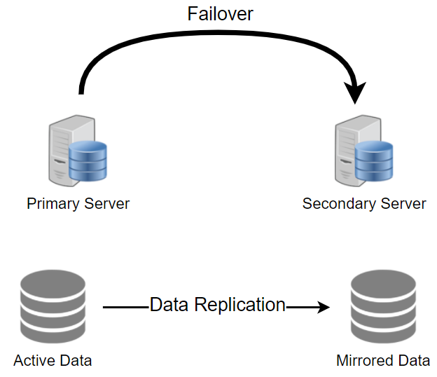
Redundancy plays a key role in removing the single points of failure in the system and provides backups if needed in a crisis. For example, if we have two instances of a service running in production and one fails, the system can failover to the other one.
Replication means sharing information to ensure consistency between redundant resources, such as software or hardware components, to improve reliability, fault-tolerance, or accessibility.
Replication is widely used in many database management systems (DBMS), usually with a primary-replica relationship between the original and the copies. The primary server gets all the updates, which then ripple through to the replica servers. Each replica outputs a message stating that it has received the update successfully, thus allowing the sending of subsequent updates.

