케라스 한국어 페이지 https://keras.io/ko/

Google search: machine learning frameworks
Top 8 Deep Learning Frameworks
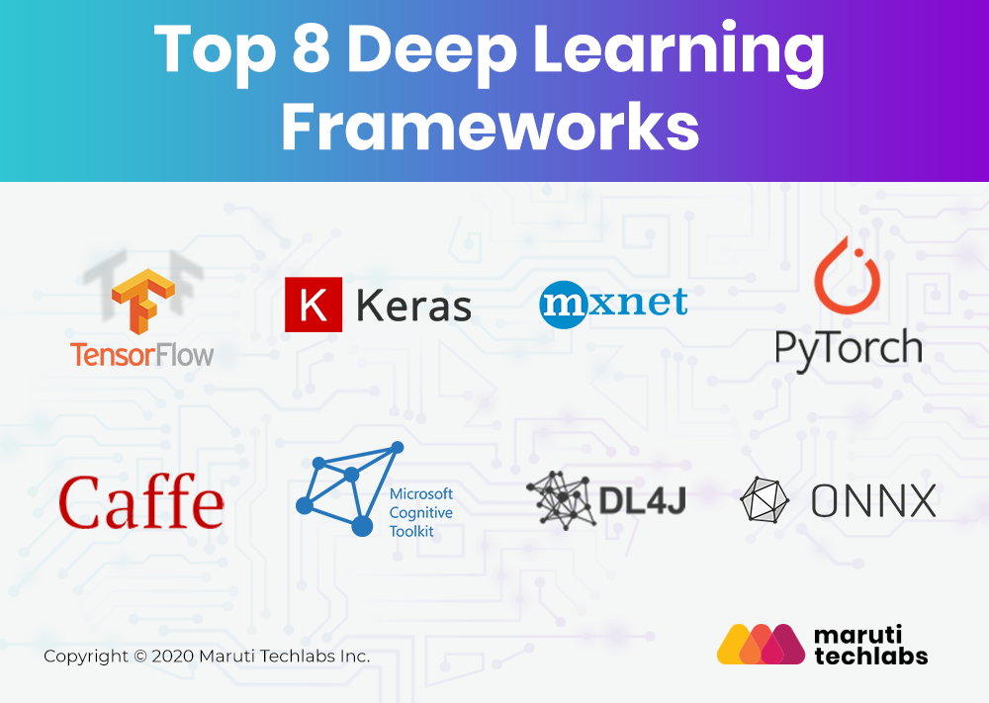

Google search: classification algorithms

R Classification – Algorithms, Applications and Examples
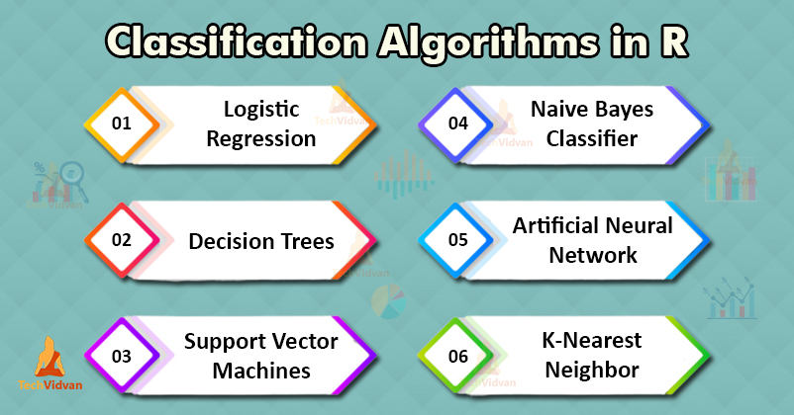

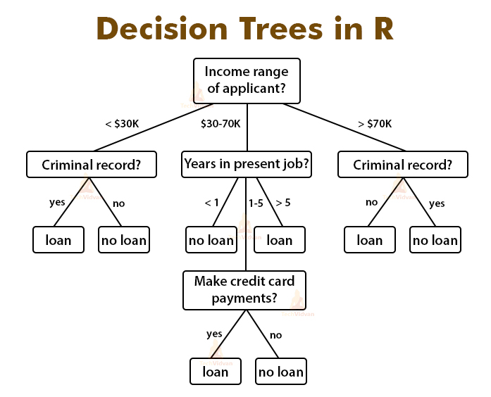
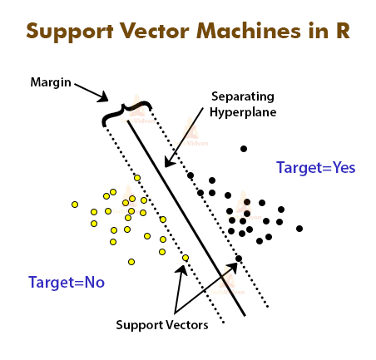

Google search: optimizer comparison

https://heartbeat.fritz.ai/an-empirical-comparison-of-optimizers-for-machine-learning-models-b86f29957050
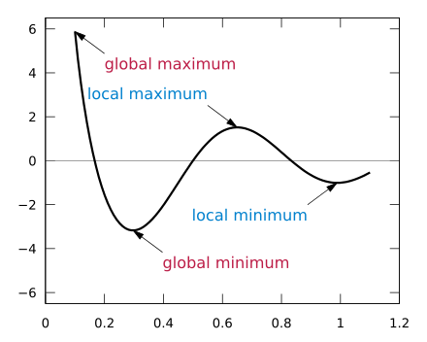
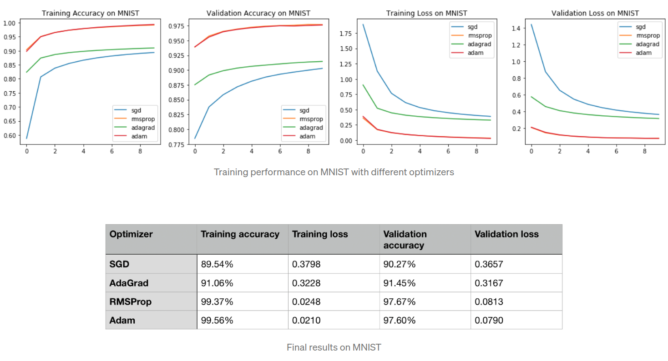
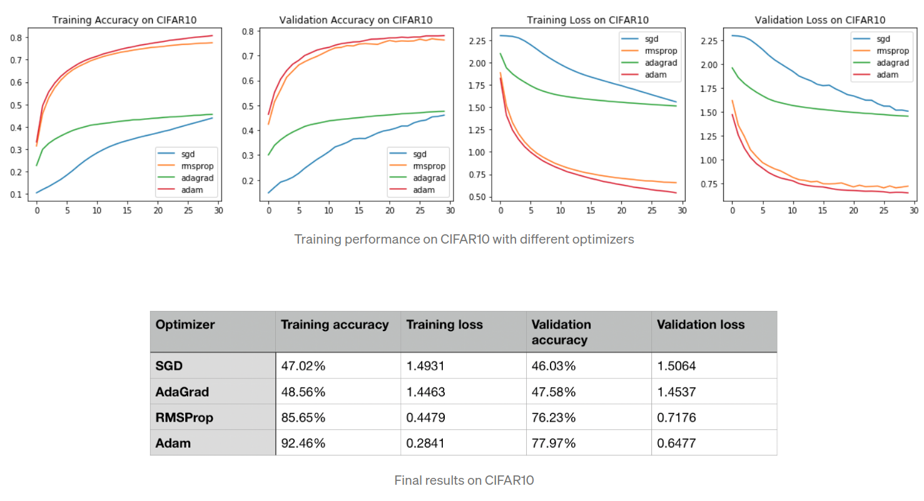
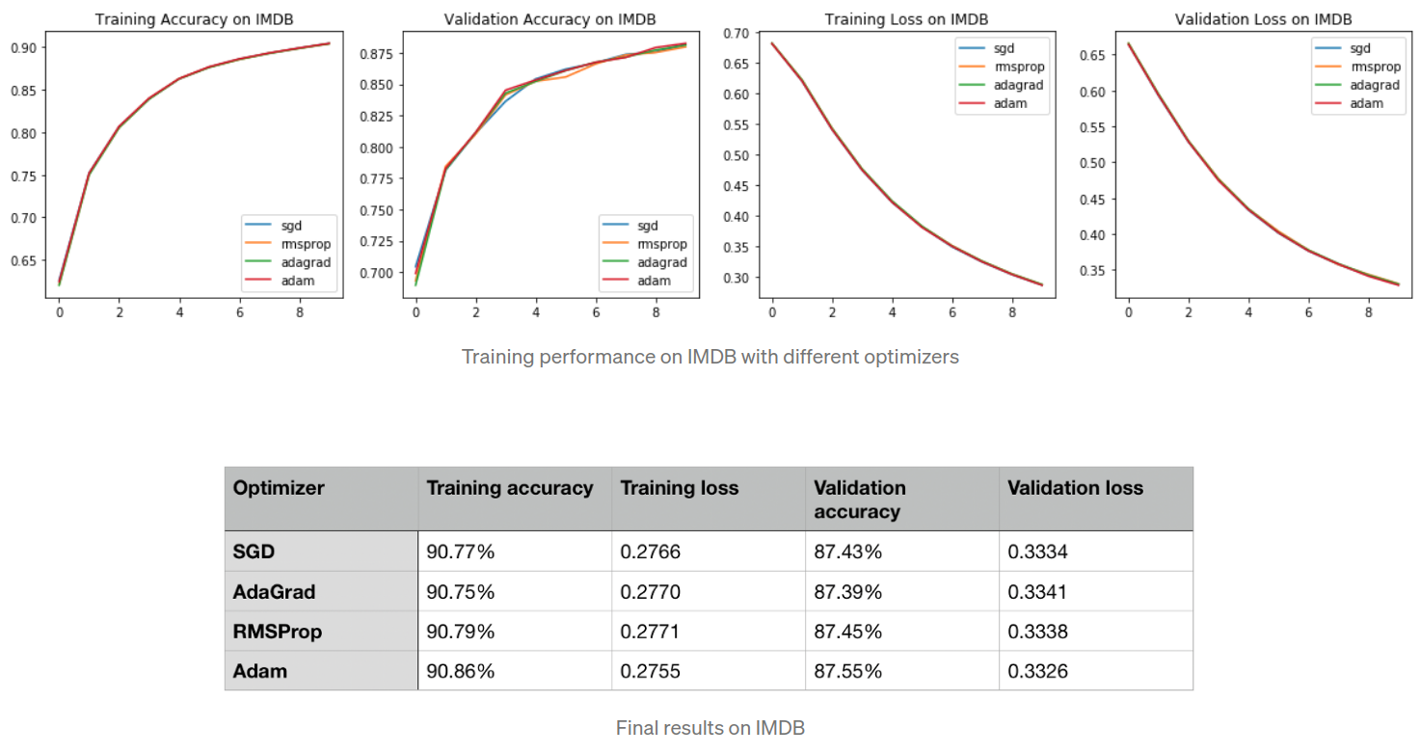

Overview of different Optimizers for neural networks
