홈 환경에서 자율주행 로봇을 이용한 상황 인지
목표 시나리오: 출퇴근 여부와 부엌의 설겆이를 인지
관련 분야: 상황 인식 컴퓨팅 , 지능형 로봇, Image Captioning, Human Action Recognition

The KIT Robo-Kitchen Data set for the Evaluation of View-based Activity Recognition Systems, Rybok et.al., Humanoids 2011, 2011.
* Video data (10 s~4 min)
* 17 different subjects of different age, gender, cultural background, and household skills
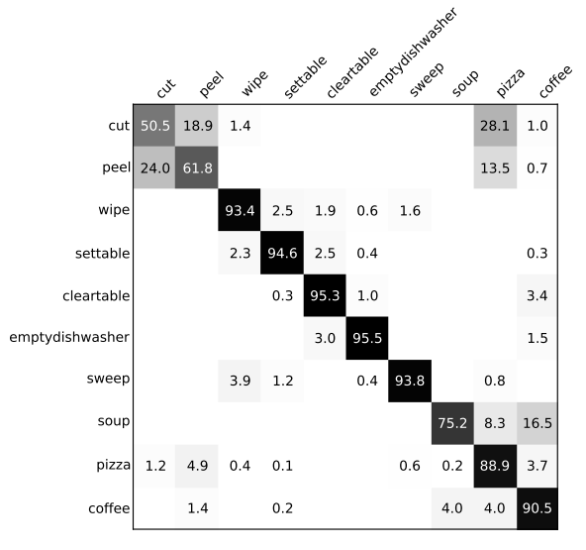

A Deep Neural Architecture for Kitchen Activity Recognition, 2017,
* KSCGR (Kitchen Scene Context based Gesture Recognition) Dataset, Challenge in ICPR 2012
- 5 menus (ham and eggs, omelet, scrambled egg, boiled egg, kinshi-tamago) done by 7 subjects
- 8 cooking gestures: breaking, mixing, baking, turning, cutting, boiling, seasoning, peeling, none,
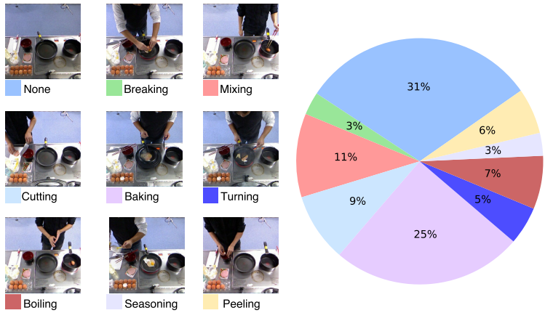

A Survey of Vision-Based Human Action Evaluation Methods, Lei et.al., 2019.
* Healthcare and rehabilitation, skill training, sports activity scoring,
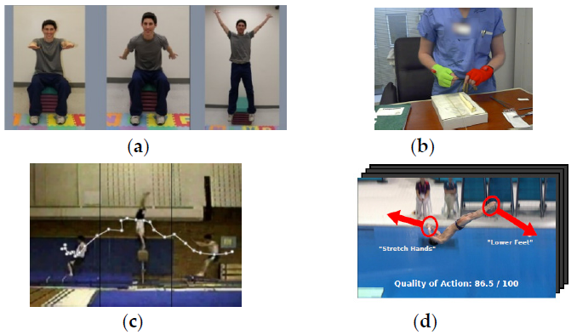
Human Action Recognition and Prediction:A Survey, Kong and Fu, 2018.

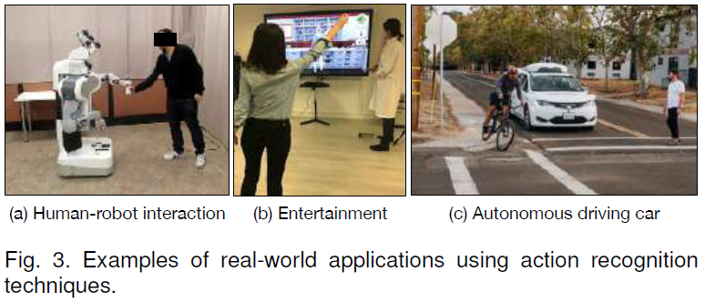

Human Activity Recognition in Smart Home With Deep Learning Approach, 2019.
* healthcare and security of smart homes
* DMLSmartActions Datasets

A Survey of Deep Learning-Based Human Activity Recognition in Radar
1999 Robots in Human Environments
2010 A Survey on Vision-based Human Action Recognition
2015 Advances in Human Action Recognition: A Survey
2018 Human Action Recognition and Prediction: A Survey
2019 A Survey of Vision-Based Human Action Evaluation Methods

