Cloud Run > Routing traffic !Failed

Problem 1. Routing traffic = Failed
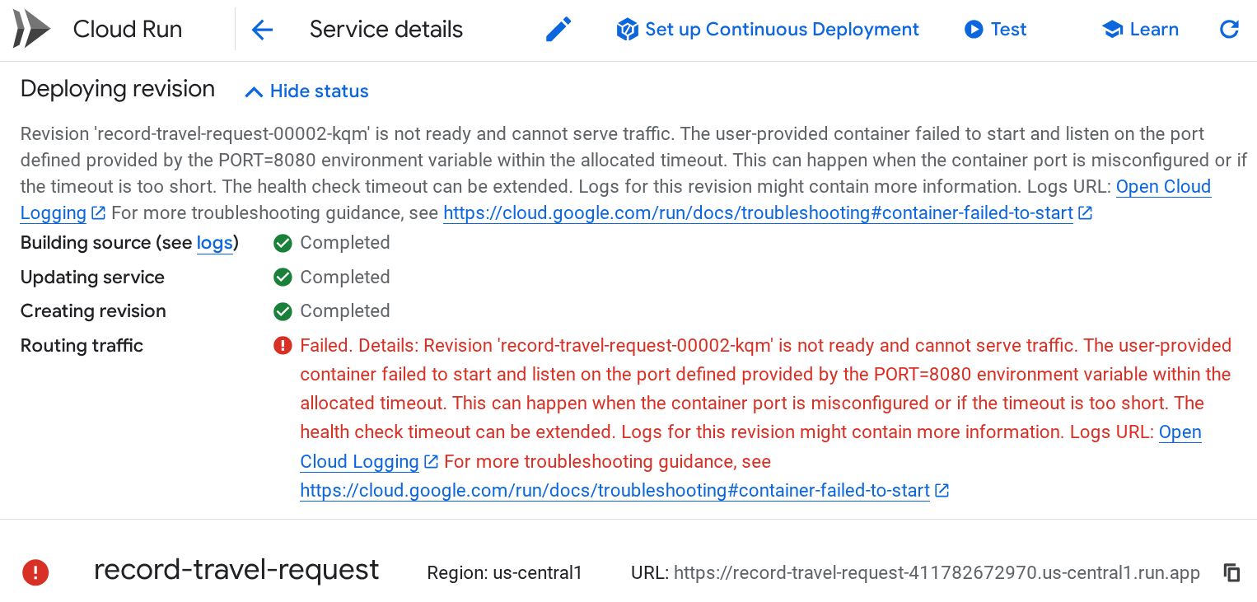

Hint 1.
Logs for this revision might contain more information. Logs URL: Open Cloud Logging For more troubleshooting guidance, see https://cloud.google.com/run/docs/troubleshooting#container-failed-to-start

Logs URL: Open Cloud Logging
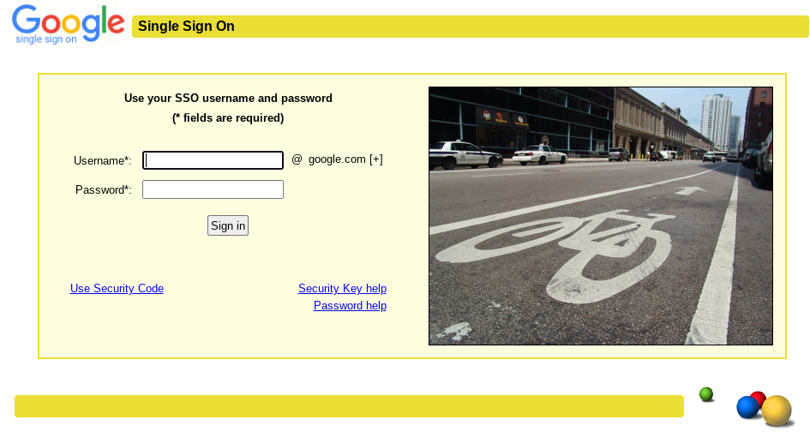
For more troubleshooting guidance, see https://cloud.google.com/run/docs/troubleshooting#container-failed-to-start

Deploying revision
Revision 'record-travel-request-00002-kqm' is not ready and cannot serve traffic. The user-provided container failed to start and listen on the port defined provided by the PORT=8080 environment variable within the allocated timeout. This can happen when the container port is misconfigured or if the timeout is too short. The health check timeout can be extended. Logs for this revision might contain more information. Logs URL: Open Cloud Logging For more troubleshooting guidance, see https://cloud.google.com/run/docs/troubleshooting#container-failed-to-start

Building source (see logs) v Completed
Updating service v Completed
Creating revision v Completed
Routing traffic v Failed.
Details: Revision 'record-travel-request-00002-kqm' is not ready and cannot serve traffic. The user-provided container failed to start and listen on the port defined provided by the PORT=8080 environment variable within the allocated timeout. This can happen when the container port is misconfigured or if the timeout is too short. The health check timeout can be extended. Logs for this revision might contain more information. Logs URL: Open Cloud Logging For more troubleshooting guidance, see https://cloud.google.com/run/docs/troubleshooting#container-failed-to-start

I was doing a lab on Google Cloud SKills Bost for Partners. The title of this lab is "Extend Agentspace assistant capabilities with Conversational Agents". I was following the instructions and working on Cloud Run.
requirements.txt
----------
functions-framework==3.*
google-cloud-bigquery
----------
main.py
----------
import functions_framework
from google.cloud import bigquery
@functions_framework.http
def record_travel_request(request):
"""Writes travel requests to BigQuery.
Args:
request (flask.Request): A request object with JSON
containing fields for user, travel_purpose, departure_city,
destination_city, departure_date, and return_date.
Returns:
JSON response containing a 'message' field indicating the
status of the request.
"""
request_json = request.get_json(silent=True)
request_args = request.args
print("JSON:" + str(request_json))
print("args:" + str(request_args))
bq_client = bigquery.Client()
table_id = "qwiklabs-gcp-02-10ec5898280c.trip.booking_requests"
row_to_insert = [
{"user": request_json["user"],
"travel_purpose": request_json["travel_purpose"],
"departure_city": request_json.get("departure_city",""),
"destination_city": request_json.get("destination_city",""),
"departure_date": request_json.get("departure_date",""),
"return_date": request_json.get("return_date",""),
},
]
errors = bq_client.insert_rows_json(table_id, row_to_insert) # Make an API request.
if errors == []:
return {"message": "New row has been added."}
else:
return {"message": "Encountered errors while inserting rows: {}".format(errors)}
----------
I clicked "Save and Redeploy". Out of 4 steps, the first three steps (1. Building source, 2. Updating service, 3. Creating revision) were completed while the last step of "Routing traffic" failed.
Q: What should I do to make this work?
For details, let me share the full message.
Full message (screenshot. See the attached image)
Full message (the same context as the screenshot, but in the text from)
Deploying revision
Revision 'record-travel-request-00002-kqm' is not ready and cannot serve traffic. The user-provided container failed to start and listen on the port defined provided by the PORT=8080 environment variable within the allocated timeout. This can happen when the container port is misconfigured or if the timeout is too short. The health check timeout can be extended. Logs for this revision might contain more information. Logs URL: Open Cloud Logging For more troubleshooting guidance, see https://cloud.google.com/run/docs/troubleshooting#container-failed-to-start
Building source (see logs) v Completed
Updating service v Completed
Creating revision v Completed
Routing traffic v Failed.
Details: Revision 'record-travel-request-00002-kqm' is not ready and cannot serve traffic. The user-provided container failed to start and listen on the port defined provided by the PORT=8080 environment variable within the allocated timeout. This can happen when the container port is misconfigured or if the timeout is too short. The health check timeout can be extended. Logs for this revision might contain more information. Logs URL: Open Cloud Logging For more troubleshooting guidance, see https://cloud.google.com/run/docs/troubleshooting#container-failed-to-start
The error message "Revision 'record-travel-request-00002-kqm' is not ready and cannot serve traffic. The user-provided container failed to start and listen on the port defined provided by the PORT=8080 environment variable within the allocated timeout" indicates that your Cloud Run service's container failed to start correctly because it didn't listen on the expected port (8080) within the default timeout period.
Here's a breakdown of the problem and the steps you should take to resolve it:
Understanding the Issue:
Cloud Run expects your containerized application to listen for incoming HTTP requests on port 8080 by default. The error message suggests that your Python function, when deployed as a container, either:
- Is not configured to listen on port 8080.
- Is taking too long to start listening on port 8080.
Troubleshooting Steps:
- Verify the functions-framework Usage:
  - The functions-framework package automatically handles the HTTP server and listens on the correct port (which defaults to 8080 in Cloud Run). Your code should work without explicitly specifying a port if you are correctly using the @functions_framework.http decorator.
- Check the Logs:
  - The error message provides a link to "Open Cloud Logging". This is the most crucial step. Click on this link and examine the logs for your Cloud Run revision (record-travel-request-00002-kqm). The logs will likely provide more specific error messages about why your container failed to start. Look for Python errors, import issues, or any other exceptions that occurred during startup.
- Ensure All Dependencies are Included:
  - Double-check your requirements.txt file. You have included functions-framework, google-cloud-bigquery. These seem correct for your provided code.
- Review Your Python Code (main.py):
  - Your Python code itself doesn't explicitly start a web server. The functions-framework handles this based on the @functions_framework.http decorator. The issue is likely not within the core logic of your function but rather in the container startup or dependency loading.
- Consider Startup Time:
  - While less likely with the provided code, if your application has a lengthy initialization process (e.g., downloading large models, establishing many connections), it might exceed the default startup timeout for Cloud Run. If the logs indicate a timeout issue without other errors, you might need to investigate optimizing your application's startup or consider increasing the health check timeout in your Cloud Run service settings (though this is usually a workaround, and fixing the underlying startup issue is better).
- Test Locally (Optional but Recommended):
  - You can test your function locally using the functions-framework CLI.
  - First, install the CLI: pip install functions-framework
  - Then, navigate to the directory containing your main.py and requirements.txt and run: func run --target record_travel_request --port 8080
  - This will simulate the Cloud Run environment locally and might help you catch errors before deploying. You can then send HTTP POST requests to http://localhost:8080/ with the JSON payload your function expects.
Most Likely Cause and Solution:
Based on the error message and the provided code, the most likely cause is an issue during the container startup that prevents the functions-framework from correctly initializing and listening on port 8080. This could be due to:
- An error during the installation of dependencies specified in requirements.txt. Check the logs for any errors related to pip install.
- An import error in your main.py that occurs before the function is even invoked. The logs should show any ImportError exceptions.
- A more fundamental issue with the container image or the Cloud Run environment, although this is less common for basic setups.
Steps to Take:
- Go to your Cloud Run service details page.
- Click on the failed revision (record-travel-request-00002-kqm).
- Click on the "Logs" link provided in the error message. This will take you to Cloud Logging, filtered for your revision.
- Carefully examine the logs. Look for any error messages, especially those that appear early in the log stream, as these are likely the cause of the startup failure.
- Based on the log messages, address the identified issue. This might involve:
  - Fixing typos in import statements.
  - Ensuring all necessary libraries are correctly listed in requirements.txt.
  - Debugging any exceptions that occur during the execution of your code upon startup.
- Once you have made the necessary changes to your main.py or requirements.txt, click "Save and Redeploy" again.
By carefully reviewing the logs, you should be able to pinpoint the reason why your container is failing to start and then take the appropriate steps to fix it.

