Deploy and query Google Agentspace
Created: 2025-03-31 (Mon)
Updated: 2025-03-31 (Mon)

https://partner.cloudskillsboost.google/course_templates/1212/labs/523437

Purpose
Create an Agentspace app for
Imaginary discovery of a new planet named "Persephone" and the organization of a conference planned for the scientific community

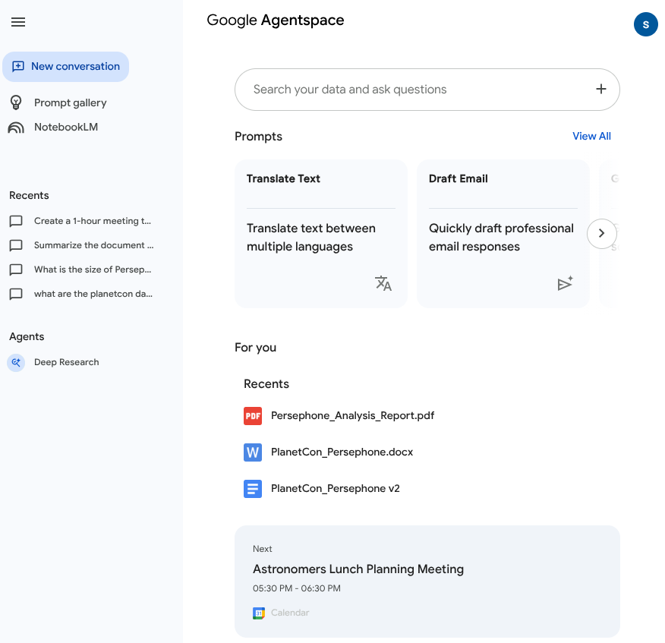

Task 1. Add content to Google Drive and Google Calendar
- Navigate to Cloud Storage > Buckets and click on the existing bucket with the name:qwiklabs-gcp-04-c2a7ac3c5189.
- Download the files listed below to your local system to use as demo data:
  - PlanetCon_Persephone.docx
  - Persephone Analysis Report.pdf
- In the Incognito window where you have logged into the Google Cloud console, create a new tab and navigate to drive.google.com.
- Create a new folder in your Qwiklab student account’s drive and name it PlanetCon: Persephone.
- Upload the documents you downloaded from Cloud Storage to the folder you just created in Google Drive named PlanetCon: Persephone. These documents relate to the imaginary discovery of a new planet named "Persephone" and the organization of a conference planned for the scientific community to discuss it.
- Open PlanetCon_Persephone.docx and dismiss the pop-ups.
- To see how Agentspace can handle multiple versions of a document, click File > Save as Google Docs. This will create a new Google Docs-native version of the file. Select the file’s name and add v2 to the file name, so it appears as PlanetCon_Persephone v2.
- Find the line Date: October 26th - 28th, 2028 and change it in this version v2 of the file to one month later: Date: November 26th - 28th, 2028
- In the same Incognito window, create a new tab, and navigate to calendar.google.com. Accept or dismiss any pop-ups.
- Ensure you are authenticated as your Qwiklabs student account by clicking the “s” in the circle in the upper right corner and confirming it is your student-...@qwiklabs.net account.
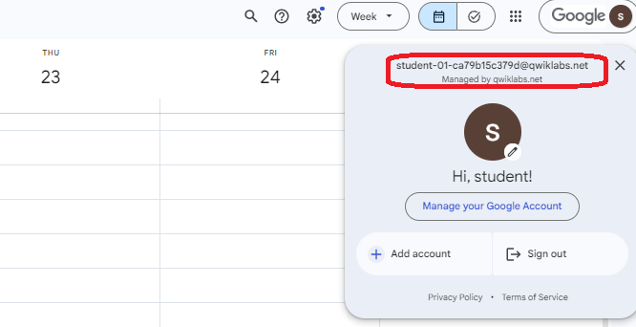
- In the upper left, click + Create and select Event from the dropdown menu.
- In the event-creation window that appears, name the event as Astronomers Lunch Planning Meeting, and set a start time of at least one hour from now.
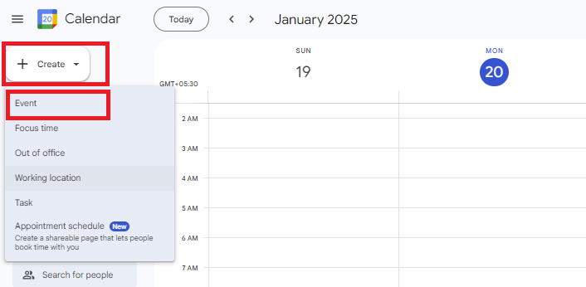
- Select Save.
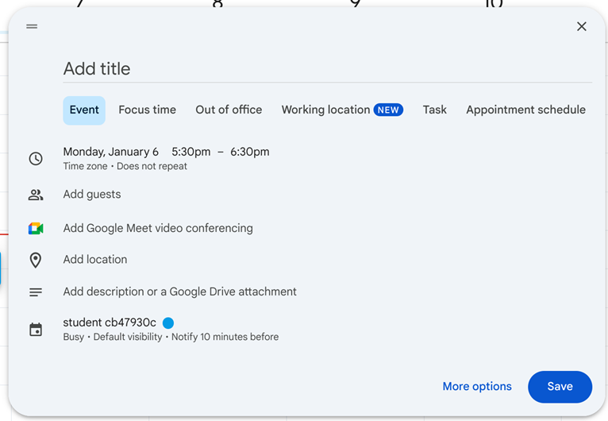
Click Check my progress to verify the objective.
Add the downloaded documents to your Drive and an event to your Calendar.
Check my progress

Assessment Completed!

Task 2. Configure an Agent Builder Identity Provider
- In the Google Cloud Console, navigate to Agent Builder by searching for it at the top of the console and click on the CONTINUE AND ACTIVATE THE API.
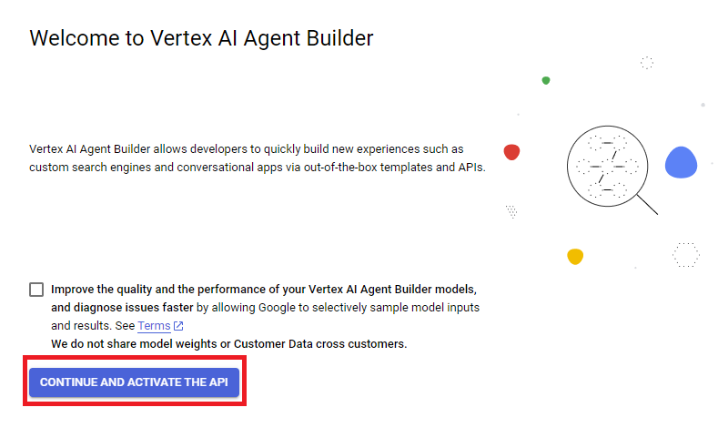
- Select Settings from the left-hand navigation pane.
- On the row for the global location, click the pencil icon .
- Select Google Identity as your identity provider.
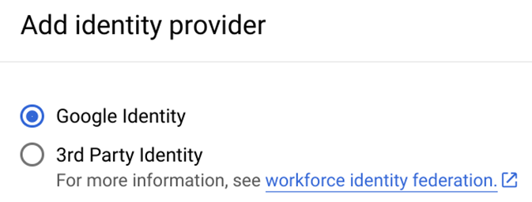
- Select SAVE.
Click Check my progress to verify the objective.
Configure an Agent Builder identity provider.
Check my progress

Task 3. Create Google Drive and Google Calendar Data Stores
- From the Agent Builder menu, select Data Stores from the left-hand navigation pane.
- Select + CREATE DATA STORE.
- Locate the Google Drive card and click SELECT.
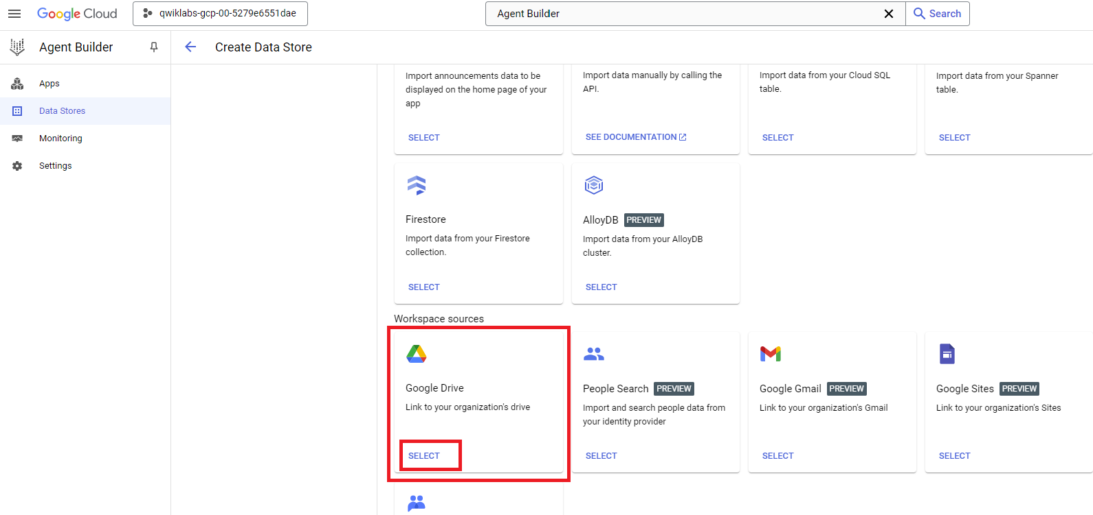
- For Choose drives you want to sync, select All.
- Note: While Agentspace makes it easier to find information across your data sources, it does not grant additional access. You will still only have access to the documents that have been shared with you via existing Drive permissions, and others will only have access to your documents that you have shared with them.
- Click CONTINUE.
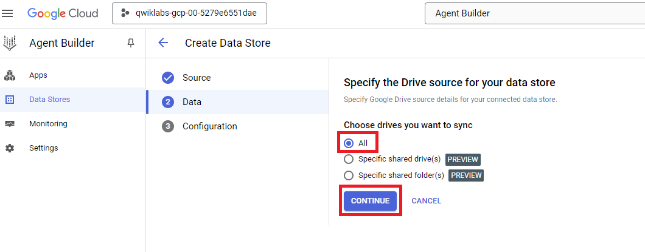
- Keep the default region of global, and give the data store the name google-drive.
- Select CREATE.
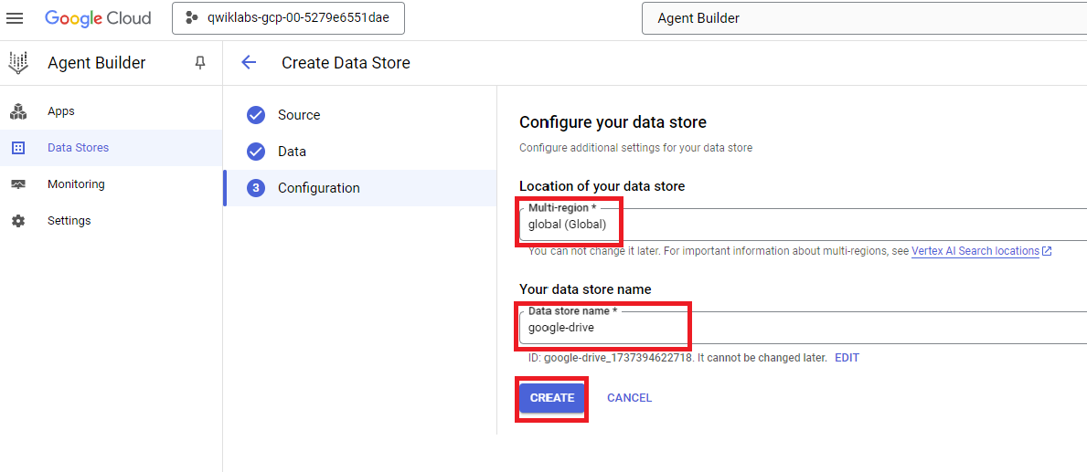
- Follow the steps in this task again, only this time create a data store for Google Calendar. Name it google-calendar.
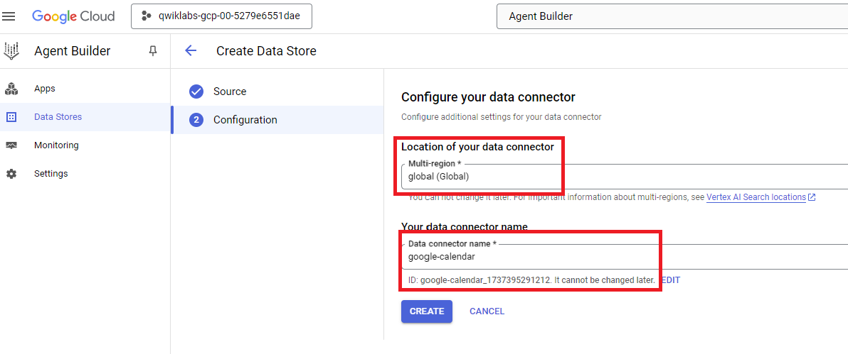
- The two data stores should be listed in the Agent Builder > Data Stores panel:
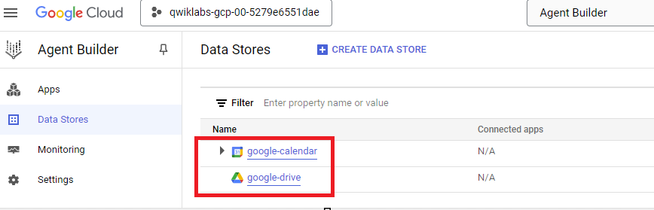
Click Check my progress to verify the objective.
Create Google Drive and Google Calendar data stores.
Check my progress

Task 4. Deploy an Agentspace app
- From the Agent Builder menu, select Apps from the left-hand navigation pane.
- Select + CREATE APP.
- Find the Enterprise Search and assistant card, which represents an Agentspace app, and select CREATE.
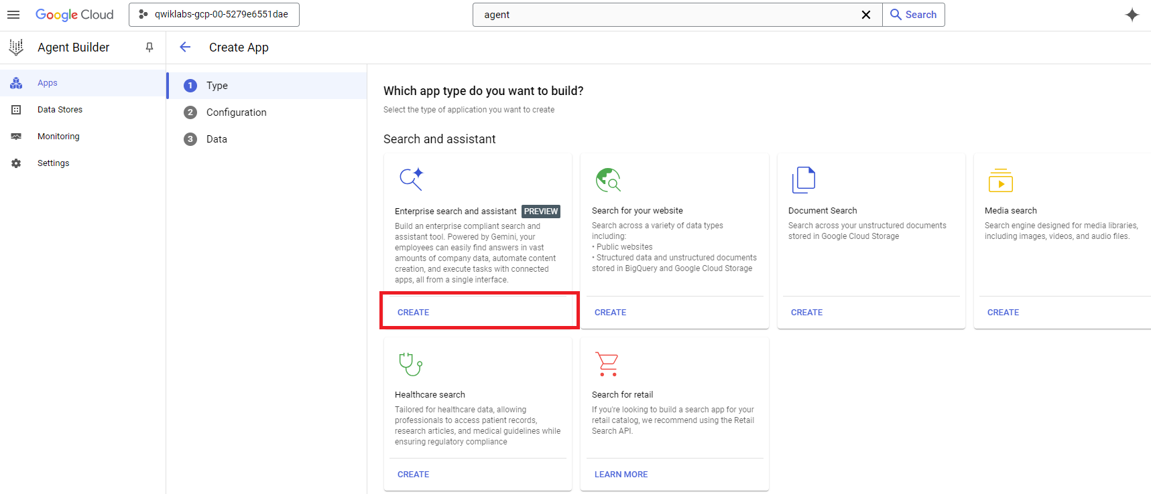
- Name your app Scientific Conferences Agentspace.
- For a company name, use Scientific Conferences.
- Under the “Select tier” header, select Search + Assistant.
- Select CONTINUE.
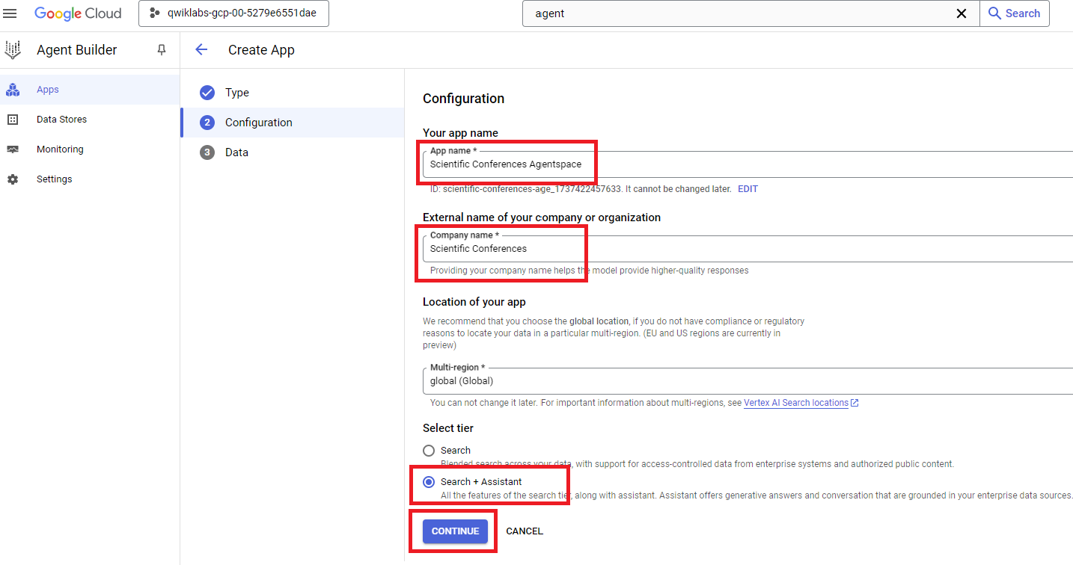
- For connected data stores, select the checkbox for the google-drive and google-calendar data stores you created earlier.
- Select CREATE.
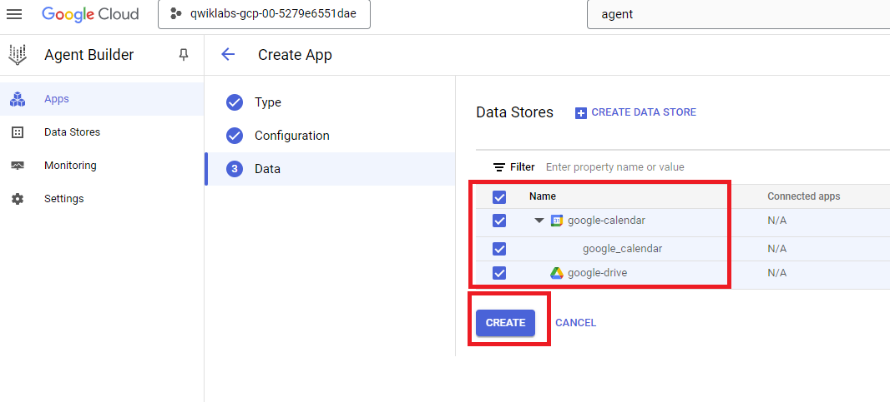
Click Check my progress to verify the objective.
Deploy an Agentspace app.
Check my progress

Task 5. Set up an OAuth Consent Screen and Create client
In order for the AI assistant to take actions on a user’s behalf, the user must grant access to your enterprise search and assistant app. To configure the OAuth consent screen and client, follow the following steps:
- Navigate to the Google Auth Platform.
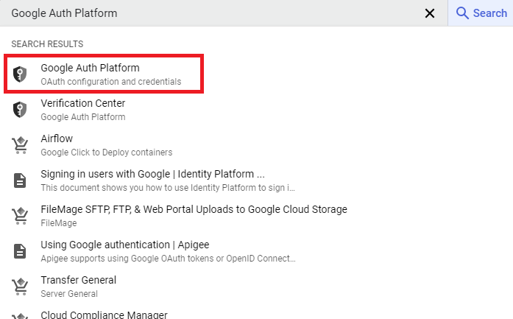
- Click GET STARTED.
- For App Name, enter Scientific Conferences Agentspace.
- For the user support email, select your Qwiklabs student account.
- Select Next.
- In the Audience section, select an Internal Audience.
- Select Next.
- In the Contact Information section, provide an email address, which can be your real professional email address or your Qwiklabs student account.
- In the Finish section, agree to the terms.
- Select Create to create your OAuth consent screen.
- Your Google Auth Platform dashboard will display a banner that you haven’t created any clients yet. Select Create OAuth Client. If you don’t see this banner, select Clients on the left and then + Create Client.
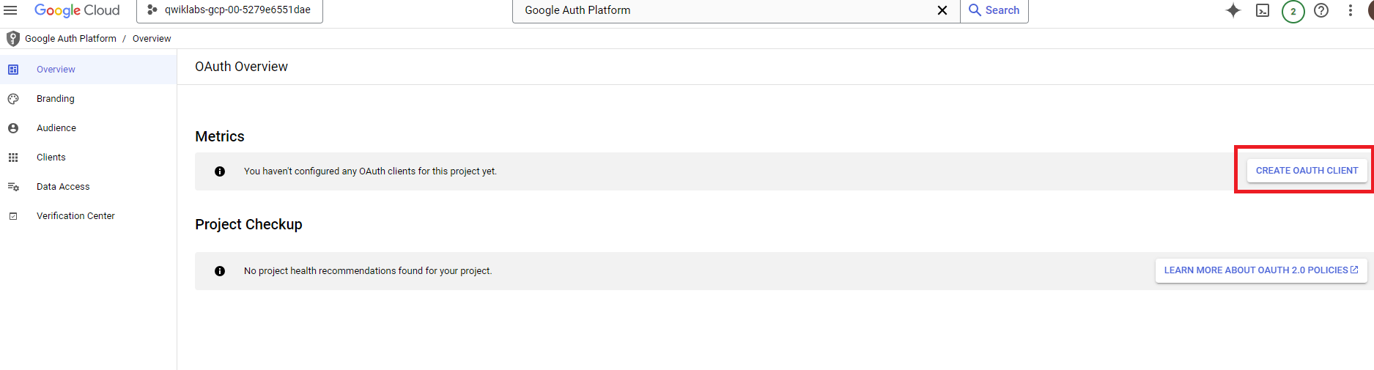
- Select an Application type of Web application.
- Name the client Agentspace Client.
- Under Authorized redirect URIs, add https://vertexaisearch.cloud.google.com/oauth-redirect
- Click Create.
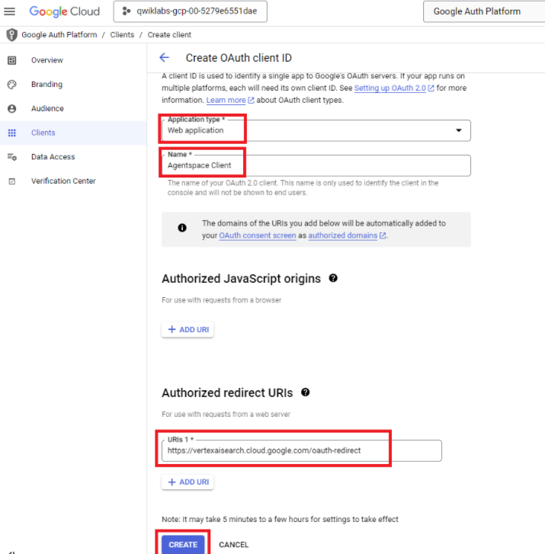
- When the client is created, click the Download button at the end of its row to display the Client ID and Client Secret values. Store these in a text document, as you will need them shortly to enable actions.
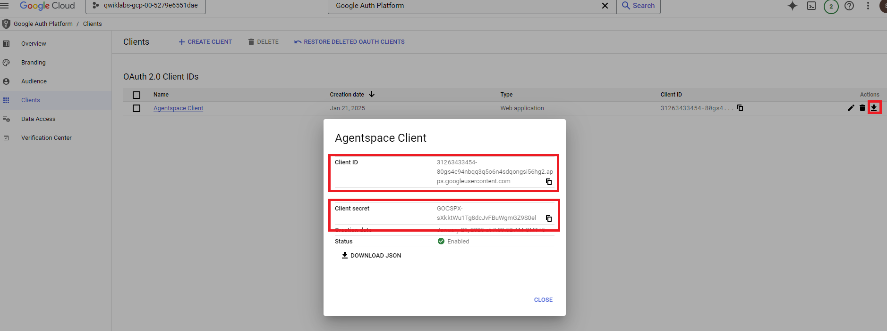
Click Check my progress to verify the objective.
Set up an OAuth Consent Screen and create a client.
Check my progress

Task 6. Enable a Google Calendar Action
To configure the action, you’ll need to enable the Google Calendar API. To do so:
- In the search bar at the top of the Cloud Console, search for the Google Calendar API and select it.
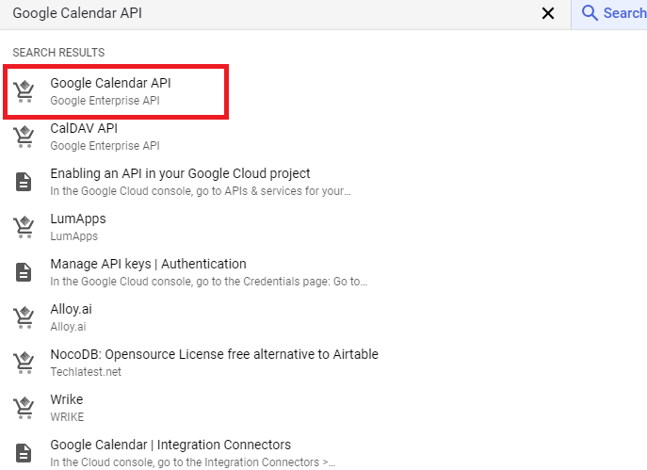
- Click Enable if the API is not already enabled.
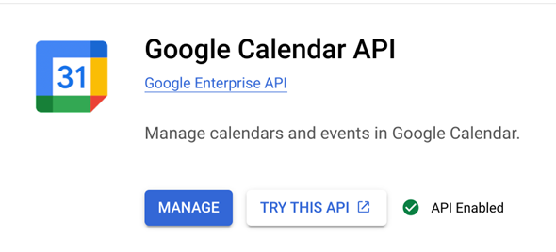
- You can now add the action to your app. Return to the Agent Builder console.
- Click on the name of your Agent Builder App: Scientific Conferences Agentspace.
- Select Actions from the left-side navigation.
- Select ADD ACTION.
- Find the Calendar card and click CONNECT.
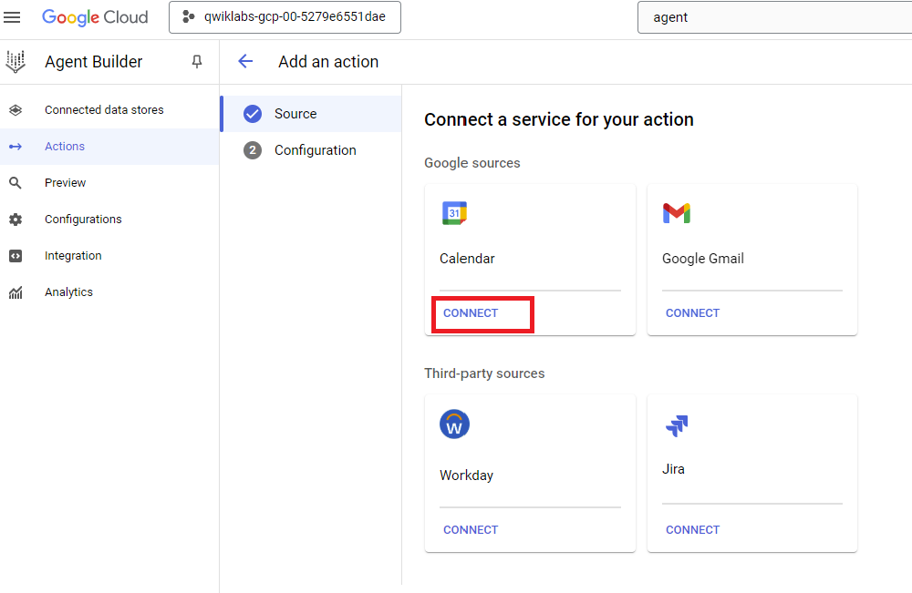
- Enter an Action connector name of calendar_action.
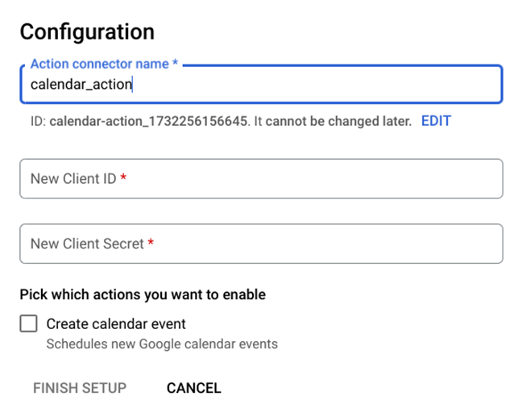
- Enter the Client ID and Client Secret of the OAuth client you created above.
- Select the checkbox to enable the Create calendar event action to allow the assistant to create meetings based on requests in the Agentspace search bar.
- Click FINISH SETUP.
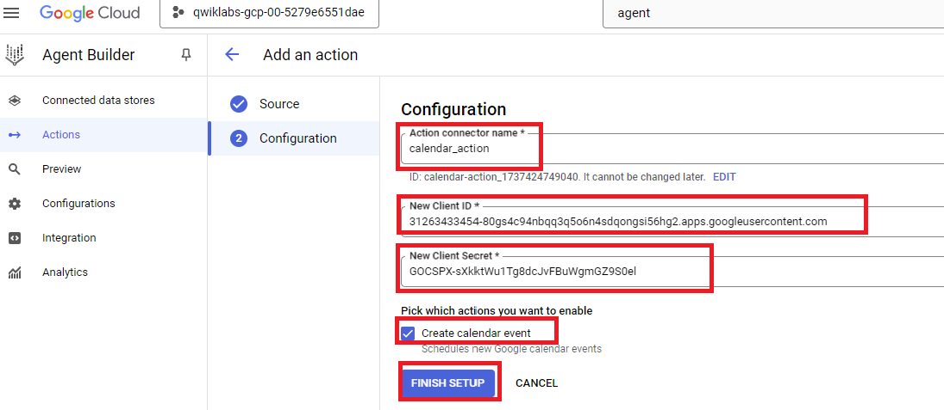
Click Check my progress to verify the objective.
Enable a Google Calender action.
Check my progress

Task 7. Query your Agentspace Assistant
- Take a 10-minute break for the app, its data stores, and actions to finish creating.
- Then, navigate to Agent Builder > Apps > Scientific Conferences Agentspace.
- Select Preview from the left-hand navigation pane to view the experience your users will see.
- Notice that under the For you header, the app shows the files you added to your Drive and the upcoming Astronomers Lunch Planning Meeting you created. This home page is designed to give users easy access to the content and events they will find most useful.
- Note: Please note that even if the files appear, they may require a little time to become accessible.
- In the search bar, enter the following query: what are the planetcon dates?
- You should see a result that not only provides the updated date you edited in the second version of the document (re-scheduling the conference to November), but also provides icons linking to the source documents for reference.
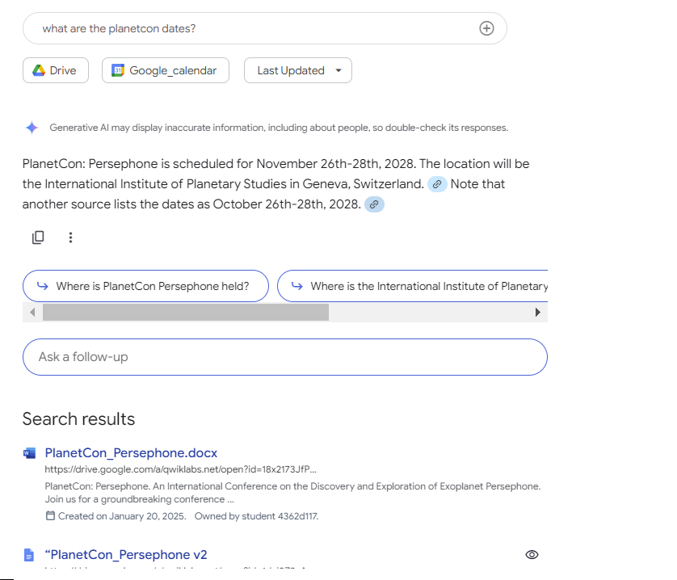
- Enter a different prompt in the primary search bar: what is the size of Persephone compared to Earth?
- You should see a result that extracts the information you are looking for from the Persephone Analysis Report.pdf document you uploaded to your drive. Remember, there is no real exoplanet Persephone, so you know the model is pulling from your uploaded data. You can further validate this by clicking the link icon and the card that appears below the response to be taken directly to the file that serves as the source of this information.
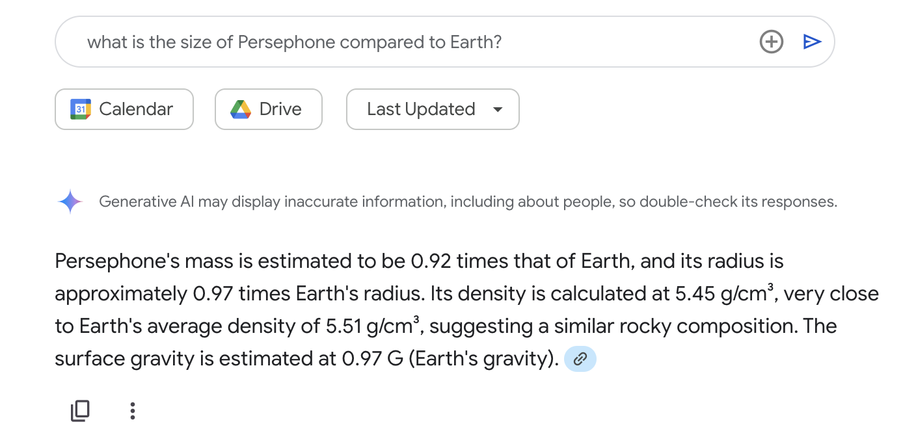
- When you don’t have time to review a document, you can use the Agentspace AI assistant to create a useful summary for you. In the search bar, enter the following query: summarize the document Persephone Analysis Report.
- Review the assistant’s response.
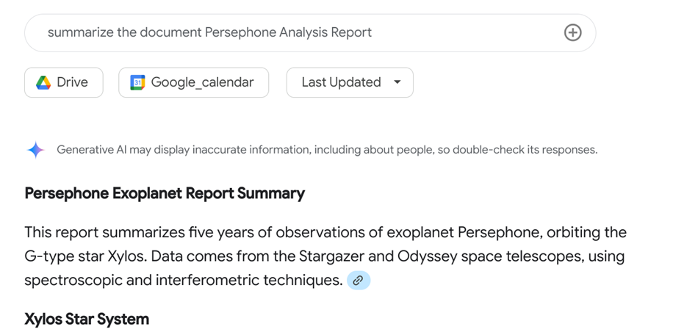
- In the search bar, enter the following: Create a 1-hour meeting tomorrow at 10am for exoplanet-research@qwiklabs.net to review conference presentation proposals.
- The assistant will prepare a template calendar event for you to approve.
- Authorize the application using the OAuth Consent Screen you configured using your Qwiklabs student account.

Error during authorization

- Confirm the appearance of the event on your Google Calendar tab (or navigate to calendar.google.com in a new tab).
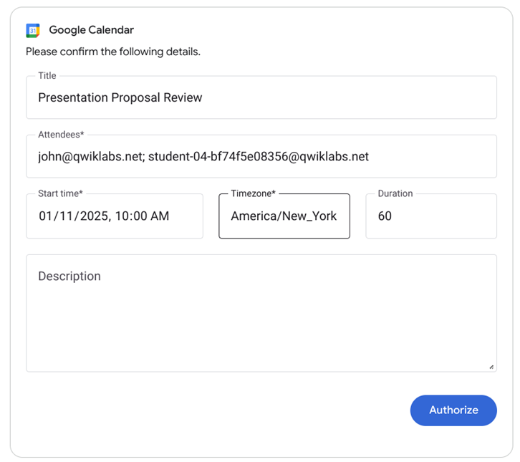
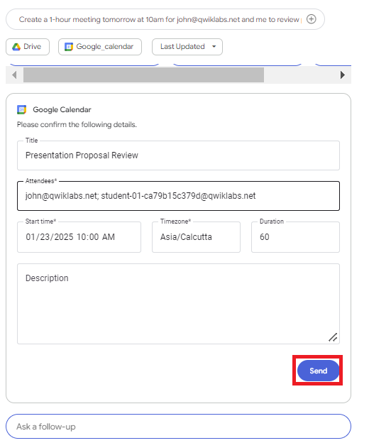

Task 8. Open the hosted link to your application
- From your Agent Builder app’s menu, select Integration from the left-hand navigation pane.
- Under The link to your web app, click OPEN to preview the hosted application. This is the application for your organization. When configuring Agentspace in production, you could use a DNS record to configure this home page to be accessible from a subdomain of your website, like agentspace.my-domain.com.
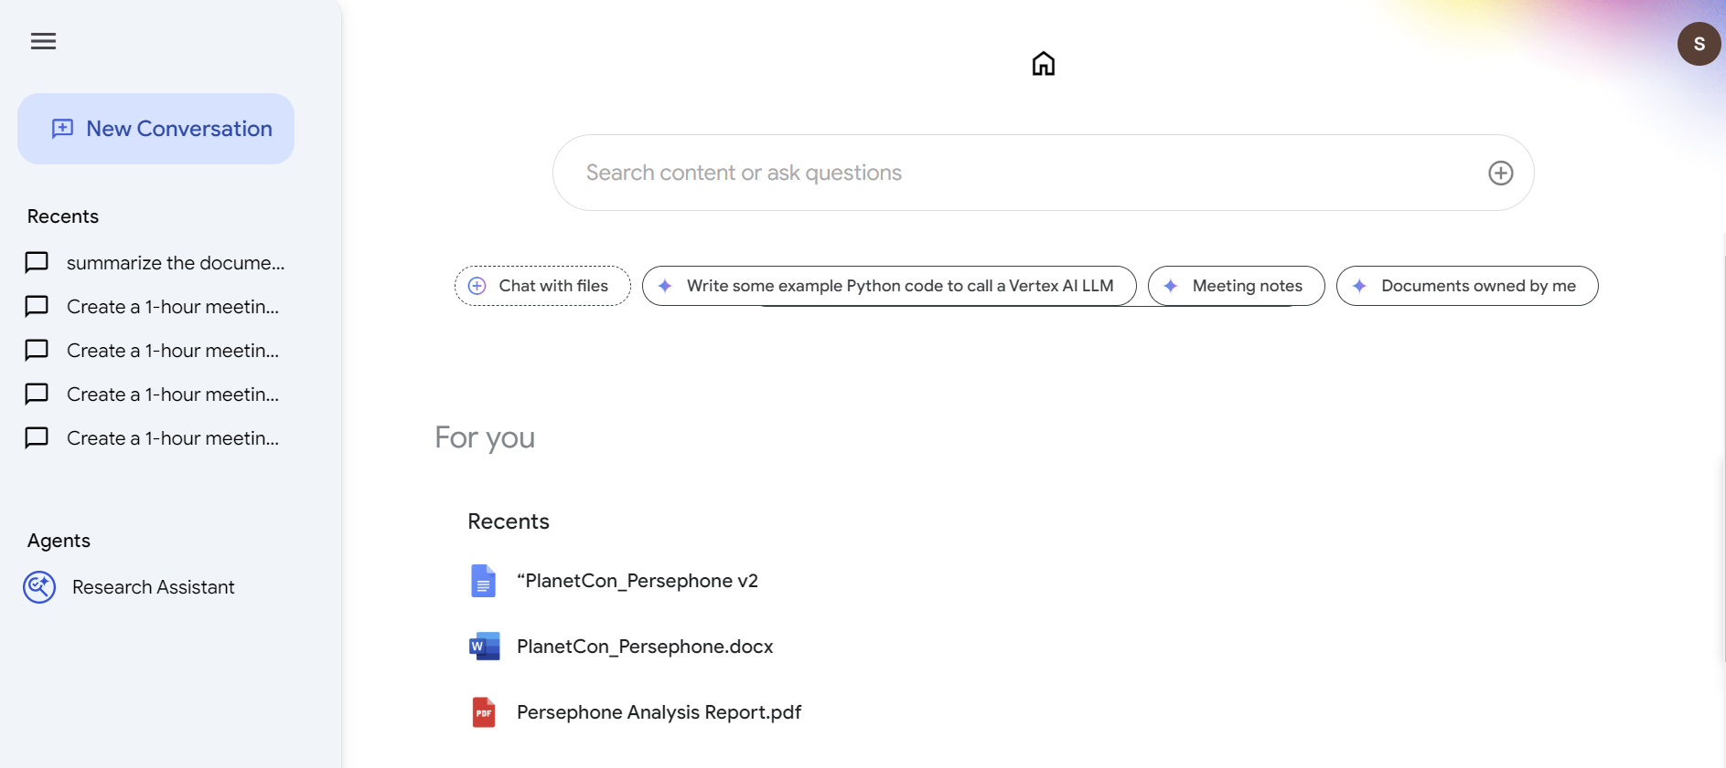

Congratulations!
In this lab, you’ve learned how to deploy Agentspace to utilize Google’s combined expertise in search, generative AI, and cloud infrastructure to ease knowledge exchange throughout your organization.
Manual Last Updated February 07, 2025
Lab Last Tested February 07, 2025

