Hands-on > Extend Agentspace assistant capabilities with Conversational Agents

Google Cloud Skills Boost > https://www.cloudskillsboost.google/course_templates/1191/labs/525477

Hands-on > Agentspace

Objectives
In this lab, you learn how to:
- Deploy a Cloud Run function
- Create an OpenAPI Tool for conversational agents to be able to call your Cloud Run function
- Deploy an Agentspace app
- Create a simple generative conversational agent using a Playbook
- Integrate your conversational agent into your Agentspace app

Task 1. Create a BigQuery table where travel requests can be recorded
In this task, you'll create a table to serve as the destination to store incoming travel requests that will be sent to the Agentspace assistant.
- Open a Cloud Shell terminal, by pressing the G key followed by the S key on your keyboard.
- In your Cloud Shell terminal, paste the following to create a travel_requests_schema.json file to define the schema for a BigQuery table which will be used to record travel requests:

cat > travel_requests_schema.json << EOF
[
{
"name": "user",
"type": "STRING",
"mode": "REQUIRED"
},
{
"name": "travel_purpose",
"type": "STRING",
"mode": "REQUIRED"
},
{
"name": "departure_city",
"type": "STRING",
"mode": "NULLABLE"
},
{
"name": "destination_city",
"type": "STRING",
"mode": "NULLABLE"
},
{
"name": "departure_date",
"type": "STRING",
"mode": "NULLABLE"
},
{
"name": "return_date",
"type": "STRING",
"mode": "NULLABLE"
}
]
EOF

Run the following commands in Cloud Shell to create the BigQuery dataset trip and table booking_requests, using the schema defined in the travel_requests_schema.json file:
bq --location=US mk -d trip
bq mk -t trip.booking_requests travel_requests_schema.json

- Click the Authorize button when prompted to authorize Cloud Shell.
- Once the dataset and table have been successfully created, you can close the Cloud Shell panel by clicking the X in the upper right of the terminal panel.
Click Check my progress to verify the objectives.
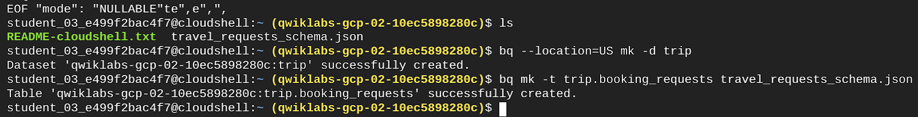

Task 2. Create a Cloud Run Function to record the requests
In this task, you'll create the Cloud Run function that will take requests sent as JSON and write them to the table you created above.
Using the search bar at the top of the Cloud Console, navigate to Cloud Run. 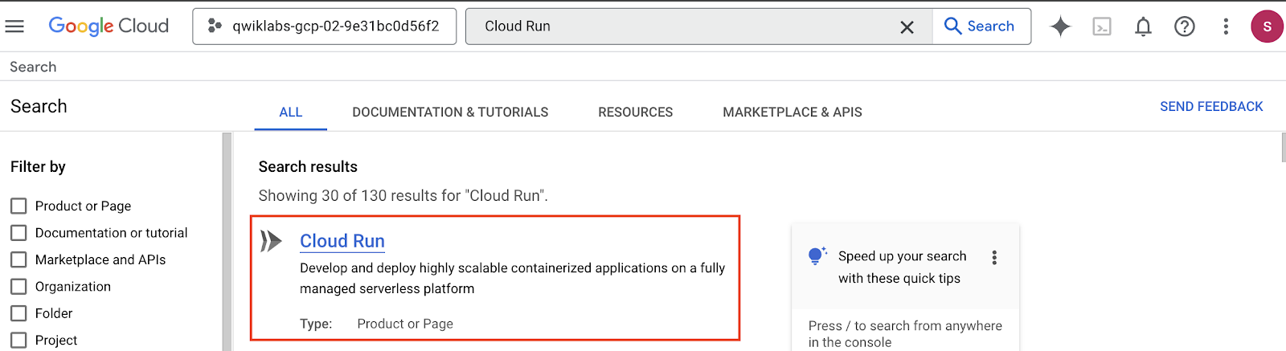
From the options at the top of the Cloud Run console, select Write a Function.
Under the Configure header, enter a Service name of record-travel-request.
Set the Region to us-central1.
Under the Endpoint URL header, copy the provided URL and paste it in a text document. You will need to access it later.

https://record-travel-request-411782672970.us-central1.run.app

Set the Runtime to Python 3.12.
Under the Authentication header, select Require authentication.
Keep the other settings as default and select CREATE. The Source tab for the function will be loaded.

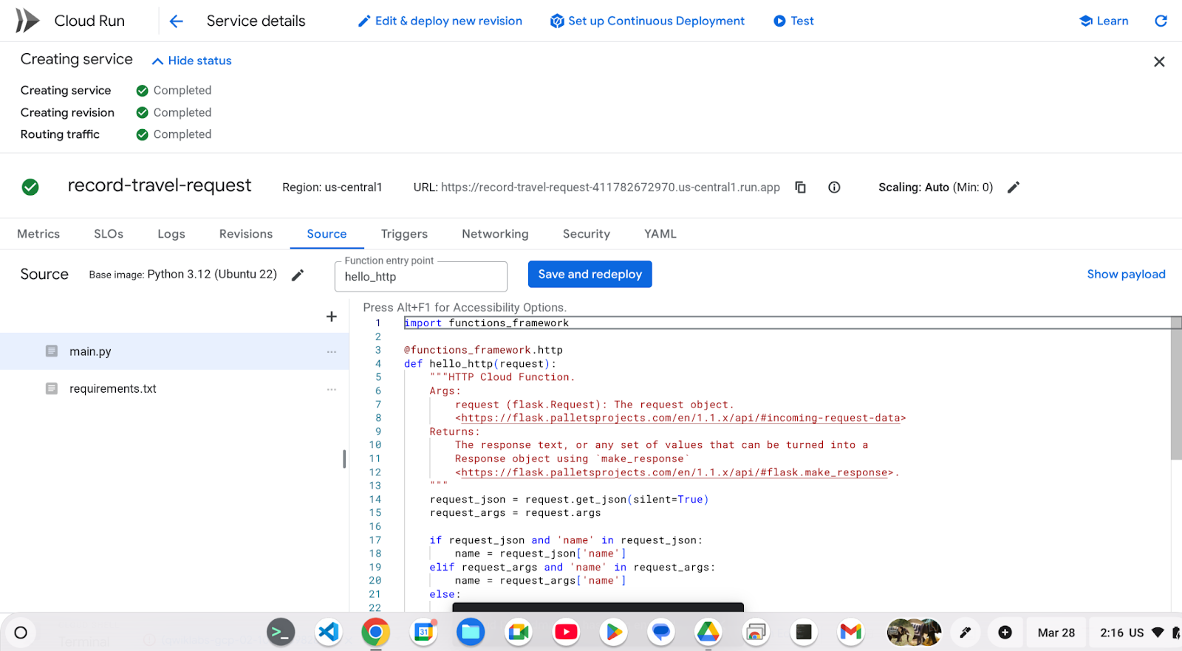
Rename the Function entry point to record_travel_request.

Click the requirements.txt file on the left, delete its contents, and paste in the following:
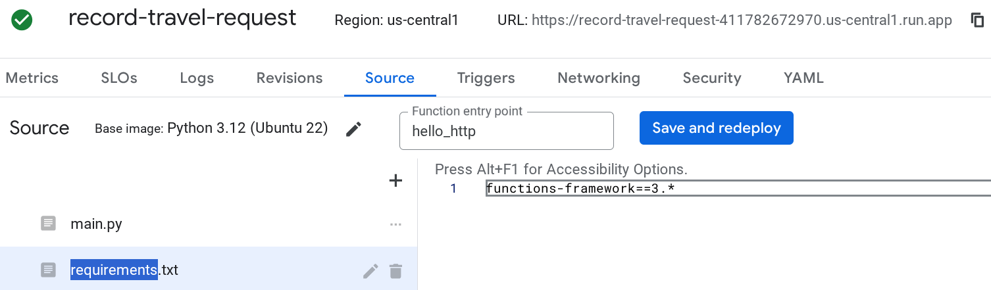

functions-framework==3.*
google-cloud-bigquery

Click the main.py file on the left, delete its contents, and paste in the following code.
import functions_framework

@functions_framework.http
def hello_http(request):
"""HTTP Cloud Function.
Args:
request (flask.Request): The request object.
<https://flask.palletsprojects.com/en/1.1.x/api/#incoming-request-data>
Returns:
The response text, or any set of values that can be turned into a
Response object using `make_response`
<https://flask.palletsprojects.com/en/1.1.x/api/#flask.make_response>.
"""
request_json = request.get_json(silent=True)
request_args = request.args

if request_json and 'name' in request_json:
name = request_json['name']
elif request_args and 'name' in request_args:
name = request_args['name']
else:
name = 'World'
return 'Hello {}!'.format(name)
import functions_framework
from google.cloud import bigquery

@functions_framework.http
def record_travel_request(request):
"""Writes travel requests to BigQuery.
Args:
request (flask.Request): A request object with JSON
containing fields for user, travel_purpose, departure_city,
destination_city, departure_date, and return_date.
Returns:
JSON response containing a 'message' field indicating the
status of the request.
"""
request_json = request.get_json(silent=True)
request_args = request.args
print("JSON:" + str(request_json))
print("args:" + str(request_args))

bq_client = bigquery.Client()
table_id = "qwiklabs-gcp-02-10ec5898280c.trip.booking_requests"

row_to_insert = [
{"user": request_json["user"],
"travel_purpose": request_json["travel_purpose"],
"departure_city": request_json.get("departure_city",""),
"destination_city": request_json.get("destination_city",""),
"departure_date": request_json.get("departure_date",""),
"return_date": request_json.get("return_date",""),
},
]

errors = bq_client.insert_rows_json(table_id, row_to_insert) # Make an API request.
if errors == []:
return {"message": "New row has been added."}
else:
return {"message": "Encountered errors while inserting rows: {}".format(errors)}

This function will take the travel request details provided to a POST request as JSON and write those values to a new row in the BigQuery table you created earlier:

import functions_framework
from google.cloud import bigquery

@functions_framework.http
def record_travel_request(request):
"""Writes travel requests to BigQuery.
Args:
request (flask.Request): A request object with JSON
containing fields for user, travel_purpose, departure_city,
destination_city, departure_date, and return_date.
Returns:
JSON response containing a 'message' field indicating the
status of the request.
"""
request_json = request.get_json(silent=True)
request_args = request.args
print("JSON:" + str(request_json))
print("args:" + str(request_args))

bq_client = bigquery.Client()
table_id = "qwiklabs-gcp-02-10ec5898280c.trip.booking_requests"

row_to_insert = [
{"user": request_json["user"],
"travel_purpose": request_json["travel_purpose"],
"departure_city": request_json.get("departure_city",""),
"destination_city": request_json.get("destination_city",""),
"departure_date": request_json.get("departure_date",""),
"return_date": request_json.get("return_date",""),
},
]

errors = bq_client.insert_rows_json(table_id, row_to_insert) # Make an API request.
if errors == []:
return {"message": "New row has been added."}
else:
return {"message": "Encountered errors while inserting rows: {}".format(errors)}

12. Click SAVE AND REDEPLOY.
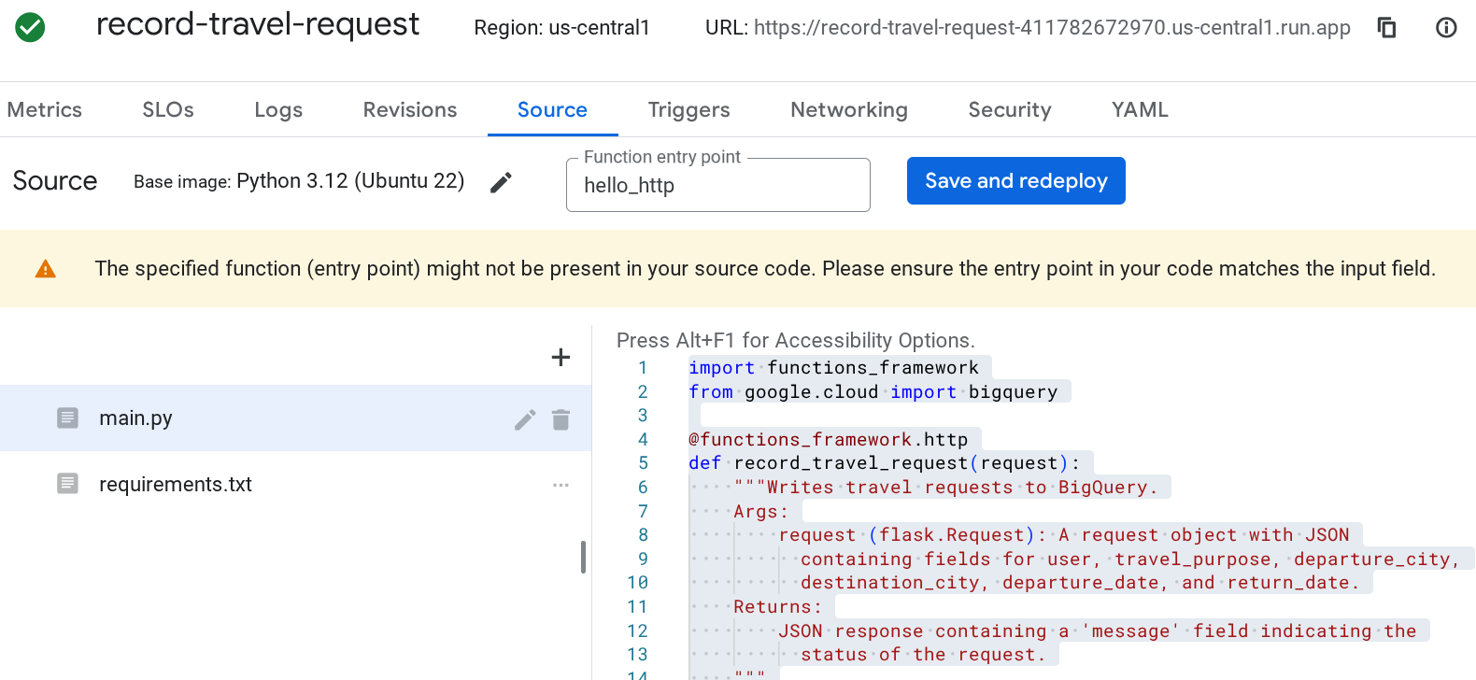

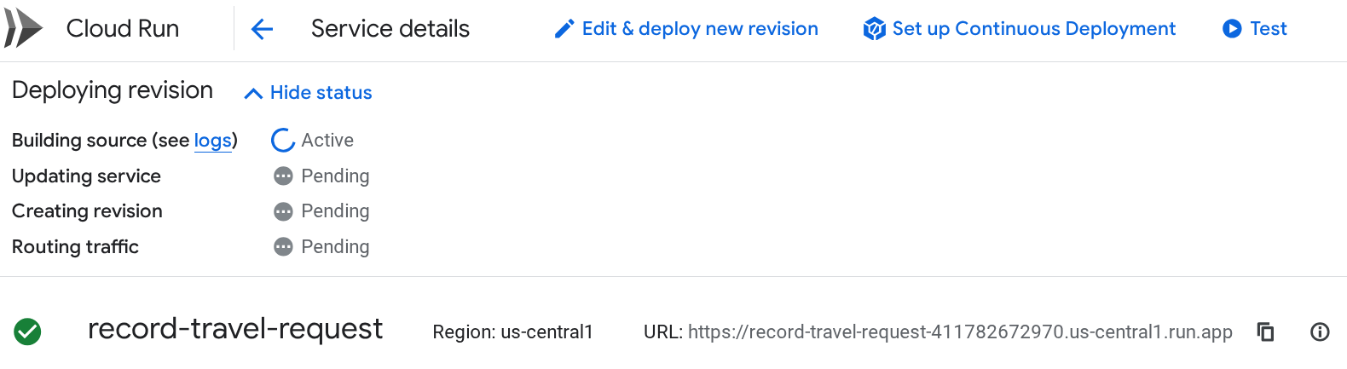
13. Wait until the Deploying revision activities all show a Completed status message.
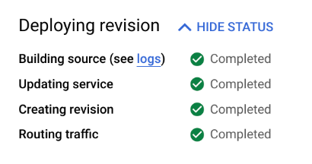
Cloud Run > Routing traffic !Failed

14. Click TEST at the top of the Cloud Run console.

15. Paste these values into the Configure triggering event test input field:
{
"user": "Ursula Matthews",
"travel_purpose": "farm inspection",
"departure_city": "Santiago",
"destination_city": "Doha",
"departure_date": "2025-09-08",
"return_date": "2025-09-16"
}

16. At the bottom of the testing pane, click TEST IN CLOUD SHELL.

17. The Cloud Shell terminal window will open, and a curl command will be prepared for you to call your function. Select the Terminal window and press enter or return on your keyboard to send the command.

18. You should see a successful execution response:
Close the Cloud Shell Terminal by pressing the X in the upper right of the Cloud Shell panel.
Open a new browser tab (or if you are using Chrome, duplicate your current browser tab by right-clicking on it and selecting Duplicate). In the new tab, navigate to BigQuery.
In the BigQuery Explorer pane, select your project ID qwiklabs-gcp-02-10ec5898280c.
Select the trip dataset.
Select the booking_requests table.
Select the PREVIEW tab to see travel requests that have been recorded. Keep this tab open to return and check for new rows as you work through the other components in this lab.
Click Check my progress to verify the objectives.
Create a Cloud Run function to record the requests
Check my progress

Task 3. Create a Conversational Agent Tool to call the Cloud Run Function
In this task, you'll create a Tool in the Conversational Agent console that can call the Cloud Run function. Your conversational agent will be able to use this Tool to record the travel requests.
- At the top of the Google Cloud Console, search for Dialogflow API and select it.
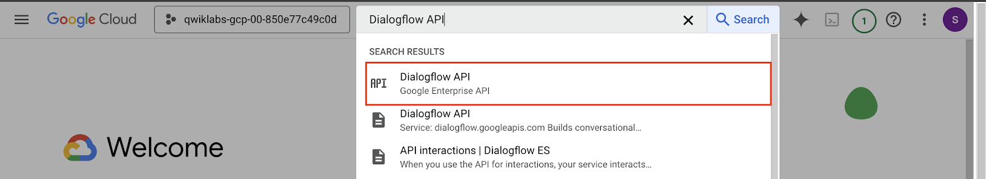
- Click Enable.
- Navigate to Agent Builder by searching for it at the top of the console.
- Click on CONTINUE AND ACTIVATE THE API.
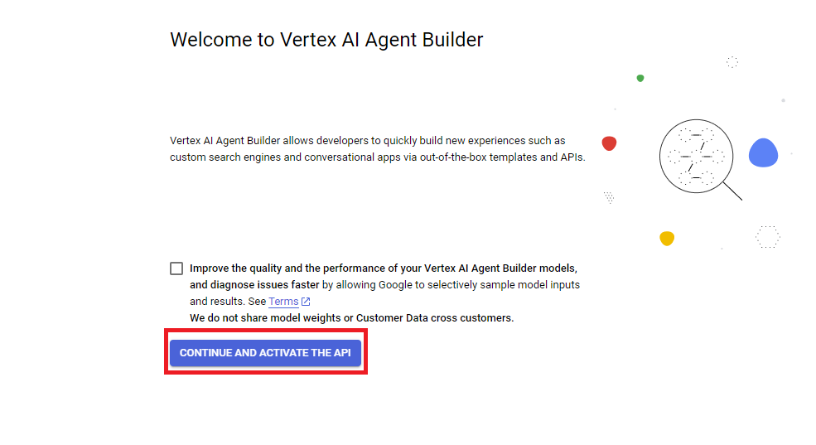
- For an app type, find the card for Conversational agent and select Create. This will open the Conversational Agents console in a new tab.
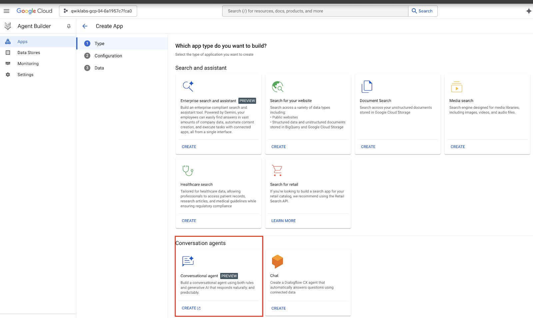
- In the Get started with Conversational Agents pane, select Build your own.
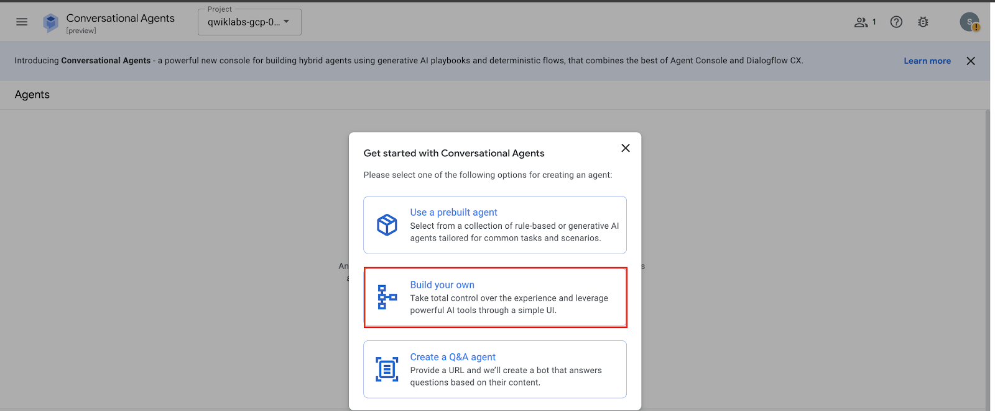
- For your agent's Display name, use Corporate Travel Bot.
- Set the location to global.
- Keep the Conversation start option Playbook selected.
- Click Create.
- After the Conversational Agent Playbook is created. Dismiss any instructional pop-ups and select Settings button on the top right-hand side of the UI.
- Navigate to General > Logging Settings.
- Click the checkboxs for Enable Cloud Logging and Enable Conversation History to enable the Cloud Logging and conversation history features for your agent.
- Click the Save button at the top of the Settings pane to save your changes.
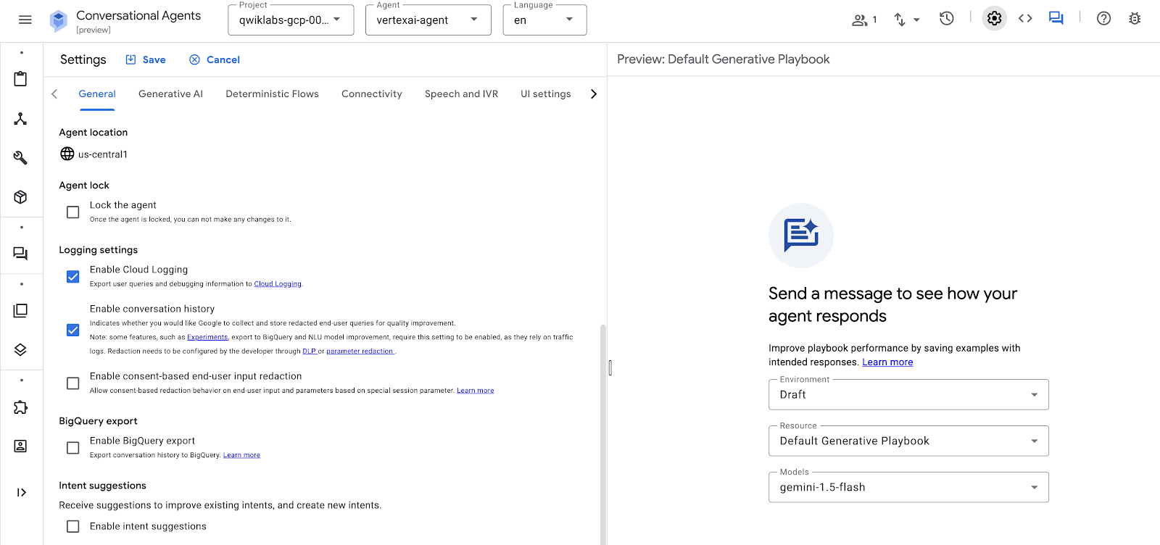
- You will be taken to your starting Playbook. Dismiss any instructional pop-ups. Before you create the Playbook, you will create a Tool that the playbook can use to call the Cloud Run function you created. From the left-hand navigation menu, select Tools.
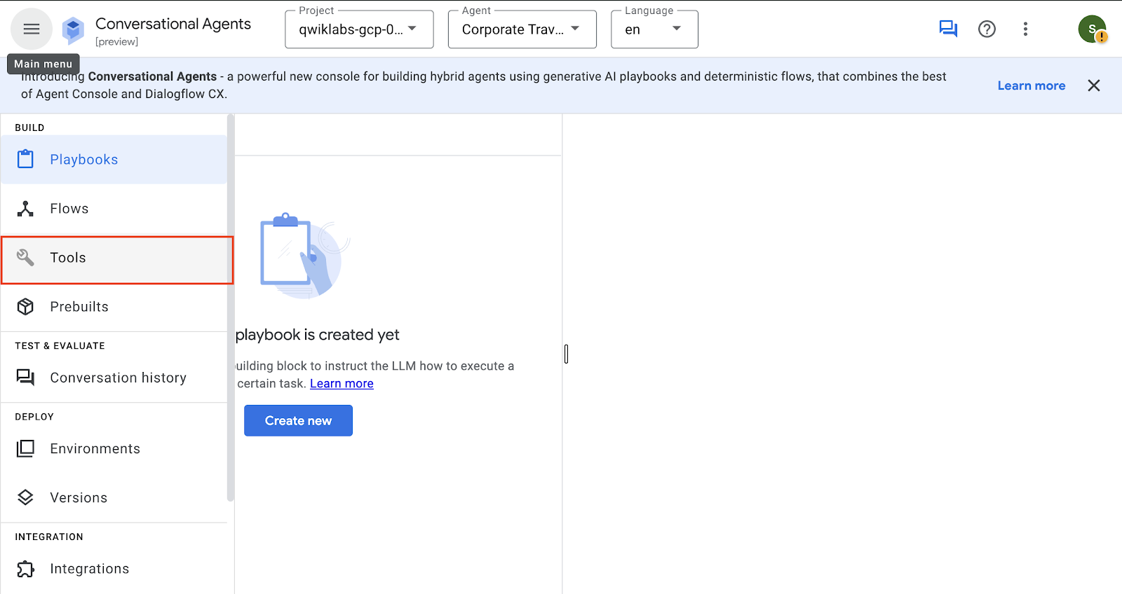
- Click + Create.
- For Tool name enter Record Travel Request.
- Keep the Type set to OpenAPI.
- For a Description, enter Used to record a travel request.
- For Schema, keep the type YAML selected, and paste the following into the text box. This OpenAPI spec describes an API with:
  - A server url set to your Cloud Functions domain
  - A path called /record-travel-request that accepts POST requests that include JSON in a schema called TravelRequest
  - A definition of that TravelRequest schema to include the fields you defined in your BigQuery schema at the start of this lab:
openapi: 3.0.0
info:
title: Travel Requests API
version: 1.0.0
servers:
- url: 'YOUR_CLOUD_RUN_FUNCTION_URL'
paths:
/:
post:
summary: Record a new travel request
operationId: recordTravelRequest
requestBody:
description: Travel request to add
required: true
content:
application/json:
schema:
$ref: '#/components/schemas/TravelRequest'
responses:
'200':
description: Success
components:
schemas:
TravelRequest:
type: object
required:
- user
- travel_purpose
properties:
user:
type: string
travel_purpose:
type: string
departure_city:
type: string
destination_city:
type: string
departure_date:
type: string
return_date:
  - type: string
  - Copied!
  - content_copy
- Replace YOUR_CLOUD_RUN_FUNCTION_URL in the spec above with your Cloud Run function's URL that you copied earlier.
- Click Save at the top of the Tools pane.
- To allow the Tool to invoke the Cloud Run function, switch to your browser tab displaying the Cloud Console (not the Conversational Agents console) and use the search bar at the top of the console to navigate to IAM.
- Check the checkbox to Include Google-provided role grants.
- Find the row for the Dialogflow Service Agent and click the pencil edit icon on its row.
- Click + Add Another Role.
- In the Select a role field, enter Cloud Run Invoker.
- Click SAVE.
Click Check my progress to verify the objectives.
- Create a Conversational Agent tool to call the Cloud Run function
- Check my progress

Task 4. Create a Conversational Agent Playbook
In this task, you'll create the conversational agent that can receive requests in natural language and use the Tool to write them to the BigQuery table via the Cloud Run function.
- In the browser tab with the Conversational Agents console, use the left-hand navigation menu to select Playbooks.
- Select the Default Generative Playbook that has already been created.
- Change the Playbook name to Confirm Travel Data.
- For a Goal, enter: Help users book travel.
- For Instructions, paste the following into the text field:
- Ask the user to provide for user name, travel purpose, departure city, destination city, and a range of dates. Assume a year of 2025 for dates without a year:
- Use ${TOOL:Record Travel Request}
- - Let the user know that they should receive a list of flights to choose from in their email within 24 hours.
- Copied!
- content_copy
- These Playbook instructions are designed for use by Agentspace because it only includes one turn of conversation, even though it does multiple things within that turn (invokes its tool and generates a response). Later, you will give the Agentspace agent the responsibility for gathering the relevant info before invoking this Playbook.
- Click Save at the top of the Playbook pane.
- In the upper right of the Conversational Agents console, click the Toggle simulator chat button () to preview the conversational agent.
- In the Enter text input box at the bottom of this panel, start the chat with can you help me book a flight?
- Provide a name, travel purpose, departure city, destination city, and a date range (for example, Joe Smith. Customer Presentation. Berlin to Valencia. Feb 21 to 28.) to observe how the agent behaves.
- You should see a card indicating that the Record Travel Request Tool was used, and you can click on it to see the Tool input and response:
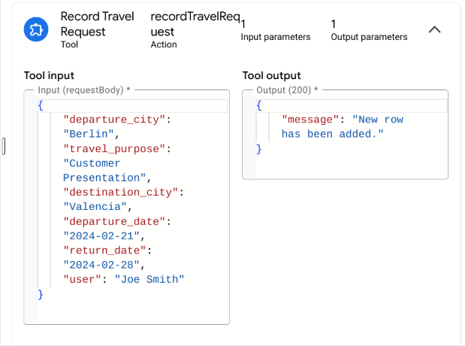
- Your chat should end with a statement similar to:
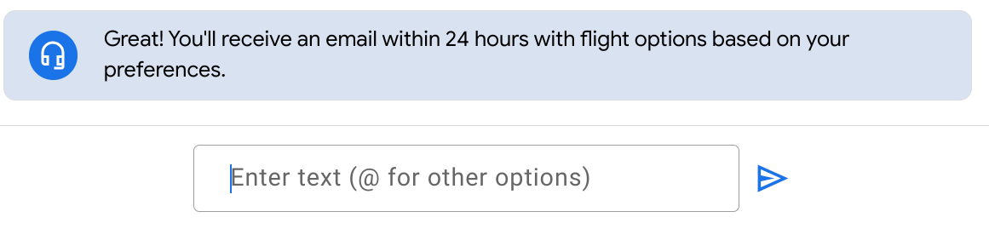
Click Check my progress to verify the objectives.
- Create a Conversational Agent playbook
- Check my progress

Task 5. Create a BigQuery Data Store
In this task, you'll be deploying an Agentspace app, and to do so, you'll need to create a data store. We'll set up a BigQuery data store, allowing you to query and access previously recorded travel requests.
- Switch back to your Google Cloud Console browser tab and navigate to Agent Builder by searching for it at the top of the console.
- Select Data Stores from the left-hand navigation pane.
- Click + Create Data Store.
- Search for BigQuery to locate the BigQuery card and click SELECT on it.
- For the kind of data, keep the default choice of Structured - BigQuery table with your own schema.
- For the BigQuery path select Browse.
- Search for dataset trip.
- Select your table booking_requests .
- Click Select.
- Click Continue.
- You can keep the schema as it is and click Continue.
- For a name, enter Travel Requests.
- Click Create.
Click Check my progress to verify the objectives.
- Create a BigQuery datastore
- Check my progress

Task 6. Create an Agentspace app
In this task, you'll create a new Agentspace app using the "Enterprise Search and Assistant" template and integrating Google as the Identity Provider, while linking to a data store.
- Navigate to Agent Builder > Apps > + Create App.
- Find the Enterprise search and assistant card and click CREATE to create an Agentspace app.
- For an app name, enter Cymbal Agentspace App
- For a company name, enter Cymbal Shops
- Keep the location set to global.
- Under select tier choose Search + Assistant.
- Click Continue.
- For an Identity provider, click SELECT on the Google Identity Provider card.
- On the Data pane, select the Travel Requests data store you created above.
- Click Create.
Click Check my progress to verify the objectives.
Create an Agentspace app
Check my progress

Task 7. Integrate your conversational agent with your Agentspace app
In this task, you'll grant your Agentspace assistant the ability to send messages to your conversational agent and receive its responses.
- Navigate to Agent Builder > Apps and select Cymbal Agentspace App App.
- From the left-hand navigation, select Configurations.
- Select the Assistant tab.
- Under the Agents header, select Add an Item. A card will be displayed to connect a New Agent:
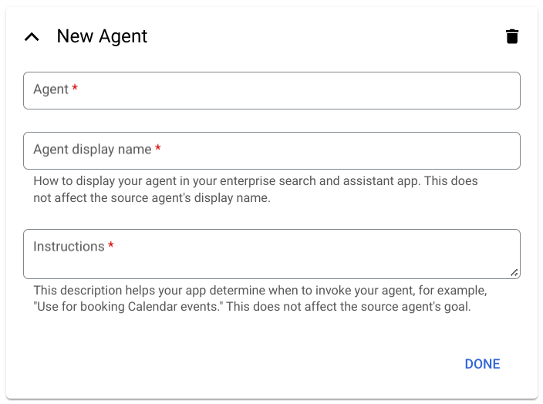
- Select your browser tab displaying your Conversational Agents console.
- From the Agent dropdown at the top of the console, select View all agents.
- At the end of your Corporate Travel Bot agent's row, select the Options icon (three vertical dots) and select Copy name.
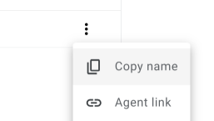
- Navigate back to your Agent Builder tab, and in the New Agent card, paste the copied value in the Agent field.
- For an Agent display name, use Corporate Travel Bot.
- For Instructions enter:
- Use for booking travel by providing a user, travel purpose, departure city, destination city, and a date range.
- Copied!
- content_copy
- Notice that these instructions instruct the Agentspace assistant to do the work of gathering the required information before passing the details to the conversational agent for a single turn of conversation.
- Click Done.
- Click Save and Publish at the bottom of the pane.
Click Check my progress to verify the objectives.
- Integrate the conversational agent with the Agentspace app
- Check my progress

Task 8. Communicate with your conversational agent through the Agentspace assistant
In this task, your Agentspace assistant will be able to communicate with the conversational agent, which will then utilize its tool to record travel requests.
Note: It can take up to 10 minutes for your Agentspace app to be created. You can try the steps below, but if they don't proceed as expected, try to give your app more time to be created.
- Select your Agentspace app's Cymbal Agentspace App. Navigate to Integration tab from the left-hand navigation menu.
- Under The link to your web app header, click Open. As stated at the start of this task, if you see a 404 error, you may need to give your app more time to be created. You can reload the page every few minutes until the Agentspace web app appears.
- In the primary search bar, enter:
Book travel for Alex Cymbal from Singapore to Council Bluffs, Iowa, departing on April 1 and returning on April 14, 2025, for a data center tour.
- Your chat will be saved as a Conversation under the Recents header on the left-hand menu of the Agentspace web app.
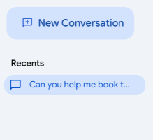
- Your assistant should have responded that your request has been recorded, and you will receive a follow up email within 24 hours. If you are asked any additional questions, use the Ask a follow-up field to reply to the assistant.
- Under the assistant's responses, there is an Options menu (three vertical dots). Expand it and select Show diagnostic info.
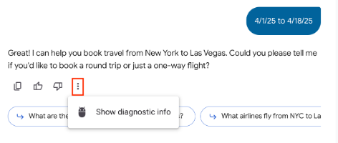
- In the diagnostic info displayed, you can view the metadata of the response, which includes "functionName": "Corporate_Travel_Bot". This confirms that the Agentspace assistant invoked your conversational agent as a function call and received a response from it, which it has passed back to you.
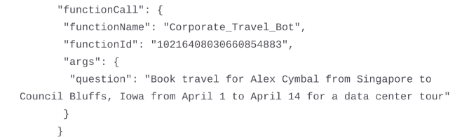
- Please note, in this activity you used very minimal Playbook instructions and no conversation examples, which means that this agent will not be very robust. If you need to restart the conversation to try it again, click the New Conversation button in the upper left.
- To confirm that requests are being recorded, return to the browser tab displaying your BigQuery booking_requests table. On the PREVIEW tab, click the Refresh icon to view the latest data.
Click Check my progress to verify the objectives.
- Communicate with the conversational agent through the Agentspace assistant
- Check my progress

Congratulations!
In this lab, you’ve learned how to extend the Agentspace assistant with conversational agents. More specifically, you've learned to:
- Deploy a Cloud Run function
- Create an OpenAPI Tool for conversational agents to be able to call your Cloud Run function
- Deploy an Agentspace app
- Create a simple generative conversational agent using a Playbook
- Integrate your conversational agent into your Agentspace app
Manual Last Updated March 10, 2025
Lab Last Tested March 10, 2025

