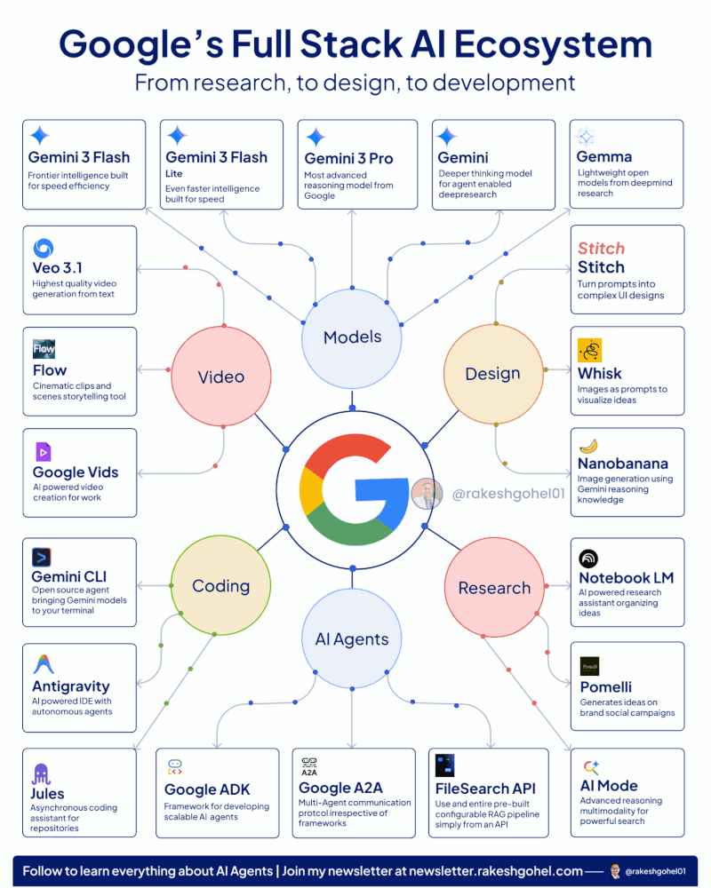

AI For Leaders
팔로워 1,598,456명
가입
4일 • 수정됨 •
팔로우
Google's Full Stack AI Ecosystem
𝗕𝗲𝗰𝗼𝗺𝗲 𝗯𝗲𝘁𝘁𝗲𝗿 𝗮𝘁 𝗔𝗜 𝗶𝗻 𝗷𝘂𝘀𝘁 𝟭 𝗺𝗶𝗻𝘂𝘁𝗲 𝗮 𝗱𝗮𝘆.
𝗚𝗲𝘁 𝘁𝗵𝗲 𝗔𝗜 𝗻𝗲𝘄𝘀𝗹𝗲𝘁𝘁𝗲𝗿 𝘀𝗺𝗮𝗿𝘁 𝗹𝗲𝗮𝗱𝗲𝗿𝘀 𝗿𝗲𝗮𝗱.
𝗦𝗶𝗴𝗻 𝘂𝗽 𝗳𝗿𝗲𝗲 𝗻𝗼𝘄 → aiforleaders.com
Original post:
__________
Google is trying to own the entire AI Agent market
And honestly? They might just pull it off....
While everyone's busy comparing ChatGPT vs Claude, Google quietly built a complete AI ecosystem that covers literally everything.
📌 Let me break down what they've assembled:
Models - The Foundation
→ Gemini 3 Pro for advanced reasoning
→ Gemini 3 Flash for speed efficiency
→ Gemini Deep Think for agent-enabled deep research
→ Gemma an SLM for faster agentic AI products
Design - From Idea to Visual
→ Stitch for turning prompts into UI designs
→ Whisk for image-based prompts
→ Nanobanana for image generation
→ Imagen for photorealistic outputs
Research - AI-Powered Intelligence
→ Notebook LM for organizing ideas
→ Pomelli for brand campaign generation
→ AI Mode for advanced multimodal search
Video - Content Creation Suite
→ Veo 3.1 for highest quality video from text
→ Flow for cinematic storytelling
→ Google Vids for AI-powered video creation
Coding - A complete suite
→ Antigravity IDE with autonomous agents
→ Gemini CLI for terminal integration
→ Jules for asynchronous coding assistance
& AI Agents - Faster and scalable solutions
→ Google A2A for multi-agent communication
→ Google ADK for scalable agent frameworks
→ Filesearch API for RAG systems with an API Call
and don't even get me started on GCP, AI Agent Marketplace, and Vertex AI builder.
The crazy part?
Each tool connects seamlessly with the others.
Like,
even for us, we build prototypes 10x faster using Notebook LM X Stitch X Google AI Studio X Google ADK then deploy in GCP.
If you're building AI agents or exploring agentic workflows, understanding Google's full stack is very essential.
Credit to Rakesh Gohel. Follow him for more.

