Mistral AI

https://mistral.ai/


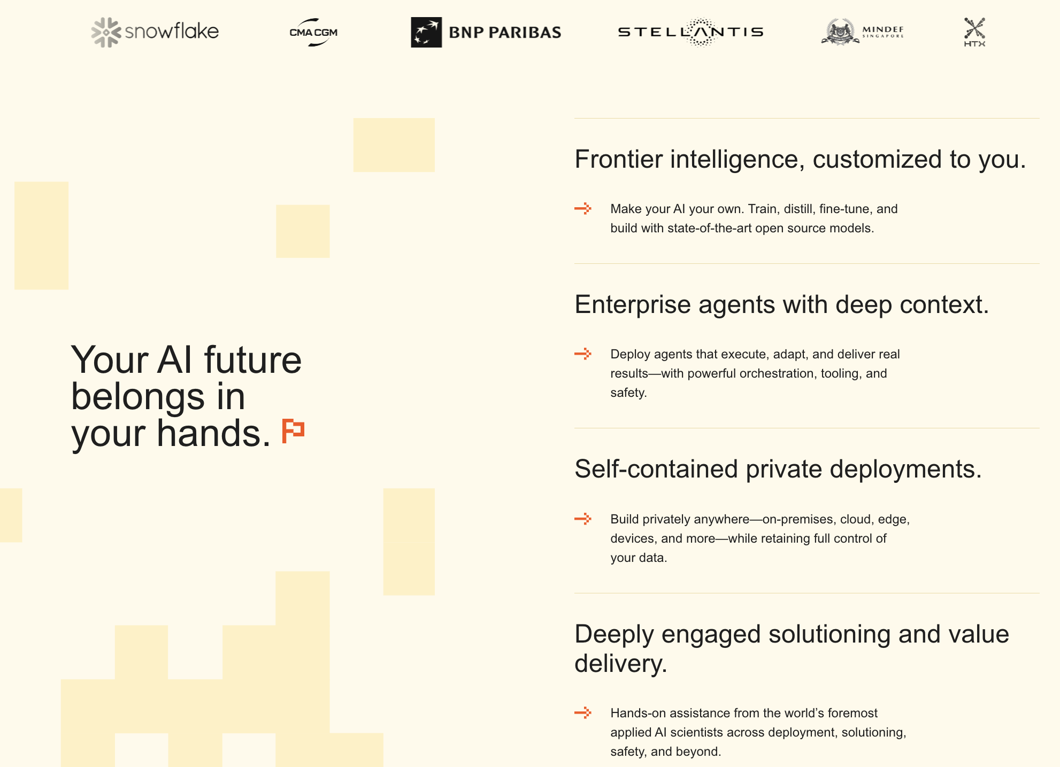

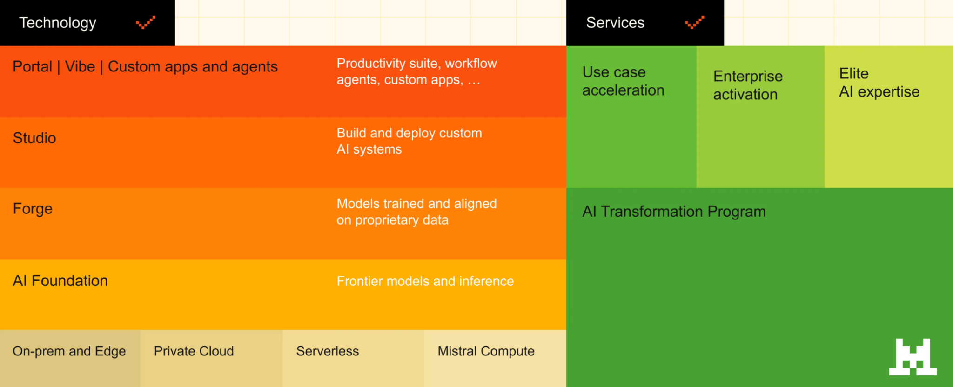

AI deployments designed for Key Black privacy.

Deploy our models in your environment, or consume as a service or from one of cloud partners.
