Introduction to Generative AI
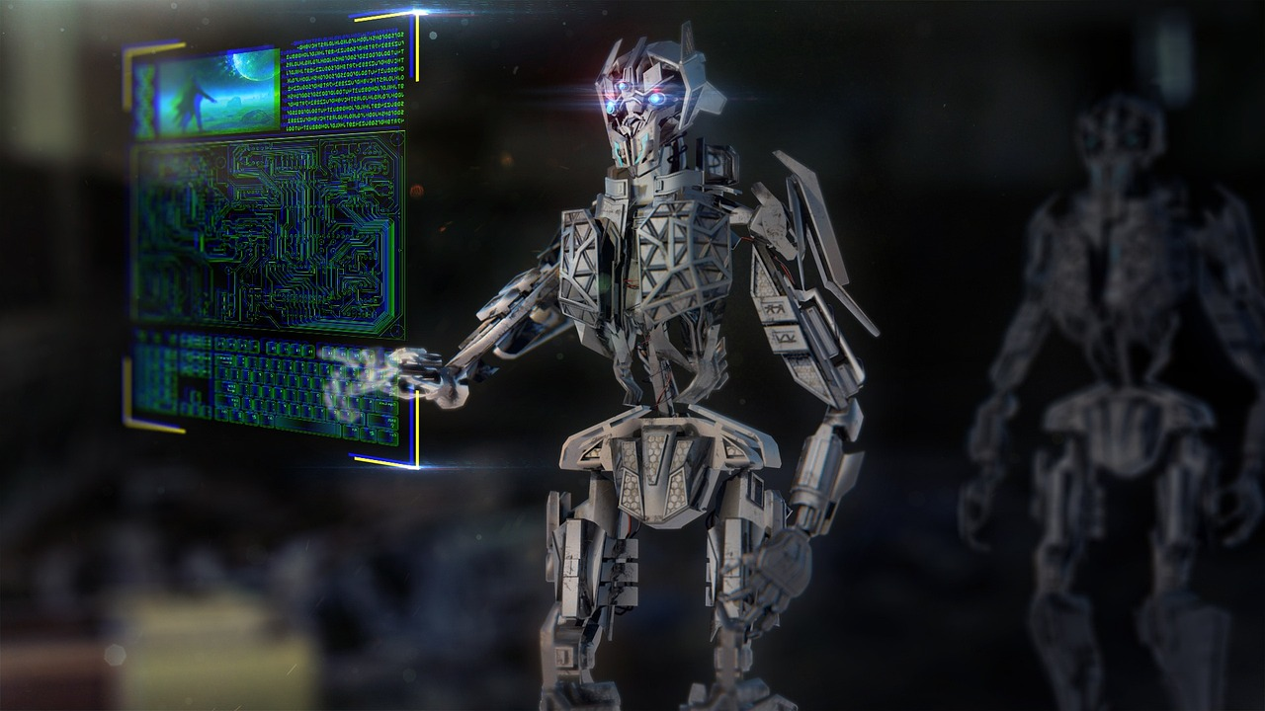
Generative AI refers to a type of artificial intelligence that is capable of generating new data, such as images, music, or text, based on a set of training data. Generative AI systems use machine learning techniques, such as neural networks, to analyze and learn patterns in the data, and then generate new data that follows those patterns.
There are several reasons that have led to a significant acceleration in the pace of research and development in generative AI, resulting in a range of exciting applications and possibilities for the future.
The current era is often referred to as the "golden age of generative AI" due to several advancements and breakthroughs in artificial intelligence, particularly in the area of generative models. Here are some of the reasons why this age is called the Golden Age:
- Powerful Language Models :
- The development of increasingly powerful language models, such as GPT-3 and BERT, has led to remarkable improvements in natural language understanding and generation. These models can perform a wide range of tasks, including:
  - Machine translation (e.g., translating text between languages)
  - Text summarisation (e.g., generating a concise summary of a news article)
  - Sentiment analysis (e.g., determining the sentiment of a movie review)
  - Conversational AI (e.g., creating chatbots that can engage in complex dialog
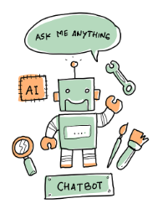
- Generative Adversarial networks :
- GANs are a class of generative models that have revolutionised image synthesis, enabling the creation of highly realistic images from random noise.We can think of GANs like an artist who creates a painting by looking at other paintings and then trying to create something new and original based on what they've seen. Examples of some popular GAN's:
  - NVIDIA's StyleGAN2 is a popular GAN that can generate high-resolution images of faces, landscapes, and objects.
  - Google's RAISR (Rapid and Accurate Image Super-Resolution) uses GANs to generate high-resolution images from low-resolution ones.
  - DALL-E is a GAN developed by OpenAI that can generate images from textual descriptions of objects and scenes.
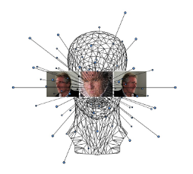
- Abundant Data:
The availability of large amounts of data has played a significant role in making generative AI possible. With the advent of the internet and the increasing digitization of information, vast amounts of data are now available for machine learning algorithms to analyze and learn from. It’s now possible to see how much data is created every day, as well as how much data we consume regularly. You might be surprised to find out that:
- In 2021, people created 2.5 quintillion bytes of data every day.
- In 2022, 91% of Instagram users engaged with brand videos.
- By 2025, 200+ zettabytes of data will be in cloud storage around the globe.
- In 2022, users sent around 650 million Tweets per day.
- In 2022, 333.2 billion emails were sent every day.
For example, in image generation, generative models can be trained on large datasets of labeled images, such as ImageNet, to learn the statistical distribution of visual features in those images. This allows the models to generate new images that are similar to the training images, but with some variation and creativity.
- Hardware Advancements
  - Advances in hardware, such as GPUs and TPUs, have made it possible to train and run large-scale generative AI models more efficiently. This has enabled the development of larger and more powerful models, such as GPT-3, which has 175 billion parameters.
  - The availability of cloud computing services has made it easier and more cost-effective to train and run generative AI models. Cloud services such as Google Cloud AI Platform and Amazon SageMaker provide pre-configured environments for training and deploying AI models.
  - Advances in edge computing, which involves running AI models on devices at the edge of the network, have enabled more efficient and responsive applications. For example, AI models can be deployed on smartphones and other mobile devices to provide real-time language translation and other services.


In conclusion, the golden age of generative AI has brought about remarkable advancements in artificial intelligence, particularly in the field of generative models. With powerful language models, GANs, abundant data, and hardware advancements, we have seen exciting applications emerge in image synthesis, natural language processing, and conversational AI, among others. As we move forward, we can expect generative AI to continue to push the boundaries of what is possible and lead to even more transformative breakthroughs.

