Practical Data Science > Construction of Decision Trees
In the previous pre-read, we understood what are decision trees and some important concepts related to decision trees. In this pre-read, we are going to see how a decision tree is constructed using dummy data.
Let’s say we want to solve a classification problem, where we are predicting whether the patient is diabetic or not. The below dataset shows 10 rows with 4 columns where Calories Intake (per day), Sugar Level, and Daily Activity are the independent variables, and Diabetic is the target variable.
The objective is to classify whether a person is diabetic or not. We can use a decision tree to solve such a problem.
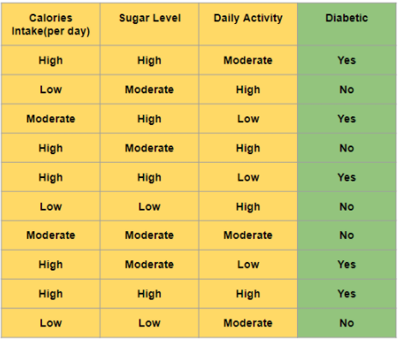

How do we construct the tree (on which feature/column should we make the first split)?
As we know from the previous pre-read, we have different splitting methods to decide the split in the decision tree. The feature which has the lowest entropy, i.e., highest information gain is selected as our root node.
We know that the formula of entropy is given as:
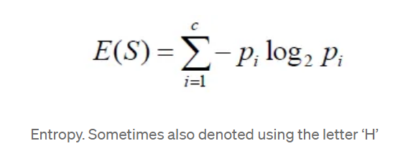
Where, is the probability of class in the dataset
As we have only 2 classes in the target variable, this formula can also be given as:
Where,
= The probability of the +ve class
= The probability of the -ve class
By using the above formula, we can calculate for the dependent feature Diabetic in the given dataset.

Now, let’s calculate the entropy and the information gain for all the independent features in the dataset one by one.
As we have 3 categories in Calories Intake(per day), i.e., High, Moderate, and Low, we can make 3 splits. Hence, for each split, we calculate the entropy.
The entropy of Calories Intake (per day) for a split on High,
The entropy of Calories Intake (per day) for a split on Moderate,
The entropy of Calories Intake (per day) for a split on Low,
Weighted Entropy of Calories Intake (per day) can be given as,
Now, we calculate the Information Gain as follows:
Similarly, we can calculate the information gain for columns Sugar Level and Daily Activity and we get the following results.
Information Gain (Sugar Level) = 0.68
Information Gain (Daily Activity) = 0.40
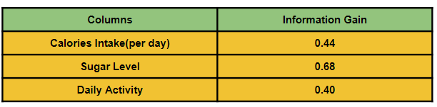
Since the feature Sugar Level has the highest Information Gain, we select Sugar Level as our root node and split the data accordingly.
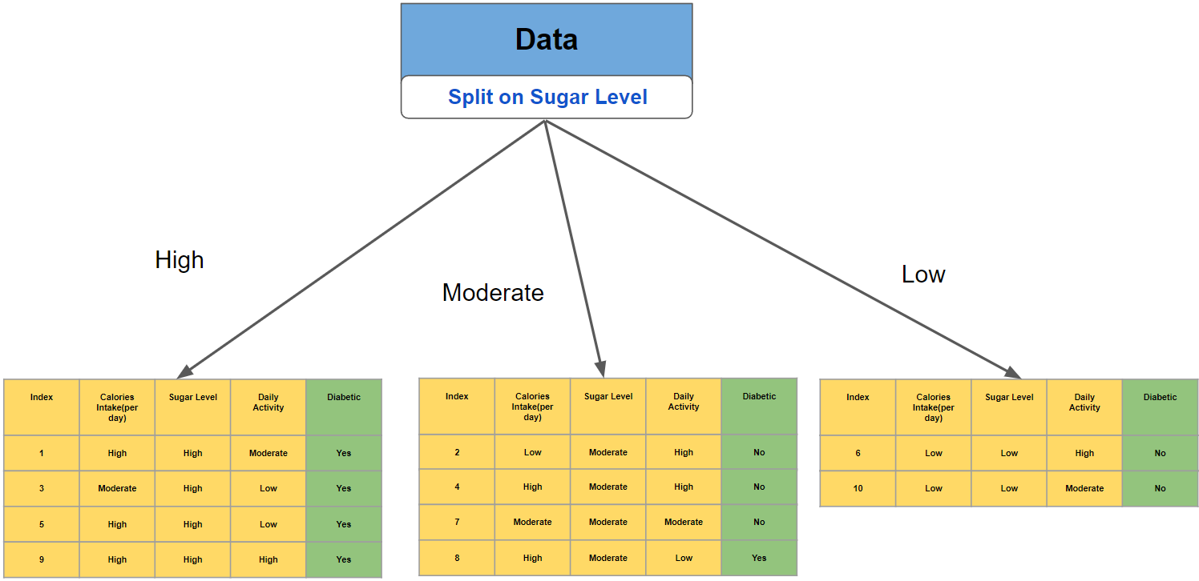
Likewise, the whole calculation of information gain and splitting of nodes is done recursively for each node in the decision tree to construct the tree. By default, splitting will stop when the leaf nodes become homogeneous/pure (meaning all the data points in that leaf node belong to the same class).
Decision trees only make the optimal split at each node, and the algorithm does not consider the larger problem as a whole. Also, once a split has been made, it is never reconsidered. Decision trees are hence considered Greedy Algorithms, which is a Computer Science term for any algorithm that tries to approximate the globally optimal solution to a problem by finding the locally optimal solution at each step of the problem instead.

