Practical Data Science > Know Your Faculty > Prof. Munther Dahleh
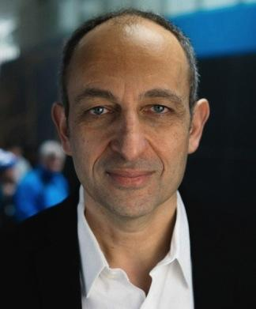
William A. Coolidge Professor (MIT Department of Electrical Engineering and Computer Science)
Research Departments: Director of Institute for Data, Systems, and Society (IDSS); Member of Laboratory of Information and Decision Systems (LIDS)
Prof. Dahleh joined LIDS as an assistant professor of EECS in 1987 and became a full professor in 1998. He spent the spring of 1993 as a visiting professor in the Department of Electrical Engineering, California Institute of Technology, and has held consulting positions with several companies in the U.S. and abroad.
Prof. Dahleh is internationally known for his fundamental contributions to robust control theory, computational methods for controller design, the interplay between information and control, the fundamental limits of learning and decision in networked systems, and the detection and mitigation of systemic risk in interconnected and networked systems.
- Professional website: https://idss.mit.edu/staff/munther-dahleh/

