Practical Data Science > Time Series

What is a Time Series?
A time series is a sequence of measurements on the same variable collected over time. The measurements are made at regular time intervals that could be years, months, quarters, etc.
Example: Monthly sales of a shoe type, Daily closing price or daily closing volume of a certain stock, Total daily transaction volume of your nearest ATM.

Time Series Forecasting
Time Series Forecasting is the process of using a statistical model to predict future values of a time series based on past results.
Some use cases:
- To forecast the number of incoming or churning customers
- To explain seasonal patterns in sales
- To detect unusual events and estimate the magnitude of their effect
- To estimate the effect of a newly launched product on the number of sold units

How is Forecasting different from Prediction?
Prediction is concerned with estimating the outcomes for unseen data. For this purpose, you fit a model to a training data set, which results in an estimator that can make predictions for a new sample .
In forecasting, we are making predictions about the future, based on time series data of the past. In time series data, each record is dependent on its sequential previous data. Forecasting is a sub-discipline of prediction, the only difference is forecasting is dependent on sequential time related data.

What are the components of a Time Series?
Trend: The trend shows the general direction of time series data over a long period of time. A trend can be increasing (upward), decreasing (downward), or horizontal (stationary).
The plot below, for example, shows that the US GDP has had an upward trend in the sixty years from 1930 to 1990.
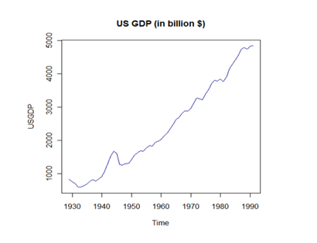
Seasonality: Seasonality is a characteristic of a time series in which the data experiences regular and predictable changes that recur every calendar year. Some examples include an increase in water consumption in summer due to hot weather conditions, or an increase in the number of airline passengers during holidays each year.
The below plot of Monthly Champagne Sales seems to show a clear seasonality at the same time each year.
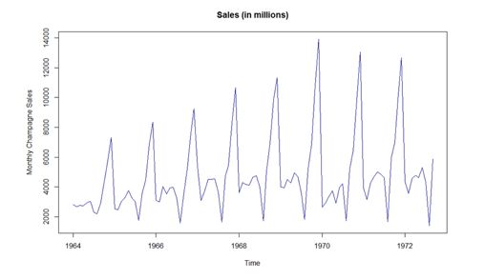
Cyclical Component: This is a characteristic with no set repetition over a particular period of time. A cycle refers to a period of ups and downs or the boom and bust of a time series, mostly observed in business cycles. These cycles do not exhibit a seasonal variation but generally occur over a time period of 3 to 12 years depending on the nature of the time series.
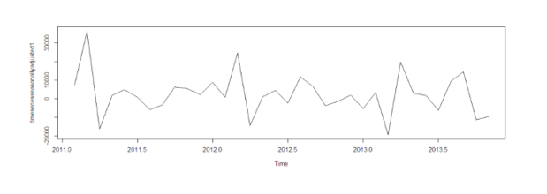
Irregular Variation: These are the fluctuations in time series data that become evident when trend and seasonality are removed from the time series. These variations are unpredictable, erratic, and may or may not be random. This is also known as the residual.
The 2-Year Government Bond Yield from the Australian Government, for example, shows such irregular variations and fluctuations even after trend and cyclical factors are taken out of consideration, as observed from the graph below.

