Pre-Work > Session Material - Introduction to Python

Before we jump into the Session following are some points that we need to know about this session. In this session, we will take a case study approach to apply the concepts we learned this week.

Problem Statement

Background
Cars Sons Ltd. is an automobile company that offers a full range from entry-level to luxury cars. The company is engaged in the business of manufacturing, purchase and sale of motor vehicles and spare parts (automobiles).

Business Context
Cars Sons Ltd. operates in the manufacturing of Hatchbacks, Sedans, MUVs, SUVs and Hybrid cars. Based on the car body type, below are the various category of cars manufactured by this company
1) Hatchback

A hatchback car is a small car with a rear door that opens upwards revealing the boot space to keep your luggage. Other than the rear door, hatchbacks are built with four doors, while two-door hatchbacks are also available in the market.
2) Sedan


The sedan is designed with separate passenger and boot space. Sedans feature four doors and a boot or trunk. A sedan is designed as a 3-box configuration vehicle — engine, passenger, and cargo.
3) Sports Utility Vehicle


SUVs are built with the combination of passenger cars along with features of off-road vehicles. This includes higher ground clearance, four-wheel drive, and other off-roading capabilities. SUVs are large in size with big wheels and have different terrain capabilities.
4) Multi Utility Vehicles (MUV)
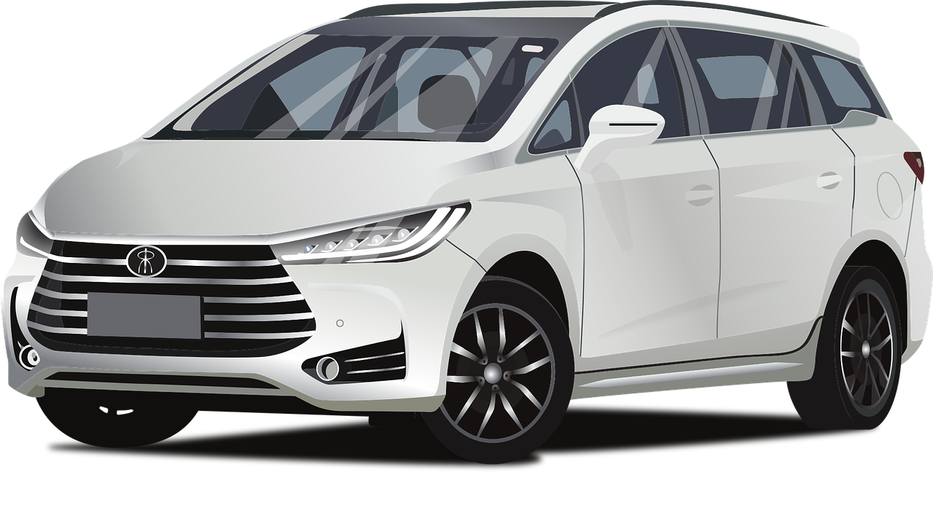

5) Hybrid Car
Hybrid cars are designed to run on petrol or diesel and electric power. They may have any kind of car body type such as Hatchback, Sedan, SUV, etc.

Objective
You have been hired as a Data Scientist in Cars Sons Ltd. The data for the company products have been provided and are required to create structured data which includes the various attributes of the product along with the sales figures.

Session Notebook

Notebook - Introduction to Python.ipynb
The above notebook will be used to solve the problem statement mentioned above. It is highly recommended to download the notebook as these files are used in the mentored learning session. By downloading this notebook, you can work along with the mentor in the session.

