Timeline of Generative AI

1940s and 1950s
In the 1940s and 1950s, the field of Artificial Intelligence emerged. One significant event was in 1948 when Claude Shannon released his paper "A Mathematical Theory of Communications." This paper discussed the concept of n-grams and focused on determining the probability of the next letter in a sequence of letters. Additionally, in 1950, Alan Turing published his paper "Computing Machinery and Intelligence." The paper introduced the Turing Test, which evaluates a machine's ability to display human-like intelligence without being distinguishable from a human.

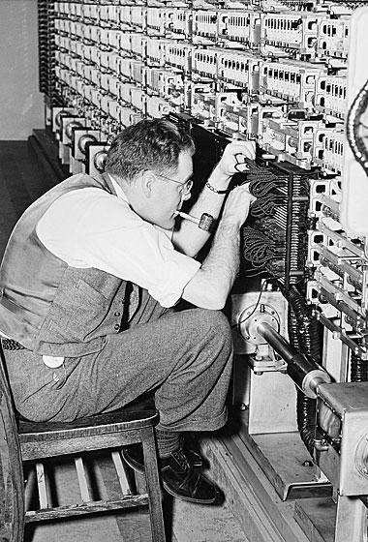
Alan Turing
In 1952, two scientists named A.L. Hodgkin and A.F. Huxley developed a way to explain how the brain uses electricity to communicate between neurons. This inspired the creation of Artificial Intelligence (AI) and natural language processing.
In 1956, a big conference called the Dartmouth Summer Research Project on AI brought together more than 100 researchers from different fields to talk about making machines that could think.
Also in 1956, a man named Arthur Samuel built one of the first examples of AI using a program that played checkers. The program learned from its experiences and got better over time.
In 1957, Noam Chomsky wrote a book called "Syntactic Structures" that helped computers understand and use human language better.

1960s – 1970s: The World's First Chatbot

In 1961, Marvin Minsky wrote a paper called "Steps Toward Artificial Intelligence" which proposed the idea of a "society of machines." These machines could work together to solve complex problems.
In 1964, the US National Research Council (NRC) created the Automatic Language Processing Advisory Committee (ALPAC) to monitor research progress in Natural Language Processing (NLP). The committee was led by John R. Pierce and included seven scientists.
Between 1964 and 1966, Joseph Weizenbaum created ELIZA, the first chatbot, at the MIT Artificial Intelligence Laboratory. ELIZA could simulate a conversation with a human using a simple algorithm that generated text responses to questions.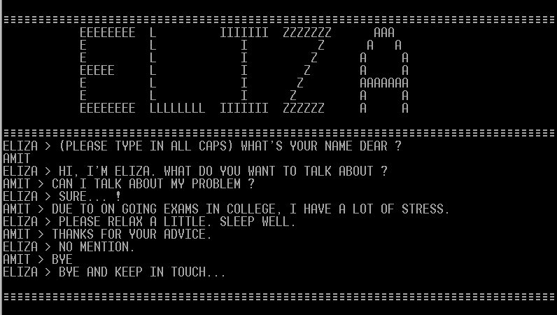

1980s – 1990s: Neural Networks Identify Patterns

During the 1980s, research in natural language processing, artificial intelligence, and machine translation made a recovery. IBM was at the forefront of this research and developed statistical models that used machine learning to make probability-based decisions.
In 1982, John Hopfield created the Hopfield network, a type of neural network that can learn and remember patterns. These networks were based on the workings of human memory.
In 1997, Sepp Hochreiter and Jürgen Schmidhuber introduced the concept of long short-term memory (LSTM) using RNN models. These neural networks allow computer programs to identify patterns and solve common problems.
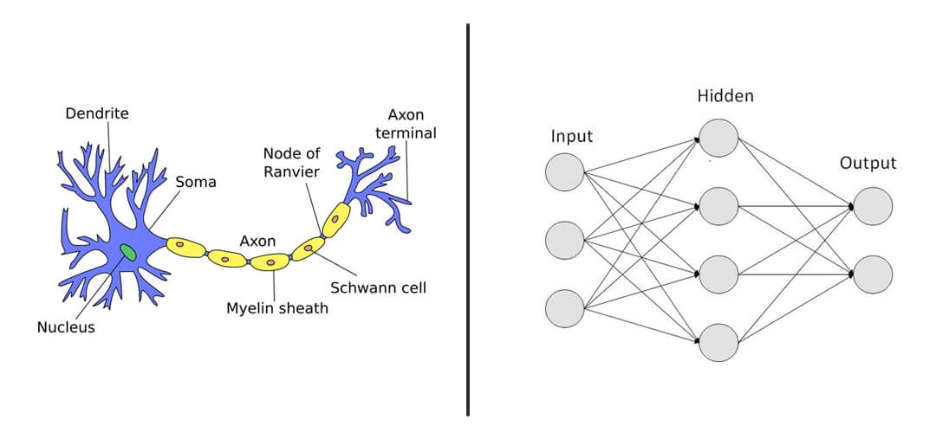

2000s – 2010s: Siri to GPT-2:

In the early 2000s, Yoshua Bengio and his team made a breakthrough with the development of the first feed-forward neural network language model, paving the way for improved natural language processing (NLP) capabilities.
Then in 2011, Apple's release of Siri brought AI and NLP assistants to the masses. Three years later, Google researchers created Word2vec, a technique that uses a neural network to learn word associations from text.
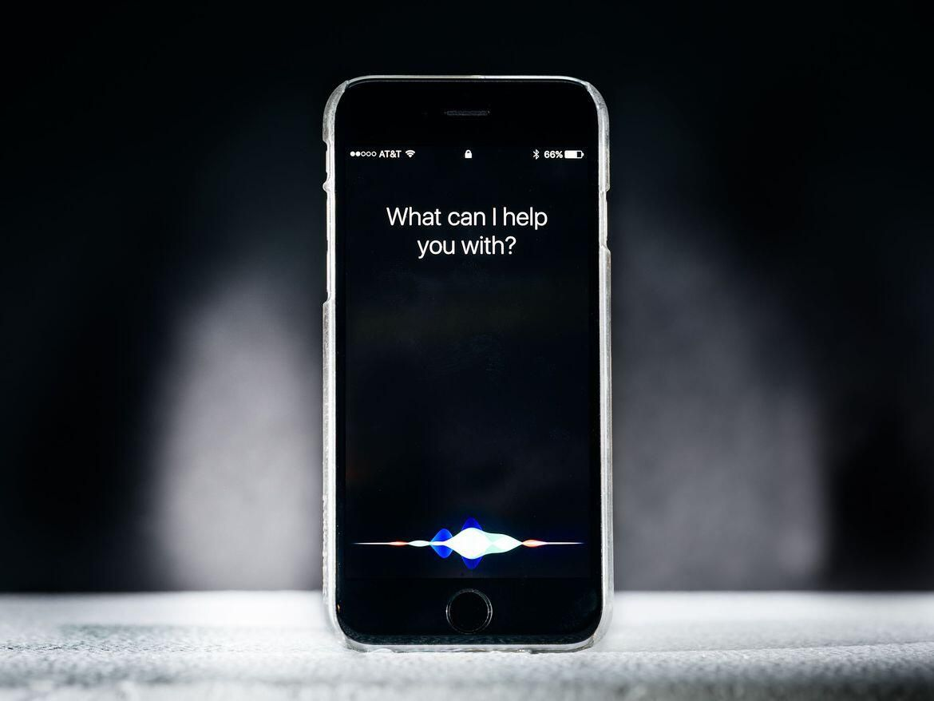

In 2014, Ian Goodfellow developed the first generative adversarial network (GAN), capable of creating new data based on a given training set. Dzmitry Bahdanau and his team introduced the attention model in 2015, which improved machine translation performance for longer sentences.
By 2017, Google researchers proposed a new network architecture, the Transformer, based solely on attention mechanisms, doing away with recurrent neural networks. In 2018, Alec Radford's paper on generative pre-training (GPT) demonstrated how a generative language model can acquire knowledge and process dependencies unsupervised.
Finally, in 2019, OpenAI released the complete version of its GPT-2 language model, which was trained on a massive dataset of diverse text, including Reddit posts with upvotes. These breakthroughs have paved the way for even more advanced AI applications in natural language processing.

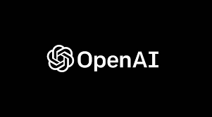

2020 and Beyond : "The AI Arms Race: ChatGPT and Competitors Push the Limits with New Generative AI Tools and Unprecedented Web Access"

2020s: ChatGPT Emerges as a Leading AI Chatbot In 2022, Stability AI develops Stable Diffusion, a deep learning text-to-image model that can generate images based on textual descriptions. This innovation leads to the creation of other diffusion-based image services, including DALL-E and Midjourney. Later that year, ChatGPT releases GPT-3.5, an AI tool that gains one million users within five days of its launch. The tool can access data from the web up to 2021.
In 2023, the race to develop the most advanced generative AI begins. Microsoft integrates ChatGPT technology into Bing, making it available to all users. Google introduces Bard, its own generative AI chatbot, while OpenAI launches GPT-4, along with a paid premium option.
Meanwhile, OpenAI offers a beta version of a browser extension for ChatGPT, which could potentially provide users with unrestricted access to current web data — something that no other generative AI tool currently offers.

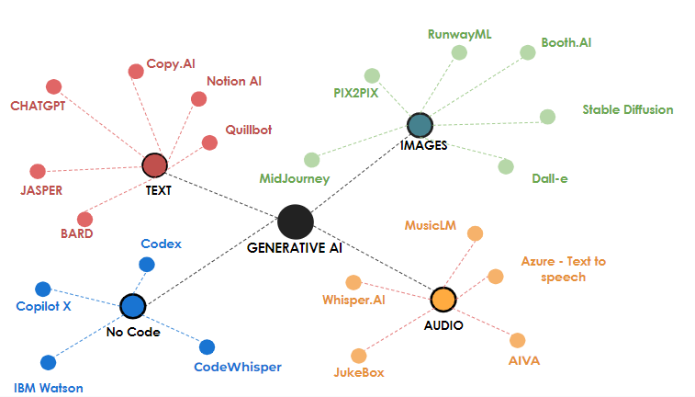
Universe of Generative AI tools

Happy learning!

