Tab 1

Data Analysis & Visualization

Course Outline
Overview
Welcome to the course on Data Analysis & Visualization. This course will introduce you to the tools and techniques utilized to explore data and discover hidden patterns using visualization.
Objective
The primary goal of this course is to understand various data exploration and data projection techniques, learn about the problem domains where network theory and ideas such as network centrality find use, and understand how and where to apply clustering algorithms from unsupervised learning.
Topics covered:
- Data Exploration and Visualization
  - Data collection
  - Hypothesis testing and practical applications
  - Multiple testing issues
  - Exploratory data analysis: PCA
  - Multi-dimensional scaling
  - t-SNE
  - Practical applications of PCA and t-SNE
- Network Analysis
  - Network representation through an adjacency matrix
  - Quantitative measures of a network: connected components, edge density, degree distribution, diameter and average path length, and homophily
  - Centrality measures: degree, Eigenvector, closeness, and betweenness centrality
  - Practical applications of Network Analysis
- Unsupervised Learning
  - Introduction to clustering
  - K-means clustering
  - Gaussian Mixture Models
  - Hierarchical clustering
  - DBSCAN
  - Clustering in networks: The Louvain Method for community detection
  - Modularity maximization
  - Practical applications of Clustering

Happy Learning!

Know Your Faculty

Dr. Caroline Uhler
Associate Professor, MIT Department of Electrical Engineering and Computer Science
Research Departments: MIT Institute for Data, Systems, and Society (MIT IDSS), MIT Laboratory for Information and Decision Systems (MIT LIDS), MIT Statistics and Data Science Center, and the MIT Operations Research Center (MIT ORC)
Dr. Caroline Uhler is a Full time Professor in the Department of Electrical Engineering and Computer Science and the Institute for Data, Systems, and Society at MIT. In addition, she is a core institute member of the Broad Institute, where she directs the Eric and Wendy Schmidt Center. She holds an MSc in mathematics, a BSc in biology, and an MEd all from the University of Zurich. She obtained her PhD in statistics from UC Berkeley in 2011 and then spent three years as an assistant professor at IST Austria before joining MIT in 2015. She is a SIAM Fellow, a Simons Investigator, a Sloan Research Fellow, and an elected member of the International Statistical Institute. In addition, she received an NIH New Innovator Award, an NSF Career Award, a Sofja Kovalevskaja Award from the Humboldt Foundation, and a START Award from the Austrian Science Foundation. Her research lies at the intersection of machine learning, statistics, and genomics, with a particular focus on causal inference, representation learning, and gene regulation.
- Professional website: https://idss.mit.edu/staff/caroline-uhler/
- Personal website: http://www.carolineuhler.com/

Learning Instruments
The following is an overview of the instructional and assessment-oriented learning instruments that will be part of the learning journey during this course week.

- Live Lectures: There will be 3 live lectures delivered by MIT faculty as part of this course week. The recordings for these live lectures will be made available four hours after live lecture completion. Attending the live lectures or viewing their recordings is crucial and highly recommended to obtain conceptual clarity on the various topics that are part of this course week.
- Pre-reads: These are instructional pages that provide a conceptual preview of the content of the live lectures. It is highly recommended to go through these pre-reads in order to derive maximum value from the live lecture component of the program.
- Lecture Slides: The slides that will be used by the faculty in the live lectures can be found under the 'Lecture Slides' heading in the section for each particular lecture. These will be provided beforehand for reference and preparation.
- Practical Applications: These are hands-on notebooks for the applications / practical examples used by the faculty in the live lectures, to reinforce the practical applicability of some of the key ideas covered in the sessions. You may use these practical applications after the live lectures for hands-on code practice to implement the techniques introduced by the faculty.
- Practice Case Studies: These are additional case studies, which represent detailed and comprehensive problem-solving exercises. They apply the concepts and ideas taught in the live lectures as a means to solve practical business problems. These practice case studies will help you understand the Python implementation of solutions, practice data interpretation, and generate insights relevant to the problem at hand.
- Additional / Reference Reading Material: These are curated external links to books, articles, open-source video content, and research papers, that provide an opportunity to augment the learning provided by the live lectures, and gain an additional conceptual/ implementational perspective.
- Post-Session Summaries: These summary handouts are meant to provide a refresher on the key ideas and takeaways covered in the live lectures, in a written, easy-to-read format. They will help solidify the understanding gained from every part of the live lectures and provide a more permanent method to internalize the ideas discussed in the course week.
- Frequently Asked Questions (FAQs): These curated FAQ Sheets provide a list of some of the most commonly asked questions and answers from historical iterations of these live lectures in the program. They represent a more direct way of internalizing the key takeaways gained and the conceptual trains of thought that all fellow attendees may have derived from the lecture, in a simple Q&A format.
- Live Lecture Transcripts: A direct speech-to-text transcription made available by the video conferencing platform hosting the live lecture component of the program. This may represent a quicker solution to refer to certain keywords or concepts covered over the course of the lecture and understand the exact information provided about that idea. Please note: These transcripts are auto-generated by the platform and not verified for 100% accuracy.
- Live Lecture Chat: These are exported text documents containing the chat history of the live lectures, and by extension, the questions asked and answers provided by all attendees (including the program Teaching Assistants) as part of the session. They provide an opportunity to refer back to specific questions or answers mentioned in the chat window of the live lectures.
- Mentor Learning Sessions (MLS): There will be two Mentor Learning Sessions this course week, which will be conducted over the weekend. The session plan and all the supporting material to be used in these sessions will be made available at the start of the week. It is a good practice to come prepared for these sessions with a list of questions you may wish to ask in the session. This is best achieved by internalizing the ideas covered and the material provided over all three live lectures in the week, as well as reviewing the material released in advance for these Mentor Learning Sessions.
MLS | Case Study
1 | Air Pollution Data Exploration
 | CAVIAR Network Analysis
2 | Socio-economic Factors for Geographic Clustering

- Practice Quiz: The practice quiz is designed to help you evaluate your understanding of the concepts covered in this week's lessons. The quiz consists of 10 multiple-choice questions that cover key topics taught in the week. By taking this quiz, you'll have an opportunity to test your knowledge and identify areas where you may need additional review. This practice quiz would supplement your learning and help you prepare for quiz assessment.
- Quiz Assessments: There will be one mandatory quiz assessment at the end of the course week. It will consist a total of 30 marks, with ten questions each weighing 3 marks. This quiz will be released at the end of the week.

Happy Learning!

Quick Note - FAQs and GL Community
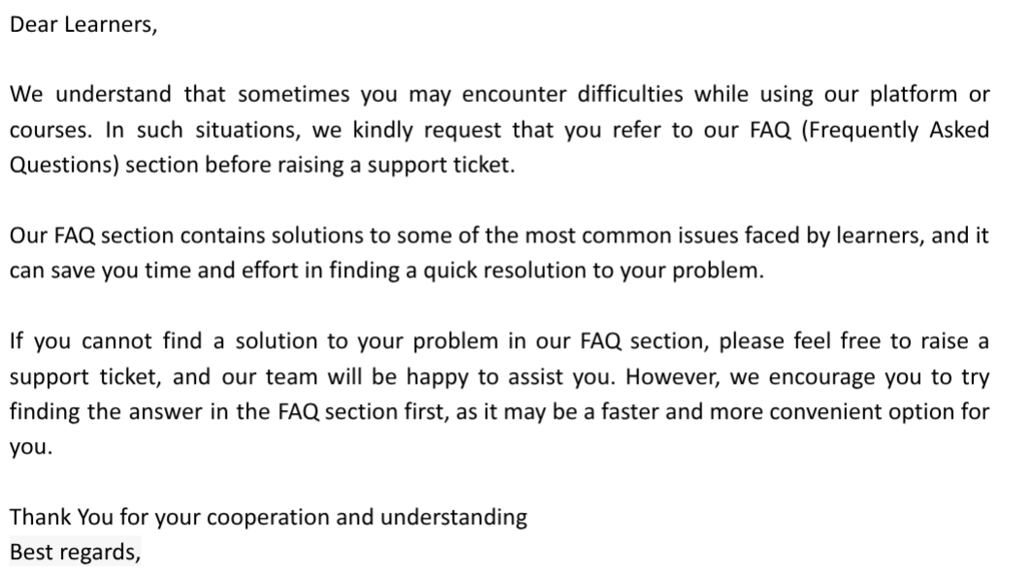

Data Exploration and Visualization

Live Virtual Class 1: Data Exploration and Visualization

Pre-reads
Matrix and Vectors
To understand machine learning in-depth, let us first understand a few topics related to linear algebra. You do not necessarily need to understand linear algebra in-depth, to get started with machine learning. However, it will be useful in understanding the mathematics behind machine learning algorithms.
In linear algebra, data is mostly represented using matrices and vectors.
Matrix
Matrices (plural of matrix) are used throughout machine learning algorithms, specifically for input variables, i.e., the variables we try to understand in machine learning. A matrix of size is a two-dimensional array that has m rows and n columns.
Vector
A vector is a one-dimensional array that has only one row - called a row vector, or just one column, also called a column vector.
For example, in the below figure, X is a matrix with 3 rows and 2 columns, while Y is a simple column vector.
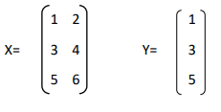
Now, let’s look at some operations that can be applied to vectors and matrices.
Addition and Subtraction
For the addition and subtraction of two vectors or two matrices, both should be of the same size. The addition and subtraction operations are performed in an "element-wise" manner between the two objects - that is, the corresponding elements from the two vectors or matrices are added to each other or subtracted from each other.
For example, the below figure shows the addition and subtraction of two column vectors, each having 3 elements.
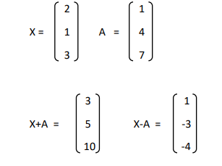
This kind of "element-wise" addition and subtraction can similarly be performed for two or more matrices of the same size as well.
Multiplying a matrix with a vector
To multiply a matrix with a column (or row) vector, the matrix must have the same number of columns (or rows) as the number of elements in the column (or row) vector.
Let us look at an example of multiplying a matrix with a vector, where X is an column vector and A is an matrix.
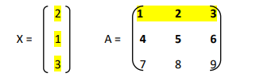
As the number of columns in A is equal to the number of elements in X, it is possible to find AX (A multiplied by X).
To do multiplication, we multiply each element of row 1 of the matrix with the corresponding element of the column vector and add them, i.e., (1*2 + 2*1 + 3*3) = 13. Similarly, we can apply the same operation to rows 2 and 3 of matrix A with the same three elements of X, and get the below result:
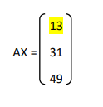
Multiplying a matrix with another matrix
One way to multiply a matrix with another matrix is what's known as the Dot Product.
To be able to multiply two matrices and get a dot product, the number of columns in the first matrix should equal the number of rows in the second matrix.
The resultant matrix would have the same number of rows as the first matrix and the same number of columns as the second matrix.
For example, the below figure shows the dot product of two matrices.
- The first element, i.e., the element at the first row and the first column of the resultant matrix, would be: (1*7) + (2*8) + (3*9) = 50
- The second element, i.e., the element at the first row and the second column of the resultant matrix, would be: (1*10) + (2*11) + (3*12) = 68
- The third element, i.e., the element at the second row and the first column of the resultant matrix, would be: (4*7) + (5*8) + (6*9) = 122
- The last element, i.e., the element at the second row and the second column of the resultant matrix, would be: (4*10) + (5*11) + (6*12) = 167
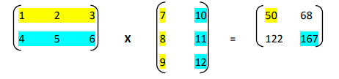
Determinant of a matrix
The determinant of a matrix is a special number that can only be calculated from a square matrix, i.e., a matrix with the same number of rows and columns.
For example: A 2 x 2 or 3 x 3 matrix would be considered a square matrix.
For a 2 × 2 square matrix:
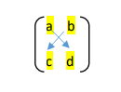
The determinant is calculated using the below formula:
det(A)= a*d - b*c
"The determinant of A equals a times d minus b times c"
Note: In Python, vectors and matrices are represented as Numpy arrays. Numpy is one of the most popular linear algebra packages in Python and can be used to implement several basic mathematical operations on matrices, such as calculating dot products and determinants.

Eigenvectors and Eigenvalues
Consider that we have a vector V and a matrix A.
If we multiply matrix A with vector V, we obtain a new, transformed vector.
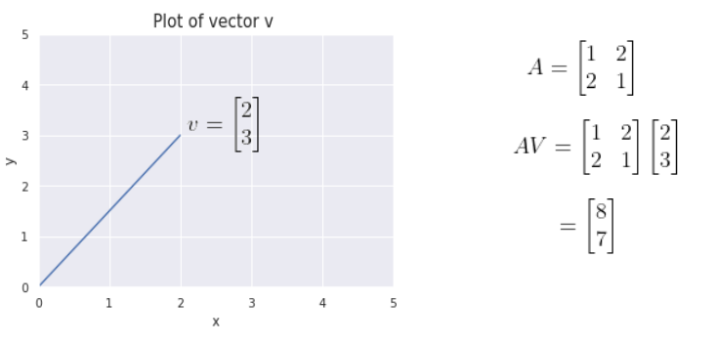
The below figure shows that multiplying by the matrix A has scaled the vector V to a new vector, with a different magnitude and a slightly different direction.
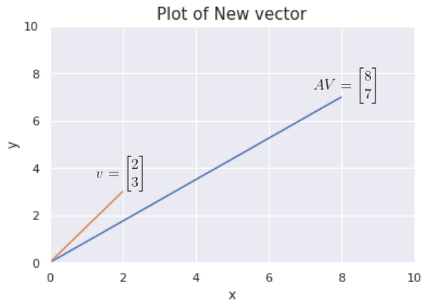
As we know, vectors have both a magnitude and a direction. The new vector AV seems to have a different direction as well as magnitude in comparison to the old vector V.
In linear algebra, the operation above is known as a linear transformation. It is not only restricted to scaling - linear transformations can be used for flipping, rotating, shearing and other mathematical operations.

Let’s now consider a different vector V and multiply it with the same matrix A: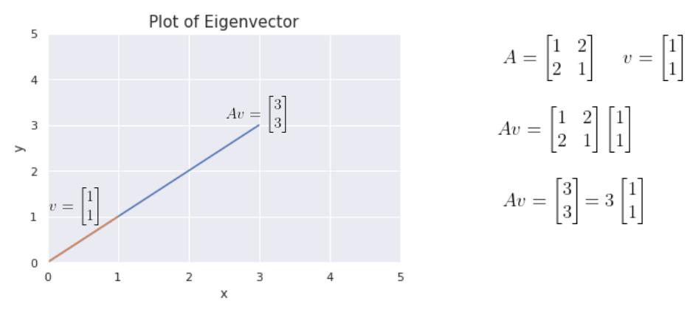
In this example, we notice that something different has happened.
We see that in this instance, while the magnitude of the new vector is certainly different, its direction has not changed.
These special vectors are known in linear algebra as Eigenvectors.
As illustrated in the example above, given the corresponding matrix A, eigenvectors are directionally-invariant when multiplied with that matrix i.e. they don’t change their direction on multiplication with matrix A - they merely get scaled in terms of magnitude. The value with which the eigenvector gets scaled, is known as the Eigenvalue, denoted by the symbol lambda.
In our example, the eigenvector is and the eigenvalue is 3.
So to summarize, the eigenvector of a matrix is a vector whose direction does not change when a linear transformation (matrix multiplication) is performed on it.
Mathematically, the equation is represented as:
- A - Transformation matrix
- v - Eigenvector
- - Eigenvalue
Taking to the left side:
Lambda is a scalar, so taking v out in common:
An eigenvector is a non-zero vector. So, v cannot be zero.
Hence, to satisfy the right-hand side condition, needs to be zero.
If we were to multiply by the inverse of the matrix on both sides:
Since the product of a matrix and its inverse is I (the identity matrix), equating the left and right sides, we get:
This is contradictory, as we have mentioned above that the Eigenvector cannot be zero.
So that means we cannot actually use the inverse of , as it is not an invertible matrix.
In linear algebra, if a matrix is not invertible then the determinant of the matrix is equal to zero.
That means, we only need to solve the equation , to get the eigenvalues and through them, the eigenvectors.
Due to Numpy in Python, we do do not need to perform these operations by hand. Numpy has functions to find the eigenvalues and eigenvectors of a matrix for us.
Why are Eigenvectors important?
The directional invariance of Eigenvectors turns out to be incredibly important, and is utilized by many applications - Principal Component Analysis (PCA), for example, is a highly popular data projection technique that can be used to reduce the dimensionality of a dataset and visualize it in lower dimensions.
This technique will be discussed in the first lecture of the week.
To understand the concept of Eigenvectors and Eigenvalues in some more detail, check out this video from 3 Blue 1 Brown:
Eigenvectors and Eigenvalues
This video talks about Eigenvectors and Eigenvalues with the help of visual representations and an example.
It includes the calculations that are needed to get these values, and how to interpret them.

The Covariance Matrix
Variance: Variance helps us understand how far our random variable is spread out from the mean.
Let's use a hypothetical income distribution of people as an example for reference. The formula for variance is given by:
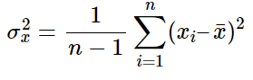
where n is the number of samples (ex: the number of people in the income distribution) and x̄ is the mean of the random variable x (ex: the mean of the income).
Covariance: Covariance, on the other hand, measures the extent to which two random variables vary together.
For a similar example, let's consider the income of a person and the expenditure of that person in a population. The formula for covariance is given by:
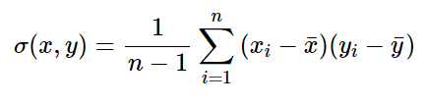
where n is the number of samples (ex: the number of people) and x̄ is the mean of the random variable x (represented as a vector). The variance, σ²(x), of a random variable, x, can also be expressed as the covariance with itself, i.e, σ(x,x).
Covariance Matrix: Following from the previous equations, the covariance matrix for two dimensions is given by:
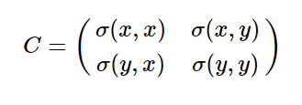
In this matrix, the variances appear along the diagonal and the covariances appear in the off-diagonal elements.
Note: The function numpy.cov() in Python's Numpy variable can be used to get the covariance matrix in Python.

Dimensionality Reduction
In real-world situations, we often deal with high-dimensional data, with lots of columns or "features" that represent the information collected about each observation. High-dimensional data is disadvantageous for a couple of reasons:
- It is generally difficult to analyze or visualize high-dimensional data and identify hidden patterns.
- Not all the features or dimensions of the data are equally important.
Therefore, we need to reduce the dimensionality of the dataset in such a way that by losing only a minimal amount of information, we can visualize the data and identify patterns more easily with a smaller number of features.
Two important techniques that we can use for dimensionality reduction are:
- PCA
- t-SNE
PCA
The main idea of principal component analysis (PCA) is to reduce the dimensionality of a dataset consisting of many variables correlated with each other, either heavily or lightly, while retaining the variation present in the dataset.
This is done by transforming the variables to a new coordinate space of variables, which are known as principal components (or simply, the PCs), and are orthogonal to each other.
The selection of principal components is such that the retention of variation present in the original variables is the maximum for the first principal component and decreases as we move down in the order. The principal components are the eigenvectors of the covariance matrix, and hence they are orthogonal.
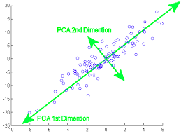
Image Source
t-SNE
The t-SNE algorithm calculates a similarity measure between pairs of instances in the high dimensional space and in the low dimensional space. This is done by setting the probabilities from the low-dimensional space similar to those of the high dimensional space. We measure the difference between the probability distributions of the two-dimensional spaces using Kullback-Leibler divergence and try to optimize it.
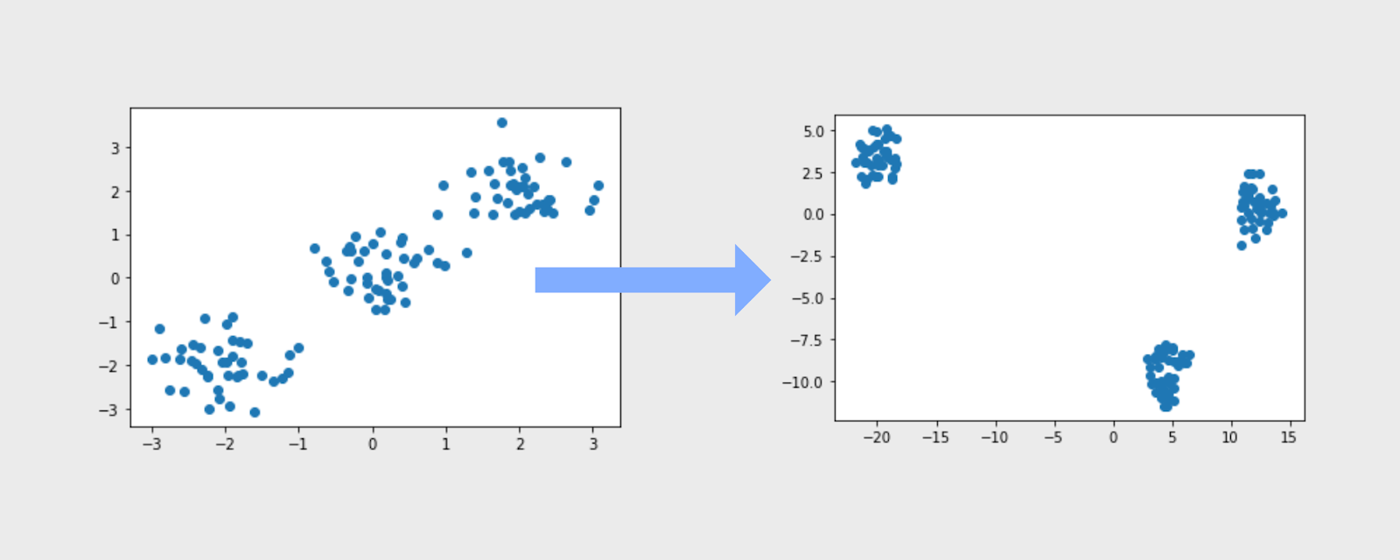
Image Source
We will learn about KL divergence in the next section.

Kullback-Leibler (KL) Divergence
Sometimes, in machine learning, it is desirable to analyze the actual and observed probability distribution to quantify the difference in the distributions of a random variable. We calculate KL divergence to measure that difference.
First, let us understand what divergence is.
Divergence is a measure of how one distribution differs from another. It is not symmetrical in nature i.e. score of the divergence for distributions p and q would give a different score from q and p.
Here we will talk about one specific type of divergence, the Kullback-Leibler (KL) divergence.
KL divergence: It quantifies how much one probability distribution differs from another probability distribution.
The KL divergence between the two distributions p and q can be calculated using the formula:
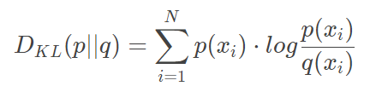
Two important points to note about KL divergence:
- The lower the KL divergence value, the better the two distributions match. If two distributions perfectly match, then it is zero.
- It is not symmetrical i.e.
The intuition behind the KL divergence score: When the probability for an event from p is large, but the probability for the same event in q is small, there is a large divergence. When the probability from p is small and the probability from q is large, there is also a large divergence, but not as large as in the former case.
To know more about KL divergence, please refer to this video here.
This video talks about the intuition behind KL divergence by explaining it with a numerical example. It also provides a real-life application of this concept.
Note: In Python, we use the rel_entr function to calculate the KL divergence.

The Binomial and Bernoulli Distributions

The Binomial Distribution
A Bernoulli trial (or a Binomial trial) is a random experiment with exactly 2 possible outcomes, “success” or “failure”, in which the probability of success is the same every time the experiment is conducted.
Example 1:
Let’s say we perform an experiment of tossing a coin. In this scenario, the outcome of the experiment can be either heads or tails. Here, we have 2 possible outcomes and we can consider any 1 out of 2 outcomes as a success (depending on the experiment).
If we consider heads as success, the probability of getting heads (probability of success) is always the same, i.e., 0.5. Similarly, if we consider tails as success, the probability of getting tails (probability of success) is always the same, i.e., 0.5. Hence, this experiment of tossing a coin can be considered a Bernoulli trial.
Example 2:
Let’s assume that the probability of a woman having breast cancer all over the world is 0.2, hence, the probability of not getting breast cancer is 1 - 0.2 = 0.8.
Let’s say we perform an experiment of randomly selecting a female candidate from anywhere in the world, to check whether she has breast cancer or not. Here, we have 2 possible outcomes and we can consider any 1 out of 2 outcomes a success. The probability is also the same every time. Hence, this experiment can also be considered a Bernoulli trial.
The binomial distribution represents the probability for 'x' successes of an experiment in 'n' trials, given a success probability 'p' for each trial of the experiment.
The formula for the binomial distribution for a random variable X is given as,
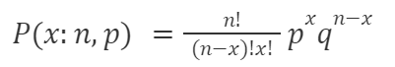
Where:
p = Probability of Success
q = 1 - p = Probability of Failure
n = Number of Trials
x = Number of successes desired

The Notation for a binomial distribution is
X ~ B (n, p)
which is read as ‘X follows a binomial distribution with n trials and probability of success in each trial is equal to p’.

There are some of the assumptions that need to be satisfied for a random variable to follow a binomial distribution. They are as follows:
- There are a fixed number of trials. (represented by the variable n)
- Each trial has 2 outcomes (called "success" and "failure" for convenience)
- The trials are all independent of one another.
- The probability of success, i.e., p is the same for all trials.

Let's consider an example. We can use the above formula to find the probability of 2 heads in 6 coin tosses
Here the experiment of tossing a coin is repeated 6 times.
- Success = ‘heads’
- n = 6 trials
- p = 0.5
- x = number of heads in 6 tosses which are 2 here
- X follows a binomial distribution with n = 6 and p = 0.5, i.e., X ~ B (6, 0.5)

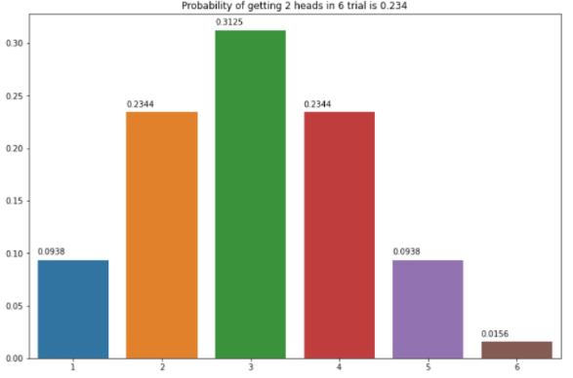
This is computed using the formula below.

So, the probability of getting 2 heads out of 6 coin tosses (trials) is 0.234. Hence, it means that there is a ~23% chance that we will get exactly 2 heads if we repeatedly toss a coin 6 times.

Let's consider another example. Suppose 80% of people who purchase shirts are men, then what would be the probability that exactly 7 are men if 10 shirt owners are randomly selected?
Here the experiment of selecting random shirt owners is repeated 10 times,
- Success = “person is male”
- n = 10 trials
- p = 0.8
- x = 7 (Number of male shirt owners desired)
- X has a binomial distribution with n=10 & p=0.8, i.e., X ~ B(10,0.8)
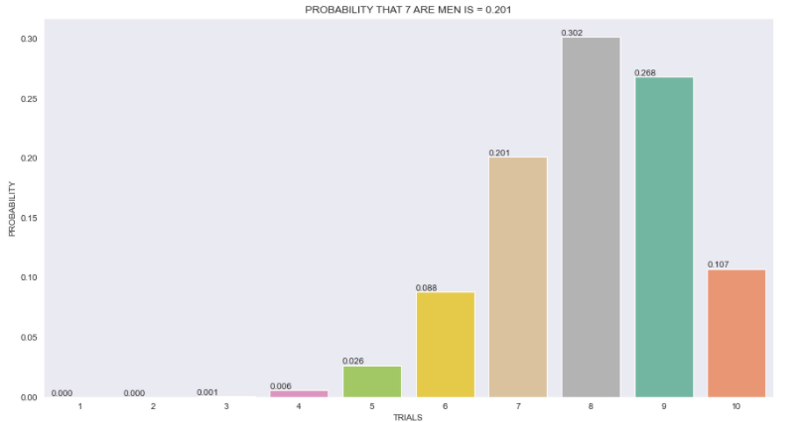

This is computed using the formula below,

So, the probability of getting 7 male shirt owners out of 10 randomly picked shirt owners(trials) is 0.201. Hence, it means that there is a ~20% chance that we will get exactly 7 male shirt owners if we randomly select 10 shirt owners.

The Bernoulli Distribution
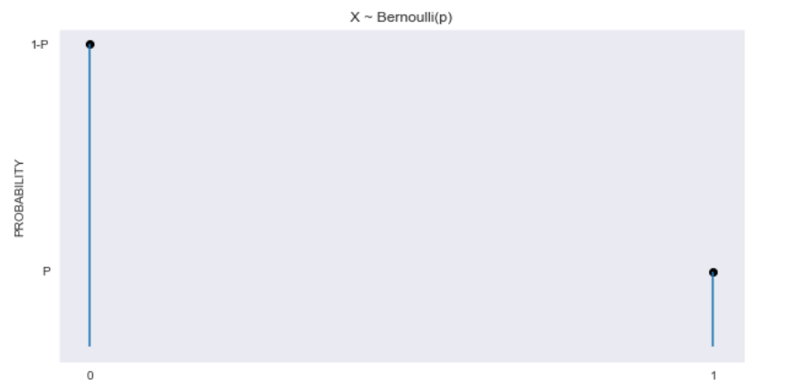
The Bernoulli Distribution is a special case of the Binomial Distribution where the number of trials is equal to 1. Hence it represents the probability of an event occurring in 1 single trial, for example, the probability of getting heads when a coin is tossed only 1 time is 0.5.

Curated External Resources - Data Exploration and Visualization
Please find below some curated external links to books, articles, and open-source video content about hypothesis testing and dimensionality reduction.

Hypothesis Testing
- This excerpt from a book takes a more detailed look at the foundations of hypothesis testing.
- This is a good summary document covering the foundational concepts of hypothesis testing and statistical inference.

PCA / t-SNE
- An end-to-end comprehensive guide for PCA
- Check out this video on PCA by StatQuest: Click here
- This article explains Principal Component Analysis with example.
- This article shows how to use t-SNE.
- This is a good summary of the differences between PCA and t-SNE.
- This resource has an excellent Q&A on t-SNE
Happy Learning!

FAQ - Data Analysis and Visualization

Post-Session Summary - Data Exploration and Visualization

Pre-reads

Power-Law Distribution

Power-Law Distribution
"Power-Law Distribution" is a term used when there are only a small number of observations which have a very high value of a certain characteristic, and a large number of observations which have a small value for that characteristic. Many unequally-distributed phenomena in the real world follow such a distribution.
The graph of a power-law distribution looks like the following image:
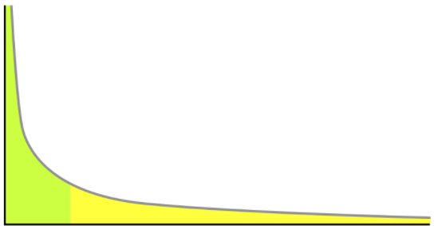

Let's consider some examples:
Example 1: The number of followers for each user on Instagram.
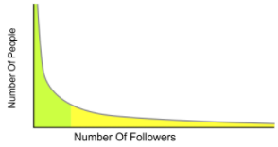

On Instagram, there are a lot of people (regular profiles) with a small number of followers each, and only a few people percentage-wise (verified handles, celebrities etc.) who have an extremely high number of followers.
Example 2: Distribution of US household income
As per a 2014 survey of US household incomes, the 90th percentile of income was $157,500. Hence 90% of US household incomes are less than $157,500. As we proceed further in the x-axis in the figure below, we observe that there are very few people who have extremely high household incomes.
The graph below depicts a frequency distribution of household incomes, where the x-axis represents "Household Income in USD($) in 2014" and the y-axis represents the "Number of people".
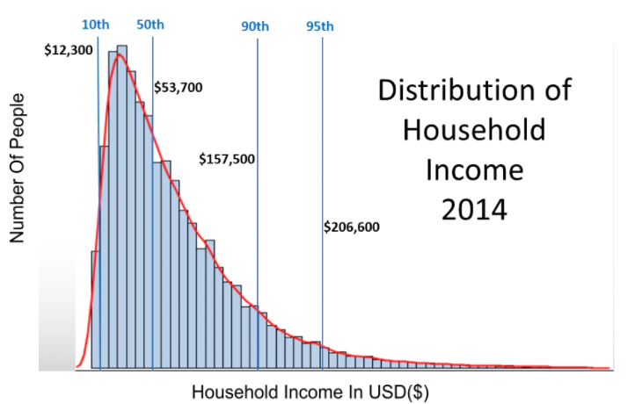

Mathematically, a power-law distribution is written as
Alternatively, we can rewrite this by taking the logarithm on both sides:
Where:
- c is a constant
- P, k are the variables of interest - For example: In the Instagram power-law distribution, k would be the number of followers and P is the number of Instagram users.
- α (alpha) is the law’s exponent.

In the graphs below, we see that as we increase the magnitude of the exponent term (alpha), the steepness/slope of the curve also increases.
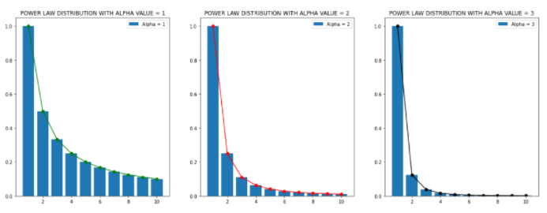

Graph Theory
Graph Theory is the study of graphical structures that model relations between two variables or objects. Structurally, graphs are merely a collection of nodes inter-connected by edges in various ways.
Graphs are used by various algorithms in machine learning to perform tasks like clustering, classification, and regression.
A graph is usually represented using nodes (or vertices) and edges (or links).

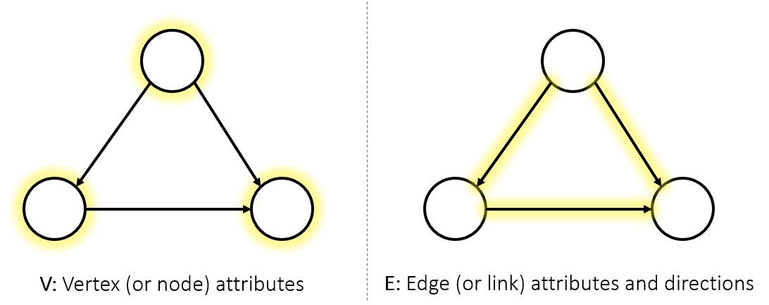
A graph is usually represented using nodes (or vertices) and edges (or links).

Mathematically, graphs are sometimes represented as:
G = (V,E)
where V is the number of vertices and E is the number of edges in the graph.

Graphs can either be directed or undirected.
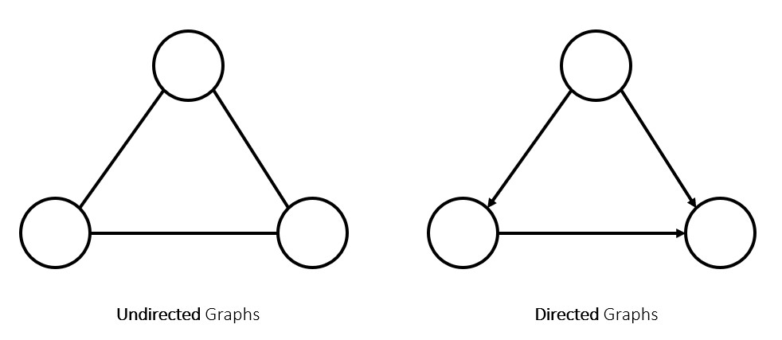
In an undirected graph, the path between 2 nodes is merely a connection between them, and has no inherent source/target, while in a directed graph, every edge is a clear path from one node to another.

Matrix Representation of Graphs

Adjacency Matrix
An adjacency matrix is the matrix representation of a graph/network, depicting the connections between the nodes in the graph merely as numbers of a matrix. This equivalence between graphs and matrices is an important part of modern graph theory.

Directed Graph
Let’s consider a directed graph:
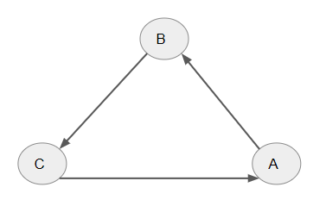
In the above directed graph, , and are the directed connections observed.
Its adjacency matrix can be given as:

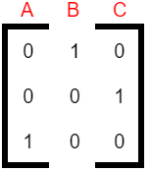
- The graph shows that , i.e., A is linked to B. Hence, the entry in the 1st row (row A) and 2nd column (column B) of the Adjacency Matrix is 1.
- The graph shows that , i.e., B is linked to C. Hence, the entry in the 2nd row (row B) and 3rd column (column C) of the Adjacency Matrix is 1.
- The graph shows that , i.e., C is linked to A. Hence, the entry in the 3rd row (row C) and 1st column (column A) of the Adjacency Matrix is 1.
- There are no other connections in the graph. Hence, all other entries of the Adjacency Matrix are 0.

Undirected Graph
Now let’s consider an undirected graph:
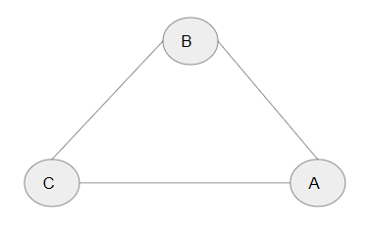
An undirected graph has no specific direction for the link/edge, hence if A and B are linked then we consider the relation as or . The adjacency matrix for this graph is as below:

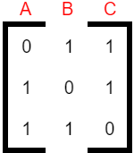

- The graph shows that A is linked to both B and C. Hence, the entries in the 2nd (column B) and 3rd (column C) elements of the 1st row (row A) are 1 in the Adjacency Matrix.
- The graph shows that B is linked to both C and A. Hence, the 1st (column A) and the 3rd (column C) elements of the 2nd row (row B) are 1 in the Adjacency Matrix.
- The graph shows that C is linked to both A and B. Hence, the 1st (column A) and 2nd (column B) elements of the 3rd row (row C) are 1 in the Adjacency Matrix.
- There are no other connections in the graph. Hence, all other entries of the Adjacency Matrix are 0.

Weighted Adjacency Matrix
We use the weighted adjacency matrix in the case of a weighted directed or weighted undirected graph.
A weighted graph is a type of graph where each link/edge is also given a numerical weight.

Weighted Directed Graph

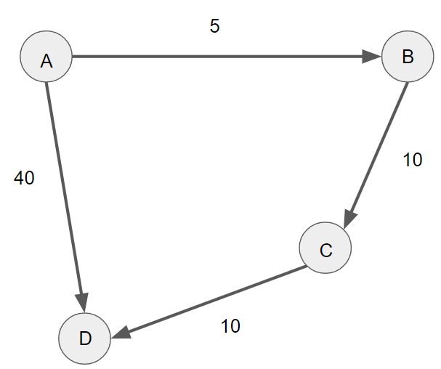

The graph above is a directed weighted graph and has four nodes/vertices: A, B, C & D. Each link/edge has a certain weight associated with it.
The weighted adjacency matrix is the same as the adjacency matrix we have seen in the beginning, the only difference is that instead of representing the connections/links as 1 we enter the weights of the links/edges.
The weighted adjacency matrix for this weighted directed graph can be given as:
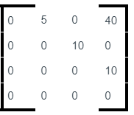
By looking at the given graph, we can say that have links/edges with weights as 5, 40, 10, and 10 respectively.

Weighted Undirected Graph
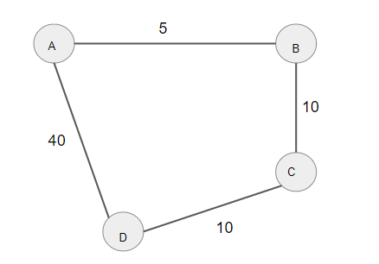
The graph above is a weighted undirected graph with four nodes/vertices A, B, C & D, where each link/edge has a certain weight associated with it.
The weighted adjacency matrix for this graph can be given as:
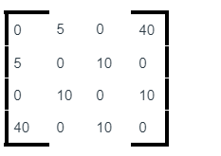
Since the graph is undirected, the connections in the graph: , have links/edges with weights as 5, 5, 40, 40, 10, 10, 10, and 10 respectively.
New Package Introduction - Network Analysis
NetworkX

NetworkX is a Python package for the creation, manipulation, and study of the structure, dynamics, and functions of complex networks. It is widely used in Network Analysis in Python, and has several inbuilt functionalities to help with the same. Some of NetworkX's features:
- Tools for studying the structure and dynamics of social, biological, and infrastructure networks
- A standard programming interface and graph implementation suitable for a wide range of applications
- A rapid development environment for collaborative and multidisciplinary projects
- An interface for existing numerical algorithms and code written in C, C++, and FORTRAN; and
- The ability to work with large non-standard data sets without difficulty
You can use NetworkX to load and save networks in standard and non-standard data formats; generate many different types of random and classic networks, analyze network structure; build network models, design new network algorithms, draw and visualize networks and a lot more.
In order to use the NetworkX package, we need to first install it on our local machine. You can install NetworkX using the pip command.
To install the package, please run the below command in a Jupyter notebook and once the command runs successfully, restart the kernel:
!pip install networkx
To import the package, run the following command in a Jupyter notebook:
import networkx as nx
There are many useful functions in NetworkX to work with graphs/network data. Let’s go through some of the important functions that we use in NetworkX case studies that implement network analysis:

1. nx.Graph() to create a graph:
A graph is defined as a collection of nodes (vertices) and identified pairs of nodes (called edges, links, etc.). Nodes in NetworkX can be any hashable object, such as text, string, an image, an XML object, another Graph, a customized node object, and so on.
To create an empty graph, we need to call the Graph() class as shown below.
import networkx as nx
G = nx.Graph()

2. nx.from_pandas_edgelist():
From the above function, we can get a Pandas dataframe containing an edge list.
The parameters used by the function are as shown below:
from_pandas_edgelist(df, source='source', target='target', edge_attr=None, create_using=None, edge_key=None)

df: Pandas data frame
A graph's edge list representation
Source: str or int
For the source nodes, a valid column name (string or integer) (for the directed case)
target: str or int
For the target nodes, a valid column name (string or integer) (for the directed case).
edge_attr: str or int, iterable, True, or None
A valid column name (str or int) or iterable column name is used to retrieve items and add them as edge attributes to the graph. If true, the rest of the columns will be added. If none is specified, no edge attributes are added to the graph.
Create_using: NetworkX graph constructor, optional (default=nx.Graph).
To create a graph type. If this is a graph instance, it must be cleared before being populated.
edge_key : str or None, optional (default=None)
A valid column name for the edge keys (for a MultiGraph). If create using is a multigraph, the values in this column are used as edge keys when adding edges.

Below we see an implementation of this function in the case study titled Game of Thrones Network Analysis:
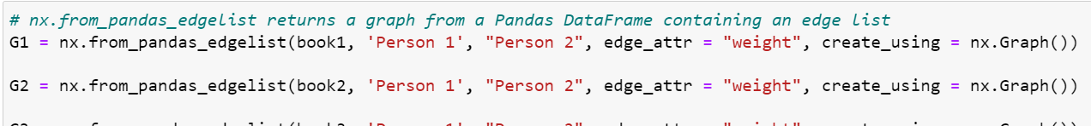

3. nx.degree_centrality(G):
The degree centrality of a node v is the proportion of nodes to which it is connected.
The parameters used by the function are as shown below:
G: Graph
A NetworkX graph
nodes: dictionary
Dictionary of nodes with the value degree centrality
Below we see a function implementation of nx.degree_centrality() in the case study titled Game of Thrones Network Analysis:
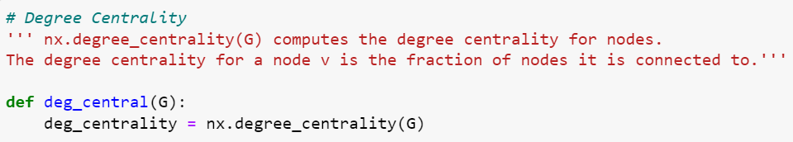

4. nx.eigenvector_centrality(G):
Eigenvector centrality calculates a node's centrality based on the centrality of its neighbors. The ith element of the vector defined by the equation is the eigenvector centrality for the node.
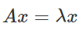
where is graph G's adjacency matrix with eigenvalue. If is the largest eigenvalue of the adjacency matrix, there is a unique solution with all of its entries being positive, according to the Perron-Frobenius theorem.
The parameters used by the function are as shown below:
eigenvector_centrality(G, max_iter=100, tol=1e-06, nstart=None, weight=None)
G: Graph
A NetworkX graph
max_iter: integer, optional (default=100)
A maximum number of iterations in power method.
tol: float, optional (default=1.0e-6)
Error tolerance is used to check convergence in power method iteration.
nstart: dictionary, optional (default=None)
the starting value of the eigenvector iteration for each node.
weight: None or string, optional (default=None)
If None, all edge weights are treated equally. Otherwise, the name of the edge attribute used as weight is stored. The weight is interpreted as the connection strength in this measure.

Below we see a function implementation of nx.eigenvector_centrality() in the case study titled Game of Thrones Network Analysis:
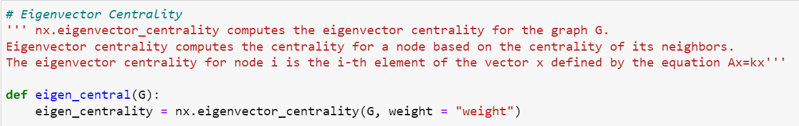

5. nx.betweenness_centrality(G):
The betweenness centrality of a node v is the fraction of all-pairs shortest paths that pass through v.
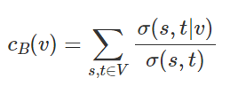
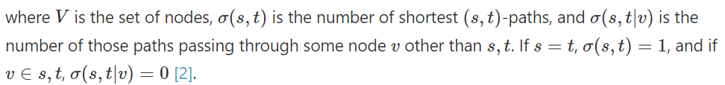

The parameters used by the function are as shown below:
betweenness_centrality(G, k=None, normalized=True, weight=None, endpoints=False, seed=None)
G: Graph
A NetworkX graph
k: int, optional (default=None)
If k is None, estimate betweenness using k node samples. The value of k < = n, where n is the number of graph nodes. Higher values provide a more accurate approximation.
normalized: bool, optional
If True, the betweenness values for graphs and directed graphs are normalized by 2/((n-1)(n-2)), where n is the number of nodes in G.
weight : None or string, optional (default=None)
If none, all edge weights are treated equally. Otherwise, the name of the edge attribute used as weight is stored. Weights are used to calculate weighted shortest paths, which are then translated into distances.
endpoints: bool, optional
Include the endpoints in the shortest path count if true.
seed: integer, random_state, or None (default)
An indicator of the state of random number generation. See Randomness. It should be noted that this is only used if k is not None.

Below we see a function implementation of nx.betweenness_centrality() in the case study titled Game of Thrones Network Analysis:
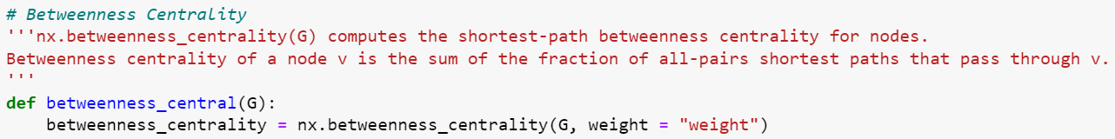

The following is a helpful article from AskPython.org that gives an in-depth introduction to NetworkX:
NetworkX Package - Python Graph Library

Louvain
This package adds the capability of community detection using the Louvain method. The name of the package is community, but it refers to Python-Louvain on PyPI.
The Louvain Community Detection Algorithm is a straightforward method for determining a network's community structure. It is a heuristic method for optimizing modularity.
To install the package, please run the below command in a Jupyter notebook and once the command runs successfully, restart the kernel:
!pip install python-louvain
To import the package, run the following command in a Jupyter notebook:
import community as community_louvain

1. community_louvain.best_partition()
community_louvain.best_partition(graph, partition=None, weight='weight,' resolution=1.0, randomize=None, random state=None)
The parameters used by the function are as shown below:
graph: networkx.Graph
The NetworkX graph that has been decomposed into
partition: dict, optional
The algorithm will begin to use this node partition. It's a dictionary in which the keys are nodes and the values are communities.
weight: str, optional
the key in the graph to be used as a weight. Default to ‘weight’.
Resolution: double, optional
The default value of 1 represents the time described in "Laplacian Dynamics and Multiscale Modular Structure in Networks." M. Barahona, R. Lambiotte, J.-C. Delvenne
Randomize: boolean, optional
Will generate different partitions at each call by randomizing the node evaluation order and the community evaluation order.
random_state: int, RandomState instance or None, optional (default=None)
If a random state is an int, it is the seed used by the random number generator; if a random state is an instance of RandomState, it is the random number generator. If None, the RandomState instance used by np. random is used as the random number generator.

Below we see a function implementation of community_louvain.best_partition() in the case study titled Game of Thrones Network Analysis:
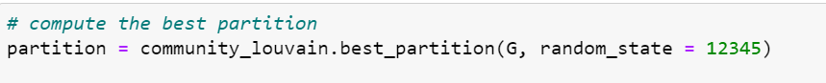
Please find below the documentation page for the Community package for your reference:
Community (Python-Louvain)

Colorlover
To install the package, run the below command in a Jupyter notebook and once the command runs successfully, restart the kernel.
!pip install colorlover
To import the package, run the following command in a Jupyter notebook
import colorlover as cl
The parameters used by the function are shown below:
Pos:
A Dictionary of Nodes
Labels:
list of labels of len(pos) to be displayed
Color :
color of nodes. If it is "None", the plotly’s default color is used.
Size:
Size of the dots representing the nodes
Opacity:
The Opacity value is between 0 and 1, defining the color opacity.
Below we can find the function implementation in the Game of Thrones case study:
Please find below the documentation page for the colorlover package for your reference:
Link
Happy Learning!

Practice Case Study

Practice Case Study

Know Your Faculty

Dr. Bradford Tuckfield
Data Science Consultant
Dr. Bradford Tuckfield is a Data Science Consultant at his own company, Kmbara, where he provides automated, data-centric solutions in domains like manufacturing, pharmaceuticals, marketing, and technology. He is also an author and has written books on data science, computer science, and algorithms, and works as an instructor at ViaX and Great Learning.
Dr. Bradford completed his Doctor of Philosophy (Ph.D.) from the Wharton School in Operations and Information Management. He comes from a background in mathematics and economics and has wide expertise in data science, including statistics, programming, and machine learning.
LinkedIn: https://www.linkedin.com/in/bradford-tuckfield-80565b25/ (Links to an external site.)Links to an external site.

Curated External Resources - Network Analysis
Please refer to this additional material if you want to know more about Graphs and Networks.
- Basics of networks: This article talks about the structure and different types of networks like directed, undirected, etc. https://www.ebi.ac.uk/training/online/courses/network-analysis-of-protein-interaction-data-an-introduction/introduction-to-graph-theory/graph-theory-graph-types-and-edge-properties/
- Overview of networks with python: This article emphasizes on the overview of networks and their applications in the industry with Python implementations. https://www.analyticsvidhya.com/blog/2018/04/introduction-to-graph-theory-network-analysis-python-codes/ (Links to an external site)
- Centrality measures in networks: This short video talks about the different centrality measures and their importance in the networks.
https://www.youtube.com/watch?v=NgUj8DEH5Tc
Happy Learning!

Unsupervised Learning

Unsupervised Learning

Data science and machine learning algorithmic techniques can be divided into three categories:
- Supervised Learning: The algorithm has prior data (labeled data) to learn from.
- Unsupervised Learning: The algorithm has no prior labeled data to learn from i.e., it learns from unlabeled data by finding patterns among examples and grouping them accordingly.
- Reinforcement Learning: The algorithm learns patterns or behaviors in a recursive manner by taking actions to maximize a certain reward, and uses feedback from the environment to learn the best action to take under the right circumstances in order to maximize that reward.
In the coming lecture, our focus will be on unsupervised learning.
Unsupervised Learning is a category of techniques that train computers to use a set of unlabeled / unseen data and learn by themselves. The algorithm is provided with a large volume of data and expected to identify hidden patterns. Since there's no prior information / label available for each data instance, there is no defined / correct outcome. The machines only need to determine if there are any patterns in the given data.
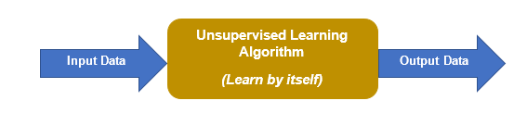

Unsupervised Learning is utilised in the following use cases:
- Clustering
- Association
- Dimensionality Reduction

Clustering:
In clustering, the key idea is to divide the data into groups such that each group shares similar properties and each group is as dissimilar as possible to the other groups.
Let us now try to understand clustering using a simple example:
An organization wants to make a marketing strategy for its new product. They want to segment the customers into different groups in order to target the right audience. They have made segments:
1. based on customer demographics like occupation, age and gender
2. based on income and spending habits
3. based on geographic locations of the customers
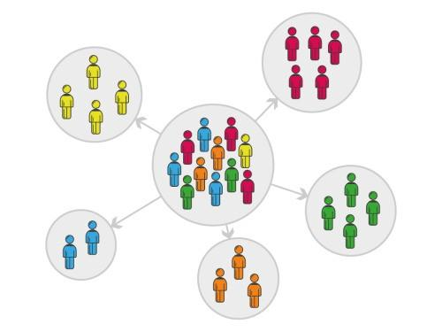
Image source

This is unsupervised learning. There was no labeled information about the people, just various features describing their characteristics such as age, gender, income etc. The algorithm simply found groups of people that may be similar to each other based on these features and organized them into these groups. Due to the absence of labels, we don't know what exactly these groups represent, just that the algorithm found the people in each group similar to the oth

Distance and Scaling Measures
Unsupervised learning algorithms use different distance measures or similarity / dissimilarity measures between each pair of observations to group data into different clusters. Points which are close to each other on that distance metric are likely to be grouped into the same cluster, while points far apart on that distance metric are likely to be members of different clusters. All this is done by computing a distance matrix which has distances between every pair of observations. There are different ways of calculating these distances, some of which are mentioned below:
Euclidean distance: Euclidean distance is calculated as the square root of the sum of the squared differences b/w two vectors.
Say there are two points P (x₁, y₁) and Q (x₂, y₂). The Euclidean distance between these two points would be calculated as:
d = √ (x₂ - x₁)² + (y₂ -y₁)²
Manhattan distance: Also called city block distance, it calculates the distance between two points by drawing an orthogonal, zig-zag grid between them.
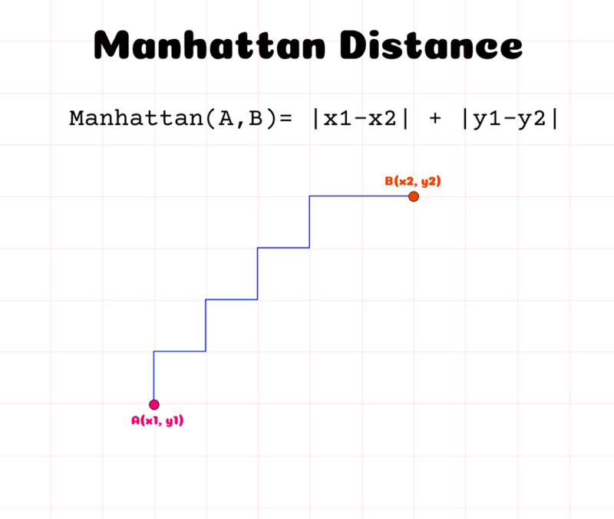
Image Source
Scaling:
Input variables in a dataset may have different units e.g. kilometers, hours, kilograms, etc. i.e. different scales. This difference in scales increases the difficulty in modeling, in turn resulting in an unstable model. Unless you scale the data, the importance of 1 km would be the same as 1 kg, which would be the same as 1 hr, the same as 1 cm, etc.
In other words, while 1000 gms and 1 kg mean the same thing, a quantity of 1000 ml from another feature is at a different scale as a number relative to 1000 g, than it is with respect to 1 kg. Unless both the weight (i.e. gms) and the volume (i.e. ml) are on the same scale, machine learning algorithms might give one of them more weightage than the other simply due to the number in that quantity. That in turn, diminishes the effect of the variable that has the smaller number (lower scale).
Thus, scaling the variables is an important step in machine learning models. By scaling the variables, we can ensure that the machine learning algorithm gives every variable a similar weightage in terms of its likelihood of contributing to the decision making of the algorithm, and that no single variable with a high numerical quantity as its value unnecessarily influences the algorithm's predictive power.
Normalization: One of the ways of scaling the data is so that all the values lie between 0 and 1. This is called Normalization. A value can be normalized as follows:
y = (x–min) / (max-min)
where,
- y: normalized version of the variable
- x: variable of interest
- min: minimum value of the variable x in this dataset
- max: maximum value of the variable x in this dataset
Standardization is another way of scaling the data, where the mean of the observations becomes 0 and the standard deviation is 1. A value can be standardized as follows:
y = (x-mean) / std_dev
where,
- y: standardized version of the variable
- x: variable of interest
- mean: average (arithmetic mean) of the variable x in the dataset
- std_dev: standard deviation of the variable x in the dataset

K-means Clustering
K-means Clustering is an unsupervised learning algorithm. Like other clustering algorithms, it tries to aggregate similar objects into groups called clusters. In K-means Clustering, K refers to the number of clusters required. The concept of a centroid, which is the geometric center of a cluster, is used to determine the clusters that K-means finds in the dataset.
Let’s understand this using an example. Suppose you go to a vegetable shop to buy some vegetables. There, you'll see different kinds of vegetables. One thing you may notice is that the vegetables will be arranged in a group of their type. The carrots and radishes will probably be kept together in one place, onion and garlic will probably be arranged in another place, potatoes will be kept together and so on. This arrangement resembles a group or a cluster, where each vegetable is kept within their kind of group, forming the clusters.
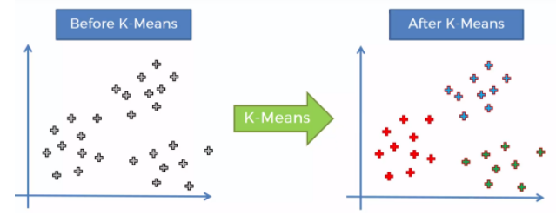

The image on the left is before clustering, where all the categories or groups appear to be mixed up (same color), while the image on the right is after clustering where groups of similar data points seem to be clustered together and depicted with different colors.
To human eyes, it can be difficult to analyze or understand a mixed-up group like the one represented by the image on the left. So we apply clustering techniques like K-means Clustering to convert this into a more visually distinct dataset with separate groups or categories of data.
Now that we have understood the basic rationale behind clustering, let's look into the working of K-Means Clustering specifically.
Working of K-Means Clustering
The steps involved in K-means Clustering are:
- Choose the number of clusters K
- Initialize the centroids
- Assign each data point to the closest centroid.
- Update the centroid by taking the mean of the cluster.
  - Repeat steps 3 and 4 until convergence i.e No discernible change in centroids is observed.
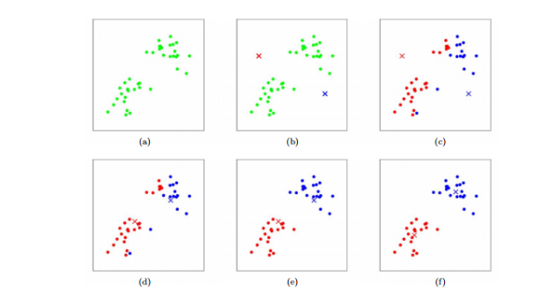
For step 3, to assign each data point to the nearest centroid, we use the distance between the centroid and the data point. This distance can be found using Euclidean distance.
The Euclidean distance d between two points (x1,y1) and (x2,y2), is defined as,
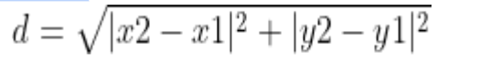
Therefore, K-means clustering uses the Euclidean distance to allocate each of the data points to its nearest cluster, so that the sum of squares within each cluster is minimum.
For step 4 we update the centroid using the mean value of all the points in the cluster, hence the name K-means clustering.
Example:
Let’s understand this with an example:
N={2,3,4,5,10,11,13,15} - Performing K-means on these points, all points on the x-axis .
Step 1: Choose K, K=2
Step 2: Initialize the centroids randomly
- c1=3
- c2=12
Note : As y=0 on the x-axis , d=|x2-x1|
Step 3.1: For each point calculate distance and assign it to the closest centroid
Data Point | Distance from C1=3 | Distance from C2=12 | Cluster Assigned
2 | 1 | 10 | c1
3 | 0 | 9 | c1
4 | 1 | 8 | c1
5 | 2 | 7 | c1
10 | 7 | 2 | c2
11 | 8 | 1 | c2
13 | 10 | 1 | c2
15 | 12 | 3 | c2
Cluster c1 contains {2,3,4,5}
Cluster c2 contains {10,11,13,15}
Step 3.2: Update the centroids
- c1=(2+3+4+5) / 4 = 3.5
- c2=(10+11+13+15) / 4=12.25
Step 3 should repeat until there is no change in the centroids.

Things to consider :
- It is always better to standardize/normalize the data points with any distance-based algorithm like K-means clustering, because different variables may have different scales, and that may affect the sum of squared error. Hence, it is a good practice to bring all the data points under one scale.
- We initialize centroids randomly, so different initializations may lead to different clusters. There is a possibility that the algorithm falls into a local optimum rather than the global optimum. So it's better to iterate with different initializations and select the one with the least sum of squared distances within clusters.

Evaluation Methods:
For K-means clustering we need a fixed value of K, and that should be known before performing the method. It is not a learned parameter, and we will have to figure it out. To find out the optimal K number, one method we can use is called the ELBOW method.
ELBOW Method:
In this method, we take different values of K i.e from 1 to the range required. For each value of K, we calculate the sum of squares within clusters, usually called WCSS (Within Cluster Sum of Squares). So we calculate the sum of squared distance between the centroids and the data points for each cluster, and do a summation of all the clusters. Then, we plot WCSS vs K - the plot shape looks similar to that of an elbow. As we see in the graph, as K increases the WCSS is going to decrease. The optimal point is at the elbow - after that as K increases, the fall in WCSS is not that significant. In the given example, K=7 appears to be the optimal value of K.

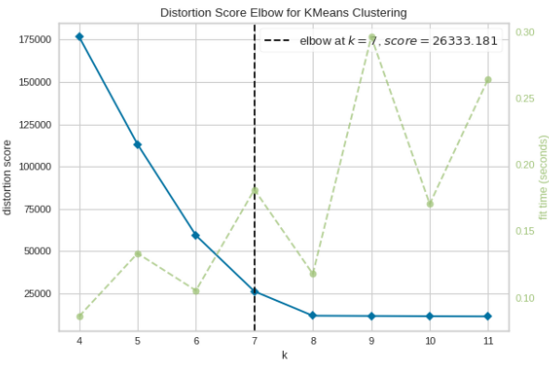

Source

Assumptions:
- K-means Clustering is limited to linear cluster boundaries: The fundamental model assumptions of K-means Clustering (points will be closer to their cluster center than to others), means that the algorithm will often be ineffective if the clusters have complicated geometries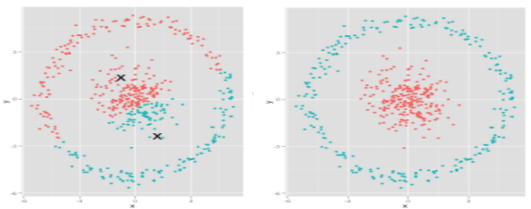
- All clusters are of the same size.
- Clusters have the same extent in every direction. This assumption would not be true in a dataset where different measurements are in different units.
- Clusters have similar numbers of points assigned to them.
Image Source

Applications:
- Document Clustering - Group similar documents together
- Customer Segmentation - Divide customers into similar grou

Gaussian Mixture Models
Gaussian Mixture Models (GMMs) are an unsupervised machine learning technique used for clustering data. K-means performs clustering taking only the mean of the data into consideration, but Gaussian Mixture Models use the mean as well as the variance of the data for clustering.
Gaussian Mixture Models assume that the underlying data represents a mixture of Gaussians, as shown in the image below.
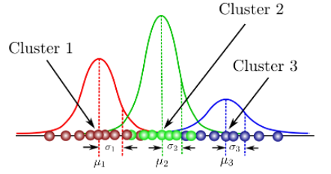
Gaussian Mixture Models are considered probabilistic models for representing normally distributed subpopulations within an overall population. The Gaussian Mixture Model tries to learn the parameters (mean, variance) of each Gaussian in the dataset to cluster the data points. The parameters mean () and variance (), of each Gaussian, are learned using the Expectation-Maximization (EM) algorithm.

How does the EM algorithm work?
The EM algorithm has 2 steps:
- The E-step
- The M-step
The E-Step and the M-Step are repeated until the parameters mean () and variance () converge.

E-step:
1. It will start by placing K Gaussians randomly with mean and variance for the kth Gaussian as shown below. The value of k is passed as a parameter.

2. Then for each Gaussian/cluster we calculate the cluster weights which show us how much each cluster is represented over all data points (each cluster's relative size) and can be given as,

3. Then for each datapoint assign a soft assignment,
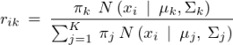
Where, is the probability that is generated from the kth cluster and K is the total number of clusters.

M-step:
After computing the soft assignments for the current iteration, we use it to update parameters - mean and variance.
First, we calculate the sum of probabilities of each data point for each cluster.
Let’s say we have a point , its probability vector can be given as
Where,
= probability of point i belonging to cluster 1
= probability of point i belonging to cluster 2
= probability of point i belonging to cluster k
This vector is calculated for each and every data point in the dataset.

Next, we calculate the sum of probabilities for all points belonging to a particular cluster. It can be mathematically represented as,
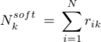

= sum of all probabilities for all points belonging to cluster k

Then, the cluster weights , show us how much each cluster is represented over all data points (each cluster's relative size). The cluster weight of each cluster is given by the ratio of the soft count over the total number of data points . It's mathematical representation can be given as,
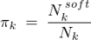
Now we re-estimate the mean of each cluster using the formula below,
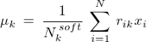
Where,
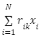= sum of all probabilities of cluster for which we are re-estimating the mean multiplied by its true value

Now we re-estimate the variance , of each cluster using the formula below,
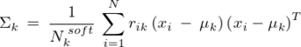
Finally, we repeat the E-step and the M-step until the estimates of parameters converge.

Convergence
We use the below function, called log-likelihood, to decide the convergence of parameters.
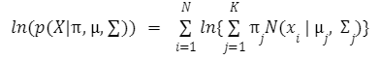

When the value of this formula does not improve by a tolerance/threshold level then we can say that the algorithm has converged.
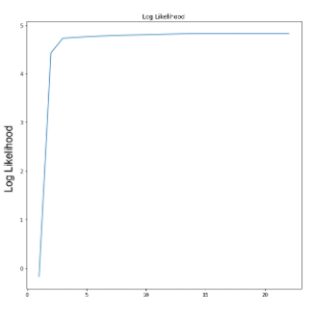
In the above graph, we can see that the change in value after 15 iterations is very small, hence we can say that the values have converged and the model has fit successfully.
The below graphic is a representation of the Gaussian Mixture Model learning the parameters at each iteration to resemble the true distribution.


Hierarchical Clustering
Hierarchical Clustering is one of the many types of clustering algorithms.
There are 2 types of hierarchical clustering:
- Agglomerative clustering
- Divisive clustering
Let's see how each of these types of algorithms work:

Agglomerative Clustering
It is a bottom-up clustering method.
Step 1: Let’s say we have N data points, then each of the points will be considered as N different clusters.
Step 2: Find two clusters that are closest among the N clusters (from step 1) and combine them into a single cluster. This will result in having N-1 clusters now.
Step 3: Find the next 2 closest clusters and combine them into a single cluster and we have N-2 clusters now. This will be continued till we have only one cluster containing all the data points. The below graphic demonstrates this process.

Source

To calculate the distance between two clusters, we use the linkage method. There are different types of linkages that can be used to compare the distance between two clusters:
- Complete-linkage: The distance between two clusters is defined as the longest distance between two points in each cluster.
- Average-linkage: The distance between two clusters is defined as the average distance between each point in one cluster to every point in the other cluster. Average-linkage and complete-linkage are the two most popular distance metrics in hierarchical clustering.
- Centroid-linkage: The distance between the centroids of two clusters. It finds the centroid of cluster 1 and centroid of cluster 2 and then calculates the distance between the two before merging.
- Single-linkage: The distance between two clusters is defined as the shortest distance between two points in each cluster. This linkage may be used to detect high values in your dataset which may be outliers as they will be merged at the end.

Divisive Clustering
In contrast to Agglomerative clustering, divisive clustering is a top-down clustering method. We work backward in this method.
Step 1: All the points are grouped together into a single cluster.
Step 2: The single cluster is split into two different clusters.
Step 3: Step 2 is repeated till the number of clusters is equal to the number of data points.

Dendrogram
A dendrogram is a diagram that shows the hierarchical relationship between objects. It is used to see the output of hierarchical clustering. The below graphic explains, how the dendrogram is being formed as the clustering happens.

Source

DBSCAN

Density-Based Spatial Clustering of Applications with Noise (DBSCAN)
DBSCAN is another type of clustering algorithm. It works based on the concept of density difference. Density is interpreted as the concentration of the samples present in a region. The algorithm differentiates between high and low-density regions and clusters the points accordingly.
There are two parameters to the algorithm which is used to define the term dense.
epsilon (eps): It specifies how close points should be to each other to be considered as part of a cluster.
Two points are considered neighbors if the distance between the two points is below the threshold epsilon.
For example, let's say we are defining epsilon = 5, then all the points having a distance less than 5 will be considered a single cluster. The Euclidean distance is calculated by default but we can also use distance measurements.
minPoints: The minimum number of points to form a dense region. For example, if we set the minPoints parameter as 4, then we need at least 4 points to form a dense region.
Let's understand how the algorithm works by considering the data points shown in the below image:

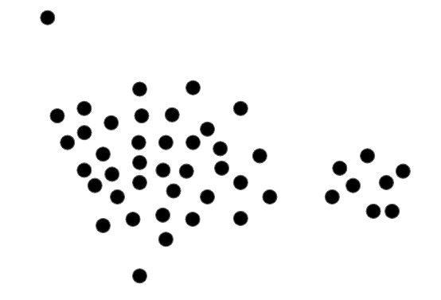

Step 1: We can take any random point and draw a circle around it. The radius of the circle (epsilon) should be passed as a parameter.
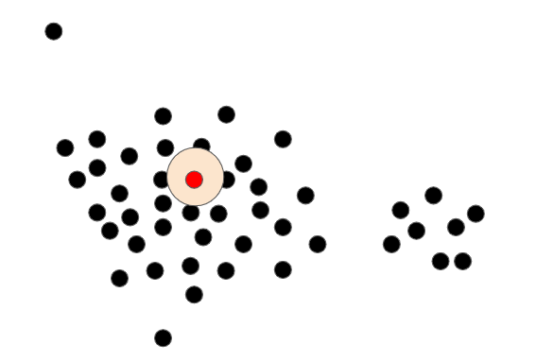
Step 2: The above step should be continued for all the data points present
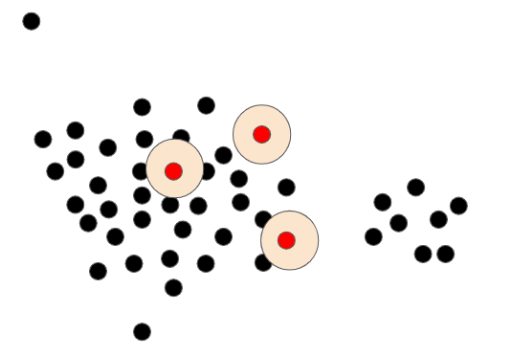
Step 3: Identifying Core points. To Classify a point as a Core, it should satisfy two criteria. The point which we are considering (red) should at least be
- surrounded by the minimum number of points specified (minpoints)
- within a circle of radius (epsilon)
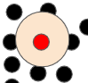

Example: We will take a point and draw a circle (epsilon=5) around it and minPoints as 4 . In the first image above we can find the conditions being satisfied as the circle is overlapping at least 4 points but in the second image the condition is not satisfied as the overlapping is less than 4, such points are called non-core points.
Step 4a: The below image shows core points (red) and non-core points (black). We randomly pick a Core point and assign it to a cluster.
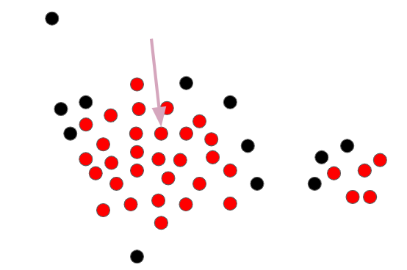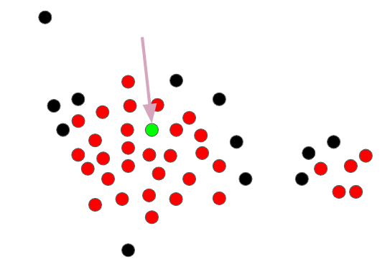
Step 4b: The core points that are within the radius of epsilon are all added to the cluster. This continues until there is no core point in the radius of epsilon. Initially, it adds only the core points to the cluster.
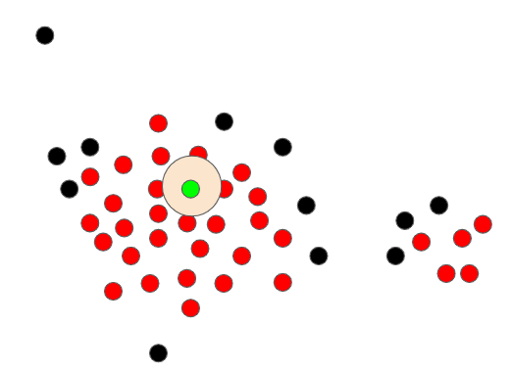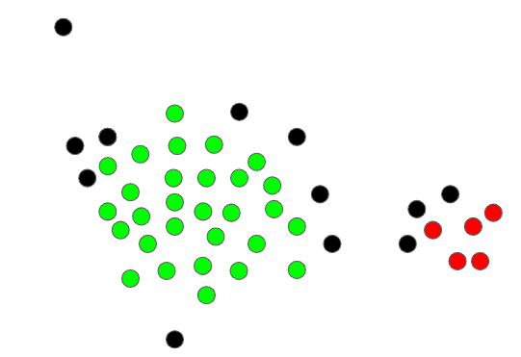
Step 5: When the cluster reaches a non-core point and if it falls in the epsilon range, it will be added to the cluster but can't be used to extend the cluster.
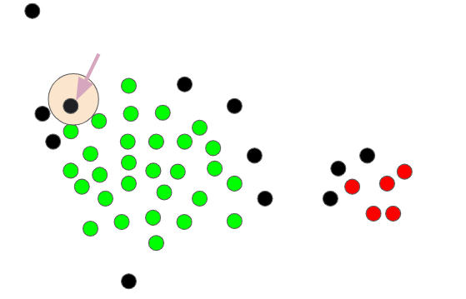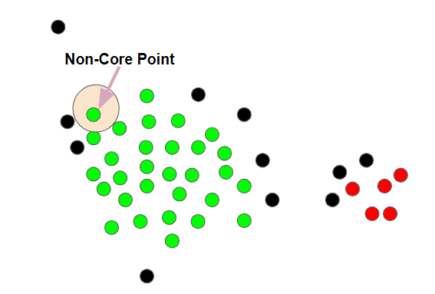
Step 6: Once a cluster is completely formed, then a new core point will be chosen to form another cluster and the process continues. There will be some points that will not be a part of any cluster and they will be treated as outliers.
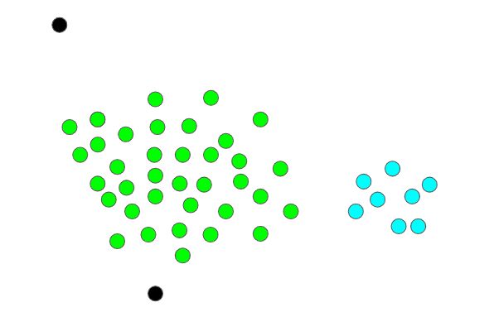
In the above images, the green represents points that belong to the first cluster, blue points represent points that belong to the second cluster whereas the black points represent outliers.

Tab 5

Practice Application

New Package Introduction - Unsupervised Learning: Scikit-Learn

Scikit-Learn
Scikit-learn is an open-source Python library that is built upon NumPy, SciPy, and Matplotlib which is typically used in machine learning projects. Scikit-learn is focused on machine learning tools including mathematical, statistical, and general purpose algorithms that form the basis for many machine learning technologies by providing functionality for dimensionality reduction, feature selection, feature extraction, ensemble techniques, and inbuilt datasets. Scikit-learn is a top choice of academic and industrial organizations for carrying out a variety of tasks because of its effectiveness and adaptability.
The essential features of scikit-learn to simplify machine learning includes:
- Unsupervised Learning Algorithms: This group of algorithms includes unsupervised neural networks, principal component analysis, cluster analysis, and factoring.
- Feature Extraction: Scikit-Learn allows you to extract features from both text and images.
- Dimensionality Reduction: With the help of this feature, the number of attributes in the data can be minimized for later feature selection, visualization, and summarization.
- Clustering: This feature allows the grouping of unlabeled data.
- Algorithms for Supervised Learning: There is an extremely high chance that any supervised machine learning algorithm you have heard of is included in the scikit-learn library. Such supervised learning algorithms are available in the scikit-learn toolkit and include generalized linear models, such as linear regression, decision trees, support vector machines, and Bayesian techniques. You will learn supervised learning techniques in the coming weeks.
- Cross-validation: Scikit-learn can be used to test the accuracy and validity of supervised models using unseen data.
- Ensemble methods: The predictions of various supervised models can be integrated. by using this feature.

Library Installation
The library usually comes pre-installed with Anaconda. So, you can directly import the library to your notebook. However, if you face any issue while importing the library, you can try to install it by running the below command in your Jupyter Notebook:
!pip install scikit-learn
Once the installation is completed successfully, restart Jupyter and try import the library again.
Now, Let’s go through some of the common functions used by the Scikit-learn library:
1) sklearn.preprocessing.StandardScaler
Each feature or variable is scaled to unit variance once the mean has been removed by StandardScaler. This process is carried out independently based on features. Since StandardScaler involves the estimation of the empirical mean and standard deviation of each feature, outliers can have an impact on it (if they are present in the dataset).
from sklearn.preprocessing import StandardScaler
scaler = StandardScaler()
data_scaled = pd.DataFrame(scaler.fit_transform(data))
In the above code, we are importing Standard Scaler (first line of code), initializing it (second line of code), applying it on my data and storing the output in another variable called data_scaled (third line of code).
You can refer to the standard scalar sklearn documentation for a better understanding of the parameters and attributes here.

2) sklearn.cluster.KMeans
The K-Means algorithm clusters the data by trying to separate samples into n groups by minimizing a criterion known as the inertia or within-cluster sum-of-squares (see below). This algorithm requires the number of clusters to be specified. It scales well to large numbers of samples and has been used across a large range of application areas in many different fields.
from sklearn.cluster import KMeans
kmeans = KMeans(n_clusters=3)
kmeans.fit(data_scaled)
The above code is performing the K-means clustering with having 3 clusters on the data frame data_scaled.
You can refer to the K-Means sklearn documentation for a better understanding of the parameters and attributes here.

3) sklearn.metrics.silhouette_score
The silhouette score measures how effectively samples are clustered with other samples that are similar to them in order to assess the quality of clusters produced by clustering algorithms like K-Means. Each sample of various clusters gets a Silhouette score.

To compute Silhouette scores we import this metric from sklearn by using the below code line:
from sklearn.metrics import silhouette_score
# Predicting on the data_scaled
preds = kmeans.fit_predict((data_scaled))

# Calculating silhouette score
score = silhouette_score(data_scaled, preds)
In the above code, we are calculating the silhouette_score on the data and its predictions. For more understanding refer to this source.
4) sklearn.decomposition.PCA
High-dimensional data can be made simpler through the use of principal component analysis (PCA), while still preserving trends and patterns. It accomplishes this by compressing the data into fewer dimensions that act as feature summaries.
Importing PCA from sklearn by using the below code line:
from sklearn.decomposition import PCA
# Initializing PCA function with n components
pca = PCA(n_components=n, random_state=1)

# fit_transform PCA on scaled data
data_pca = pd.DataFrame(pca.fit_transform(df_scaled))
Here, we are creating the object for the PCA and then fitting it on the data data_scaled, storing the results into another variable. You can refer to the PCA sklearn documentation for a better understanding of the parameters and attributes here.
5) sklearn.preprocessing.LabelEncoder
Label encoding is the process of transforming labels into a numeric form so that they may be read by machines. The operation of those labels can then be better determined by machine learning techniques. It is a significant supervised learning pre-processing step for the structured dataset.
Encoding the variable from sklearn by using the below code line:
from sklearn.preprocessing import LabelEncoder
ln = LabelEncoder()
You can refer to the LabelEncoder sklearn documentation for a better understanding of the parameters and attributes here.

6) sklearn.manifold.TSNE
T-distributed Stochastic Neighbourhood Embedding (tSNE) is an unsupervised Machine Learning algorithm. It has become widely used in data science to visualize the structure of high-dimensional data in 2 or 3 dimensions.
Importing TSNE from sklearn by using the below code line:
from sklearn.manifold import TSNE
# Initializing T-SNE function with 2 components
tsne = TSNE(n_components=2, random_state=1, perplexity=35)

tsne_data = tsne.fit_transform(data)
Here, we are creating the object for the TNSE and then fitting it on the dataframe data, storing the results into another variable. You can refer to the TSNE sklearn documentation for a better understanding of the parameters and attributes here.

7) sklearn.cluster.AgglomerativeClustering
Agglomerative clustering uses a bottom-up approach, wherein each data point starts in its own cluster. These clusters are then joined greedily, by taking the two most similar clusters together and merging them.
Performing hierarchical clustering, computing cophenetic correlation, and creating dendrograms from sklearn by using the below code line:
from sklearn.cluster import AgglomerativeClustering
# Initializing Agglomerative Clustering
model = AgglomerativeClustering(n_clusters=3, affinity="euclidean", linkage="ward",)

# Fitting on PCA data
model.fit(data_pca)
Here, Initializing Agglomerative Clustering with distance as Euclidean, linkage as a ward with clusters=3. We are fitting the Agglomerative Clustering model on the pca data. You can refer to the Agglomerative clustering sklearn documentation for a better understanding of the parameters and attributes here.
8) sklearn.mixture.GaussianMixture
Subpopulations within a larger population that are normally distributed are represented using Gaussian Mixture models. Mixture models have the benefit of not requiring knowledge of the subpopulation to which a data point belongs. It enables the model to automatically learn the subpopulations.
Importing Gaussian Mixture from sklearn by using the below code line:
from sklearn.mixture import GaussianMixture
# Initializing Gaussian Mixture Model
gmm = GaussianMixture(n_components=5, random_state=1)

# Fitting and predicting Gaussian Mixture Model on data_pca
preds = gmm.fit_predict((data_pca))
In the above code, we are initializing Gaussian Mixture Model with a number of clusters as 5 and random_state=1. You can refer to the Gaussian Mixture sklearn documentation for a better understanding of the parameters and attributes here.

Know Your Faculty

Dr. Bradford Tuckfield
Data Science Consultant
Dr. Bradford Tuckfield is a Data Science Consultant at his own company, Kmbara, where he provides automated, data-centric solutions in domains like manufacturing, pharmaceuticals, marketing, and technology. He is also an author and has written books on data science, computer science, and algorithms, and works as an instructor at ViaX and Great Learning.
Dr. Bradford completed his Doctor of Philosophy (Ph.D.) from the Wharton School in Operations and Information Management. He comes from a background in mathematics and economics and has wide expertise in data science, including statistics, programming, and machine learning.
LinkedIn: https://www.linkedin.com/in/bradford-tuckfield-80565b25/ (Links to an external site.)Links to an external site.

Clarification Note - Genomic Data Clustering
The frequency table displayed is the following:
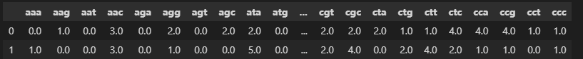
In the video, at 3:20, the instructor says “the PCA table is going to have one row for every column of the frequency table".
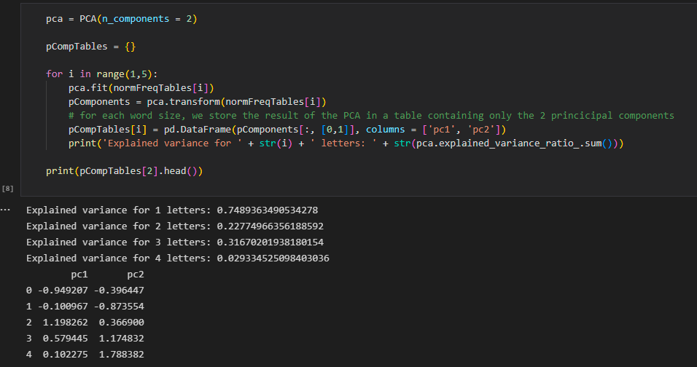
Here, this refers to the fact that for every entry/row in the frequency table we calculate it. But, the other part of the explanation may be a little confusing.
At first, we scale the ‘freqTables’ into ‘normFreqTables’. If you print 'normFreqTables[1] or normFreqTables[2]', you will be able to see the kind of data we are fitting the PCA algorithm into:
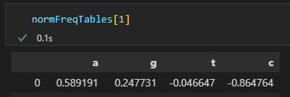
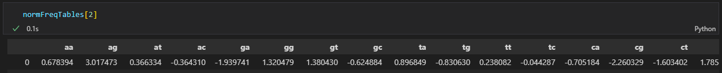
We fit PCA to the above data and then, the ‘pCompTables’ shows the value of components for each entry in the corresponding normFreqTables.
So that means pCompTables[1] is the Principal Component table that we get from normFreqTables[1], and similarly, we calculate pCompTables[2] using normFreqTables[2].

New Package Introduction - Unsupervised Learning: Scikit-Learn-Extra

Scikit-Learn-Extra
The scikit-learn-extra is a Python module for machine learning that extends scikit-learn. It includes algorithms that are useful but do not satisfy the scikit-learn inclusion criteria, for instance, due to their novelty or lower citation number.

Library installation
The latest release can be installed with conda, by running the below command in Anaconda Prompt (or terminal for Mac).
conda install -c conda-forge scikit-learn-extra
Alternatively, we can install using the pip command
pip install scikit-learn-extra

User Guide
This library helps us to implement the K-Medoids algorithm on the data. K-Medoids can be more robust to noise and outliers in comparison to K-Means as it will choose one of the cluster members as the medoid while K-Means uses the mean which can get affected by the outliers in the data.
To import the K-Medoids function,
from sklearn_extra.cluster import KMedoids
model = KMedoids()

Parameters:
metric: distance metric to be used (default: ‘euclidean’)
n_clusters: number of clusters to be formed and hence the number of medoids (one per cluster) (default value: 8)
init: ‘heuristic’ method used for medoid initialization
max_iter: maximum number of the algorithm’s iterations to be performed when fitting the data.

Example
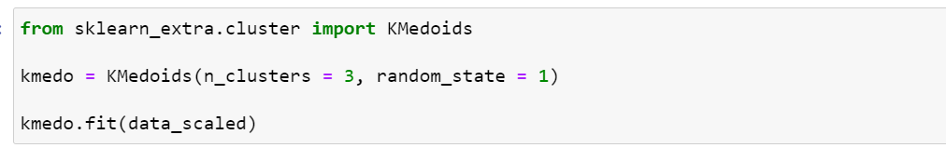
In the above code, we are implementing the K-Medoids clustering algorithm with 3 clusters having random state 1.
For your reference, go through this documentation page of the Scikit-Learn-Extra package.

Curated External Resources - Unsupervised Learning
These are curated external links to articles, and videos, that provide an opportunity to augment the learning, provided by the live lecture, on various clustering algorithms.
- K-Means Algorithm: This is a centroid-based clustering algorithm that tries to minimize the distance of the points within a cluster with their centroid. To know more about the K-Means clustering, its applications, and its implementation in python, please refer to this article. https://www.analyticsvidhya.com/blog/2019/08/comprehensive-guide-k-means-clustering/
- K-Medoids (PAM) Algorithm: This is an alternative to K-Means clustering which focuses on the drawbacks of K Means. It is robust to outliers. To know more about the algorithm, please refer to this video. https://youtu.be/GApaAnGx3Fw
- GMM Clustering: This algorithm assumes that there are some Gaussian distributions and each of them represents a cluster. It also tries to overcome the drawbacks of K-Means. To know more about GMM clustering and its implementation in python, please refer to this article. https://www.analyticsvidhya.com/blog/2019/10/gaussian-mixture-models-clustering/
- Hierarchical Clustering: This algorithm creates clusters in an ordered manner i.e. top to bottom or bottom to top. It groups similar objects into clusters. To know more about the Hierarchical clustering algorithm and its implementation in python, please refer to this article. https://www.kdnuggets.com/2019/09/hierarchical-clustering.html
- DBSCAN: This is a density-based clustering algorithm that aims to create clusters based on the density of a region. It is very robust to outliers. To know more about the DBSCAN algorithm and its implementation in python, please refer to this article. https://www.kdnuggets.com/2020/04/dbscan-clustering-algorithm-machine-learning.html
Happy Learning!

Tab 6

Practice Project: Data Analysis and Visualization

