Foundations of AI

Course Outline
Overview:
Welcome to the course on Foundations of AI. This course will aim to build the programming and statistical foundations necessary for the rest of the program. It will cover the concepts, tools, and techniques that will be required to effectively learn and implement the ideas that will be covered in subsequent courses.
Objective:
The primary goal of this course is to ensure that you can work with data and extract observations and insights from it. This course will also focus on some fundamental statistical concepts required to draw meaningful inferences from data. By the end of this course, you should have a good foundation in both Python and statistics that is needed to better appreciate the subsequent courses in this program.

Topics Covered
Week | Module | Name of the topic
1 | Python for Data Science | - Numpy arrays and Functions  - Accessing and Modifying Numpy arrays  - Saving and Loading Numpy arrays  - Pandas Series (Creating, Accessing, and Modifying Series)  - Pandas DataFrames (Creating, Accessing, Modifying, and combining DataFrames)  - Pandas Functions  - Saving and Loading datasets using Pandas
1 | Python for Visualization | - Data Loading and Overview  - Histogram and Bar Plot  - Box Plot and Violin Plot  - Line Plot and Joint Plot  - Scatter Plot, Pair Plot, and Heatmap  - Strip Plot, Swarm Plot, Cat Plot  - Plotly
2 | Inferential Statistics | - Introduction to Inferential Statistics  - Fundamentals of Probability Distributions  - Foundations of Sampling and Inference  - The Central Limit Theorem  - Estimation
2 | Hypothesis Testing | - Introduction to Hypothesis Testing and Formulation.  - Basic concepts of hypothesis testing.  - Performing Hypothesis Testing  - One-tailed vs Two-Tailed tests  - Hypothesis testing steps

Learning Material Breakdown*:
Week | Module | No. of Videos | Total Duration | No. of Quiz Assessments | No. of TYU's
1 | Python for Data Science | 34 | ~4.5 hours | 1 | 34
2 | Statistics for Data Science | 22 | ~4.2 hours | 1 | 22
*excluding optional content
Project Assessment:
You need to submit a project at the end of this course.
The project is about a Food aggregator company that collects the data of orders that are placed on their smartphone app, 'Foodhub'. They want to analyze the data to get a fair idea about the demand for different restaurants, which will help them enhance their customer experience. The objective here is to perform the data analysis to find answers to these questions that will help the company improve its business.

Know Your Faculty

Matthew Graziano
Senior Data Science Manager, Progressive Insurance
Experienced Data Scientist with a demonstrated history of working in the insurance industry. Skilled in Management, Data Analytics, Python, R, and data strategy.
Matthew Graziano is heading a team comprising of full stack data scientists and engineers to develop predictive models, APIs, and applications for Progressive's service. He has played a crucial role in Progressive's response to the changes in driving behavior and economic conditions due to the COVID-19 pandemic, including lockdowns, work from home, supply chain disruptions, etc. Under his leadership, the team has enhanced the existing models resulting in sustained growth and profitability. His efforts have ensured an aligned response across various business units such as pricing, claims, control, product, and R&D to the changing situation.
Under his leadership, Matthew Graziano has helped in bringing about a cultural shift in the organization towards a probabilistic rate-making approach. He has encouraged decision-makers to consider the variations in loss estimates and has emphasized the importance of providing stable rates over time to ensure sustained growth and profitability in targeted business segments. He has also taken an active role in providing developmental, mentoring, and technical training opportunities to analysts, interns, and data scientists. He has focused on identifying their strengths, curating mission statements, and helping individuals plan strategically to achieve their personal and career goals. Additionally, he has influenced senior leaders and product managers to adopt a global rate-making strategy and leverage predictive models in pricing decisions. He has done this by effectively communicating the technical intricacies of the models and translating them into business insights.


Dr. Abhinanda Sarkar
Faculty Director, Great Learning
Dr. Abhinanda Sarkar is the Academic Director at Great Learning for Data Science and Machine Learning Programs. Dr. Sarkar received his B.Stat. and M.Stat. degrees from the Indian Statistical Institute (ISI) and a Ph.D. in Statistics from Stanford University. He has taught applied mathematics at the Massachusetts Institute of Technology (MIT), been on the research staff at IBM, led Quality, Engineering Development, and Analytics functions at General Electric (GE), served as Associate Dean at the MYRA School of Business, and co-founded OmiX Labs.
Dr. Sarkar’s publications, patents, and technical leadership have been in applying probabilistic models, statistical data analysis, and machine learning to diverse areas such as experimental physics, computer vision, text mining, wireless networks, e-commerce, credit risk, retail finance, engineering reliability, renewable energy, and infectious diseases, His teaching has mostly been on statistical theory, methods, and algorithms, together with application-oriented topics such as financial modeling, quality management, and data mining.
Dr. Sarkar is a certified Master Black Belt in Lean Six Sigma and Design for Six Sigma. He has been a visiting faculty at Stanford and ISI and continues to teach at the Indian Institute of Management (IIM-Bangalore) and the Indian Institute of Science (IISc). Over the years, he has designed and conducted numerous corporate training sessions for technology and business professionals. He is a recipient of the ISI Alumni Association Medal, the IBM Invention Achievement Awards, and the Radhakrishnan Mentor Award from GE India.

Learning Instruments
The following is an overview of the instructional and assessment-oriented learning instruments that will be part of the learning journey during this course.

- Video Lectures: The recorded video lectures form the foundational learning material in this course. If you do not have any background in programming or do not have a working knowledge of Python for data analysis, it is strongly recommended that you go through all the video lectures in the order that they are present in the course.
- Test Your Understanding: These are practice quizzes that will be interspersed with the video lectures, to nudge you to test your understanding of the key concepts and takeaways from the videos watched. They are a useful instrument to regularly understand your conceptual proficiency over the learning material.
- Reference Notebooks and Datasets: This is the hands-on material, such as code notebooks and datasets, that will be referred to by the faculty in the recorded video lectures. You may utilize this material to understand how the concepts and topics covered in the video lectures are actually implemented in code.
- Lecture Slides: The slides that will be used by the faculty can be found for reference under the 'Lecture Slides' text heading in the section containing the video lectures.
- Practice Case Studies: These are additional case studies, which represent detailed and comprehensive problem-solving exercises. They apply the concepts and ideas taught in the video lectures as a means to solve practical business problems. These practice case studies will help you understand the Python implementation of solutions, practice data interpretation, and generate insights relevant to the problem at hand.
- Practical Exercises: These are simple hands-on notebooks that directly show how certain concepts from the video lectures are implemented in Python code. You may utilize these for additional hands-on practice.
- Additional / Reference Material: These are curated external links to books, articles, open-source video content, and research papers, that provide an opportunity to augment the learning provided by the faculty in the video lectures, and gain an additional conceptual/implementational perspective.
- Practice Hands-on Quizzes: These are optional hands-on quizzes, with questions focused on the Python implementation of the concepts you will have learned in the video lectures. They provide a way to test your progress in terms of internalizing the ideas presented in the form of code. These are optional quizzes, and will hence not carry any weightage towards your final score in this course.
- Frequently Asked Questions (FAQs): This curated FAQ list provides some commonly-asked questions and answers from previous iterations of the program. They represent a direct way of internalizing the key takeaways from the video lectures and the conceptual trains of thought in a simple Q&A format.
- Optional Sections: There are optional sections for both weeks containing video lectures, practice quizzes, and other associated material. These sections will give you an opportunity to explore specific topics in greater depth and offers advanced study and a deeper understanding of concepts. These are completely optional and won't be required to attempt the quiz or project assessments in this course.
- Mentor Learning Sessions (MLS): There will be two Mentor Learning Sessions in this course, one for each of the two weeks - Week 1: Python for Data Science and Week 2: Statistics for Data Science. The session plan and all the supporting material to be used in these sessions will be made available at the start of the respective week. It is a good practice to come prepared for these sessions with a list of questions you wish to ask in the session. This is best achieved by internalizing the ideas covered and the material provided for all the recorded video lectures in the week, as well as reviewing the material released in advance for these Mentor Learning Sessions.
MLS | Topic | Case Study
1 | Python for Data Science | Uber Data Analysis
2 | Statistics for Data Science | Medicon Dose Testing
 |  | Mobile Internet Usage Analysis

- Quiz Assessments: There will be two quiz assessments in this course, one for Week 1: Python for Data Science, and one for Week 2: Statistics for Data Science. They will consist of 15 marks each and will have a time limit of 60 minutes for quiz completion.
- Project Assessment: There will also be one hands-on project assessment as part of this course, consisting of a total of 60 marks. The problem statement and material needed to start attempting the project will be made available as part of the Week 2 content. The project will be in the form of a "templatized" notebook, with certain pre-filled code blocks provided in various sections. The idea behind this is to ensure the focus of these project assessments is not on the syntactical details of Python programming, but rather on the business logic of the problem and how each code block contributes to the overall solution-building exercise being implemented in the Python notebook.

Overview - Python for Data Science

WEEK 1 OVERVIEW
In this week's module, we will dive into two fundamental libraries extensively employed in Data Manipulation: NumPy and Pandas. These libraries serve as fundamental building blocks for data manipulation, analysis, and processing tasks. We will also explore various visualization tools to enhance our data summary and visualization capabilities, with a focus on the widely used Python libraries, Matplotlib, Seaborn and Plotly.

- NumPy arrays and Functions
- Accessing and Modifying NumPy arrays
- Saving and Loading NumPy arrays
- Pandas Series (Creating, Accessing, and Modifying Series)
- Pandas DataFrames (Creating, Accessing, Modifying, and Combining DataFrames)
- Pandas Functions
- Saving and Loading datasets using Pandas
- Data Loading and Overview
- Histogram, Box Plot and Bar Plot
- Line Plot, and Scatter Plot
- Joint Plot, Violin Plot, and Strip Plot
- Swarm Plot, Cat Plot, and Pair Plot
- Heatmaps, and Customizing of Plots
- Plotly

Week | Module | No. of Videos | Total Duration | No. of Practice Quizzes | No. of Graded Quizzes | No. of TYUs
1 | Python for Data Science | 34 | ~4.5 hours | 3 | 1 | 34

By mastering the concepts and techniques covered in this module, you will acquire essential skills in using NumPy, Pandas, Matplotlib, Seaborn and Plotly for data manipulation, analysis, and visualization. These skills will empower you to efficiently work with data in various real-world Data Science scenarios.
Power Ahead!

Quick Note #1
1. The preceding Pre-work course will have given you a basic understanding of Python programming, and is a prerequisite for you to be able to internalize the upcoming material.
If you do not have a background in programming or have never coded in Python before, then it is highly recommended that you first complete the Pre-work before proceeding into this course.
2. We would recommend that you manually change the resolution of the video to 720p or 1080p to avoid any video blur issues. (Please refer to the image below for changing resolution)

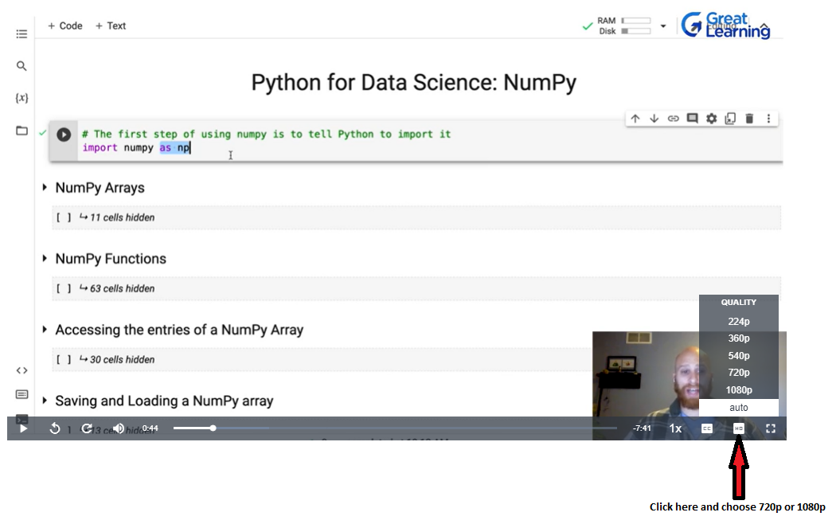
3. All the videos come with subtitles in the English language. (Please refer to the image below to enable subtitles for the video)
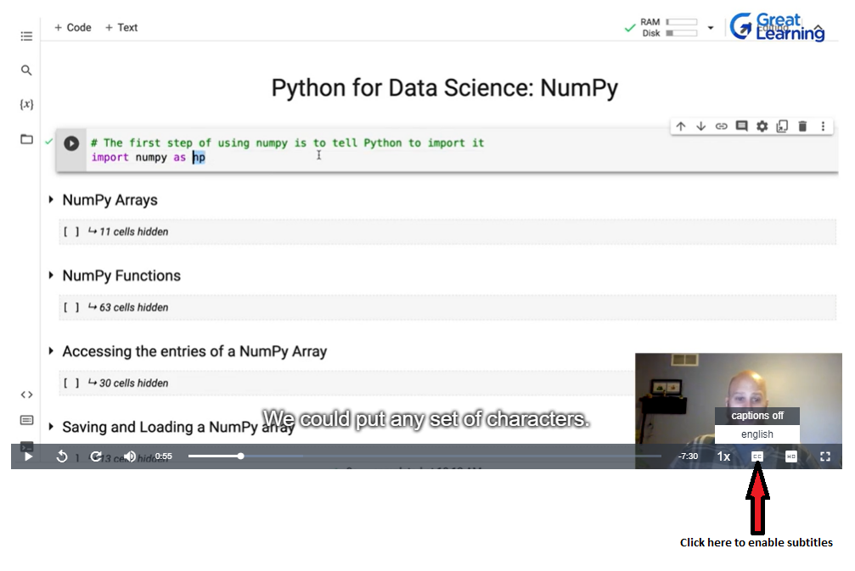
4. We recommend you increase or decrease the playing speed of the videos if you find the videos too slow-paced or fast-paced respectively. (Please refer to the image below to adjust the playing speed of the video)
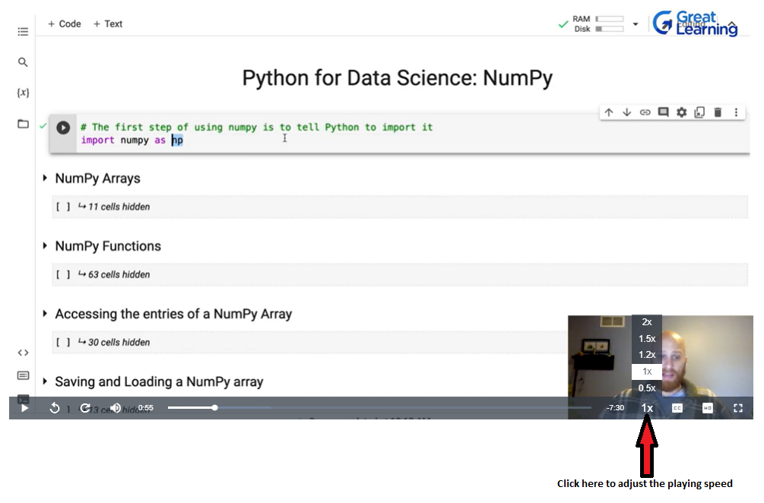
Please note that at some places in the video lectures, you might feel that the professor is going fast at times while teaching a concept. We would recommend you slow down the speed of the video manually to 0.5x or replay that part to gain a better understanding of the concept.

Happy Learning!

Week 1 - Video Lecture Materials
The following materials are highly recommended to be downloaded as these files are used in the lecture videos so that you can work simultaneously with the faculty while watching the video content.

Lecture Video Notebooks and Datasets:
Python_for_Data_Science_NumPy.ipynb
Pandas_for_Data_Science_Pandas.ipynb
Data_Visualization_with_Python.ipynb
StockData.csv
StockData.xlsx
Automobile.csv
Lecture video notebooks are the same notebooks that faculty have used while teaching the concepts in the lecture videos. By downloading these notebooks and datasets, you can work along with the professor through the video content.

Images:
Box_Plot.png
Skewed_Box_Plot.png
Line_Plot.png
The above images are used in the lecture video notebooks. Kindly download the images and save it in the same working directory to avoid errors while running the notebooks.

How to open an .ipynb file in Google Colab
Download a Jupyter Notebook with the '.ipynb' extension from Olympus. For example:
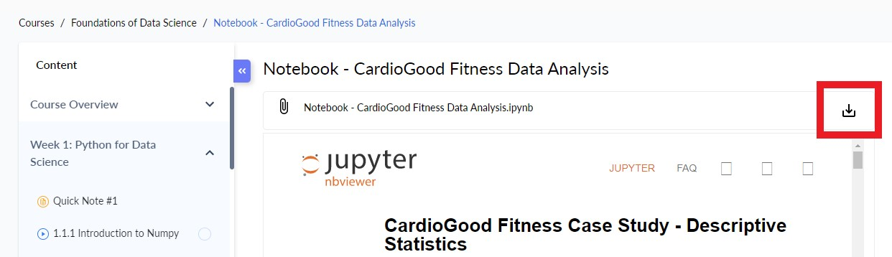
Click on the highlighted button to download the file
Follow the steps below to open the .ipynb file in Google Colab:
1. First open a browser and sign-in into your GMAIL account
2. Open your Google drive

3. Upload the downloaded file into your Google drive. To do this operation click on New as shown in the below image
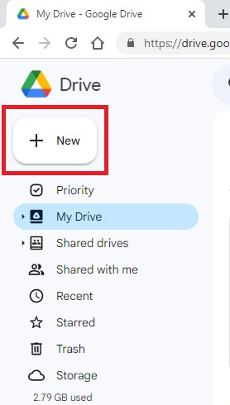

4. Click on File upload
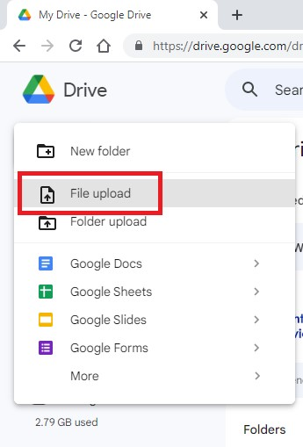

5. Navigate to the folder where your Jupyter Notebook(.ipynb file) from Olympus was downloaded to. Usually, the file will be downloaded to your default download folder named 'downloads'. Select the file and click on Open as shown below
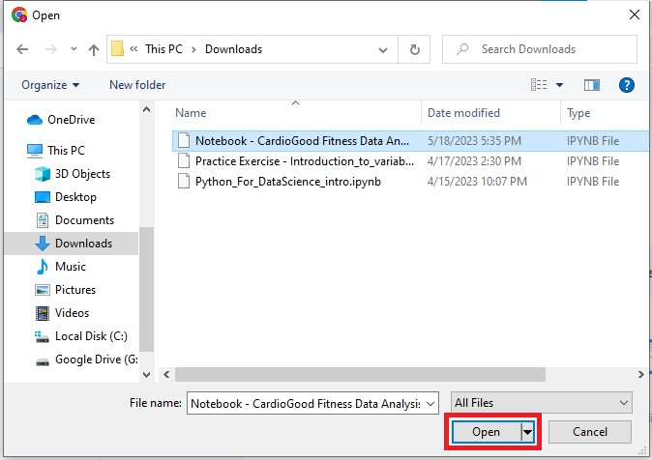

6. The file will be uploaded to the Google Drive once you do the above step. You can see the file in your Google Drive as shown in the below image
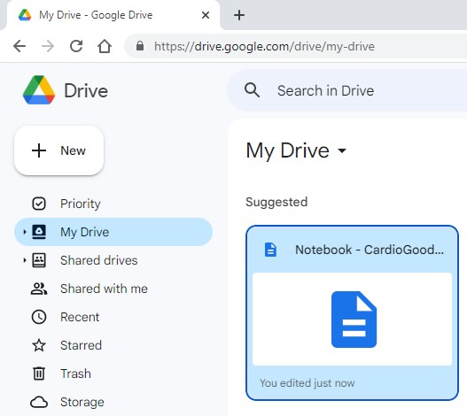

7. To open the .ipynb file in Google Colab, right click on the file and click on Open with, this will show the Google Colaboratory option as shown below
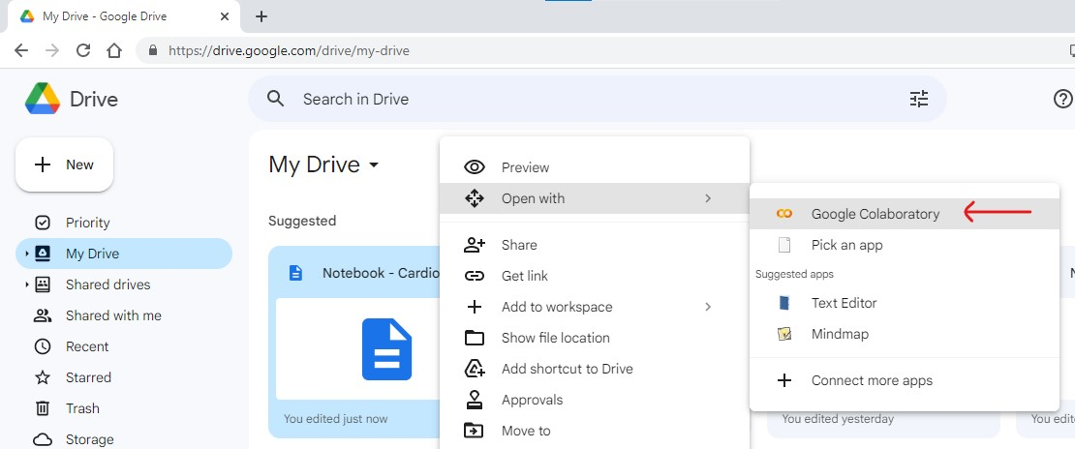

8. Click on Google Colaboratory to open the file in an adjacent tab:
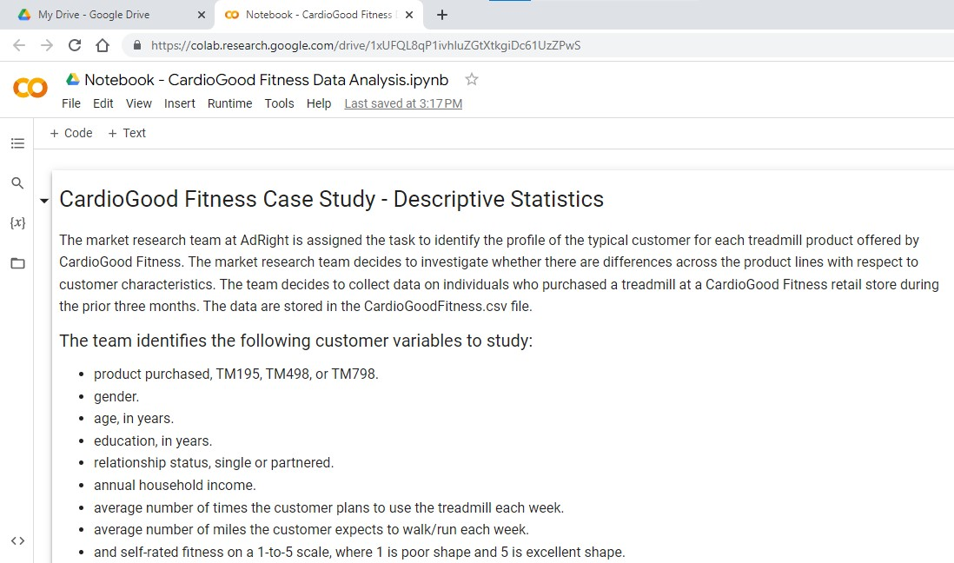

Happy Learning!

Guide to Google Colab
The Google Colab Toolbar looks like -
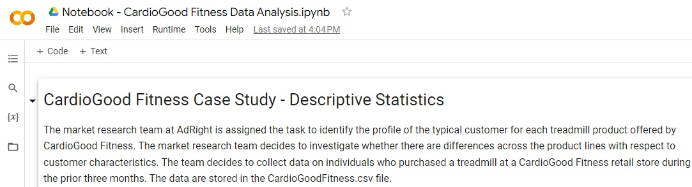

- File: When you click on the view you will find a list of options like 'New Notebook', 'Open Notebook', 'Upload Notebook', 'Save', 'Rename', 'Move', 'Save a copy in drive', 'Download' etc
The 'Download' option will show options to download the current notebook in different formats like .ipynb, .py formats
- Edit: When you click on the view you will find options like Cut, Copy, Paste, Delete, etc. for Cells.
Cells here refer to the fields where the code is written. (Area marked in Red in the following image)
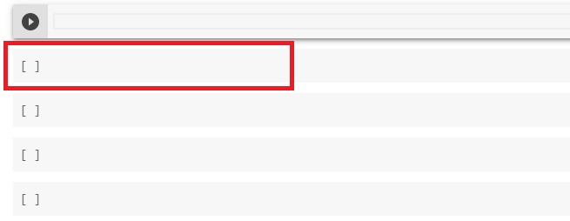
- View: When you click on the view you will find the 'Table of contents', 'Notebook info', 'Executed code history', etc., options
- Insert: When you click on the view you will find 'Code Cell', 'Text Cell', etc. options
- Runtime: When your notebook hangs or is in an endless loop (while loop)- you can click on Runtime and 'Interrupt Execution', 'Restart Runtime'. There will be other options like 'Run all', 'Run before', 'Run after', etc
- Tools: When you click on the view you will find 'Settings', 'Keyboard shortcuts'
- +Code: When you click on +Code option it will add a new code block
- +Text: When you click on +Text option it will add a new text block

Happy Learning!

FAQs - Data Visualization

1. What is the Seaborn library?
Tags: #seaborn #plot #visualization
Seaborn is a Python data visualization library built on top of another Python visualization library, Matplotlib. It provides a high-level interface for drawing attractive and informative plots. Visualization is the central part of Seaborn, which helps in the exploration and understanding of data.

2. How to order categorical variables in plots in seaborn?
Tags: #plots #hue #order
The order parameter of the seaborn plot function can be used to specify the order of categorical variables. The order parameter can take a list of items or categories to determine the order. For example, if there are two categories category_1 and category_2, and category_2 is to be displayed before category_1, then category_2 can be mentioned first and category_1 second in the order parameter.
sns.catplot(x = 'variable_to_plot', y = 'variable_to_plot', hue = 'hue_variable’,
data = df, order = ['category_2','category_1'] ,kind = "bar")
The hue_order parameter of the seaborn plot function can be used to specify the 'hue' order of categorical variables. The order parameter can take a list of items or categories to determine the order. For example, if there are two hue categories hue_1 and hue_2, and hue_2 is to be displayed before hue_1, then hue_2 can be mentioned first and hue_1 second in the order parameter.
hue_order = ['hue_2', 'hue_1']
sns.catplot(x = 'variable_to_plot', y = 'variable_to_plot', hue = 'hue_variable’,
data = df, hue_order = hue_order, kind = "bar")

3. How to print labels on the x-axis vertically?
Tags: #print #labels #plt
The xticks() function can be used to rotate the labels on the x-axis. Sample code:
plt.xticks(rotation = 90)

4. I am getting this error while running the code:
ModuleNotFoundError: No module name 'seaborn'

How to resolve this?
Tags: #error #install #seaborn
The error suggests that the Seaborn library is not present in the system. It can be installed by using the following command in a notebook:
!pip install seaborn --user
If the library is already installed and the error message is still showing, then the steps mentioned below can be followed:
Step 1: Uninstall the seaborn library.
!pip uninstall seaborn
When the above code is run, it will pop with the command Proceed (y/n)?
Write y in front of '?' symbol.
Step 2: Install the seaborn library.
!pip install seaborn --user

5. How do I change the color of the different levels of the hue variable in a countplot to suit my preference?
Tags:#countplot #color #hue
The palette parameter of the countplot function (and many other Seaborn plot functions) can be used to change the hue colors of the plot. The palette parameter can only take values that can be interpreted by Seaborn’s color_palette(). Sample Code:
sns.countplot(data = df, x = 'variable_to_plot', hue = 'hue_variable’, palette = 'Spectral')

6. I am getting this error while running the code.

UsageError: unrecognized arguments: #this code is to plot in line with the notebook

How to resolve this?
Tags:#error #matplotlib #usageerror
The magic function %matplotlib inline can be used to enable inline plotting, where the plots/graphs will be displayed just below the cell where your plotting commands are written.
Adding a comment in the same line as a magic function will raise an error as Python perceives those comments to be part of the magic command specified in the line. So, it is important to ensure that no comment or other operation is specified in the same line as a magic command. The best practice, in this case, is to pass the comment in the previous or next line as shown below:
%matplotlib inline
# tells Python to display the graphs inline

7. How to set the size of a Seaborn plot?
Tags: #height #width #size #matplotlib
The figure() function of matplotlib.pyplot can be used to adjust the figure size of the Seaborn plot. The figure() function creates a figure. It has a parameter called figsize which takes a tuple as an argument that contains the height and the width of the plot.
import matplotlib.pyplot as plt
# setting the dimensions of the plot
plt.figure(figsize = (20,7))

8. How do I label my histogram plot in Seaborn?
Tags : #axis #label #seaborn #histogram
The xlabel() and ylabel() function of matplotlib.pyplot can be used to set the labels for the histogram.The labels to be assigned can be set as an argument to function. For example :
plt.title('Histogram: Price')
plt.xlabel('Price of cars')
plt.ylabel('Frequency')
sns.histplot(data = df, x = 'price', color = 'orange');

9. I noticed that a range from -4 to 4 is often used to visualize plotting the distribution. However, other examples take a range from -3 to 3. Could you please explain a little bit why it is used in such a range, and if it is a standard in the industry, or if there are other standards for that range?
Tags: #range #plotting #distribution #visualize
The range from -4 to 4 is often used to visualize the distribution of a variable because it is a relatively wide range that includes the majority of values for many distributions. This range is used in plotting histograms, density plots, and other visualizations to give a general idea of the shape of the distribution.
The choice of range is not a standard in the industry and can vary depending on the specific distribution and the desired level of detail in the visualization. There is no one "correct" range, but rather a choice that depends on the specific use case and the goal of the visualization.
For example, if the variable of interest has a very skewed distribution, it may be appropriate to use a wider range, such as -6 to 6, to capture the full shape of the distribution. On the other hand, if the variable of interest has a very small range, it may be appropriate to use a narrower range, such as -2 to 2, to focus on the details of the distribution.
In summary, the choice of range for visualizing a distribution depends on the specific distribution and the goal of the visualization. There is no standard range, but rather a choice that depends on the use case and the desired level of detail.

10. Why am I getting this error while plotting a chart in Seaborn?
module 'seaborn' has no attribute 'displot'

How to resolve this?
Tags: #error #seaborn #plotting
You will need to update the Seaborn library using the below code:
%pip install seaborn==0.11.0

Happy Learning!

Quick Note #2
For the upcoming practice case study on EDA, it is recommended to first go through the problem statement and then download the dataset provided. Please try to answer the questions provided in the problem statement by yourself and after that, you can refer to the case study video and reference notebook.
Important Note:
Before we begin the case study video, it's worth noting that the professor in the video is using Jupyter Notebook, but please don't worry if you're not familiar with it. You can still follow along using Google Colab, which provides a similar environment to run Jupyter Notebooks. All the code and examples in the video can be replicated in Google Colab. Only the user interface will be slightly different but the overall functionality remains the same.

Happy Learning!

Problem Statement - CardioGood Fitness Data Analysis

Context
The market research team at AdRight is assigned the task to identify the profile of the typical customer for each treadmill product offered by CardioGood Fitness. The market research team decides to investigate whether there are differences across the product lines with respect to customer characteristics. The team decides to collect data on individuals who purchased a treadmill at a CardioGood Fitness retail store at any time in the past three months. The data is stored in the CardioGoodFitness.csv file.

Objective
Perform descriptive analysis to create a customer profile for each CardioGood Fitness treadmill product line.

Data Dictionary
The team identified the following customer variables to study:
- Product: Product purchased - TM195, TM498, or TM798
- Gender: Male or Female
- Age: Age of the customer in years
- Education: Education of the customer in years
- MaritalStatus: Single or partnered
- Income: Annual household income
- Usage: The average number of times the customer plans to use the treadmill each week;
- Miles: The average number of miles the customer expects to walk/run each week;
- Fitness: Self-rated fitness on a 1-to-5 scale, where 1 is the poor shape and 5 is excellent shape.

Questions to explore
- What are the different types of variables in the data?
- What is the distribution of different variables in the data?
- Which product is more popular among males or females?
- Is the product purchase affected by the marital status of the customer?
- Is there a significant correlation among some of the variables?
- What is the distribution of the average number of miles for each product?

Curated External Resources - Python for Data Science
Here are a few curated books and articles for you to go through:
- Numpy User Guide, written by the Numpy community - This Numpy user guide covers the basics of Numpy using different examples and exercises along with code. It also helps to perform high-performance calculations with clean and efficient Numpy code and analyze large datasets with statistical functions.
- Python for Data Analysis by Wes McKinney - This Data Analysis book is the definitive resource for anyone who wants to master data analysis tasks using Pandas. It was written by the creator of the Pandas library. You can go through the below chapters to develop a deeper understanding and practice various techniques in Pandas:
  - Chapter 5: Getting started with Pandas
  - Chapter 7: Data Wrangling: Clean, Transform, Merge, Reshape
  - Chapter 9: Data Aggregation and Group Operations
- A Brief Introduction to Pandas - This article gives a brief introduction to the Pandas library and covers the most commonly used methods available in Pandas for Data Science.
- Visualization with Seaborn - This HTML page is a Detailed Guide to Data Visualization with Seaborn, taken from the Python Data Science Handbook.
- Detailed Seaborn Library walkthrough - This notebook shows the implementation of various plots in the Seaborn library and how to customize them.
Happy Learning!

Optional Content - Lecture Video Materials

The following materials are highly recommended to be downloaded as these files are used in the lecture videos so that you can work simultaneously with the faculty while watching the video content.

Lecture Video Notebook:
Hands_on_Notebook_ExploratoryDataAnalysis.ipynb
Lecture video notebook is the same notebooks that faculty have used while teaching the concepts in the lecture videos. By downloading this notebook, you can work along with the professor through the video content.

Images:
Box Plot.png
The above image is used in the lecture video notebook. Kindly download the image and save it in the same working directory to avoid errors while running the notebook.

Dataset used in the sessions:
Melbourne_Housing.csv
The above dataset attached is used for the notebook that is shown in the lecture videos by faculty. Kindly download and save this dataset in the same working directory to avoid errors while running the notebook.
Melbourne_Housing_NoMissing.csv
The above dataset has been used in the video 'Missing Value Treatment'
Melbourne_Housing_NoOutliers.csv
The above dataset will be created in the video 'Outlier Detection and Analysis'

FAQ - Exploratory Data Analysis

1.What is difference between unique() and nunique() functions of Pandas?
The Pandas unique() function returns all the unique elements in a series and includes missing values (NaN).
The Pandas nunique() function returns the count of unique elements in a series or dataframe and can include or exclude missing values (NaN) depending upon the value of the dropna parameter.

2. What is the best way to deal with the missing values?
The strategy to deal with missing values varies with the problem at hand, the data provided, and other factors too. Some of the common strategies are listed below.
- Drop the missing values
- Impute the missing values
  - Using central tendency measures (mean, median, mode) of a column
    - With mean: Missing values are imputed with the mean of the column. Preferred for continuous data with no outliers
    - With median: Missing values are imputed with the median of the column. Preferred for continuous data with outliers
    - With mode: Missing values are imputed with the mode of the column. Preferred for categorical data
  - Using central tendency measures (mean, median, mode) of a column grouped by categories of a categorical column: Preferred for cases where the data under similar categories of a categorical column are likely to have similar properties

3. I tried to impute missing values in the data using the following code:
data['column'] = data['column'].fillna(data['column'].mean(), inplace=True)

but it changed all the values in the column to NaN. How to rectify the error?
When imputing missing values using the fillna() function, one should either set the inplace parameter True
data['column'].fillna(data['column'].mean(), inplace=True)
or assign the updated value back to the original data
data['column'] = data['column'].fillna(data['column'].mean())
Warning Note : Doing both at the same time will convert all the values in the column to NaN. So, please make sure to use one of the above mentioned steps.

4. How to decide whether to treat the outliers or not?
Treatment of outliers is an extensive subject and depends on a variety of things. The first part is to detect the presence of the outliers, which is generally best done by visualization techniques. Once they are detected, we must investigate the nature of the outliers before deciding on the treatment to be applied.
- Outliers can be reasonable and valid values, and in such cases, can be left untreated.
- Outliers can be measurement errors or data entry errors. In such cases, we should look for opportunities to correct the error wherever possible. If they can’t be corrected, then dropping such entries is the best way forward.
- Outliers can be values and starkly different from the rest of the values. Such values should be removed.

Happy Learning!

Week 2: Statistics for Data Science

Quick Note #4
The pre-work course should have given you a basic understanding of Descriptive Statistics and is a prerequisite for you to be able to appreciate the upcoming material.
If you do not have a background in statistics, then it is highly recommended that you complete pre-work first before proceeding ahead.
Important Note:
It's worth noting that the professor in the video is using Jupyter Notebook, but please don't worry if you're not familiar with it. You can still follow along using Google Colab, which provides a similar environment to run Jupyter Notebooks. All the code and examples in the video can be replicated in Google Colab, and the user interface will be slightly different but the overall functionality remains the same.

Happy Learning!

Week 2 - Video Lecture Materials
The following materials are highly recommended to be downloaded as these files are used in the lecture videos so that you can work simultaneously with the faculty while watching the video content.

Lecture Slides:
Lecture Slides - Inferential Statistics.pdf
Lecture Slides - Hypothesis Testing.pdf

Lecture Video Notebooks and Datasets:
Notebook_Inferential_Statistics.ipynb
Notebook_Hypothesis_Testing.ipynb
debugging.csv
sat_score.csv
Lecture video notebooks are the same notebooks that faculty have used while teaching the concepts in the lecture videos. By downloading these notebooks and datasets, you can work along with the professor through the video content.

Quick Note #5
Important Note:
It's worth noting that the professor in the video is using Jupyter Notebook, but please don't worry if you're not familiar with it. You can still follow along using Google Colab, which provides a similar environment to run Jupyter Notebooks. All the code and examples in the video can be replicated in Google Colab, and the user interface will be slightly different but the overall functionality remains the same.

Happy Learning!

FAQs - Inferential Statistics

1. What is the difference between the population and the sample? What is the difference between parameter and statistic?
Tags: #population #sample #parameter #statistic
Population and parameter are the universal set.
In statistics, a population is an entire pool from which a statistical sample is drawn. Examples of populations can be the number of newborn babies in North America, the total number of tech startups in Asia.
A parameter is any summary number, like an average or percentage, that describes the entire population. Since we can't measure the entire population, therefore, measuring its parameter is also difficult.
For example, the average height of adult women in the United States is a parameter that has an exact value — we just don’t know what it is! or the average height of all CFA exam candidates in the world, the mean weight of U.S. taxpayers, and so on.
We know what we have to collect and that collection is termed sample (a specific set from the population). Parameters associated with it would be sample parameters like sample mean or sample standard deviation and are referred to as statistic.

2. When should I use pmf, pdf, cdf, and ppf functions while calculating probabilities?
Tags: #pmf #cdf #ppf #probabilities
Let's understand the functions with probability notations.
Suppose that X is a discrete random variable. Now, when we want to calculate mass probabilities, like P(X=x), we use the pmf function. This is the probability that X takes the value x. An example of discrete distribution is Binomial Distribution.
The pdf function is similar to the pmf function except for the fact that it is used for continuous distributions. An example of continuous distributions is Normal Distribution. If X is a continuous random variable, we calculate the probability that X takes the value x, P(X=x) using the pdf function.
The cdf function helps us calculate the cumulative probability P(X<=x), which is the probability that X takes the value less than or equal to x. This is the cumulative distribution function and is applicable in both discrete and continuous cases.
The ppf function is an inverse form of the cdf function. Suppose P(X<=x) = alpha, where we are provided the alpha (probability) value, then we can calculate the value of x using the ppf function. This is the Percent Point Function and is applicable in both discrete and continuous cases.

3. How to set the value of k for binom.pmf() and binom.cdf() functions?
Tags: #pmf #cdf #probability
- If we want to calculate the probability that the random variable X is exactly equal to x, that is P(X=x), then binom.pmf(k=x,...) will be used.
- If we want to calculate the probability that the random variable X is less than or equal to x, that is P(X<=x), then binom.cdf(k=x,...) will be used.
- If we want to calculate the probability that the random variable X is greater than or equal to x, that is P(X>=x) = 1-P(X<x) = 1-P(X<=x-1), then 1-binom.cdf(k=x-1,...) will be used.

4. How to choose loc and scale for a continuous random variable following uniform distribution?
Tags: #uniform distribution #loc #scale
In scipy.stats.uniform(), the parameters loc and scale refer to the starting point and range of the uniform distribution. Using the parameters loc and scale, one obtains the uniform distribution on [loc, loc + scale]. For a continuous random variable following uniform distribution on [1, 4], loc and scale will be 1 and 3 respectively.
In general, if X~U(a,b), the loc and scale are a and (b-a) respectively.

5. What is z-score and how is it used in real-life scenarios?
Tags: #z-score #standard deviations
A z-score (also called the standard score) measures how many standard deviations below or above the mean a data point lies. The z-score is very useful as it enables us to compare two scores coming from two different normal populations. The two scores might be on two different scales however we can compare them using the z-score.
Real-life application – Suppose you have appeared for two different competitive exams having different scoring systems. How will you compare your scores’ in two exams? Let’s assume that the competitive exams are popular and the distributions of their scores follow two different normal distributions. To compare your scores (coming from two different normal populations), you need to standardize each of your scores. Then, you can easily compare them.

6. What does norm.ppf() do?
Tags: #ppf #cdf #probability
The norm.ppf() function is the inverse of the norm.cdf() function. It takes a percentage p and returns a point such that the probability of the normal random variable being less than or equal to that number is p%. Thus, it just does the opposite work of norm.cdf().
For example, if the percentage p is equal to 0.92, you will get the point below which 92% of data falls. This also means that 8% of data falls above that point.

7. When we evaluate the probability to the right of a binomial distribution using 1-binom.cdf(), we subtract 1 from the k. But, in a normal distribution, we do not subtract 1 from x while we calculate the probability to the right of the distribution using 1-norm.cdf(). Why there is such a difference?
Tags: #cdf #distribution #continuous
This is due to the fact that binomial distribution is a discrete distribution; whereas normal distribution is a continuous one. The cdf() function behaves differently for a continuous distribution and a discrete distribution. In the case of a continuous distribution, the cdf is a strictly monotonic increasing continuous function; whereas the cdf of a discrete distribution is a step function.
Thus, according to the definition of cdf(), 1-binom.cdf() will calculate the probability that X is greater than a certain value. 1-norm.cdf() will also do the same thing. But for continuous function, we do not have to subtract any value as the probability at a single point is always zero.

Happy Learning!

Hypothesis Testing Steps
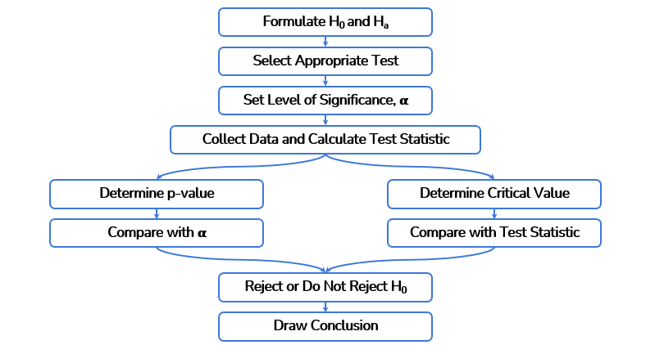

FAQs - Hypothesis Testing

1. What is alpha in hypothesis testing?
Tags: #hypothesis testing #probability
Alpha is the level of significance. It is basically the probability of an error that we reject the null hypothesis when it is true. It is basically a small chance that our test result is by chance. 5% and 1% are standard values of alpha taken for most practical problems. A 5% value of alpha would mean that we are 95% confident that our test results are significant and not by chance. Note that the value of alpha is decided prior to the test and is not changed after that.

2. What are the steps of conducting a hypothesis test?
Tags: #hypothesis testing #p-value
The following are the steps of conducting a hypothesis test
- Formulate the null and the alternative hypotheses appropriately for the problem in question.
- Based on the nature of the data under the hypothesis, select the appropriate test.
- Decide the significance level prior to conducting the test.
- Collect the appropriate data for the test.
- Calculate the p-value by conducting the test.
- Compare the p-value with alpha and make a conclusion based on the p-value

3. How to decide whether to use the normal distribution or the t-distribution to calculate the confidence interval?
Tags: #distribution #confidence interval #standard deviation
The distribution that will be used for the calculation of confidence interval depends on whether the population standard deviation is known or unknown. When the population standard deviation is known, the normal distribution is used. On the other hand, when the population standard deviation is unknown, we estimate it using the sample standard deviation and calculate the confidence interval using the t-distribution.

4. Which Python function is used to compute a confidence interval for the population mean?
Tags: #confidence interval #population #sample
The interval() function is used to calculate a confidence interval. The interval() function calculates the endpoints within which the specified percentage of values of the distribution lie.
For example, from a population, we have drawn a random sample of size 100, whose mean is calculated to be 500 and the population standard deviation is known to be 25. Then the 95% confidence interval for the population mean can be calculated by using the interval() function of the norm class of scipy.stats as shown below:
import numpy as np
from scipy.stats import norm
np.round(norm.interval(0.95, loc = 500, scale = 25/np.sqrt(100)), 2)
where np.round() is used to round off the output to the specified number of decimal points.
Now, for the same example as above, consider that the population standard deviation is not known to us. In that case, the 95% confidence interval for the population mean can be calculated by using the interval() function of the t class of scipy.stats as shown below:
import numpy as np
from scipy.stats import t
np.round(t.interval(0.95, df = 100-1, loc = 500, scale = 25/np.sqrt(100)), 2)
where the df argument denotes the degrees of freedom of the t-distribution. It is calculated as (n-1), n being the sample size.

FAQs - Statistics for Data Science
1. How to set the value of k for binom.pmf() and binom.cdf() functions?
Tags: #pmf #cdf #probability
If we want to calculate the probability that the random variable X is exactly equal to x, then binom.pmf(k=x,...) will be used.
If we want to calculate the probability that the random variable X is less than or equal to x, then binom.cdf(k=x,...) will be used.
If we want to calculate the probability that the random variable X is greater than or equal to x, then 1-binom.cdf(k=x-1,...) will be used.

2. What are the Empirical rules of a normal distribution?
Tags: #normal distribution #standard deviations #empirical rule
The empirical rule states that 68% of the observations of a normal distribution fall within the first standard deviation from the mean (µ ± σ), 95% within the first two standard deviations from the mean (µ ± 2σ), and 99.7% within the first three standard deviations from the mean (µ ± 3σ).
Let’s assume pizza delivery timings in a restaurant are known to be normally distributed.
µ(mean delivery time): 30 minutes
σ(standard deviation) : 5 minutes
Using the Empirical Rule, we can determine that,
68% of the delivery times are between 25-35 minutes (30 ± 5)
95% of the delivery times are between 20-40 minutes (30 ± 2x5)
99.7% of the delivery times are between 15-45 minutes (30 ±3x5)

3. What is the degree of freedom?
Tags: #estimate #observations
The Degree of freedom of an estimate is the number of independent pieces of information that went into calculating the estimate. Let's understand with an example. Suppose there are 10 observations, and we have an estimate of the sum of those 10 observations. Now, if 9 of the ten observations are known to us, the 10th one can be calculated by subtracting the sum of 9 observations from the estimate of the sum of all observations. This way, if 9 of the observations are known to us, then the one left out observation is redundant. So, we say that the degrees of freedom for the estimate of the sum is 10 - 1 = 9.
This applies universally to all other estimates as well. So, in general terminology for n observations, the degree of freedom for an estimate of these n observations is k = n-1.

4. What are the functions used in Statistical Analysis from the Scipy Stats library to calculate probabilities in a normal distribution?
Tags: #pdf #cdf #ppf
pdf(x, loc=0, scale=1) - Probability density function.
cdf(x, loc=0, scale=1) - Cumulative distribution function.
ppf(q, loc=0, scale=1) - Percent point function (inverse of cdf - percentiles).
Please refer to this (Links to an external site.)Links to an external site. page for the official Scipy documentation.

Happy Learning!

Curated External Resources - Statistics for Data Science
Here are some of the curated books and articles for you to go through:
- Prem S. Mann • Introductory Statistics, Seventh Edition - This book covers the basics of statistics using real-life examples, exercises, and precise presentation. You don't need to have a high-level knowledge of mathematics or statistics to go through this book. You can go through the listed chapters to develop a good understanding of the basic statistics.
  - Chapter 1: Introduction
  - Chapter 3: Numerical Descriptive Measures
  - Chapter 4: Probability
- Think Stats: Probability and Statistics for Programmers - Think Stats is a short book that emphasizes simple techniques that can be used to explore real data sets and answer interesting questions. It shows how to perform statistical analysis computationally, rather than mathematically, with programs written in Python.
- Probability Distributions - This article covers the concept of a probability distribution, and what are its general properties for different types of distributions - Discrete and Continuous, in easy-to-understand terminology.
- CLT Demonstration - This is an interactive simulation that lets you explore various aspects of sampling distributions. It can be used to demonstrate Central Limit Theorem.
- Check out these videos on Hypothesis Testing and The Null Hypothesis and Alternative Hypothesis by StatQuest:
  - Hypothesis Testing and The Null Hypothesis click here
  - Alternative Hypothesisclick here

Optional Content: Hypothesis Testing

FAQs - Common Statistical Tests

1. Why do I get the below error and how to resolve it?
Tags: #error #hypothesis
ttest_1samp() got an unexpected keyword argument ‘alternative’
The parameter alternative = 'greater' and alternative = 'less' has been introduced in the SciPy version 1.6.0. onwards. So, you will get an error if you run the code in an older SciPy version. When you remove the parameter 'alternative', you get the p-value for the two-tailed test as implemented by the previous version. But, we would recommend that you install the latest SciPy version in your system to perform the hypothesis test.
You can run the below command in the jupyter notebook to update the SciPy version.
!pip install scipy --upgrade
If the above code throws a User related Environment Error, then please run the below code:
!pip install scipy --upgrade --user
After installing the new SciPy version, restart the jupyter notebook and run the below code to check the current Scipy version in your system.
import scipy
scipy.__version__
If you see that the version has been updated successfully, then you can use the 'alternative' parameter with values 'less', 'greater', or 'two-sided'.

2. How can I assume two or more population variances/standard deviations to be equal?
Tags: #sample #population #standard deviations #population variances
When the sample standard deviations are almost equal, the population standard deviations may be assumed to be equal. An empirical rule can be applied to check the same. If the ratio of two sample standard deviations is between 0.7 and 1.4, the population standard deviations may be assumed to be equal.
Alternatively, the levene() test can be applied to check whether all input samples are from populations with equal variances or not. This test has been covered in the ANOVA video.

3. Why do I get an error for the below code?
Tags: #p-value #code #error
stats, p_value = proportions_ztest (24, 90, value = 0.5, alternative ='greater')
proportion_ztest() is a function from statsmodel package; not scipy package. Hence, you should use the parameter alternative = 'larger' for proportion_ztest() instead of alternative = 'greater'. Similarly, the parameter alternative = 'smaller' should be used in proportion_ztest() instead of alternative = 'less'. Please refer to the documentation of the proportion_ztest() for more details.

4. Why is the value parameter set as 0.5 in the below code?
Tags: #z-test #parameter
proportions_ztest(24, 90, value = 0.5, alternative = 'larger')
The 'value' parameter refers to the value of the hypothesized population parameter. Here, the proportion of the people who voted for the Democratic party is the population parameter. Hence, the 'value' should refer to the population proportion. The Democratic party will win if more than 50% of people vote for it. Hence, the hypothesized population proportion should be 0.5.

5. How is the value 7.843455779613616e-05 less than 0.05?
Tags: #0.05
Python writes scientific notation using 'e' for example, 7.84 x 10⁻⁵ is displayed as 7.84e-05. So the value 7.84e-05 i.e 7.84 x 10⁻⁵ is less than 0.05.

Happy Learning!

Mentor Learning Session 1: Python for Data Science

Session Plan - Python for Data Science
Learning Objectives
- To gain clarity on the fundamental concepts of exploratory data analysis and data preprocessing
- To understand the implementation of exploratory data analysis and necessary data preprocessing in Python using the foundational libraries for data manipulation and visualization (NumPy, Pandas, Matplotlib, Seaborn)
- To gain insights into the practical challenges involved in solving real-world problems
Session Structure
Duration | Section | Details
35 min | Welcome and Introduction | - Introduction of mentor and learners
5 min | Explanation of session structure | - Discuss the agenda and learning objectives of the session
30 min | Concepts covered in the videos of the week | - Gauge the understanding of the group through discussion questions and identify the areas where there is a lack of clarity or need for discussion and exchange of thoughts  - Discuss the key foundational concepts around the areas identified above
5 min | Python Setup | - Overview of using Google Colab
60 min | Uber Hands-on Case Study | - Walkthrough of the case study to problem solve for the objectives mentioned in the problem brief  - Demonstration of how to apply various data manipulation and visualization techniques to explore data and identify observations and insights  - Exchange questions to ensure that the group has clarity on how to work through various important functions in Python  - Summarize the key findings from the analysis in the light of the objectives outlined in the problem brief
10 min | Extended Q&A | - Discuss the doubts regarding the implementation, concepts, or any other relevant question where the group needs help.
5 min | Summary of the session | - Summary of the week with the key takeaways  - Brief about the next session
Key points to note
- The first section on conceptual clarity is intended to be an interactive one where it is expected that the learners in the group will share the most challenging questions they want to be discussed in the session.
- It is upon the mentor's discretion to decide how much time to spend on what questions/topics and the goal should be to cover the most fundamental questions first that are in the interest of the whole group.
- It is to be kept in mind that a lot of tactical questions around various functions in Python should best be covered in the Hands-on Case Study section.
- Learners are expected to have completed all the learning material shared in the week.
- It is likely that some questions may not get covered in the session due to various reasons and such questions may be answered after the session by learners sharing these questions via support requests on Olympus.
- Log in to your session 5 mins before the scheduled start and make sure you are ready with all the material to be used for the session.

Happy Learning!

Problem Statement - Uber Data Analysis

Context
Uber Technologies, Inc. is an American multinational transportation network company based in San Francisco and has operations in approximately 72 countries and 10,500 cities. In the fourth quarter of 2021, Uber had 118 million monthly active users worldwide and generated an average of 19 million trips per day.
Ridesharing is a very volatile market and demand fluctuates wildly with time, place, weather, local events, etc. The key to being successful in this business is to be able to detect patterns in these fluctuations and cater to demand at any given time.
As a newly hired Data Scientist in Uber's New York Office, you have been given the task of extracting insights from data that will help the business better understand the demand profile and take appropriate actions to drive better outcomes for the business. Your goal is to identify good insights that are potentially actionable, i.e., the business can do something with it.

Objective
To extract actionable insights around demand patterns across various factors.

Key Questions
- What are the different variables that influence pickups?
- Which factor affects the pickups the most? What could be plausible reasons for that?
- What are your recommendations to Uber management to capitalize on fluctuating demand?

Guidelines
- Perform univariate analysis on the data to better understand the variables at your disposal.
- Perform bivariate analysis to better understand the relationships between different variables.
- Create visualizations to explore data and extract the insights.

Data Dictionary
The data contains information about the weather, location, and pickups.
- pickup_dt: Date and time of the pick-up
- borough: NYC's borough
- pickups: Number of pickups for the period
- spd: Wind speed in miles/hour
- vsb: Visibility in miles to the nearest tenth
- temp: Temperature in Fahrenheit
- dewp: Dew point in Fahrenheit
- slp: Sea level pressure
- pcp01: 1-hour liquid precipitation
- pcp06: 6-hour liquid precipitation
- pcp24: 24-hour liquid precipitation
- sd: Snow depth in inches
- hday: Being a holiday (Y) or not (N)

Mentor Learning Session 2: Statistics for Data Science

Session Plan - Statistics for Data Science
Learning Objectives
- To gain clarity on the fundamental concepts of inferential statistics and hypothesis testing
- To understand how to visualize probability distributions and implement basic tests in Python using the scipy library
- To gain insights into various practical challenges involved in solving real-world problems
Session Structure
Duration | Topic | Details
5 min | Learning Objectives | - Reflection on the learning objectives of the session and the agenda
20 min | Conceptual Discussion | - Gauge the understanding of the group through discussion questions and identify the areas where there is a lack of clarity or need for discussion and exchange of thoughts  - Discuss the key foundational concepts around the areas identified above
35 min | Medicon dose Hands-on Case Study | - Walkthrough of the case study to problem solve for the objectives mentioned in the problem brief  - Demonstration of how to visualize various distributions to explore data and identify observations and insights  - Exchange questions to ensure that the group has clarity on how to work through various distributions in statistics  - Summarize the key findings from the analysis in the light of the objectives outlined in the problem brief
20 min | Conceptual Discussion | - Gauge the understanding of the group through discussion questions and identify the areas where there is a lack of clarity or need for discussion and exchange of thoughts  - Discuss the key foundational concepts around the areas identified above
20 min | Mobile Internet Hands-on Case Study | - Walkthrough of the case study to problem solve for the objectives mentioned in the problem brief  - Demonstration of how to formulate a hypothesis, apply tests, and identify observations and insights  - Exchange questions to ensure that the group has clarity on the steps performed while applying a test  - Summarize the key findings from the analysis in the light of the objectives outlined in the problem brief
15 min | Extended Q&A | - Discuss various additional questions and ideas on the topics discussed so far  - Exchange thoughts and perspectives on various practical challenges, considerations, and probable approaches to tackle them
5 min | Session Summary | - Outline the key takeaways from the session

Key points to note
- The section for the conceptual discussion is intended to be an interactive one where it is expected that the learners in the group will share the most challenging questions they would want to be discussed in the session.
- It is upon the mentor's discretion to decide how much time to spend on what questions/topics and the goal should be to cover the most fundamental questions first that are in the interest of the whole group.
- Learners are expected to have gone through all the learning material shared in the week.
- It is likely that some questions may not get covered in the session due to various reasons and such questions will be answered post the session. It is expected that learners will share such questions via support requests on Olympus.
- Log in to your session 5 minutes before the scheduled start and make sure you are ready with all the material to be used for the session.
Happy Learning!

Problem Statement #1 - Medicon Dose Testing

Inferential Statistics - Medicon Dose Testing Case Study

Context
​Medicon, a pharmaceutical company, has manufactured the sixth batch (40,000 units) of COVID-19 vaccine doses. This vaccine was clinically tested last quarter and around 2,00,000 doses have already been given to the people in five batches.
Now, the sixth batch of doses needs to be tested for their time of effect (measured as the time taken for the dose to completely cure COVID-19), as well as for quality assurance (which tells you whether the dose will be able to do a satisfactory job or not).
You are working with the quality assurance team of Medicon and want to understand the quality of the sixth batch so that the company can plan for the next batch of doses.
Note: Please note that this is not a clinical trial, the vaccine has already cleared clinical trials. This test is to ensure the quality and effectiveness of the sixth batch.

Problem Statement
The previous analysis found that a dose is 10 times more likely to produce a satisfactory result or not.
Q1. The quality assurance team has collected 100 volunteers who were ready for the trial of this new batch and given one dose to each volunteer. Help the team to answer the following questions:
a) What is the probability distribution for the number of unsatisfactory doses?
b) What is the probability that exactly 3 doses will not do a satisfactory job?
c) What is the probability that at most 3 doses will not do a satisfactory job out of 100 selected?

Problem Statement #2 - Mobile Internet Usage Analysis

Hypothesis Testing - Mobile Internet Case Study

Context
​ExperienceMyServices reported that a typical American spends an average of 144 minutes (2.4 hours) per day accessing the Internet via a mobile device with a standard deviation of 110 minutes.
To test the validity of this statement, you collected 30 samples from friends and family. The results for the time spent per day accessing the Internet via a mobile device (in minutes) are stored in "InternetMobileTime.csv".

Key Question​:
Is there enough statistical evidence to conclude that the population mean time spent per day accessing the Internet via mobile device is different from 144 minutes? Use the p-value approach and a level of significance of 0.05.
Note: We can assume that the samples are randomly selected, independent, and come from a normally distributed population

