Project Description - FoodHub

This assessment is no longer accepting submissions
Available From:02 Oct 25 3:25 AM
Due Date:14 Oct 25 5:00 PM
Total Marks:60
Submission Type:File Upload
Need help with your project? Get instant assistance from Glaide!

Description

Context
The number of restaurants in New York is increasing day by day. Lots of students and busy professionals rely on those restaurants due to their hectic lifestyles. Online food delivery service is a great option for them. It provides them with good food from their favorite restaurants. A food aggregator company FoodHub offers access to multiple restaurants through a single smartphone app.
The app allows the restaurants to receive a direct online order from a customer. The app assigns a delivery person from the company to pick up the order after it is confirmed by the restaurant. The delivery person then uses the map to reach the restaurant and waits for the food package. Once the food package is handed over to the delivery person, he/she confirms the pick-up in the app and travels to the customer's location to deliver the food. The delivery person confirms the drop-off in the app after delivering the food package to the customer. The customer can rate the order in the app. The food aggregator earns money by collecting a fixed margin of the delivery order from the restaurants.

Objective
The food aggregator company has stored the data of the different orders made by the registered customers in their online portal. They want to analyze the data to get a fair idea about the demand of different restaurants which will help them in enhancing their customer experience. Suppose you are hired as a Data Scientist in this company and the Data Science team has shared some of the key questions that need to be answered. Perform the data analysis to find answers to these questions that will help the company to improve the business.

Data Description
The data contains the different data related to a food order. The detailed data dictionary is given below.
Data Dictionary
- order_id: Unique ID of the order
- customer_id: ID of the customer who ordered the food
- restaurant_name: Name of the restaurant
- cuisine_type: Cuisine ordered by the customer
- cost: Cost of the order
- day_of_the_week: Indicates whether the order is placed on a weekday or weekend (The weekday is from Monday to Friday and the weekend is Saturday and Sunday)
- rating: Rating given by the customer out of 5
- food_preparation_time: Time (in minutes) taken by the restaurant to prepare the food. This is calculated by taking the difference between the timestamps of the restaurant's order confirmation and the delivery person's pick-up confirmation.
- delivery_time: Time (in minutes) taken by the delivery person to deliver the food package. This is calculated by taking the difference between the timestamps of the delivery person's pick-up confirmation and drop-off information

Submission Guidelines
- There are two ways to work on this project:
i. Full-code way: The full code way is to write the solution code from scratch and only submit a final Jupyter notebook with all the insights and observations.
ii. Low-code way. The low-code way is to use an existing solution notebook template to build the solution and then submit a business report with insights and recommendations.
The primary purpose of providing these two options is to allow learners to opt for the approach that aligns with their individual learning aspirations and outcomes. The below table elaborates on these two options.
Submission type | Who should choose | What is the same across the two | What is different across the two | Final submission file [IMP] | Submission Format
Full-code | Learners who aspire to be in hands-on coding roles in the future focussed on building solution codes from scratch | Perform exploratory data analysis to identify insights and recommendations for the problem | Focus on code writing: 10 - 20% grading on the quality of the final code submitted | Solution notebook from the full-code template submitted in .html format | .html
Low-code | Learners who aspire to be in managerial roles in the future-focussed on solution review, interpretation, recommendations, and communicating with business | Focus on business report: 10 - 20% grading on the quality of the final business report submitted | Business report in .pdf format with problem definition, insights, and recommendations | .pdf
Please follow the below steps to complete the assessment.Kindly note that if you submit a report, ONLY the report will be evaluated. Please make sure that all the sections mentioned in the rubric have been covered in your submission.
i. Full-code version
- Download the full-code version of the learner notebook.
- Follow the instructions provided in the notebook to complete the project.
- Clearly write down insights and recommendations for the business problems in the comments.
- Submit only thesolution notebook prepared from the learner notebook [format: .html]
ii. Low-code version
- Download the low-code version of the learner notebook.
- Follow the instructions provided in the notebook to complete the project.
- Prepare a business report with insights and recommendations to the business problem.
- Submit only the report [format: .pdf]
2. Any assignment found copied/plagiarized with other submissions will not be graded and awarded zero marks.
3. Please ensure timely submission as any submission post-deadline will not be accepted for evaluation.
4. Submission will not be evaluated if
- it is submitted post-deadline, or,
- more than 1 file is submitted.

Best Practices for Full-code submissions
- The final notebook should be well-documented, with inline comments explaining the functionality of code and markdown cells containing comments on the observations and insights.
- The notebook should be run from start to finish in a sequential manner before submission.
- It is important to remove all warnings and errors before submission.
- The notebook should be submitted as an HTML file (.html) and NOT as a notebook file (.ipynb).
- Please refer to the FAQ page for common project-related queries.

Best Practices for Low-code submissions
- The report should be made keeping in mind that the audience will be the Data Science lead of a company.
- The key points in the report should be the following:
  - Business Overview of the problem and solution approach
  - Key findings and insights which can drive business decisions
  - Business recommendations
  - Focus on explaining the key takeaways in an easy-to-understand manner.
  - The inclusion of the potential benefits of implementing the solution will give you the edge.
- Copying and pasting from the notebook is not a good idea, and it is better to avoid showing codes unless they are the focal point of your report.
- The report should be submitted as a PDF file (.pdf) and NOT as a .doc file.
- Please refer to the FAQ page for common project-related queries.
Happy Learning!

Rubrics
CriteriaUnderstanding the structure of the data- Overview of the dataset shape, datatypes
- Statistical summary and check for missing values
- Answer all the key questions asked in this sectionPoints5
CriteriaUnivariate Data Analysis- Explore all the variables and provide observations on the distributions of all the relevant variables in the dataset
- Answer all the key questions asked in this sectionPoints15
CriteriaMultivariate Data Analysis- Perform bivariate/multivariate analysis to explore relationships between the important variables in the dataset
- Answer all the key questions asked in this sectionPoints20
CriteriaQuality & Use of visualisations- Use proper visualizations for the analysis and provide observations on the plotsPoints6
CriteriaConclusion and Recommendations- Conclude with the key insights/observationsPoints6
CriteriaReport/Notebook - Overall QualityLow Code Version (Business Report):
- Structure and flow
- Crispness
- Visual appeal
- All key insights and recommendations covered?

OR
Full Code Version (Notebook):
- Structure and flow
- Well commented code
- All key insights and recommendations covered?Points8

Project Discussion Forum
Dear Learner,

This is the Project discussion thread for the FoodHub project of Foundations for Data Science course.

This discussion forum is open from Oct 1st (Wednesday) 12:00 AM EST to October 14th (Tuesday) 4:00 AM GMT to help you with your project-related queries.
You can also use this forum, to discuss your approaches, and share roadblocks you face and discuss them amongst your peers. Additionally, and a member of the support team will answer your queries.

Points to note:

Please feel free to raise any blockers or doubts that are preventing you from moving ahead with the project.

- Please do not share your codes here as we do not want anyone to be biased by someone else's work.
- For faster resolution, please make sure you mention the following points:
a. Error screenshot
b. Python version or any other technical details you want to mention
c. The steps that you have taken to resolve the issue and why you think it might still be occurring.
- Please do not post general questions outside the scope of the project.
- Please maintain the professional decorum of the forum.
- You will get a response to your query in 24-48 hours.
- Queries hinting towards or giving away the solution will be removed from the forum.
- Participation in the project discussion forum/ Discussion question is optional and shall not impact your project scores.
Please refer to the following links for frequently asked questions to make sure that your question is not already answered:
- Project FAQ
- Week 1: Python for Data Science FAQs & Week 2: Statistics for Data Science FAQs

All Comments (70)


Dr. Anja Hagedorn
14 Oct 25 4:52 PM
Hi everyone,
I’ve completed and submitted my FoodHub project.
It was interesting to explore how different factors like preparation time and distance affect delivery performance.
I found Question 12 a bit challenging since it didn’t have one specific question behind it — it was more open-ended than the others, but it was a good exercise in figuring out which relationships really matter.
Thanks to the support team and peers for the discussions!
2


Osamah Abu Judeh
14 Oct 25 3:30 PM
Its clear, thanks & no questions
1


Suprita Puned
14 Oct 25 3:12 PM
No Questions for now. I submitted low code version.
1


Gabriele Lattanzio
14 Oct 25 2:45 PM
Interesting project, no questions atm
1


Kunal Dinesh Desai
14 Oct 25 2:43 PM
No questions, I did the low code version
1


Kenneth Bresson
14 Oct 25 2:04 PM
Project file submitted. Thanks.
1


Marco Raineri
14 Oct 25 9:31 AM
I chose the full code version even though, being a novice in programming, wasn't easy. I've done my best to try to solve the questions because I aspire to be able to build solution codes from scratch. I hope that I've done a good job!
2


Varadish Kusumanchi
14 Oct 25 8:33 AM
no questions, submitted full code version
1


Madison Delano Campelo Tobal
14 Oct 25 8:21 AM
No questions
1


Ahmed Magdy Mahmoud Mohamed Saleh
14 Oct 25 8:01 AM
No questions
1


Susanna Saitta
14 Oct 25 8:00 AM
No questions.
1


Hussam Abou-Soud
14 Oct 25 7:36 AM
Went for full code, nothing to add.

1


Mariia Kozhina
14 Oct 25 7:33 AM
No issues. Full code version
1


Ilia Slesarev
14 Oct 25 7:25 AM
No issues
1


Omar Abdelnabi
14 Oct 25 6:37 AM
No issues
1


Siddh Shah
14 Oct 25 6:17 AM
I am going for Full Code Approach, Ready to upload
1


Julian Perez
14 Oct 25 4:56 AM
We're almost there — just a little push and it's done! I finally decided low code, but really there is a lot of work behind :)
Good day to everyone!!
1


Cristian Fabián Brochero Rodríguez
14 Oct 25 4:51 AM
Opt for full code. No specific question.
1


Martina Balet
14 Oct 25 3:51 AM
Hi, I struggled to convert to html but finally managed to do so. Interesting project.
1


Bhumit
14 Oct 25 3:27 AM
all good so far, opting for full code version
1


Rosalia Tsikandelova
14 Oct 25 3:11 AM
No questions I really enjoyed the problem solving of this assignment :)
1


Péter Zsemberi
14 Oct 25 2:49 AM
No questions, I did the low code version.
1


Mahsa Aslani
14 Oct 25 2:07 AM
Did the full code version. A good start.
1


Isabella Bresciani Lira
14 Oct 25 1:42 AM
Low code version
1


Akos Bartolits
14 Oct 25 12:39 AM
I have also opted for full code submission.
1


David Boucquey
13 Oct 25 10:20 PM
Opt for full code. No specific question.
1


Garima
13 Oct 25 10:07 PM
Chosen low code option, no questions. Thanks
1


Charbel Nabih Ziade
13 Oct 25 9:53 PM
No questions
1


Matteo Ferrari
13 Oct 25 9:42 PM
I’m really enjoying working on the FoodHub dataset with Python: a thoughtful mix of analysis, exploration, and visualization.
Even though I’m following the low-code path, I had a lot of fun adding extra graphs and analyses to get a deeper feel for the dataset and the possible business angles behind it.
Curiosity grows the more you explore: Each small finding makes me want to dig deeper to understand what drives the patterns in the data, how they reflect the business context, and where there might be opportunities for improvement, or best practices to leverage on.
Python makes that process feel quite natural, turning a simple exercise into a genuine discovery journey... even if the learning curve can be a bit steep :)
I just found the dataset to be a bit too clean: of course is just for academic purposes, I wish real-life data were so consistent!
I’d love to hear your thoughts!
2


Karim Benna
13 Oct 25 8:01 PM
I have no questions currently
1


Dieuwert Van Den Broeke
13 Oct 25 7:11 PM
No questions, did the full code option.
1


Bettina
13 Oct 25 7:00 PM
No questions

1


Zamani Xolo
13 Oct 25 4:54 PM
No Question, so far
1


Sara Lee
13 Oct 25 1:48 PM
all good so far
1


Nousheen Hamid
13 Oct 25 5:07 AM

I am currently working on the low code FoodHub project as part of the Foundations for Data Science course. I have completed data cleaning and basic exploratory data analysis, but I am facing some challenges in the following areas:
- Multivariate Analysis – I am trying to visualize relationships such as rating vs cost, cuisine vs food preparation time, and day_of_the_week vs delivery_time. While my plots are generating, some of the x-axis labels overlap and are difficult to read. I tried resizing the figure, but it still looks crowded. I hope I will solve it.
- I have written a function to compute revenue based on different order cost thresholds, but I want to ensure I am applying it correctly across the dataset.


Aleksander Anderssen Thornam
13 Oct 25 4:50 AM
Interesting "kick-off" to the world of Python and Data Science.
Did the full-code option with a lot of back and forth for a newbie coder.
Great learning experience!


Sivwete Godspower
12 Oct 25 11:48 PM
I am going for the low code option.
It is an interesting case
1


Alexandre Amaral
12 Oct 25 11:42 PM
working on it! all good!
1


Rahima Djahel
12 Oct 25 11:31 PM
Opting for full code here!

1


Rares Juretchi
12 Oct 25 10:28 PM
Low code!
1


Matteo Ferrari
12 Oct 25 9:53 PM
Low code here!
1


Namya Vyas 12 Oct 25 9:39 PM
No questions!
1


Sofia 12 Oct 25 7:41 PM
All good!
1


Afnan Alharbi 12 Oct 25 4:43 PM
No questions so far.
1


Lily Adler 12 Oct 25 4:22 PM
Opting for full code!
3


Matthew Lauckhart 12 Oct 25 4:08 PM
Opting for full code here!
1


Nakita Bernice Meiring 12 Oct 25 3:12 PM
I opted for full code, being a newbi its a bit challenging, but that's the plan


Luis Humberto Serna 12 Oct 25 1:51 AM
just about to start, seems not so complex so far.
1


Mercy Mwende Wambua 11 Oct 25 9:59 PM
No Questions so far. Have opted for a full code submission to challenge learning and wow. What a project.
1


Ângela Filipa Brochado Pontes 11 Oct 25 9:30 PM
All good!
1



James T Nyanda 11 Oct 25 4:28 PM
I just chose the low code side provided my roles, but I just want to understand if someone can choose both low code and full code...
Thanks


Nisrine Kamal 10 Oct 25 8:19 PM
Hello ,
I can't see the difference beetween the informations/answers to put in the slide"Executive Summary" and "Conclusions and Recommendations".
Thanks for your help



Edoardo Ponte 10 Oct 25 7:50 PM
Are you opting either for full code of low code submissions?



Julien SALEH 10 Oct 25 4:38 PM
All good, interesting case
1


Alvin Chang 09 Oct 25 9:36 AM
No questions so far
1

Low Code vs Full Code Submission
There are two ways to work on the Capstone project:
i. Full-code way: The full code way is to write the solution code from scratch and only submit a final Jupyter notebook with all the insights and observations.
ii. Low-code way: The low-code way is to use an existing solution notebook template to build the solution and then submit a business report with insights and recommendations.
The primary purpose of providing these two options is to allow learners to opt for the approach that aligns with their individual learning aspirations and outcomes. The below table elaborates on these two options.
Submission type | Who should choose | What is the same across the two | What is different across the two | Final submission file [IMP] | Submission Format
Full-code | Learners who aspire to be in hands-on coding roles in the future focussed on building solution codes from scratch | Perform exploratory data analysis to identify insights and recommendations for the problem | Focus on code writing: 10-20% grading on the quality of the final code submitted | Solution notebook from the full-code template submitted in .html format | .html
Low-code | Learners who aspire to be in managerial roles in the future-focussed on solution review, interpretation, recommendations, and communicating with business |  | Focus on business report: 10-20% grading on the quality of the final business report submitted | Business report in .pdf format with problem definition, insights, and recommendations | .pdf
Please follow the below steps to complete the assessment. Kindly note that if you submit a report along with the notebook, ONLY the report will be evaluated. Please make sure that all the sections mentioned in the rubric have been covered in your submission.

i. Full-code version
- Download the full-code version of the learner notebook.
- Follow the instructions provided in the notebook to complete the project.
- Clearly write down insights and recommendations for the business problems in the comments.
- Submit only the solution notebook prepared from the learner notebook [format: .html]

ii. Low-code version
- Download the low-code version of the learner notebook.
- Follow the instructions provided in the notebook to complete the project.
- Prepare a business report with insights and recommendations to the business problem.
- Submit only the presentation [format: .pdf]
2. Any assignment found copied/plagiarized with other submissions will not be graded and awarded zero marks.
3. Please ensure timely submission as any submission post-deadline will not be accepted for evaluation.
4. Submission will not be evaluated if
- it is submitted post-deadline, or,
- more than 1 file is submitted.

Best Practices for Full-code submissions
- The final notebook should be well-documented, with inline comments explaining the functionality of code and markdown cells containing comments on the observations and insights.
- The notebook should be run from start to finish in a sequential manner before submission.
- It is important to remove all warnings and errors before submission.
- The notebook should be submitted as an HTML file (.html) and NOT as a notebook file (.ipynb).
- Please refer to the FAQ page for common project-related queries.

Best Practices for Low-code submissions
- The report should be made keeping in mind that the audience will be the Data Science lead of a company.
- The key points in the presentation should be the following:
  - Business Overview of the problem and solution approach
  - Key findings and insights which can drive business decisions
  - Business recommendations
  - Focus on explaining the key takeaways in an easy-to-understand manner.
  - The inclusion of the potential benefits of implementing the solution will give you the edge.
- Copying and pasting from the notebook is not a good idea, and it is better to avoid showing codes unless they are the focal point of your presentation.
- The report should be submitted as a PDF file (.pdf) and NOT as a .doc file.
- Please refer to the FAQ page for common project-related queries.

Happy Learning!

FAQ - FoodHub

1. How should one approach the FoodHub project?
- Before starting the project, please read the problem statement carefully and go through the criteria and descriptions mentioned in the rubric.
- Once you understand the task, download the learner notebook and the dataset to get started with the project.
- Many parts of the learner notebook are omitted and replaced with questions. You are expected to fill in the gaps as per the instructions/questions. Try to use descriptive statistics and visualization to understand the data.
- Once the EDA is completed, it is important to close the analysis with key findings and recommendations to the business.

2. Is there a way to transfer the graphs from Colab to the presentation without it looking blurry?
There are multiple ways to transfer the graphs.
1. Use the following line of code just after the visualization code:
plt.savefig("output.jpg", bbox_inches='tight')
For example:
sns.histplot(data=data, x='column')
plt.savefig("output.jpg", bbox_inches='tight')
2. Use the snipping tool to snip the visual plot from the Jupyter notebook and paste the snip in ppts.
3. Right-click on the image and click on copy and paste the copied plot in the ppt or document.

3. How should the presentation look like?
The presentation should be made keeping in mind that the audience will be the Data Science team of an organization and should focus on explaining the key takeaways in an easy-to-understand manner. The visualizations used should be readable and it is better to avoid showing codes unless they are the focal point of your presentation.

4. In Question 14, do we need to add the cost of the orders while calculating total revenue?
The total revenue should be calculated based on the applied surcharges only.

5. How to convert .ipynb file to .html format?
We suggest referring to the "How to Convert Your Project Notebook into HTML Format" and "How to convert Jupyter Notebook from .ipynb extension to HTML?" pages.You can find it on Olympus.

6. Not able to convert .ipynb file to .html format in google colab?
We suggest you please use the below code:
!pip install nbconvert
!jupyter nbconvert --to html 'Another_copy_of_FDS_Project_LearnerNotebook_FullCode (1).ipynb'
Replace 'Another_copy_of_FDS_Project_LearnerNotebook_FullCode (1).ipynb' with your .ipynb notebook name.
After completing the following steps, you will find two files displayed on the left side of your screen: one with a .html extension and another with a .ipynb extension. For visual guidance, we have included screenshots for your reference.

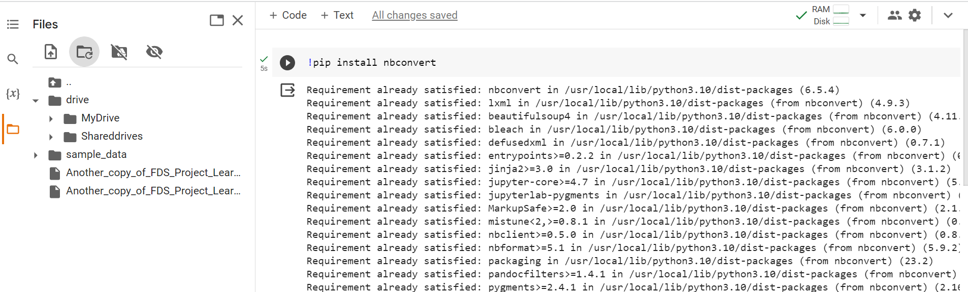
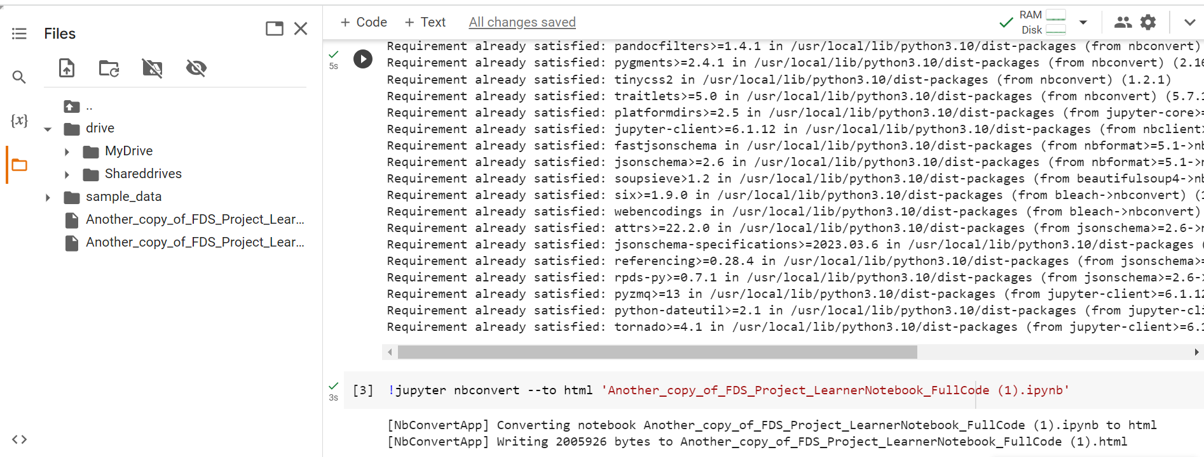

Happy Learning!

How to convert Jupyter Notebook from .ipynb extension to HTML?
Please follow the below steps to download the Jupyter Notebook with .ipynb format to HTML.
- Open the notebook in Jupyter and make sure it is saved with the required outputs being shown after each cell
- Go to the File tab
- Click on Download as
- Click on HTML (.html)
[Refer to the below screenshot]
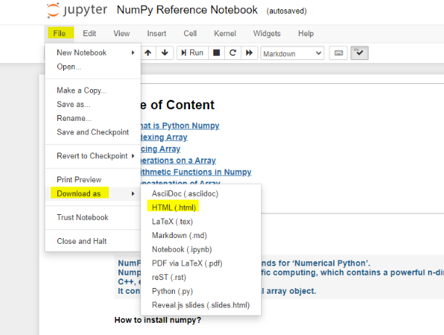

Happy Learning!

How to convert your Project Notebook into html format?
- After you've written all the code in your project notebook, start running it from the first cell, all the way to the bottom.
- Once all the cells are executed successfully, download the notebook as a .ipynb file.
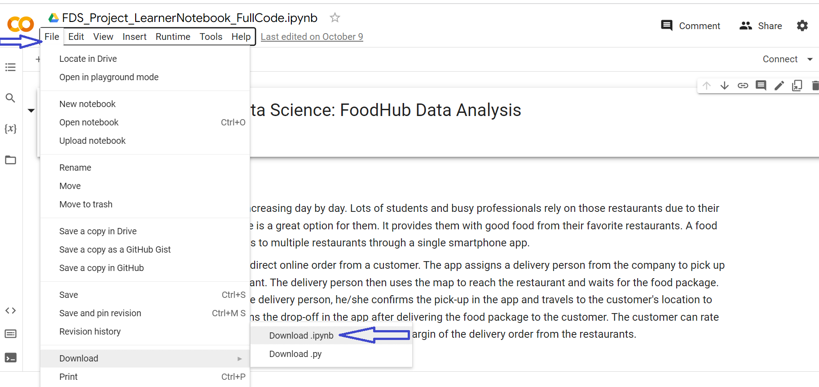
3. Go to the Colab website (https://colab.research.google.com)
4. Open a new notebook there.
5. The screen will look like the below image Click on the Files icon on the left.
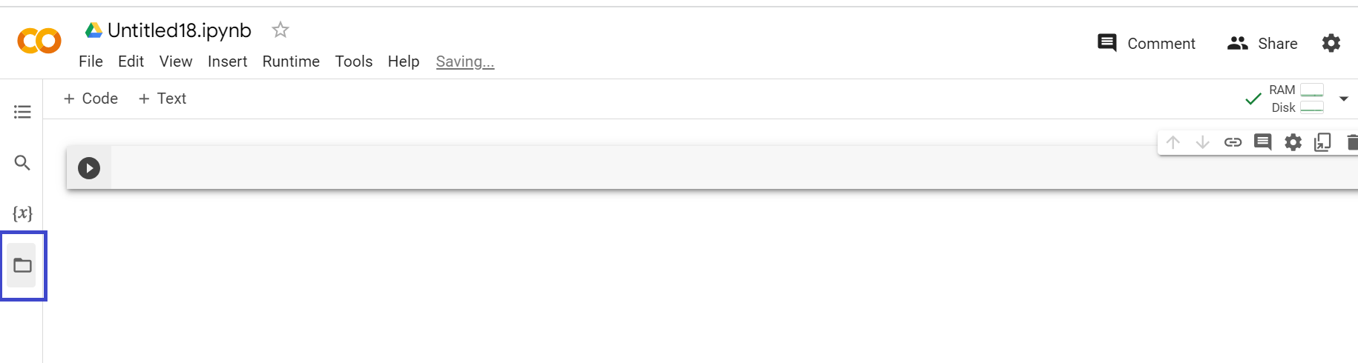

6. Once you click on the above-annotated icon, you will be able to see the upload icon under the new sidebar that has opened up - Files. Look for the project notebook that you just downloaded and upload it to Colab again.
7. Once you start uploading the file, you'll be able to see your files at the bottom left. Depending on the size of the file, this process might take a few minutes
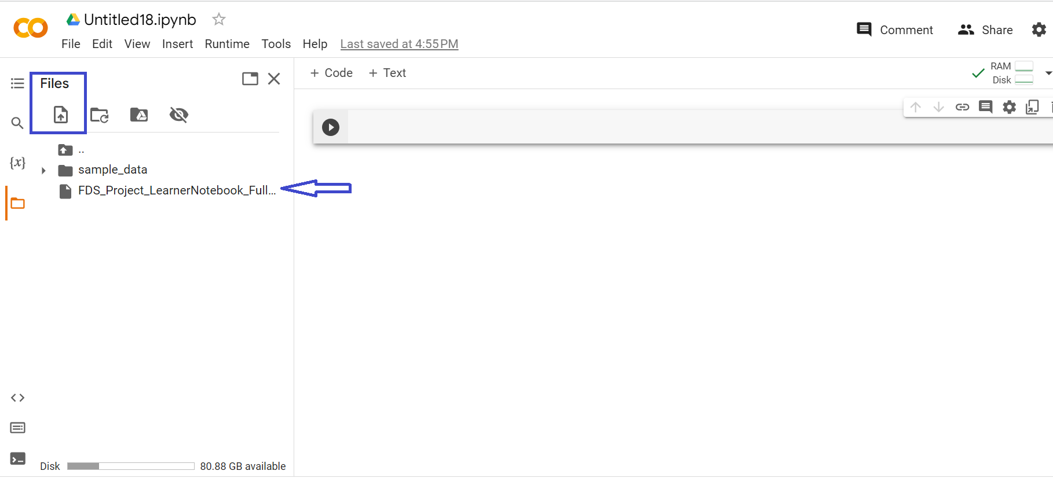
8. To convert this notebook into an HTML file, use the following command and run it inside a code cell.
!pip install nbconvert
! jupyter nbconvert --to html 'FDS_Project_LearnerNotebook_FullCode.ipynb'
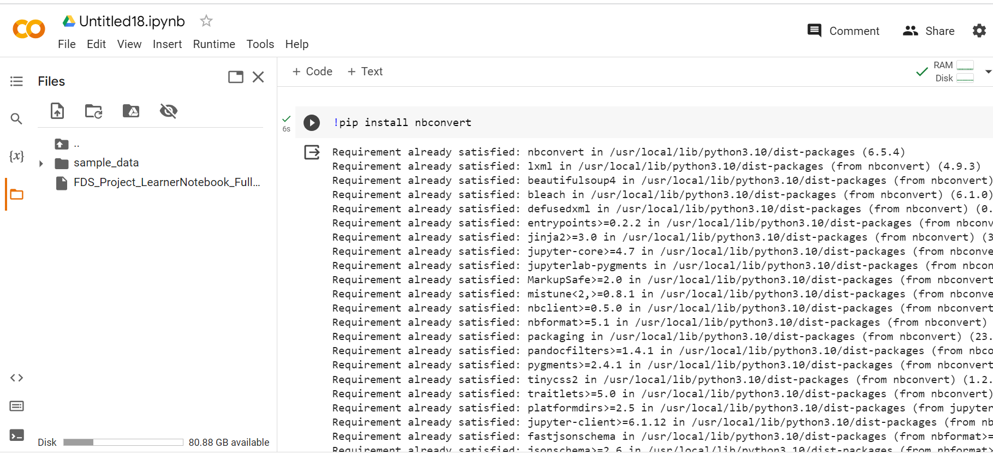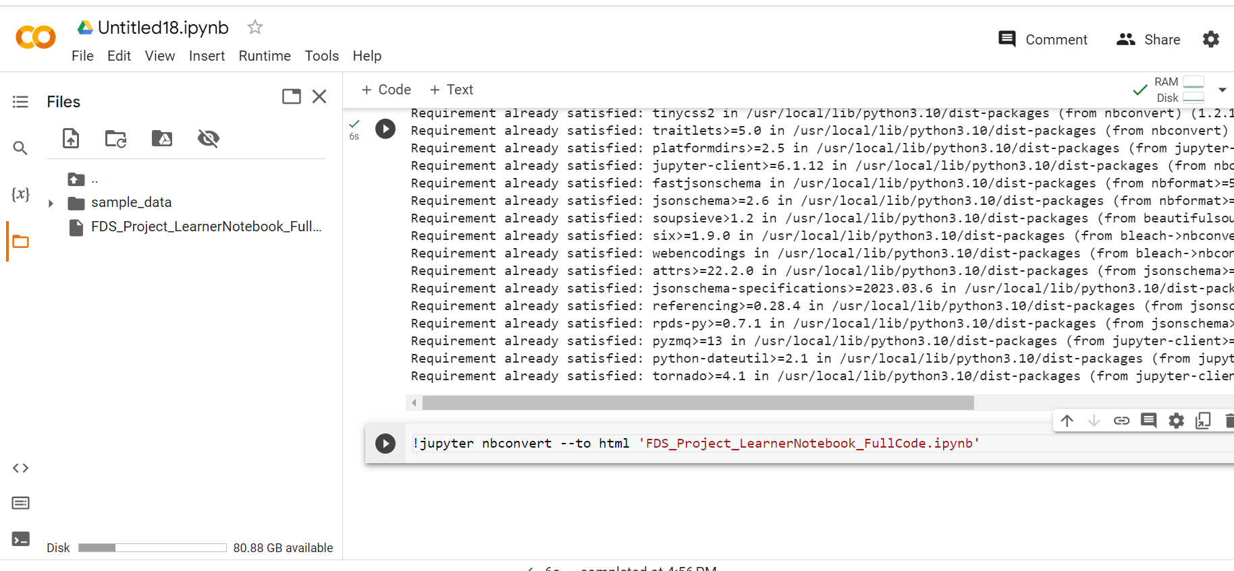
9. You can now download this HTML file, along with the IPYNB file. There will be two files that you will now be able to see in the sidebar:
  - one in IPYNB format,
  - and the other in HTML format
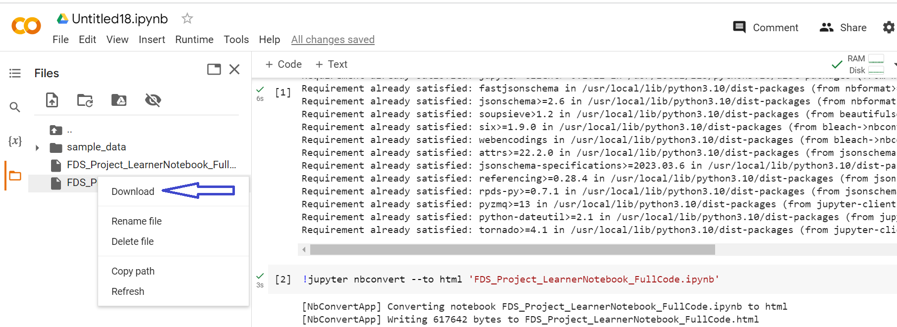
Note:
If we try to use the HTML conversion code on the project file you have worked on, an error will occur.
NbConvertApp] WARNING | pattern 'FDS_Project_SolutionNotebook.ipynb' matched no files
This application is used to convert notebook files (*.ipynb) to various other formats.
Happy Learning!

