Tab 1

Machine Learning

Course Outline
Welcome to the course on Machine Learning. This course will introduce you to the tools and techniques developed to build regression & classification models and their evaluation measures.
Objective: The primary goal of this course is to understand the classical linear and nonlinear regression for prediction and inferential purposes along with their assumptions. We will also focus on the machine learning algorithms required for solving classification problems.
Topics covered:
- Introduction to Supervised Learning: Regression
  - Elementary Statistics
  - Maximum likelihood and Bayesian Estimators
  - Linear Regression
  - Performance Assessment - Estimating parameter means and confidence intervals for prediction
  - Practical application
- Model Evaluation, Cross-Validation and Bootstrapping
  - Prediction vs Modelling
  - Assumptions behind Regression
  - Overfitting and Regularization
  - Bias-variance tradeoff
  - Cross-validation
  - Bootstrapping
  - Practical application
- Introduction to Supervised Learning: Classification
  - Intro: Classification
  - Gaussian Models
  - Bayesian formulation
  - Logistic Regression
  - Performance Assessments
  - Other classification algorithms - K-NN
  - Practical application
Happy Learning!

Know Your Faculty

Dr. John Tsitsiklis
Clarence J. Lebel Professor, MIT Department of Electrical Engineering and Computer Science
Research Departments: MIT Institute for Data, Systems, and Society (MIT IDSS); MIT Laboratory of Information and Decision Systems (MIT LIDS), and the MIT Operations Research Center (MIT ORC)
John Tsitsiklis received a BS degree in mathematics (1980), and a BS (1980), MS (1981), and Ph.D. (1984) degrees in electrical engineering, all from the Massachusetts Institute of Technology. During the academic year 1983-84, he was an acting assistant professor of electrical engineering at Stanford University. Since 1984, he has been with the department of Electrical Engineering and Computer Science at MIT, where he is currently a Clarence J. Lebel Professor of Electrical Engineering. He has served as acting co-director (Spring 1996 and 1997), co-associate director (2008-2013) and director (2017-2020) of the Laboratory for Information and Decision Systems, and as a co-director of the Operations Research Center (2002-2005) and Associate Director of the Institute for Data, Systems, and Society (2015-2020).
He is a member of the National Academy of Engineering and holds an honorary doctorate from the Université Catholique de Louvain. He has served, in Greece, in the National Council on Research and Technology (2005-2007) and as the Chair of the Council of the Harokopio University (2013-2016).
- Professional website: https://idss.mit.edu/staff/john-tsitsiklis/



Dr. Georg Huettenegger
Specialist Leader, Conversational AI
Dr. Georg Huettenegger holds a Master’s and Doctorate degree (Ph.D.) in computer science from the Vienna University of Technology. He is a published author with over 20 years of industry experience. Since 2016 he has been focused on Conversational AI, driving transformative change in big enterprises working for relevant vendors, professional services companies, and users. He has also been a Great Learning industry mentor.
LinkedIn: https://www.linkedin.com/in/georg-huettenegger/

Learning Instruments
The following is an overview of the instructional and assessment-oriented learning instruments that will be part of the learning journey during this course week.

- Live Lectures: There will be 3 live lectures delivered by MIT faculty as part of this course week. The recordings for these live lectures will be made available four hours after live lecture completion. Attending the live lectures or viewing their recordings is crucial and highly recommended to obtain conceptual clarity on the various topics that are part of this course week.
- Pre-reads: These are instructional pages that provide a conceptual preview of the content of the live lectures. It is highly recommended to go through these pre-reads in order to derive maximum value from the live lecture component of the program.
- Lecture Slides: The slides that will be used by the faculty in the live lectures can be found under the 'Lecture Slides' heading in the section for each particular lecture. These will be provided beforehand for reference and preparation.
- Practical Applications: These are hands-on notebooks for the applications / practical examples used by the faculty in the live lectures, to reinforce the practical applicability of some of the key ideas covered in the sessions. You may use these practical applications after the live lectures for hands-on code practice in implementing the techniques introduced by the faculty.
- Practice Case Studies: These are additional case studies, which represent detailed and comprehensive problem-solving exercises. They apply the concepts and ideas taught in the live lectures as a means to solve practical business problems. These practice case studies will help you understand the Python implementation of solutions, practice data interpretation, and generate insights relevant to the problem at hand.
- Additional / Reference Reading Material: These are curated external links to books, articles, open-source video content, and research papers, that provide an opportunity to augment the learning provided by the live lectures, and gain an additional conceptual/implementational perspective.
- Post-Session Summaries: These summary handouts are meant to provide a refresher on the key ideas and takeaways covered in the live lectures, in a written, easy-to-read format. They will help solidify the understanding gained from every part of the live lectures and provide a more permanent method to internalize the ideas discussed in the course week.
- Frequently Asked Questions (FAQs): These curated FAQ Sheets provide a list of some of the most commonly-asked questions and answers from historical iterations of these live lectures in the program. They represent a more direct way of internalizing the key takeaways gained and the conceptual trains of thought that all fellow attendees may have derived from the lecture, in a simple Q&A format.
- Live Lecture Transcripts: A direct Speech-to-Text transcription made available by the video conferencing platform hosting the live lecture component of the program. This may represent a quicker solution to refer to certain keywords or concepts covered over the course of the lecture and understand the exact information provided about that idea. Please note: These transcripts are auto-generated by the platform and not verified for 100% accuracy.
- Live Lecture Chat: These are exported text documents containing the chat history of the live lectures, and by extension, the questions asked and answers provided by all attendees (including the program Teaching Assistants) as part of the session. They provide an opportunity to refer back to specific questions or answers mentioned in the chat window of the live lectures.
- Mentor Learning Sessions (MLS): There will be two Mentor Learning Sessions this course week, which will be conducted over the weekend. The session plan and all the supporting material to be used in these sessions will be made available at the start of the week. It is a good practice to come prepared for these sessions with a list of questions you may wish to ask in the session. This is best achieved by internalizing the ideas covered and the material provided over all three live lectures in the week, as well as reviewing the material released in advance for these Mentor Learning Sessions.
MLS | Case Study
1 | BigMart Sales Prediction
2 | HR Employee Attrition Prediction

- Practice Quiz: This practice quiz is designed to help you evaluate your understanding of the concepts covered in this week's lessons. The quiz consists of 10 multiple-choice questions that cover key topics taught this week. By taking this quiz, you'll have an opportunity to test your knowledge and identify areas where you may need additional review. This practice quiz would supplement your learning and help you prepare for quiz assessment.
- Quiz Assessments: We release the assessments for the upcoming courses one week in advance for learners. The quiz for this course week will consist of 30 marks.
Happy Learning!

Tab 2

Basic Terminologies
In the previous week, we learnt about dimensionality reduction techniques like PCA and t-SNE, and about clustering algorithms like K-Means clustering, Gaussian Mixture Models, Hierarchical clustering and DBSCAN. These techniques broadly fall into the category of Unsupervised Learning, which is characterized by a lack of "labeled data".
This week we will study Supervised Learning, which can broadly be classified into Regression & Classification problems.
Before getting into the content of this week, let us first understand a few basic but helpful terminologies.

Continuous and Categorical variables
A continuous variable can take an infinite number of distinct numerical values, possibly in a given range of numbers. For example, the Monthly Income of employees in a certain firm is a continuous variable.
A categorical variable, on the other hand, can take only a limited (finite) number of distinct values. For example, in an image dataset of single handwritten digits, the digit in the image would be a categorical variable because it can only take a finite number of distinct values, in this case from 0 to 9, and nothing beyond that.

Dependent and Independent Variables
In data science, given a set of variables, we need to establish the relationship between one variable and others. The variable to be estimated is dependent on the rest of the variables and hence called the dependent variable, while the remaining variables that affect the dependent variable are called independent variables.
For example, if we have 4 features Age, Education Level, Work Experience, and Salary, and need to find the relation between the Salary and the rest of the features, the Salary would be the dependent variable while Age, Education Level, and the Work Experience would be independent variables.

Variance and Standard Deviation
In statistics, it is important to understand the magnitude of the spread of the observed data from the Mean.
Variance and Standard Deviation are two quantities that address this concept. To calculate the variance, we take the difference between each number in the dataset and the mean of the data, square this difference to make it positive (independent of sign), and finally divide the sum of the squares by the total number of values in the dataset.
Mathematically, the variance of the population can be given as follows:
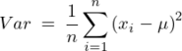
Where is a data point, is the population mean, and is the total number of data points.
One of the major drawbacks of using variance, to understand the spread of the data, is its interpretability. The unit of variance is the square of the original unit of the data. To overcome this, another quantity is introduced, which is the square root of the variance. This is called the standard deviation of the population.
Mathematically, the standard deviation of the population can be given as follows:
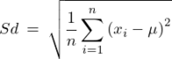
Being the square root of the variance, the standard deviation is more interpretable, having the same units as the original data points. The standard deviation is able to give a sense for the measure of spread of the dataset around its mean.

Confidence Interval
Inferential statistics is associated with estimating the population parameters by extracting samples from the same population. In general, when we make an estimate about some quantity of the population (for example, mean), we come up with a single number. This single number is called a point estimate. For example, if we take a sample from a population and the sample mean is 35, then our most reasonable estimate of the population mean is also 35. The drawback of point estimates is that we do not know how sure we can be that the population mean is close to 35.

To increase the informativeness of our estimate, we associate it with another concept known as the confidence interval.
A confidence interval is a range of values around the point estimate, constructed so that this range will contain the population parameter with a certain degree of confidence, expressed in percentage terms.
Let’s consider an example: Suppose we are extracting 100 samples (data sets) from a group of students in a university, where each sample has a certain number of records. We have calculated the mean age of students from each sample. When we construct confidence intervals (95% confidence level) using the method that will be covered in the first lecture, 95% of samples (data sets) are expected to result in confidence intervals that contain the true population mean.
The higher the confidence, the greater the width of the confidence interval.

Supervised Learning - Linear Regression
Now that we have understood the basic terminologies needed, we are ready to learn about the key concepts behind supervised learning algorithms such as regression and classification.
Let’s start with an example: Suppose you're given a dataset that contains the area of different houses and their market price. Your goal is to come up with an algorithm that will take the area of the house as its input and return its market price as the output.
In this example, the input variable, i.e., the area of the house is called the independent variable (X), the output variable, i.e., house price is called the dependent variable (Y), and this algorithm is an example of supervised learning.
In supervised learning, algorithms are trained using the "labeled" data (in this example, the dependent variable - house price, is considered a label for each house), and after training the algorithm, we can predict the output for instances where this label (house price) is not known. "Labeled data" in this context simply means that the data is already tagged with the correct output. So, in the above example, we already know the correct market price for each house, and that data is used to teach the algorithm so that it can correctly predict the price of a house if it is not known beforehand.
The reason this paradigm of machine learning is known as supervised learning is that it is similar to the process of supervision that a teacher would conduct on the test results of a student on an examination, for example, the answers that the student gives (predictions) are evaluated against the correct answers (the labels), and the difference (error) is what the student would need to minimize to score perfectly on the exam. This is exactly how supervised machine learning algorithms learn.
There are mainly 2 types of supervised learning algorithms:
- Regression, where the output variable is a continuous variable, for example, the price of a house.
- Classification, where the output variable is categorical, for example, approve the loan or not, i.e., yes or no categories.
In this lecture, we will be learning about regression algorithms, which find great use in machine learning prediction of several numerical variables, such as price, income, age, time duration, etc.

Linear Regression
Linear Regression is useful for finding the linear relationship between the independent and dependent variables of a dataset. In the previous example, the independent variable was the area of the house and the dependent variable was the market price.
This relationship is given by the linear equation:
Where is the constant term in the equation, is the coefficient of the variable , and is the difference between the actual value and the predicted value ().
and are called the parameters of the linear equation, while and are the independent and dependent variables, respectively.

What is an error?
With given and in the training data, the aim is to estimate and in such a way that the given equation fits the training data the best. The difference between the actual value and the predicted value is called the error or residual. Mathematically, it can be given as follows:
In order to estimate the best fit line, we need to estimate the values of and which requires minimizing the mean squared error. To calculate the mean squared error, we add the square of each error term and divide the sum by the total number of records:
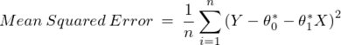
The equation of the best fit line can be given as follows:
Where is the predicted value, are the estimated parameters.
This equation is called the Linear Regression model. The above explanation is demonstrated in the below picture:
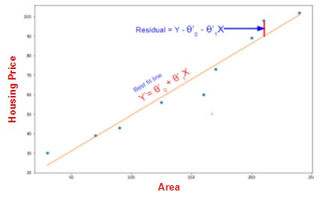
Before applying the model to the unseen data, i.e., the data not observed by the model during the training phase, it is important to check its performance to make it reliable. There are a few metrics to measure the performance of a regression model.
- R-squared: R-squared is a useful performance metric to understand how well the regression model has fitted over the training data. For example, an R-squared of 80% reveals that the model is able to capture 80% of the variation in the dependent variable. A higher R-squared value indicates a better fit for the model.
- Adjusted R-squared: The adjusted R-squared is a modified version of R-squared that takes into account the number of independent variables present in the model. The R-squared always increases when a new independent variable is added to the model, irrespective of whether that variable adds value to the model or not. Hence, R-squared might be misleading when we have multiple independent variables and cannot identify unnecessary variables included in the model.
However, when a new variable is added, the adjusted R-squared increases if that variable adds value to the model, and decreases if it does not. Hence, adjusted R-squared is a better choice of metric than R-squared to evaluate the quality of a regression model with multiple independent variables, because adjusted R-squared only remains high when all those independent variables are required to predict the value of the dependent variable well; it decreases if there are any independent variables which don't have a significant effect on the predicted variable.
- RMSE: RMSE stands for Root Mean Squared Error. It is calculated as the square root of the mean of the squared differences between the actual output and the predictions. The lower the RMSE the better the performance of the model. Mathematically, it can be given as follows:
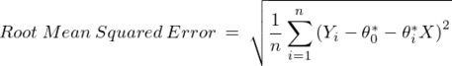

Maximum Likelihood and Empirical Risk Minimization
To establish the relationship between variables, it is required to calculate the parameters of the model. Now that we have understood the basics of supervised learning algorithms and linear regression, let us look at how to estimate the parameters of the linear regression model. We will see the intuition of two methods that are used to estimate these parameters:
- Maximum Likelihood
- Empirical Risk Minimization
Maximum Likelihood
Let (Xi​,Yi​) be a sample in a certain dataset with n records. Consider Yi​∣Xi​ as an event that shows the occurrence of Yi​ provided Xi​ has already occurred, i.e., given the input features Xi​, the occurrence of Yi​.
In the entire sample, there are n such events. The likelihood of the event Yi​∣Xi​ is the probability of occurrence of this event.
In the context of linear regression, let us consider the relationship between Yi​ and Xi​ which is as follows:
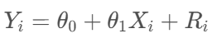
Where θ0​ is the constant term in the equation, θ1​ is the coefficient to the variable Xi​, and Ri​ is the error term (residual).
It is assumed that the events in the sample are independent of each other and the error terms follow a normal distribution, with a mean equal to the prediction and standard deviation σ. Keeping in mind the normal distribution, mathematically, the likelihood function is defined as follows:
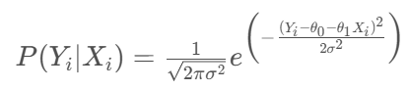
The above equation shows the likelihood of a single event. To estimate the collective likelihood of the entire sample of events, we need to combine the likelihood of all the individual events in the sample.
Now, as we assumed that the events in the sample are independent of each other, we can apply the multiplication rule of probability. Hence, the likelihood of the entire sample of events can be given as follows:
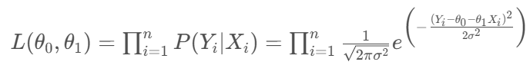
The above equation shows the combined probability of all the events to occur in the sample. To estimate the parameters, the above expression has to be maximized and the maximum value of the above expression is called the maximum likelihood.
Empirical Risk Minimization
If the error is high, then it can be considered that the algorithm is not making predictions close to the actual value, i.e., the prediction is at higher risk. Hence, the higher the error, the higher the risk and vice versa.
Empirical risk can be defined as the collective error made by the model over all the training records. During the estimation of the parameters of the model, we use the principle of empirical risk minimization where the empirical risk is minimized to get the model parameters. The expression of empirical risk can be given as follows:
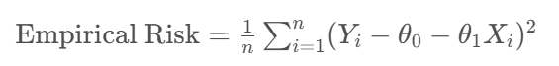
A higher empirical risk is equivalent to a lower likelihood and vice versa.

New Package Introduction - Introduction to Supervised Learning and Regression

Scikit-Learn
Some of the common functions used from the Scikit-learn library in the hands-on applications related to the first lecture are listed below:
1) from sklearn.linear_model import LinearRegression
A predictive model can be fitted, using linear regression, to an observed dataset of target variable and the independent variables.
sklearn.linear_model.LinearRegression(*, fit_intercept=True, normalize='deprecated', copy_X=True, n_jobs=None, positive=False)
Example
from sklearn.linear_model import LinearRegression
model = LinearRegression()
model.fit(xtrain, ytrain)
You can refer to the LinearRegression sklearn documentation for a better understanding of the parameters and attributes here.

2) from sklearn.model_selection import train_test_split
Machine learning algorithms that are applicable to prediction-based algorithms and applications are fitted on one part of the data, called training data, and are evaluated on the other (smaller) part of the data, called test data. We split the data into train and test sets using the train_test_split function.
sklearn.model_selection.train_test_split(*arrays, test_size=None, train_size=None, random_state=None, shuffle=True, stratify=None)
Example
from sklearn.model_selection import train_test_split
# Creating the training and testing data from X and Y
xtrain,xtest,ytrain,ytest = train_test_split(X,Y,test_size=0.2, random_state=42)
You can refer to the train_test_split sklearn documentation for a better understanding of the parameters and attributes here.

3) from sklearn.preprocessing import MinMaxScaler
MinMaxscaler is a scaling technique for continuous variables used in machine learning. The minimum and maximum values are scaled to be 0 and 1, respectively, by the MinMaxscaler.
sklearn.preprocessing.MinMaxScaler(feature_range=(0, 1), *, copy=True, clip=False)
Example
from sklearn.preprocessing import MinMaxScaler
scaler = MinMaxScaler()
# scaling the training data
scaled_train = scaler.fit_transform(x_train)
You can refer to the MinMaxscaler sklearn documentation for a better understanding of the parameters and attributes here.

4) from sklearn.model_selection import cross_val_score
In applied machine learning, cross-validation is mostly used to evaluate how well a machine-learning model performs on untrained data. That is, to use a small sample to assess how the model will generally perform when used to generate predictions on data that was not utilized during the model's training.
To start the cross-validation process, the data is divided into k folds and shuffled (to avoid any unintended ordering problems). The following procedure is followed for each of the k-folds:
- A model is trained using of the folds as training data
- The resulting model is validated on the remaining part of the data (i.e., it is used as a test set to compute a performance measure).
sklearn.model_selection.cross_val_score(estimator, X, y=None, *, groups=None, scoring=None, cv=None, n_jobs=None, verbose=0, fit_params=None, pre_dispatch='2*n_jobs', error_score=nan)
You can refer to the cross_val_score sklearn documentation for a better understanding of the parameters and attributes here.

Statistical functions (statsmodels):
A Python package called statsmodels offers classes and functions for estimating a variety of statistical models, running statistical tests, and exploring statistical data.
Statsmodels can be installed easily by running the below command in your Jupyter notebook:
Installation:
!pip install statsmodels
Once the command runs successfully, restart the kernel, and then we can import the library by running the following command in a Jupyter notebook
import statsmodels.api as sm
5) Ordinary Least Squares(OLS):
A popular method for calculating the coefficients of linear regression equations that represent the relationship between one or more independent quantitative variables and a dependent variable is ordinal least squares regression (OLS). It's applicable for simple or multiple linear regression.
OLS(endog, exog, missing, hasconst); here endog = dependent variable, exog = independent variables
You can refer to the documentation for a better understanding of the parameters and attributes here.
To fit and summarize the model
model = sm.OLS(y, x)
res = model.fit()
print(res.summary())
Below we can find the function implementation in the BigMart_Sales_Prediction case study:
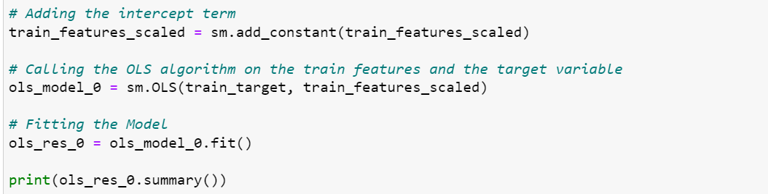

6) Variance inflation factor(VIF):
The variance inflation factor measures how much the variance of parameter estimates will rise when the exog idx (x) variable is added to the linear regression. It is a measurement of the exog design matrix's multicollinearity.
It's suggested to assume that if VIF is more than 5, the explanatory variable provided by exog idx is highly correlated with the other explanatory variables and that, as a result, the parameter estimates will have significant standard errors.
To import the function, run the following command in a Jupyter notebook
from stats.model.stats.outliers_influence import variance_inflation_factor
You can refer to the documentation for a better understanding of the parameters and attributes here.
Below we can find the function implementation in the BigMart_Sales_Prediction case study:
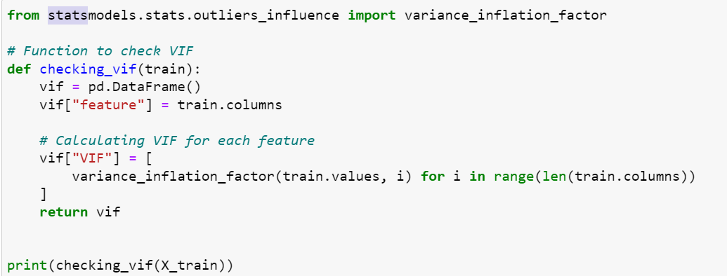

Regression Diagnostics and specification tests:
We don't know whether our statistical model is correctly described in many scenarios of statistical analysis. For example, when using ols we assume linearity and homoscedasticity. Some test statistics additionally assume that the errors are normally distributed or that we have a large sample. Because our results are dependent on these statistical assumptions, the results are only correct if our assumptions are correct (at least approximately).
- Homoscedasticity - If the residuals are symmetrically distributed across the regression line, then the data is said to be homoscedastic.
- Heteroscedasticity - If the residuals are not symmetrically distributed across the regression line, then the data is said to be heteroscedastic. In this case, the residuals can form a funnel shape or any other non-symmetrical shape
The diagnostic tests for linear regression are described briefly below.
7) Heteroscedasticity tests:
The null hypothesis for these tests is that all observations have the same error variance, i.e., the errors are homoscedastic. The tests differ in terms of the type of heteroscedasticity accepted as an alternate hypothesis.
het_goldfeldquandt: It is used to test the presence of heteroscedasticity in the given data.
To import the function, run the following command in a Jupyter notebook
from statsmodels.compat import lzip
GQ_test = sms.het_goldfeldquandt(y_train, x_train)
You can refer to the documentation for a better understanding of the parameters and attributes here.
Below we can find the function implementation in the superkart case study:
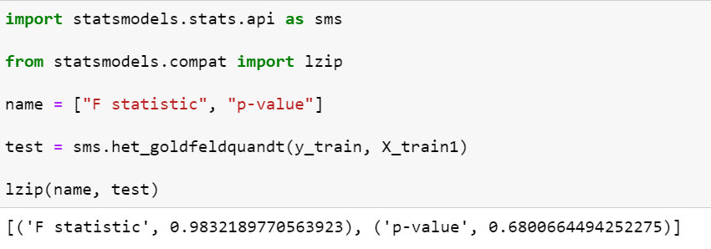

SciPy (Scientific Python):
An open-source Python library called SciPy is used to solve problems in science and mathematics. It is based on the NumPy extension and offers a large variety of high-level functions for manipulating and visualizing data. It provides many user-friendly and effective numerical functions for numerical integration and optimization.
scipy.stats package is imported as
from scipy import stats
And in some cases, we assume that individual objects are imported as:
from scipy.stats import norm
You can refer to the documentation for a better understanding of the parameters and attributes here.

8) Q_Q plot:
The plot obtained is known as a quantile-quantile plot, or Q_Q plot, when the quantiles of two variables are placed against one another. With respect to the locations, this plot summarises whether or not the distributions of two variables are similar.
To import the function, run the following command in a Jupyter notebook
import scipy.stats as ststs
scipy.stats.probplot(x, sparams=(), dist='norm', fit=True, plot=None, rvalue=False)
You can refer to the documentation for a better understanding of the parameters and attributes here.
Below we can find the function implementation in the superkart case study:
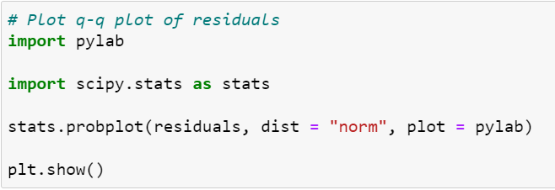

9) Pearsonr:
A linear relationship between two variables' strength and direction is measured by the Pearson correlation coefficient. Values usually fall between -1 and 1, with 1 denoting a perfectly positive correlation and -1 denoting a perfectly inverse relationship.
To import the function, run the following command in a Jupyter notebook
from scipy.stats import pearsonr
scipy.stats.pearsonr(x, y, *, alternative = 'two sided')
You can refer to the documentation for a better understanding of the parameters and attributes here.

Happy Learning!

Curated Articles - Introduction to Supervised Learning and Regression
Please find below some curated external links to articles about linear regression, maximum likelihood, and empirical risk minimization.
- Linear Regression: This article explains the linear regression algorithm along with the underlying assumptions. It talks about the various performance measures used to evaluate the model.
- Maximum Likelihood Estimation: This article explains the concept of maximum likelihood estimation and why it is used in machine learning with the help of examples.
- Empirical Risk Minimization: This article gives an intuition behind empirical risk minimization.
Happy Learning!

The Assumptions of Linear Regression
When applying linear regression to solve real-life regression problems, we need to understand that the algorithm operates under some assumptions. These assumptions allow us to correctly conclude from the results of our analysis. In case one or more of these assumptions are violated, the results and the performance of the model might not be reliable enough to extract inferences from the model and apply those to the unseen data. This is why it is necessary to check whether the below-specified assumptions are satisfied by the linear regression model or not.
- Linearity: The first and foremost assumption is related to the type of relation between the dependent and independent variables. Since the linear regression model fits a line to the data, the relation between the independent variables and the dependent variable must be linear; otherwise, it might fail to identify the pattern in the data and result in a higher error.
- Multicollinearity: This is a phenomenon related to the correlation among the independent variables in the data. Linear regression assumes that there is no multicollinearity between the independent variables. Multicollinearity reduces the precision of the estimated coefficients, which weakens the statistical power of the regression model. This is because correlated variables will provide repeated information to the model and hence the significance of one variable might decrease than the actual value. To avoid this, it is necessary to include only non-correlated independent variables in the model.
- Homoscedasticity: According to this assumption, the error associated with each data point should be equally spread (meaning “constant variance”) along the best fit line. The derivation of the equation of the linear regression model assumes that the error terms have a constant variance. Hence, the results from the linear regression model might not be reliable in case the assumption of homoscedasticity is violated.
- Normal Distribution of error terms: If error terms are non-normally distributed, confidence intervals may become too wide or narrow. Once the confidence interval becomes unstable, it leads to difficulty in estimating coefficients based on the minimization of least squares. The presence of a non–normal distribution suggests that there are a few unusual data points that must be studied closely to make a better model.
- Endogeneity: This is the phenomenon of independent variables being correlated to the error terms of the model. With endogeneity, the optimization process will lead to biased parameters of the model. This will adversely affect the performance of the model. To avoid this, it is assumed that the independent variables are not correlated to the error terms.

Correlation vs Causation

Correlation
The term correlation means that there is some kind of relationship or pattern between two variables.
How can we determine if there is a correlation between variables?
Graphically, the correlation can be observed using a scatter plot between two variables.
Positive correlation: When one variable increases, the other variable also increases in tandem. The below scatter plot shows a positive correlation between two variables.
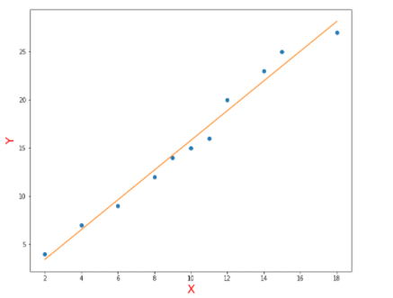
Negative correlation: When one variable increases, the other variable decreases. The below scatter plot shows a negative correlation between two variables.
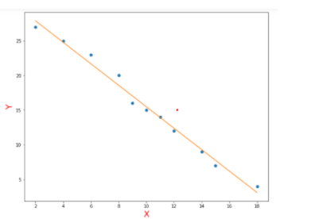
No (or zero) correlation: If the scatter plot shows that two variables are randomly scattered, i.e., one variable neither increases nor decreases with the other variable, then they may be thought to have no correlation between them.
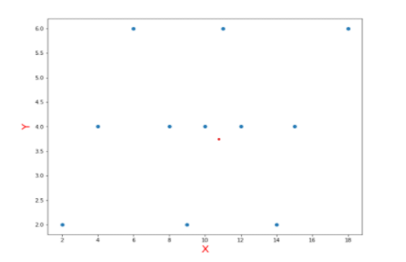

Causation
Causation means that one event causes another event to occur.
Let’s consider the example in the below image:
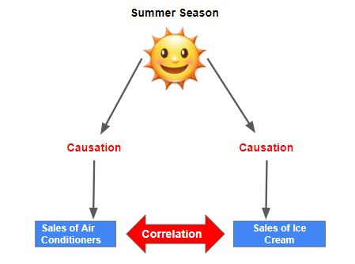
We know that in summers, there is likely to be an increase in sales of ice cream and sales of air conditioners. Hence, we can say that:
- There is a causal relationship between the summer season and sales of ice cream.
- There is a causal relationship between the summer season and sales of air conditioners.

Correlation vs Causation
It is important to note that correlation does not imply causation. There might be a third variable affecting the relationship between the two variables.
For example, we observed above that due to the causal relationship of summers with sales of air conditioners and sales of ice cream, the plot of sales of air conditioners and sales of ice cream in summers might show some positive correlation as both increase in the summer season but there is no particular causal relationship between the two variables.

Bootstrapping

What is bootstrapping?
Bootstrapping is a statistical procedure that resamples a single dataset to create many simulated samples.

How do we perform bootstrapping?
We perform bootstrapping using sampling with replacement method, where each sample is called a "Bootstrap Sample".
In sampling with replacement, we draw an item randomly from the population and put it back into the population before drawing the next item, i.e., each item has an equal chance of getting selected every time we draw an item. Hence, one item can be selected multiple times in a particular sample.
In bootstrapping, the number of records in each bootstrap sample can be smaller than or equal to the total number of records in the original data.
Let's consider an example of a bootstrap sample on dummy data: The below image shows bootstrap samples created from the original dataset. Let's say in our case, we want 3 records in each bootstrap sample.
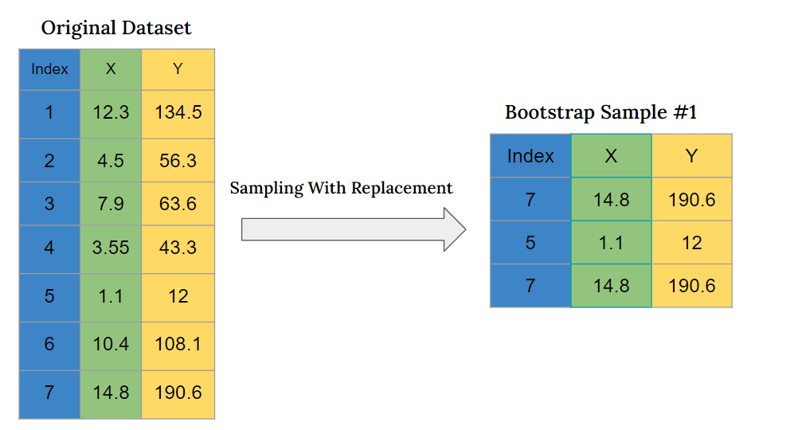
In the above image, we can see that 3 records have been randomly sampled to create a bootstrap sample and here the record with index 7 is repeated 2 times in the bootstrap sample.
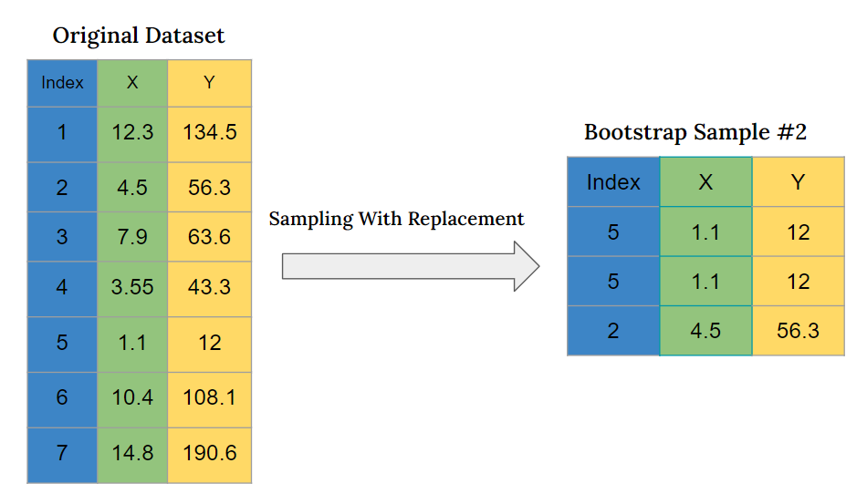
In the above image, we can see that 3 records have been randomly sampled to create a bootstrap sample and here the record with index 5 is repeated 2 times in the bootstrap sample.
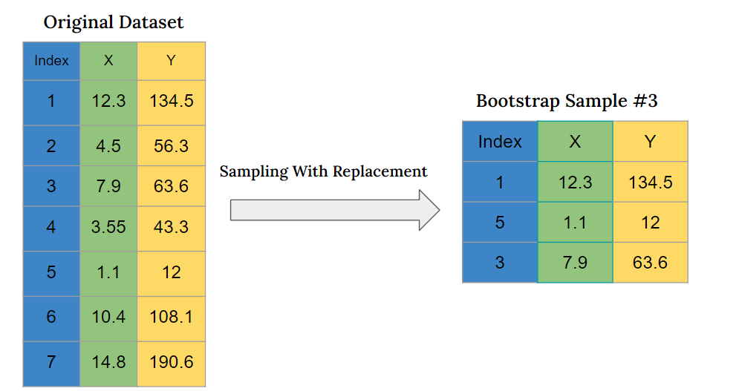
In the above image, we can see that 3 records have been randomly sampled to create a bootstrap sample and all the records are unique.

Bias-Variance Trade-off
Let us begin with some key terminologies that will be useful during this lecture:
Training data: The training data is part of the original data used to train the model. Generally, it is taken as the bigger fraction of the data.

Validation data: This is a smaller fraction (in comparison to the training data) of the original data used to validate the model. The performance of the model is iteratively validated using the validation data and optimizing the parameters of the model.

Testing/unseen data: The model is finally tested on the testing data which has not been observed by the model, hence called unseen data, to get an understanding of whether the model can replicate the performance from the training data to the new data.

Model Complexity: A model is considered more complex if it has a higher number of parameters that we need to estimate while training the model. The parameters refer to the coefficients associated with the variables in the model.

Overfitting refers to the scenario where a machine learning model can’t generalize on the test / unseen dataset. A clear sign of overfitting is that the error on the training set is very small than the error on the test dataset, i.e., the model has fitted very closely to the training data including the noise, and hence cannot give good performance on the testing data.

Underfitting refers to a model that does not fit the training dataset well and fails to identify the pattern in the data, and consequently, gives a poor performance on the training as well the testing dataset. Hence, an underfit machine learning model is not a suitable model.
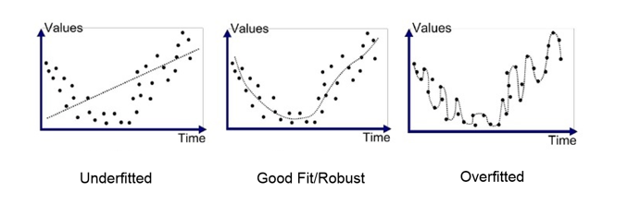
Bias
In very simple terms, Bias is the amount by which a model’s predictions differ from the target values, on the training data, i.e., the training error. Every algorithm starts with some level of bias because bias is a result of assumptions of the model that makes the target function easier to learn. A high level of bias can lead to underfitting, which occurs when the algorithm is unable to capture relevant relations between features and target outputs. A high bias model typically includes more assumptions about the target function. A low bias model incorporates fewer assumptions about the target function.

Variance
Variance indicates how much the performance of the model would differ if different training data is used. A model with high variance would fit the training data too closely and would result in a significant change in the performance for the small changes in the dataset, i.e., the model will not give a generalized performance, which will lead to overfitting.
A model cannot overfit and underfit at the same time. If it overfits, then it will perform well on the training data but won't be able to reproduce the results on the validation data, and if it underfits, then it will perform poorly on both the training and validation datasets. This creates the possibility of an exchange or tradeoff between bias and variance.

Bias-Variance Trade-off
If we increase the bias of an overfit model, we are making the model simpler and capable of generalizing over the validation set. Its performance on the validation set will improve and, consequently, the variance will decrease. On the other hand, if we decrease the bias of an underfit model, we are making the model more complex and the model will fit the training data more closely and, consequently, the variance will increase. This phenomenon is called the Bias-Variance tradeoff.
The below image shows this trade-off between bias and variance. It shows that the model with high bias and low variance will underfit the model and the model with low bias and high variance will overfit the data.
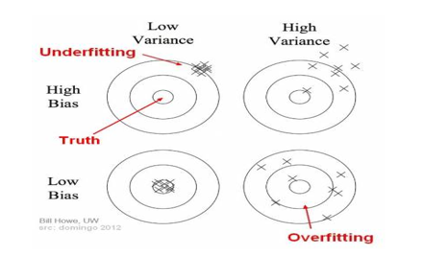

Regularization - Ridge Regression & Lasso Regression
In real-life cases, the machine learning models follow the existing patterns in the training data up to different extents. The main purpose of modeling is to make it perform well on unseen data. To do so, the model needs to be free from both overfitting and underfitting.
In machine learning, regularization is the process of making a model simpler by reducing the importance of variables that are less significant, i.e., adding a penalty in the cost function if more importance is given to such variables.
A variable plays its role in a model with its values and the coefficients associated with it. This indicates that regularization can be done by regulating this coefficient. In general, regularization works well when we have a high number of features.
Regularization is a technique used to reduce the overfitting of the model. There are two major types of regularization techniques used in regression problems. They are given as follows:
- Ridge regression
- Lasso regression

Let us discuss them one by one:

- Ridge Regression: In Ridge regression, as a modification in the cost function, an additional term that is equal to the product of a regularization parameter and the sum of the square of the coefficients of the model is added. Ridge regression is also called L2 regularization because the additive term contains the second order of the coefficients.
Mathematically, the loss function for Ridge regression is as follows:
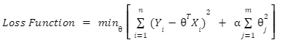
Where, is the regularization parameter, is the total number of observations, and is the total number of columns.
The higher the value of the regularization parameter, the higher the penalty, and therefore the magnitude of the coefficients is reduced.
The L2 regularization will reduce the effect of some coefficients by minimizing them, but it will not completely eradicate the effect of the feature/variable from the model.
- Lasso Regression: It is another type of regression that uses regularization but in a different way. In Lasso regression, as a modification in the cost function, the product of the regularization parameter and the sum of the modulus of the model coefficients is added. As the model parameters are of the first order, it is also called L1 regularization.
Mathematically, the loss function for Lasso regression is given as follows:
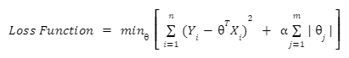
Where, is the regularization parameter, is the total number of observations, and is the total number of columns.
The higher the value of the regularization parameter, the bigger the penalty, and therefore the magnitude of the coefficients is reduced.
The L1 regularization will drive some coefficients to 0 and hence performs feature selection because multiplying a variable with 0 removes the effect of that variable from the model.

Cross-Validation

Cross-Validation
Cross-Validation, as the name suggests, we are cross-validating something before the final approval. Here, we are cross-validating our model by dividing the training dataset into 2 parts - the train and the validation datasets and then checking the performance of the model which we trained on the training dataset using the validation dataset.
There are many ways of doing cross-validation, one of the most used ways is K-fold cross-validation.

K-fold cross-validation:
Let’s say that there is a dataset with 1000 observations. We randomly divide them into 5 groups of equal size, called folds, and each fold consists of 200 observations.
The first fold can be kept separate to be used as the validation set, and the rest of the folds are used to train the model. After training our model, we can calculate the performance of the model on the validation set. We repeat this process K times and at each iteration, we choose a new fold for the validation set and the test of the folds for the training set.
The below image shows the process of K-fold cross-validation discussed above.

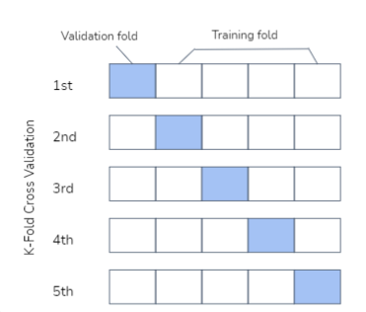

New Package Introduction - Model Evaluation, Cross-Validation and Bootstrapping
Some of the common functions used from the Scikit-learn library in the case studies related to the second lecture are listed below:
1) from sklearn.linear_model import Ridge
In order to reduce the overfitting of linear models, ridge regression is a form of linear regression approach used in machine learning. The Ridge module in Sklearn is used to solve a regression model where the regularisation is L2 and the loss function is the linear least squares function.
sklearn.linear_model.Ridge(alpha=1.0, *, fit_intercept=True, normalize='deprecated', copy_X=True, max_iter=None, tol=0.001, solver='auto', positive=False, random_state=None)
Example
from sklearn.linear_model import Ridge
model = Ridge()
model.fit(xtrain, ytrain)
You can refer to the ridge algorithm available in sklearn documentation for a better understanding of the parameters and attributes here.

2) from sklearn.linear_model import Lasso
L1 regularisation is carried out using the regularisation method LASSO. By adding the penalty (shrinkage quantity) equal to the tally of the absolute values of the coefficients, it alters the loss function.
sklearn.linear_model.Lasso(alpha=1.0, *, fit_intercept=True, normalize='deprecated', precompute=False, copy_X=True, max_iter=1000, tol=0.0001, warm_start=False, positive=False, random_state=None, selection='cyclic')
Example
from sklearn.linear_model import Lasso
model = Lasso()
model.fit(xtrain, ytrain)
You can refer to the lasso algorithm available in sklearn documentation for a better understanding of the parameters and attributes here.

3) from sklearn.preprocessing import StandardScaler
sklearn.preprocessing.StandardScaler(*, copy=True, with_mean=True, with_std=True)
The distribution of data is scaled using StandardScaler so that the mean of the observed values is 0 and the standard deviation is 1.
Example
from sklearn.preprocessing import StandardScaler
scaler = StandardScaler()
# scaling the training data
scaled_train = scaler.fit_transform(x_train)
You can refer to the standard scaler sklearn documentation for a better understanding of the parameters and attributes here.

Know Your Faculty

Dr. Georg Huettenegger
Specialist Leader, Conversational AI
Dr. Georg Huettenegger holds a Master’s and Doctorate degree (Ph.D.) in computer science from the Vienna University of Technology. He is a published author with over 20 years of industry experience. Since 2016 he has been focused on Conversational AI, driving transformative change in big enterprises working for relevant vendors, professional services companies, and users. He has also been a Great Learning industry mentor.
LinkedIn: https://www.linkedin.com/in/georg-huettenegger/

