Tab 1

A Beginner's Guide to Google Compute Engine
Published: June 25, 2025

For a similar lab, refer to Cloud Skill Boost “Google Cloud Fundamentals: Getting Started with Compute Engine” (25 minutes, No cost)

Overview
- In this lab, you will create virtual machines (VMs) and connect to them.
- You will also create connections between the instances.

Objectives
- Create a Compute Engine virtual machine using the Google Cloud console.
- Create a Compute Engine virtual machine using the gcloud command-line interface.
- Connect between the two instances.

Tasks

Task 1. Sign in to the Google Cloud console
- Sign in to Qwiklabs using an incognito window.
- Note the lab's access time (for example, 1:15:00), and make sure you can finish within that time.
There is no pause feature. You can restart if needed, but you have to start at the beginning.
- When ready, click Start lab.
- Note your lab credentials (Username and Password). You will use them to sign in to the Google Cloud Console.
- Click Open Google Console.
- Click Use another account and copy/paste credentials for this lab into the prompts.
If you use other credentials, you'll receive errors or incur charges.
- Accept the terms and skip the recovery resource page.
Note: Do not click End Lab unless you have finished the lab or want to restart it. This clears your work and removes the project.

Task 2. Create a virtual machine using the Cloud console
- In the Navigation menu (), click Compute Engine > VM instances.
- Click CREATE INSTANCE.
- On the Create an Instance page, for Name, type my-vm-1.
- For Region and Zone, select the region and zone assigned by Google Cloud Skills Boost.
- For Machine type, accept the default.
- Click on the OS and storage.
- Under Operating system and storage, if the Image shown is not Debian GNU/Linux 11 (Bullseye), click Change and select Debian GNU/Linux 11 (Bullseye).
- Click Networking.
- For Firewall, click Allow HTTP traffic.
- Leave all other defaults unmodified.
- To create and launch the VM, click Create.
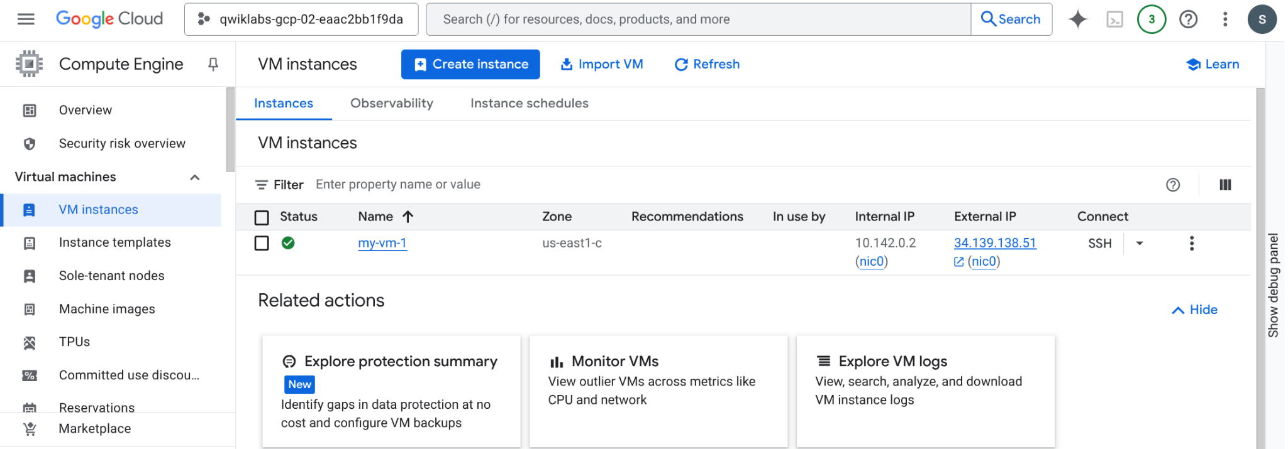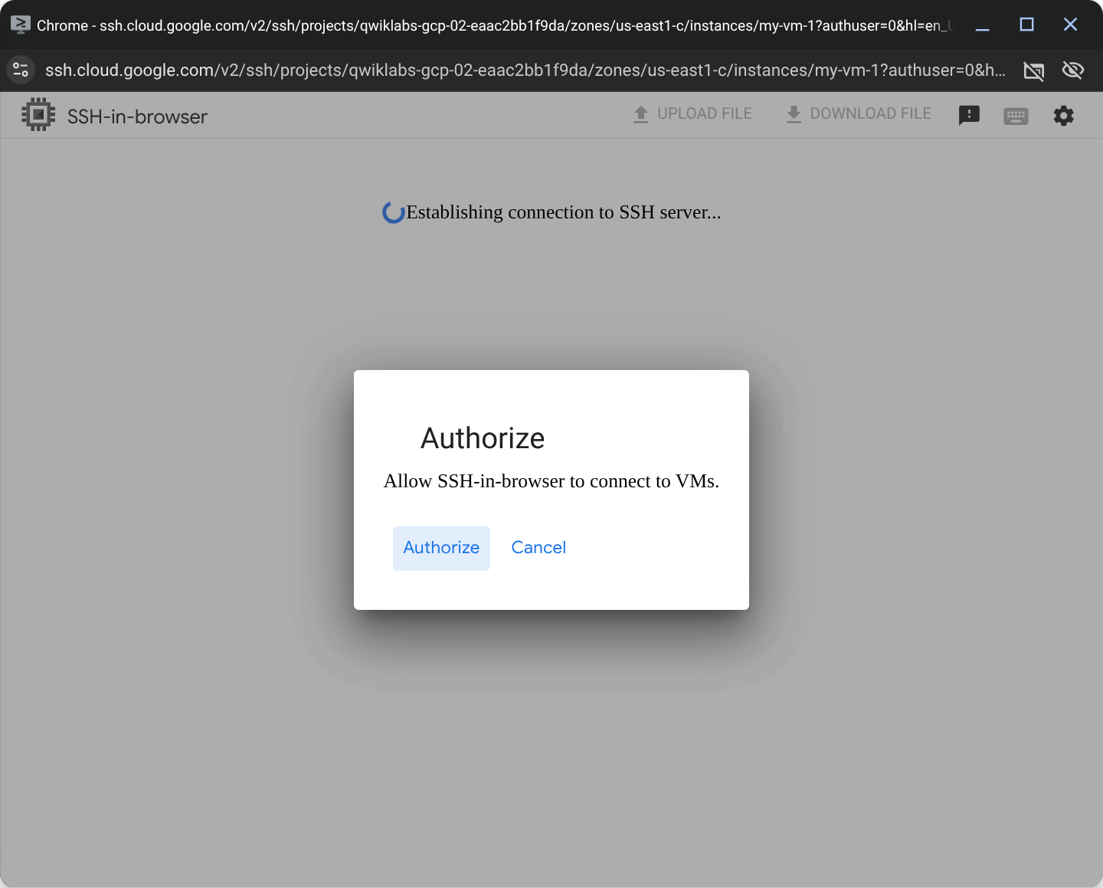
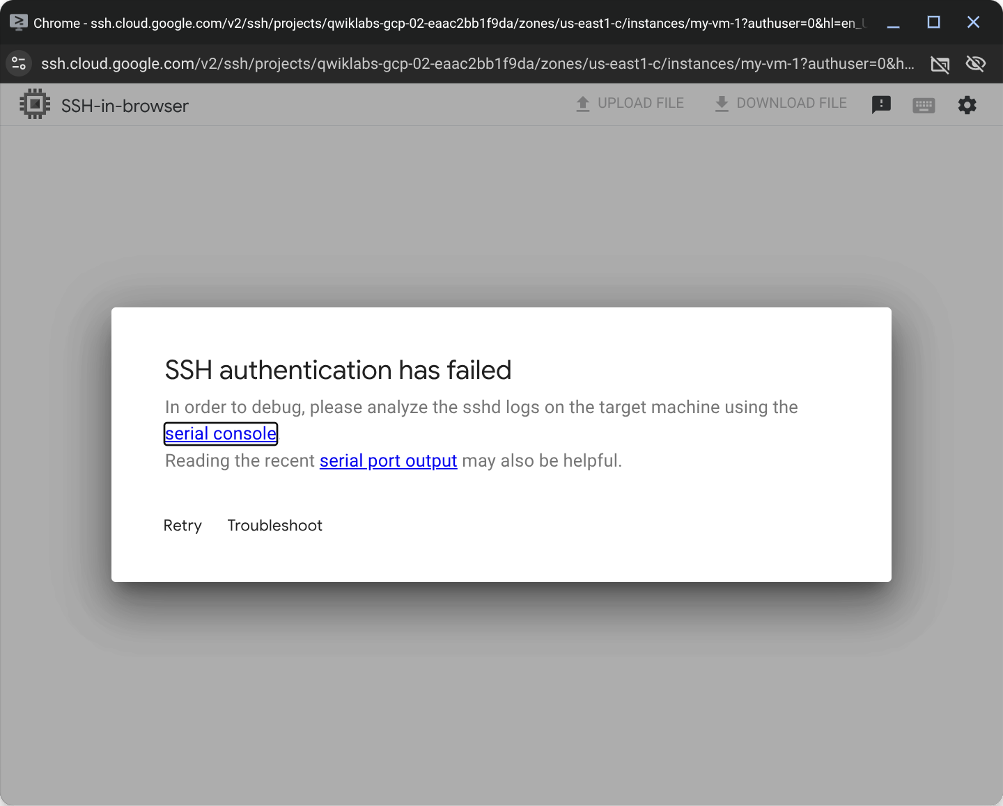
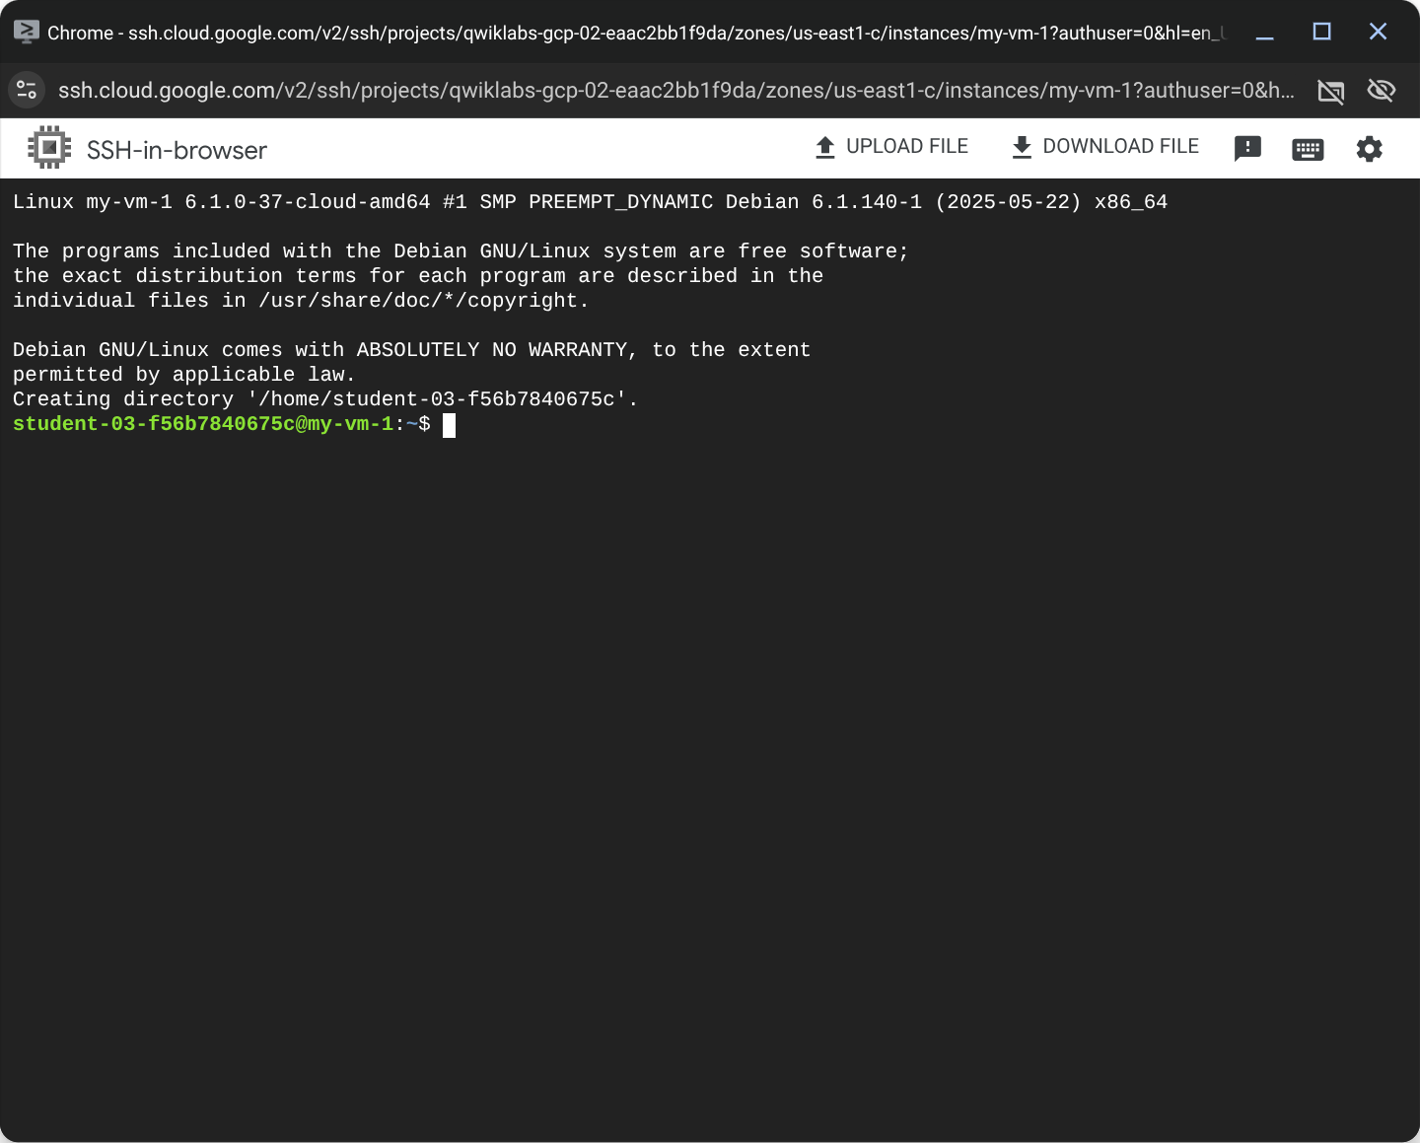

Task 3. Create a virtual machine using the gcloud command line
- In the Cloud console, on the top right toolbar, click the Activate Cloud Shell button ().
- Click Continue.
- To display a list of all the zones in the region to which Google Cloud Skills Boost assigned you, enter this partial command gcloud compute zones list | grep followed by the region that Google Cloud Skills Boost or your instructor assigned you to.
Your completed command will look like this:
$ gcloud compute zones list | grep us-east1
NAME: us-east1-b
REGION: us-east1
NAME: us-east1-c
REGION: us-east1
NAME: us-east1-d
REGION: us-east1
$

4. Choose a zone from that list other than the zone to which Google Cloud Skills Boost assigned you. For example, if Google Cloud Skills Boost assigned you to region us-east1 and zone us-east1-b you might choose zone us-east1-c.
5. To set your default zone to the one you just chose, enter this partial command gcloud config set compute/zone followed by the zone you chose.
Your completed command will look like this:
$ gcloud config set compute/zone us-east1-b
Updated property [compute/zone].
$

6. To create a VM instance called my-vm-2 in that zone, execute this command:
$ gcloud compute instances create "my-vm-2" \
--machine-type "e2-medium" \
--image-project "debian-cloud" \
--image-family "debian-11" \
--subnet "default"

Created [https://www.googleapis.com/compute/v1/projects/qwiklabs-gcp-02-eaac2bb1f9da/zones/us-east1-b/instances/my-vm-2].
NAME: my-vm-2
ZONE: us-east1-b
MACHINE_TYPE: e2-medium
PREEMPTIBLE:
INTERNAL_IP: 10.142.0.3
EXTERNAL_IP: 34.138.63.175
STATUS: RUNNING
$
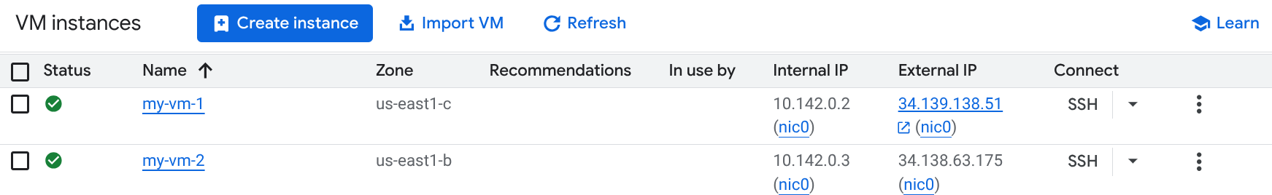

7. To close the Cloud Shell, execute the following command:

$ exit

Task 4. Connect between VM instances
- In the Navigation menu, click Compute Engine > VM instances.
You will see the two VM instances you created, each in a different zone.
Notice that the Internal IP addresses of these two instances share the first three bytes in common. They reside on the same subnet in their Google Cloud VPC even though they are in different zones.
- To open a command prompt on the my-vm-2 instance, click SSH in its row in the VM instances list.
- Use the ping command to confirm that my-vm-2 can reach my-vm-1 over the network:

$ ping my-vm-1.zone 1

Notice that the output of the ping command reveals that the complete hostname of my-vm-1 is my-vm-1.us-Zone 1.c.PROJECT_ID.internal, where PROJECT_ID is the name of your Google Cloud Platform project. The Cloud console automatically supplies Domain Name Service (DNS) resolution for the internal IP addresses of VM instances.

4. Press Ctrl+C to abort the ping command.
5. Return to the Cloud Console tab.
6. Click SSH in the my-vm-1 row in the VM instances list.
7. At the command prompt on my-vm-1, install the Nginx web server:

$ sudo apt install -y nginx-light

8. Use the nano text editor to add a custom message to the homepage of the web server:

$ sudo nano /var/www/html/index.nginx-debian.html
9. Use the arrow keys to move the cursor to the line just below the h1 header. Add text like this, and replace YOUR_NAME with your name:

Hi from YOUR_NAME

10. Press Ctrl+O and then press Enter to save your edited file, and then press Ctrl+X to exit the nano text editor.

11. Confirm that the web server is serving your new page. At the command prompt on my-vm-1, execute this command:

curl http://localhost/

The response will be the HTML source of the web server's home page, including your line of custom text.

12. Return to the command prompt on my-vm-2
13. To confirm that my-vm-2 can reach the web server on my-vm-1, at the command prompt on my-vm-2, execute this command:

curl http://my-vm-1.zone 1/

The response will again be the HTML source of the web server's home page, including your line of custom text.

14. In the Navigation menu, click Compute Engine > VM instances.
15. Copy the External IP address for my-vm-1 and paste it into the address bar of a new browser tab.

You will see your web server's home page, including your custom text.

Note: Note: If you forgot to click Allow HTTP traffic when you created the my-vm-1 VM instance, your attempt to reach your web server's home page will fail. You can add a firewall rule to allow inbound traffic to your instances, although this topic is out of scope for this course.

Tab 2

This guide provides a hands-on walkthrough of the skills needed to get started with Compute Engine. The tutorial begins with core concepts, such as choosing an appropriate machine type. From there, it covers the two primary methods for launching an instance: through the Google Cloud Console and via the gcloud command-line interface (CLI). An important section is dedicated to establishing a secure SSH connection and troubleshooting common errors. Finally, the guide demonstrates how to manage the VM lifecycle, establish network connectivity between instances, and understand the cost implications of the resources.

Core Compute Engine Concepts
Before creating a VM, it is helpful to understand the available machine types. A machine type determines the virtual hardware resources for an instance, including vCPUs, memory, and persistent disk performance. Compute Engine groups these into machine series and families.
- General-Purpose (E2, N2, N2D, N1): These offer a good balance of price and performance.
  - E2 series: A cost-effective choice, suitable for web servers, microservices, and development environments. This series is used in the tutorial.
  - N2 series: Offers higher performance than E2, better for more demanding applications.
- Compute-Optimized (C3, C2D): These provide the highest per-core performance and are designed for compute-intensive workloads like high-performance computing (HPC) and gaming.
- Memory-Optimized (M3, M2, M1): These offer very large memory sizes (up to 12 TB) and are built for in-memory databases and large-scale analytics.
Choosing the right machine family is a key step in optimizing for performance and cost.

2. Getting Started with Google Cloud
A properly configured Google Cloud project is required before provisioning any resources.
- Activate the Google Cloud Free Tier or Trial. Navigate to the Google Cloud Console. New users receive free credits for the trial and access to "Always Free" tier products, which includes an e2-micro Compute Engine instance. A Google account is required.
- Create a New Project. Cloud resources are organized within projects. From the console dashboard, select the project dropdown menu and click New Project. Assign a descriptive name, such as compute-engine-tutorial.
- Enable the Compute Engine API. An API must be enabled before its service can be used. Use the console's top search bar to find and select "Compute Engine API". On the API page, click Enable. This one-time setup authorizes the project to manage VMs.

3. Create a VM with the Google Cloud Console
First, a VM will be created using the web-based console, which is useful for visualizing resources.
- From the Google Cloud Console, open the Navigation menu (☰) and go to Compute Engine > VM instances.
- Click CREATE INSTANCE.
- On the Create an Instance page, configure the settings:
  - Name: vm-1
  - Region and Zone: Select a geographic region and zone.
  - Machine type: Leave the default e2-medium. As noted earlier, this is a balanced, cost-effective choice for general workloads.
  - Boot disk: Ensure the Image is set to Debian GNU/Linux 11 (Bullseye). If not, click Change to select it.
  - Firewall: Check the box for Allow HTTP traffic. This creates a firewall rule allowing web traffic on port 80.
- Leave all other settings as their defaults and click Create.
The new vm-1 instance will appear with a RUNNING status on the VM instances page.

4. Create a VM with the gcloud CLI
Next, a second VM will be created programmatically using the gcloud CLI to demonstrate an automated approach.
- Activate Cloud Shell by clicking the icon (>_) in the top-right corner of the console. This provides a pre-authenticated terminal with the Cloud SDK.
List the available zones in your desired region (e.g., us-central1).
Bash
gcloud compute zones list | grep us-central1

Choose a zone different from the one used for vm-1. Set it as the default for subsequent commands.
Bash
# Replace us-central1-c with your chosen zone
gcloud config set compute/zone us-central1-c

Execute the following command to create a new VM named vm-2.
Bash
gcloud compute instances create "vm-2" \
--machine-type "e2-medium" \
--image-project "debian-cloud" \
--image-family "debian-11" \
--subnet "default"

- After the command completes, close Cloud Shell by typing exit and pressing Enter.

5. Connecting to Your VMs with SSH
Google Cloud provides a secure, browser-based SSH terminal. Clicking the SSH button initiates a connection managed by Identity-Aware Proxy (IAP) for TCP forwarding, which avoids exposing the SSH port directly to the internet.
Troubleshooting Common SSH Connection Errors
If the SSH window fails to open, check for these common issues:
- Pop-up Blocker: The browser-based SSH client opens in a new pop-up window. Ensure the browser has not blocked it. Look for a pop-up blocked icon in the address bar and set it to always allow pop-ups from google.com.
- Firewall Rules: IAP requires a firewall rule that allows ingress traffic from Google's IAP IP range (35.235.240.0/20) on TCP port 22. This rule, often named default-allow-ssh, is usually created automatically. If it was deleted or modified, the connection will fail. Verify its existence under VPC network > Firewall.
- OS Login: Some organizations enforce OS Login for enhanced security. If enabled, it requires users to have specific IAM roles (roles/compute.osLogin or roles/compute.osAdminLogin) on the project or instance to connect. Without these roles, access is denied. Check with a project administrator if OS Login might be active.

6. Establishing Network Connectivity
This section demonstrates how the two VMs communicate over their private network.
- On the VM instances page, both vm-1 and vm-2 reside on the same default VPC network, allowing secure communication using their internal IP addresses.
- Open an SSH session to vm-2.
From the vm-2 command prompt, test connectivity to vm-1. Google Cloud's internal DNS resolves the instance name automatically.
Bash
ping vm-1
- Press Ctrl+C to stop the command after seeing a successful reply.
- Next, set up a simple web server on vm-1. Open a separate SSH session to vm-1.
In the vm-1 terminal, update packages and install the Nginx web server:
Bash
sudo apt-get update && sudo apt-get install -y nginx-light

Return to the vm-2 terminal and use curl to request the webpage from vm-1.
Bash
curl http://vm-1/
- The command should return the default Nginx welcome page HTML, confirming internal network connectivity.

7. Managing VM Lifecycle and Costs
Effectively managing VMs involves more than just creation. Understanding how to stop, start, and delete instances is important for controlling costs.
- Stopping a VM: To stop a running VM (e.g., vm-2), select it on the VM instances page and click the STOP button at the top.
  - Cost Impact: When a VM is stopped, billing ceases for vCPUs and memory. However, charges still apply for any attached persistent disk storage.
- Starting a VM: To restart a stopped VM, select it and click START/RESUME. The instance will resume with the same configuration and disk.
- Deleting a VM: To permanently remove a VM and its resources, select it and click DELETE.
  - Cost Impact: Deleting a VM stops all associated billing, including for the boot disk (unless the disk's deletion rule was changed). This action is irreversible.

Summary and Next Steps
This guide covered the process of provisioning, connecting, and managing Compute Engine resources. Key actions performed include:
- VM Creation: Launched vm-1 using the Google Cloud Console and vm-2 using the gcloud CLI.
- SSH and Troubleshooting: Established secure, browser-based SSH connections and reviewed steps to resolve common connection errors.
- Networking: Verified internal connectivity between instances using ping and curl.
- Lifecycle Management: Reviewed how to stop, start, and delete VMs to manage operational state and control costs.
These foundational skills are useful for building more complex applications and scalable infrastructure on Google Cloud.

