Excerpts

Relevant excerpts from https://deepmind.google/discover/blog/rt-2-new-model-translates-vision-and-language-into-action/

This work builds upon Robotic Transformer 1 (RT-1), a model trained on multi-task demonstrations, which can learn combinations of tasks and objects seen in the robotic data. More specifically, our work used RT-1 robot demonstration data that was collected with 13 robots over 17 months in an office kitchen environment.

We evaluated the same model in the real world (since it was trained on simulation and real data)

RT-2 shows that vision-language models (VLMs) can be transformed into powerful vision-language-action (VLA) models, which can directly control a robot by combining VLM pre-training with robotic data.

RT-2 overview: we represent robot actions as another language, which can be cast into text tokens and
trained together with Internet-scale vision-language datasets.
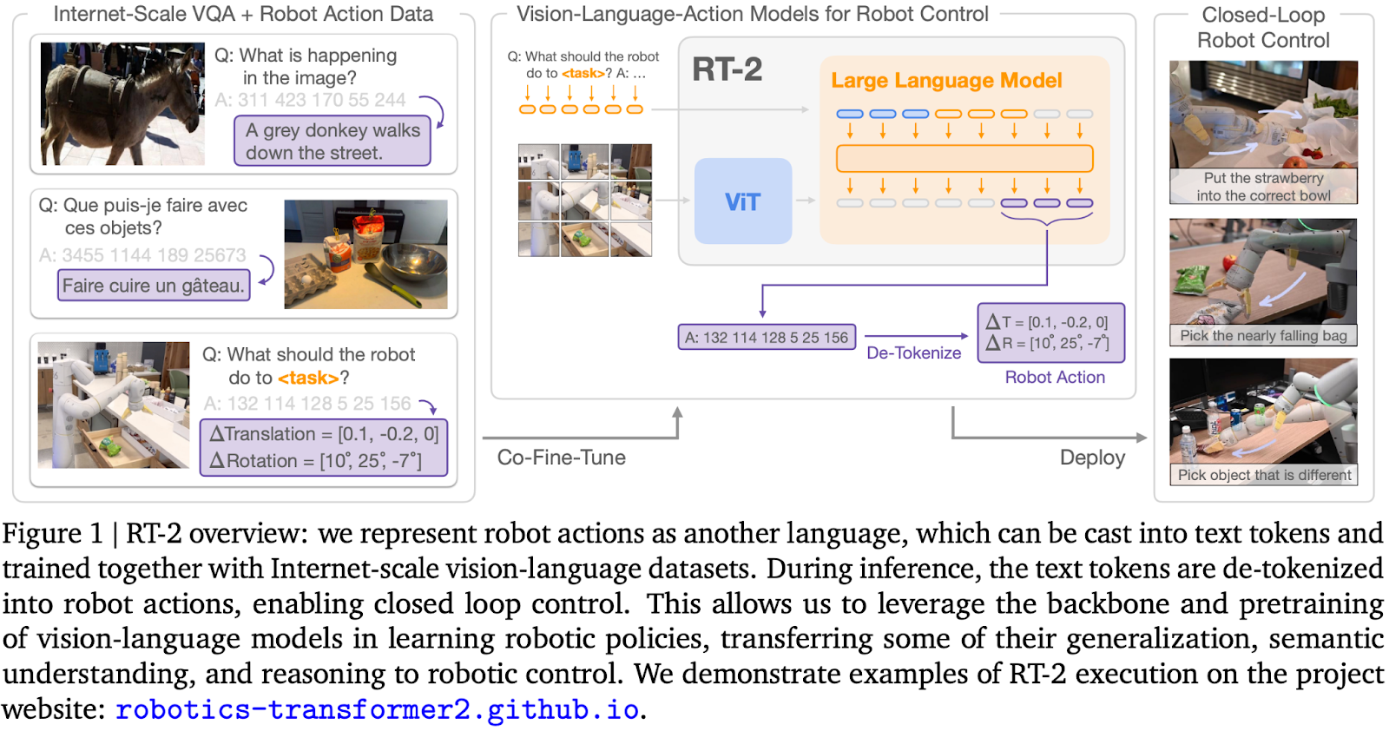

While a number of recent works have sought to incorporate language models (LLMs) and vision-language models (VLMs) into robotics (Ahn et al., 2022; Driess et al., 2023; Vemprala et al., 2023), such methods generally address only the “higher level” aspects of robotic planning, essentially taking the role of a state machine that interprets commands and parses them into individual primitives (such as picking and placing objects), which are then executed by separate low-level controllers that themselves do not benefit from the rich semantic knowledge of Internet-scale models during training. Therefore, in this paper we ask: can large pretrained vision language models be integrated directly into low-level robotic control to boost generalization and enable emergent semantic reasoning?

To this end, we explore an approach that is both simple and surprisingly effective: we directly
train vision-language models designed for open-vocabulary visual question answering and visual
dialogue to output low-level robot actions, along with solving other Internet-scale vision-language
tasks. Although such models are typically trained to produce natural language tokens, we can train
them on robotic trajectories by tokenizing the actions into text tokens and creating “multimodal
sentences” (Driess et al., 2023) that “respond” to robotic instructions paired with camera observations
by producing corresponding actions. In this way, vision-language models can be directly trained to
act as instruction following robotic policies. This simple approach is in contrast with prior alternatives
for incorporating VLMs into robot policies (Shridhar et al., 2022a) or designing new vision-languageaction architectures from scratch (Reed et al., 2022): instead, pre-existing vision-language models,
with already-amortized significant compute investment, are trained without any new parameters to
output text-encoded actions. We refer to this category of models as vision-language-action (VLA)
models. We instantiate VLA models by building on the protocol proposed for RT-1 (Brohan et al.,
2022), using a similar dataset, but expanding the model to use a large vision-language backbone.
Hence we refer to our model as RT-2 (Robotics Transformer 2).

... we observe a number of emergent capabilities. While the model’s physical skills are still limited to the
distribution of skills seen in the robot data, the model acquires the ability to deploy those skills in
new ways by interpreting images and language commands using knowledge gleaned from the web.
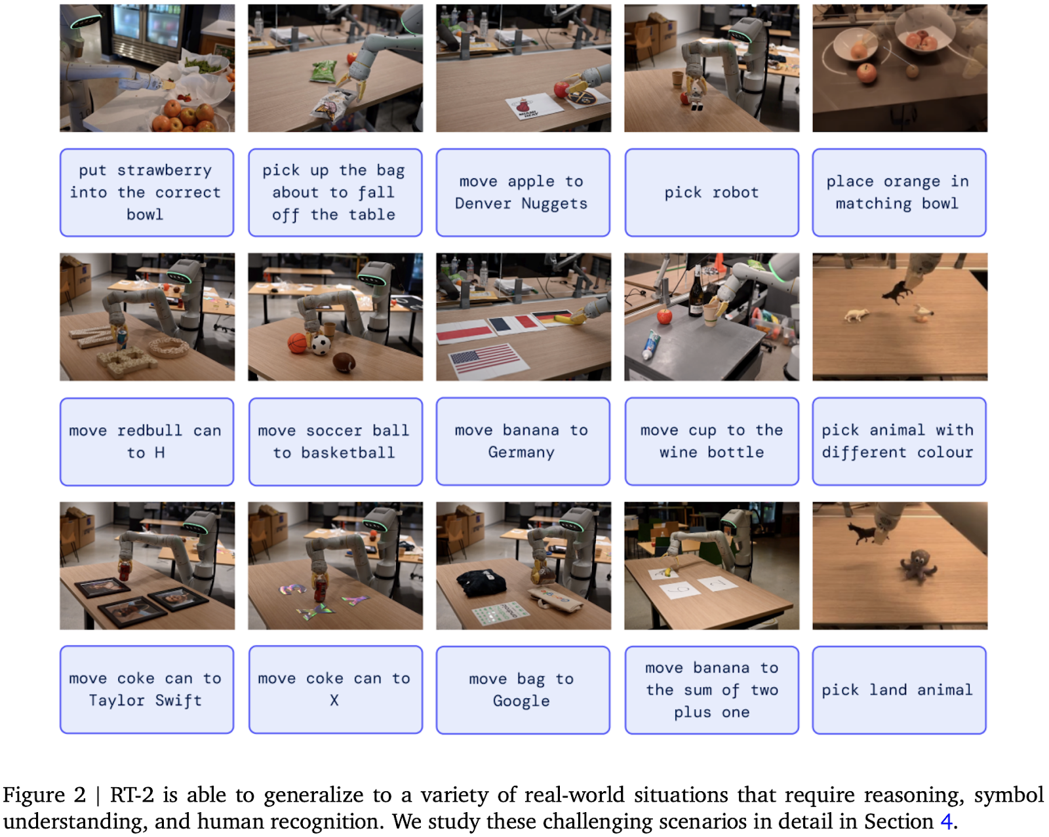

The model is able to re-purpose pick and place skills learned from robot data to place objects near semantically indicated locations, such as specific numbers or icons, despite those cues not being present in the robot data. The model can also interpret relations between objects to determine which object to pick and where to place it, despite no such relations being provided in the robot demonstrations. Furthermore, if we augment the command with chain of thought prompting, the model is able to make even more complex semantic inferences, such as figuring out which object to pick up for use as an improvised hammer (a rock), or which type of drink is best suited for someone who is tired (an energy drink).

Comparitive results

Baseline models
- RT-1 (predecessor)
- VC-1 (another visual pre-training method)
Two variants of RT-2
- PaLM-E (12B parameters)
- PaLI-X (55B parameters)

VC-1 < RT-1 < PaLM-E 12B < PaLI-X 55B in average
A blind A/B study
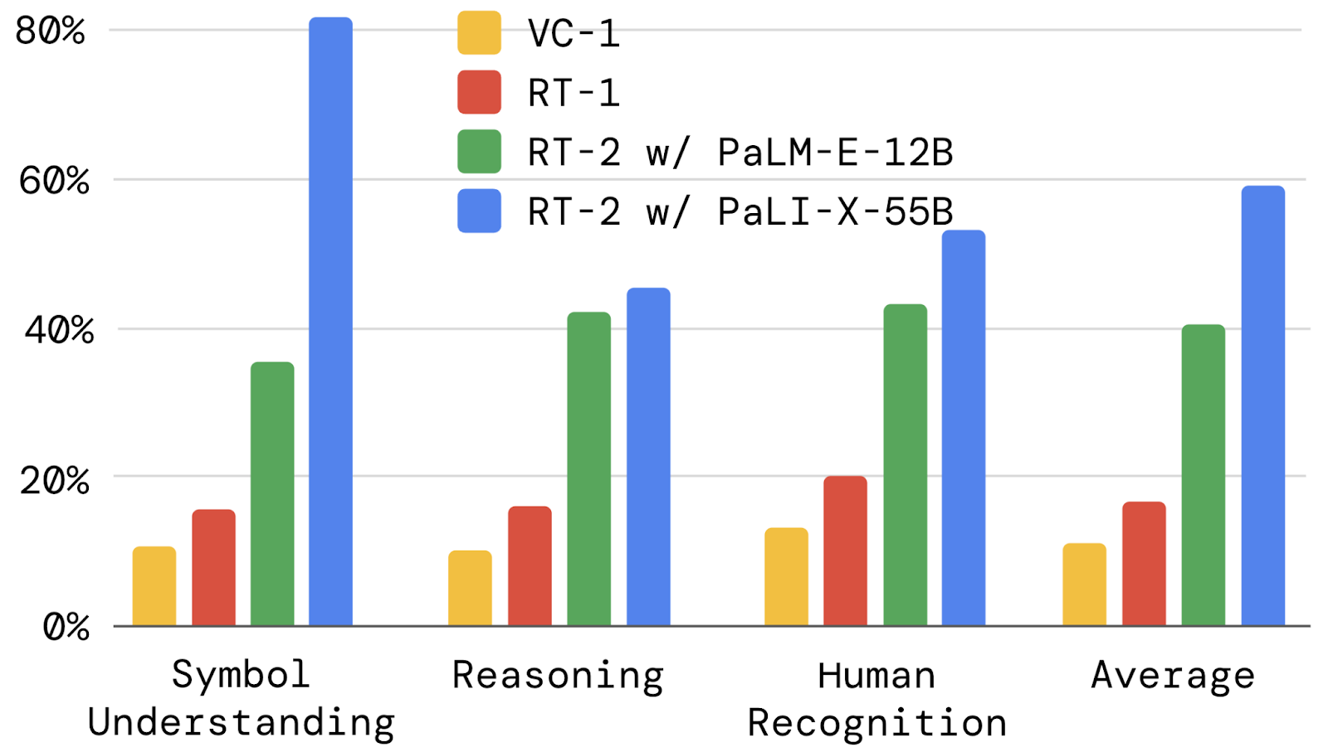

The emergent properties of RT-2 are categorized into:
- symbol understanding,
- reasoning and
- human recognition

Q: What are they?

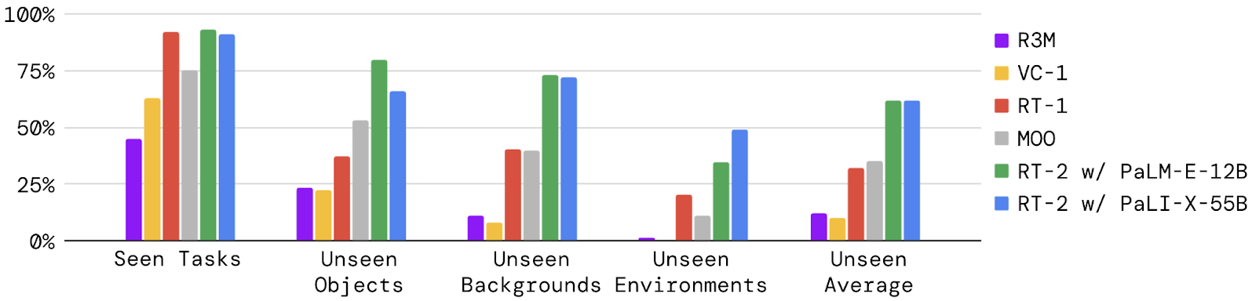

Two most significant design decisions:
- the model size
- training recipe

- the model size: 5B vs 55B for the RT-2 PaLI-X variant,
- training recipe: training the model from scratch vs fine-tuning vs co-fine-tuning.

Q: Why wasn'tt PaLM-E 12B considered for this test?
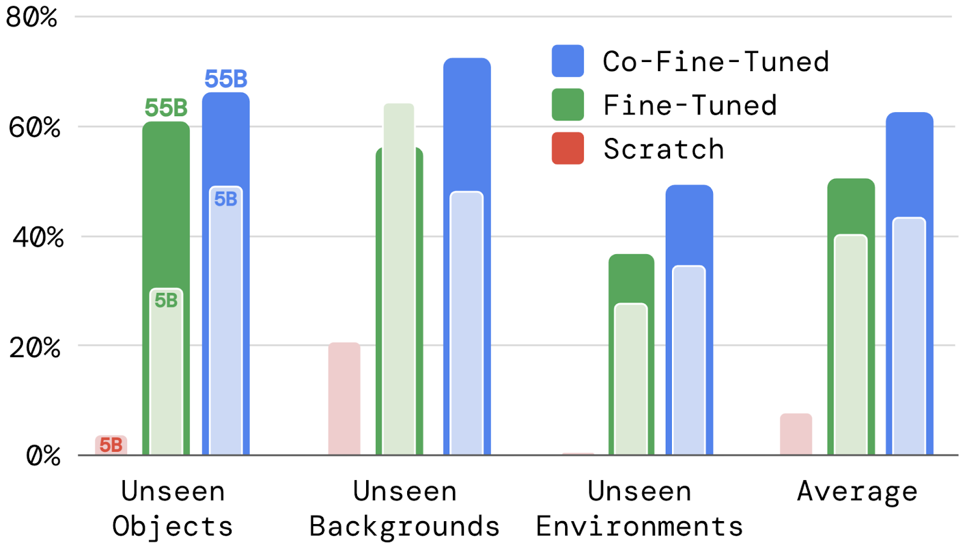

Open-source language-table benchmark
- We demonstrate RT-2's generalization capabilities with the objects never seen in language table datasets before such as ketchup bottle, banana and others:
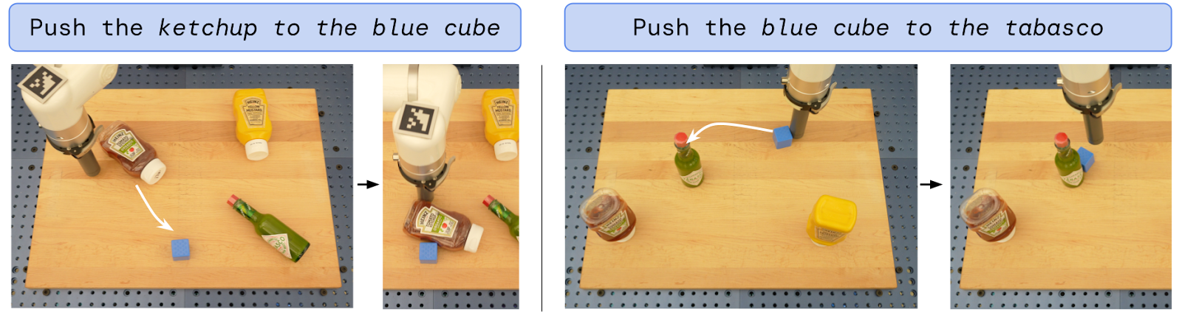
Q: Can this model recognize other objects unseen in language table datasets, but
- included in the pretraining dataset of the VLM model and
- unseen by the same VLM model?
VLM Model | can recognize this image standalone | can't recognize
has the images in the pretraining dataset | O | N/A
doesn't have ... | O | O

In general, is it safe to say that any image objects recognized by VLM (regardless of having them in the pretraining dataset) can extend its ability to recognize these objects for RT-2?

What is RT-2? Google DeepMind’s vision-language-action model for robotics, Jul 28, 2023, Vincent Vanhoucke
  - Speaking robot: Our new AI model translates vision and language into robotic actions
  - RT-2, our new vision-language-action model, helps robots more easily understand and perform actions — in both familiar and new situations.

Excerpts
Robotics Transformer 2, or RT-2, is a first-of-its-kind vision-language-action (VLA) model. A Transformer-based model trained on text and images from the web, RT-2 can directly output robotic actions. Just like language models are trained on text from the web to learn general ideas and concepts, RT-2 transfers knowledge from web data to inform robot behavior.
In other words, RT-2 can speak robot.

A brighter future for robotics
RT-2’s ability to transfer information to actions shows promise for robots to more rapidly adapt to novel situations and environments. In testing RT-2 models in more than 6,000 robotic trials, the team found that RT-2 functioned as well as our previous model, RT-1, on tasks in its training data, or “seen” tasks. And it almost doubled its performance on novel, unseen scenarios to 62% from RT-1’s 32%.

In other words, with RT-2, robots are able to learn more like we do — transferring learned concepts to new situations.

Not only does RT-2 show how advances in AI are cascading rapidly into robotics, it shows enormous promise for more general-purpose robots. While there is still a tremendous amount of work to be done to enable helpful robots in human-centered environments, RT-2 shows us an exciting future for robotics just within grasp.

