Gemini Robotics QA System
Created 2025-03-27 (Thu)
Updated 2025-03-27 (Thu)

Sign into Google Cloud Console
Navigate to Vertex AI > Vector Search
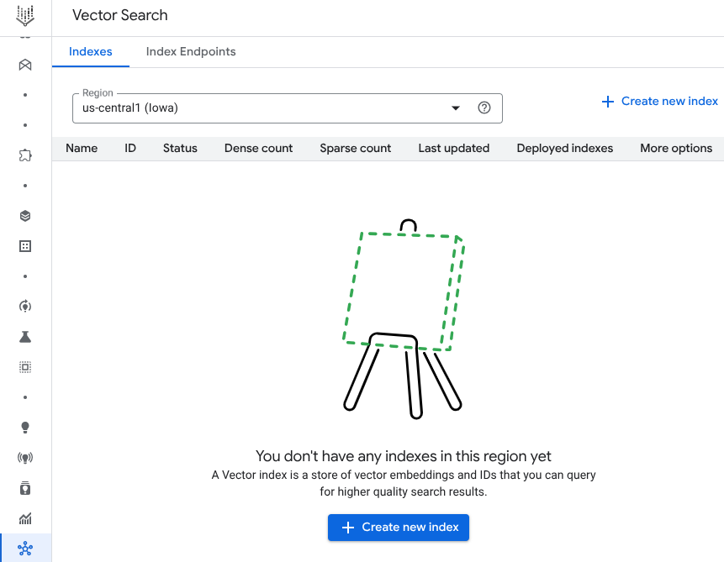

To Create new index , the files are necessary.

[T Kim] Gemini Robotics (digest)
- In essence, this doc
[T Kim] RT-2

Convert the Google Docs file into the
C
Blogs,

After creating PDF files,

Enter the values and click Create.
- Note the Region and the location of the GCS folder URI should be equal.
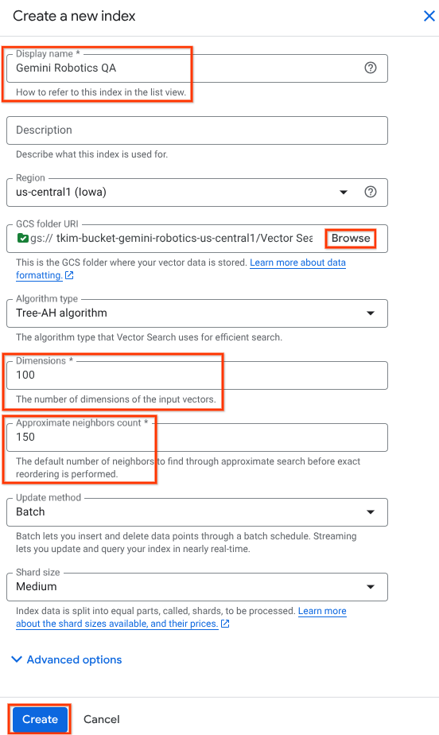

Refer to the default values for Dimensions and Approximate neighbors count.

Configure index parameters
Before you create an index, configure the parameters for your index. For example, create a file named index_metadata.json:
{
"contentsDeltaUri": "gs://BUCKET_NAME/path",
"config": {
"dimensions": 100,
"approximateNeighborsCount": 150,
"distanceMeasureType": "DOT_PRODUCT_DISTANCE",
"shardSize": "SHARD_SIZE_MEDIUM",
"algorithm_config": {
"treeAhConfig": {
"leafNodeEmbeddingCount": 5000,
"fractionLeafNodesToSearch": 0.03
}
}
}
}

