Task 4 - Create a Gemini API Key

3. Create API Credentials:
There are a couple of ways to authenticate to the Vertex AI API. The most common way for development is to use API keys. For production, Service accounts are highly recommended.
API Keys (for development):
In the Google Cloud Console, navigate to "APIs & Services" > "Credentials."
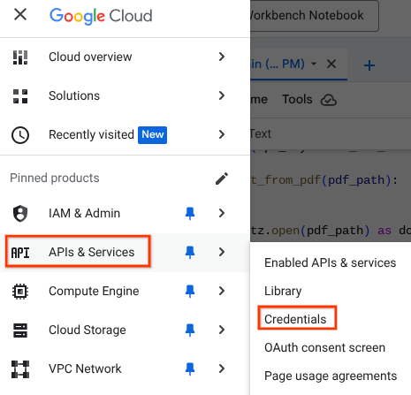

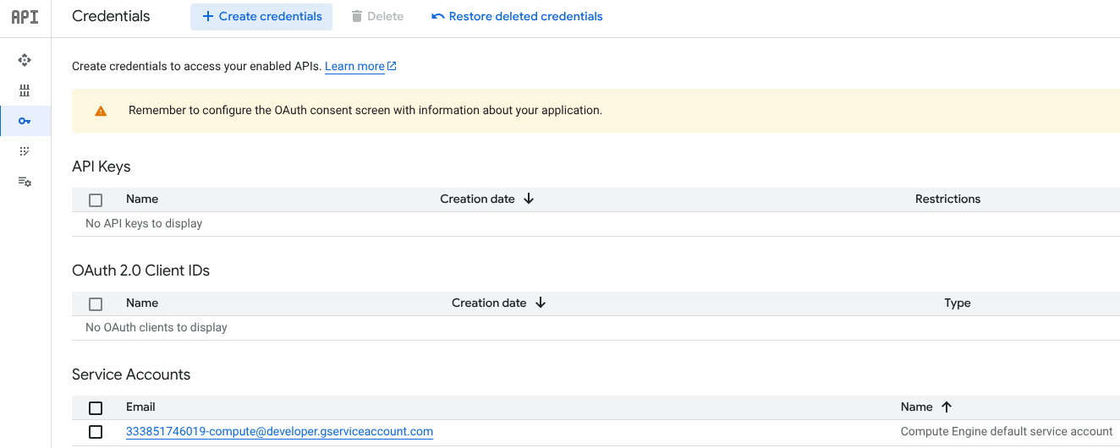
Click "Create Credentials" > "API key."
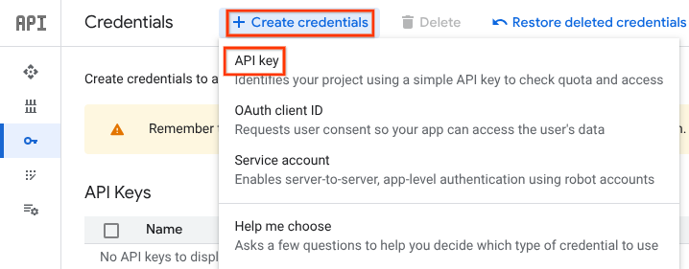

A new API key is generated.
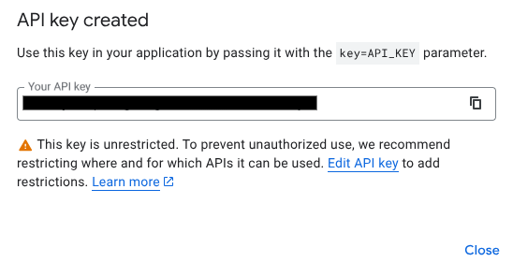
Click Close and notice the API key is created.
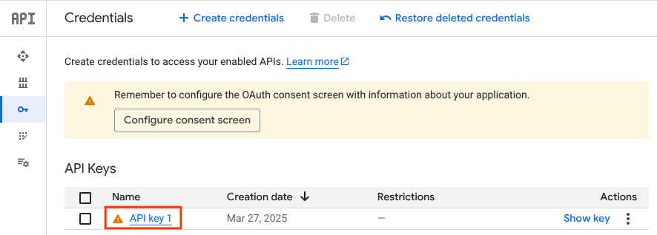
https://screenshot.googleplex.com/3H9dzzeKbsmGynE

You can see the key again. Click the Show key.


First, test if the API key works.

Open Colab Enterprise and click the terminal icon
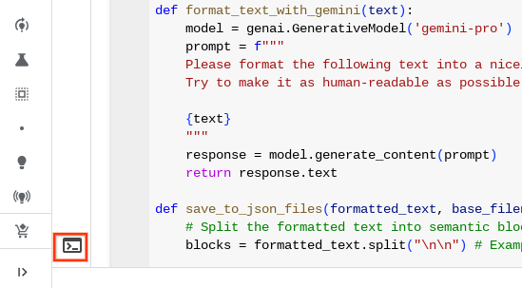

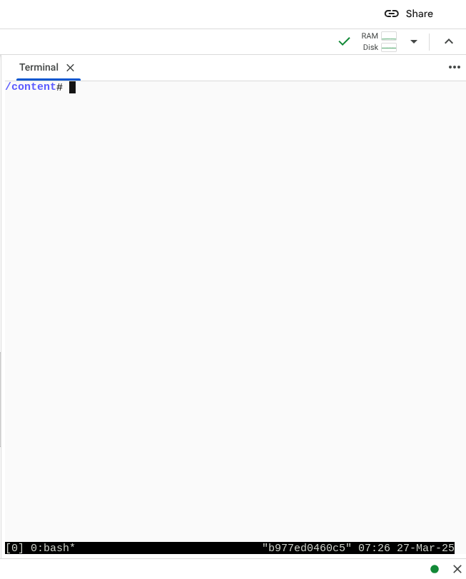

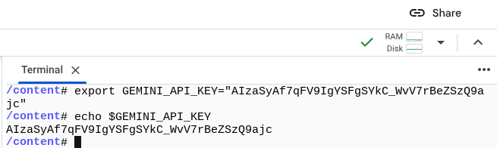

Change the code

genai.configure(api_key="YOUR_API_KEY") # Replace with your actual API key

# Configure your Gemini API key
my_api_key = os.environ.get("GEMINI_API_KEY")
if not my_api_key:
raise ValueError("GEMINI_API_KEY environment variable is not set.")
genai.configure(api_key=my_api_key) # Replace with your actual API key

And run

You can restrict the key's usage to specific APIs or IP addresses for added security.
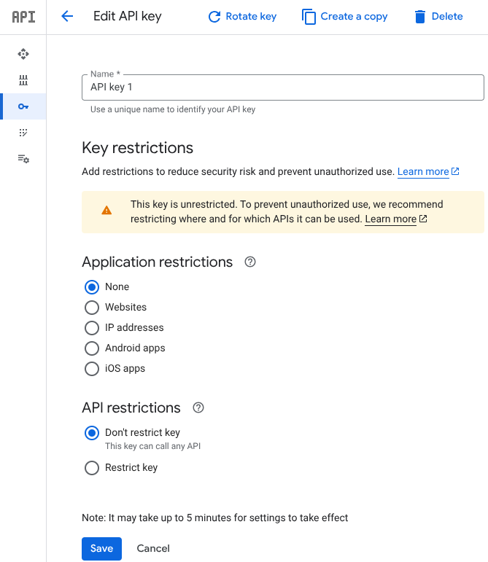
Check Restrict key and click Select APIs.
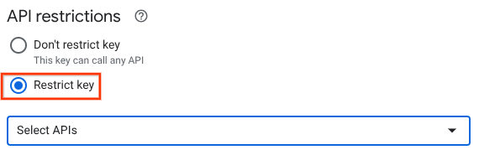

Service Accounts(for production):
  - In the Google Cloud Console, navigate to "IAM & Admin" > "Service Accounts".
  - Click "Create Service Account".
  - Give the service account a name, and description.
  - Grant the service account appropriate roles, such as "Vertex AI User".
  - Create a JSON key for the service account. This JSON file contains the credentials needed to authenticate.
  - Important: Store this JSON file securely. Do not expose it in your client-side code or public repositories.
  - When using a service account, you would authenticate to the google cloud platform using the google-auth library.
4. Using the API Key:
- Once you have your API key, you can use it in your code.
- When utilizing the python google-generativeai library, you configure it like so:

How can I create my Gemini API Key?
To create a Gemini API key, you'll need to use Google Cloud's Vertex AI platform. Here's a step-by-step guide:
1. Set up a Google Cloud Project:
- If you don't already have a Google Cloud project, you'll need to create one.¹
  - Go to the Google Cloud Console: console.cloud.google.com
  - Click on the project dropdown at the top of the page.²
  - Click "New Project."³
  - Enter a project name and select an organization (if applicable).
  - Click "Create."

2. Enable the Vertex AI API:
- In the Google Cloud Console, navigate to the API Library.⁴
  - You can search for "Vertex AI API" in the search bar at the top of the page.⁵
  - Click on the "Vertex AI API" result.⁶
  - Click "Enable."⁷

3. Create API Credentials:
- There are a couple of ways to authenticate to the Vertex AI API.⁸ The most common way for development is to use API keys. For production, Service accounts are highly recommended.⁹
- API Keys (for development):
  - In the Google Cloud Console, navigate to "APIs & Services" > "Credentials."¹⁰
  - Click "Create Credentials" > "API key."¹¹
  - A new API key will be generated.¹²
  - Important: Copy and store this key securely. Do not expose it in your client-side code or public repositories.¹³
  - You can restrict the key's usage to specific APIs or IP addresses for added security.¹⁴
- Service Accounts(for production):
  - In the Google Cloud Console, navigate to "IAM & Admin" > "Service Accounts".¹⁵
  - Click "Create Service Account".¹⁶
  - Give the service account a name, and description.¹⁷
  - Grant the service account appropriate roles, such as "Vertex AI User".¹⁸
  - Create a JSON key for the service account.¹⁹ This JSON file contains the credentials needed to authenticate.
  - Important: Store this JSON file securely.²⁰ Do not expose it in your client-side code or public repositories.²¹
  - When using a service account, you would authenticate to the google cloud platform using the google-auth library.
4. Using the API Key:
- Once you have your API key, you can use it in your code.²²
- When utilizing the python google-generativeai library, you configure it like so:
Python
import google.generativeai as genai

genai.configure(api_key="YOUR_API_KEY") #replace "YOUR_API_KEY"

Security Best Practices:
- Never embed your API key directly in client-side code (e.g., JavaScript). This is a major security risk.²³
- Use environment variables: Store your API key as an environment variable on your server or development machine.²⁴ This prevents it from being hardcoded in your source code.
- Restrict API key usage: In the Google Cloud Console, restrict your API key's usage to only the necessary APIs and IP addresses.²⁵
- Use service accounts for production: For production applications, service accounts are the recommended authentication method.
- Rotate API keys: Periodically rotate your API keys to minimize the impact of potential security breaches.²⁶
By following these steps and security best practices, you can create and use your Gemini API key safely and effectively.

