Task@Google Cloud > Vertex AI로 Workbench Instance를 생성

관련 문서
- Task 1 - 실습 목표 및 허깅 페이스 가입

Vertex AI에서 Workbench Instance를 생성

Google Cloud에 로그인 후, Project를 오픈한다.
- 예: Vertex Workbench Notebook

Vertex AI > Workbench > Instances 메뉴를 선택한다.
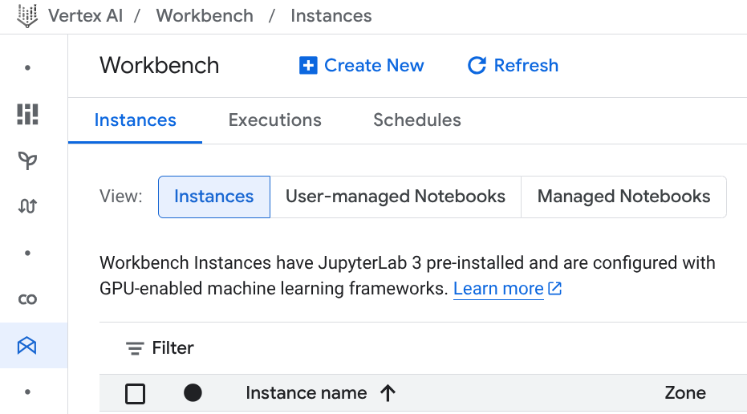

Create New를 클릭해서 Workbench Instance를 설정한다.
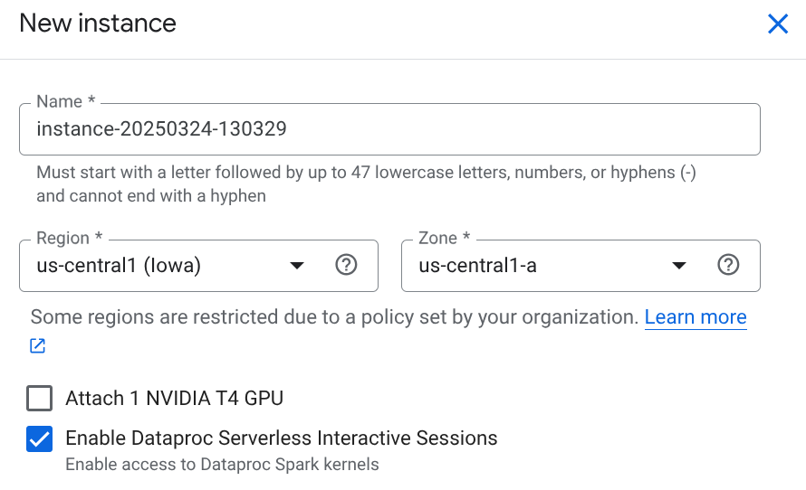

Name을 tkim-instance-t4gpu-vllm-test로 입력한다.
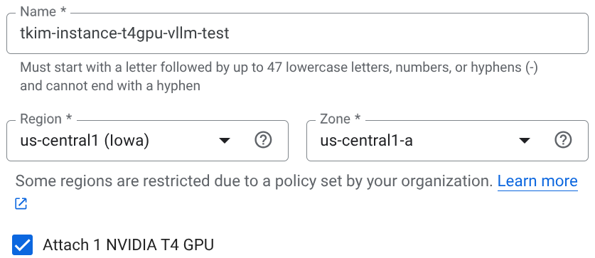

VPN Network가 필요하므로 생성한다.

CLI를 오픈한다.
메뉴 우측 상단의 Cloud Shell 아이콘을 클릭한다.


Authorize를 클릭한다.
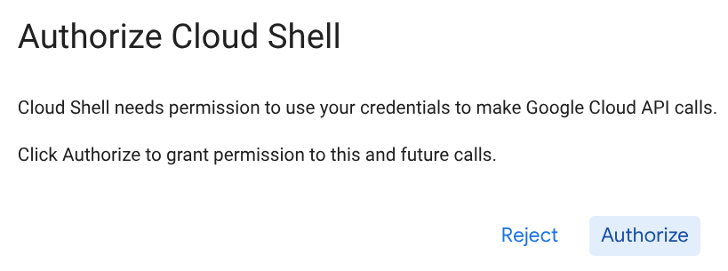
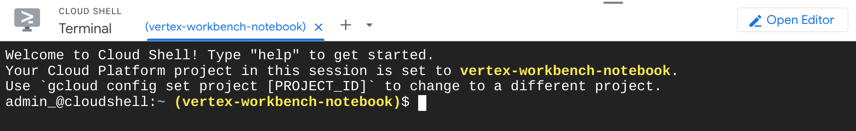

참고: 01-Argolis Networking Challenge Lab > Summary
- Prevent resources from being spun up in all regions
- Create VPC networks with subnets
- Activate firewall rules
- Create a service account key for Secret Manager

명령어를 복사해서 붙여넣는다.

# Variables
MY_PREFIX=tkim

# Enter the value or select the REGION
REGION=us-central1

# Handle the rest of the part automatically.
# You may edit some lines to change the configuration.
PROJECT_ID=$(gcloud config list --format 'value(core.project)')
NETWORK=${MY_PREFIX}-network-${REGION}

SUBNET=${MY_PREFIX}-subnetwork-${REGION}
SUBNET_RANGE=10.128.0.0/20
# Example: 10.138.0.0/20, 10.132.0.0/20, 10.128.0.0/20

INSTANCE_NAME=${MY_PREFIX}-instance-vllm-test
ZONE=$REGION-a

# 1. Create a VPN network
$ gcloud compute networks create $NETWORK --project $PROJECT_ID --subnet-mode=custom --mtu=1460 --bgp-routing-mode=regional

admin_@cloudshell:~ (vertex-workbench-notebook)$ gcloud compute networks create $NETWORK --project $PROJECT_ID --subnet-mode=custom --mtu=1460 --bgp-routing-mode=regional

Created [https://www.googleapis.com/compute/v1/projects/vertex-workbench-notebook/global/networks/tkim-network-us-central1].
NAME: tkim-network-us-central1
SUBNET_MODE: CUSTOM
BGP_ROUTING_MODE: REGIONAL
IPV4_RANGE:
GATEWAY_IPV4:
INTERNAL_IPV6_RANGE:

Instances on this network will not be reachable until firewall rules
are created. As an example, you can allow all internal traffic between
instances as well as SSH, RDP, and ICMP by running:

$ gcloud compute firewall-rules create <FIREWALL_NAME> --network tkim-network-us-central1 --allow tcp,udp,icmp --source-ranges <IP_RANGE>
$ gcloud compute firewall-rules create <FIREWALL_NAME> --network tkim-network-us-central1 --allow tcp:22,tcp:3389,icmp

admin_@cloudshell:~ (vertex-workbench-notebook)$

# 1-1. VPN network 확인
$ gcloud compute networks list --project=$PROJECT_ID --filter="name=$NETWORK"

admin_@cloudshell:~ (vertex-workbench-notebook)$ gcloud compute networks list --project=$PROJECT_ID --filter="name=$NETWORK"

NAME: tkim-network-us-central1
SUBNET_MODE: CUSTOM
BGP_ROUTING_MODE: REGIONAL
IPV4_RANGE:
GATEWAY_IPV4:
INTERNAL_IPV6_RANGE:
thekim@cloudshell:~ (vertex-workbench-notebook)$

# 2. Create a subnet for this network
$ gcloud compute networks subnets create $SUBNET \
--project=$PROJECT_ID \
--range=$SUBNET_RANGE \
--network=$NETWORK \
--region=$REGION

admin_@cloudshell:~ (vertex-workbench-notebook)$ gcloud compute networks subnets create $SUBNET \
--project=$PROJECT_ID \
--range=$SUBNET_RANGE \
--network=$NETWORK \
--region=$REGION

Created [https://www.googleapis.com/compute/v1/projects/vertex-workbench-notebook/regions/us-central1/subnetworks/tkim-subnetwork-us-central1].
NAME: tkim-subnetwork-us-central1
REGION: us-central1
NETWORK: tkim-network-us-central1
RANGE: 10.128.0.0/20
STACK_TYPE: IPV4_ONLY
IPV6_ACCESS_TYPE:
INTERNAL_IPV6_PREFIX:
EXTERNAL_IPV6_PREFIX:
admin_@cloudshell:~ (vertex-workbench-notebook)$

# 2-1. subnetwork 확인
$ gcloud compute networks subnets list --project=$PROJECT_ID --filter="name=$SUBNET" --regions=$REGION

admin_@cloudshell:~ (vertex-workbench-notebook)$ gcloud compute networks subnets list --project=$PROJECT_ID --filter="name=$SUBNET" --regions=$REGION

NAME: tkim-subnetwork-us-central1
REGION: us-central1
NETWORK: tkim-network-us-central1
RANGE: 10.128.0.0/20
STACK_TYPE: IPV4_ONLY
IPV6_ACCESS_TYPE:
INTERNAL_IPV6_PREFIX:
EXTERNAL_IPV6_PREFIX:
admin_@cloudshell:~ (vertex-workbench-notebook)$

# 3. Create firewall rules
Instances on this network will not be reachable until firewall rules are created. In other words, connect instances on this network to the Internet.

For example,
- Create a firewall rule for HTTP
- Create a firewall rule for SSH to verify the result. (Not required by the lab)
- Add the tag(s) for the firewall rule(s) to the VM instance to take the rule(s) effect.

# 4. Variables for firewall rules
FIREWALL_NAME_HTTP=allow-http-traffic-${REGION}
TAG_NAME_HTTP=http-${REGION}
FIREWALL_NAME_SSH=allow-ssh-traffic-${REGION}
TAG_NAME_SSH=ssh-${REGION}
FIREWALL_PRIORITY=1000

# 5. Create firewall rules
# to allow HTTP (tcp:80) traffic with a tag (http)

gcloud compute firewall-rules create $FIREWALL_NAME_HTTP \
--network=$NETWORK \
--target-tags=$TAG_NAME_HTTP \
--allow=tcp:80 \
--priority=$FIREWALL_PRIORITY

# Optionally for each firewall rule, you may add source-ranges
# export IP_RANGE=
# --source-ranges=$IP_RANGE

admin_@cloudshell:~ (vertex-workbench-notebook)$ gcloud compute firewall-rules create $FIREWALL_NAME_HTTP \
--network=$NETWORK \
--target-tags=$TAG_NAME_HTTP \
--allow=tcp:80 \
--priority=$FIREWALL_PRIORITY

Creating firewall...working..Created [https://www.googleapis.com/compute/v1/projects/vertex-workbench-notebook/global/firewalls/allow-http-traffic-us-central1].
Creating firewall...done.
NAME: allow-http-traffic-us-central1
NETWORK: tkim-network-us-central1
DIRECTION: INGRESS
PRIORITY: 1000
ALLOW: tcp:80
DENY:
DISABLED: False
admin_@cloudshell:~ (vertex-workbench-notebook)$

# to allow SSH (tcp:22) traffic with a tag (ssh)
gcloud compute firewall-rules create $FIREWALL_NAME_SSH \
--network=$NETWORK \
--target-tags=$TAG_NAME_SSH \
--allow=tcp:22 \
--priority=$FIREWALL_PRIORITY

admin_@cloudshell:~ (vertex-workbench-notebook)$ gcloud compute firewall-rules create $FIREWALL_NAME_SSH \
--network=$NETWORK \
--target-tags=$TAG_NAME_SSH \
--allow=tcp:22 \
--priority=$FIREWALL_PRIORITY

Creating firewall...working..Created [https://www.googleapis.com/compute/v1/projects/vertex-workbench-notebook/global/firewalls/allow-ssh-traffic-us-central1].
Creating firewall...done.
NAME: allow-ssh-traffic-us-central1
NETWORK: tkim-network-us-central1
DIRECTION: INGRESS
PRIORITY: 1000
ALLOW: tcp:22
DENY:
DISABLED: False
admin_@cloudshell:~ (vertex-workbench-notebook)$

# 6. GUI로 재확인
메뉴에서 VPN Network > VPC networks을 선택한다.

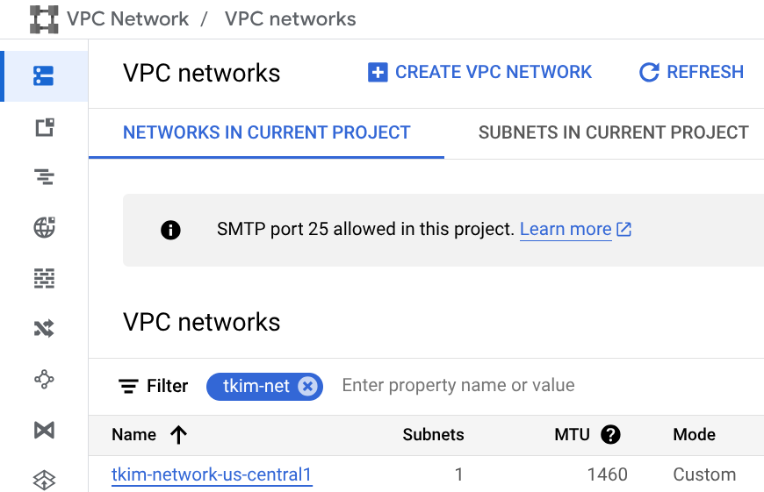

이름을 클릭한 다음, SUBNETS탭을 클릭한다.
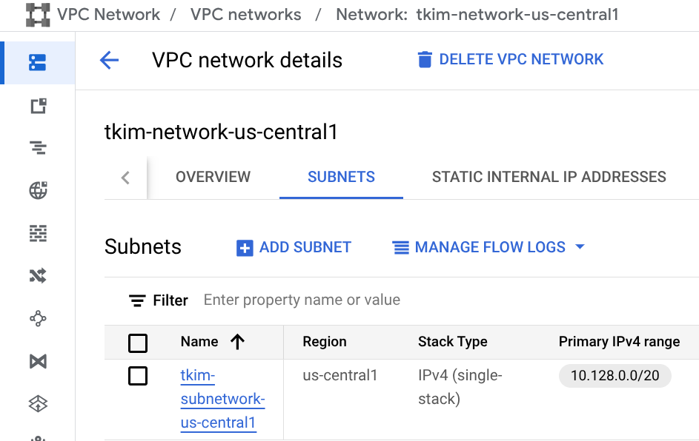

다음은 FIREWALLS탭을 클릭한다.
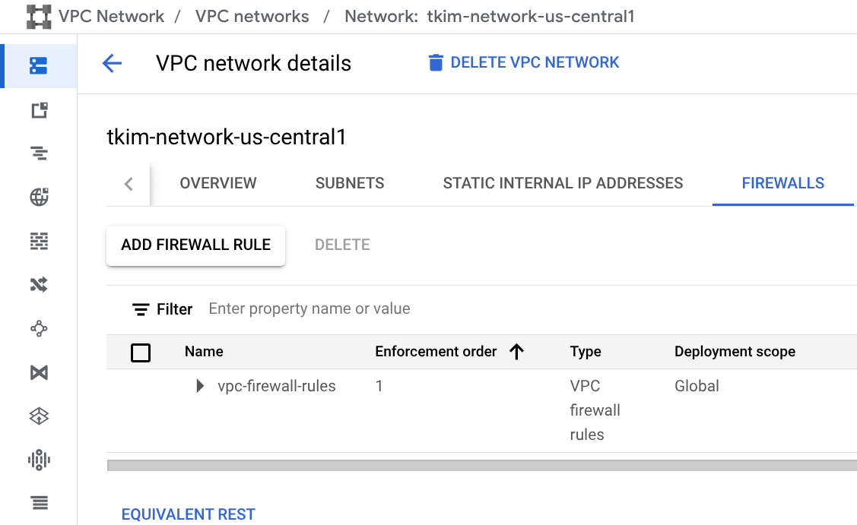

이름을 클릭한다.
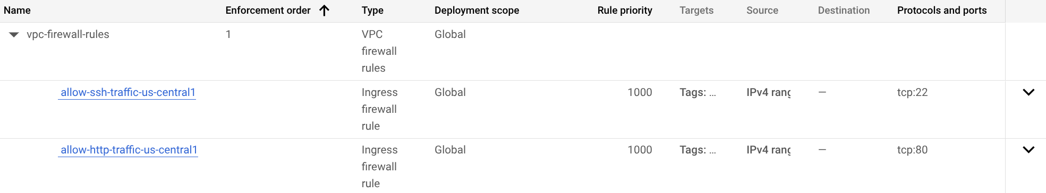

참고. GCE로 VM 생성할 때는 add-tags도 실행한다.
관련 문서: Google Cloud CLI Doc. > gcloud compute instances add-tags

Add tags 명령어
$ gcloud compute instances add-tags $INSTANCE_NAME \
--tags=$TAG_NAME_HTTP \
--project=$PROJECT_ID \
--zone=$ZONE

$ gcloud compute instances add-tags $INSTANCE_NAME \
--project=$PROJECT_ID \
--tags=$TAG_NAME_SSH \
--zone=$ZONE

Create New를 클릭해서 Workbench Instance를 설정한다.
다시 Vertex AI > Workbench Instance의 Create New를 클릭한다.
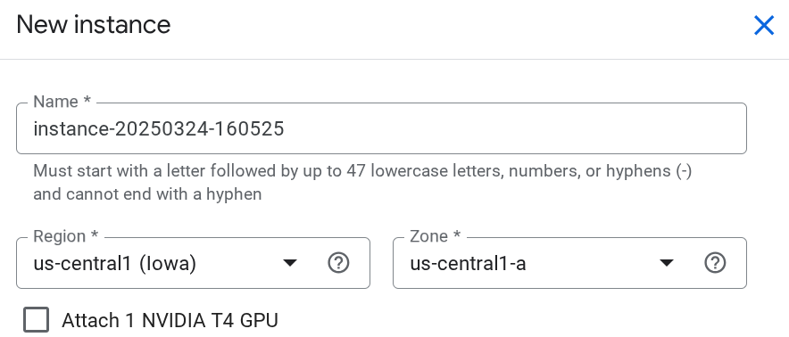

Name을 입력하고,
- Tkim-instance-t4gpu-vllm-test
Attach 1 NVIDIA T4 GPU를 체크한 다음, Network를 클릭해서 생성한 VPN 네트워크를 선택하면
- tkim-network-us-central1
Subnetwork는 자동으로 선택된다.
- tkim-subnetwork-us-central1
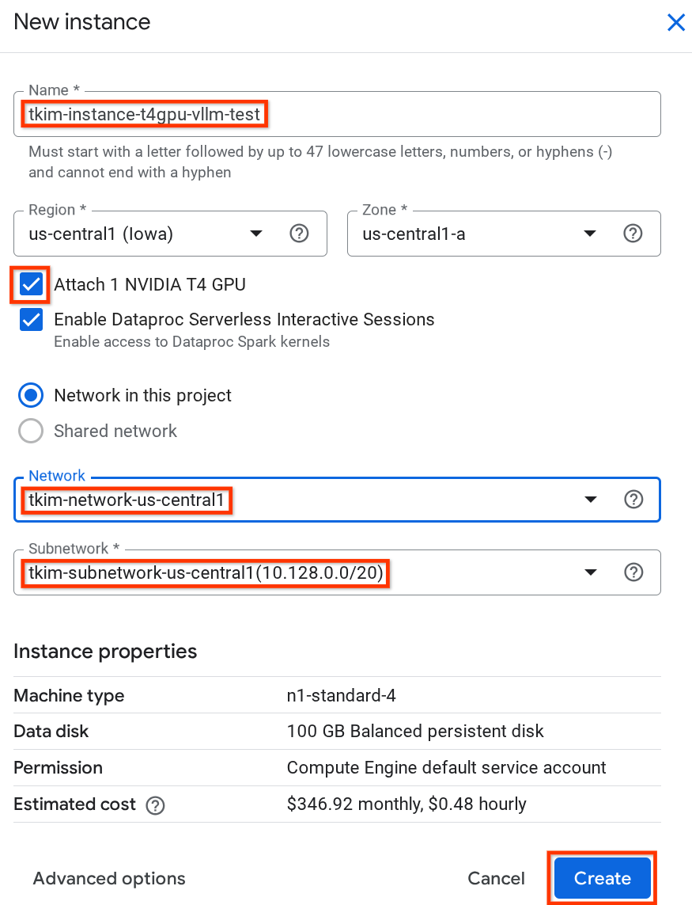

마지막으로 Create를 클릭한다.

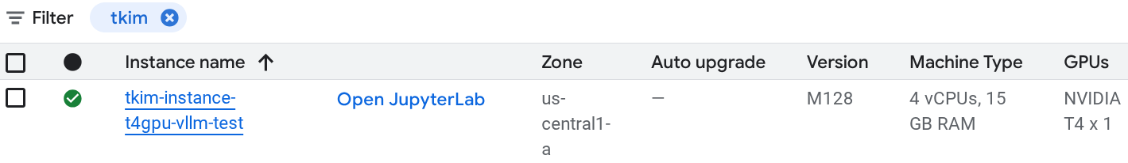
성공!

Open JupyterLab을 클릭한다.
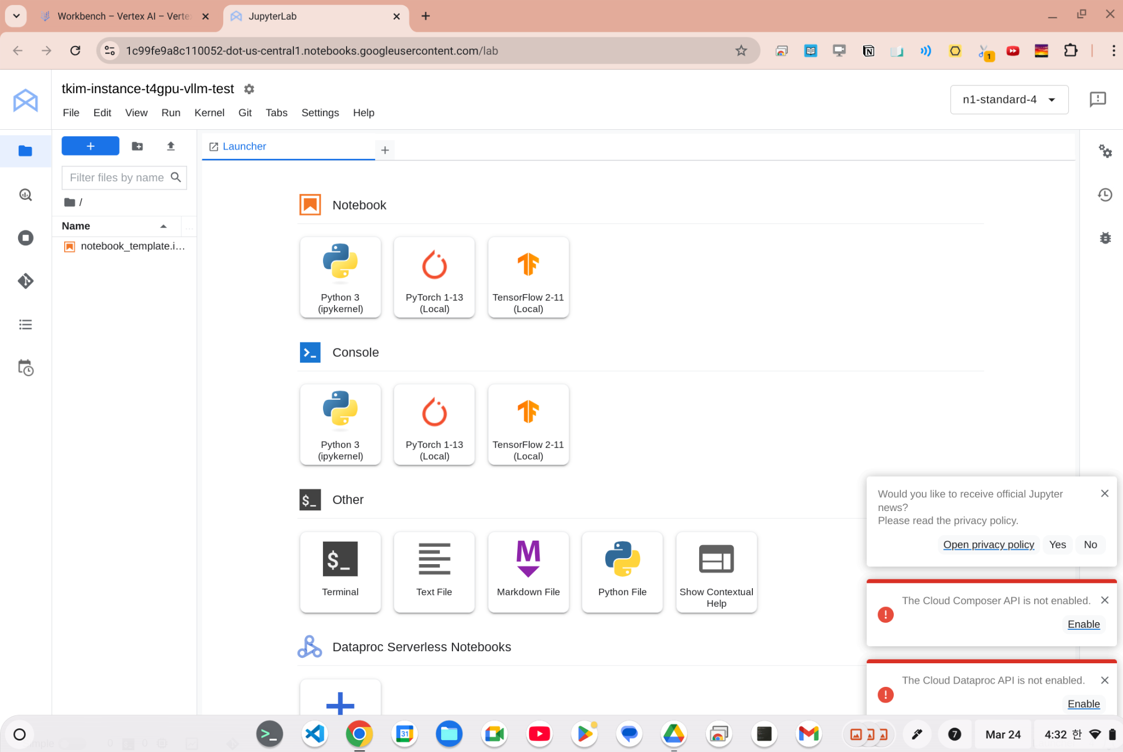

생성된 Workbench Instance를 삭제

시나리오: GPU없이 Workbench Instance가 생성되어 삭제한다.
위에 생성한 네트워크가 안 보여서 대신 아래 네트워크를 선택했지만,
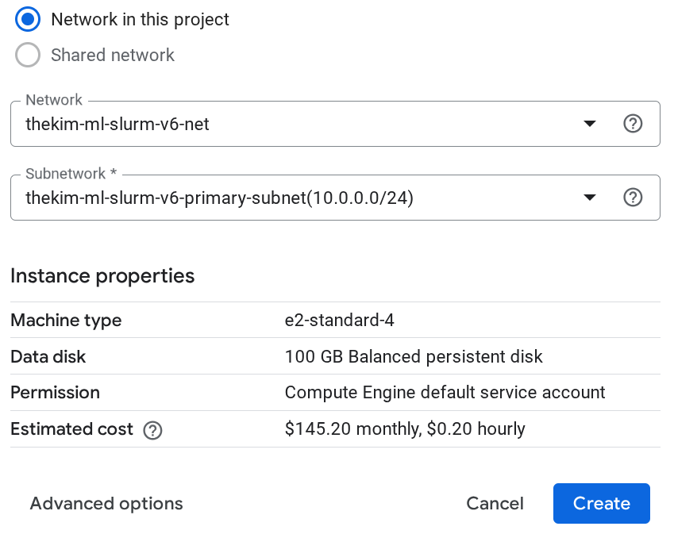

생성된 Workbench Instance의 GPUs가 None으로 생성됨.
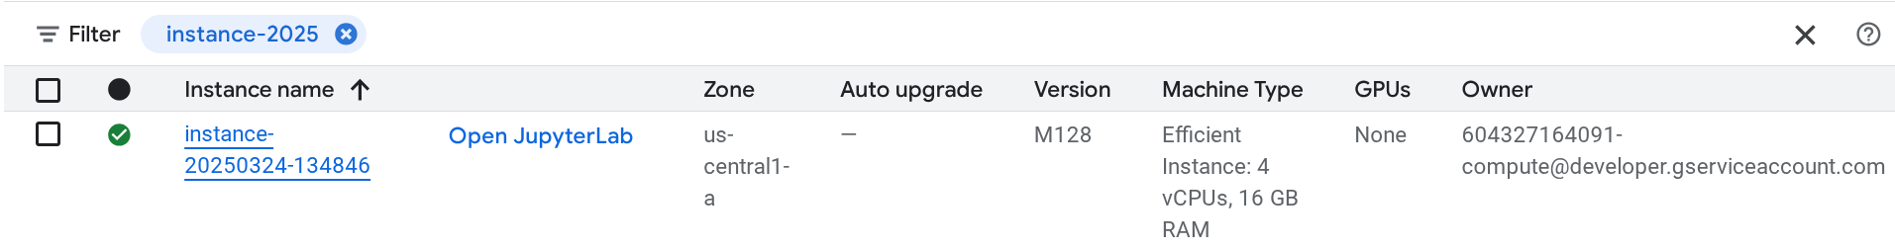
이 Instance를 체크하고
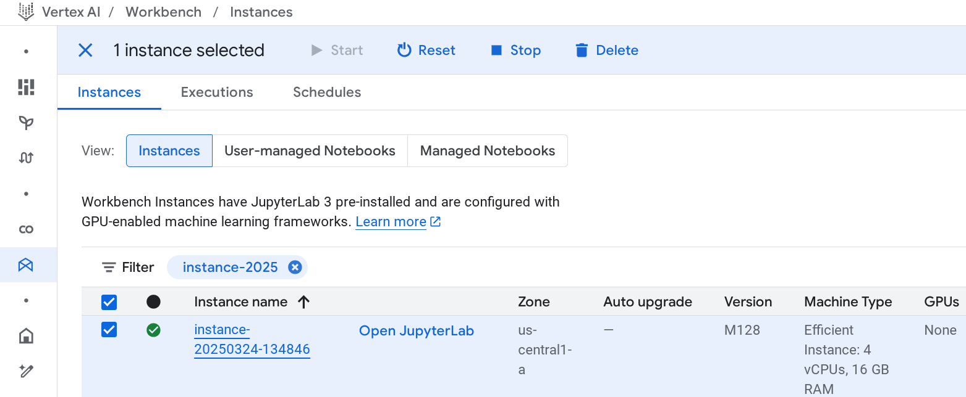
Delete를 클릭한 후, Confirm을 누른다.

