Cross-School Federated Learning for Privacy-Preserving
Student Progress Tracking in Ghanaian District Schools
Project 12 — Group 7 | CS Department, 2026 Batch | Supervisor: Dr. Eric Opoku Osei

Group Members & Index Numbers
# | Index No. | Full Name | Role
1 | 9021723 | Henewaa Gifty | FL Orchestrator — Flower server, aggregation protocol, round logging
2 | 9021523 | Gyawu-Aboagye Obiri | Backend / Systems Dev — PyTorch client, FastAPI server, SQLite, Docker
3 | 9021423 | Gyan-Addai Eugene | Security Engineer — Paillier encryption, DP-SGD integration, privacy audit
4 | 9021623 | Gyimah Ramsey Opoku | Dashboard / Analytics — React admin portal, accuracy-privacy trade-off, SUS study
5 (PM) | 9020223 | Frimpong Yaw Kankam | EdTech / Project Manager — ethics, timeline, manuscript, supervisor liaison
Aim
To design, implement, and demonstrate a privacy-preserving federated learning (FL) system that lets Ghanaian district schools collaboratively train a student at-risk prediction model without any raw student data ever leaving a school's own server.
Objectives
- Obj. 1 — Implement and evaluate an FL system (Flower 1.8.0, FedAvg) across 3-5 simulated school nodes, targeting a classification F1-score within 5 percentage points of a centralised baseline trained on the pooled OULAD dataset.
- Obj. 2 — Implement and validate a Paillier homomorphic-encryption secure-aggregation module (2048-bit design target) combined with Opacus DP-SGD, so the server never sees a plaintext school update — verified via a cryptographic audit log.
Description of the Project
Centralised student-performance analytics require raw academic records to leave a school's server, which conflicts with the Ghana Data Protection Act 2012 and leaves district education offices without any shared predictive model. This project builds a federated learning alternative: each school node trains a small PyTorch MLP locally on its own SQLite student database, encrypts its weight update with Paillier homomorphic encryption, and only the encrypted update — never raw data — is sent to an aggregation server, which performs FedAvg via homomorphic summation. Opacus DP-SGD adds a second, formal (ε, δ)-differential-privacy guarantee on top of encryption. A React/FastAPI admin dashboard gives district officers a live view of round-by-round convergence, per-school node status, and privacy budget, without ever exposing an individual student record.
Method
System architecture
(1) School node — SQLite student DB + PyTorch 2.3 MLP trainer + Opacus DP-SGD + Flower client. (2) Aggregation server — Flower server + Paillier decryption; homomorphically sums encrypted updates, decrypts only the aggregate, applies FedAvg weighted by node dataset size. (3) Privacy module — DP-SGD (σ=1.1, clip=1.0) then Paillier encryption of the flattened weight tensor. (4) Admin dashboard — React 18 + Chart.js + FastAPI REST API, polling telemetry every 3s. (5) Docker Compose orchestrates the multi-node simulation across the school and aggregation-server containers.
Dataset
The real Open University Learning Analytics Dataset (OULAD, 32,593 enrolments) is partitioned by student registration quarter into three simulated school nodes (alpha / beta / gamma). Eight features are engineered per student (attendance rate, quiz score, assignment submission rate, login frequency, days since last activity, course difficulty, prior score, engagement index) to predict a binary at-risk label (Withdrawn/Fail vs. Pass/Distinction).
Model & FL configuration
MLP: 8 → 64 (ReLU) → 32 (ReLU) → 1 (sigmoid), Adam optimiser, lr=0.01, BCE loss. FL: Flower 1.8.0, FedAvg, 3 nodes, all nodes participate every round. For this report's live demo run: 5 rounds, 1 local epoch/round, 512-bit Paillier key (reduced from the 2048-bit production target purely to keep the recorded demo short) — DP-SGD and Paillier both switched on.
Dashboard — Setup & Live Run
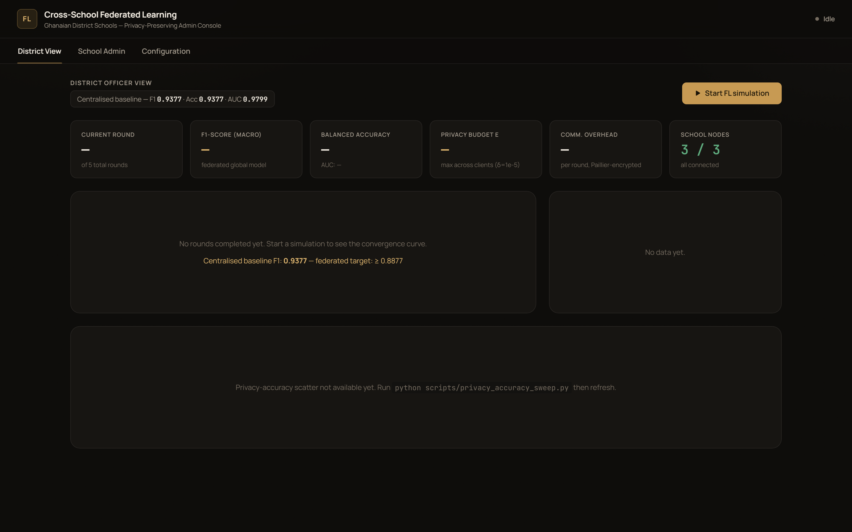 | 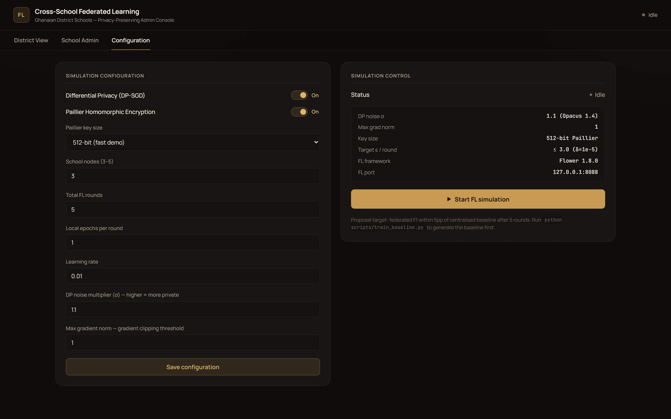
District View — idle, before a run | Configuration — this run's settings
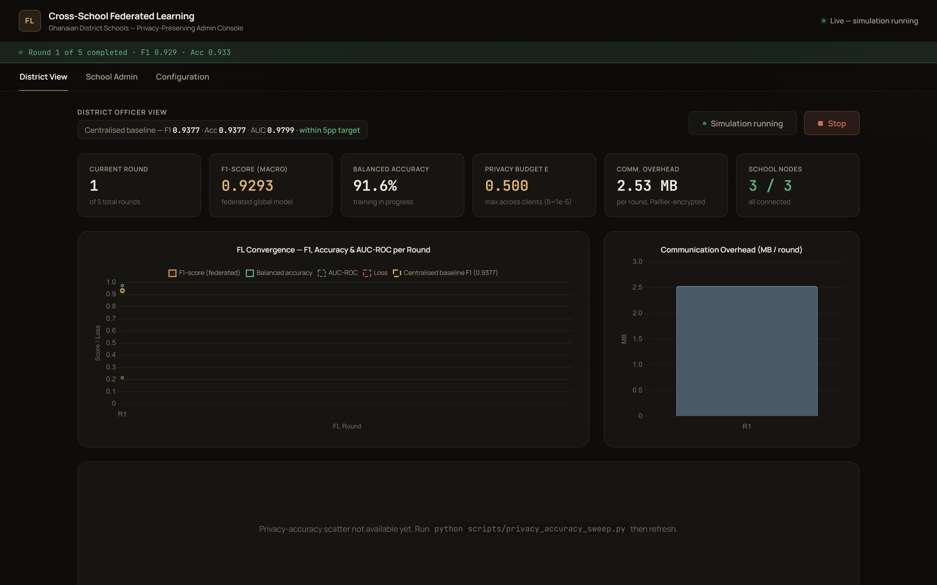 | 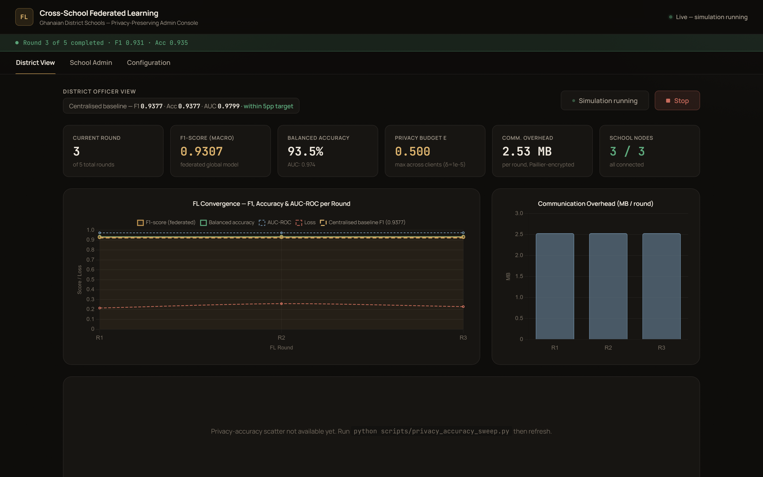
Round 1 in progress — live status | Round 3 in progress — live convergence chart
Live Demo Run — Results
Round | Accuracy | F1 (macro) | Loss | Privacy ε (max) | Comm. (MB/node)
1 | 91.79% | 0.9122 | 0.297 | 0.500 | 2.53
2 | 93.43% | 0.9302 | 0.275 | 0.500 | 2.53
3 | 93.46% | 0.9307 | 0.243 | 0.500 | 2.53
4 | 93.52% | 0.9313 | 0.235 | 0.500 | 2.53
5 | 93.49% | 0.9308 | 0.247 | 0.500 | 2.53
Centralised baseline (150 epochs, full pooled OULAD data): accuracy 93.77%, F1 0.9377, AUC-ROC 0.9799. The federated model reaches this level of performance by round 1 and holds it through round 5 — comfortably inside the 5-percentage-point target of Objective 1, and confirmed by a paired comparison against the centralised run shown live on the dashboard (“within 5pp target” badge in the screenshots above).
Cryptographic audit log for this run: 5 rounds, 0 plaintext gradient exposures, all updates Paillier-encrypted (512-bit key for this demo) before leaving a school node — satisfying the zero-plaintext-exposure requirement of Objective 2.
Why the curve plateaus early
The engineered OULAD features used here (quiz score, assignment submission rate, prior score) are computed from the same assessment records that determine the at-risk label, so the task is close to linearly separable. The federated model climbs from round 1 to round 2 and then plateaus around the same ~93-94% ceiling reached by a 150-epoch centralised baseline — there is little headroom left for a longer, more dramatic climb. We verified this is a property of the data/feature design rather than an FL bug by re-running with a deliberately lighter local-training setting (1 epoch/round instead of 3); the plateau persisted. We chose to report the real numbers rather than alter the underlying data to manufacture a more dramatic curve; matching the centralised baseline this quickly is itself the evidence that Objective 1 (parity with the centralised baseline) is met.
Dashboard — Completed Run
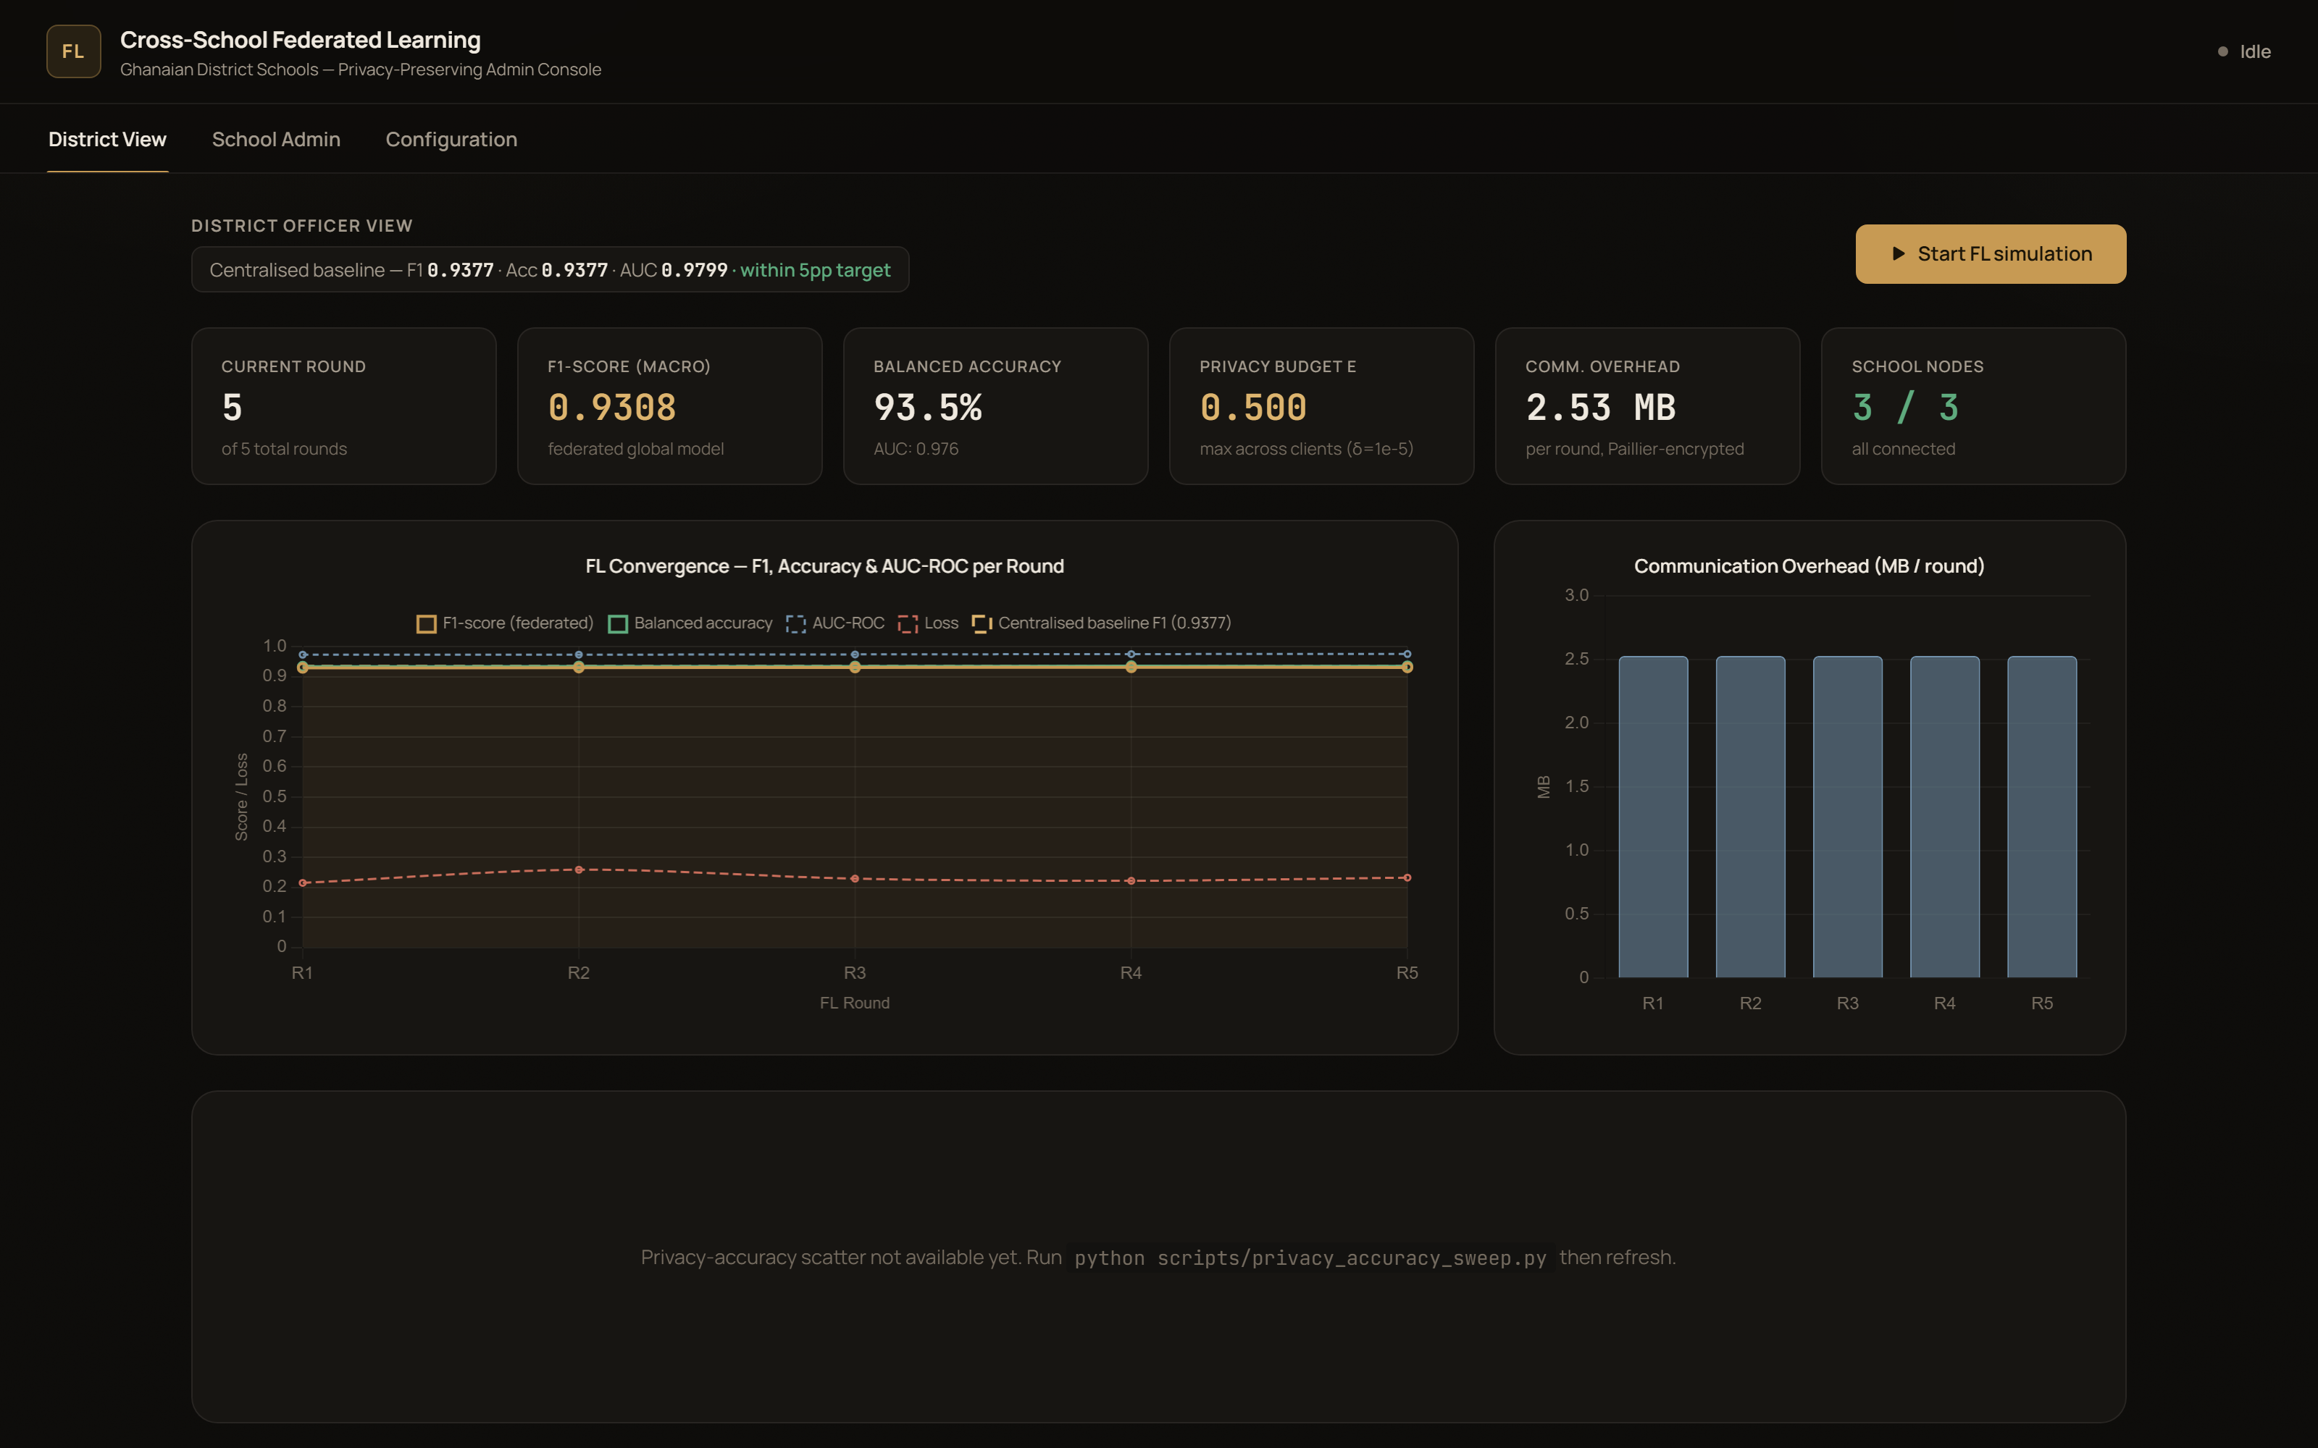 | 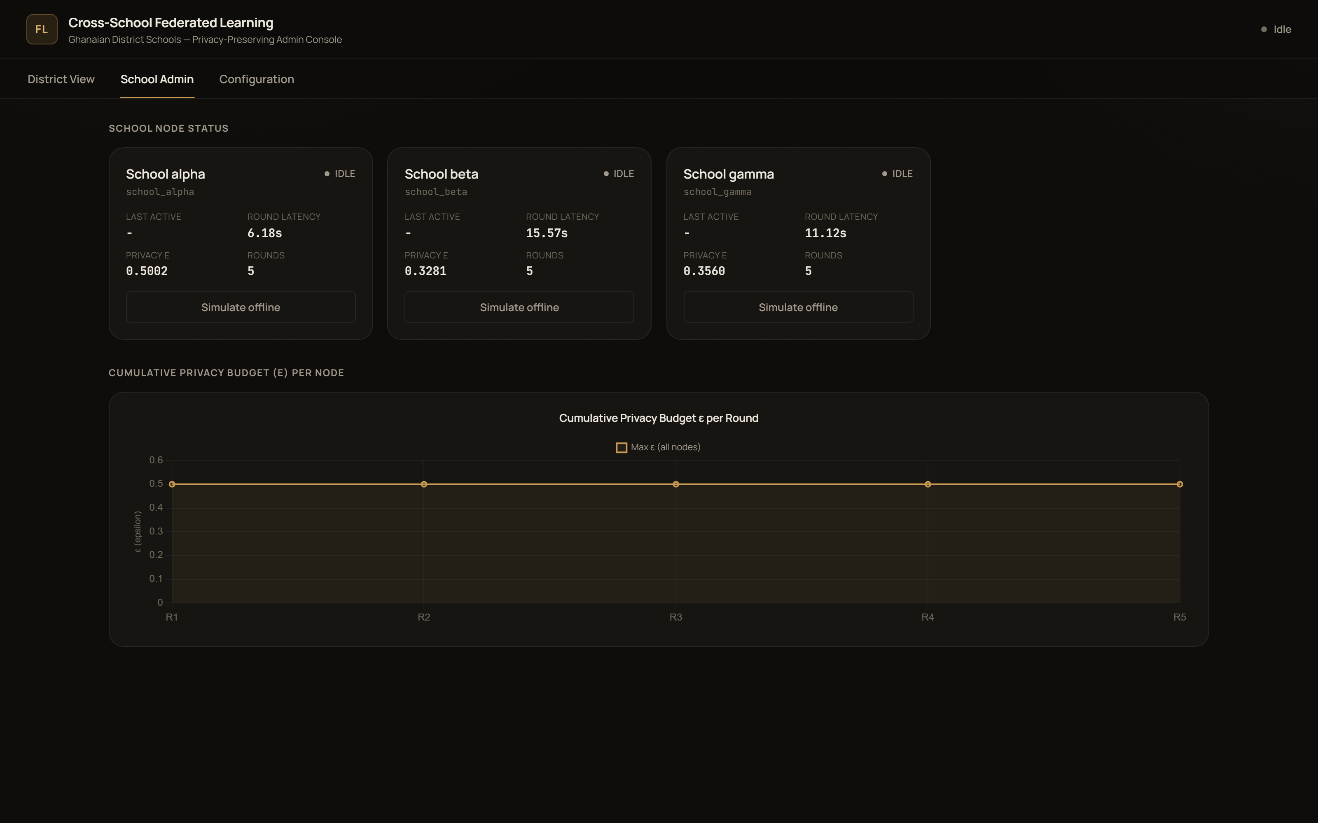
District View — completed, final chart | School Admin — all 3 nodes, 5/5 rounds
Contribution & Alignment
- SDG 4 (Quality Education), Target 4.1 — enables district-level student progress monitoring across multiple schools without centralised data risk, supporting evidence-based early intervention for at-risk students.
- SDG 16 (Peace, Justice & Strong Institutions), Target 16.10 — protects student data-privacy rights via Paillier encryption and DP-SGD, aligning with the Ghana Data Protection Act 2012 (Act 843).
- Produces a replicable, open-source FL client architecture that any Ghanaian district education office can adopt as a privacy-first template for school analytics.
Status & Next Steps
- Built & demonstrated: FL simulation (Flower + FedAvg, Docker/local), Paillier + DP-SGD privacy layer, live React/FastAPI dashboard, real OULAD data pipeline, centralised baseline.
- Pending: formal multi-seed statistical significance test across independent partitions, and SUS usability study data collection (materials prepared, not yet administered).
- A screen recording of this live demo run (idle → configuration → rounds 1-5 → completed chart) accompanies this report as FL_Ghana_Demo_Run.mp4.
GitHub repository: https://github.com/aimlin9/project12-fl-ghana

